

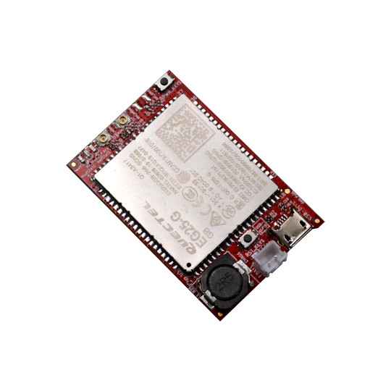
USB-gLINK
User Manual

Rev.1.0 April 2020
olimex.com

Table of Contents
What is USB-gLINK 3
USB-gLINK ordering options 4
USB-gLINK Open Source Licensee 5
USB-gLINK software installation 6
USB-gLINK connectors description: 7
USB-gLINK power consumption 10
Revision History 11

What is USB-gLINK

USB-gLINK is Open Source Hardware Industrial grade -25+85ºC LTE cat 4 module optimized for IoT applications with integrated LiPo Battery power supply charger and Navigation.
USB-gLINK will work with OLinuXino OSHW Linux Computers, Beaglebone and Raspberry Pi and any other PC running Windows, Linux or Android.
The LTE speed is 150Mbps downlink and 50Mbps uplink, but is backward-compatible with existing EDGE and GSM/GPRS networks. This allows USB-gLINK to connect to any existing 2G, 3G and 4G network.
Inside USB-gLINK there is build in navigation which supports: GPS, GLONASS, BeiDou/Compass, Galileo and QZSS.
The networking supported protocols are : TCP / UDP / PPP / FTP / HTTP / NTP / PING / QMI / NITZ / SMTP / MQTT / CMUX / HTTPS / FTPS / SMTPS / SSL / MMS / FILE.
USB-gLINK can operate on these bands: B1 / B2 / B3 / B4 / B5 / B7 / B8 / B12 / B13 / B18 / B19 / B20 / B25 / B26 / B28 / B38 / B39 / B40 / B41, which covers every mobile operator anywhere in the world. This allow your solution based on USB-gLINK to be sold globally without hardware changes.

There are number of carriers who already approved the module used in USB-gLINK: Deutsche Telekom (Europe), Verizon/AT&T/Sprint/U.S. Cellular/T-Mobile (North America), Telus/Rogers (Canada)
These regulatory are passed: GCF (Global), CE (Europe), FCC/PTCRB (North America), IC (Canada), Anatel (Brazil), IFETEL (Mexico), SRRC/CCC/NAL (China), KC (South Korea), NCC (Taiwan, China), JATE/TELEC (Japan), RCM (Australia & New Zealand), FAC (Russia), NBTC (Thailand), IMDA (Singapore), ICASA (South Africa)

USB-gLINK ordering options

USB-gLINK can be ordered as:
- USB-gLINK just the module
- USB-gLINK-ANT the module with GSM multiband antenna and GPS active antenna
- we also recommend you to buy USB micro cable if you do not have
- we offer LiPo batteries compatible with USB-gLINK but as these batteries are subject to many transport regulations they can be shipped only by ground i.e. in EU countries

USB-gLINK Open Source Licensee
USB-gLINK is Open Source Hardware.

The Hardware files are released under CERN OSHW licensee.
The software is released under GPL 3 licensee.
The documentation is released under CC BY-SA 3.0 licensee.

USB-gLINK software installation

If you use OLinuXino Linux SBC computers you can use the install script from this package.
Note that before you run the scrip you have to change settings.ini and to fill inside it user/pin/gateway information.

For Windows PC use these drivers.
For Linux PC (x86) use these drivers.
For Android use these drivers.

USB-gLINK connectors description:

YELLOW LED:
Flicker slowly (200ms High/1800ms Low) - search network
Flicker slowly (1800ms High/200ms Low) – Idle
Flicker quickly (125ms High/125ms Low) – data transfer
ON – voice call
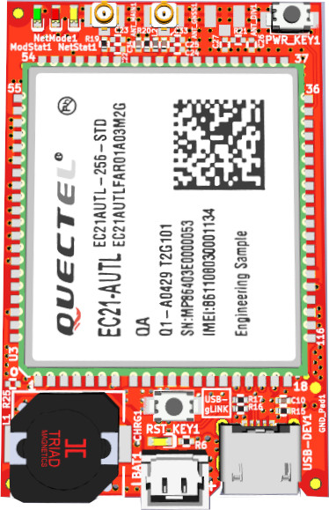
PWR button
GPS antenna
GSM antenna
RESET button
USB connector
LiPo battery connector
LiPo charge LED
RED LED: On – registered to LTE network
GREEN LED: Module status – ON module is working
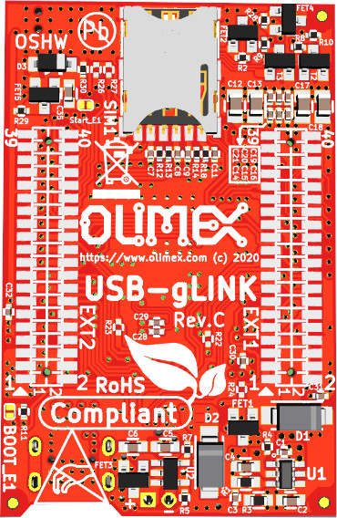
NANO SIM
EXT1
EXT2
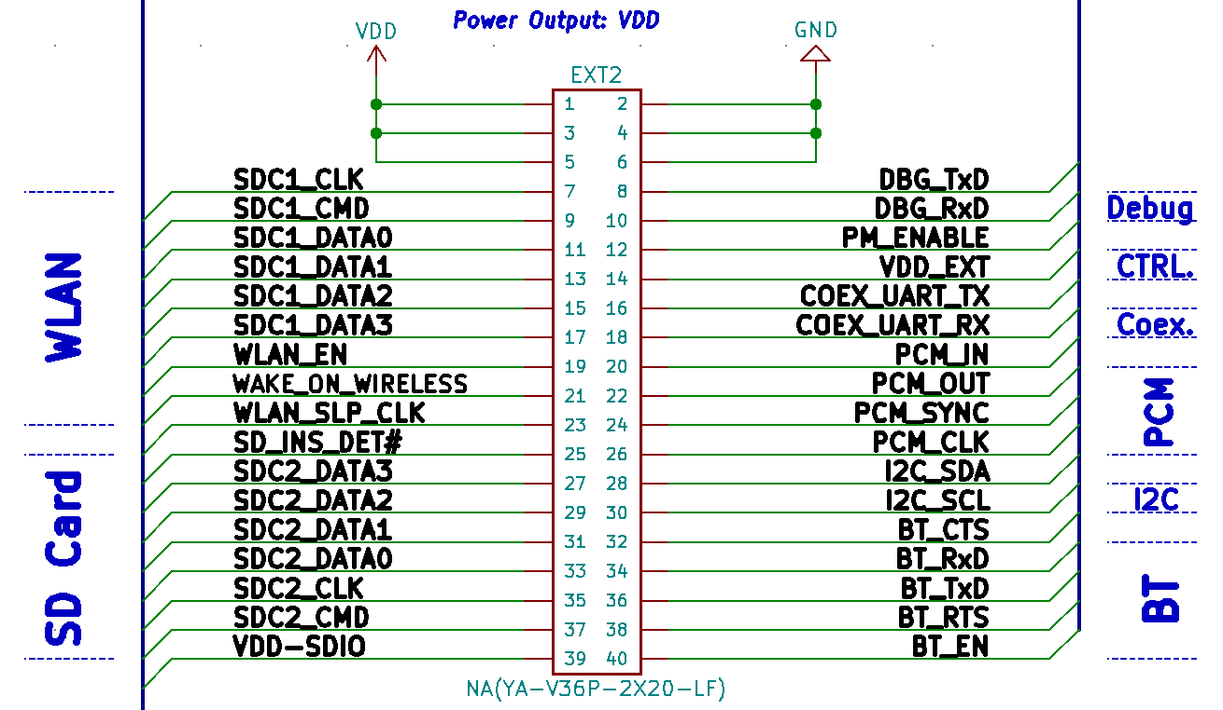
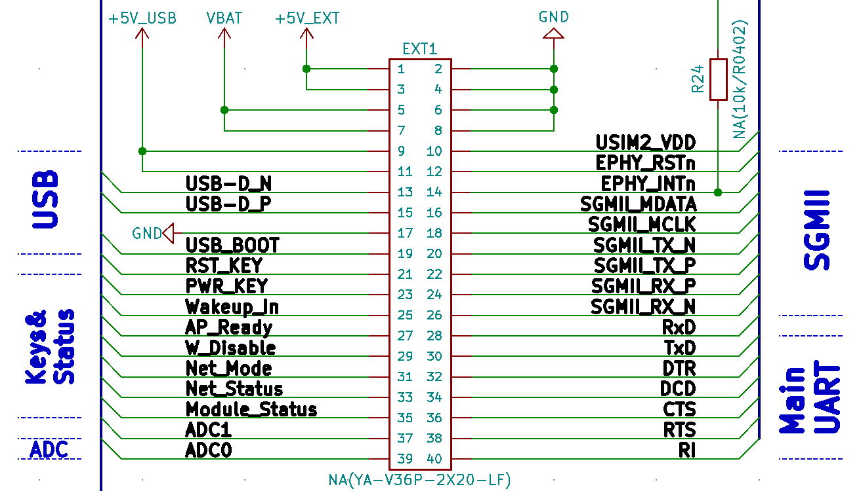

USB-gLINK power consumption

- 0.2A @ Active operation
- 22mA @ Idle
- 3mA @ Sleep
- 20 uA @ Power off

Revision History
Revision 1.0 April 2020

