

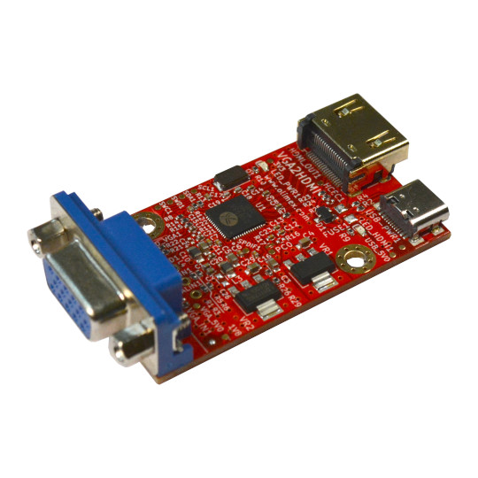

VGA2HDMI
User Manual
Rev.1.0 March 2024 olimex.com
Table of Contents
What is VGA2HDMI 3
VGA2HDMI features: 4
Order codes for VGA2HDMI: 5
HARDWARE 6
VGA2HDMI layout: 7
VGA2HDMI schematics: 8
Revision History 9

What is VGA2HDMI

VGA2HDMI is an open source hardware board which converts signals from VGA to HDMI. This allow old retro computers, game consoles and devices with VGA output to be displayed on modern displays and TVs with HDMI input.
AgonLight2, AgonOrigins and Cerberus2100 are tested to work with VGA2HDMI.

VGA2HDMI features:

- VGA connector input
- HDMI connector output
- USB-C power supply connector
- Power supply status LED
- VGA signal LED
- HDMI signal LED
- Dimensions are: 51 x 33 mm

Order codes for VGA2HDMI:

VGA2HDMI VGA2HDMI converter
VGA2HDMI-BOXED VGA2HDMI converter in plastic box
USB-CABLE-A-TO-C-1M USB-A to USB-C cable
CABLE-HDMI-50CM HDMI cable

HARDWARE

VGA2HDMI layout:

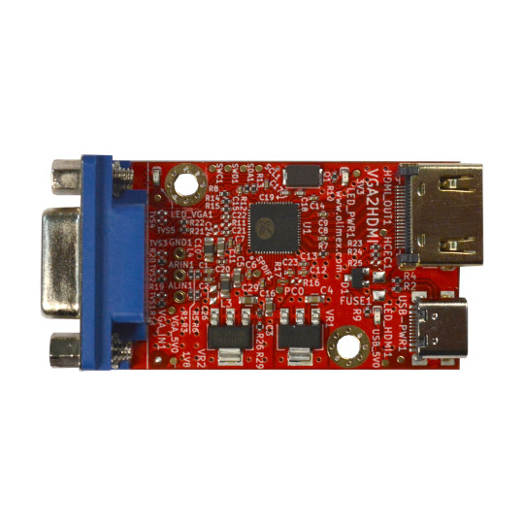
VGA input
HDMI output
Power supply USB-C

VGA2HDMI schematics:
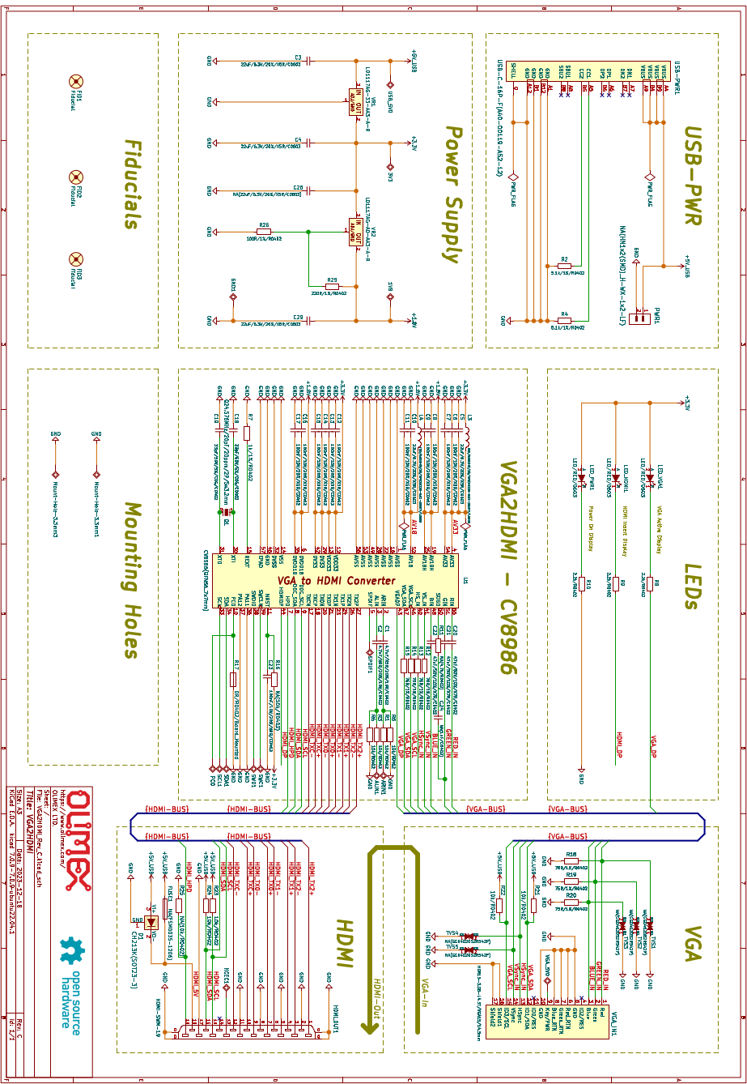

Revision History
Revision 1.0 March 2024

