

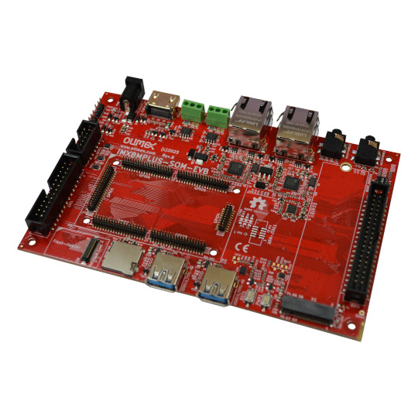

iMX8MP-SOM-EVB
User Manual
Rev.1.0 May 2024 olimex.com
Table of Contents
What is iMX8MP-SOM-EVB 3
Order codes for iMX8MP-SOM-EVB and accessories: 4
HARDWARE 5
iMX8MP-SOM-EVB layout: 6
iMX8MP-SOM-EVB schematics: 7
iMX8MP-SOM-EVB connectors: 8
UEXT 8
Micro-SD-card 9
Buttons 10
EXT1 11
EXT2: 12
M.2 nVM: 13
Audio out: 14
Audio in: 15
SOFTWARE 16
Recommended Olimage Linux images and changelog 16
Olimage Linux guide 16
Revision History 17

What is iMX8MP-SOM-EVB

iMX8MP-SOM-EVB is evaluation board for iMX8MP-SOM system on module development board with:

- connectors for iMX8MP-SOM system on module
- HDMI 2.0 connector
- Two Gigabit Ethernet connectors (LAN1 with TSN support)
- Two USB3.0 hosts
- Two CAN drivers and connectors
- M2 nVM SSD disk connector
- UEXT connecotr
- SD-card
- Reset and Power Buttons
- eMMC / Flash connector
- Audio Input on 3.5 mm jack
- Audio Output on 3.5 mm jack
- Dimensions: 155x102 mm

Order codes for iMX8MP-SOM-EVB and accessories:

iMX8MP-SOM-4GB-IND module with iMX8MPLUS, 4GB LPDDR4, EEPROM, PMIC
iMX8MP-SOM-EVB evaluation board for iMX8MP-SOM which can be used as reference design
MICRO-SD-16GB-CLASS10 16GB microSD card
SY1005E power adapter 5V 2A
USB-SERIAL-F serial debug cable for console log
CABLE-HDMI-50CM HDMI cable
BATTERY-LIPO1400mAh LiPo battery for standalone operation
LCD/LCD-OLinuXino-5CTS 5 inch LCD 800x480 pixels with capacitive touch panel
LCD-OLinuXino-7CTS 7 inch LCD 1024x600 pixels with capacitive touch panel
LCD-OLinuXino-10CTS 10 inch LCD 1024x600 pixels with capacitive touch panel
UEXT modules There are temperature, humidity, pressure, magnetic field, light sensors. Modules with LCDs, LED matrix, Relays, Bluetooth, Zigbee, WiFi, GSM, GPS, RFID, RTC, EKG, sensors and etc.

HARDWARE

iMX8MP-SOM-EVB layout:

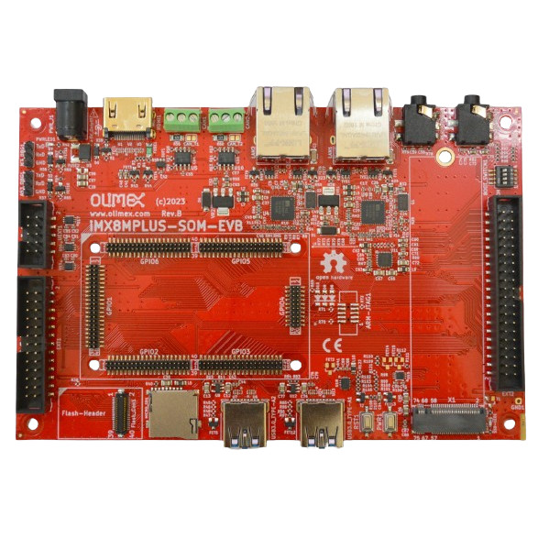
Flash module
MicroSD card
USB3 hosts
Reset Power Buttons
M.2 nVM slot
Power +5V
HDMI
CAN
Gigabit Ethernet
Audio
boot
GPIO
UEXT
GPIO
debug
Optional JTAG

iMX8MP-SOM-EVB schematics:

iMX8MP-SOM-EVB latest schematic is on Olimex web.

iMX8MP-SOM-EVB connectors:

UEXT

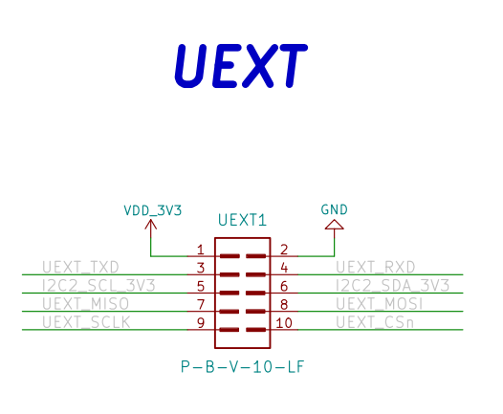

Micro-SD-card

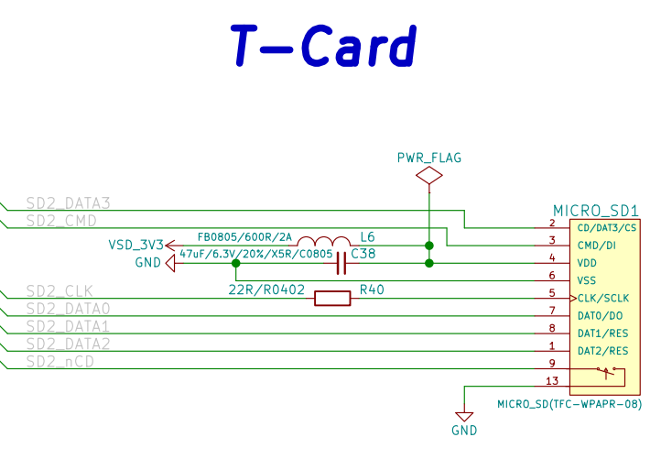

Buttons
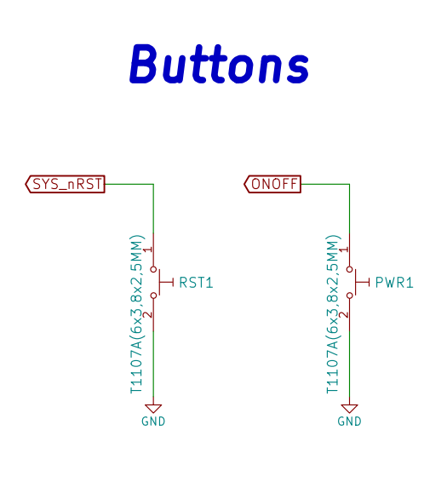

EXT1
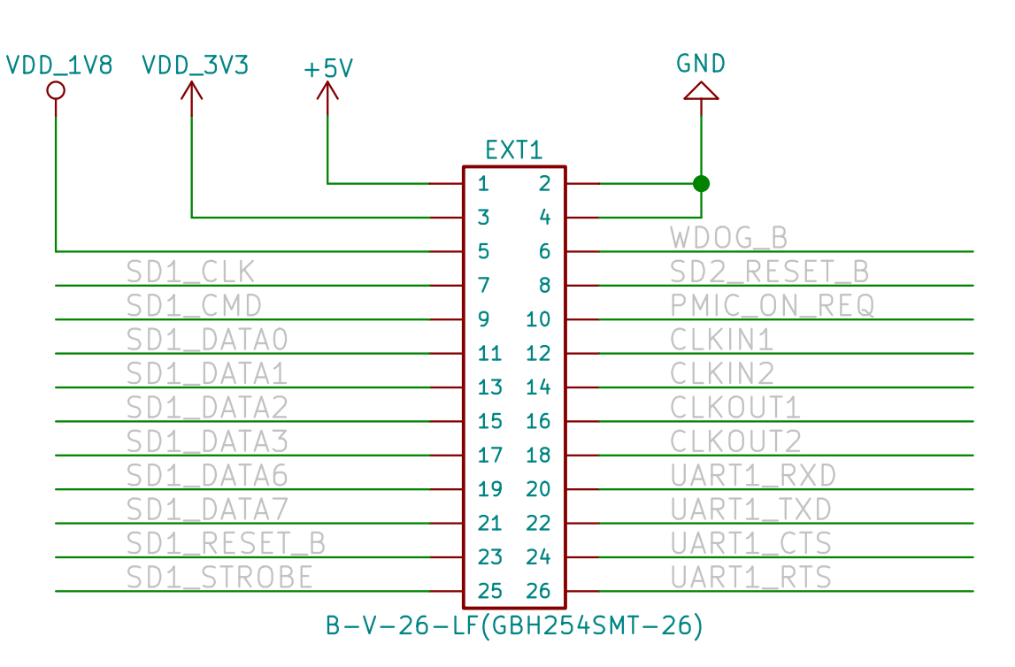

EXT2:
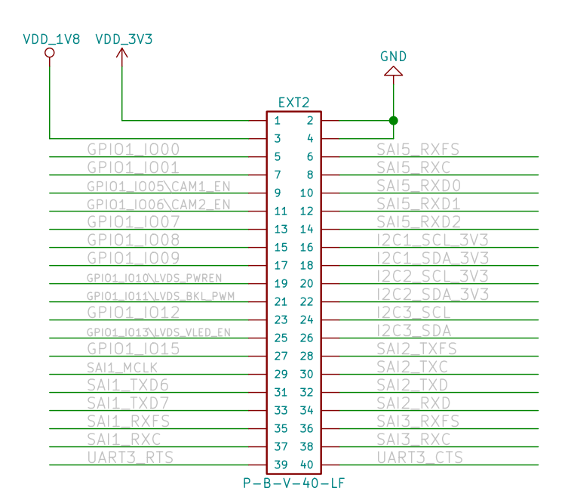

M.2 nVM:
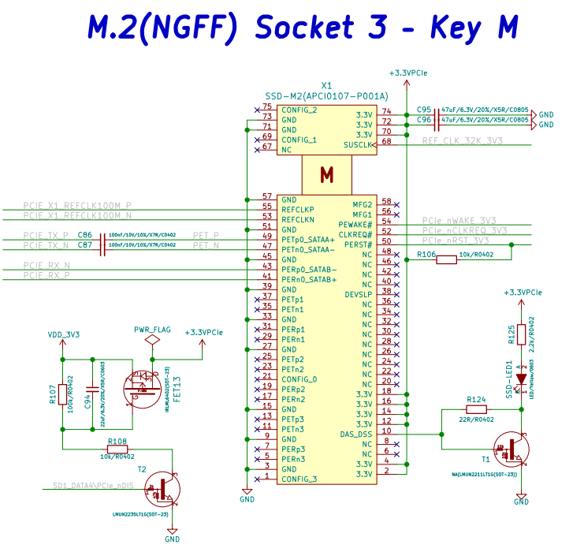

Audio out:
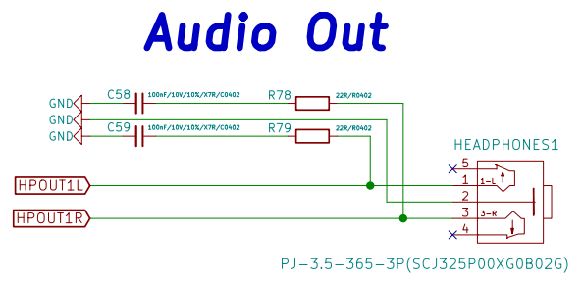

Audio in:
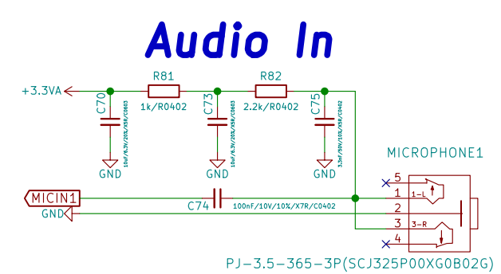

SOFTWARE

- Recommended Olimage Linux images and changelog
- Olimage Linux guide

Revision History
Revision 1.0 May 2024 initial

