

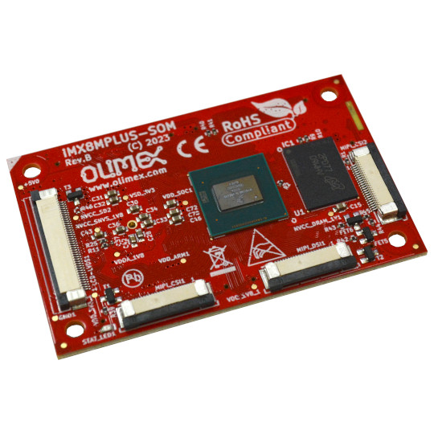

IMX8MP-SOM-xGB-IND

User Manual

document revision 3.0 www.olimex.com
Table of Contents
iMX8MP-SOM-4GB-IND board features 3
MIMX8ML8CVNKZAB chip features 4
iMX8MP-SOM-EVB-IND board of peripherals features 5
Order codes for iMX8MP-SOM and accessories 6
HARDWARE 7
iMX8MP-SOM layout 7
iMX8MP-SOM schematics 8
iMX8MP-SOM connectors 9
GPIO1 9
GPIO2 10
GPIO3 11
GPIO4 12
GPIO5 13
GPIO6 14
LCD 14
MIPI-DSI 15
MIPI-CSI 16
EEPROM 17
User LED 18
SOFTWARE 19
Recommended Olimage Linux images 19
Document Revision History 20

iMX8MP-SOM-4GB-IND board features

iMX8MP-SOM-4GB-IND exposes all MIMX8ML8CVNKZAB GPIOs and features in a very compact format. It takes care for power supply and high speed memory signals complexities.

- Main chip: i.MX 8M Plus – MIMX8ML8CVNKZAB – Quad core Cortex-A53@1600Mhz + Arm Cortex-M7@800 Mhz
- 4GB LPDDR4 RAM
- PMIC PCA9450
- 24 Mhz crystal
- 32.768 kHz crystal
- EEPROM memory (for Linux configuration or settings)
- Power LED
- User LED
- 5 x 40 pin + 1 x 20 pin total 220 pin connectors with 1.27 mm/0.05" step
- LVDS, 2 x MIPI CSI, MIPI DSI ribbon connectors on top
- Extended operating temperature – from -20°C to +85°C
- Dimensions: (70 x 43)mm
- 4 holes for mounting
- Open source hardware design, all KiCAD design files available for download

Compatible with iMX8MP-SOM-EVB-IND – iMX8MP-SOM-4GB-IND can be placed on top of expansion board for easier R&D and prototyping.

MIMX8ML8CVNKZAB chip features

The main chip has the following features:
- MIMX8ML8CVNKZAB Quad core Cortex-A53 @1600Mhz + Arm Cortex-M7 @800 Mhz
- 512KB Cache
- Vivante GC520L, Vivante GC7000UL
- HDMI HD1080p60 H.264, HD1080p60 H.265, VP8 video codec, VP9 video codec
- MIPI-DSI
- LVDS 4/8 lanes
- NPU 2.3 TOPS
- 2 x Gigabit Ethernet (1 x TSN)
- 2 x MIPI-CSI camera
- 1 x ISP camera
- 2 x USB3 with OTG
- 1 x PCIe 3.0
- 2 x CAN FD
- 3 x SPI
- 5 x I2C
- 3 x SDIO eMMC 5.1
- 4 x UART 5Mbit
- 4 x PWM
- Audio: ASRC, HiFi 4 DSP, SAI/I2S, eARC

iMX8MP-SOM-EVB-IND board of peripherals features

iMX8MP-SOM-EVB-IND can be placed on top of expansion board for easier R&D and prototyping. It has the following features:

- iMX8MP-SOM matching connectors
- Two Gigabit Ethernet connectors
- Two CAN transceivers
- HDMI output connector
- Power jack for 5V DC
- Two serial debug UARTs (for A53 and M7)
- Micro SD-card connector
- Flash module connector
- Two USB 3.0 hosts
- PCI Express 3.0 M.2 expansion slot (2280) for nVME
- Headphone 3.5mm connector
- Microphone 3.5 mm connector
- Reset button
- PWR button
- UEXT connector
- Two GPIO connectors at 0.1" step
- Optional ARM JTAG connector
- Boot slide switch
- Open-hardware design, design made with KiCAD
- Industrial grade temperature range: (-45+85)C
- Dimensions: (155 x 102)mm

Order codes for iMX8MP-SOM and accessories

iMX8MP-SOM-EVB Expansion board for easy evaluation of iMX8MP-SOM which can be used as reference design; requires SOM module iMX8MP- SOM-4GB-IND

iMX8MP-SOM-4GB-IND Main module with i.MX8 quad-core MIMX8ML8CVNKZAB, 4GB LPDDR4, EEPROM, PMIC

If you have the EVB board you can attach extra peripherals:

MICRO-SD-16GB-CLASS10 Blank 16GB microSD card
USB-CARD-READER USB card reader and writer
SY1505E Power adapter 5V 3A
SY2005E Power adapter 5V 5A
USB-SERIAL-F Serial debug cable for console log
Flash-e32Gs16M Plug-and-play eMMC and SPI memory expansion module
CABLE-HDMI-50CM HDMI cable
USB-KEYBOARD-PS2 Mini keyboard
PWR-CABLE Cable with free leads fitting the Olimex barrel jacks
UEXT modules There are temperature, humidity, pressure, magnetic field, light sensors. Modules with LCDs, LED matrix, Relays, Bluetooth, Zigbee, WiFi, GSM, GPS, RFID, RTC, EKG, sensors and etc.

HARDWARE

iMX8MP-SOM layout

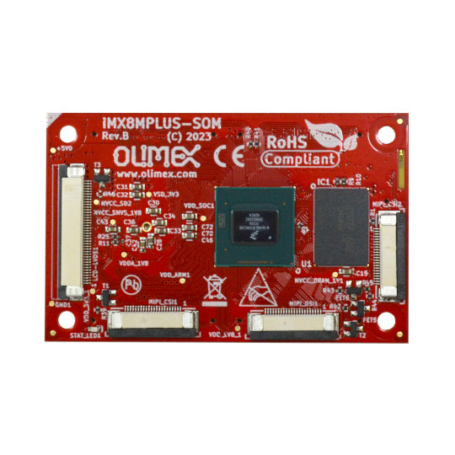
MIMX8ML8CVNKZAB
32Gb LPDDR4
MIPI-CSI2
LCD LVDS
Orientation mark
MIPI-CSI1
MIPI-DSI
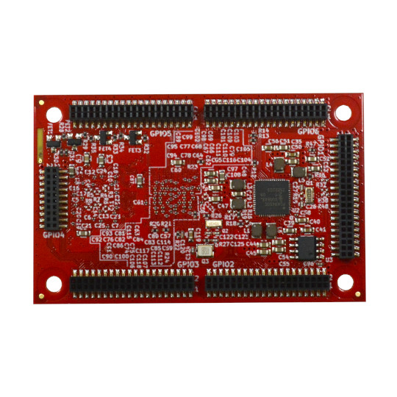
GPIO5
GPIO6
GPIO4
GPIO3
GPIO2
GPIO1
EEPROM
PMIC
GPIO3
GPIO2

iMX8MP-SOM schematics

iMX8MP-SOM-4GB-IND latest schematic is at our GitHub.

Hardware sources and more can also be found here:

https://github.com/OLIMEX/iMX8MP-SOM/tree/main/HARDWARE

iMX8MP-SOM connectors

GPIO1

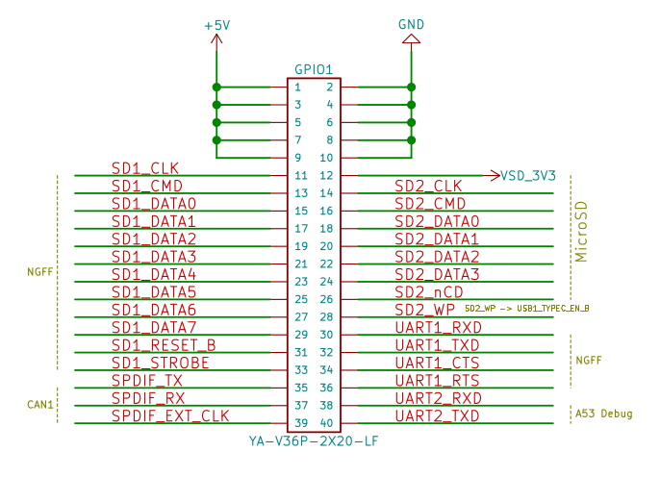

GPIO2
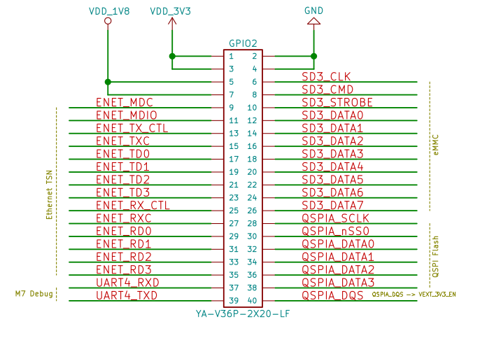

GPIO3
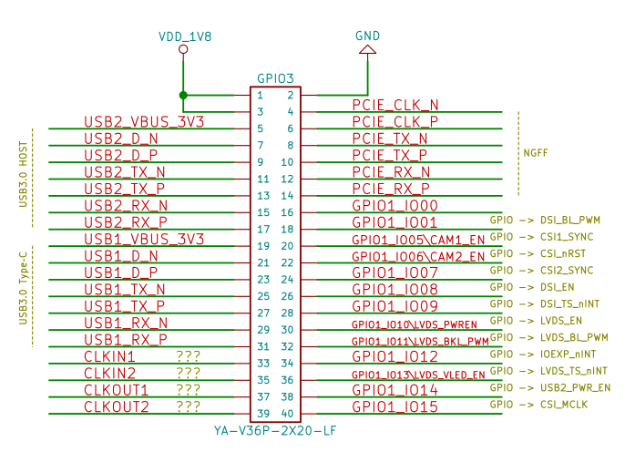

GPIO4
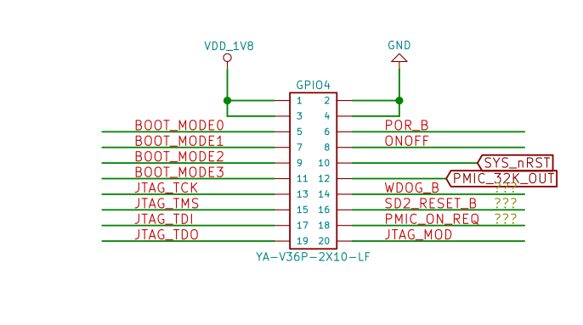

GPIO5
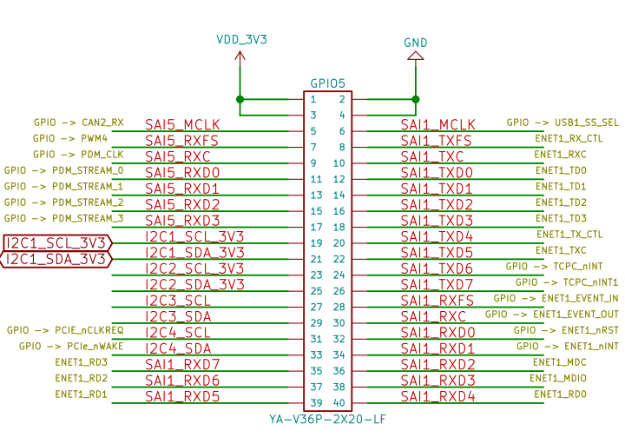

GPIO6

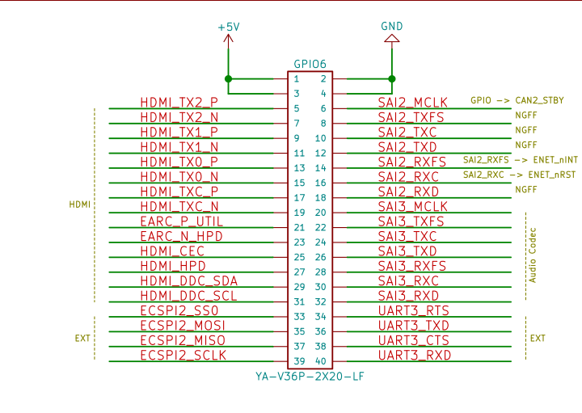
LCD
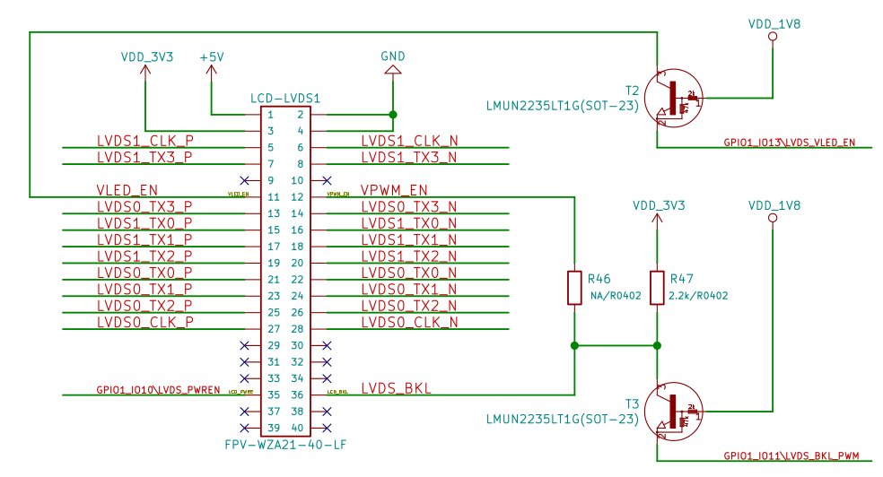

MIPI-DSI
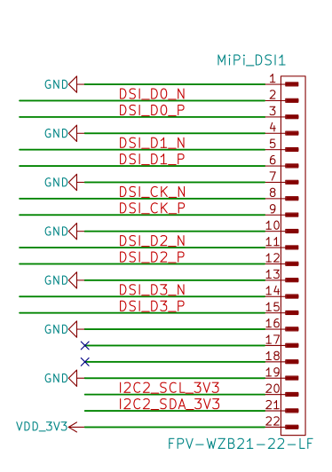

MIPI-CSI
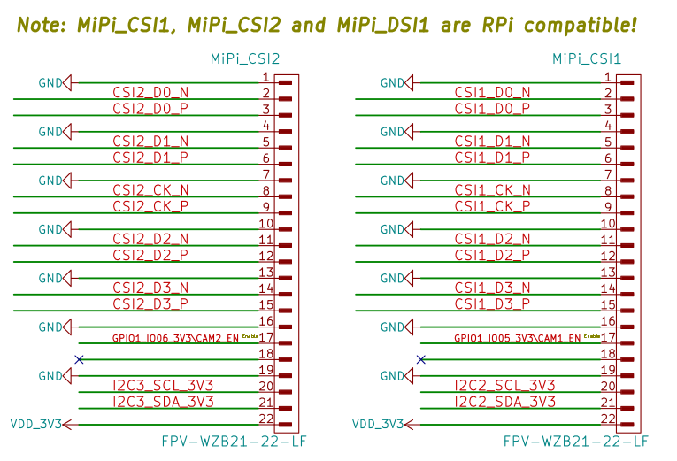

EEPROM
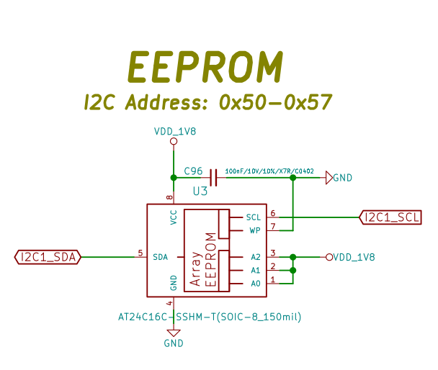

User LED
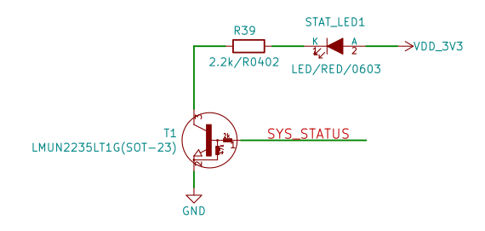

SOFTWARE

You can find Olimex-maintained recommended images here:

- Recommended Olimage Linux images

It is recommended to start with the base Armbian image. The minimal Armbian image has no graphical user interface.

The software we provide and maintain for iMX8MP-SOM-EVB is the same as for the main board:

- Armbian-based Debian 12 “bookworm” images (base and minimal) with support for the main chip and most peripherals, like USB 3.0, GbE, NVMe M.2 slot, Flash-header slot, serial debug, HDMI output (+audio over HDMI), CAN, etc. Known software issues: Currently there is no support for the ES8388 audio driver, e.g. HEADPHONES1 and MICROPHONE1 jacks won’t work without additional software work (HDMI audio works ok).
- Buildroot setup

Document Revision History
Revision 3.0 Feburary 2025
- Removed misleading links
- Added info about new Armbian-based Debian release
Revision 2.0 December 2024
- Improved formatting
- Fixed wrong info about Linux available
Revision 1.0 May 2024
- Initial document

