GitHub and CICD Lab 1 - An Introduction To GitHub

EXPLAINATION
In this task, I first created a folder (ArchOSC Assignment). I then created another folder named “Pictures” and placed it in it. I then took a screenshot of inside of my newly created lab folder, including the "Pictures" folder which I created. I pasted it into paint, made the necessary editing and saved it to my "Pictures folder" and that is showed below.
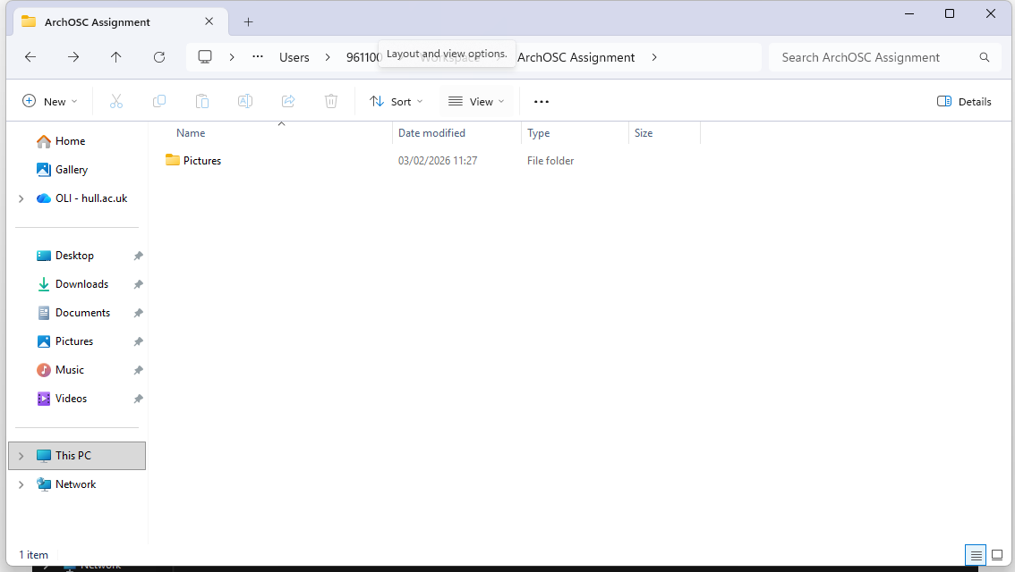

Secondly, I opened a Windows terminal in my “ArchOSC Assignment” folder and took a screenshot of it as instructed. I then added the screenshot of the terminal showing that I have created a local repository (repo) in my ArchOSC Assignment by entering the git init command to your pictures folder and updated it in the “Picture” folder. This is illustrated below.
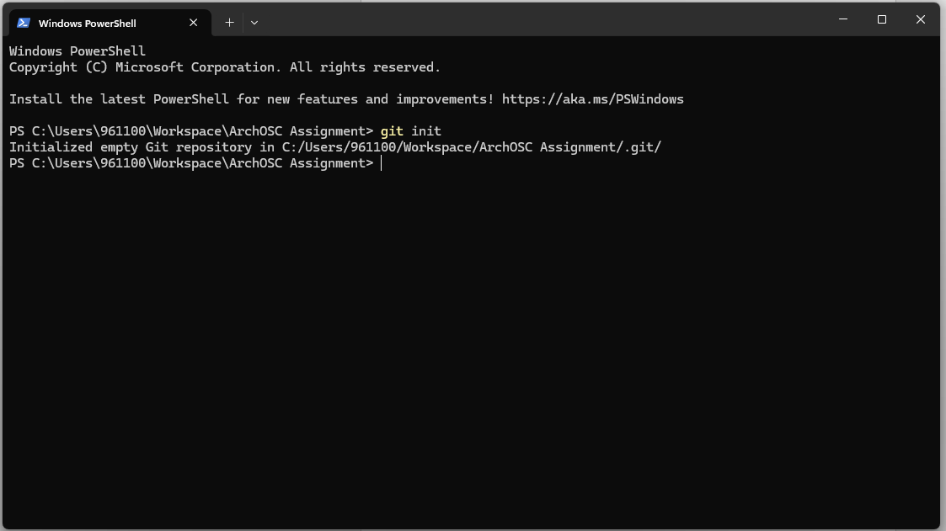

Third, since I already have a github account, I created a github repository and set to the name ArchOSC Assignment where my local repo would be linked to. The git ignore has also been set to visual studio indicated below.
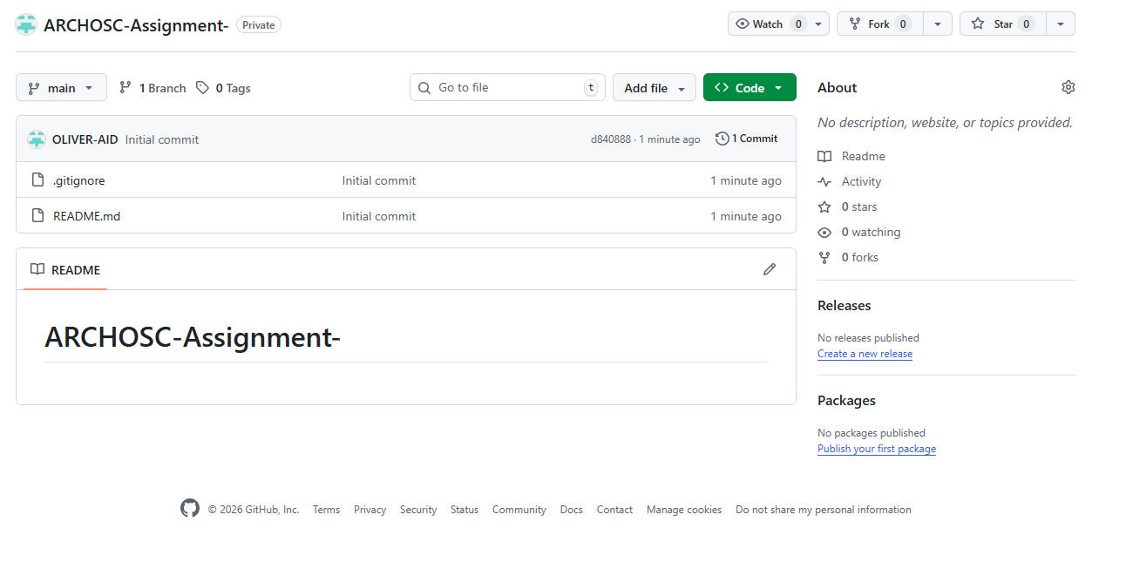
Next, using the terminal, I created a link between my local repository and the one on GitHub, this will allow me to push my local changes to GitHub when I have completed them. I have added a screenshot of my terminal showing the addition of my GitHub repository as a remote repository to my pictures folder. This is also shown here:
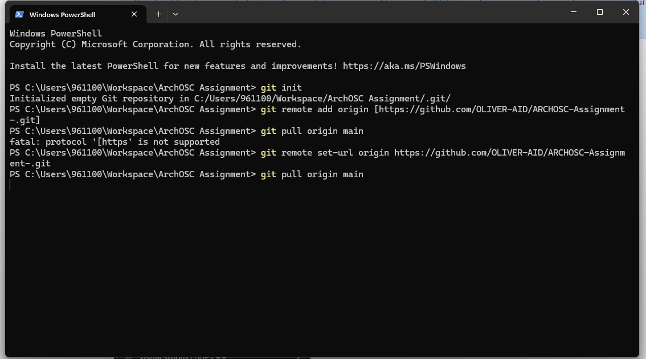

Furthermore, I created a basic website using the HTML in Visual Studio code. To make things clear, I named the it index.html. When the site is opened, it takes you to the page shown below.
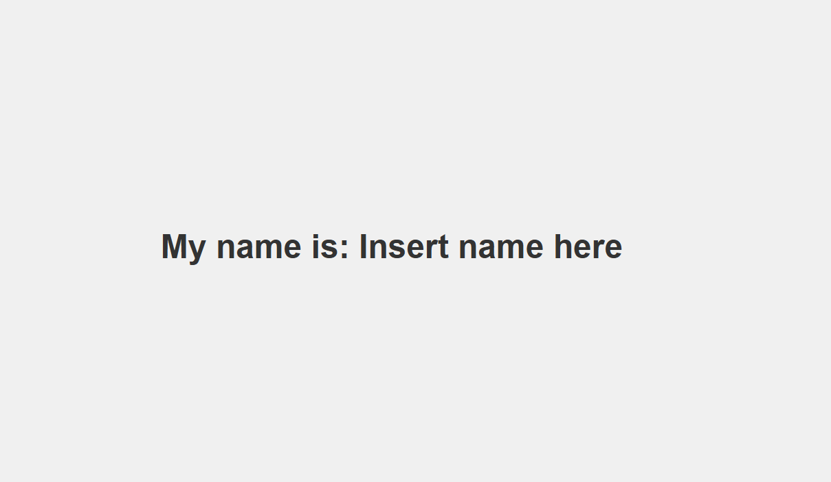
The index.html file and the Picture folder have both been added to the github repository and committed through the terminal.
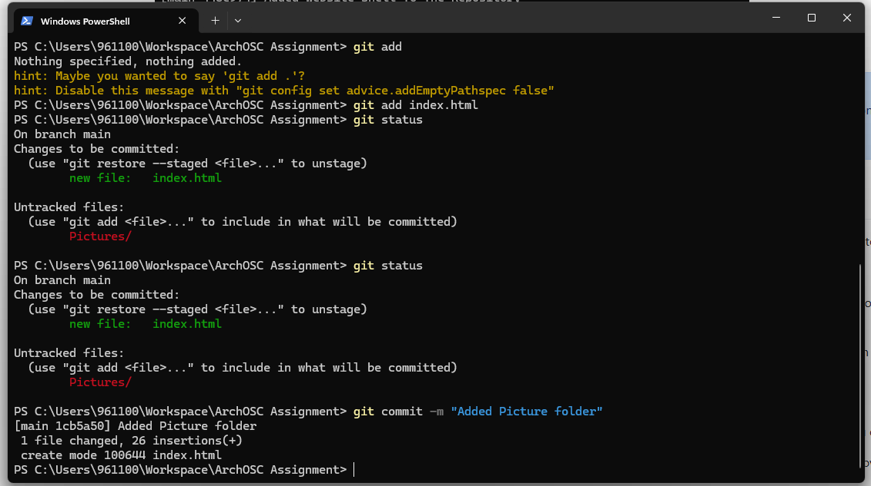
All related files in my local repo have been named, branched and push to github (online respository).
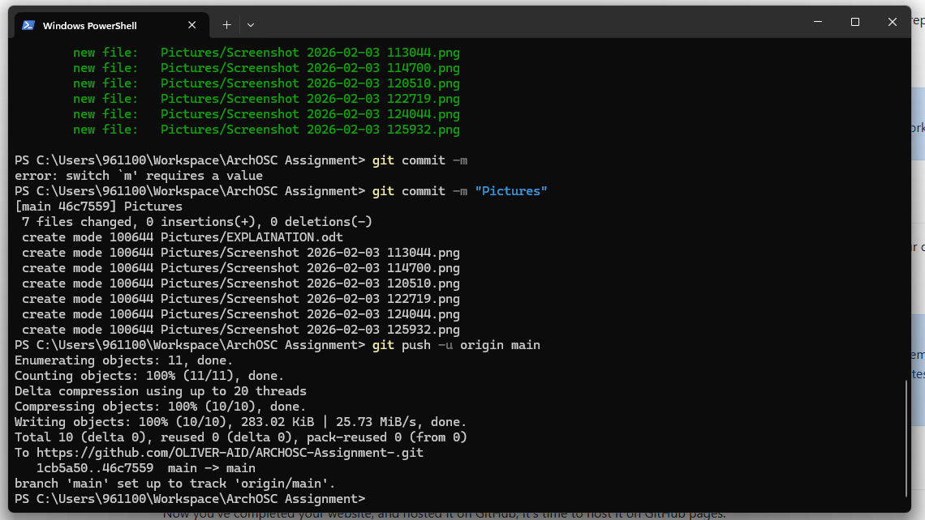
Since practicing for the first time resulted in a few mistakes, corrections were made to put everything else in order shown in the image below
