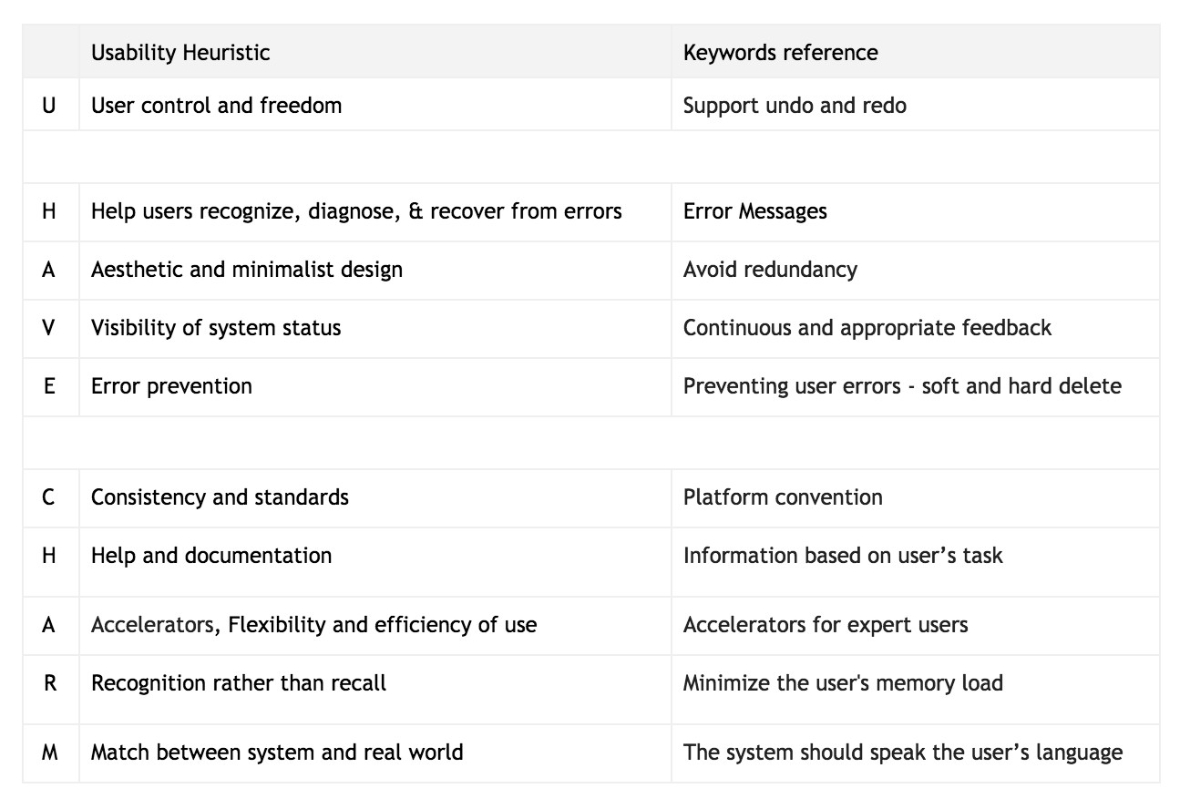

<https://uxdesign.cc/10-usability-heuristics-every-designer-should-know-129b9779ac53>

<https://blog.prototypr.io/10-usability-heuristics-with-examples-4a81ada920c>

<https://www.designprinciplesftw.com/collections/10-usability-heuristics-for-user-interface-design>

<https://medium.com/@erangatl/10-usability-heuristics-explained-caa5903faba2>

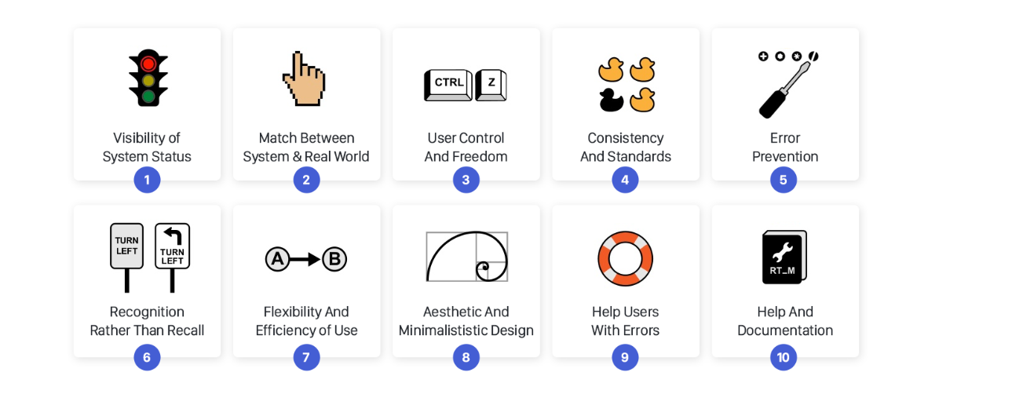

All u need to know

<https://www.nngroup.com/articles/ten-usability-heuristics/>

<https://www.nngroup.com/videos/usability-heuristic-system-status/>

<https://www.nngroup.com/videos/match-system-real-world/>

<https://www.nngroup.com/videos/usability-heuristic-user-control-freedom/>

<https://www.nngroup.com/videos/usability-heuristic-consistency-standards/>

<https://www.nngroup.com/articles/slips/>

<https://www.nngroup.com/articles/recognition-and-recall/>

<https://www.nngroup.com/videos/flexibility-efficiency-use/>

<https://www.nngroup.com/videos/aesthetic-and-minimalist-design/>

<https://www.nngroup.com/videos/usability-heuristic-recognize-errors/>

<https://www.nngroup.com/videos/help-and-documentation/>

<https://www.nngroup.com/articles/usability-heuristics-applied-video-games/>

<https://asktog.com/atc/principles-of-interaction-design/>

<http://designingwebinterfaces.com/6-tips-for-a-great-flex-ux-part-5>