Hospital Readmission Risk Analysis
Findings & Recommendations Report
Diabetes 130-US Hospitals Dataset

1. Executive Summary
This project analyzed 101,766 hospital encounters from the UCI Diabetes 130-US Hospitals dataset to identify patients at risk of readmission within 30 days of discharge. After cleaning and de-duplicating patient records, 69,990 unique patient encounters were used to build and evaluate predictive models. The best-performing model, XGBoost, achieved a ROC-AUC of 0.646 and clearly separates high-risk from low-risk patients: high-risk patients are actually readmitted 22.9% of the time, versus 3.2% for low-risk patients - a more than 7x difference. This report summarizes the key clinical drivers of readmission risk identified across the analysis, presents the supporting charts and interactive Power BI dashboard, and translates the findings into concrete, actionable recommendations for hospital care teams.

2. Methodology Overview
The analysis followed a 10-stage pipeline:
- Data Understanding & Quality Assessment - initial inspection of 101,766 encounters across 50 columns
- Data Cleaning & Preprocessing - handled missing values, removed death/hospice discharges and duplicate patient encounters
- Exploratory Data Analysis - readmission patterns by age, race, diagnosis, and utilization
- Feature Engineering - created age, utilization, and medication-based predictive features
- Baseline Machine Learning Model - Logistic Regression
- Model Evaluation - cross-validation, precision-recall analysis, threshold tuning
- Random Forest / XGBoost - stronger tree-based models
- SHAP Interpretation - explained individual and global model predictions
- Power BI Dashboard - interactive 3-page reporting tool for care teams
- Recommendations & Reporting - this document

3. Data Cleaning Summary
Key cleaning steps applied to the raw dataset:
- Removed weight and payer_code columns (96.9% and 39.6% missing respectively)
- Filled sparse categorical gaps (race, medical_specialty, diagnosis codes) as "Unknown"
- Filled missing lab test results (max_glu_serum, A1Cresult) as "Not Tested" rather than dropping - a missing test is itself informative
- Removed 2,423 encounters ending in death or hospice discharge, since 30-day readmission is not a meaningful outcome for these patients
- Removed 29,353 repeat encounters, keeping only the first encounter per patient to prevent the same patient from leaking across model training and testing
Result: 101,766 rows x 50 columns reduced to 69,990 rows x 47 columns, with zero missing values remaining.

4. Key Findings from Exploratory Analysis
Readmission rate rises steadily and substantially with patient age, from 1.96% (ages 0-10) to a peak of 10.79% (ages 80-90):
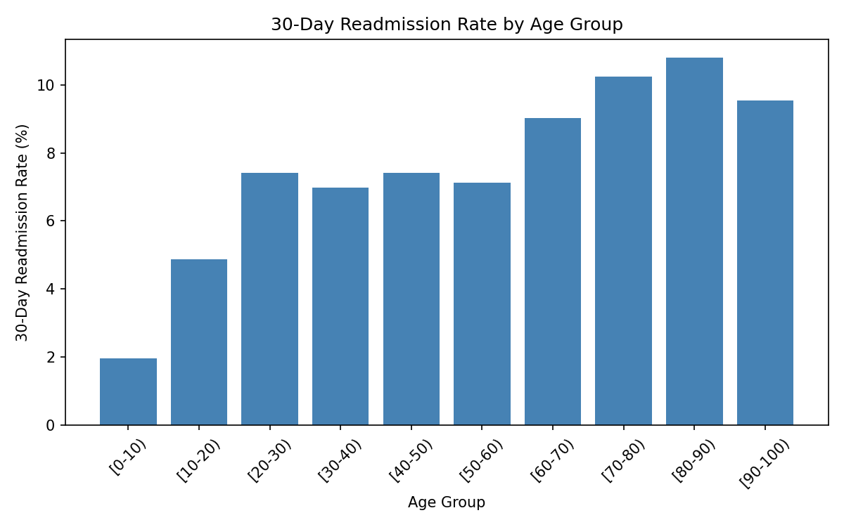
Figure 1. 30-Day Readmission Rate by Age Group
Prior hospital utilization is the single strongest behavioral signal: patients with any prior inpatient stay are readmitted at nearly double the rate of those without one (15.4% vs. 8.1%).

5. Model Performance Comparison
Three models were trained and compared on an identical, stratified 80/20 train-test split:
Model | Accuracy | Precision | Recall | F1 Score | ROC-AUC
Logistic Regression (baseline) | 0.629 | 0.128 | 0.537 | 0.207 | 0.628
Random Forest | 0.669 | 0.138 | 0.512 | 0.218 | 0.640
XGBoost (best model) | 0.674 | 0.140 | 0.515 | 0.221 | 0.646

5-fold cross-validation confirmed the baseline result is stable (ROC-AUC 0.625 +/- 0.004, versus a dummy "always predict no readmission" classifier's ROC-AUC of 0.5).
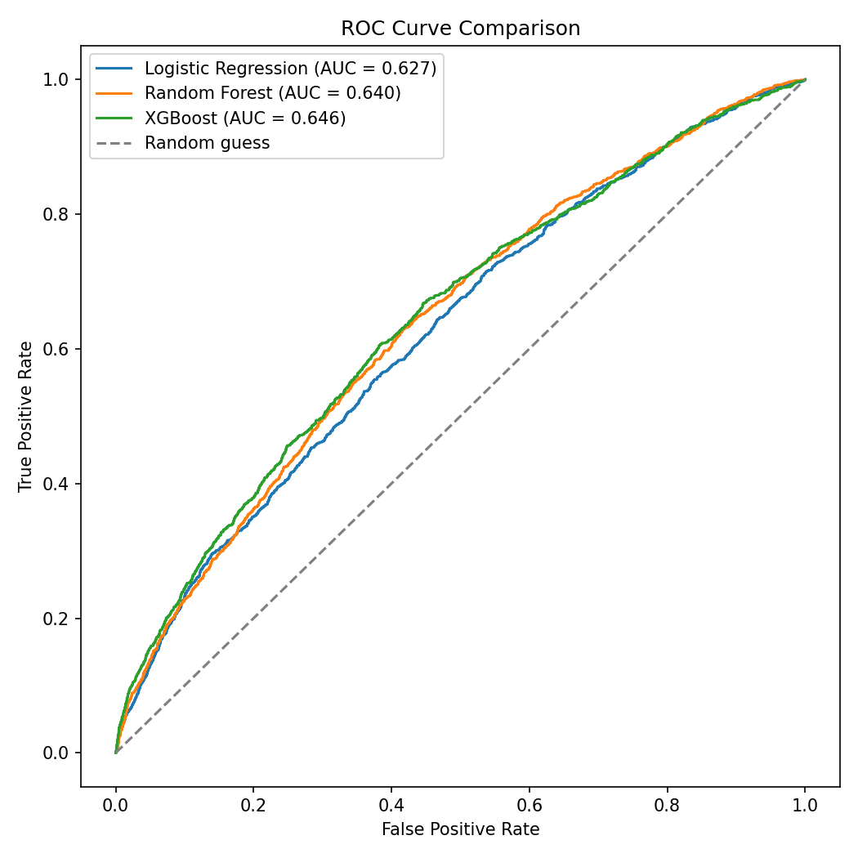
Figure 2. ROC Curve Comparison - Logistic Regression vs. Random Forest vs. XGBoost
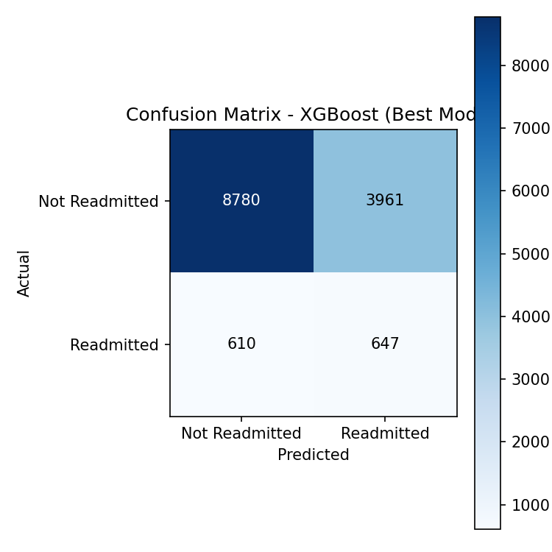
Figure 3. Confusion Matrix - XGBoost (Best Model)
XGBoost was selected as the final model for interpretation and dashboard scoring.

6. Top Predictive Drivers (SHAP Interpretation)
SHAP analysis of the XGBoost model identified the following as the strongest individual predictors of 30-day readmission risk, in order of impact:
- Discharge disposition - where and how the patient was discharged (e.g. home, another facility, with home health)
- Prior inpatient visits - whether the patient had any inpatient admission in the year before this encounter
- Number of inpatient visits - the count of prior inpatient stays
- Length of stay (time in hospital) - longer stays associated with higher risk
- Patient age - older patients at higher risk
- Primary diagnosis category - Musculoskeletal, Circulatory, and Respiratory diagnoses showed elevated risk contributions
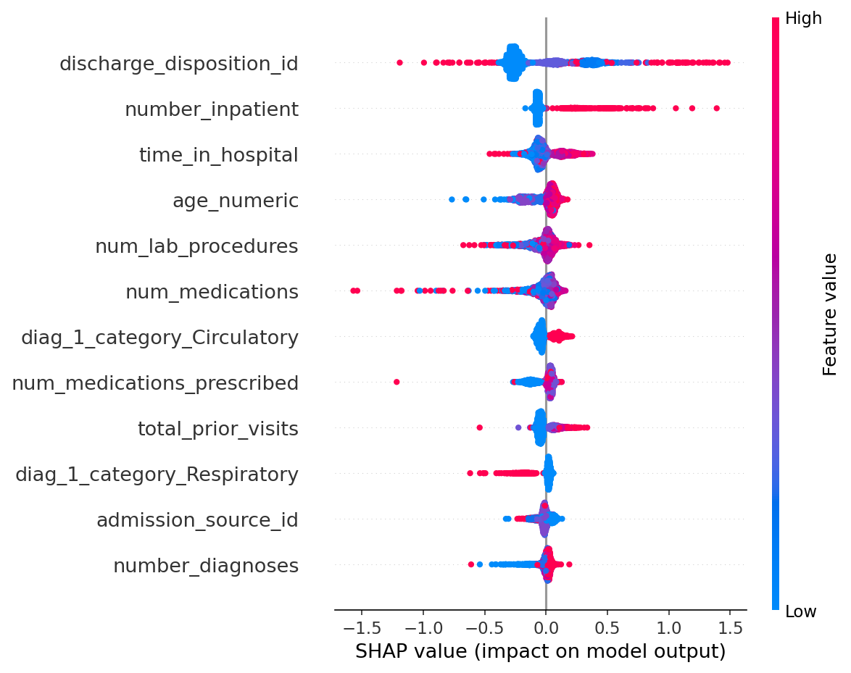
Figure 4. SHAP Summary Plot - Feature Impact on Predicted Readmission Risk

7. Power BI Dashboard
A 3-page interactive Power BI dashboard was built to make these findings actionable for care teams. Each page is shown below.

7.1 Overview Page
KPI summary, risk tier distribution, and readmission rate by risk tier and age group, with slicers for age and risk tier.
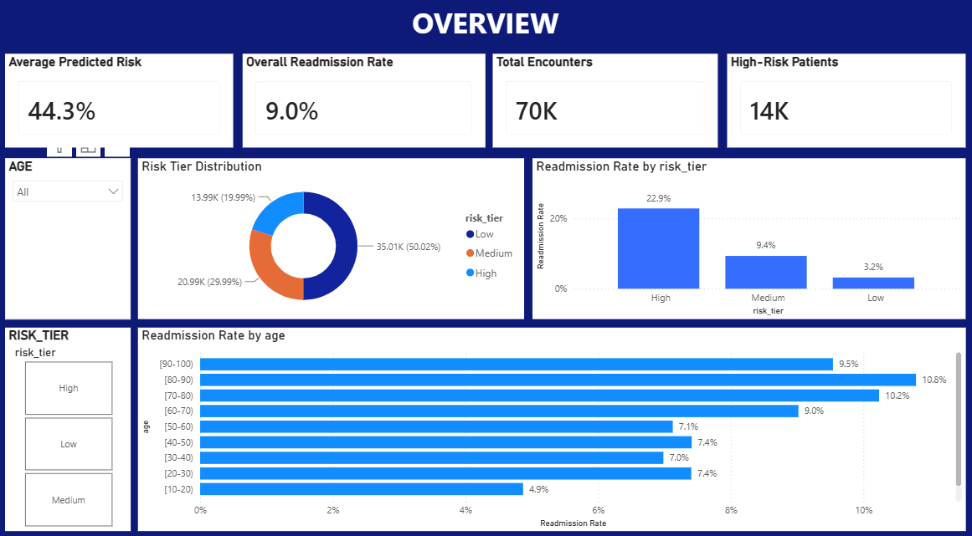
Figure 5. Dashboard - Overview Page

7.2 Risk Drivers Page
Readmission rate broken down by diagnosis category, discharge disposition, and prior inpatient visit history, filterable by race and diagnosis category. One notable outlier: the "Still patient or expected to return" discharge disposition shows a 50% readmission rate, far above every other category - this reflects a very small group of encounters and should be treated as a data quality flag to investigate further rather than a generalizable finding, given how sharply it departs from the rest of the distribution.
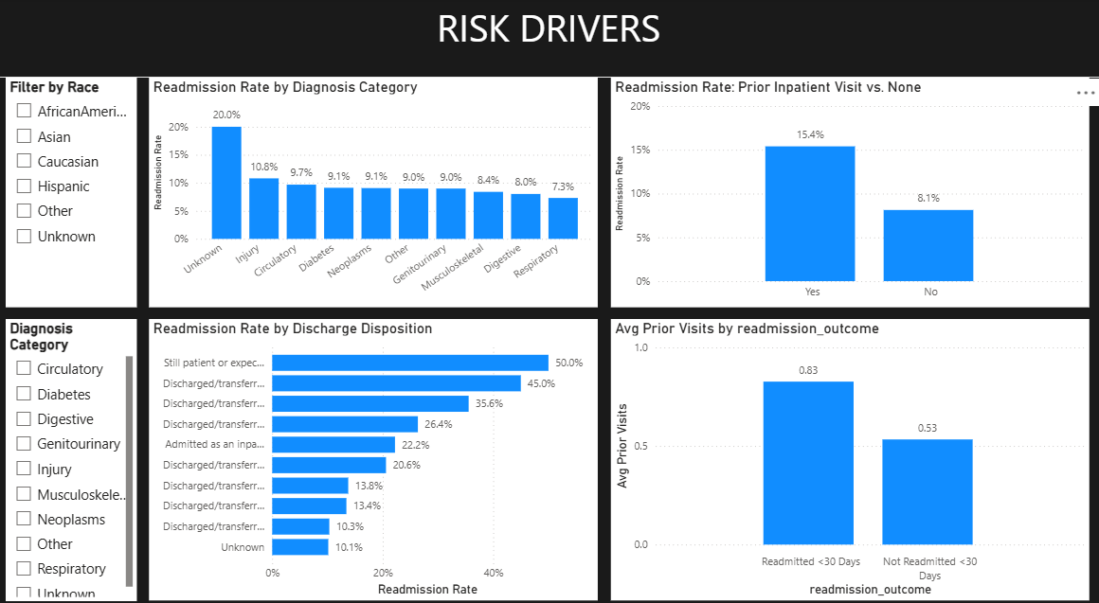
Figure 6. Dashboard - Risk Drivers Page

7.3 Patient Detail Page
A sortable, risk-ranked patient table with model risk scores, plus average predicted risk by gender and age group, filterable by risk tier.
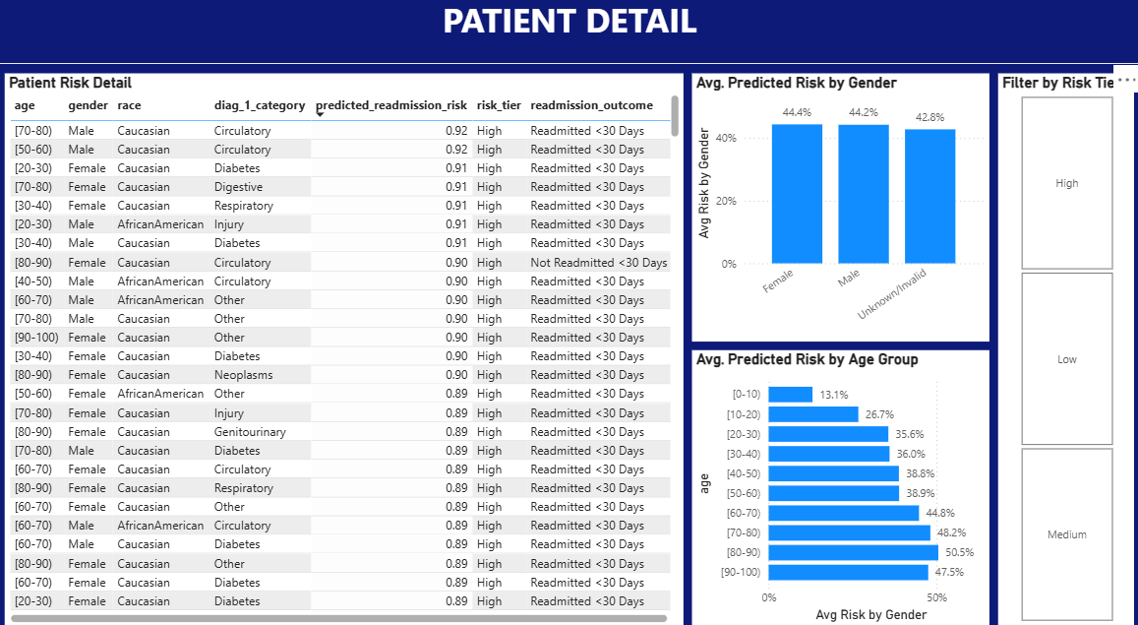
Figure 7. Dashboard - Patient Detail Page

8. Dashboard Risk Tiering Validation
Patients were scored by the XGBoost model and grouped into three relative risk tiers. The actual observed readmission rate by tier (shown live on the dashboard's Overview page) confirms the model meaningfully separates risk:
Risk Tier | Patients | Actual Readmission Rate
Low | 34,995 | 3.2%
Medium | 20,997 | 9.4%
High | 13,998 | 22.9%

9. Recommendations
Based on the findings above, the following actions are recommended for hospital care teams and administrators:

9.1 Prioritize Discharge Planning for High-Risk Patients
- Use the Power BI "Patient Detail" page to identify High risk-tier patients before discharge
- Apply enhanced discharge planning (e.g. confirmed follow-up appointment, medication reconciliation, home health referral) for any patient with a prior inpatient visit in the past year

9.2 Target Older Patients for Post-Discharge Follow-Up
- Patients aged 70+ show the highest readmission rates (10.2%-10.8%) - prioritize this group for post-discharge phone check-ins or home visits within 7 days of discharge

9.3 Flag Frequent Utilizers Proactively
- Patients with any prior inpatient stay are readmitted at nearly 2x the rate of those without - build an automated flag in the EHR for this group at time of admission, not just at discharge

9.4 Extra Attention for Musculoskeletal, Circulatory, and Respiratory Diagnoses
- These diagnosis categories contributed disproportionately to model-predicted risk - consider diagnosis-specific discharge checklists for these groups

9.5 Investigate the "Still Patient" Discharge Outlier
- The 50% readmission rate for the "still patient or expected to return" discharge disposition is far outside the normal range and warrants a manual data quality review before acting on it operationally

9.6 Operationalize the Model as a Screening Tool, Not a Sole Decision-Maker
- Current model precision (~14%) means most flagged patients will not actually be readmitted - the model should be used to prioritize limited care-management resources toward a smaller, higher-risk group, not to deny care or make unilateral decisions
- Recommend clinical staff review and use judgment alongside the risk score, particularly for borderline (Medium tier) patients

10. Limitations & Next Steps
- Model performance (ROC-AUC 0.646) leaves room for improvement - consider adding lab result trends, social determinants of health, or medication adherence data if available
- The dataset spans 1999-2008 encounters; validate findings against more recent hospital data before operational deployment
- Consider periodic model retraining as patient populations and discharge practices change over time

