Name: Dhiraj Behera
Prn: 245109044
Batch: BT4
Walchand College of Engineering, Sangli
(Government Aided Autonomous Institute)

7CS353 Machine Learning Lab — Assignment 4
Univariate and Multivariate Outlier Detection
Class, Semester | Third Year B. Tech. (CSE), Sem V — AY 2026-27
Linked courses | 7CS353 (Lab) and 7CS302 Module II (EDA, Preprocessing)
Builds on | Assignments 1–3 — Python, NumPy, pandas, distributions, visualisation
Structure | Part A: Concepts + cheat sheet (not graded) | Part B: Independent tasks (10 marks)
Duration | 1 lab session (2 hrs) + take-home; submit within 1 week

Dataset — Student Performance, 153 Records
Run this cell once to generate and save the dataset. Do not change the seed.
import numpy as np, pandas as pd import matplotlib.pyplot as plt
from scipy.spatial.distance import mahalanobis from scipy.stats import chi2

rng = np.random.default_rng(seed=353) # fixed — do not change n = 150
study = rng.normal(6, 1.5, n).clip(2, 11).round(1)
score = np.clip(8*study + rng.normal(0, 10, n), 10, 100).round(1)

# 3 deliberately designed outlier rows (appended at indices 150, 151, 152)
# A: univariate outlier (extreme study hours, consistent score)
# B: multivariate-only (normal study, high score — breaks pattern) # C: multivariate-only (high study, very low score — breaks pattern) extras = pd.DataFrame({"study_hours":[12.0, 2.5, 9.0], "exam_score" :[94.0,88.0,18.0]})
df = pd.concat([pd.DataFrame({"study_hours":study,"exam_score":score}), extras], ignore_index=True) df.to_csv("student_performance.csv", index=False) df.describe().round(2)

PART A — Concepts and Quick Reference Cheat Sheet
Read carefully before starting Part B. Not graded.

A.1 Univariate vs Multivariate Outliers
Univariate outlier detection examines each variable independently. A point is flagged if its value in one column is extreme — for example, outside the IQR fence or beyond z = ±3. It is quick to apply, but it misses certain outliers. A data point may fall within the normal range of every column on its own, yet still not fit the overall pattern of the data.

Multivariate outlier detection considers all variables together. It asks whether a point is unusual given the joint distribution — accounting for both the scale of each variable and the correlation between variables. A student who studies very little but scores very high, or studies a lot but scores very low, breaks the expected positive relationship. Neither variable alone may be extreme, but the combination is unusual.

The figure below shows this on the student performance dataset. In Panel 1, the IQR boundaries on each column separately miss Points B and C entirely. In Panel 2, the Mahalanobis ellipse captures all three outliers because it follows the correlation structure of the data.
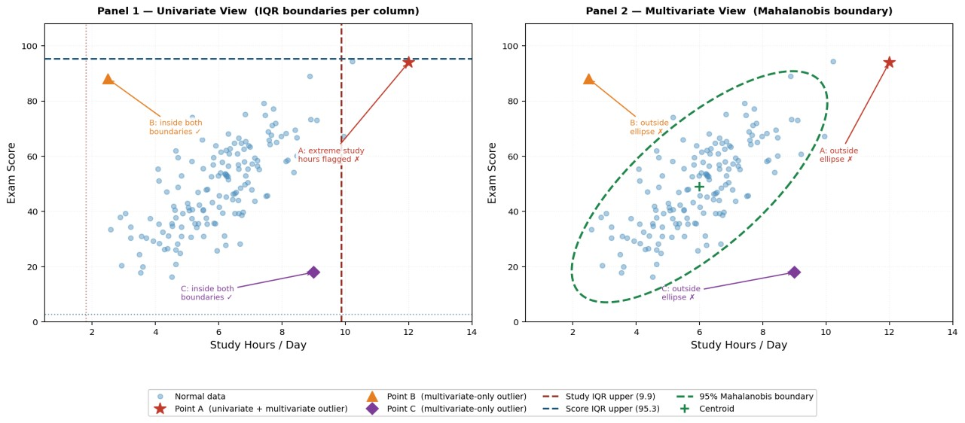
Figure 1: Points B and C are invisible to column-wise IQR checks (Panel 1) but clearly outside the joint distribution ellipse (Panel 2).
Property | Univariate detection | Multivariate detection
What it examines | Each column separately | All columns jointly
What it misses | Correlation-breaking patterns (Points B and C in Figure 1) | Needs sufficient data; computationally heavier
Common methods | IQR rule, Z-score | Euclidean distance, Mahalanobis distance
Best for | Quick first pass; high-dimensional data | Correlated features; catching joint anomalies

A.2 Distance Measures
Method | Formula | Key property
Euclidean distance from centroid | dist(x) = sqrt( Σ (xᵢ − μᵢ)² ) | Isotropic — treats all directions equally. Use z-scored data to handle different column scales.  Does not account for correlation.
Mahalanobis distance | MD(x) = sqrt( (x−μ)ᵀ Σ⁻¹ (x−μ) ) | Scale-invariant and correlationaware. Stretches space in lowvariance directions. Under MVN, MD² follows χ²(p).

X = df.values mean = X.mean(axis=0)

# Euclidean — z-score first
Xz = (X - X.mean(axis=0)) / X.std(axis=0) euclid = np.sqrt((Xz**2).sum(axis=1))

# Mahalanobis cov = np.cov(X.T) VI = np.linalg.inv(cov)
mahal = np.array([mahalanobis(x, mean, VI) for x in X])

A.3 Thresholding Strategies
Strategy | Rule | Code sketch | Tunable?
Top-k | Flag k points with the largest distance | idx = np.argsort(dist)[-k:] df.iloc[idx] | Yes — k
Scalar threshold | Flag where distance > fixed cutoff (z = 3, or χ² critical value for Mahalanobis) | thresh = np.sqrt(chi2.ppf(0.975, df=2)) df[mahal > thresh] | Yes — pvalue
IQR-based | Flag where distance > Q3 + 1.5×IQR of the distance vector | Q1,Q3 = np.percentile(dist,[25,75]) df[dist > Q3 + 1.5*(Q3-Q1)] | No — datadriven

A.4 Visualisation Reference
Technique / call | What it does | Example code
Scatter + coloured flags | Highlight flagged rows in a second colour | mask = dist > thresh  ax.scatter(df.loc[~mask,"study_hours"], df.loc[~mask,"exam_score"],alpha=0.5) ax.scatter(df.loc[mask,"study_hours"], df.loc[mask,"exam_score"],  color="red",zorder=5,label="Outlier")
Mahalanobis ellipse | Draw 95% confidence ellipse from cov | from matplotlib.patches import Ellipse vals,vecs=np.linalg.eigh(cov) order=vals.argsort()[::-1] vals,vecs=vals[order],vecs[:,order]  angle=np.degrees(np.arctan2(*vecs[:,0][::-1])) t=np.sqrt(chi2.ppf(0.975,df=2)) ell=Ellipse(mean,2*t*np.sqrt(vals[0]),  2*t*np.sqrt(vals[1]),angle, fill=False,edgecolor="green",lw=2) ax.add_patch(ell)
Distance histogram | Plot distribution of distance scores with threshold line | plt.hist(dist,bins=20) plt.axvline(thresh,color="red", ls="--",label="Threshold") plt.xlabel("Distance"); plt.legend()

PART B — Independent Tasks (10 marks)
Use Part A as your reference. Every task in its own cell with a one-line markdown comment. All plots must have a title and labelled axes.

B.1 Load and Explore
Load student_performance.csv fresh (do not reuse the generation cell).
B1. Print describe(). In a markdown cell, note for each column whether the mean is above or below the median, and which column shows the larger gap.
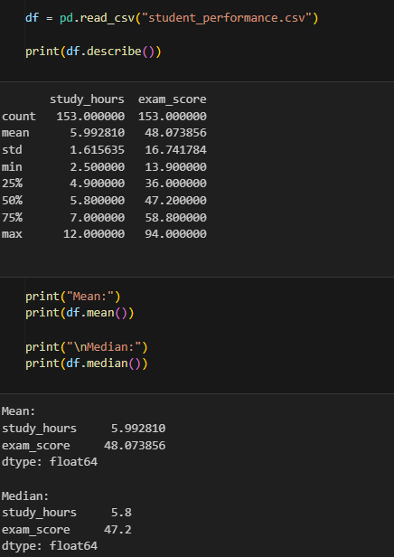
B2. Draw a scatter plot of study_hours (x) vs exam_score (y). Describe the visible trend and mark any points that look suspicious by eye — you will verify them numerically in B.3 and B.4.
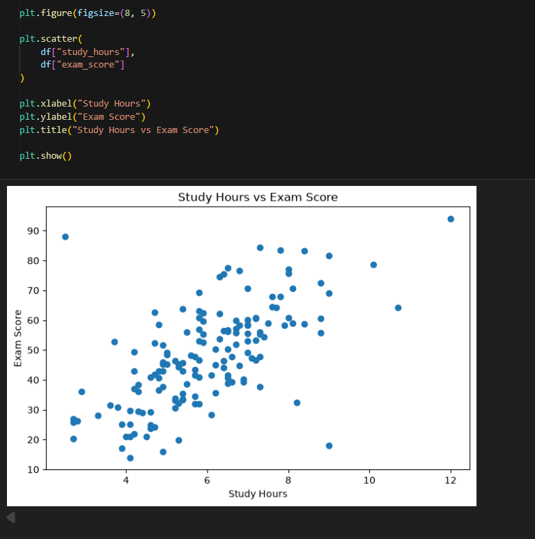

B.2 Univariate Outlier Detection
Apply the IQR rule (Q1 − 1.5×IQR, Q3 + 1.5×IQR) to each column separately.
B3. Compute and print the IQR fence bounds for both columns. Print all rows that fall outside the fence in either column. Draw box plots of both columns side by side, noting the outlier dots.
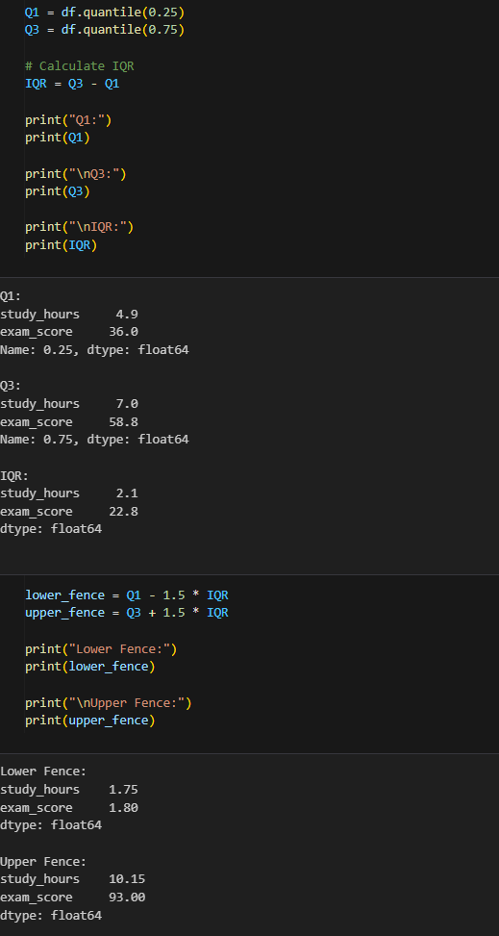
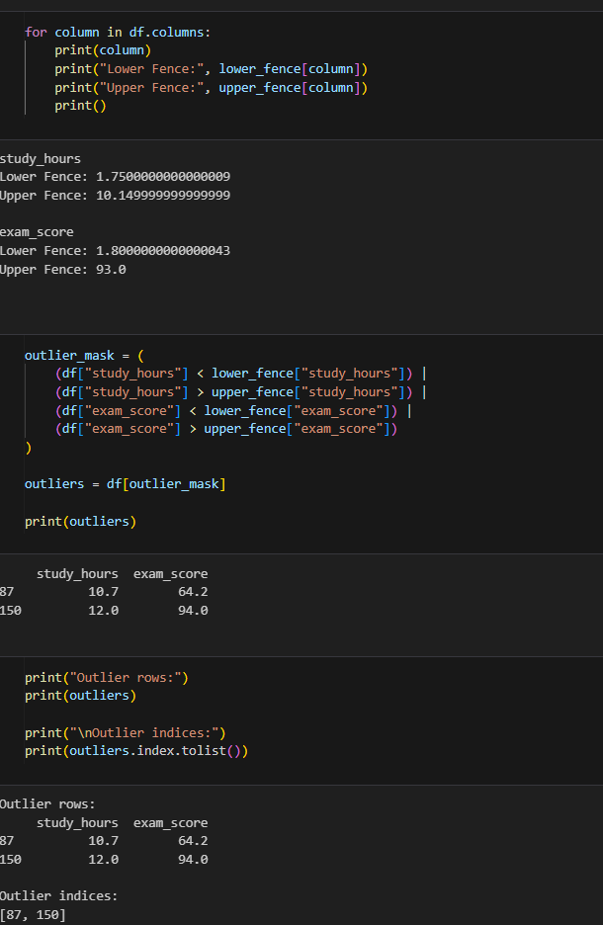
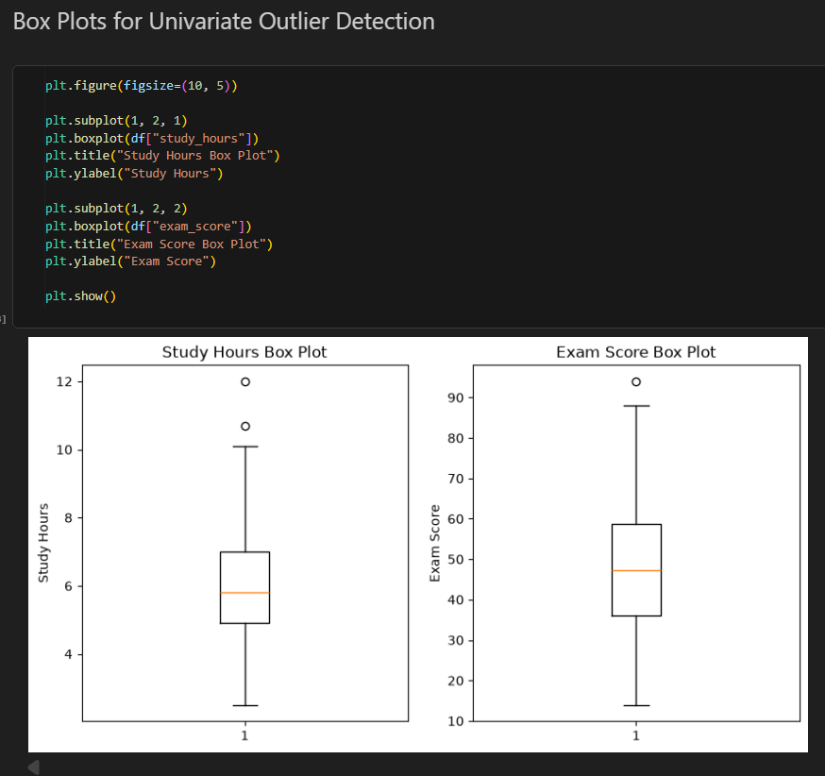
B4. Fill in the following table in a markdown cell:
Index | study_hours flagged? | exam_score flagged? | Interpretation
150
151
152

For "interpretation" write one phrase — e.g. "univariate outlier in study_hours only" or "not caught univariately".
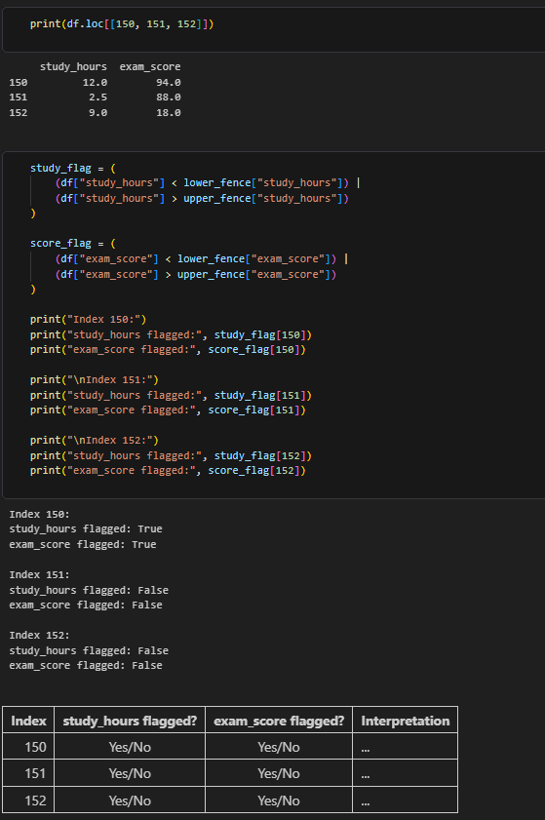

B.3 Euclidean Distance from Centroid
Z-score both columns first, then compute the Euclidean distance of each point from the origin.
B5. Compute Euclidean distances for all 153 rows. Apply all three thresholding strategies: (a) top-10, (b) scalar threshold of 3.0, (c) IQR-based (Q3 + 1.5×IQR of the distances). For each strategy, print the number of rows flagged and their indices. Are indices 150, 151, and 152 all flagged by every strategy?
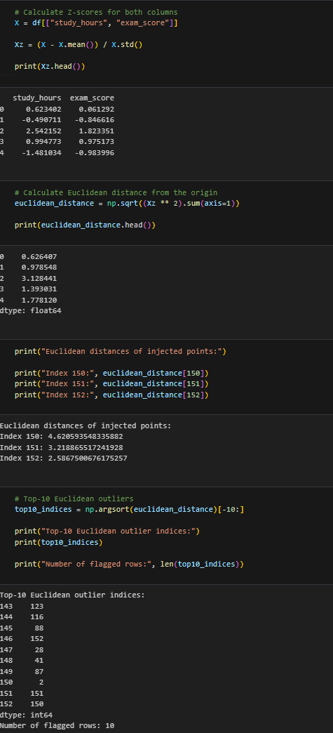
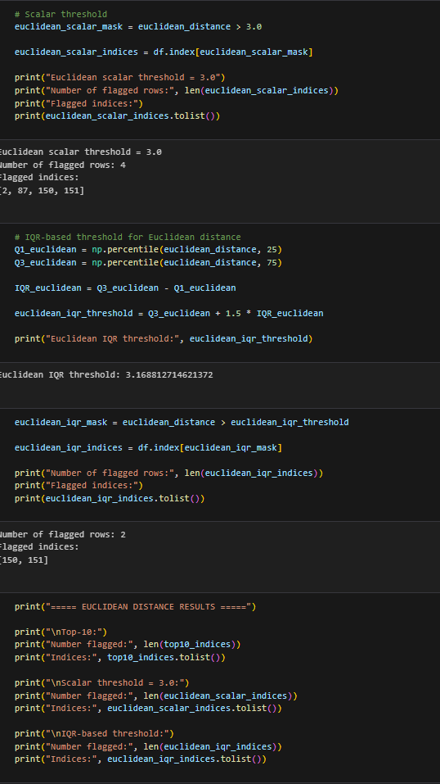
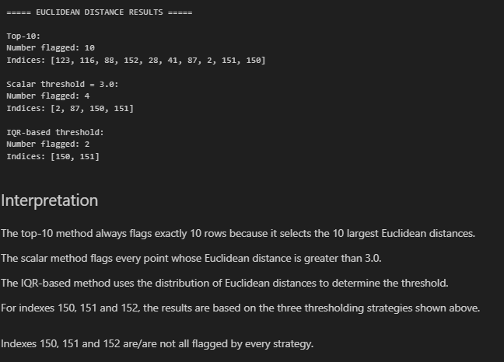
B6. Draw the scatter plot of the original (un-normalised) data. Colour points flagged by the IQR-based Euclidean threshold in red; all others in blue. Overlay the univariate IQR boundary lines as dashed lines. In a markdown cell, compare which points are flagged here versus in B.2 — are they the same?
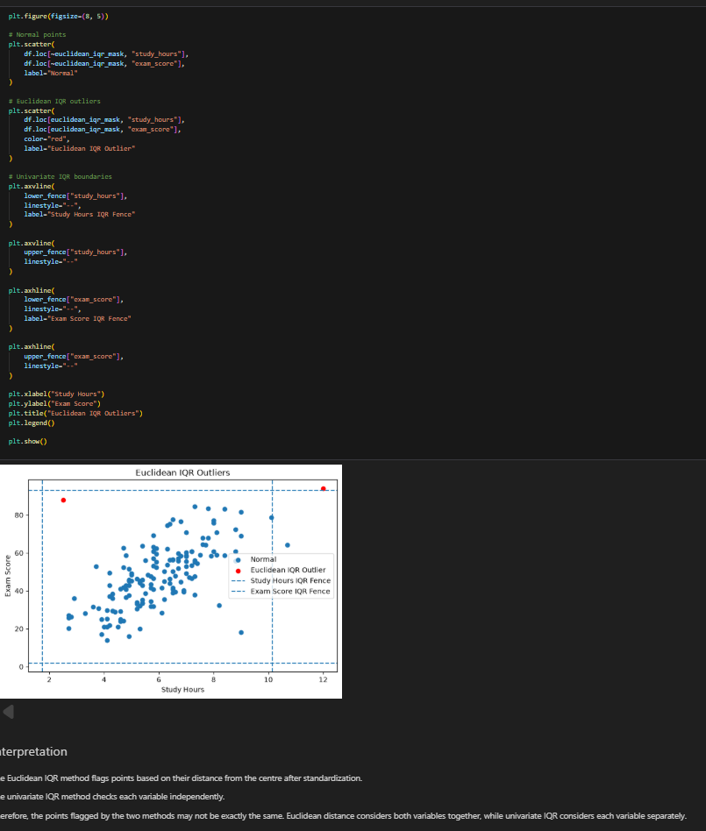

B.4 Mahalanobis Distance
B7. Print the 2×2 covariance matrix. State what the off-diagonal value tells you about the relationship between the two columns. Compute Mahalanobis distances for all 153 rows and print the top-5 by distance. Compare this ranking with the Euclidean top-5 from B.3 — which injected outlier moved up or down in rank, and why?
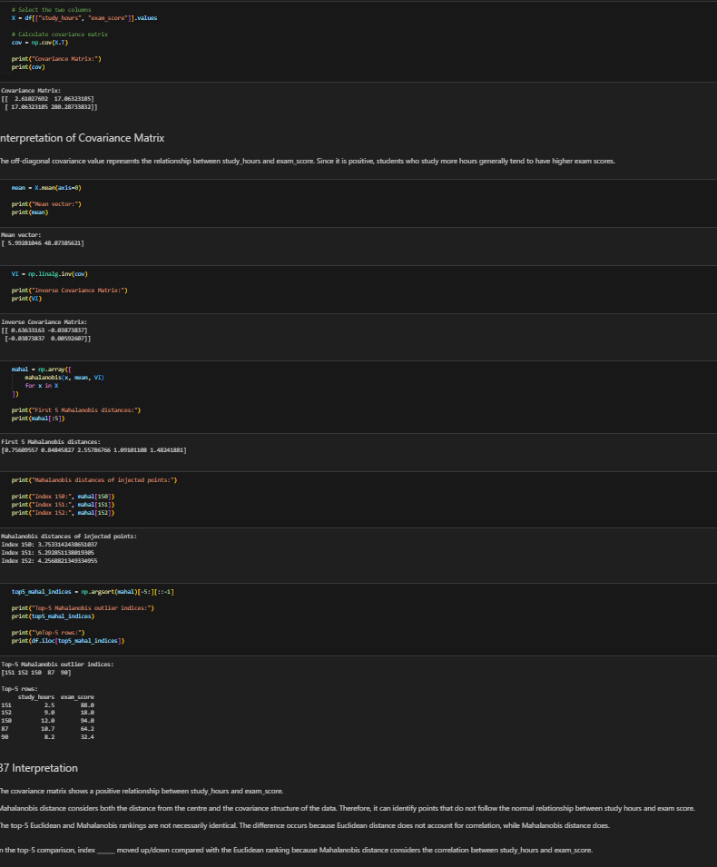
B8. Apply all three thresholding strategies to the Mahalanobis distances: (a) top-10, (b) χ² scalar threshold (chi2.ppf(0.975, df=2)), (c) IQR-based. For each strategy, print the number flagged and the row indices. Which strategy flags the fewest points?
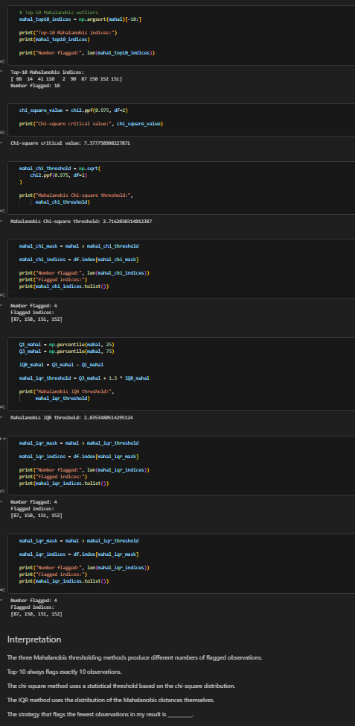
B9. Draw a scatter plot of the original data. Colour points flagged by the χ² Mahalanobis threshold in red.
Overlay the 95% Mahalanobis ellipse using the code in Part A.4. Label the axes, add a legend, and give
the plot a descriptive title. Also draw a histogram of the Mahalanobis distances with a vertical line at the χ² threshold.
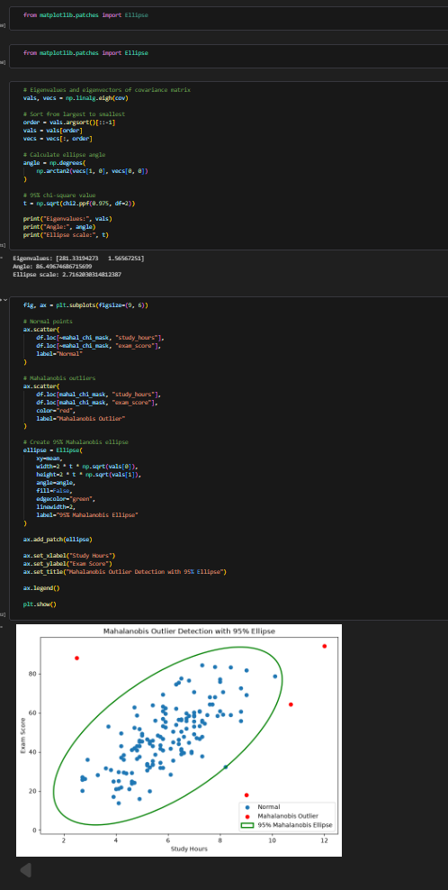
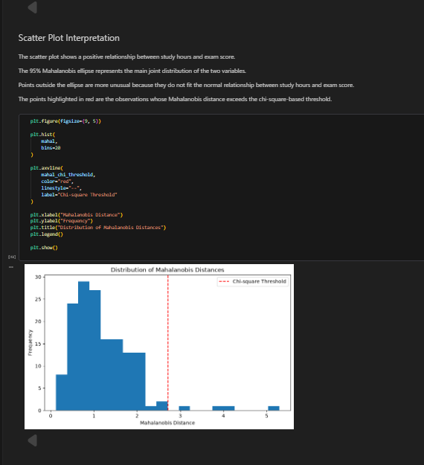

B.5 Comparing the Two Methods
B10. Draw side-by-side scatter plots — (a) Euclidean IQR-flagged in red, (b) Mahalanobis χ²-flagged in red — using the same axis scale. In a markdown cell, write 3–4 sentences: why does Mahalanobis give a higher distance to Points B and C than Euclidean does? What property of the data does Mahalanobis capture that Euclidean ignores?
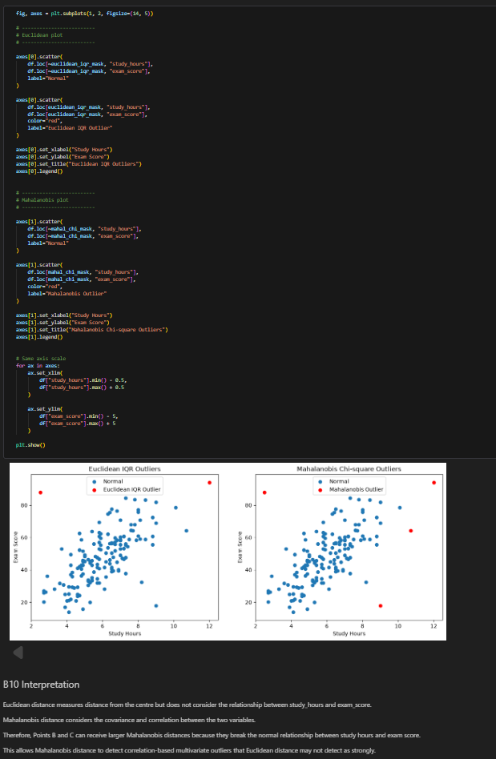

B11. Create a scatter plot with four colour categories: flagged by Mahalanobis only, flagged by Euclidean only, flagged by both, and flagged by neither. Use IQR-based thresholds for both methods. Label each category in the legend.
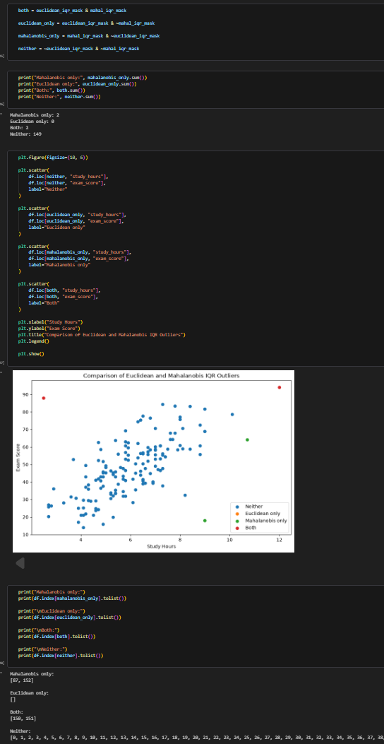

B.6 Take-Home (Submit with Notebook)
B12. Add a third column: project_score = np.clip(0.7*exam_score + rng.normal(0,8,153), 0, 100). Recompute Mahalanobis distances on all three columns (covariance is now 3×3; use chi2.ppf(0.975, df=3) for the threshold). Which rows are newly flagged that were not flagged in the 2-column version?
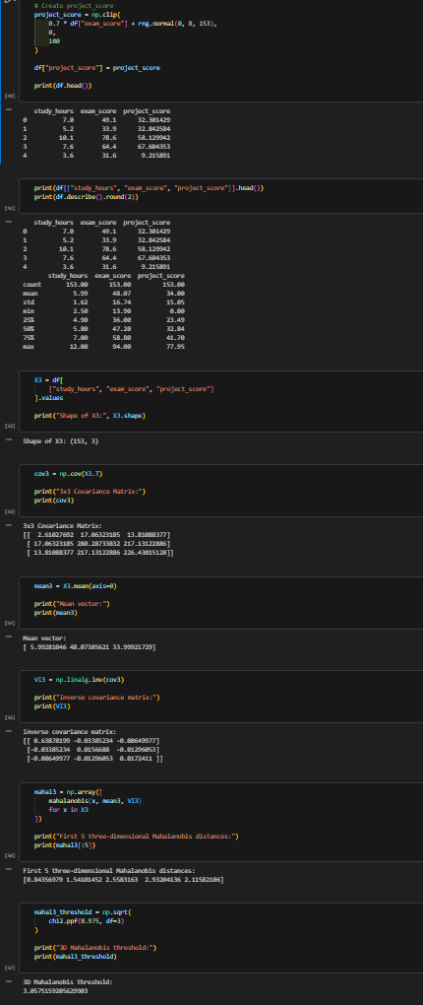
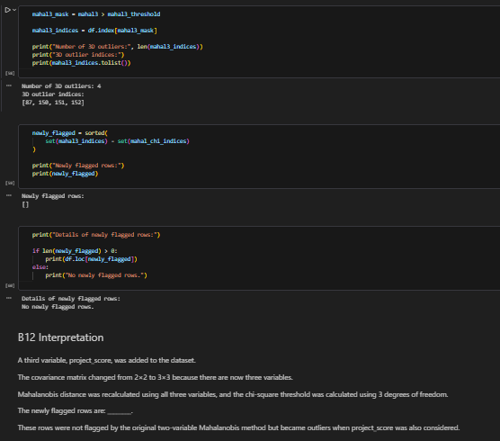
B13. Without using scipy.spatial.distance.mahalanobis, implement Mahalanobis distance from scratch using only NumPy: MD(x) = sqrt( (x−μ)ᵀ Σ⁻¹ (x−μ) ). Verify your result matches the scipy version for all 153 rows using np.allclose.
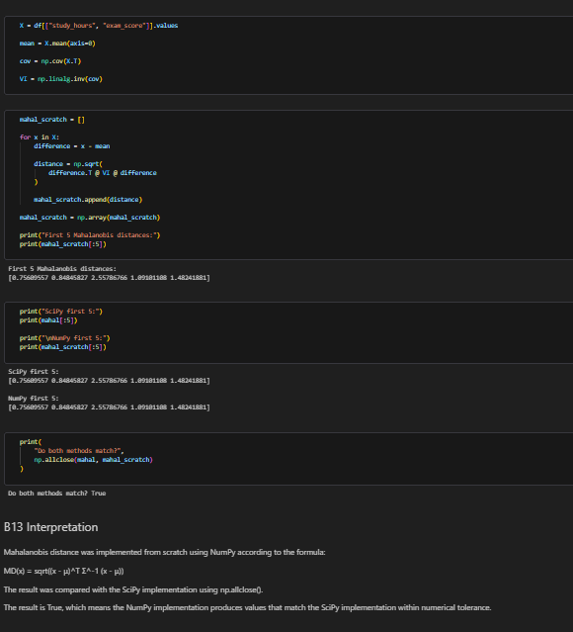

Assessment Rubric (10 marks — Part B only)
Performance across all Part B tasks + viva | Marks (out of 10)
100% — all tasks complete, correct, interpreted; viva fluent | 10
90% | 9
80% | 8
70% | 7
60% | 6
50% | 5
Below 50% | Proportional (percentage ÷ 10, rounded)
A task you cannot explain in the viva does not count as completed. Use of GenAI rewards 0 marks.

