Assignment No : 1
Name : Om A. Akiwate
PRN : 255209003
Date : 21-07-2026
Batch : BT4

Objectives:
• Set up and use a Python environment (Python with IDE or Jupyter Notebook) without any installation headaches.
• Use variables, lists, loops, conditionals, and functions, the minimum Python needed for ML.
• Represent data as vectors using NumPy and compute mean, variance, and standard deviation.
• Load a CSV with pandas, summarize it, and draw your first histogram and scatter plot.

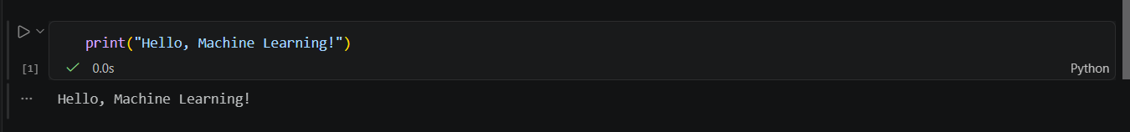
Dataset :
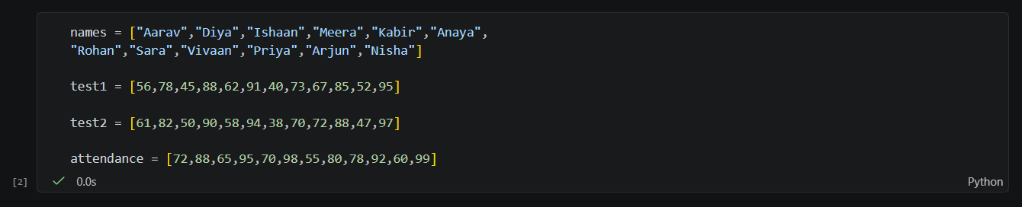
A1. Variables and printing :
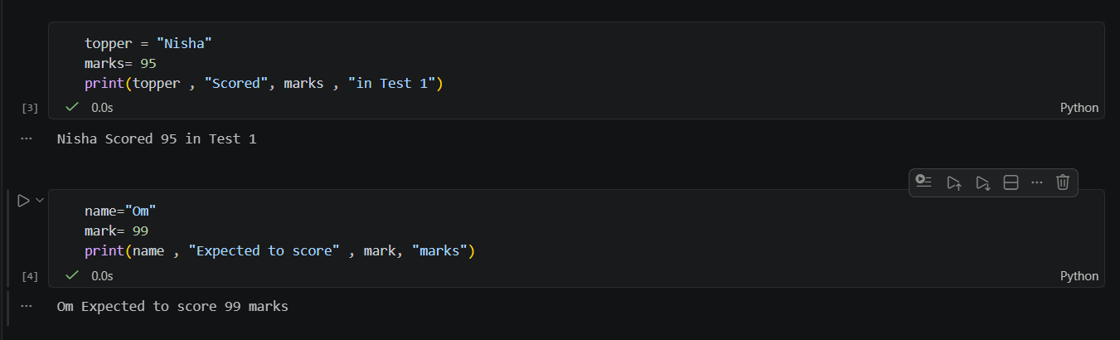

A2. Lists and Indexing :
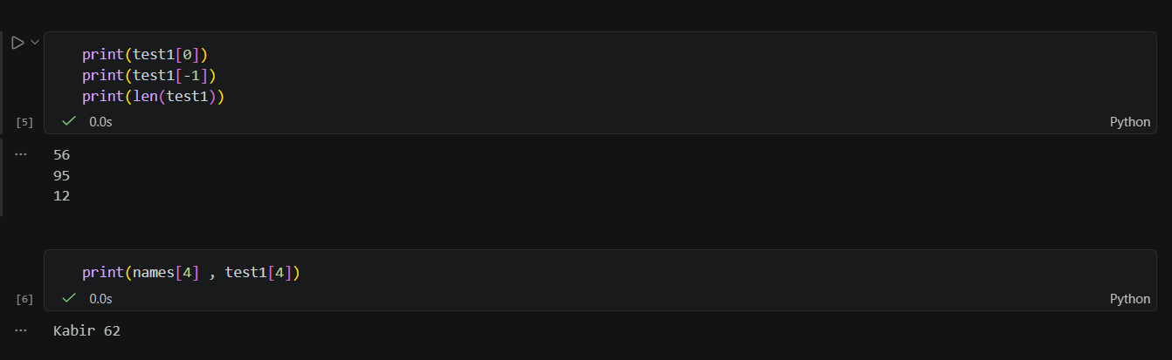
A3. Loops :
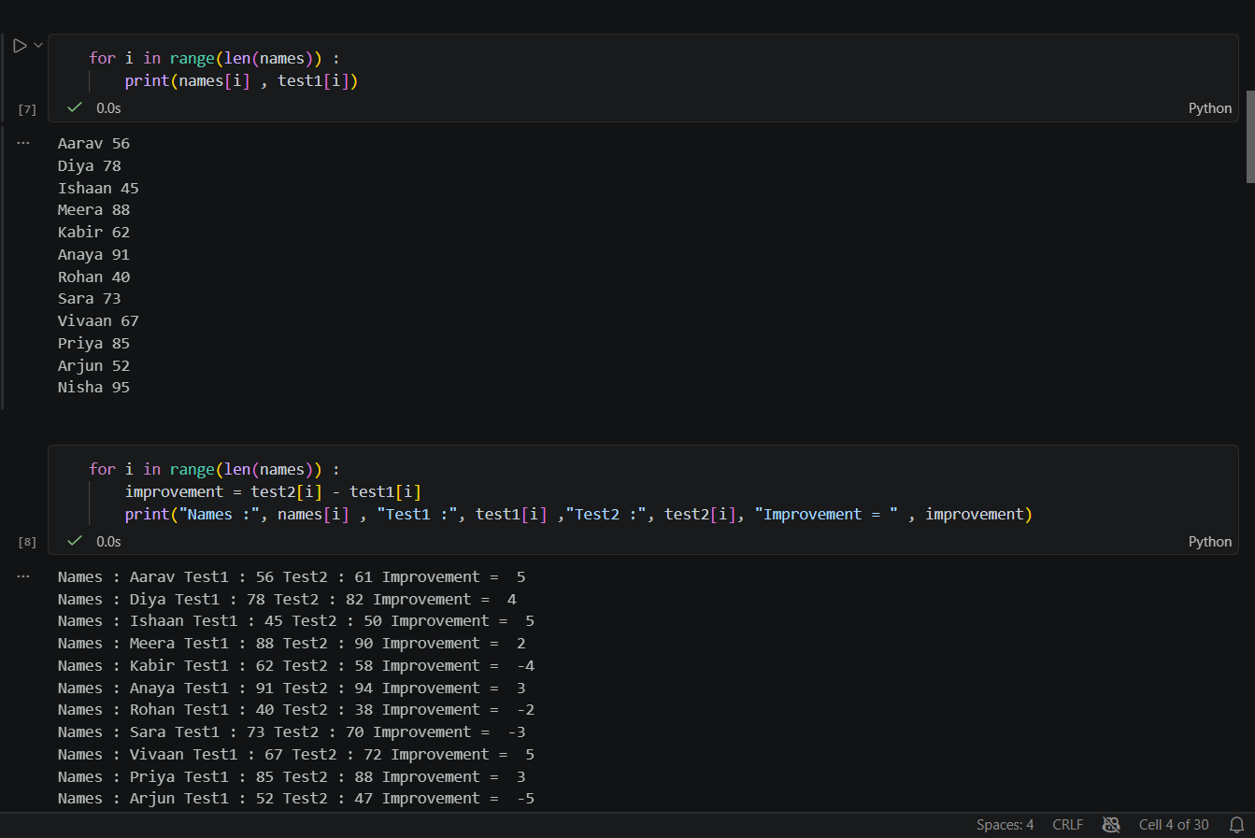
A4. Condionals :
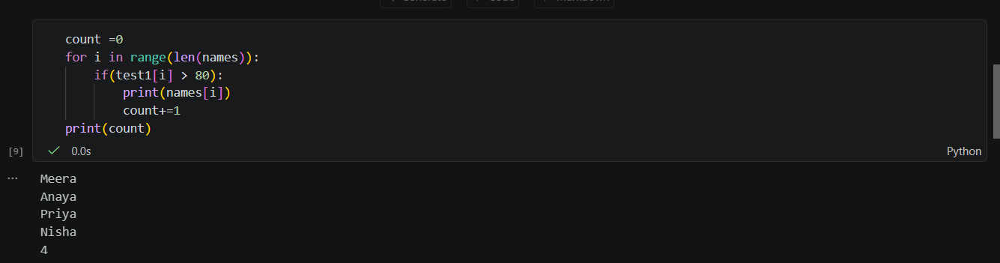

A5. Functions :
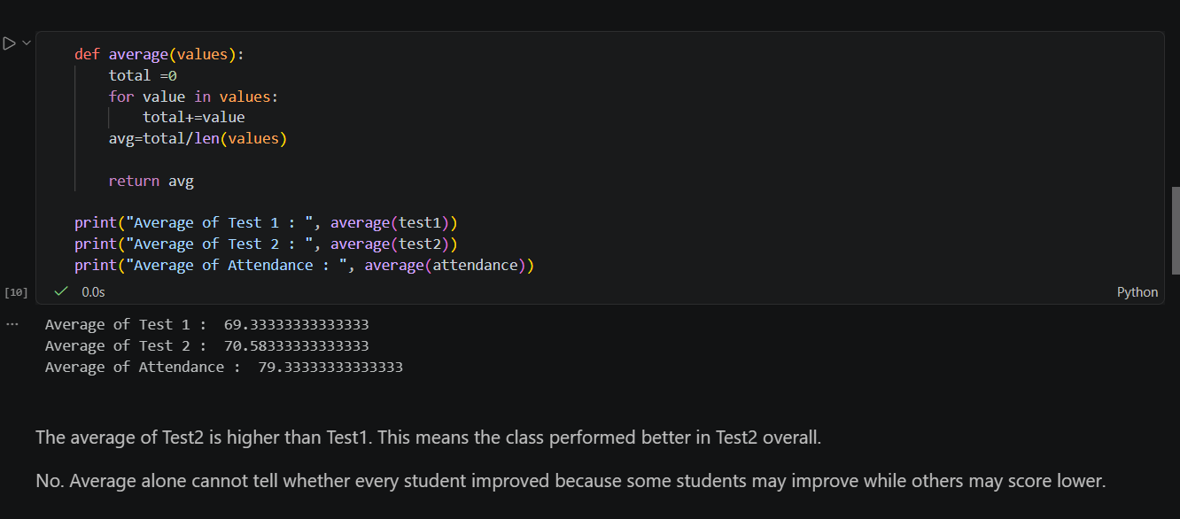

Part B : Data as Vectors with Numpy
B1. From lists to vectors :
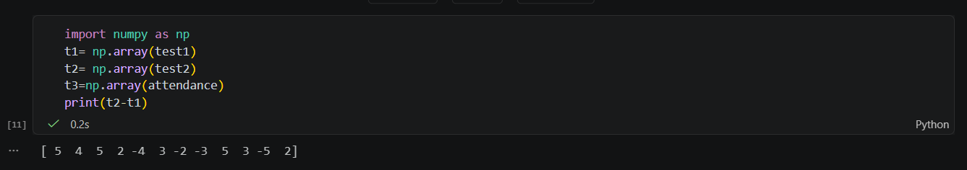
B2. Summary Stats :
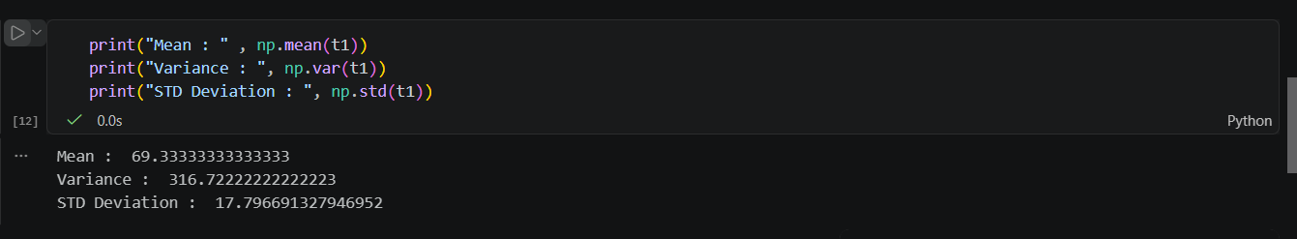
B3. Interpreting spread :
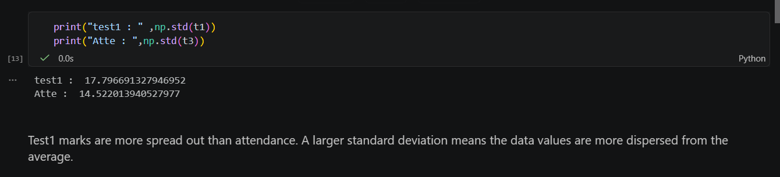

B4. A first taste of geometry :
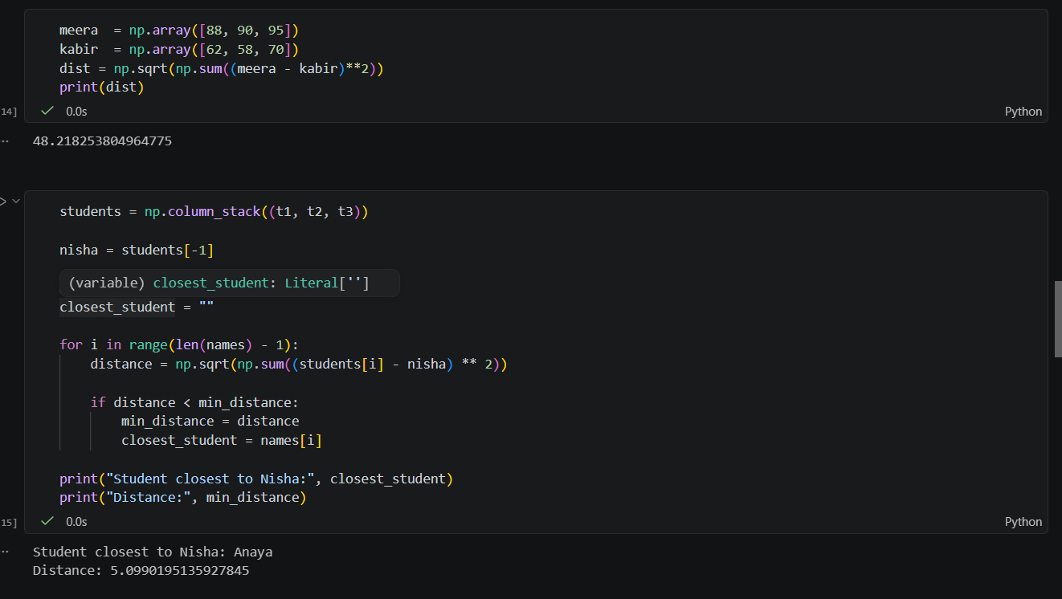
Part C : First look at real EDA with pandas
C1. Load and inspect :
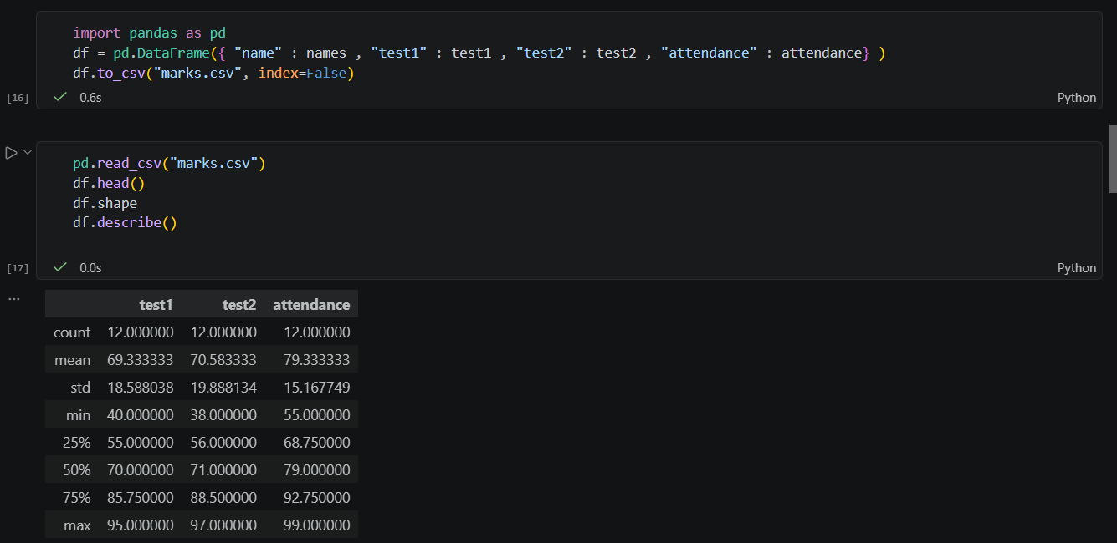

C2. Selecting and Filtering :
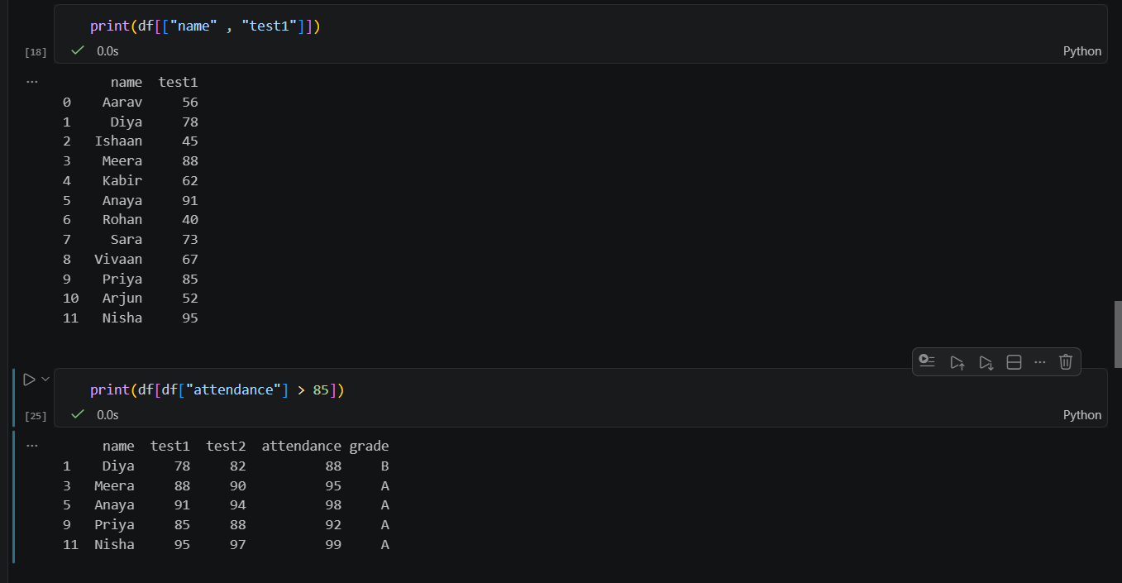
C3. Histogram and your first distribution :
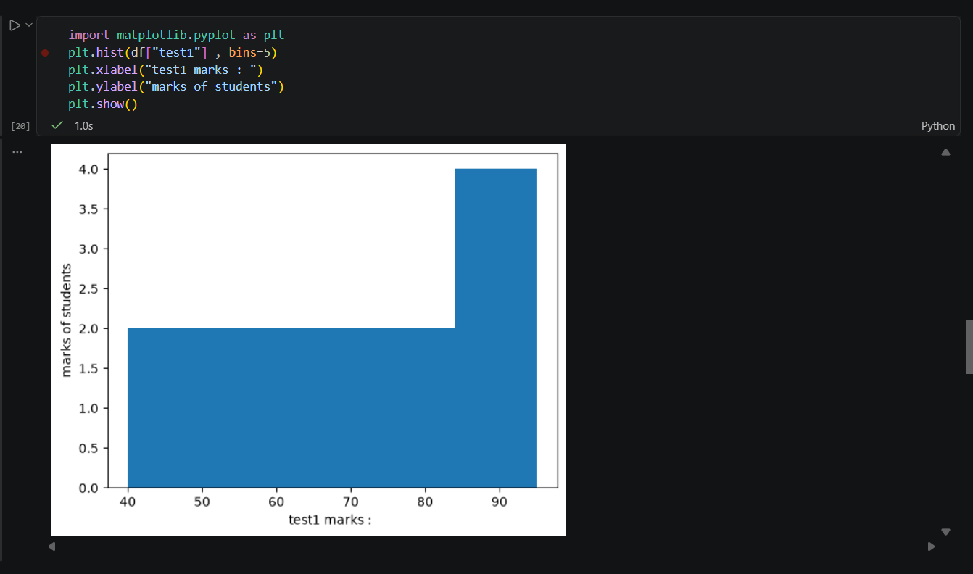

C4. Scatter Plot :
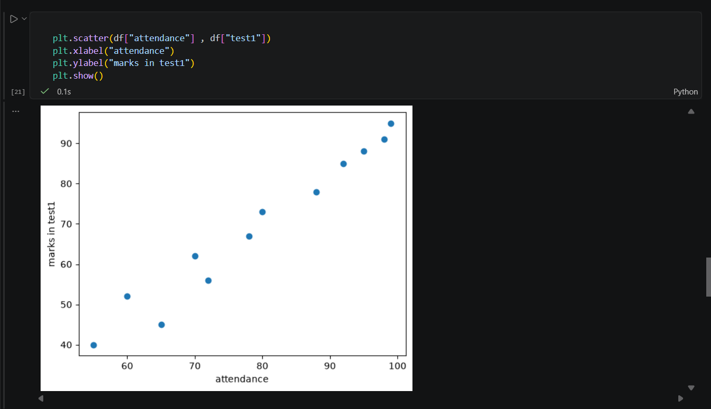

Home Challenge :
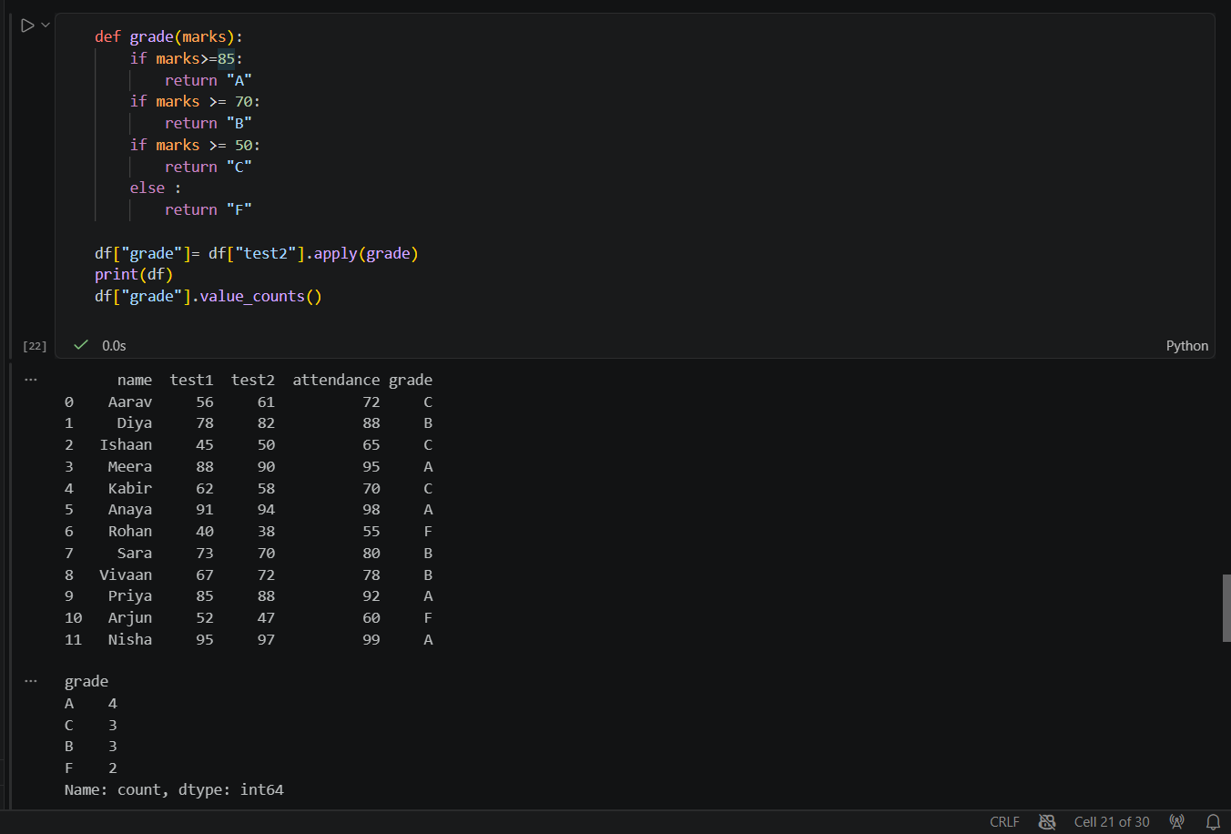
D1: Write a function grade(marks) that returns "A" for 85 and above, "B" for 70–84, "C" for 50–69, and "F" below 50. Add a new column "grade" to the DataFrame for Test 2 and print how many students got each grade (hint: df["grade"].value_counts()).
D2. One student's Test 1 entry was mistyped: change Rohan's test1 to 400 and recompute the mean and standard deviation. Write 2–3 sentences on how a single wrong value distorted both numbers.
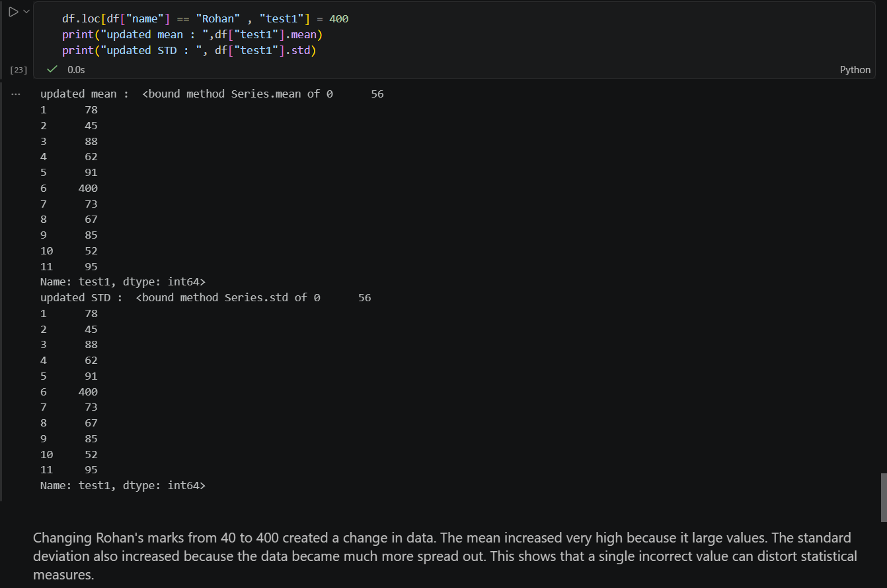
D3. Optional stretch: without using np.var, compute the variance of test1 yourself using only a loop and the formula: average of squared differences from the mean. Verify it matches np.var(t1).



