Assignment 4

Name: Om A. Akiwate
Prn: 255209003
Batch: BT4

Dataset — Student Performance, 153 Records
Run this cell once to generate and save the dataset. Do not change the seed.
import numpy as np, pandas as pd import matplotlib.pyplot as plt
from scipy.spatial.distance import mahalanobis from scipy.stats import chi2

rng = np.random.default_rng(seed=353) # fixed — do not change n = 150
study = rng.normal(6, 1.5, n).clip(2, 11).round(1)
score = np.clip(8*study + rng.normal(0, 10, n), 10, 100).round(1)

# 3 deliberately designed outlier rows (appended at indices 150, 151, 152)
# A: univariate outlier (extreme study hours, consistent score)
# B: multivariate-only (normal study, high score — breaks pattern) # C: multivariate-only (high study, very low score — breaks pattern) extras = pd.DataFrame({"study_hours":[12.0, 2.5, 9.0], "exam_score" :[94.0,88.0,18.0]})
df = pd.concat([pd.DataFrame({"study_hours":study,"exam_score":score}), extras], ignore_index=True) df.to_csv("student_performance.csv", index=False) df.describe().round(2)

B.1 Load and Explore
Load student_performance.csv fresh (do not reuse the generation cell).
B1. Print describe(). In a markdown cell, note for each column whether the mean is above or below the median, and which column shows the larger gap.
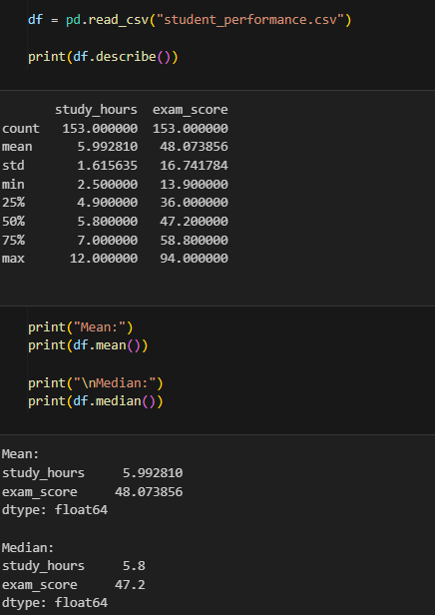
B2. Draw a scatter plot of study_hours (x) vs exam_score (y). Describe the visible trend and mark any points that look suspicious by eye — you will verify them numerically in B.3 and B.4.
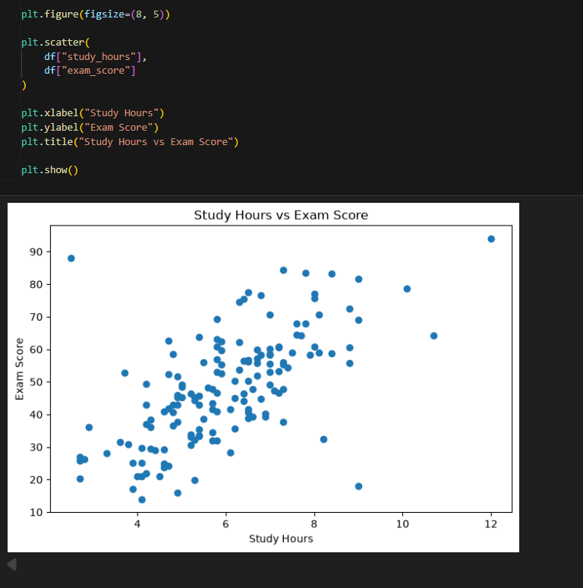

B.2 Univariate Outlier Detection
Apply the IQR rule (Q1 − 1.5×IQR, Q3 + 1.5×IQR) to each column separately.
B3. Compute and print the IQR fence bounds for both columns. Print all rows that fall outside the fence in either column. Draw box plots of both columns side by side, noting the outlier dots.
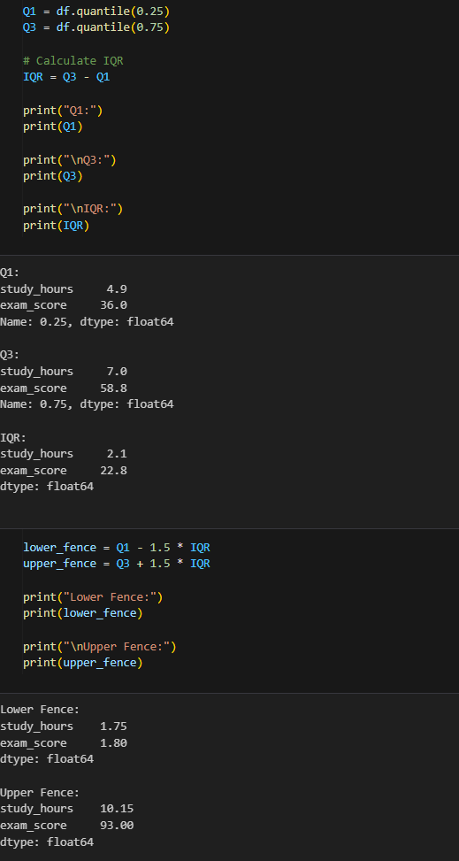
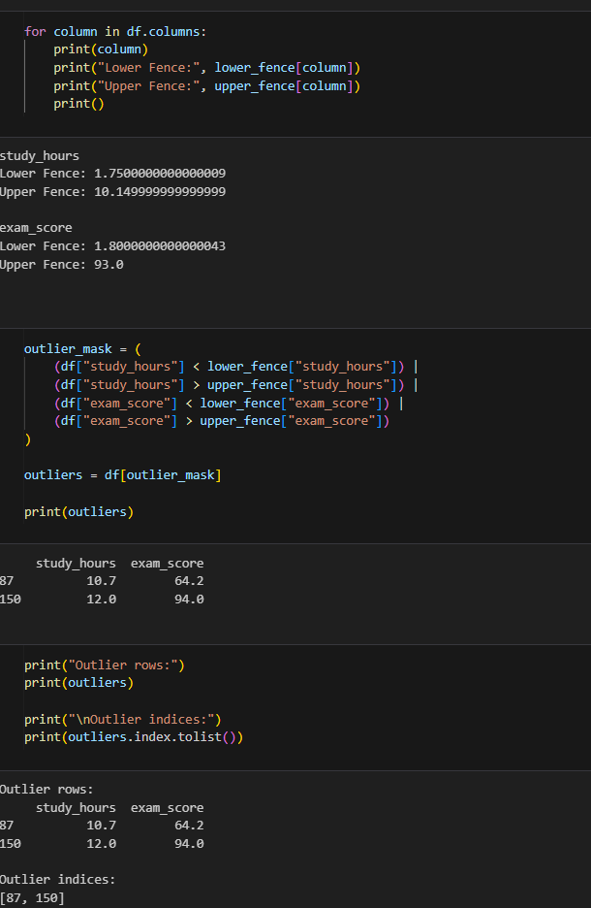

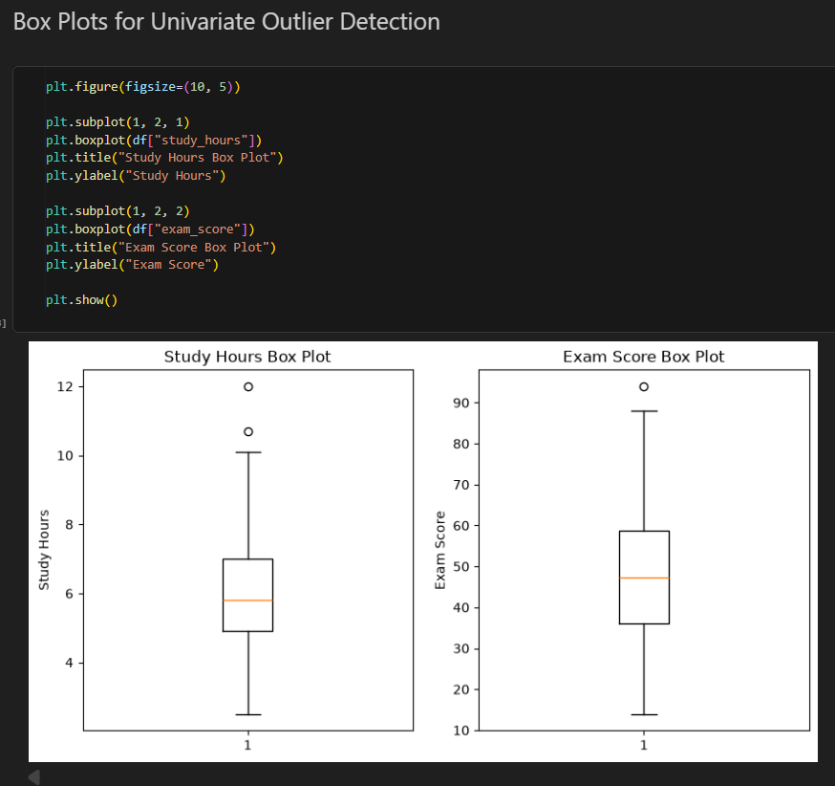

B4. Fill in the following table in a markdown cell:
Index | study_hours flagged? | exam_score flagged? | Interpretation
150
151
152

For "interpretation" write one phrase — e.g. "univariate outlier in study_hours only" or "not caught univariately".
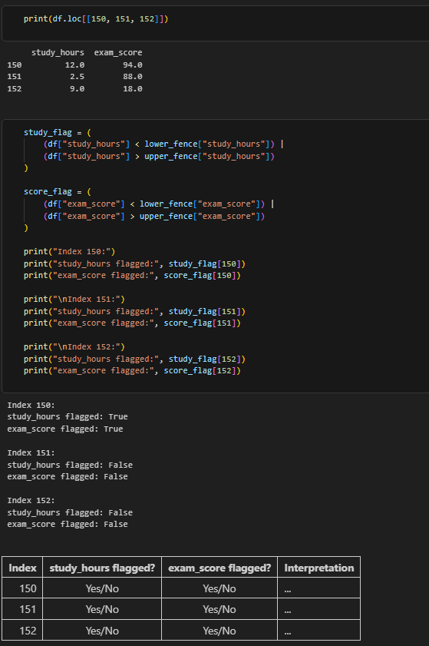

B.3 Euclidean Distance from Centroid
Z-score both columns first, then compute the Euclidean distance of each point from the origin.
B5. Compute Euclidean distances for all 153 rows. Apply all three thresholding strategies: (a) top-10, (b) scalar threshold of 3.0, (c) IQR-based (Q3 + 1.5×IQR of the distances). For each strategy, print the number of rows flagged and their indices. Are indices 150, 151, and 152 all flagged by every strategy?
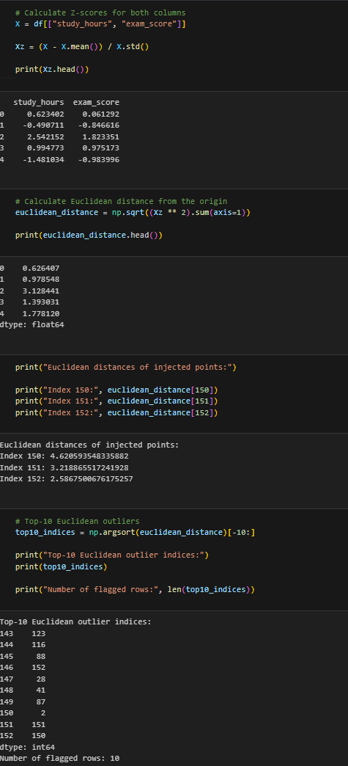
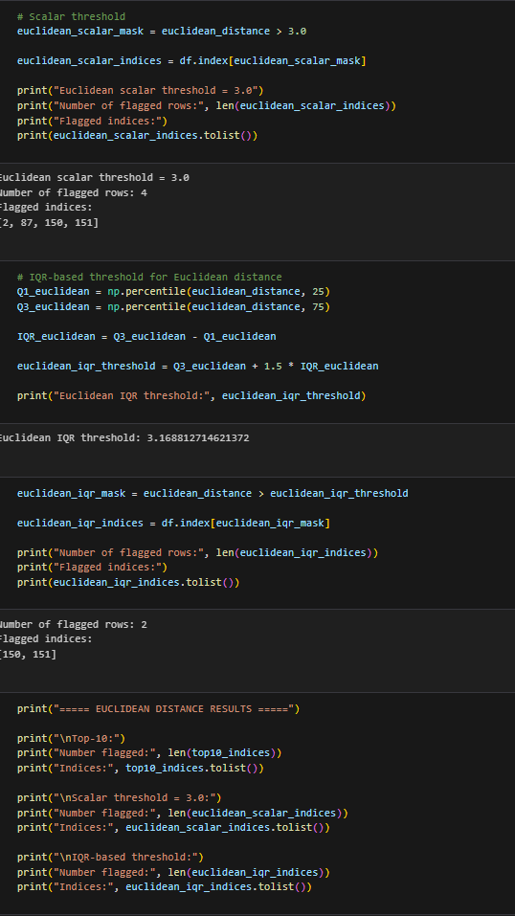
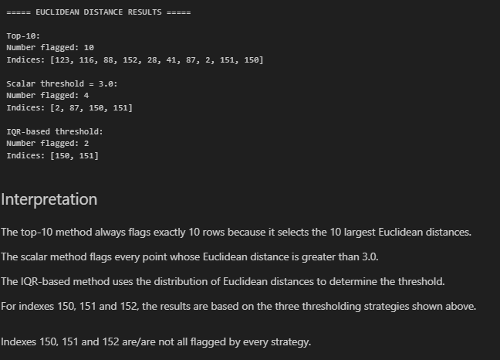

B6. Draw the scatter plot of the original (un-normalised) data. Colour points flagged by the IQR-based Euclidean threshold in red; all others in blue. Overlay the univariate IQR boundary lines as dashed lines. In a markdown cell, compare which points are flagged here versus in B.2 — are they the same?
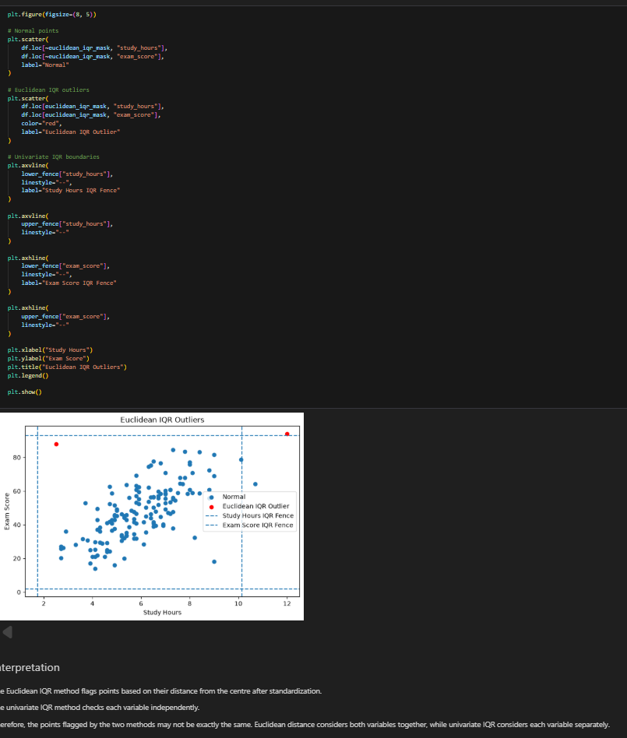

B.4 Mahalanobis Distance
B7. Print the 2×2 covariance matrix. State what the off-diagonal value tells you about the relationship between the two columns. Compute Mahalanobis distances for all 153 rows and print the top-5 by distance. Compare this ranking with the Euclidean top-5 from B.3 — which injected outlier moved up or down in rank, and why?
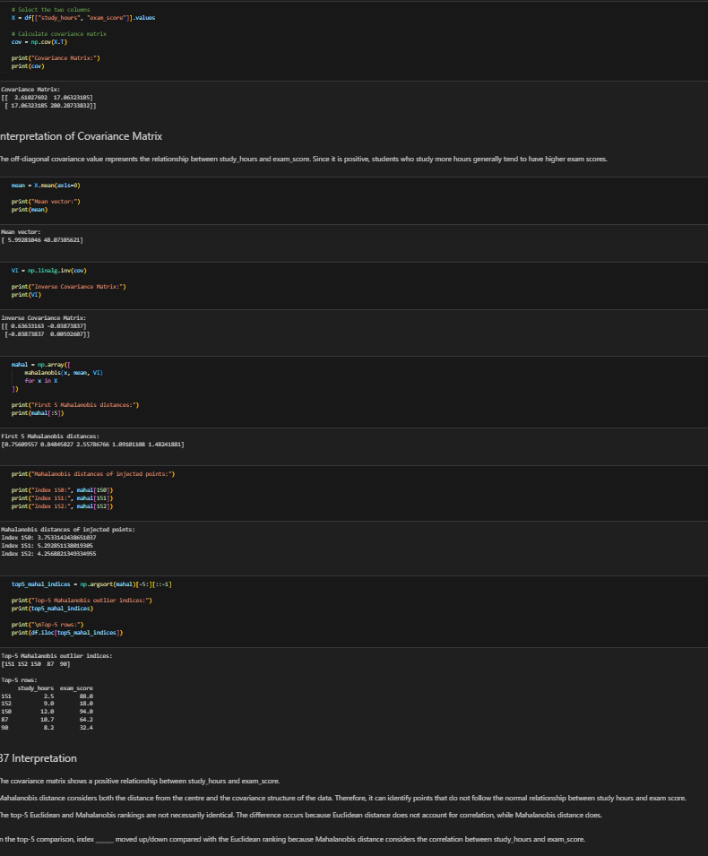
B8. Apply all three thresholding strategies to the Mahalanobis distances: (a) top-10, (b) χ² scalar threshold (chi2.ppf(0.975, df=2)), (c) IQR-based. For each strategy, print the number flagged and the row indices. Which strategy flags the fewest points?
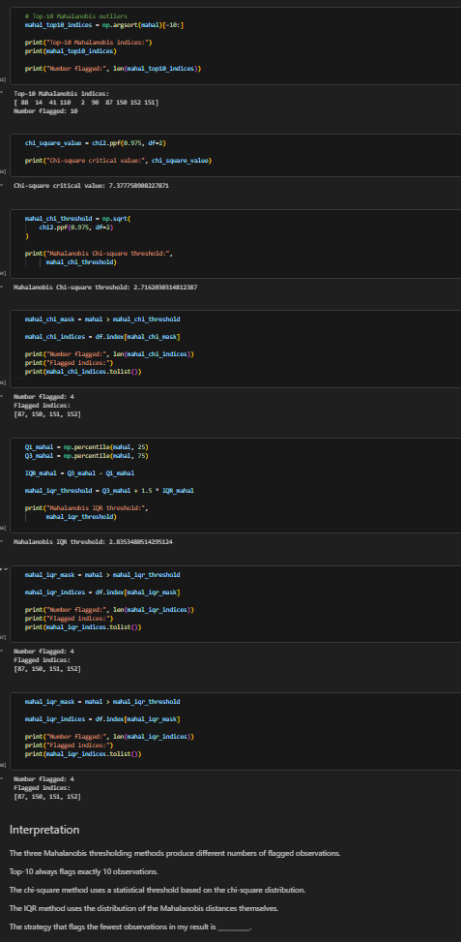

B9. Draw a scatter plot of the original data. Colour points flagged by the χ² Mahalanobis threshold in red.
Overlay the 95% Mahalanobis ellipse using the code in Part A.4. Label the axes, add a legend, and give
the plot a descriptive title. Also draw a histogram of the Mahalanobis distances with a vertical line at the χ² threshold.
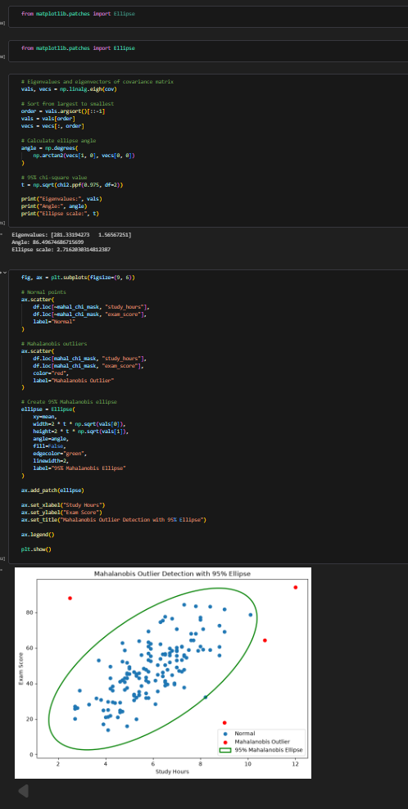
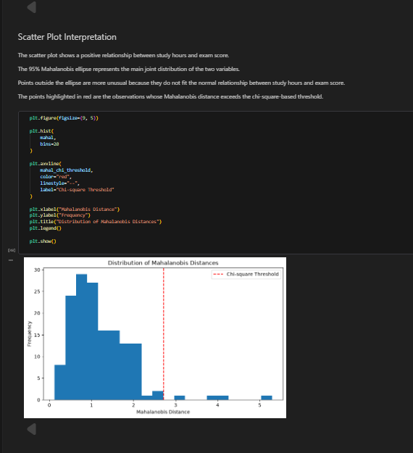

B.5 Comparing the Two Methods
B10. Draw side-by-side scatter plots — (a) Euclidean IQR-flagged in red, (b) Mahalanobis χ²-flagged in red — using the same axis scale. In a markdown cell, write 3–4 sentences: why does Mahalanobis give a higher distance to Points B and C than Euclidean does? What property of the data does Mahalanobis capture that Euclidean ignores?
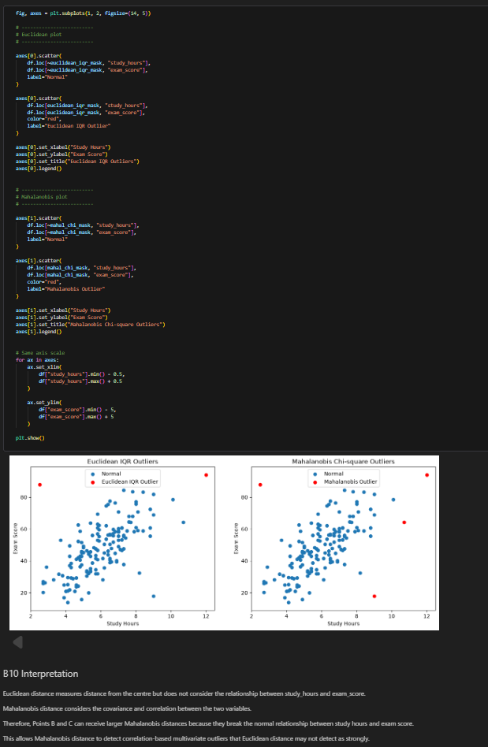

B11. Create a scatter plot with four colour categories: flagged by Mahalanobis only, flagged by Euclidean only, flagged by both, and flagged by neither. Use IQR-based thresholds for both methods. Label each category in the legend.
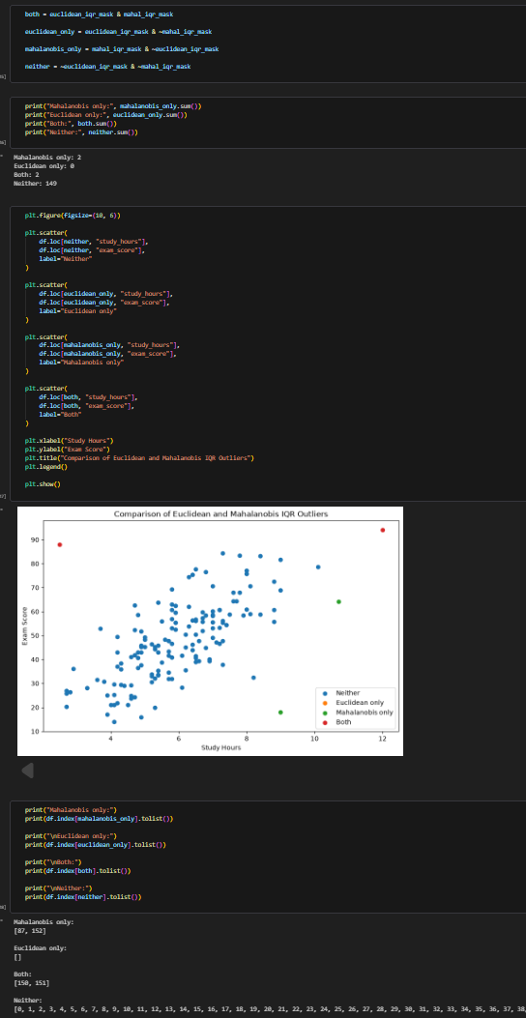

B.6 Take-Home (Submit with Notebook)
B12. Add a third column: project_score = np.clip(0.7*exam_score + rng.normal(0,8,153), 0, 100). Recompute Mahalanobis distances on all three columns (covariance is now 3×3; use chi2.ppf(0.975, df=3) for the threshold). Which rows are newly flagged that were not flagged in the 2-column version?
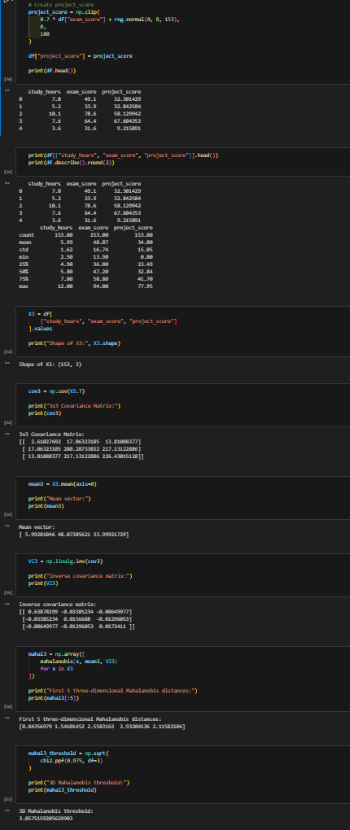
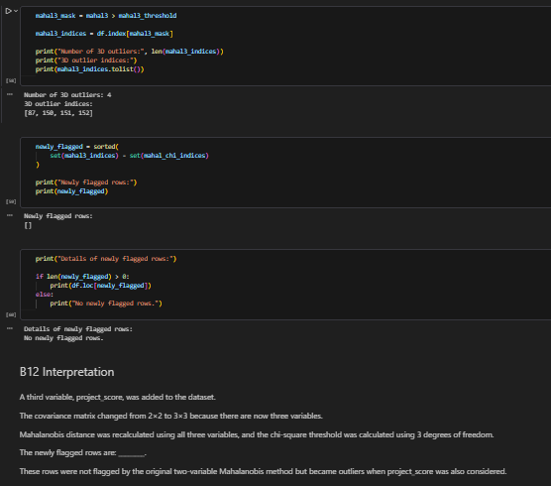
B13. Without using scipy.spatial.distance.mahalanobis, implement Mahalanobis distance from scratch using only NumPy: MD(x) = sqrt( (x−μ)ᵀ Σ⁻¹ (x−μ) ). Verify your result matches the scipy version for all 153 rows using np.allclose.


