Project CySA Cohort 28 Best Hits!
Create three networks in virtualbox network manager (host-only) 1,2,3 all with DHCP enabled.
Install pfsense on new box, do not use FW
create a new VM with free BSD and load the boot image to start from scratch - same as installing on FW but worked better for me
https://youtu.be/D2wjR3pCwrU (30 min video)
setup NICs in virtualbox for pfsense as follows:
Network Card 1: either bridged connection or leave disabled (i did bridged then disabled later) - because this translates to WAN or em0 on initial setup**
Network Card 2: Virtual Host Only with DHCP enabled Host-Only - making this the second interface translates to em1 or LAN and facilitates access to web gui**
Network Card 3: Virtual Host-Only with DHCP enabled Host-Only 2
I'm cloning this pfsense box to serve as a second FW in front of the DMZ
DMZ's pfsense box NICs are as follows:
Network Card 1: same either bridged connection or leave disabled (again, i did bridged to prevent skipping in initial setup)
Network Card 2: Virtual Host Only with DHCP enabled Host-Only 2
Network Card 3: Virtual Host-Only with DHCP enabled Host-Only 3

My goal is to create network topography within virtualbox as follows: (maybe a little too ambitious)
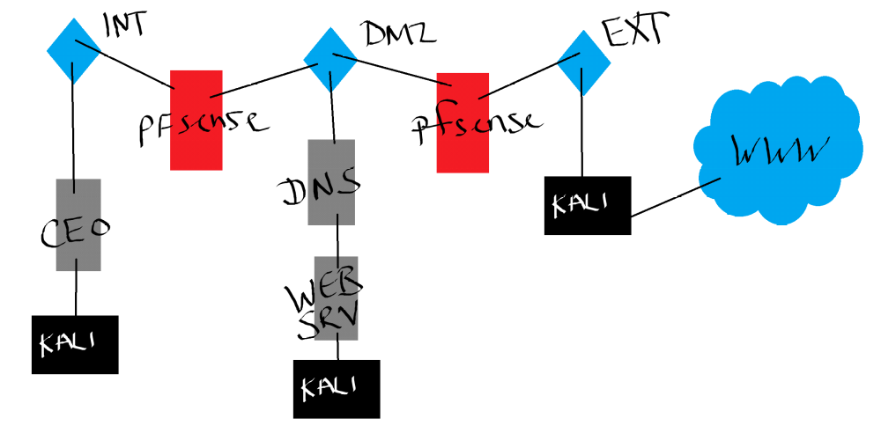
I have replaced the CEO-PC image with a fresh install of ubuntu desktop. CEO won't know the difference from redhat and he's still using linux so he can feel smart. Also, the updated interface has a much cleaner feel than the image we were provided.
Login credentials for CEO-PC are: $eclab!2
(decrypt and login password both)
I can access the pfsense web gui from ceo-pc and kali boxes both.
Next step is to fiddle with the DMZ - kali should be a no-brainer but I'll likely need to lookup commandline tools to change the DNS and WEBSERVER boxes to hook to the DMZ virtual host-only switch.
Best solution I can get here is a release renew cycle. It has to be performed everytime on startup:
# sudo dhclient -r
# sudo dhclient
this will force release and renew a DHCP lease for eth1 or eth0 on the WebServer
The interface name will be important later when setting default gateway for both the webserver and DNS server.
Accessing Nessus in Kali:
(Video in share drive)
In order to access nessus we have to use a browser window. The Nessus program from Tenable uses a webgui.
Step 1: open terminal
Step 2: type "/etc/init.d/nessusd start"
Step 3: open web browser window
Step 4: in address bar type "https://kali:8834"
Step 5: Login
Image credentials are:
User: om3rg0d
PW: $eclab!2

Routing issue solved!
I was unable to ping across the pfsense firewall; internal scanner box ping to DMZ scanner box wasn't functioning properly. Error message ping: connect: Network is unreachable
Solution:
Add default gateway to each box that points to the internal IP address of the pfSense ->
open terminal on linux:
type: "sudo route add default gw 192.168.x.x (inside facing IP address of pfSense) eth0 (Interface)"
you must add the default gateway to each VM that points to the respective inward facing pfsense IP address.

Source for setting up security policy in pfSense:
http://resources.intenseschool.com/pfsense-series-firewall-rules/
Can ping webserver from LAN with security policy:
Can ping internal scanner from DMZ scanner
Evidence - can access web server from LAN with security policy:

