# Dynamic Pricing For Online Portal

T.E. mini-project report submitted in fulfilment of the requirements of the degree of **Information Technology**

by

**Nikhil Sharma EU1224039(57) Ved Singh EU1224052(60)**

**Om Shingare EU1224007 (58)**

**Piyush Jangale EU1224048 (25)**

Under the guidance of **Mrs. Pratiksha Patil** Assistant Professor



## Department of Information Technology

**St. John College of Engineering and Management, Palghar (Autonomous) University of Mumbai**

2024–2025

**CERTIFICATE**

This is to certify that the T.E. Mini-Project entitled **“Dynamic Pricing For Online Portal”** is a bonafide work of **“Nikhil Sharma” (EU1224039) (57), “Ved Singh” (EU1224052) (60), “Om Shingare” (EU1224007) (58) and “Piyush Jangale” (EU1224048) (25)** submitted to University of Mumbai in partial fulfilment of the requirement for the award of the degree of **“Information Technology Engineering”** during the academic year 2024–2025.

### Mrs. Pratiksha Patil

Guide

### Dr. Arun Saxena Dr. Kamal Shah

Head of Department Principal

ii

# T.E. Mini-Project Report Approval

This mini-project synopsis entitled ***Dynamic Pricing For Online Portal*** by ***Nikhil* *Sharma (57*)*, Ved Singh (60), Om Shingare (58), Piyush Jangale (25)*** is approved for the degree of ***Information Technology Engineering*** from ***University of Mumbai***.

### Examiners

1.

2.

Date:

Place:

# Declaration

We declare that this written submission represents our ideas in our own words and where others’ ideas or words have been included, we have adequately cited and referenced the original sources. We also declare that we have adhered to all principles of academic honesty and integrity and have not misrepresented or fabricated or falsified any idea/data/fact/source in our submission. We understand that any violation of the above will be cause for disciplinary action by the Institute and can also evoke penal action from the sources which have thus not been properly cited or from whom proper permission has not been taken when needed.



Signature

Nikhil Sharma (EU1224039)



Signature

Ved Singh (EU1224052)



Signature

Om Shingare (EU1224007)



Signature

Piyush Jangale (EU1224048)

Date:

**Abstract**

This project aims to develop a dynamic pricing model for ride-sharing services by leveraging historical data to analyze the relationship between the number of drivers, riders, and pricing fluctuations. The model will allow users to manually input the number of available drivers and riders, and subsequently display the corresponding fare based on historical trends and demand patterns.

By utilizing advanced data analytics techniques, including regression analysis and machine learning, the project will identify key factors influencing pricing, such as peak times, geographic demand, and driver availability. The dynamic pricing system not only provides real-time pricing insights but also enhances decision-making for both service providers and customers, ultimately aiming to optimize the balance between supply and demand. Additionally, it will facilitate better forecasting and resource allocation for ride-sharing companies, improving operational efficiency and customer satisfaction.

The findings will contribute to a deeper understanding of pricing strategies in the ride-sharing industry, potentially informing future operational and marketing decisions while addressing issues like price fairness and transparency.

|  |  |  |
| --- | --- | --- |
|  | **Table of Contents** |  |
|  | **Abstract** | **v** |
|  | **List of Figures** | **viii** |
|  | **List of Tables** | **ix** |
|  | **List of Abbreviations** | **x** |
| **Chapter 1** | **Introduction** | **11** |
|  | 1.1 Motivation | 11 |
|  | 1.2 Problem Statement | 12 |
|  | 1.3 Objectives | 13 |
|  | 1.4 Scope | 13 |
| **Chapter 2** | **Review of Literature** | **14** |
| **Chapter 3** | **Requirement Gathering and Planning** | **18** |
|  | 3.1 Technical Feasibility | 18 |
|  | 3.1.1 Hardware Requirements | 18 |
|  | 3.1.2 Software Requirements | 18 |
| **Chapter 4** | **Report on Present Investigation** | **19** |
|  | 4.1 Proposed System | 19 |
|  | 4.1.1 Block diagram of Proposed System | 19 |
|  | 4.2 Implementation | 20 |
|  | 4.2.1 Algorithm/Flowchart | 20 |
|  | 4.2.2 Pseudo code | 21 |
|  | 4.2.3 Screenshots of the output with description | 23 |
|  |  |  |
|  |  |  |

|  |  |  |
| --- | --- | --- |
|  |  |  |
|  |  |  |
| **Chapter 5** | **Results and Discussion** | **25** |
| **Chapter 6** | **Conclusion** | **26** |
|  | **References** | **27** |
|  | **Acknowledgement** | **28** |

**List of Figures**

|  |  |  |
| --- | --- | --- |
| **Figure No.** | **Figure Name** | **Page No.** |
| 4.1.1 | Proposed System | 19 |
| 4.2.1 | Flowchart | 20 |
|  |  |  |
|  |  |  |
|  |  |  |
|  |  |  |

**List of Tables**

|  |  |  |
| --- | --- | --- |
| **Figure No.** | **Figure Name** | **Page No.** |
| 2.1 | Literature Survey | 14 |

**Chapter 1**

**Introduction**

## Motivation

* This project is motivated by the increasing complexity of the ride-sharing industry and the need for efficient pricing strategies. As demand for ride-hailing services grows, traditional fixed pricing models often result in inefficiencies and customer dissatisfaction. By developing a dynamic pricing model that leverages historical data, this project aims to create a responsive pricing strategy that aligns with real-time market conditions. This approach will empower ride-sharing companies to optimize fares, enhance transparency for customers, and improve overall operational efficiency. Ultimately, the goal is to foster a more sustainable and equitable ride-sharing ecosystem for drivers, riders, and service providers.

## Problem Statement

* The ride-sharing industry faces significant challenges related to pricing inefficiencies, particularly during fluctuations in demand and supply. Traditional pricing models often fail to adapt to real-time market conditions, leading to customer dissatisfaction and suboptimal resource allocation. This results in instances of unfair surge pricing and a lack of transparency for riders. Additionally, drivers may experience inconsistent earnings due to unpredictable fare structures. Therefore, there is a pressing need for a dynamic pricing model that leverages historical data to better align fares with actual demand and supply, ultimately enhancing the experience for both riders and drivers while improving operational efficiency for service providers.

## Objectives

* + - The primary objective of this project is to develop a dynamic pricing model for ride-sharing services that utilizes historical data to optimize fare calculations based on real-time demand and supply conditions. Specifically, the project aims to identify key factors influencing pricing, such as peak times and geographic demand, to provide accurate fare estimates. Additionally, the model will empower service providers to make data-driven decisions, enhancing operational efficiency and resource allocation. Ultimately, the objective is to create a fairer, more transparent pricing structure that improves customer satisfaction for riders and earnings consistency for drivers in the ride-sharing ecosystem.
    - **Utilization of Historical Data**:

Optimize fare calculations based on real-time demand and supply conditions.

* + - **Key Factors to Identify**:

Peak times

Geographic demand

* + - **Goals**:

Provide accurate fare estimates.

Empower service providers to make data-driven decisions.

Enhance operational efficiency and resource allocation.

* + - **End Goals**:

Create a fairer and more transparent pricing structure.

Improve customer satisfaction for riders.

Ensure earnings consistency for drivers in the ride-sharing ecosystem.

## Scope

This project focuses on developing a dynamic pricing model for ride-sharing services through several key components. First, it involves collecting and analyzing historical ride data, including demand patterns and fare fluctuations. Second, the project will create a user-friendly interface for users to input the number of drivers and riders, generating real-time fare estimates. Additionally, rigorous testing will ensure the model’s accuracy and reliability. The project will provide implementation guidelines for integrating the model into existing platforms. Finally, it will evaluate the model's impact on fare fairness, driver earnings, and customer satisfaction, while suggesting areas for future improvements.

**Chapter 2**

**2.1 Literature Survey**

Following table 2.1 describes analysis of literature review.

Table 2.1. Literature Survey

|  |  |  |  |  |  |
| --- | --- | --- | --- | --- | --- |
| **Sr.**  **No.** | **Paper Title** | **Author Names** | **Conclusion** | **Research Gaps** | |
| 1 | A Machine Learning Framework for Predicting Purchase by Online Customers based on Dynamic Pricing. | Rajan Gupta, Chaitanya Pathak | The paper mentions that while there are various existing models for dynamic pricing (such as agent-based models, inventory-based models, and game theory models), none effectively combine multiple techniques to address purchase behavior prediction through dynamic pricing. | The paper mentions that while there are various existing models for dynamic pricing (such as agent-based models, inventory-based models, and game theory models), none effectively combine multiple techniques to address purchase behavior prediction through dynamic pricing. | |
| 2 | An Application of Reinforced Learning-Based Dynamic Pricing for Improvement of Ridesharing Platform Service in Seoul. | Jaein Song,Yun Ji Cho,Min Hee Kang,Kee Yeon Hwang | The study employed reinforcement learning (RL) to determine optimal surge pricing for ridesharing services. | | The study identifies a lack of research in addressing the regional equity problem in ridesharing services, particularly in marginalized or low-demand areas during late-night hours. |
| 3 | Demand Prediction for Ride-Sharing Services. | Chen, Y., et al. | The paper reviews various dynamic pricing algorithms, analyzing their effectiveness in optimizing revenue through real-time fare adjustments based on demand and supply. It includes case studies of implemented models in existing ride-sharing platforms. | | Limited exploration of user acceptance and transparency issues related to dynamic pricing. |

**Chapter 3**

**Requirement Analysis**

## Technical Feasibility:

Technical feasibility is an assessment of whether a proposed project, product, or service can be successfully implemented using current or available technology. It involves evaluating in detail the technical requirements, constraints, and capabilities of the proposed solution/process to determine whether it is feasible to develop, implement, and maintain it within the given constraints and available resources.

## Hardware Requirements

* + - 1 gigahertz (GHz) or faster 32-bit (x86) or 64-bit (x64) processor.
    - 1 gigabyte (GB) RAM (32-bit) / 2 GB RAM (64-bit).
    - 1 GB available disk space (32-bit) / 20 GB (64-bit)..

## Software Requirements

* + - Visual Studio Code (VS Code).
    - Language used : Python
    - Matplotlib Library

**Chapter 4**

**Report on Present Investigation**

## Proposed System

The proposed system is designed to predict ride costs using a machine learning model, specifically a Random Forest (RF) algorithm, based on user inputs. The system begins with a user-friendly interface where the user inputs relevant ride parameters, such as distance, time, and location. Once the input is received, the system preprocesses the data by handling missing values, calculating multipliers like surge pricing, and ensuring that the data is in the correct format for the machine learning model. The core of the system is the Random Forest model, which is trained on historical ride data, using features such as time, distance, and traffic conditions to predict the ride cost. This model is trained and periodically updated using the database, which stores both historical ride data and user input. After preprocessing, the system predicts the ride cost based on the input data and displays the result to the user in a clear format through the frontend interface. If there are issues during data processing, such as incomplete or invalid input, the system offers error handling mechanisms that guide the user to provide correct information. The overall system relies on a combination of Python, web technologies (like React.js for frontend and Flask or Django for backend), and machine learning libraries like scikit-learn to deliver accurate ride cost predictions efficiently.

## Block diagram of Proposed System

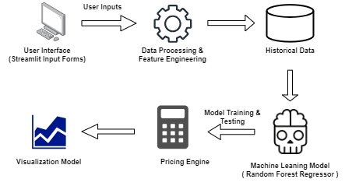

Fig 4.1.1 Block diagram

## Implementation

* + 1. **Flowchart**

The below figure 4.2.1 shows Flowchart for Proposed System.

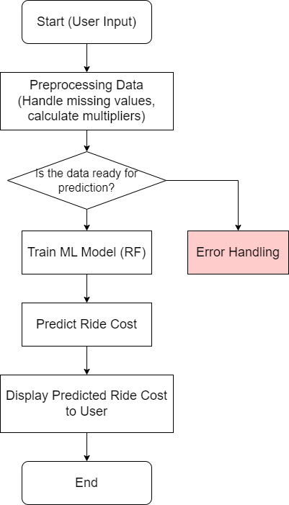

Fig. 4.2.1. Flowchart

## Pseudo code:

1. Import necessary libraries:

- pandas for data manipulation

- plotly for visualization

- numpy for numerical operations

- sklearn for machine learning

2. Load CSV file containing ride data.

3. Display the first few rows of the dataset (head) and summary statistics (describe).

4. Visualization:

- Scatter plot showing Expected Ride Duration vs. Historical Cost of Ride.

- Box plot showing distribution of Historical Cost of Ride by Vehicle Type.

- Heatmap of the correlation matrix for all numerical variables.

5. Calculate demand multiplier:

- Determine high and low demand percentiles (75th and 25th).

- If number of riders > high demand percentile, adjust demand multiplier accordingly.

- Otherwise, adjust based on low demand percentile.

6. Calculate supply multiplier:

- Determine high and low supply percentiles (75th and 25th).

- If number of drivers > low supply percentile, adjust supply multiplier accordingly.

- Otherwise, adjust based on low supply percentile.

7. Define price adjustment factors:

- Set thresholds for high and low demand/supply.

8. Calculate adjusted ride cost:

- Multiply historical cost by demand and supply multipliers using thresholds.

9. Calculate profit percentage:

- Compute profit as (adjusted cost - historical cost) / historical cost.

10. Classify rides:

- Identify profitable rides (positive profit percentage).

- Identify loss-making rides (negative profit percentage).

11. Visualization:

- Donut chart showing distribution of profitable and loss-making rides.

- Scatter plot showing Expected Ride Duration vs. Adjusted Ride Cost.

12. Preprocessing the data:

- Fill missing values in numeric features with the mean.

- Detect and replace outliers using IQR method.

- Fill missing values in categorical features with the most frequent value.

13. Map Vehicle_Type from categorical to numerical (Premium: 1, Economy: 0).

14. Split the dataset into training and testing sets (80% train, 20% test).

15. Train a Random Forest Regression model on training data.

16. Define a function to predict ride cost based on user input:

- Convert Vehicle_Type to numeric.

- Use the model to predict adjusted ride cost.

17. Predict ride cost using user-defined input values.

18. Visualization:

- Scatter plot comparing actual vs. predicted ride costs.

- Add a line showing the ideal case where predicted equals actual.

19. Import libraries:

- pandas and numpy for data manipulation.

- StandardScaler for normalization.

20. Define a function for data preprocessing pipeline:

- Identify numeric and categorical features from the dataset.

21. Handle missing values:

- For numeric features, fill missing values with the column mean.

- For categorical features, fill missing values with the mode.

22. Detect and handle outliers:

- For numeric features, calculate the IQR (interquartile range).

- Replace values that are outside the bounds of IQR with the feature mean.

23. Return preprocessed data for further use.

24. Map Vehicle_Type from categorical to numerical (Premium: 1, Economy: 0).

25. Define training and testing sets:

-Use features such as Number_of_Riders, Number_of_Drivers, Vehicle_Type, Expected_Ride_Duration as input.

- Set adjusted_ride_cost as the target variable.

26. Split data into training and testing sets (80% train, 20% test.)

27. Import libraries:

- RandomForestRegressor from sklearn for machine learning.

28. Train a Random Forest Regression model:

- Fit the model on training data (x_train, y_train).

29. Define helper function to convert Vehicle_Type:

- Map "Premium" to 1 and "Economy" to 0.

30. Define a prediction function:

- Accept input parameters such as number of riders, drivers, vehicle type, and expected ride duration.

- Convert vehicle type to numeric using the helper function.

- Prepare input data in the format expected by the model.

- Predict the adjusted ride cost using the trained Random Forest model.

31. Make an example prediction:

- Use the function to predict the ride cost for a sample input.

32. Visualize model performance:

- Predict the adjusted ride cost for the test dataset.

- Create a scatter plot to compare actual vs. predicted values.

- Add a reference line showing the ideal case (where actual = predicted).

## Screenshot of Output with Description

* + - 1. **Dynamic Pricing Model:**

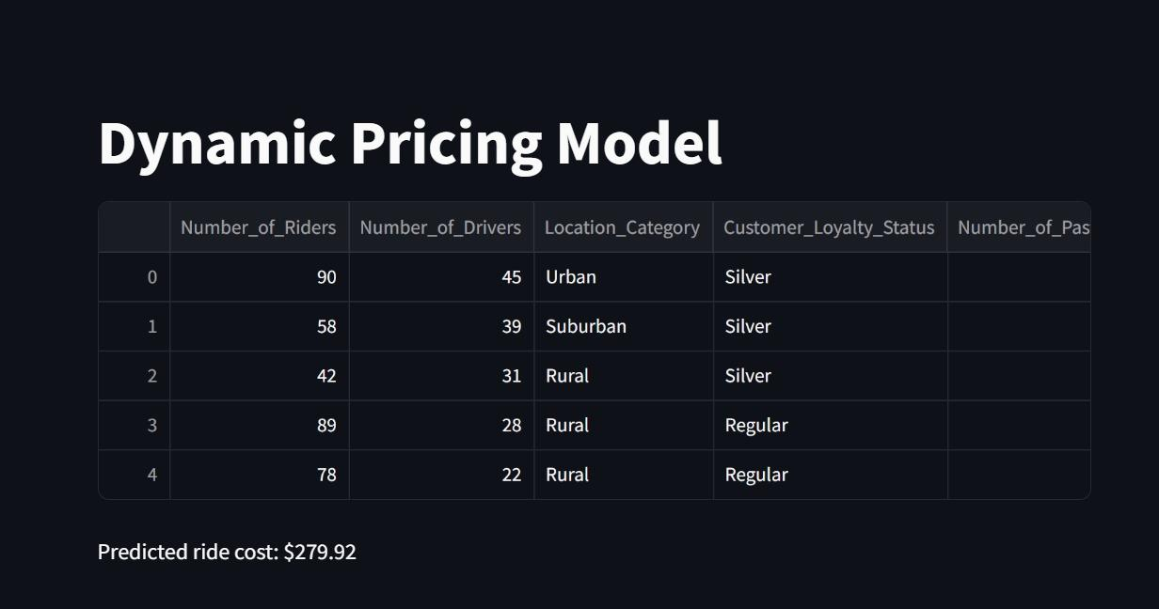

Fig. 4.2.3.1. dynamic Pricing Model

## Dynamic Model with Parameters:

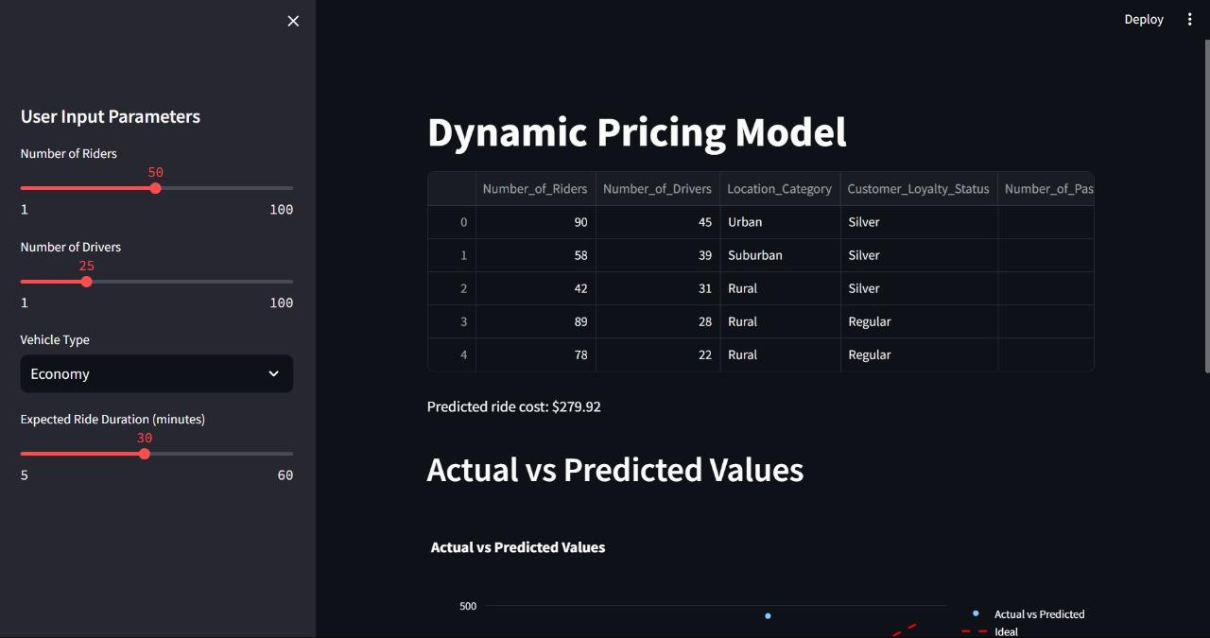

## Fig. 4.2.3.2. Dynamic Model with Parameters

## User Input Parameters:

1. 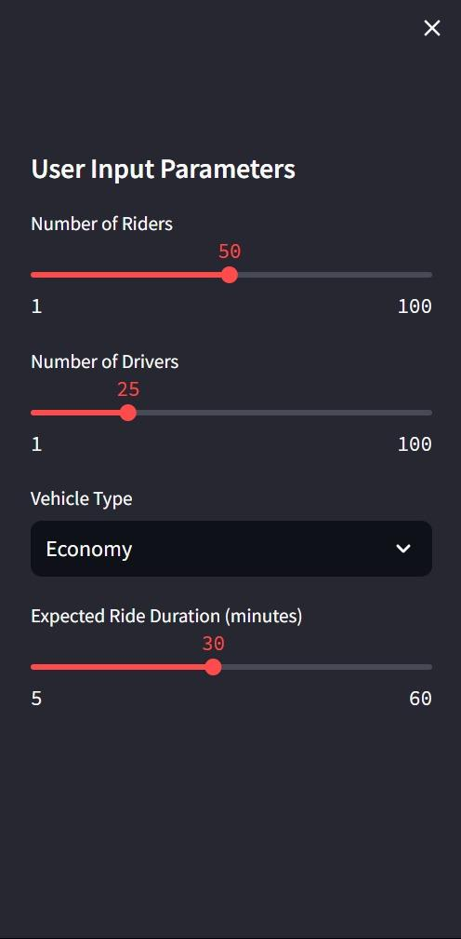

Fig. 4.2.3.3. User Input Parameters

## Actual vs Predicted Value Graph with User Input Parameters:

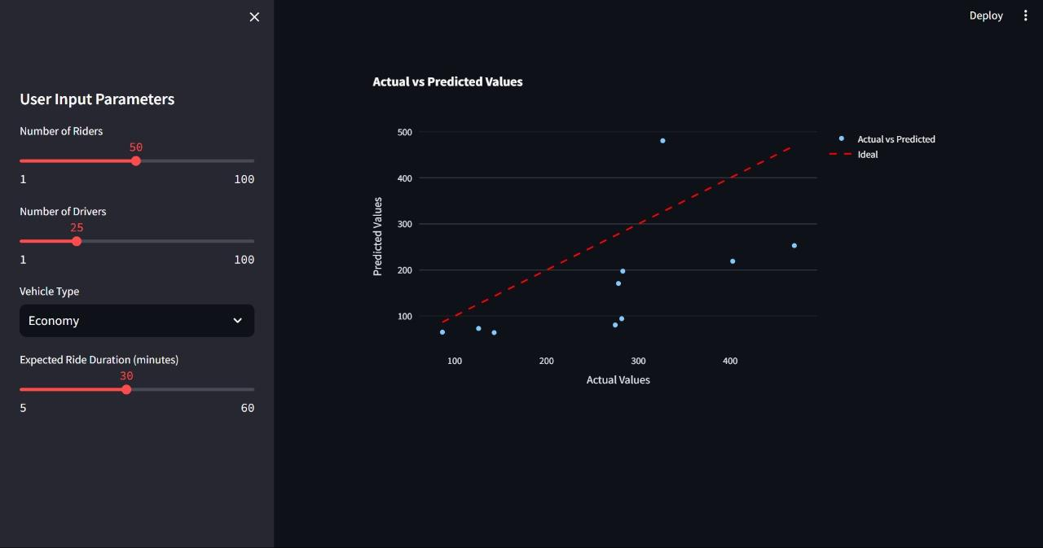

Fig. 4.2.3.3. Actual vs Predicted and Graph

**Chapter 5**

**Result and Discussion**

The dynamic pricing model uses a RandomForestRegressor to predict ride costs based on real-time factors such as the number of riders, drivers, vehicle type, and expected ride duration. By incorporating demand and supply multipliers, the model adjusts prices dynamically, increasing the cost when demand is high and supply is low, and reducing it when supply is abundant. The model was trained on historical data and tested for accuracy by comparing predicted prices to actual costs. This comparison, visualized through scatter plots, shows the model's effectiveness in predicting prices close to the real values.

The model also calculates profitability by determining which rides yield a profit based on the adjusted prices. This helps identify the rides that are financially beneficial and those operating at a loss. Overall, the model successfully captures dynamic market conditions and adjusts prices accordingly, though further improvements, such as incorporating more features and refining thresholds, could enhance its accuracy and performance.

**Chapter 6 Conclusion and Future Scope**

## Conclusion:

This project aims to develop a dynamic pricing model for ride-sharing services that effectively leverages historical data to optimize fare calculations based on real-time demand and supply. By integrating advanced data analytics and user-friendly interfaces, the model seeks to enhance transparency and fairness in pricing, ultimately improving customer satisfaction and driver earnings. The findings will contribute valuable insights into pricing strategies, promoting a more efficient and equitable ride-sharing ecosystem that adapts to market fluctuations and user needs.

## Future Scope:

* Integration of External Factors: Incorporate variables such as weather conditions, local events, and traffic patterns to enhance demand forecasting accuracy.
* User Feedback Mechanism: Develop a system to collect real-time feedback from users regarding pricing perceptions and satisfaction, allowing for continuous model refinement.
* Geographical Expansion: Test and adapt the pricing model across diverse Indian cities and rural areas to assess its applicability in varying contexts.
* Longitudinal Studies: Conduct long-term studies to evaluate the effects of dynamic pricing on driver retention and customer loyalty over time.
* Fairness Metrics Enhancement: Explore additional fairness metrics and implement them into the pricing model to ensure equitable outcomes for all stakeholders.
* Machine Learning Improvements: Investigate advanced machine learning techniques, such as deep learning, to further refine demand prediction and pricing strategies.

## References

[1] Nath A, Khandelwal A, Kanojia A, Minocha I, Niyogi R (2017) Design and implementation of an intelligent cab service system. In: 2017 tenth international conference on contemporary computing (IC3). IEEE, pp 1–6

[2]Salanova, J.M., Estrada, M., Aifadopoulou, G., Mitsakis, E.: A review of the modeling of taxi services. Procedia Soc. Behav. Sci. 20, 150–161 (2011)

[3]An Application of Reinforced Learning-Based Dynamic Pricing for Improvement of Ridesharing Platform Service https://www.mdpi.com/2079-9292/9/11/1818

[3]An Application of Reinforced Learning-Based Dynamic Pricing for Improvement of Ridesharing Platform Service <https://www.mdpi.com/2079-9292/9/11/1818>

[4] A Study on Dynamic Pricing Models Using Machine Learning Algorithmshttps://www.mit.edu/~dbertsim/papers/Revenue%20Management/Dynamic%20Pricing-%20A%20Learning%20Approach

[5] LingAdeu Optimizing Ride Fares: A Dynamic Pricing Model for Ride-Sharing Services https://github.com/LingAdeu/dynamic-pricing-model

## 

## Acknowledgement

We would like to extend our immense gratitude towards the Mumbai University for keeping this “Mini Project” project as a part of our curriculum. We are in debt thankful to our project guide, Mrs. Pratiksha Patil, St. College of Engineering and Management to guide and be with us throughout our project timeline. A very thank you to our HOD of Information Technology Department, Dr. Arun Saxena, for providing us all the needful facilities and best guidance. We also extend our gratitude toward our respected principal, Dr. Kamal Shah to provide all the facilities and encouragement towards our project and to the whole Information Technology Department who has been supportive till the end. We would like to give our special thanks to all our teaching and non-teaching staff and to our parents to be supportive with us throughout the process. Indeed, we feel very obliged to be a part of this successful project which was only successful due to our Project Guide, Project Faculty, HOD, Principal, IT Department, Parents and due to the whole teaching and non-teaching staff.



Signature

Nikhil Sharma (EU1224039)



Signature

Ved Singh (EU1224052)



Signature

Om Shingare (EU1224007)



Signature

Piyush Jangale (EU1224048)