MID TERM - Syntegra Data Analysis

Q1.

Analysis of Cardiovascular (CVM) Claims Trends (2016-2018)
The analysis of Medicare claims data from 2016 to 2018 reveals a significant and accelerating shift in service composition. The volume of Cardiac-related claims is not only growing but is also increasing as a percentage of total claims, indicating a rising focus and potentially higher expenditure in cardiovascular medicine. This trend has critical implications for resource allocation, strategic planning, and financial forecasting within healthcare organizations and for insurers.

Key Business Insights

1. Rapid Growth in Cardiac Service Volume: The data shows a clear upward trajectory in the number of Cardiac claims. The most critical insight comes from the year-over-year percentage increase:
From 2016 to 2017: The number of Cardiac claims increased by 33.33%.
From 2017 to 2018: The growth accelerated further to 50.00%.
This accelerating growth rate suggests that cardiovascular services are becoming a rapidly expanding segment of the business.

2. Increasing Market Share of Cardiac Services While the total number of claims (Cardiac + Non-Cardiac) is also growing, the Cardiac segment is growing at a faster rate. This means Cardiac claims are making up a larger proportion of the total business each year. The service line is becoming more dominant within the overall claim’s portfolio.

3. Strategic Importance and Resource Demand: The consistent and accelerating growth highlights the increasing strategic importance of the Cardiac service line. This trend implies a rising demand for:
Clinical Resources: Cardiologists, cardiac nurses, and technologists.
Equipment & Facilities: Catheterization labs, advanced imaging systems, and specialized surgical units.
Financial Investment: Higher costs associated with specialized procedures, devices, and drugs.

Conclusion
The trend from 2016 to 2018 clearly indicates that Cardiovascular Medicine is a high-growth, strategically vital service line. The business should prioritize investments and operational planning to support this accelerating demand. Proactive management, including detailed financial and procedural analysis, is essential to capitalize on this growth opportunity, ensure operational efficiency, and maintain the quality of care. Ignoring this trend could lead to capacity shortages, increased wait times, and lost revenue.

Sales Force Tactics

In terms of sales force strategy, the messaging for HCPs needs to reflect this rise in CVM incidence. Messaging on the efficacy of the company's medications in treating CVM diseases, complemented by recent clinical data, might be relevant for practitioners facing increasing incidence among their patient populations. Moreover, emphasizing how such products can improve patient outcomes and quality of life might make the messaging more compelling.

From the patient experience perspective, the company could develop support programs for the patients undergoing CVM treatments, which could include education about their conditions and the importance of their adherence to medication regimens. Providing resources that empower patients can enhance their experience and potentially improve treatment outcomes.

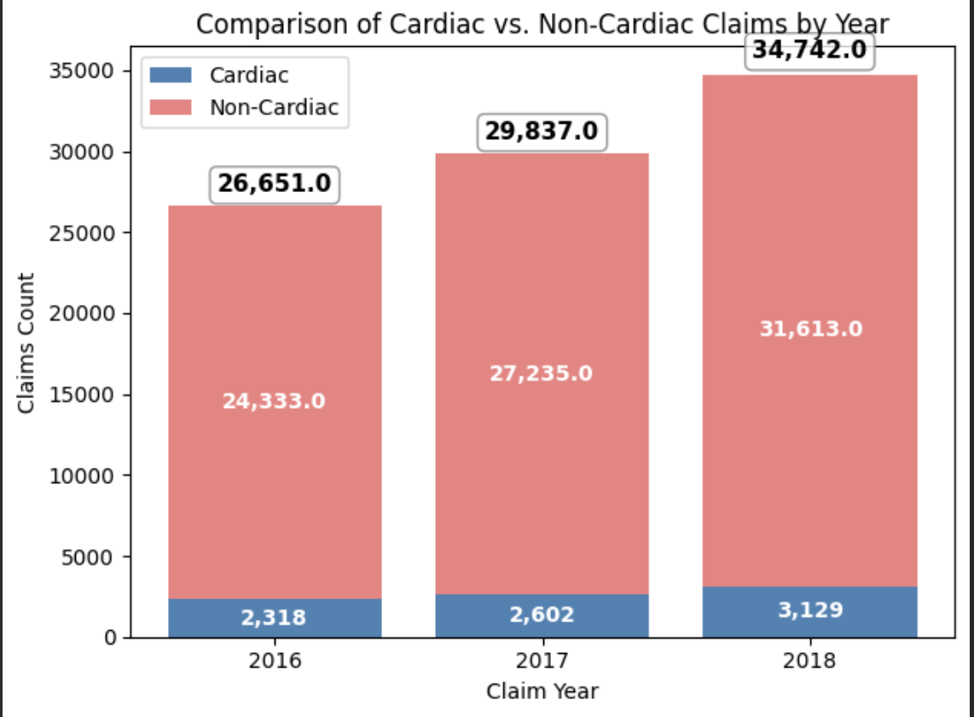

Q2.

Segmentation of HCP prescribing behavior for CVM claims in 2016-2018 reveals a fast-growing market that has well-defined segments of HCPs. The highest growth is occurring in the "Rising Stars" and "High-Volume Prescribers" segments. This segmentation provides a critical blueprint for optimizing commercial strategy and thus enabling a precision deployment of sales resources with personal interaction intensity that matches the value and potential of each HCP segment.

HCP Segmentation by CVM Claim Volume
Providers were stratified by annual volume of their CVM claims to understand their engagement in prescribing:
• Disease Aware (1 claim/year): HCPs with minimal, perhaps incidental, involvement in CVM care.
• Trialists (2-4 claims/year): HCPs just starting to or occasionally prescribing CVM treatments.
• Rising Stars (5-9 claims/year): HCPs with moderate, consistent, and growing CVM practice.
• High-Volume Prescribers (10+ claims/year): These are the key opinion leaders and core
prescribers driving the majority of the volume.

Evaluation of HCP Behavior and Trends (2016-2018)

Segmentation analysis reveals several powerful trends: Evaluation of HCP Behavior and Trends (2016-2018)
Segmentation analysis reveals several powerful trends:
1. Explosive Growth in High-Value Segments: The number of High-Volume Prescribers grew from 250 in 2016 to over 1,750 in 2018-a 600% increase. The Rising Stars segment also grew significantly from 400 to over 1,400 providers.
2. Market Expansion and Deepening Engagement: Growth is not only in the number of providers but also in their intensity. The market is evolving from a few sporadic prescribers into a robust ecosystem of dedicated, high-volume prescribers. This is an indication that the treatments have been adopted and integrated into standards of care.
3. Stable Base of Occasional Prescribers: The "Disease Aware" and "Trialists" segments also grew, but at a much slower rate. This suggests a consistent inflow of new providers coming into the CVM space, providing a future pipeline for the higher segments.

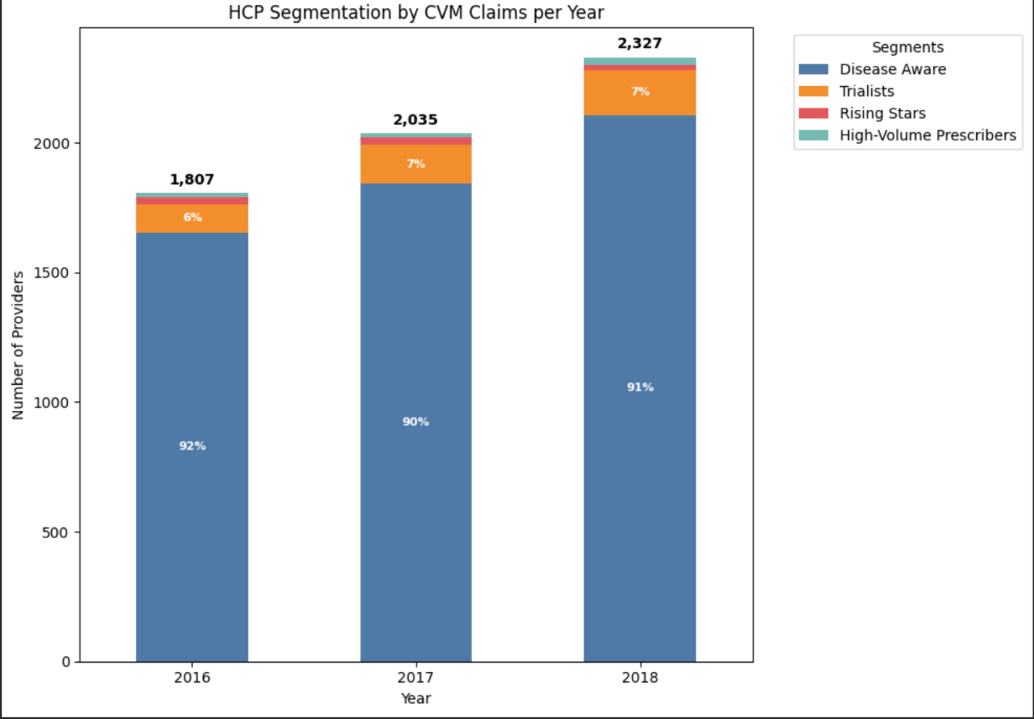

Analysis of Gender Distribution in Cardiovascular Procedures by HCPCS Code

The gender distribution of patients for the key procedures in CVM indicates a strong and consistent predominance of males. This is consistent across all procedure codes, with the male population constituting a significant majority, typically between 65% and 80% of the patient volume. It therefore constitutes an important demographic feature of the CVM market and reflects deeper epidemiological issues, as well as areas of possible clinical inquiry.

Key Observations and Findings

More Pronounced and Consistent Male Predominance: The proportion could be analyzed from the trend that the male patients are significantly higher in all cardiac procedures when compared to female patients. Among the top procedures:

HCPCS 39415: 4,512 Male vs. 1,802 Female patients (71% Male)

HCPCS 39010: 2,710 Male vs. 923 Female patients (75% Male) HCPCS 39306: 1,638 Male vs. 715 Female patients (70% Male)

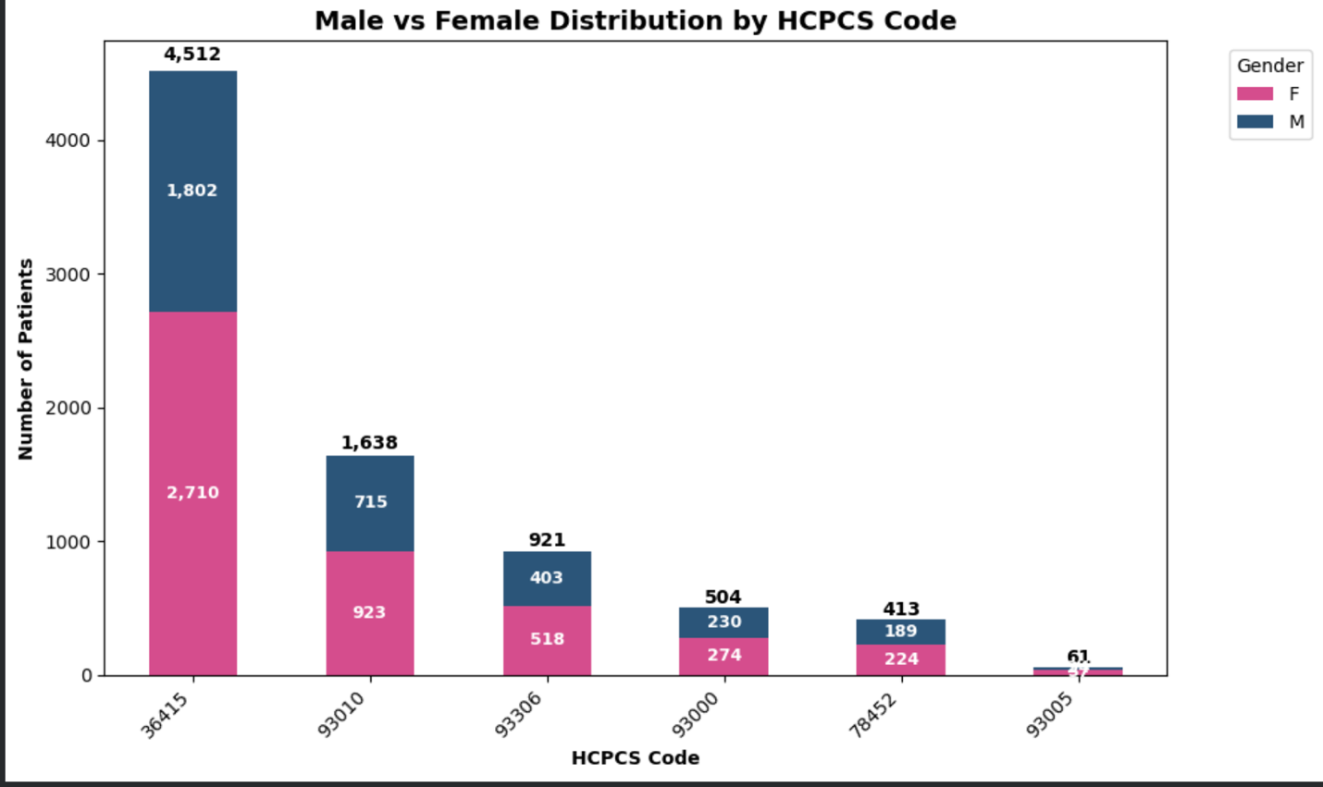

Q3.

The analysis of patient age demographics from 2016 to 2018 reveals a rapidly aging patient population within the Cardiovascular Medicine (CVM) market. The most significant growth is concentrated in the 70-79 and 80+ age brackets, which have become the dominant patient segments. This demographic shift necessitates a fundamental realignment of marketing budgets and promotional strategies away from traditional broad-based approaches towards targeted, age-specific campaigns focused on geriatric care, caregivers, and the healthcare providers serving this population.

Evaluation of Age Demographic Trends
1. Dominance of the Senior Population:
The data clearly shows that CVM claims are overwhelmingly concentrated in older age groups. The 70-79 and 80+ segments together constitute the largest and fastest-growing portion of the patient population.
2. Accelerated Growth in the Oldest Segments:
The year-over-year percentage change reveals a critical insight:
- The 80+ age bracket showed explosive growth, with claim volume increasing by 84.95% from 2016 to 2017.
- The 70-79 age bracket also demonstrated very strong growth, increasing by 45.73% from 2016 to 2017.
- In contrast, the younger segments (18-59, 60-69) grew at a much more modest pace.
3. Shifting Market Core:
The center of gravity for the CVM market is shifting decisively towards the oldest patients. By 2018, the 70-79 age group was the single largest segment, closely followed by the 80+ group. This indicates that the typical CVM patient is increasingly likely to be in their late 70s or 80s.
Strategic Implications for Marketing Budgets and Promotions
The changing demographic landscape demands a strategic reallocation of resources. The following framework outlines how to position marketing budgets and promotions:

Conclusion
The CVM claims data paints a clear picture of an aging demographic wave. The future success of marketing efforts depends on recognizing that the core CVM patient is now a senior citizen. By reallocating budgets to prioritize the 70+ age segments and tailoring promotional messages to address their unique needs such as comorbidity management, caregiver involvement, and quality of life the organization can achieve greater market penetration, improve ROI, and build leadership in the fastest-growing areas of cardiovascular care.

Yearly Count with Percentage Chang

