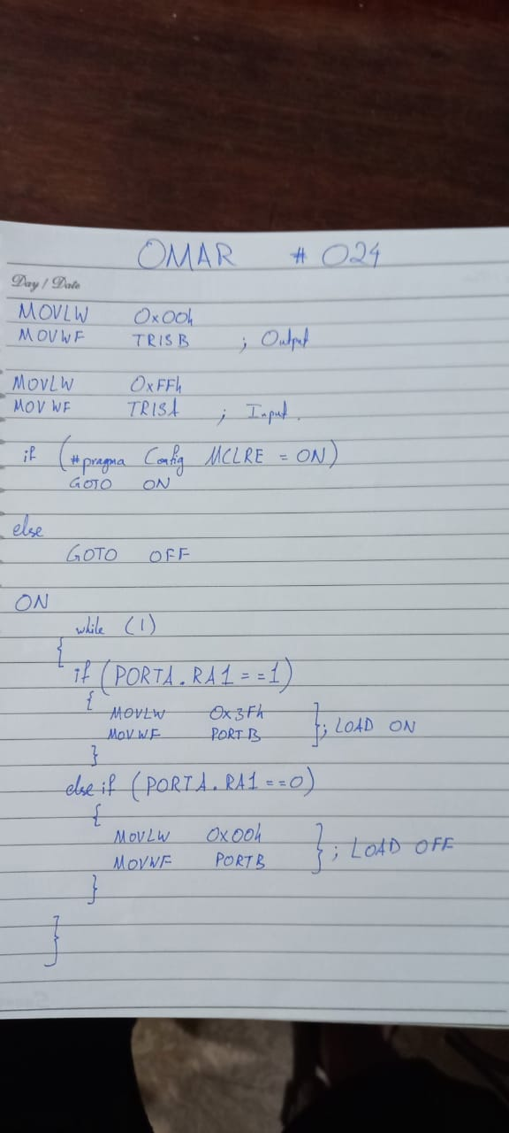

[RA1 Input Switch Not Working (PIC16F887) [Newbie] | Microchip](https://www.microchip.com/forums/m578238.aspx)