SOURCE CODE:

#include<p16f84.inc>

MAIN_PROG CODE

START //SEGMENT DIVISION FOR RUNNING CODE ON MPLAB

BSF STATUS,5 ;// Bank 1

MOVLW 0xFF

MOVWF TRISA //INPUT

MOVLW 0x00

MOVWF TRISB //OUTPUT

BCF STATUS,5 ;// Bank 0

BSF PORTB,6//LOAD IS ON WHEN RE-SET

Main

BTFSS PORTA, 1 //SKIP NEXT COMMAND IF BIT==1

BCF PORTB, 6

BTFSC PORTA, 1 // SKIP NEXT COMMAND IF BIT==0

BSF PORTB, 6

GOTO Main

End

MPLAB v8.92:

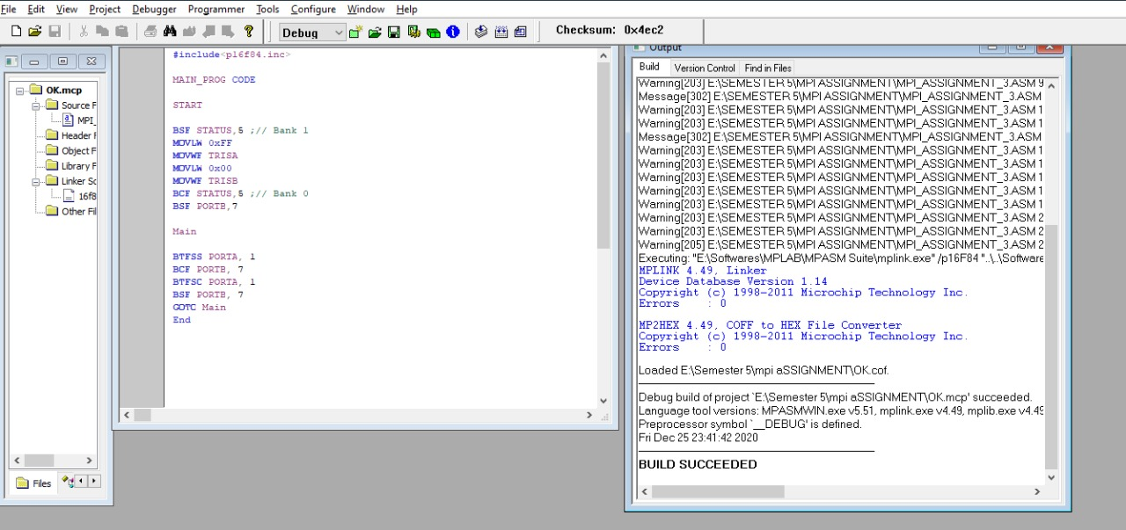

Saving code and linker :

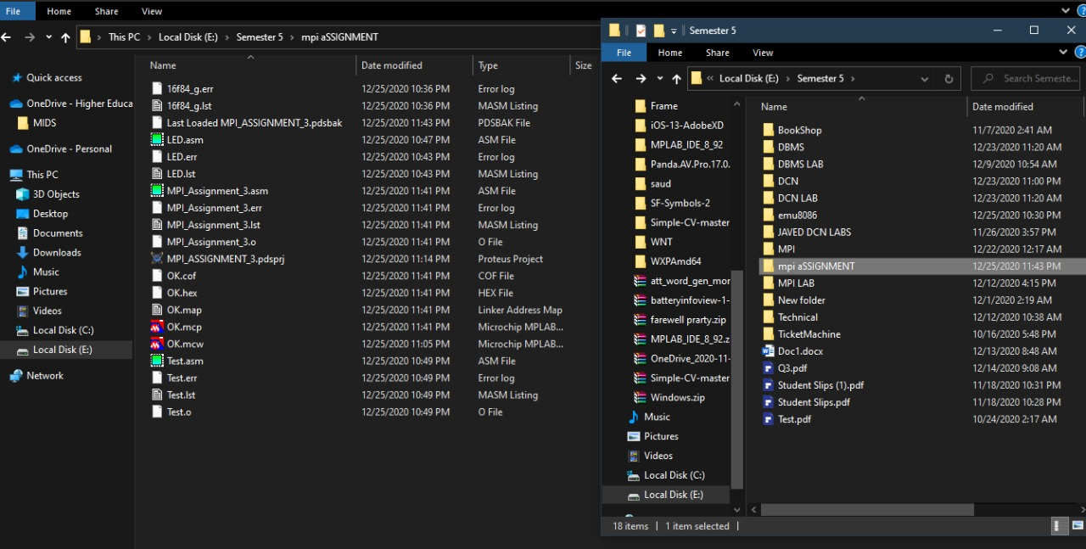

Schematic diagram on priteus:

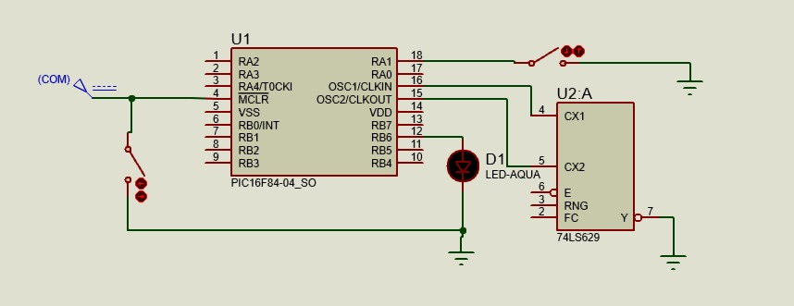

**Code for DELAY:**

