**Digital Image Processing**

Assignment#1



Name: OMAR

Class: BCE-07

Enrollment No: 01-132182-024

**Question No. 3: Down Sampling:**

CODE:

clear all, close all ; %#

a=imread('R.jpg');

grayimage=rgb2gray(a);

figure,imshow(grayimage);

title('image:1024*1024');

%getting resolution/size of image

[r,c]=size(grayimage);

%down sampling starts

b1=grayimage(1:2:r,1:2:c);

figure,imshow(b1);

title('image:512*512');

b2=grayimage(1:4:r,1:4:c);

figure,imshow(b2);

title('image:256*256');

b3=grayimage(1:8:r,1:8:c);

figure,imshow(b3);

title('image:128*128');

output:

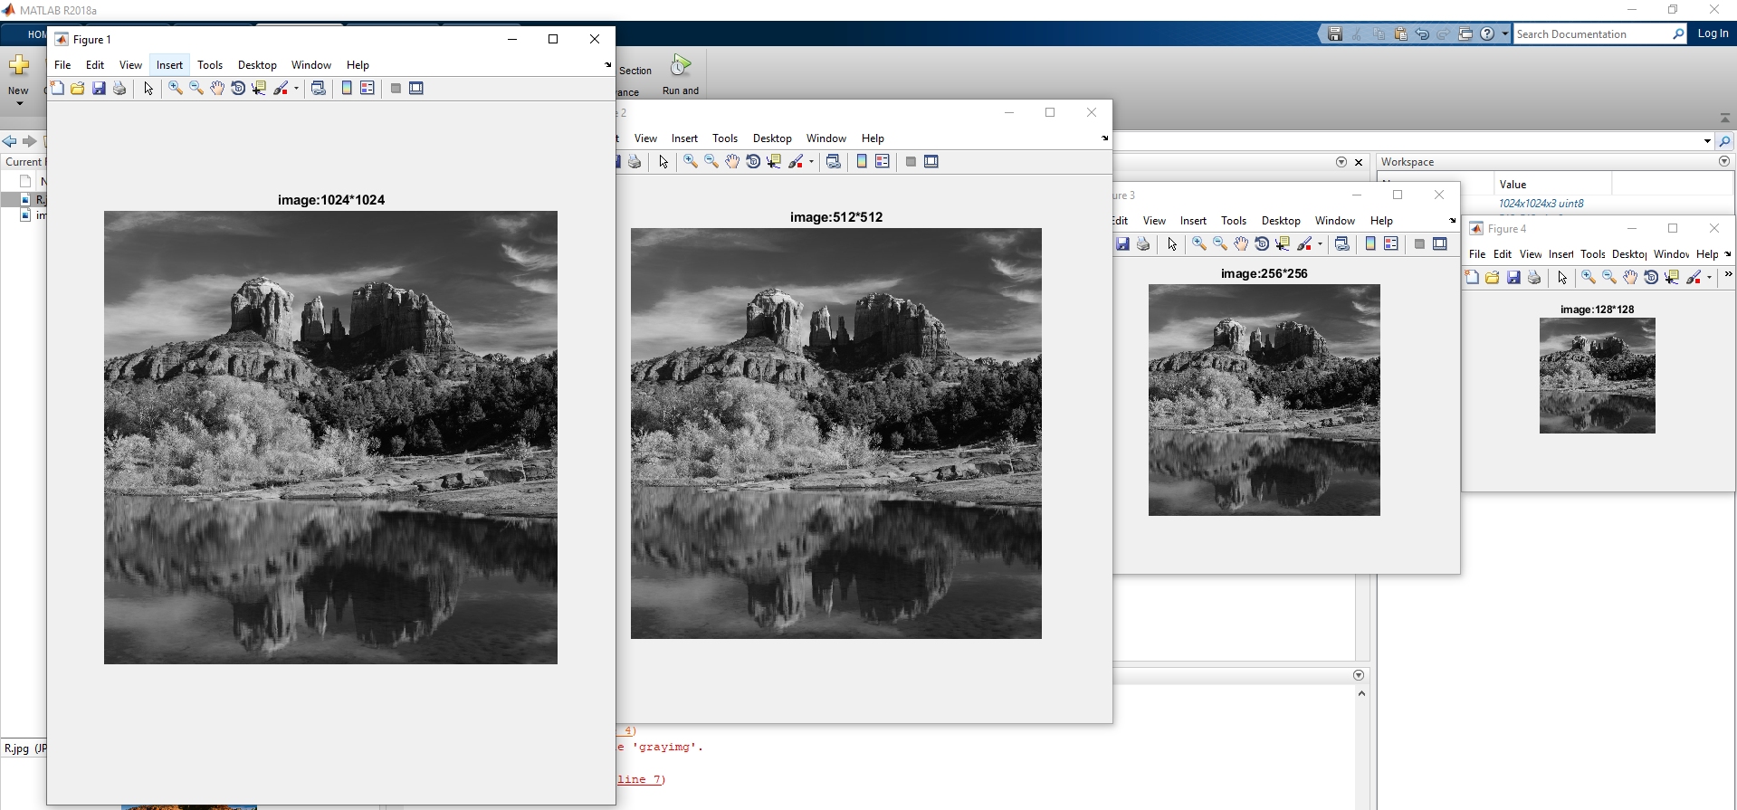

**PRESENT YOUR RESULTS AFTER QUANTIZING THE SAME INPUT IMAGE TO 128, 64, 8 AND 2 LEVELS.**

**Quantization**

**CODE:**

clear all, close all ; %#

a=imread('R.jpg');

grayimage=rgb2gray(a);

figure,imshow(grayimage);

title('original image, quantized to 256 levels');

%getting resolution/size of image

[r,c]=size(grayimage);

%nested loop and if-else condition for changing intensities

for i=1:r

for j=1:c

intensity=grayimage(i,j);

if intensity<=50

grayimage(i,j)=10;

elseif intensity>50 && intensity<=100

grayimage(i,j)=70;

elseif intensity>100 && intensity<=180

grayimage(i,j)=150;

elseif intensity>180 && intensity<=255

grayimage(i,j)=210;

end

end

end

figure,imshow(grayimage);

title('Qunntized image, to 4 levels')

%8levels#######################################

for i=1:r

for j=1:c

intensity=grayimage(i,j);

if intensity<=50

grayimage(i,j)=10;

elseif intensity>50 && intensity<=100

grayimage(i,j)=50;

elseif intensity>100 && intensity<=150

grayimage(i,j)=90;

elseif intensity>150 && intensity<=180

grayimage(i,j)=120;

elseif intensity>180 && intensity<=210

grayimage(i,j)=150;

elseif intensity>210 && intensity<=230

grayimage(i,j)=190;

elseif intensity>230 && intensity<=240

grayimage(i,j)=210;

elseif intensity>240 && intensity<=255

grayimage(i,j)=240;

end

end

end

figure,imshow(grayimage);

title('Qunntized image, to 8 levels')

%2levels#######################################

for i=1:r

for j=1:c

intensity=grayimage(i,j);

if intensity<=150

grayimage(i,j)=0;

elseif intensity>150 && intensity<=255

grayimage(i,j)=1;

end

end

end

figure,imshow(grayimage);

title('Qunntized image, to 2 levels')

OUTPUT:

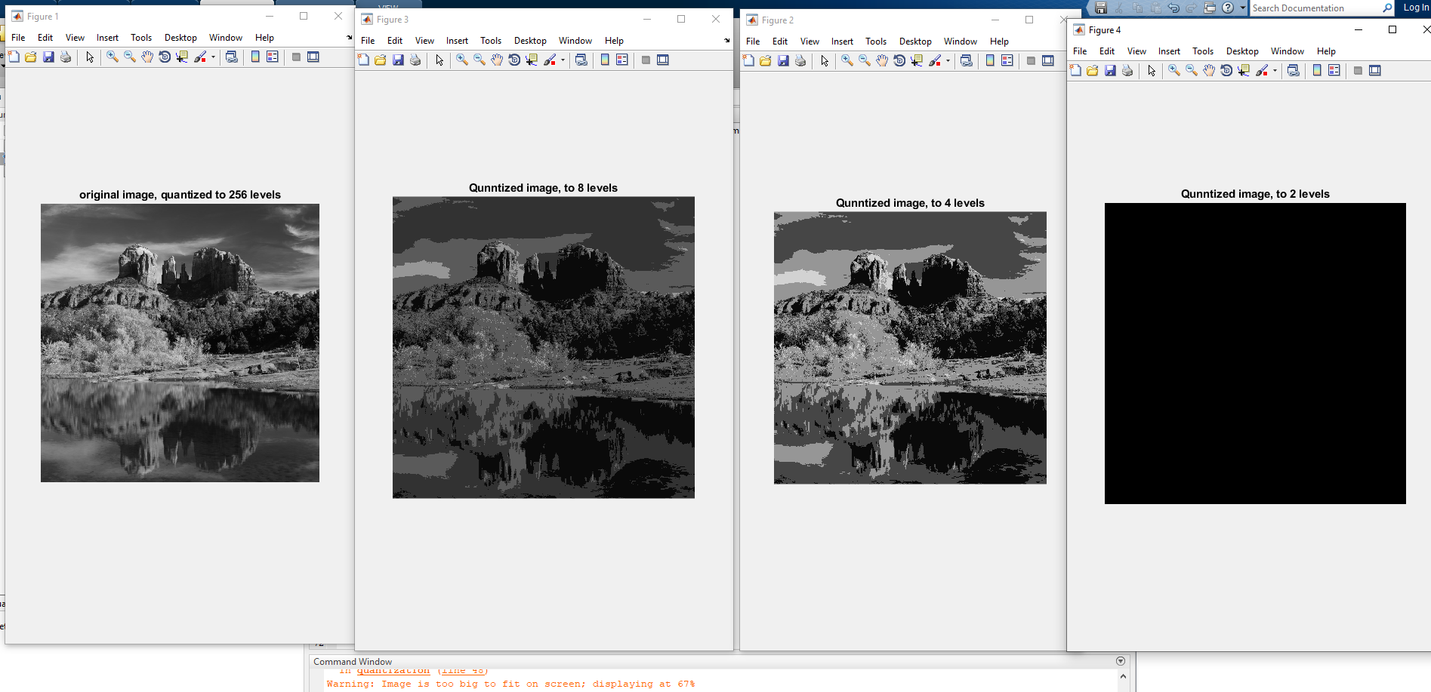

**Question No. 1**

What are PBM, PGM, and PPM and DICOM files. Explain the contents of the files. Also describe how to read and write them using MATLAB using examples.

PBM file extension

1-bit black and white image; formatted in text format; basic raster image format in which each pixel is represented by a byte that contains a 1 or 0; 1 represents black and 0 represents white pixels.

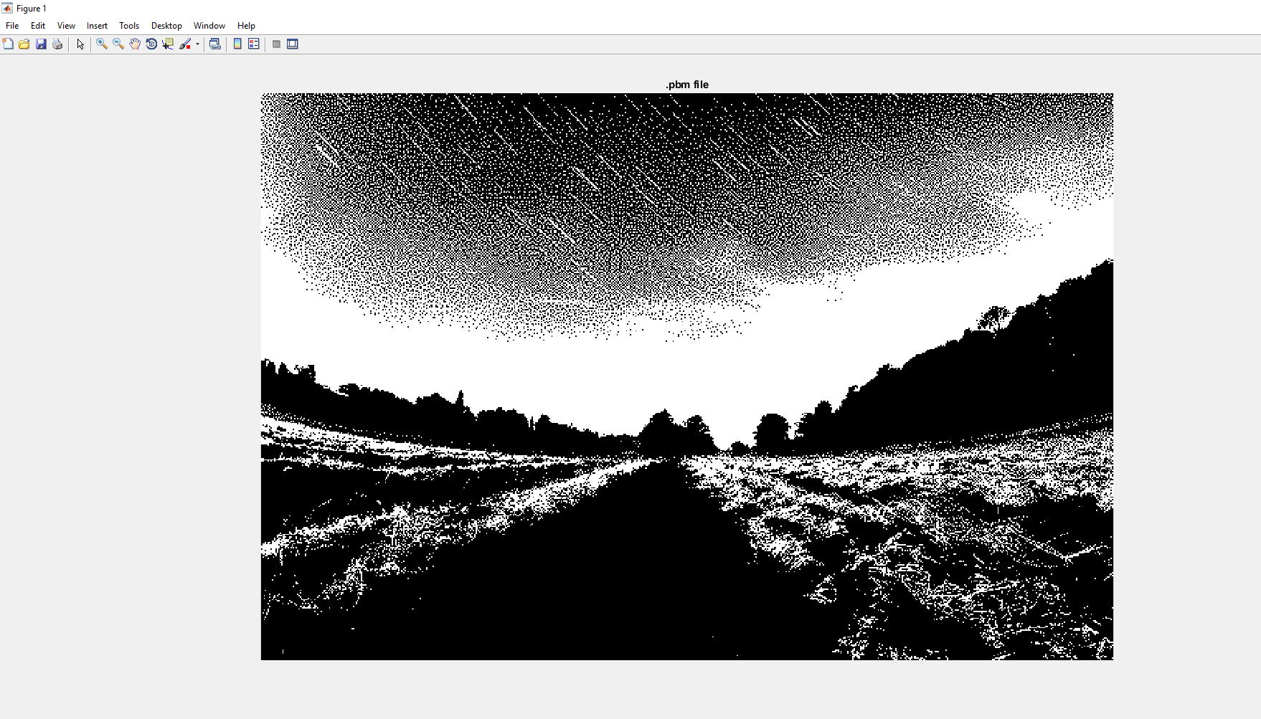

# PPM File

* File extension: PPM
* File type: Image

PPM files mostly belong to Photoshop by Adobe. PPM is the filename extension of uncompressed color image files saved in Portable Pixmap format. The PPM image format supports 0 to 255 RGB color and the file can be written in text or binary format. A PPM file begins with a magic number followed by the dimensions, and the color matrix made up of RGB (red, green, blue) triplets. PPM files use image/x-portable-pixmap Internet media type. Because these files are uncompressed, they typically require larger storage space and bandwidth when transmitted over the Internet. Due to the large file size, PPM is often used as an intermediate image processing format. PPM is also the filename of an archive of plugins used by Total Commander, a Windows-based file manager. Insight, a molecular data collection, analysis, and visualization software, saves proton chemical shifts data in PPM files.

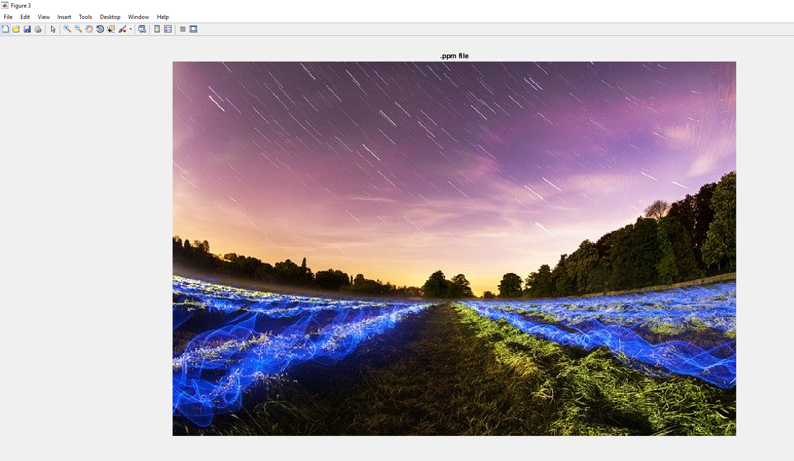

PGM file extension

A PGM file is a grayscale image file saved in the portable gray map (PGM) format and encoded with one or two bytes (8 or 16 bits) per pixel. It contains header information and a grid of numbers that represent different shades of gray from black (0) to white (up to 65,536). PGM files are typically stored in ASCII text format, but also have a binary representation.

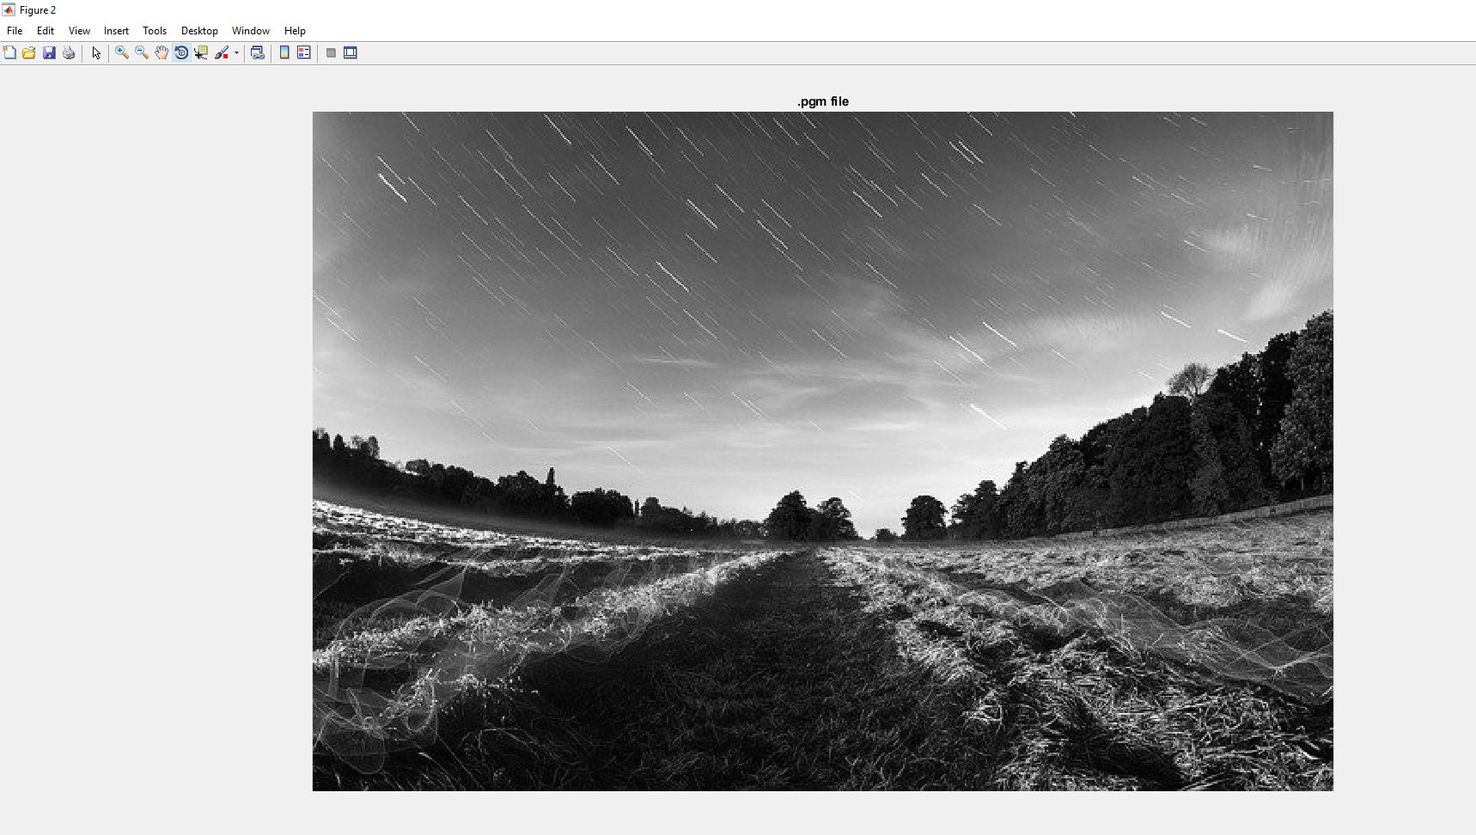

Code:

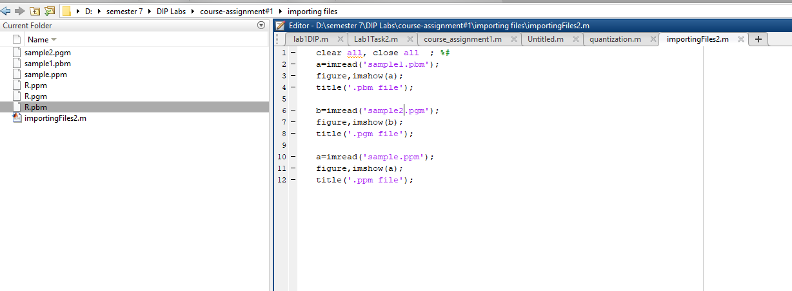

**Question No. 4:**

**a-Define Connectivity and Adjacency of pixels of an image?**

b. When can we say that a given set of black pixels are 4-connected or direct-neighbor? Explain with examples.

c. When can we say that a given set of black pixels is 8-connected? Explain with examples.

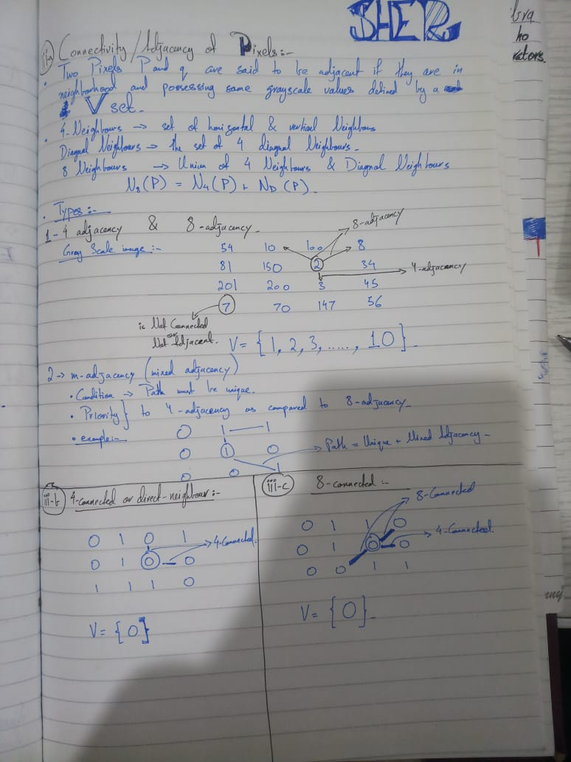

**Question No#5: Give a comparison of rods and cones cells of human vision system. Also elaborate brightness adaptation and discrimination in image processing along with defining Weber Ratio.**

* The main difference between rods and cones is that rods are very sensitive to the light and can be used for vision under low light conditions (scotopic vision) whereas cones are not very sensitive to light and can be used in high light conditions (photopic vision). Rods confer monochromatic vision whereas cones confer color vision.
* Brightness Adaptation and Discrimination The eyes ability to discriminate between different intensity levels is an important consideration in presenting image processing results. The range of light intensity levels to which the human visual system can adapt is enormous on the order of 1010 from the scotopic threshold to the glare limit.
* Weber's Law states that the ratio of the increment threshold to the background intensity is a constant. And when you measure increment thresholds on various intensity backgrounds, the thresholds increase in proportion to the background. The fraction I/I is known as the Weber fraction (aka Fechner fraction).

**Question No. 2:**

**A common measure of transmission for digital data is the bit rate, defined as the number of bits transmitted per second. Generally, transmission is accomplished in packets consisting of a start bit, a byte of information, and a stop bit. Using these facts, answer the following:**

**(a) How many minutes would it take to transmit an image with 1024 intensity levels using a modem of 128K bit rate?**

**(b) What would the time be at 3000K baud connection?**

