**Digital Signal Processing Lab**

**EEL-325**

Lab Journal: 05



* + - 1. Name: M.OMAR
      2. Class: BCE-6
      3. Enrollment No: 01-132182-024

**Experiment No. 4**

**Z-Transform and Inverse Z-Transform Analysis in MATLAB**

**Objectives:**

Objective of this lab is to understand following.

1. We will be able to find Z-transform and its properties of any given transfer function.
2. Inverse of Z-Transform.

## Introduction:

## Definition

The Z-transform can be defined as either a *one-sided* or *two-sided* transform.[[8]](https://en.wikipedia.org/wiki/Z-transform#cite_note-8)

### Bilateral Z-transform

The *bilateral* or *two-sided* Z-transform of a discrete-time signal {\displaystyle x[n]} is the [formal power series](https://en.wikipedia.org/wiki/Formal_power_series) {\displaystyle X(z)} defined as

|  |  |  |  |  |  |  |
| --- | --- | --- | --- | --- | --- | --- |
| {\displaystyle X(z)={\mathcal {Z}}\{x[n]\}=\sum _{n=-\infty }^{\infty }x[n]z^{-n}} | |  |  |  | | --- | --- | --- | |  |  |  | |  | | **(Eq.1)** |

where {\displaystyle n} is an integer and {\displaystyle z} is, in general, a [complex number](https://en.wikipedia.org/wiki/Complex_number):

{\displaystyle z=Ae^{j\phi }=A\cdot (\cos {\phi }+j\sin {\phi })}

where {\displaystyle A} is the magnitude of {\displaystyle z}, {\displaystyle j} is the [imaginary unit](https://en.wikipedia.org/wiki/Imaginary_unit), and {\displaystyle \phi } is the [*complex argument*](https://en.wikipedia.org/wiki/Complex_argument) (also referred to as *angle* or *phase*) in [radians](https://en.wikipedia.org/wiki/Radian).

### Unilateral Z-transform

Alternatively, in cases where {\displaystyle x[n]} is defined only for {\displaystyle n\geq 0}, the *single-sided* or *unilateral* Z-transform is defined as

|  |  |  |  |  |  |  |
| --- | --- | --- | --- | --- | --- | --- |
| {\displaystyle X(z)={\mathcal {Z}}\{x[n]\}=\sum _{n=0}^{\infty }x[n]z^{-n}.} | |  |  |  | | --- | --- | --- | |  |  |  | |  | | **(Eq.2)** |

In [signal processing](https://en.wikipedia.org/wiki/Signal_processing), this definition can be used to evaluate the Z-transform of the [unit impulse response](https://en.wikipedia.org/wiki/Finite_impulse_response#Impulse_response) of a discrete-time [causal system](https://en.wikipedia.org/wiki/Causal_system).

An important example of the unilateral Z-transform is the [probability-generating function](https://en.wikipedia.org/wiki/Probability-generating_function), where the component {\displaystyle x[n]} is the probability that a discrete random variable takes the value {\displaystyle n}, and the function {\displaystyle X(z)} is usually written as {\displaystyle X(s)} in terms of {\displaystyle s=z^{-1}}. The properties of Z-transforms (below) have useful interpretations in the context of probability theory.

## Inverse Z-transform

The *inverse* Z-transform is

|  |  |  |  |  |  |  |
| --- | --- | --- | --- | --- | --- | --- |
| {\displaystyle x[n]={\mathcal {Z}}^{-1}\{X(z)\}={\frac {1}{2\pi j}}\oint _{C}X(z)z^{n-1}dz} | |  |  |  | | --- | --- | --- | |  |  |  | |  | | **(Eq.3)** |

where *C* is a counterclockwise closed path encircling the origin and entirely in the [region of convergence](https://en.wikipedia.org/wiki/Radius_of_convergence) (ROC). In the case where the ROC is causal (see [Example 2](https://en.wikipedia.org/wiki/Z-transform#Example_2_(causal_ROC))), this means the path *C* must encircle all of the poles of {\displaystyle X(z)}.

A special case of this [contour integral](https://en.wikipedia.org/wiki/Contour_integral) occurs when *C* is the unit circle. This contour can be used when the ROC includes the unit circle, which is always guaranteed when {\displaystyle X(z)} is stable, that is, when all the poles are inside the unit circle. With this contour, the inverse Z-transform simplifies to the [inverse discrete-time Fourier transform](https://en.wikipedia.org/wiki/Discrete-time_Fourier_transform#Inverse_transform), or [Fourier series](https://en.wikipedia.org/wiki/Fourier_series), of the periodic values of the Z-transform around the unit circle:

{\displaystyle x[n]={\frac {1}{2\pi }}\int _{-\pi }^{+\pi }X(e^{j\omega })e^{j\omega n}d\omega .}

The Z-transform with a finite range of *n* and a finite number of uniformly spaced *z* values can be computed efficiently via [Bluestein's FFT algorithm](https://en.wikipedia.org/wiki/Bluestein%27s_FFT_algorithm). The [discrete-time Fourier transform](https://en.wikipedia.org/wiki/Discrete-time_Fourier_transform) (DTFT)—not to be confused with the [discrete Fourier transform](https://en.wikipedia.org/wiki/Discrete_Fourier_transform) (DFT)—is a special case of such a Z-transform obtained by restricting *z* to lie on the unit circle.

## Region of convergence

The [region of convergence](https://en.wikipedia.org/wiki/Radius_of_convergence) (ROC) is the set of points in the complex plane for which the Z-transform summation converges.

{\displaystyle \mathrm {ROC} =\left\{z:\left|\sum _{n=-\infty }^{\infty }x[n]z^{-n}\right|<\infty \right\}}

### Example 1 (no ROC)

Let *x[n]* = (0.5)*n*. Expanding *x[n]* on the interval (−∞, ∞) it becomes

{\displaystyle x[n]=\left\{\cdots ,0.5^{-3},0.5^{-2},0.5^{-1},1,0.5,0.5^{2},0.5^{3},\cdots \right\}=\left\{\cdots ,2^{3},2^{2},2,1,0.5,0.5^{2},0.5^{3},\cdots \right\}.}

Looking at the sum

{\displaystyle \sum _{n=-\infty }^{\infty }x[n]z^{-n}\to \infty .}

Therefore, there are no values of *z* that satisfy this condition.

### Example 2 (causal ROC)

[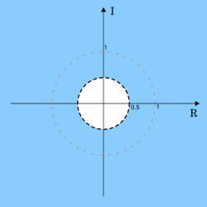](https://en.wikipedia.org/wiki/File:Region_of_convergence_0.5_causal.svg)

ROC shown in blue, the unit circle as a dotted grey circle and the circle |*z*| = 0.5 is shown as a dashed black circle

Let {\displaystyle x[n]=0.5^{n}u[n]\ } (where *u* is the [Heaviside step function](https://en.wikipedia.org/wiki/Heaviside_step_function)). Expanding *x[n]* on the interval (−∞, ∞) it becomes

{\displaystyle x[n]=\left\{\cdots ,0,0,0,1,0.5,0.5^{2},0.5^{3},\cdots \right\}.}

Looking at the sum

{\displaystyle \sum _{n=-\infty }^{\infty }x[n]z^{-n}=\sum _{n=0}^{\infty }0.5^{n}z^{-n}=\sum _{n=0}^{\infty }\left({\frac {0.5}{z}}\right)^{n}={\frac {1}{1-0.5z^{-1}}}.}

The last equality arises from the infinite [geometric series](https://en.wikipedia.org/wiki/Geometric_series) and the equality only holds if |0.5*z*−1| < 1 which can be rewritten in terms of *z* as |*z*| > 0.5. Thus, the ROC is |*z*| > 0.5. In this case the ROC is the complex plane with a disc of radius 0.5 at the origin "punched out".

## Procedure:

## Open MATLAB Software.

## We create the new project.

## Make a new script and name it on the name of your lab.

## Write the code in main file and burn the code using run command.

## In the function file write the functionality of the code and code in main file.

## The function file and the script main file must be in the same folder.

## Run the mail file and get the output of the given input and observe the result.

## 

## Problem No. 01:

**Task1:** Find Pole and Zeros of given transfer function.

Codes and Results:

n=[ 1 3 0]

d=[1 -3 2]

[z,p,k]=tf2zp(n,d);

disp('1) ZERORES ARE AT'); disp(z);

disp('2) POLES ARE AT'); disp(p);

figure(1);

zplane(n,d);

title('z-plane analysis');

figure(2);

freqz(n,d);

title('freq analysis');

figure(3);

impz(n,d);

title('impulse response analysis');

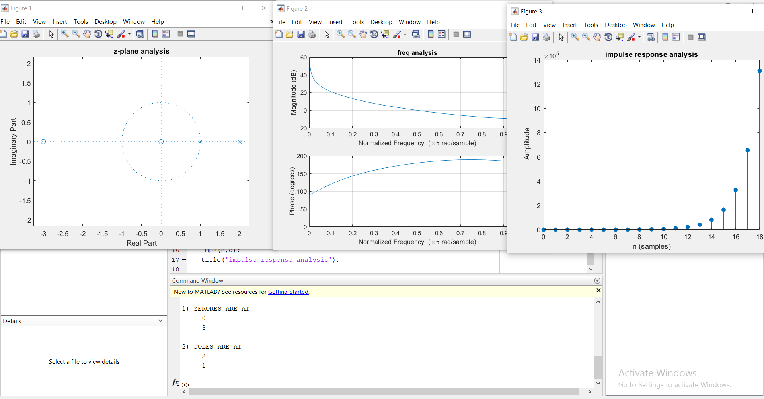

**Task2 :** Find Pole and Zeros of given transfer function.

Codes and Results:

n=[ 1 -0.565 0]

d=[1 -1.131 0.64]

[z,p,k]=tf2zp(n,d);

disp('1) ZERORES ARE AT'); disp(z);

disp('2) POLES ARE AT'); disp(p);

figure(1);

zplane(n,d);

title('z-plane analysis');

figure(2);

freqz(n,d);

title('freq analysis');

figure(3);

impz(n,d);

title('impulse response analysis');

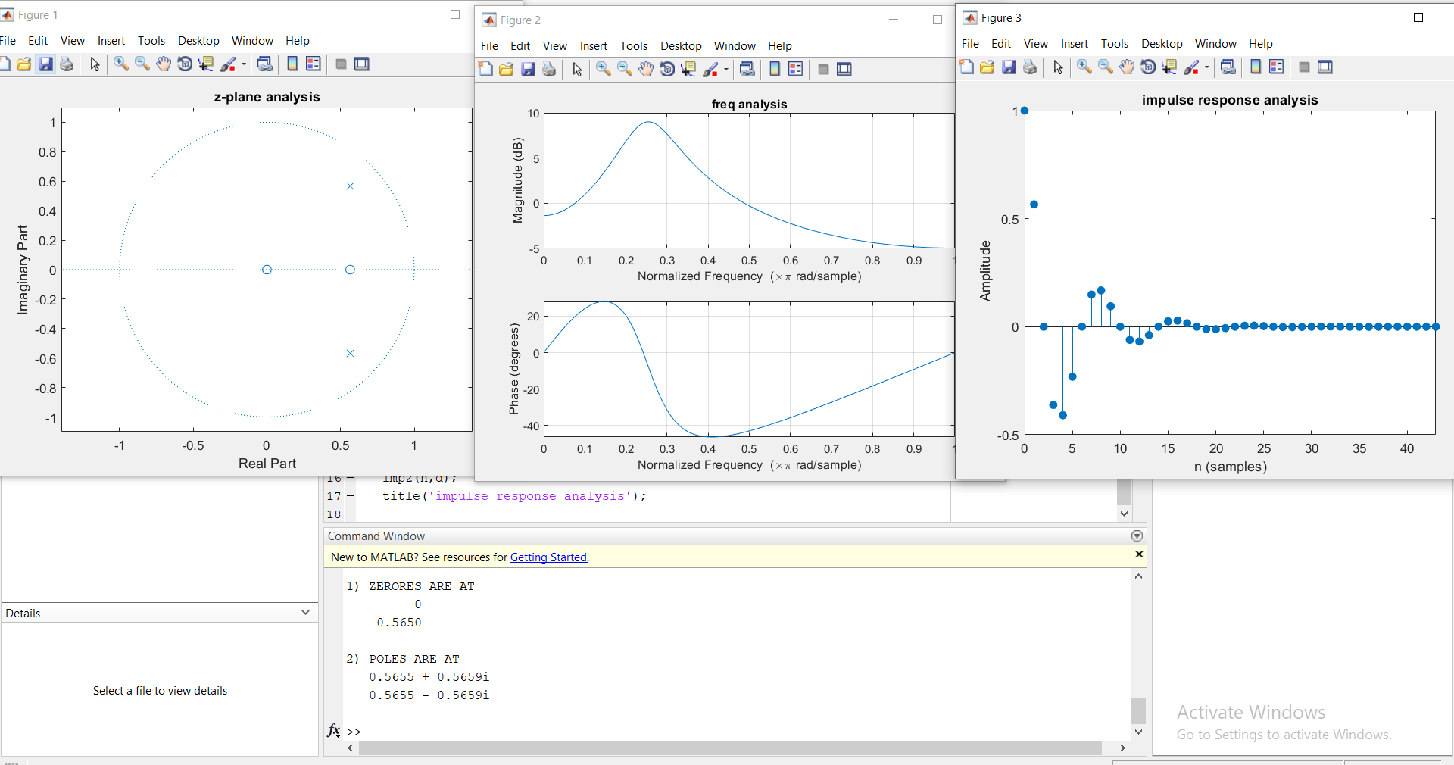

## 

## Problem No. 02:

**Task1:** Find out stability and frequency response of given function.

Codes and Results:

Since some poles are outside unit circle in z-plane analysis and also in impulse response the function is increasing which shows that system is ***UNSTABLE***

**Task2:**  Find out stability and frequency response of given function.

Codes and Results:

Since all poles are inside unit circle in z-plane analysis and also in impulse response the function is decreasing which shows that system is ***STABLE***

Conclusion: Today we learned about how on different analysis we can predict whether a system is stable or not.