**Digital Image Processing Lab**

**CEL-445**

**Lab Journal: 3**



Name: OMAR

Class: BCE-07

Enrollment No: 01-132182-024

**INTRODUCTION:**

* **Digital Image Processing:**

Digital image processing deals with manipulation of digital images through a digital computer. It is a subfield of signals and systems but focus particularly on images. DIP focuses on developing a computer system that is able to perform processing on an image. The input of that system is a digital image and the system process that image using efficient algorithms and gives an image as an output. The most common example is Adobe Photoshop. It is one of the widely used application for processing digital images.

* **Image cropping:**

Cropping is**the removal of unwanted outer areas from a photographic or illustrated image.** The process usually consists of the removal of some of the peripheral areas of an image to remove extraneous trash from the picture, to improve its framing, to change the aspect ratio, or to accentuate or isolate the subject matter from its background.



* **Tasks:**

1. Take a picture of yourself
2. Draw a circle and rectangle on your face using opencv python
3. Write your name above the circle using opencv python
4. Resize image, rotation, cropping

Code:

print("hi")  
#!/usr/bin/env python  
# coding: utf-8  
  
# In[1]:  
  
  
import cv2  
import numpy  
import matplotlib  
  
  
# In[43]:  
  
  
img=cv2.imread("pic.jpg")  
  
  
# In[21]:  
  
  
cv2.imshow("Orignal",img)  
cv2.waitKey(0)  
  
  
# In[23]:  
  
  
cr_img=img[80:280,150:330]  
  
  
# In[24]:  
  
  
cv2.imshow("cropped_img",cr_img)  
cv2.waitKey(0)  
  
  
# In[13]:  
  
  
jav=cv2.resize(img,[50,100])  
  
  
# In[14]:  
  
  
cv2.imshow("ResizeImg",jav)  
cv2.waitKey(0)  
  
  
# In[19]:  
  
  
rotate=cv2.rotate(img,cv2.ROTATE_90_CLOCKWISE)  
  
  
# In[20]:  
  
  
cv2.imshow('rotimg',rotate)  
cv2.waitKey(0)  
  
  
# In[ ]:  
  
  
  
  
  
# In[28]:  
  
  
rec=cv2.rectangle(img,(15,25),(200,150),(0,255,255),1)  
  
  
# In[29]:  
  
  
cv2.imshow('rectangle',rec)  
cv2.waitKey(0)  
  
  
# In[32]:  
  
  
import numpy as np  
  
  
# In[35]:  
  
  
font=cv2.FONT_HERSHEY_SIMPLEX  
  
  
# In[ ]:  
  
  
  
  
  
# In[44]:  
  
  
cv2.putText(img,'SHER',(100,100),font,1,(255,255,255),2)  
  
  
# In[45]:  
  
  
cv2.imshow('JAV',img)  
cv2.waitKey(0)  
  
  
# In[ ]:  
rec1=cv2.circle(img, center = (650,350), radius =200, color =(255,0,0), thickness=8)  
  
  
# In[29]:  
  
  
cv2.imshow('circle',rec1)  
cv2.waitKey(0)  
  
font=cv2.FONT_HERSHEY_SIMPLEX  
  
  
# In[ ]:  
  
  
  
  
  
# In[44]:  
  
  
cv2.putText(img,'SHER',(600,150),font,1,(255,255,255),2)  
  
  
# In[45]:  
  
  
cv2.imshow('JAV',img)  
cv2.waitKey(0)

**OUTPUTS:**

**Image(original):**

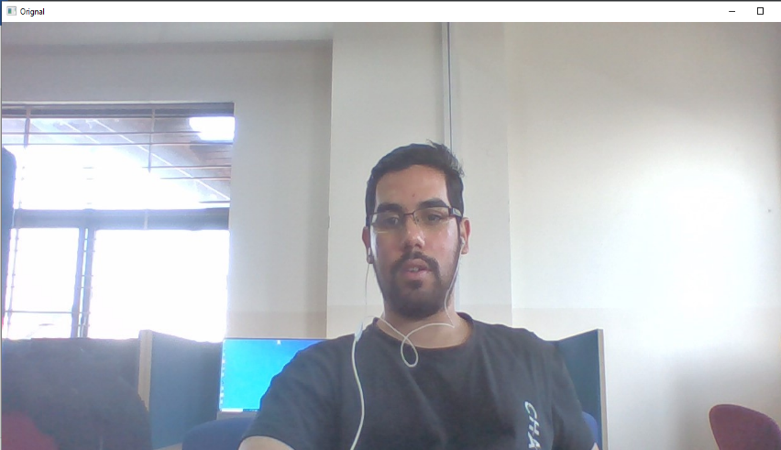

**Cropped:**

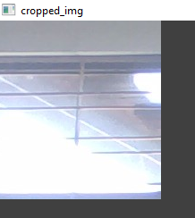

**Resize:**

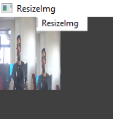

**rotate:**

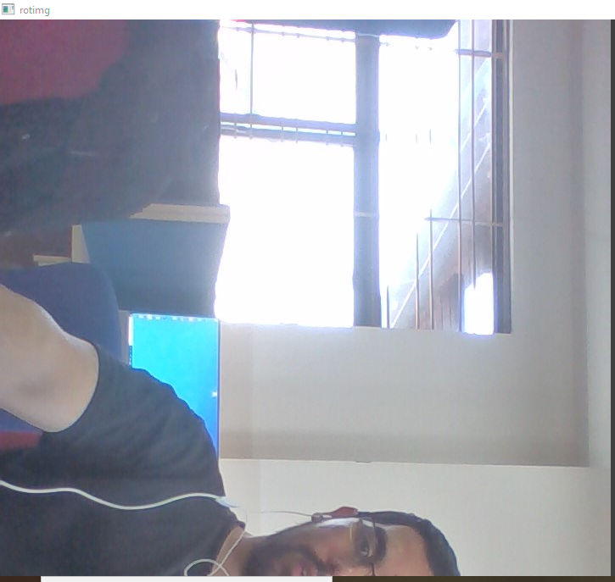

**Circle-Rectangle-Text:**

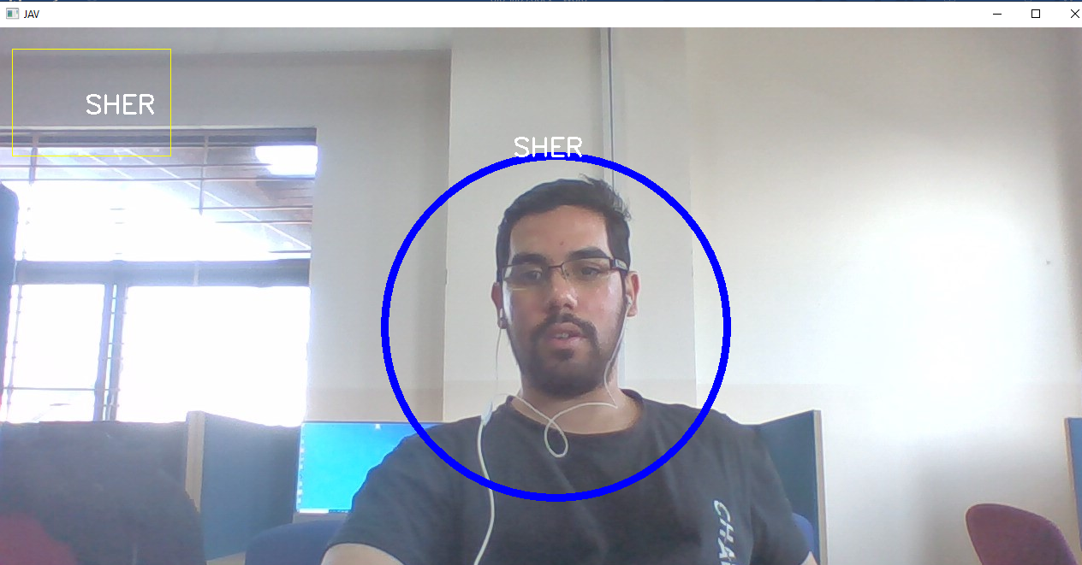

* **Conclusion:**

In this lab we learned about Digital Image Processing and some of the functions that we can perform on an image file such importing, cropping, resizing, and drawing onan image file. This was a very interesting lab and we learned a lot in this lab.