**Digital Signal Processing Lab**

Lab EEL-325

Lab Journal: 10



Name: Omar

Class: BCE-6

Enrollment No: 01-132182-024

**Lab # 10**

**Sine Wave Generation on DSP Kit TMS TMS320C6713 DSK**

**Software used:**

* Code composer Studio

**Objective**  Objective of this lab is to familiarize students with input and output ports of DSP kit.

**Introduction**

Sine Wave Generation using Eight Points with DIP Switch Control.

**Task Procedure:**

Follow the instructions below to ensure that CCS and the C6713 DSK are set up properly.

* Open CCS and set your workspace directory location on your hard disk.
* Follow settings that you have to done in-order to compile a program.
* Go to project option: properties 🡪C/C++ Build 🡪C600compiler 🡪predefined
* Symbols now here you have to add CHIP_6713

Go to project option: properties 🡪C/C++ Build 🡪C600compiler 🡪Include option.

Spectrum digital DSK – EVM-eZdsp onboard USB Emulator. Device:

DSK6713 and then save the configuration.

**Task 1:**

Sine Wave Generation on DSP Kit TMS TMS320C6713 DSK

**Code**

/* program to generation of sin wave*/

#include<stdio.h>

#include<math.h>

#define pi  3.1415625

float a[200];

main()

{

int  i=0;

for(i=0;i<200;i++)

a[i]=sin(2*pi*5*i/200);                 /*similar to a=sin(2πft)*/

}

**Output**

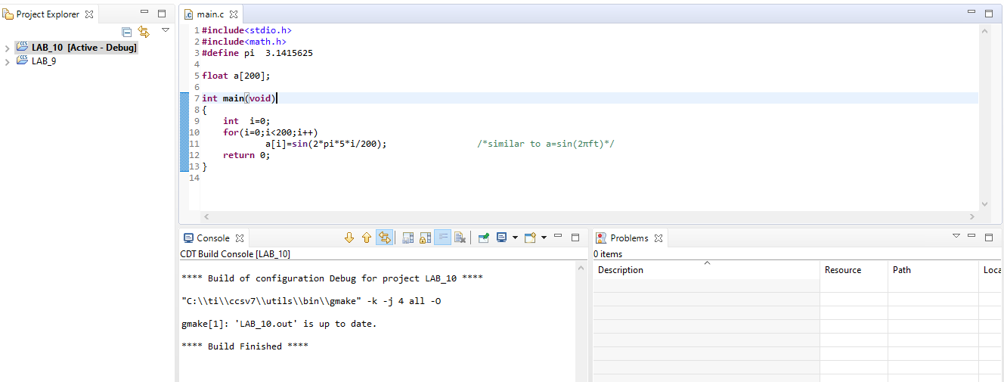

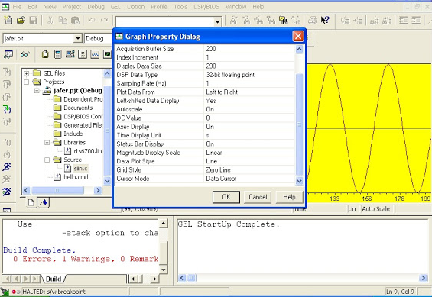

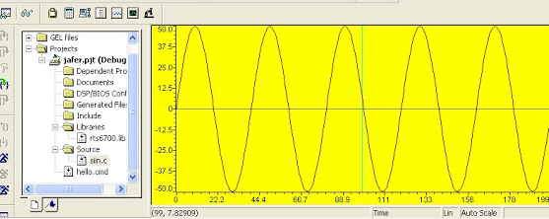

**Conclusion: -**

Sine Wave Generation on DSP Kit TMS TMS320C6713 DSK