*Digital System Design Lab*

# CEL-442



*Class: BCE-6(A).*

### Enrollment no: 01-132182-024

**LAB NO. 13  
LIFO (Last In First Out)**

**Introduction:**

LIFO (Last-In-First-Out) Inventory Cost Method. LIFO, which stands for last-in-first-out, is an inventory valuation method which assumes that the last items placed in inventory are the first sold during an accounting year

**Objective:** To Access recent item fast without any sequential delay.

|  |  |
| --- | --- |
| **Task** | **Last in First out** |

**Code :**

`timescale 1ns / 1ps

//////////////////////////////////////////////////////////////////////////////////

// Company:

// Engineer:

module DSD_Lab12(Read,Write,delete,,A,out);

input A , Read,Write,delete;

output reg out;

integer count=0;

reg [3:0]mem;

always@(*)

begin

if(count>3)

begin

out = 1'bx;

end

if(Write == 1'b1)

begin

if(count<4)

begin

mem[count] =A;

count = count+1;

end

end

if(Read == 1'b1)

begin

out = mem[count-1];

end

if(delete == 1'b1)

begin

count = count-1;

end

if(Write == 1'b0 & Read == 0)

begin

out = 1'bx;

end

end

endmodule

**Test Fixture**

`timescale 1ns / 1ps

////////////////////////////////////////////////////////////////////////////////

// Company:

// Engineer:

//

// Create Date:   16:08:24 05/18/2019

// Design Name:   DSD_Lab12

// Module Name:   D:/Study/DSD Labs/DSD_Lab12Secnd/gjjnhb.v

// Project Name:  DSD_Lab12Secnd

// Target Device:

// Tool versions:

// Description:

//

// Verilog Test Fixture created by ISE for module: DSD_Lab12

//

// Dependencies:

//

// Revision:

// Revision 0.01 - File Created

// Additional Comments:

//

////////////////////////////////////////////////////////////////////////////////

module gjjnhb;

// Inputs

reg Read;

reg Write;

reg delete;

reg A;

// Outputs

wire out;

// Instantiate the Unit Under Test (UUT)

DSD_Lab12 uut (

.Read(Read),

.Write(Write),

.delete(delete),

.A(A),

.out(out)

);

initial begin

// Initialize Inputs

Read = 1;

Write = 1;

delete = 0;

A = 0;

// Wait 100 ns for global reset to finish

#100;

Read = 1;

Write = 0;

delete = 0;

A = 1;

// Wait 100 ns for global reset to finish

#100;

Read = 0;

Write = 1;

delete = 1;

A = 0;

// Wait 100 ns for global reset to finish

#100;

Read = 0;

Write = 0;

delete = 0;

A = 1;

// Wait 100 ns for global reset to finish

#100;

// Add stimulus here

end

endmodule

**Output**

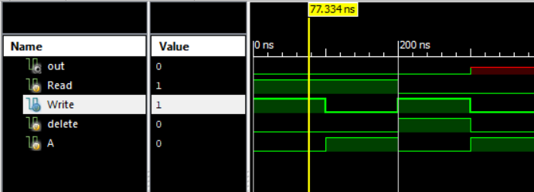

**Conclusion:**In this Lab  We learn LIFO which is a fast way to access data which entered first. And after performing all these tasks successfully I can say that I have learned these topics pretty much Alhamdulillah.