Feature Extraction:
- These features that I can make extract for it in economic language.
- But I will see how it can help me to make a good prediction.
- At first, I need to make feature selection.
- Second I will make my decisions.
df['Log_GDP'] = np.log(df['GDP'])
df['Log_Population'] = np.log(df['Population'])
df['GDP_per_Capita_Squared'] = df['GDP per Capita'] ** 2
df['Inflation_Sqrt'] = np.sqrt(df['Inflation Rate'])
df['Debt_to_GDP'] = df['Government Debt'] / df['GDP']
df['Debt_to_GDP_growth'] = df['Debt_to_GDP'].pct_change()
df['FDI_to_GDP'] = df['Foreign Direct Investment'] / df['GDP']
df['Trade_Balance'] = df['Exports'] - df['Imports']
df['Trade_to_GDP'] = (df['Exports'] + df['Imports']) / df['GDP']
df['Spending_to_GDP'] = df['Government Spending'] / df['GDP']
// الأستثمارات الي الإقتصاد
df['Investment_to_GDP'] = df['Investment'] / df['GDP']
// العمله هل الدوله بتصرف أكتر من دخلها الخارجي ولا لا
df['CurrentAccount_to_GDP'] = df['Current Account Balance'] / df['GDP']
df['Exports_per_Capita'] = df['Exports'] / df['Population']
df['Imports_per_Capita'] = df['Imports'] / df['Population']
df['Spending_per_Capita'] = df['Government Spending'] / df['Population']
df['Inflation_Unemployment'] = df['Inflation Rate'] * df['Unemployment Rate']
df['GDP_Investment'] = df['GDP'] * df['Investment']
df['Interest_Inflation'] = df['Interest Rate'] * df['Inflation Rate']
df['Debt_Interest'] = df['Government Debt'] * df['Interest Rate']df['GDP_diff'] = df['GDP'].diff()
df['Inflation_diff'] = df['Inflation Rate'].diff()
df['Unemployment_diff'] = df['Unemployment Rate'].diff()
df['GDP_growth_calc'] = df['GDP'].pct_change()
df['Population_growth'] = df['Population'].pct_change()
df['Investment_growth'] = df['Investment'].pct_change()
df['GDP_MA3'] = df['GDP'].rolling(3).mean()
df['Inflation_MA3'] = df['Inflation Rate'].rolling(3).mean()
df['GDP_STD3'] = df['GDP'].rolling(3).std()
df['Inflation_volatility'] = df['Inflation Rate'].rolling(5).std()
df['Exchange_volatility'] = df['Exchange Rate'].rolling(5).std()
df['Total_Crisis'] = (
df['Financial_Crisis'] +
df['COVID_Crisis'] +
df['Energy_Crisis']
)
df['Crisis_Impact'] = df['Total_Crisis'] * df['GDP Growth']
df['Years_since_2000'] = df['Year'] - 2000
df['GDP_rank'] = df.groupby('Year')['GDP'].rank()
df['Inflation_rank'] = df.groupby('Year')['Inflation Rate'].rank()
df['Inflation_Level'] = pd.cut(df['Inflation Rate'],
bins = [-np.inf, 2, 5, 10, np.inf],
labels = ['Low', 'Normal', 'High', 'Extreme'])

// from sklearn.decomposition import PCA

pca = PCA(n_components = 5)
X_pca = pca.fit_transform(df.select_dtypes(include = 'number'))

- D1- Here are some features that make a NAN and infinite data. I made decision to drop it and I will see it in the future. Drop I think 600 Raws – Data loss. Then I got bad accuracy of these features.
- D2- I will delete these features to get the rows that I deleted before make it go on the model.

Feature selection:
- Variance. to check every single feature.
- Correlation Correlation. to check relation between features.
- XGboost. to see the affect in decision.
These are the ways I used.
- Variance
Selected features [['Exports', 'Foreign Direct Investment', 'GDP Growth', 'GDP per Capita', 'Government Spending', 'Imports', 'Investment', 'Life Expectancy',
'Population', 'exchange_rate', 'Total_Crisis', 'Trade_Balance',
'Inflation_diff', 'GDP_growth_calc', 'Investment_growth', 'GDP_lag1',
'GDP_lag3', 'GDP_lag5', 'Trade_to_GDP', 'GDP_MA3', 'Inflation_MA3',
'GDP_STD3', 'Inflation_volatility', 'Exchange_volatility']]

- Correlation

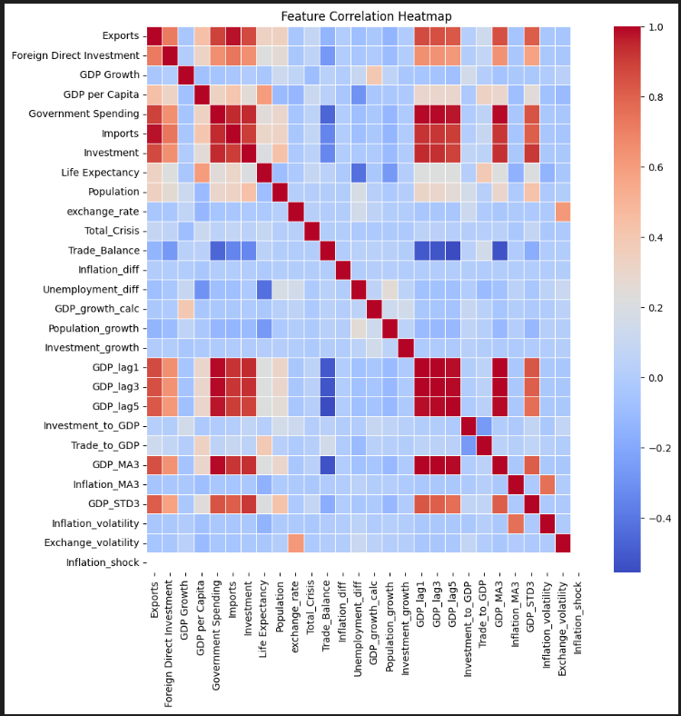

3-Model XGboost.
feature importance
4 Government Spending 0.303924
17 GDP_lag1 0.230882
22 GDP_MA3 0.201292
21 Trade_to_GDP 0.110832
6 Investment 0.072512
5 Imports 0.042162
13 Unemployment_diff 0.008594
8 Population 0.007947
3 GDP per Capita 0.006272
19 GDP_lag5 0.004488
0 Exports 0.004247
9 exchange_rate 0.002940
7 Life Expectancy 0.001339
18 GDP_lag3 0.001014
11 Trade_Balance 0.000603
14 GDP_growth_calc 0.000190
20 Investment_to_GDP 0.000165
15 Population_growth 0.000155
16 Investment_growth 0.000123
2 GDP Growth 0.000073
26 Exchange_volatility 0.000070
24 GDP_STD3 0.000046
25 Inflation_volatility 0.000037
23 Inflation_MA3 0.000034
1 Foreign Direct Investment 0.000032
12 Inflation_diff 0.000028
10 Total_Crisis 0.000000
27 Inflation_shock 0.0000

D2. feature importance
4 Government Spending 0.587214
6 Investment 0.252119
5 Imports 0.137999
3 GDP per Capita 0.007025
8 Population 0.006061
9 exchange_rate 0.005011
7 Life Expectancy 0.001665
1 Foreign Direct Investment 0.001024
0 Exports 0.000857
2 GDP Growth 0.000798
10 Total_Crisis 0.000227

