SWE 463 — Mobile Application Development
Project Phase 2 — User Interface and Technical Design
Mawjod (موجود)
A Lost-and-Found Mobile App for KFUPM Students

Group Number | Group [XX]
Course | SWE 463 — Mobile Application Development
GitHub Repository | https://github.com/OMARALYAMANI/Mawjod
Design Reference | Screens implemented directly in Flutter (Material 3, Arabic RTL). Screenshots in Section 3 and repository.

Member Full Name | Student ID
Omar Alyamani | 202249820
Abdullah Alshahrani | [ID]
Omar Aljughaiman | [ID]
Rakan Alseed | [ID]

1. Phase 1 Updates and Final Scope
Phase 1 (the proposal) was approved. During Phase 2 the team refined the scope and the interaction design based on review and usability testing of the running app. The table lists the main changes; the final approved scope follows.
Feedback / Decision | Change Made | Affected Feature / Screen
Clearer login validation | Added invalid-email (non-KFUPM) and empty-password states | Sign In
University identity | Replaced generic pin with a KFUPM identity logo | Sign In
Simpler, focused feed | Home shows only lost items; replaced Lost/Found filter with a category filter | Home Feed
Faster contact | Direct Call (phone dialer) and WhatsApp buttons instead of showing name/number | Report Details
Clearer resolution | Replaced "تم الحل" with a green "وجدته" action; status becomes "تم العثور عليه" | My Reports
Awareness of new items | Added a Notifications screen (matching alerts are Phase-3 logic) | Notifications

Final Approved Scope (Essential Features)
- University-email authentication: sign up / log in restricted to @kfupm.edu.sa.
- Create a report: report a lost item with a photo, category, item name, location, and notes.
- Lost-items feed: a real-time list of lost items (newest first) filtered by category.
- Report details & contact: item photo + details, with direct Call and WhatsApp buttons to reach the owner.
- My Reports management: view own reports, expand for details, mark "وجدته" (found) → status "تم العثور عليه", or delete.
- Notifications: alerts for new lost items matching the user (matching is Phase-3 backend logic).

2. Screen Designs and Interface States
All screens use one consistent visual system (Material 3) with a full Arabic right-to-left (RTL) layout, readable text, sufficient contrast, clear labels, and comfortable touch targets. Every approved feature maps to at least one screen. The screens below are the actual Flutter implementation running from the repository.
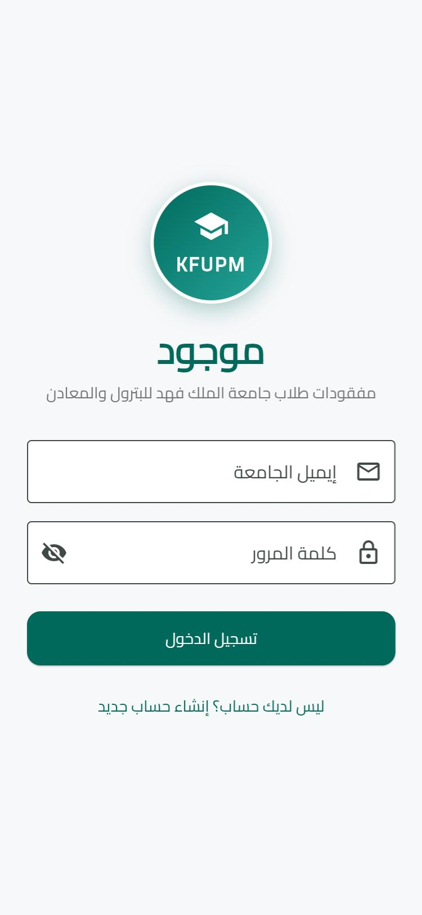  Sign In — KFUPM identity + university email | 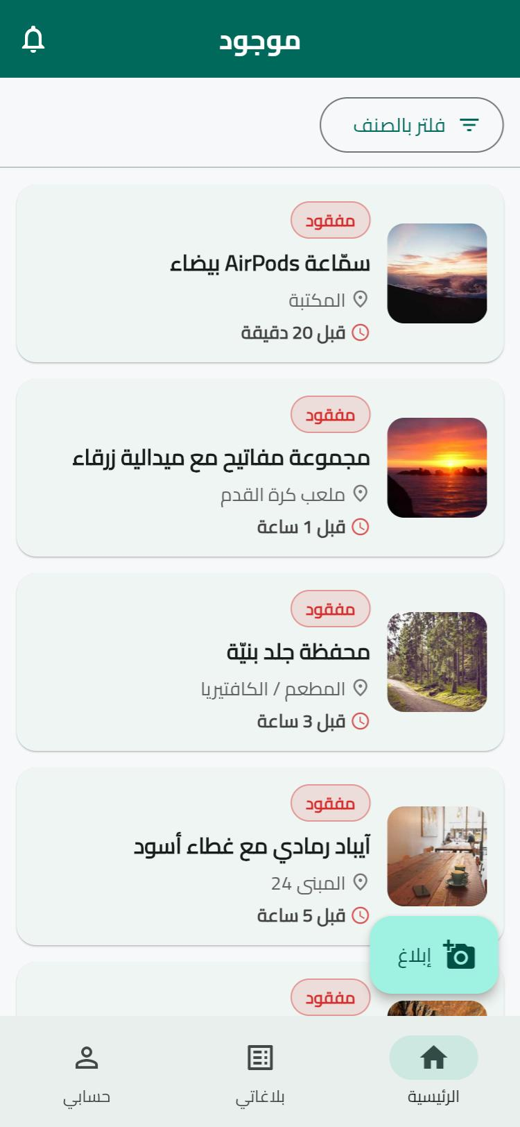  Home — lost items + category filter + alerts | 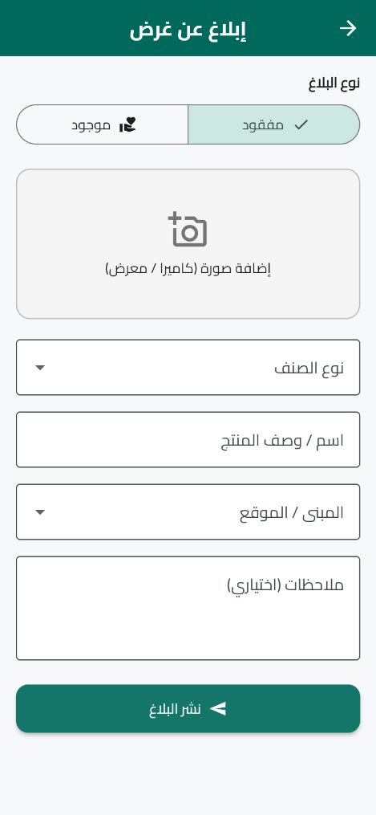  Create Report — lost item form
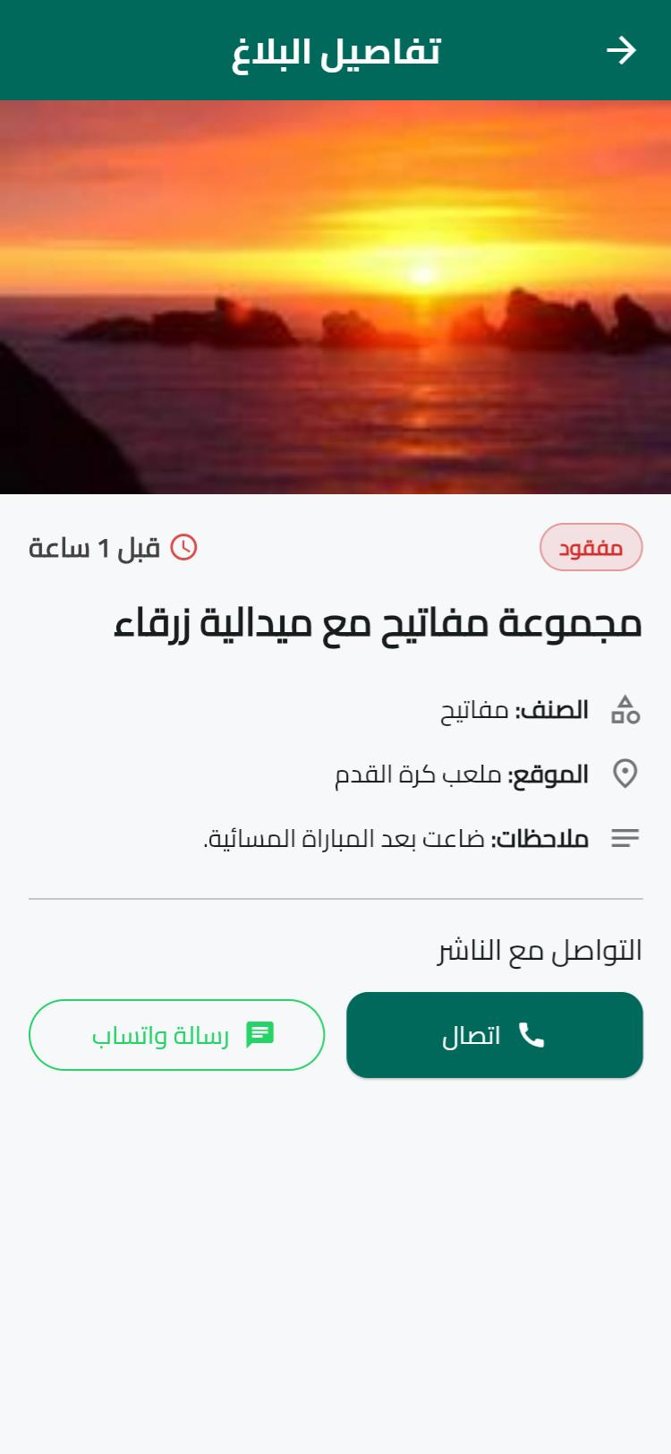  Report Details — photo + Call / WhatsApp | 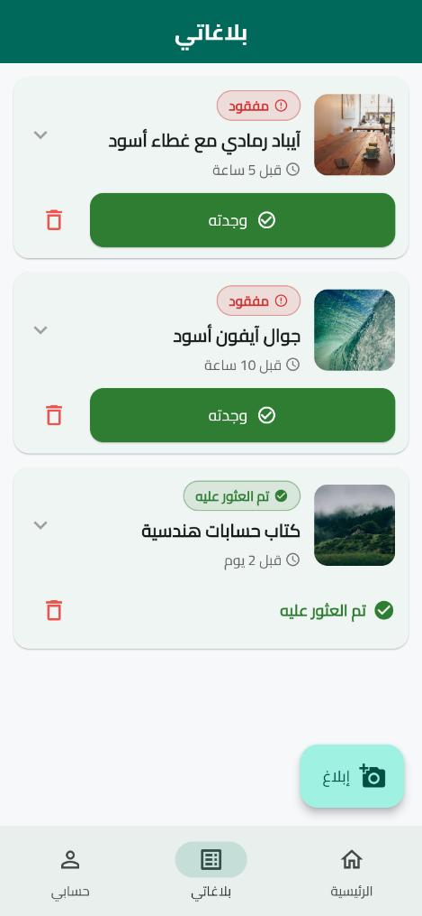  My Reports — "وجدته" / status / delete | 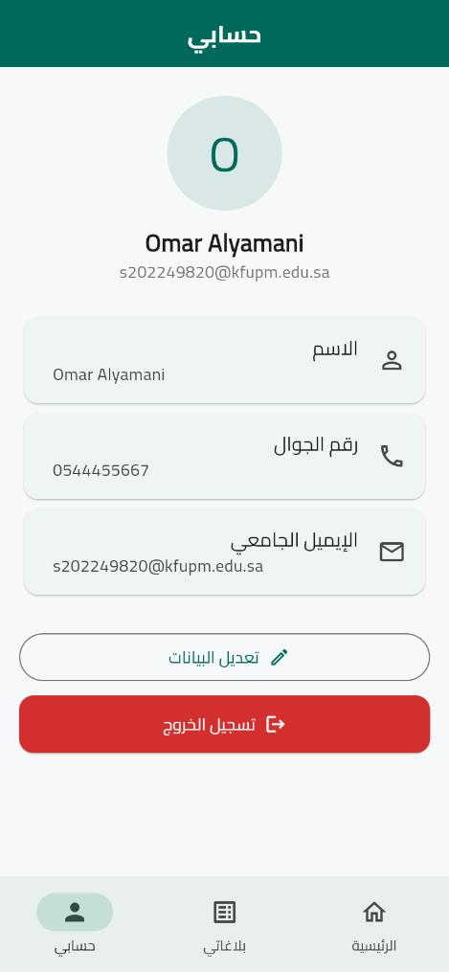  Profile — data + sign out

Additional Screens & States
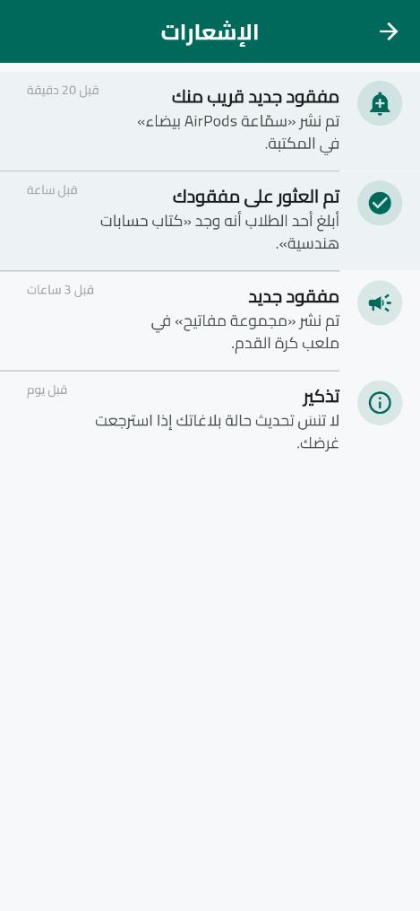  Notifications — new / matched items | 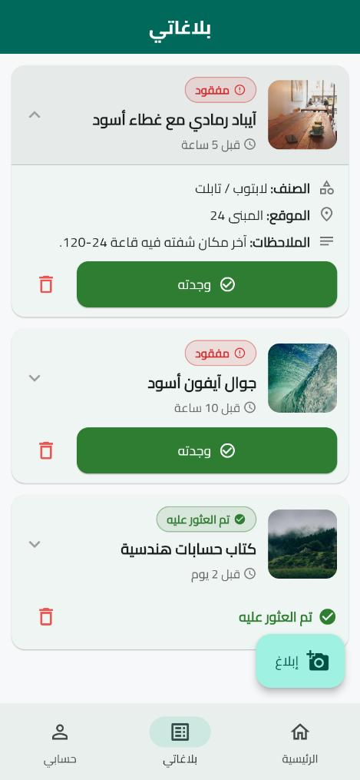  My Reports — card expanded (inline details) | - Loading: CircularProgressIndicator while fetching the feed and on sign-in.  - Empty: friendly message + icon when the feed or My Reports is empty.  - Validation: inline field errors + non-KFUPM email rejection on Sign In.  - Success: success SnackBar after publishing a report.  - Network-error: retry view reserved for Firestore failures (Phase 3).

3. Navigation Flow
The app starts at Sign In. After a successful login the user reaches the Home feed, part of a bottom navigation bar with three tabs (Home, My Reports, Profile). A floating action button opens Create Report, the bell icon opens Notifications, tapping a report card opens Report Details, and signing out from Profile returns to Sign In. Every main screen is reachable and back navigation is supported throughout.
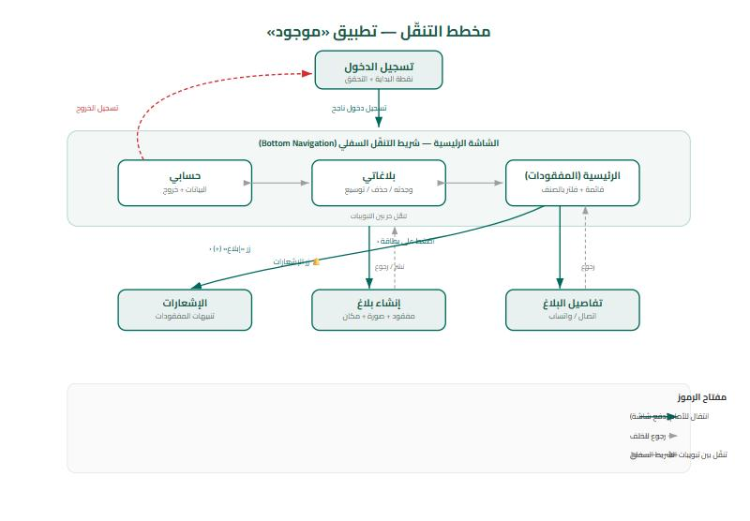
Figure 1 — Navigation flow (green = forward/push, dashed = back, red = sign out).
Textual flow: Sign In → Home. Home / My Reports / Profile via bottom tabs. Home → Report Details (tap card) → Call/WhatsApp. Home → Create Report (FAB). Home → Notifications (bell). Profile → Sign Out → Sign In. My Reports cards expand in place (no navigation).

4. Flutter Widget Plan
Screen | Purpose | Main Flutter widgets | Main interaction
Sign In | Authenticate the student | Form, TextFormField, ElevatedButton, CircularProgressIndicator | Validate & submit
Home | Browse lost items | Scaffold, AppBar(actions), ListView.builder, Card, Image.network, OutlinedButton | Tap card / filter by category
Create Report | Report a lost item | Form, SegmentedButton, DropdownButtonFormField, TextFormField | Fill fields & publish
Report Details | Show item + contact | ListView, Image.network, ElevatedButton/OutlinedButton + url_launcher | Call / WhatsApp owner
My Reports | Manage own reports | ListView.builder, Card (expandable), ElevatedButton, AlertDialog | Expand / "وجدته" / delete
Notifications | Alerts of new items | Scaffold, ListView.separated, ListTile, CircleAvatar | Read alerts
Profile | View data & sign out | CircleAvatar, Card, ListTile, ElevatedButton | Edit data / sign out
Root (shell) | Host the tabs | NavigationBar, IndexedStack, FloatingActionButton | Switch tabs / add report

5. Data Model and State Management

Main Data Entities
Entity | Key fields (Dart types) | Source
AppUser | uid String, name String, email String, phone String | Firebase Authentication + users collection
Report | id String, type ReportType(enum), category String, title String, building String, notes String, imageUrl String, status ReportStatus(enum: open / resolved→"تم العثور عليه"), ownerId/Name/Phone String, createdAt DateTime | Cloud Firestore (reports); image in Firebase Storage

Data Source & Persistence
In Phase 2 the UI runs on local sample data (lib/data/mock_data.dart) so the project builds and runs without a backend. In Phase 3 the source becomes Cloud Firestore: lost reports are read as a real-time stream (newest first), new reports are written to the reports collection, images are uploaded to Firebase Storage, and the user profile is stored in the users collection. The Notifications feature will match a new report’s category against users’ open lost reports and alert them — this is backend logic implemented in Phase 3. Authentication state and the user profile persist across restarts through Firebase.

State Management Plan
Changing value | Used by screens | Approach
Current user / auth status | All screens (gate), Profile | Provider (shared)
Reports list + category filter | Home, My Reports | Provider (shared)
Report status (open / found) | My Reports, Home | Provider (shared)
Loading / submitting flags | Sign In, Create Report | setState (local)
Card expanded, password visibility | My Reports, Sign In | setState (local)
Justification: the user and the reports list (with filter and status) are shared by several screens, so one primary approach — Provider (ChangeNotifier) — manages them, mapping cleanly to Firestore streams in Phase 3. Simple, screen-local interface details (spinners, expanded card, password visibility) use setState. Only one third-party state package (provider) is used.

6. Flutter Project Structure and Repository
The starter project opens and runs without compilation errors (flutter analyze: No issues found). The screenshots in Section 3 are from this running build. Repository: https://github.com/OMARALYAMANI/Mawjod

Folder Structure
lib/
main.dart # app entry, theme, Provider, starts at Sign In
core/
constants.dart # email domain, categories, buildings
theme.dart # Material 3 theme (Cairo font)
ui_helpers.dart # icons, Type/Status badges, time
models/ app_user.dart report.dart
data/ mock_data.dart # sample data (Phase 3: Firestore)
state/ app_state.dart # ChangeNotifier (Provider)
screens/
login_screen.dart root_nav.dart
home_feed_screen.dart create_report_screen.dart
report_details_screen.dart my_reports_screen.dart
notifications_screen.dart profile_screen.dart
widgets/
report_card.dart state_views.dart kfupm_logo.dart

Planned Packages (pub.dev)
Package | Purpose
provider | State management (shared app/auth state)
firebase_core / firebase_auth | Firebase init & university-email authentication
cloud_firestore | Real-time reports database
firebase_storage | Report image storage
image_picker | Capture / pick a report photo
url_launcher | Open phone dialer (tel:) and WhatsApp (wa.me)
google_fonts | Arabic font (Cairo)
intl / uuid | Date formatting / unique IDs

Proof the Starter Project Runs
Running — Sign In | Running — Home | Running — Details

7. Group Contribution Record
Each member confirms their own row. Contributions are specific and verifiable (repository commits, screens, and diagram).
Member & ID | Assigned Phase 2 task | Actual contribution | Evidence
Omar Alyamani  202249820 | Project setup, state & data model | Flutter project, Provider state, Report/AppUser models, repo setup | Commits, lib/state, lib/models
Abdullah Alshahrani  [ID] | Create Report & Details | Create-report form, report details with Call/WhatsApp (url_launcher) | lib/screens/create_report, report_details
Omar Aljughaiman  [ID] | Home, filter & theme | Lost-items feed, category filter, Material 3 RTL theme & report card | lib/screens/home_feed, theme.dart
Rakan Alseed  [ID] | Auth/Profile, My Reports, Notifications & docs | Sign In (KFUPM logo), Profile, My Reports ("وجدته"), Notifications, this document & diagram | lib/screens/login, my_reports, notifications
Note: student IDs marked [ID] to be filled and confirmed by each member before submission.

8. References, Sources & AI-Use Disclosure
- Technical: Flutter & Dart official documentation (docs.flutter.dev) — widgets, navigation, state management.
- Packages: pub.dev packages in Section 6, each under its open-source license (BSD/MIT/Apache-2.0); url_launcher for dialer/WhatsApp.
- Assets: Material Icons (bundled with Flutter) and the Cairo font via google_fonts (Open Font License). Sample card images are placeholders (picsum.photos).
AI-Use Disclosure: AI tools were used only for learning, debugging, and small suggestions (project scaffolding help and drafting documentation), as permitted by the course policy and disclosed in the repository README. No complete application or unexplained AI-generated code was submitted; every member understands and can explain the submitted work.

