SWE 463 — Mobile Application Development
Project Phase 3 — Working Flutter Prototype
Mawjod (موجود)
A Lost-and-Found Mobile App for KFUPM Students

Group Number | Group 08
Course | SWE 463 — Mobile Application Development
GitHub Repository | https://github.com/OMARALYAMANI/Mawjod
Git Tag | phase-3

Member Full Name | Student ID
Omar Alyamani | 202249820
Abdullah Alshahrani | 202173050
Omar Aljughaiman | 202172810
Rakan Alseed | 202181250

2. Changes from the Approved Phase 2 Design
The Phase 2 design was implemented as approved. The changes below are implementation-level refinements; screen flow, state approach (Provider), and the overall scope are unchanged.
Change | Justification
Added a repository layer (ReportRepository / AuthRepository) with a local persistence implementation (shared_preferences) | Phase 2 ran on in-memory mock data. A real persistence layer was connected so data survives restarts, and it keeps the Firebase swap trivial for Phase 4.
Added a working Sign-Up screen and an AuthGate that restores the saved session | Needed for a complete, testable authentication flow beyond the mock sign-in shown in Phase 2.
Contact changed to direct Call (tel:) and WhatsApp (wa.me) via url_launcher | Faster, real contact action instead of only displaying the number.
Feed shows lost items only; category filter replaces the Lost/Found filter | Matches the refined concept: the feed is a searchable list of items still missing.

3. Feature Progress
Completion: 5 of 6 essential features are fully implemented end-to-end, and 1 is in progress — about 90% (well above the required 50%).
Essential Feature | Status | Evidence
University-email authentication (login + sign-up, session saved) | Implemented | auth_repository + tests
Create a report (photo, category, location, notes) + validation | Implemented | create_report_screen
Lost-items feed with category filter (real-time list) | Implemented | home_feed_screen
Report details + contact (Call / WhatsApp) | Implemented | report_details_screen
My Reports: expand, "وجدته" → resolved, delete | Implemented | my_reports_screen
Notifications of matching lost items | In progress | notifications_screen (UI)

4. Complete End-to-End User Flow
The core vertical slice — user input → validation → data change → visible result — is the "report a lost item" flow:
- Sign in with the test account (or create a new @kfupm.edu.sa account).
- Tap the «إبلاغ» button → the Create Report form opens.
- Fill the form; required fields are validated (category, item name, and location unless "unsure" is on).
- Tap «نشر البلاغ» → the report is saved through ReportRepository into local persistence (shared_preferences).
- The app returns to the feed, reloads from the repository, and the new report appears at the top — and it is still there after restarting the app.
How to test: run the app, sign in with s202249820@kfupm.edu.sa / 123456, create a report, confirm it appears in the feed and in «بلاغاتي», then hot-restart and confirm it persists. This exact flow (add → persist → read back) is also covered by automated tests in test/repository_test.dart (6 passing tests).

5. Screens and Navigation
All major screens from the approved design are implemented and reachable. Navigation path: AuthGate → Sign In / Sign Up; after login → bottom navigation bar with three tabs (Home · My Reports · Profile); the FAB «إبلاغ» opens Create Report; the bell opens Notifications; tapping a feed card opens Report Details; and signing out from Profile returns to Sign In. Back behaviour works on every pushed screen (verified in the live run). Screenshots below are from the running build; the remaining screens (Create Report, My Reports, Notifications, Profile) match the approved Phase 2 design and are reachable as described.
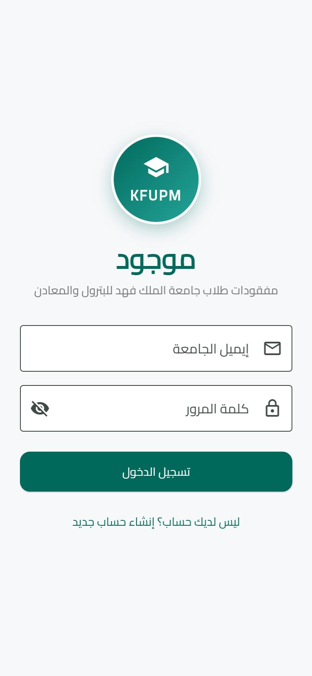  Sign In — KFUPM identity + university-email validation | 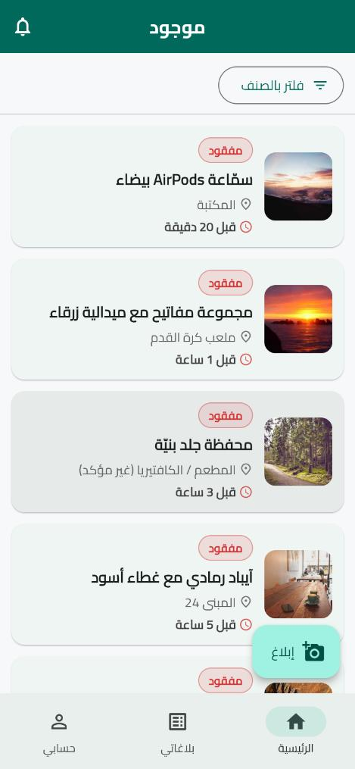  Home — lost items read from the repository + category filter
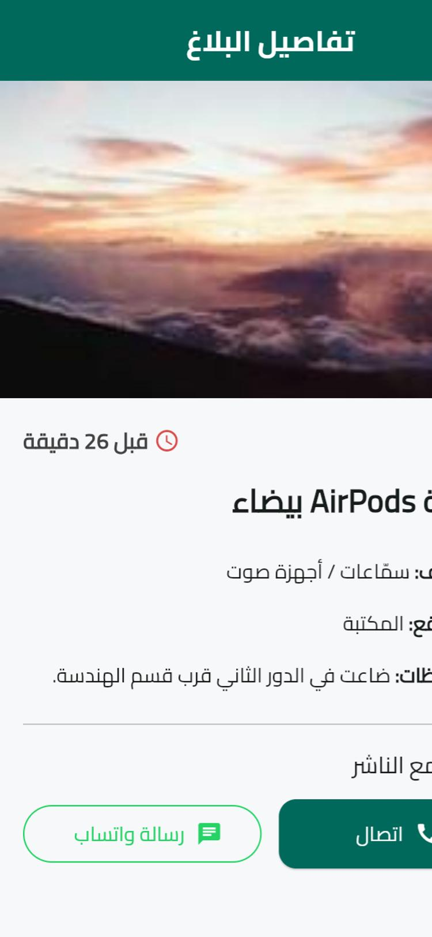  Report Details — photo + direct Call / WhatsApp | 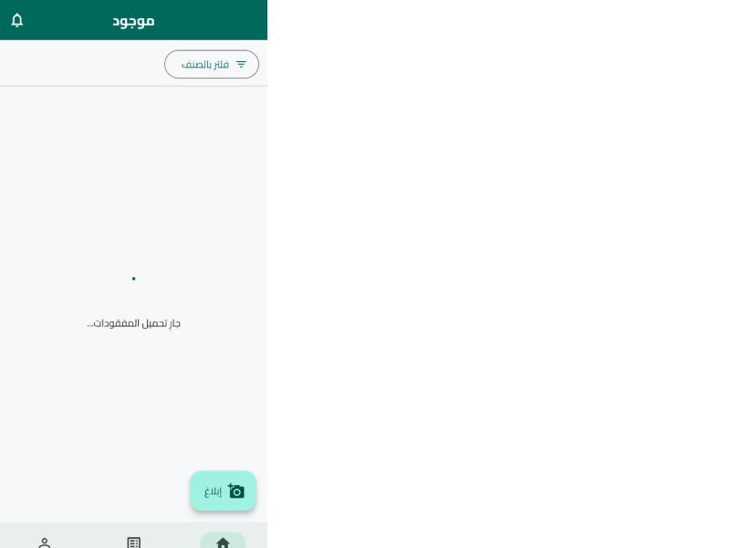  Loading state while the feed reads from the repository

6. State and Data Implementation

State Management (Provider)
Shared state (current user, reports list, category filter) lives in AppState (ChangeNotifier) and is consumed with context.watch; the UI refreshes automatically when state changes (e.g., after creating or resolving a report). Local, screen-only state uses setState (loading flags, password visibility, expanded card).

Data Source (connected)
A repository layer is connected and testable:
- ReportRepository / AuthRepository: abstract interfaces that the whole app depends on.
- LocalReportRepository / LocalAuthRepository: real on-device persistence via shared_preferences (JSON). Reports and the signed-in session survive app restarts; the store is seeded on first run.
abstract class ReportRepository {
Future<List<Report>> fetchReports();
Future<void> add(Report r);
Future<void> update(Report r);
Future<void> delete(String id);
}

What remains temporary
The local repository is the temporary data source for Phase 3. Because the app depends only on the interfaces, Phase 4 adds FirestoreReportRepository / FirebaseAuthRepository and swaps them in main.dart — no screen or state code changes. firebase_* packages are already in pubspec for this.

7. Quality, Runtime States & Known Issues
- Validation: required fields rejected with clear messages; non-KFUPM email blocked; password length and confirm-match checks on sign-up.
- Loading: spinner shown while reading the repository (see screenshot).
- Empty: friendly message when the feed/My Reports has no matching items.
- Error: an error view with a Retry button is shown if a repository read fails (reportsError in AppState).
- Success: success SnackBar after publishing a report.
Known issues / Phase 4 work:
- data is local to the device — Phase 4 connects Firestore for real-time sharing across devices.
- Notifications is a display screen; the category-matching alert logic is Phase 4.
- editing profile data and attaching a real photo: UI ready, full implementation in Phase 4.
flutter analyze: No issues found. No secrets/keys are committed.

8. Contribution Record
Member & ID | Assigned task | Completed work | Evidence
Omar Alyamani  202249820 | Data layer, state, tests | Repository interfaces + local persistence, AppState wiring, repository tests | lib/repositories, lib/state, test/
Abdullah Alshahrani  [ID] | Create & Details | Create-report validation + save flow, details with Call/WhatsApp | lib/screens/create_report, report_details
Omar Aljughaiman  [ID] | Feed, filter, theme | Home feed from repository, category filter, Material 3 RTL theme | lib/screens/home_feed, theme.dart
Rakan Alseed  [ID] | Auth, Profile, docs | Login/Sign-up + AuthGate, Profile, My Reports, Notifications, README & report | lib/screens/login, signup, my_reports
Student IDs marked [ID] to be filled and confirmed by each member before submission.

9. Testing Instructions
- Clone the repo and run: flutter pub get
- Run the app: flutter run (or flutter run -d chrome)
- Sign in with the seeded test account — Email: s202249820@kfupm.edu.sa, Password: 123456 — or create a new @kfupm.edu.sa account.
- Test the core flow: tap «إبلاغ» → fill the form (try leaving a field empty to see validation) → «نشر البلاغ» → confirm the report appears in the feed and in «بلاغاتي».
- In «بلاغاتي», tap a card to expand it, press «وجدته» and confirm the status changes to «تم العثور عليه»; try delete.
- Open a feed card → Details → «اتصال» / «رسالة واتساب» open the dialer / WhatsApp.
- Run automated tests: flutter test (6 tests should pass).
AI-Use Disclosure: AI was used only for learning, debugging, and small suggestions, as disclosed in README.md. Every member understands and can explain the submitted code.

