PLS-SEM Analytics Portfolio
Public-Sector Workforce Outcomes: Entrepreneurial Leadership, Well-Being, Inclusion, Stress, and Organizational Effectiveness
O.M. Akojenu (Oluwaseyi Maugbe Akojenu)
Credit Analyst, Thrive Microfinance Bank | Consultant, Elytics Data Analytics & Advisory
BSc Statistics (First Class Honours), University of Ibadan
GitHub: OMAkojenu | Email: oakojenu176@stu.ui.edu.ng

Role & Scope of This Case Study
This document presents a technical walkthrough of the quantitative analysis I conducted on two large-scale public-sector employee survey datasets (valid n = 117,263), using Partial Least Squares Structural Equation Modelling (PLS-SEM). I was responsible for the measurement model specification, structural model estimation, bootstrapped significance testing, mediation analysis, and reliability/validity diagnostics presented below.
The two analyses fed into research subsequently published in peer-reviewed journals:
- Olumekor, M., Cinar, E., Vivona, R., & Demircioglu, M. A. (2025). Entrepreneurial leadership, well-being, and inclusion in public sector organizations. Public Administration Review. (Early online 30 Oct 2025.)
- Olumekor, M., Van Der Meer, J., Polbitsyn, S. N., & Palumbo, R. (2025). Public sector effectiveness: The role of wellbeing, and inclusive working environment. Public Management Review, 1–24. https://doi.org/10.1080/14719037.2025.2597960
This document is presented as a portfolio record of analytical methodology and rigor, not as an independent claim of new empirical findings, given the results already appear in the peer-reviewed record under the above authorship.

Study One: Entrepreneurial Leadership, Inclusion, and Well-Being
Underlies: Olumekor, Cinar, Vivona & Demircioglu (2025), Public Administration Review

1.1 Objective
To examine whether entrepreneurial leadership (EL) in public sector organizations promotes an inclusive workplace culture (IP), employee well-being (WP), and organizational effectiveness (EFF), and to test the indirect pathways by which EL affects EFF through WP and IP.

1.2 Sample
Valid respondent sample size: n = 117,263 public sector employees. Given this scale, PLS-SEM was selected for its robustness with large samples and its suitability for complex models combining reflective multi-item and single-item constructs.

1.3 Measurement Model
Reflective-mode measurement model. Indicator loadings were assessed against a relaxed threshold of 0.50 (ideal ≥0.708, ≥50% explained variance). EL_8 was dropped for low explained variance, retaining an 8-item EL scale (EL_1–EL_7, EL_9). All VIF values remained below the conservative threshold of 4, indicating collinearity was not a concern.
Indicator → Construct | Loading | Boot. Mean | Boot. SD | T Stat. | 2.5% CI | 97.5% CI | Expl. Var. | VIF
EL_1 → EL | 0.863 | 0.863 | 0.001 | 929.131 | 0.861 | 0.864 | 0.744 | 3.587
EL_2 → EL | 0.819 | 0.819 | 0.001 | 548.063 | 0.816 | 0.822 | 0.670 | 2.742
EL_3 → EL | 0.855 | 0.855 | 0.001 | 693.650 | 0.852 | 0.857 | 0.731 | 3.448
EL_4 → EL | 0.846 | 0.846 | 0.001 | 765.087 | 0.844 | 0.848 | 0.716 | 3.226
EL_5 → EL | 0.782 | 0.782 | 0.001 | 542.180 | 0.779 | 0.785 | 0.611 | 2.092
EL_6 → EL | 0.652 | 0.652 | 0.002 | 290.408 | 0.648 | 0.657 | 0.425 | 1.587
EL_7 → EL | 0.655 | 0.655 | 0.002 | 304.816 | 0.651 | 0.659 | 0.429 | 1.695
EL_9 → EL | 0.650 | 0.649 | 0.002 | 304.760 | 0.645 | 0.654 | 0.422 | 1.576
WP_1 → WP | 0.852 | 0.853 | 0.001 | 760.697 | 0.851 | 0.855 | 0.727 | 3.291
WP_2 → WP | 0.822 | 0.822 | 0.001 | 567.567 | 0.819 | 0.824 | 0.675 | 3.122
WP_3 → WP | 0.849 | 0.849 | 0.001 | 734.743 | 0.847 | 0.851 | 0.722 | 3.876
WP_4 → WP | 0.851 | 0.851 | 0.001 | 864.717 | 0.849 | 0.853 | 0.724 | 3.084
WP_5 → WP | 0.731 | 0.731 | 0.002 | 468.735 | 0.729 | 0.734 | 0.535 | 1.810
WP_6 → WP | 0.687 | 0.687 | 0.002 | 376.977 | 0.683 | 0.690 | 0.472 | 1.706
IP_1 → IP | 0.903 | 0.902 | 0.001 | 1262.262 | 0.901 | 0.904 | 0.815 | 2.467
IP_2 → IP | 0.893 | 0.893 | 0.001 | 1115.458 | 0.891 | 0.895 | 0.798 | 2.396
IP_3 → IP | 0.679 | 0.680 | 0.002 | 296.881 | 0.675 | 0.684 | 0.462 | 1.241
EFF → EFF | 1.000 | 1.000 | 0.000 | NA | 1.000 | 1.000 | 1.000 | 1.000

1.4 Structural Model
EL was modelled as the exogenous construct driving IP, WP, and EFF. All three hypothesized paths were significant at p < 0.001.
Path | Est. | Boot. Mean | Boot. SD | T Stat. | P | 2.5% CI | 97.5% CI
EL → IP | 0.859 | 0.859 | 0.001 | 729.476 | 0.000 | 0.856 | 0.861
EL → WP | 0.684 | 0.685 | 0.002 | 385.177 | 0.000 | 0.682 | 0.688
EL → EFF | 0.343 | 0.343 | 0.005 | 62.702 | 0.000 | 0.333 | 0.354
H1 (EL → EFF, direct): confirmed, β = 0.343. H2 (EL → WP): confirmed, β = 0.684. H3 (EL → IP): confirmed, β = 0.859.

1.5 Indirect Effects (Mediation)
Indirect paths from EL to EFF were tested through WP and IP as mediators.
Indirect path | Est. | Boot. Mean | Boot. SD | T Stat. | 2.5% CI | 97.5% CI
EL → WP → EFF | 0.107 | 0.107 | 0.002 | 48.480 | 0.103 | 0.111
EL → IP → EFF | -0.098 | -0.098 | 0.005 | -21.125 | -0.109 | -0.090
H4a (EL → WP → EFF): significant and positive (0.107); combined with a significant positive direct effect, well-being promotion acts as a complementary mediator. H4b (EL → IP → EFF): significant but negative (-0.098); combined with the positive direct effect, inclusive workplace culture acts as a competitive mediator on this path.

1.6 Reliability & Convergent Validity
Construct | Alpha | rhoC | AVE | rhoA
EL | 0.899 | 0.920 | 0.594 | 0.905
IP | 0.770 | 0.869 | 0.691 | 0.802
WP | 0.887 | 0.915 | 0.642 | 0.887
EFF | 1.000 | 1.000 | 1.000 | 1.000
All constructs exceeded the 0.70 threshold for Cronbach's alpha, composite reliability (rhoC), and rhoA, confirming internal consistency. AVE values confirmed convergent validity.

1.7 Discriminant Validity (HTMT)
Construct pair | Est. | Boot. Mean | Boot. SD | T Stat. | 2.5% CI | 97.5% CI
EL → IP | 1.018 | 1.018 | 0.001 | 830.702 | 1.016 | 1.021
EL → WP | 0.759 | 0.759 | 0.002 | 403.402 | 0.756 | 0.763
EL → EFF | 0.378 | 0.378 | 0.003 | 129.579 | 0.373 | 0.384
IP → WP | 0.786 | 0.787 | 0.002 | 384.190 | 0.783 | 0.791
IP → EFF | 0.332 | 0.332 | 0.004 | 93.912 | 0.325 | 0.339
WP → EFF | 0.339 | 0.339 | 0.003 | 123.648 | 0.334 | 0.343
HTMT ratios were within accepted thresholds (< 0.85 for conceptually distinct constructs, < 0.90 for conceptually similar ones), confirming the constructs are empirically distinct.

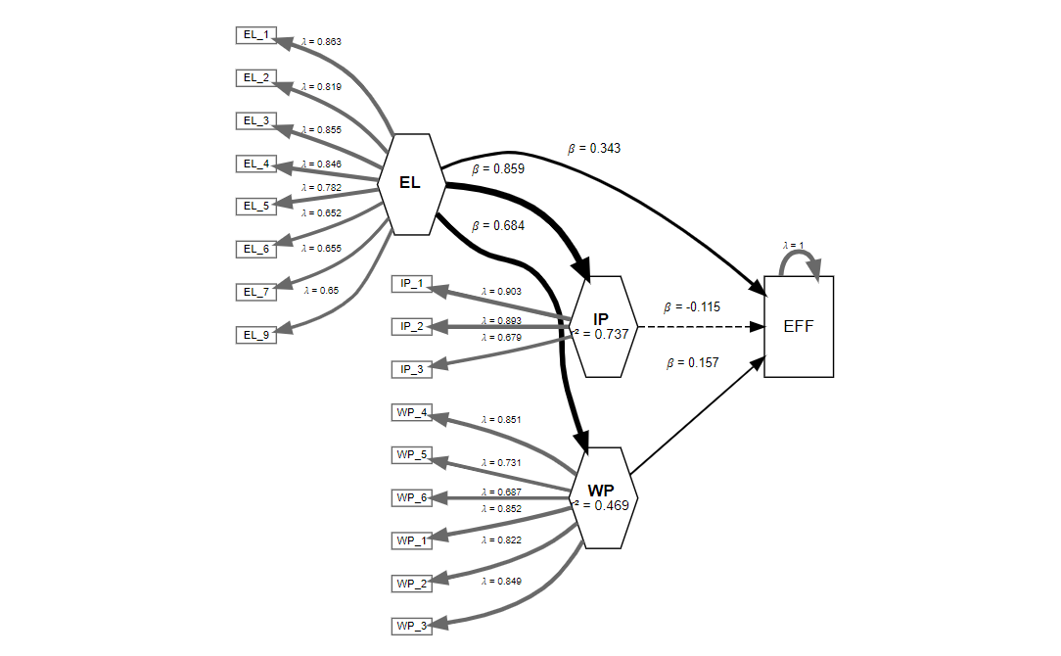

Study Two: Stress, Burnout, and Inclusive Workplaces on Effectiveness
Underlies: Olumekor, Van Der Meer, Polbitsyn & Palumbo (2025), Public Management Review

2.1 Objective
To examine the influence of stress and burnout (WO), discrimination (DD), and harassment/bullying (HB) on organizational effectiveness (EFF) in public sector organizations, and to test whether stress and burnout mediate the effects of discrimination and harassment/bullying on effectiveness.

2.2 Sample
Same valid sample: n = 117,263. PLS-SEM was again used for its robustness at this scale and its ability to combine multi-item reflective constructs (well-being outcome/stress-burnout) with single-item constructs (discrimination; harassment & bullying; effectiveness).

2.3 Measurement Model
Stress and burnout (WO) was measured with three items, each with loadings above 0.708 and explained variance above 50%. Discrimination (DD), harassment/bullying (HB), and effectiveness (EFF) were single-indicator constructs, with loadings of 1.000 by definition.
Indicator → Construct | Loading | Boot. Mean | Boot. SD | T Stat. | 2.5% CI | 97.5% CI | Expl. Var. | VIF
WO_1 → WO | 0.854 | 0.854 | 0.001 | 624.947 | 0.851 | 0.856 | 0.729 | 2.004
WO_2 → WO | 0.897 | 0.897 | 0.001 | 977.581 | 0.895 | 0.898 | 0.804 | 2.437
WO_3 → WO | 0.889 | 0.889 | 0.001 | 994.492 | 0.887 | 0.890 | 0.790 | 2.072
DD → DD | 1.000 | 1.000 | 0.000 | NA | 1.000 | 1.000 | 1.000 | 1.000
HB → HB | 1.000 | 1.000 | 0.000 | NA | 1.000 | 1.000 | 1.000 | 1.000
EFF → EFF | 1.000 | 1.000 | 0.000 | NA | 1.000 | 1.000 | 1.000 | 1.000

2.4 Structural Model
All three constructs showed a significant negative effect on organizational effectiveness.
Path | Est. | Boot. Mean | Boot. SD | T Stat. | P | 2.5% CI | 97.5% CI
WO → EFF | -0.134 | -0.134 | 0.003 | -46.842 | 0.000 | -0.139 | -0.129
DD → EFF | -0.051 | -0.051 | 0.003 | -14.672 | 0.000 | -0.057 | -0.044
HB → EFF | -0.068 | -0.068 | 0.004 | -19.411 | 0.000 | -0.075 | -0.062
H1 (stress/burnout → EFF): confirmed, β = -0.134. H2 (discrimination → EFF): confirmed, β = -0.051. H3 (harassment/bullying → EFF): confirmed, β = -0.068.

2.5 Indirect Effects (Mediation)
Stress and burnout (WO) was tested as a mediator of the effects of discrimination and harassment/bullying on effectiveness.
Indirect path | Est. | Boot. Mean | Boot. SD | T Stat. | 2.5% CI | 97.5% CI
HB → WO → EFF | -0.014 | -0.014 | 0.001 | -26.420 | -0.015 | -0.013
DD → WO → EFF | -0.025 | -0.025 | 0.001 | -32.827 | -0.026 | -0.024
H4a (discrimination → WO → EFF): confirmed, -0.025 — stress/burnout partially and complementarily mediates the effect of discrimination on effectiveness. H4b (harassment/bullying → WO → EFF): confirmed, -0.014, stress/burnout partially and complementarily mediates the effect of harassment/bullying on effectiveness.

2.6 Reliability & Convergent Validity
Construct | Alpha | rhoC | AVE | rhoA
WO | 0.855 | 0.911 | 0.774 | 0.864
DD | 1.000 | 1.000 | 1.000 | 1.000
HB | 1.000 | 1.000 | 1.000 | 1.000
EFF | 1.000 | 1.000 | 1.000 | 1.000
Alpha, rhoC, and rhoA values each exceeded 0.70, confirming internal consistency across all constructs.

2.7 Discriminant Validity (HTMT)
Construct pair | Est. | Boot. Mean | Boot. SD | T Stat. | 2.5% CI | 97.5% CI
WO → DD | 0.189 | 0.189 | 0.003 | 62.478 | 0.184 | 0.195
WO → HB | 0.243 | 0.243 | 0.003 | 71.229 | 0.236 | 0.249
WO → EFF | 0.168 | 0.168 | 0.003 | 54.091 | 0.163 | 0.174
DD → HB | 0.380 | 0.379 | 0.004 | 99.096 | 0.372 | 0.386
DD → EFF | 0.101 | 0.100 | 0.003 | 30.008 | 0.093 | 0.105
HB → EFF | 0.118 | 0.117 | 0.003 | 35.904 | 0.111 | 0.123
All HTMT ratios fell below the 0.85 threshold, confirming the constructs are empirically distinct.
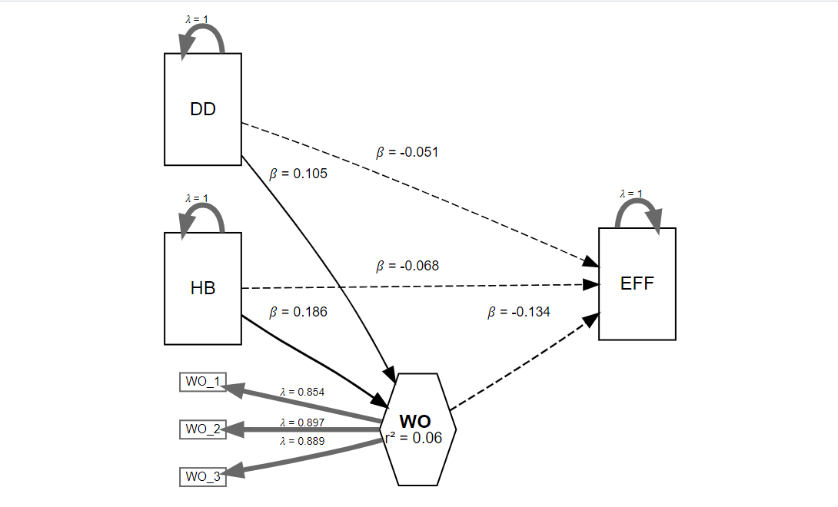

Methodological Approach Demonstrated
- Reflective measurement model specification and indicator retention/elimination decisions (e.g., dropping EL_8 for low explained variance)
- Multicollinearity screening via Variance Inflation Factor (VIF)
- Bootstrapped structural path estimation (percentile method, 95% confidence intervals)
- Specific indirect effect (mediation) testing and classification of mediation type (complementary vs. competitive) from the sign of direct vs. indirect effect products
- Internal consistency reliability (Cronbach's alpha, composite reliability rhoC, rhoA) and convergent validity (AVE) assessment
- Discriminant validity via the Heterotrait-Monotrait (HTMT) ratio
- Handling of both multi-item reflective constructs and single-item constructs within one structural model
- Analysis executed at large-sample scale (n = 117,263), appropriate diagnostic reporting for PLS-SEM at this scale

Note on Use
This case study is intended for portfolio and professional-development purposes (e.g., Elytics consultancy materials, GitHub, CV). Findings and figures are drawn directly from analysis I conducted; the substantive conclusions were subsequently published by Olumekor et al. as cited above, and any onward sharing of this document should retain that attribution.

