**CHAROTAR UNIVERSITY OF SCIENCE AND TECHNOLOGY**

**FACULTY OF TECHNOLOGY AND ENGINEERING**

**CHANDUBHAI S. PATEL INSTITUTE OF TECHNOLOGY**

**DEPARTMENT OF ARTIFICIAL INTELLIGENCE & MACHINE LEARNING**

|  |  |
| --- | --- |
| **Subject :** Mobile Application Development | **Semester:** 5 |
| **Subject Code:** AIML308 | **Academic Year :**2025-26(ODD) |

**NAME : CHOKSI OM CHIRAGBHAI ID: 23AIML010**

**Practical 8**

**Problem Definition**

You are building a mobile application where users navigate through multiple screens like login, dashboard, and profile. Design a Product Catalog App using GridView and custom cards with images.

|  |  |
| --- | --- |
| Supplementary Problems - | News app |

**Technical Approach:**

This Flutter application implements a multi-screen news app with REST API integration, focusing on asynchronous data handling and JSON parsing. The core implementation uses the http package for API calls, flutter_dotenv for secure environment variable management, and FutureBuilder for reactive UI updates based on async operations. Key widgets include StatefulWidget for state management, FutureBuilder for handling loading/error/success states, ListView.builder for dynamic article rendering, and Scaffold for consistent app structure across screens.

**File Structure:**

lib/

├── main.dart  # Main entry point of the Flutter application

├── login.dart  # Handles user authentication and login screen

├── dashboard.dart  # Displays the main dashboard after login

├── profile.dart  # Manages user profile information

├── news.dart  # Fetches and displays news articles

└── models/

    └── article.dart  # Defines the Article model class

**Screenshots:**

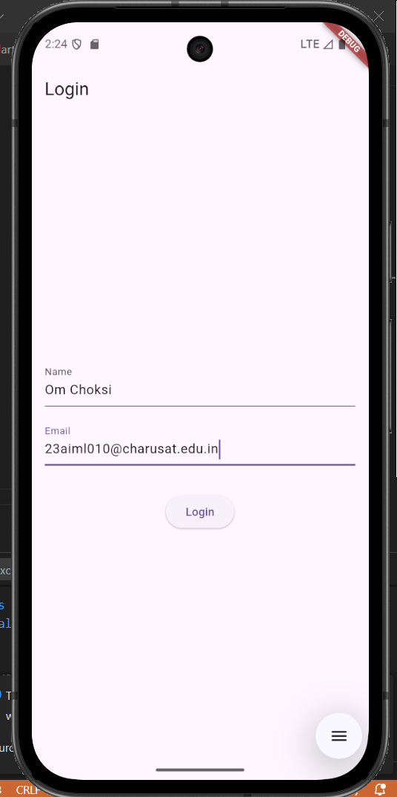

**Key Questions:**

**1. What is JSON parsing?**

**Ans:** JSON parsing converts the JSON response string from the News API into structured Dart objects using factory constructors like Article.fromJson(), which maps JSON fields to object properties for easy data manipulation in the app.

**2. How to handle async APIs?**

**Ans**: Async APIs are handled using async/await syntax in functions like fetchNews(), combined with FutureBuilder widget that reacts to different connection states, ensuring UI updates when data arrives without blocking the main thread.

**3. How to deal with loading/error states?**

**Ans:** Loading states are managed with FutureBuilder's ConnectionState.waiting showing a CircularProgressIndicator, error states use snapshot.hasError to display error messages, and success states render data using snapshot.hasData with ListView.builder for article display.

**Key Skills to be Understand:**

API consumption, Async/Await

Handle API data and render UI