**CHAROTAR UNIVERSITY OF SCIENCE AND TECHNOLOGY**

**FACULTY OF TECHNOLOGY AND ENGINEERING**

**CHANDUBHAI S. PATEL INSTITUTE OF TECHNOLOGY**

**DEPARTMENT OF ARTIFICIAL INTELLIGENCE & MACHINE LEARNING**

|  |  |
| --- | --- |
| **Subject :** Mobile Application Development | **Semester:** 5 |
| **Subject Code:** AIML308 | **Academic Year :**2025-26(ODD) |

**NAME : CHOKSI OM CHIRAGBHAI ID: 23AIML010**

**Practical 9**

**Problem Definition**

You are building a mobile application where users navigate through multiple screens like login, dashboard, and profile. Develop a Login Authentication App using API-based credential check and session handling.

|  |  |
| --- | --- |
| Supplementary Problems - | Two-factor login or role-based access |

**Technical Approach:**

This Flutter application implements a multi-screen news app with REST API integration, focusing on asynchronous data handling and JSON parsing. The core implementation uses the http package for API calls, flutter_dotenv for secure environment variable management, and FutureBuilder for reactive UI updates based on async operations. Key widgets include StatefulWidget for state management, FutureBuilder for handling loading/error/success states, ListView.builder for dynamic article rendering, and Scaffold for consistent app structure across screens.

**File Structure:**

lib/

├── main.dart

├── home_screen.dart

├── login_screen.dart

├── profile_screen.dart

├── services/

│ └── auth_service.dart

└── signup_screen.dart

backend/

├── .env

├── .gitignore

├── check-db.js

├── package.json

├── package-lock.json

├── server.js

├── models/

│ └── User.js

├── routes/

│ └── auth.js

**Screenshots:**

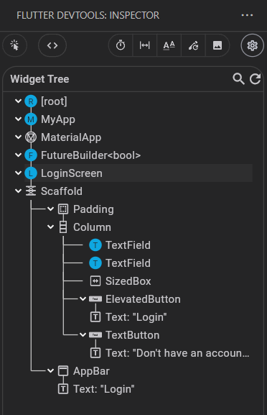

**Key Questions:**

**1. How to send login credentials securely?\*\***

**Ans:** Credentials are sent via HTTPS POST requests with JSON payload containing email and password, using proper headers and secure token-based authentication with JWT for subsequent requests.

**2. How to store token/session?**

**Ans**: JWT tokens and user data are stored locally using SharedPreferences, with automatic session restoration on app restart and complete cleanup on logout.

**3. How to handle invalid login?**

**Ans:** Invalid login attempts return appropriate HTTP status codes (400) with error messages, which are parsed from JSON response and displayed to users via SnackBar notifications with user-friendly error text.

**Key Skills to be Understand:**

Auth Logic, API calls, Sessions

Implement login flow using APIs