COMP1710/COMP6780: Laboratory 3

**MOOC Week 4, Good and Bad Web Design**

# Objectives

This lab aims to introduce you to modern design conventions and use this to continue with formatting tables and forms using CSS. You will also update your files on Stuweb.

Specifically, you will:

* Browse examples of “Bad” websites
* Browse examples of “Good” websites
* Create a Call-To-Action
* Using your newly obtained knowledge, format the previously created forms and tables, including:
  + Source Log
  + Feedback Form
* Create a Sitemap
* upload your assignment.html and sitemap.html page into your public_html space of your account on Stuweb,

MOOC online learning for week 4 is open this week,

# HTML Discussion: Good & Bad Designs

## Exploring designs

* + 1. Navigate to ([Personal & Business Car Leasing | LINGsCARS](https://www.lingscars.com/))
    2. Can you list out 3 design flaws with this website?
    3. Navigate to ([Visit | Australian War Memorial (awm.gov.au)](https://www.awm.gov.au/visit))
    4. Can you list out 3 design conventions used in this website?
    5. Your tutor will introduce and explain more about design conventions.
  1. **Design your own website**
     1. Using these new tips and tricks, **grab a pen and paper** and design how you would like your website to look. ***Note:*** *You will not get enough time to complete this exercise so feel free to review and return to this exercise in your own time.*

Some tips to not get caught up on choosing the right images or colors (Use wireframing):

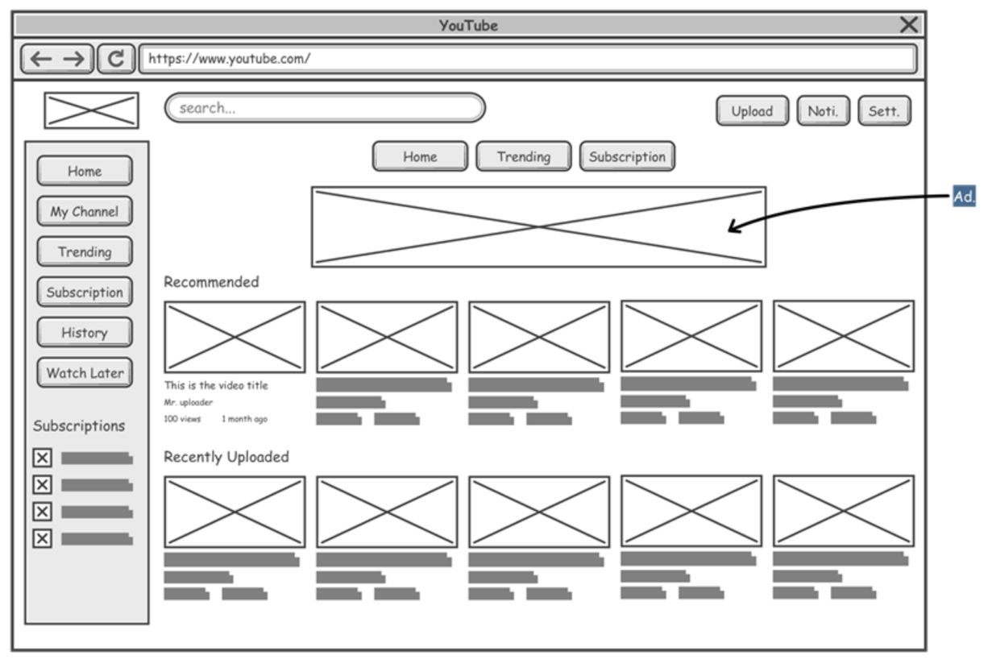

# *Some good wireframing tools are:*

# Lucidchart

# Figma

# Mockflow

# Wireframe.css

# HTML Tasks: Creating a Call-to-Action

## Preparation

* + 1. Create a folder called “COMP1710_Lab3”, or you can reuse the folder we created in lab 2 (“COMP1710_Lab2"). Navigate to [Microsoft – Cloud, Computers, Apps & Gaming](https://www.microsoft.com/en-au) for an Example CTA.
    2. Use your text editor to create a new cta.html file.
    3. Create a Heading 1 and decide on a tagline/title for your CTA.
    4. Afterwards create a Paragraph and insert some text that adds a bit of context to your CTA
    5. Finally insert a link that directs your users to a specific URL.
    6. OPTIONAL: Add an image to your CTA.

# HTML Tasks: Source log & Forms

* 1. **Format source log table**

1. On your favourite text editor, create a new file and save it to the CSS folder as “sourcelog.css”.
2. Open the “sourcelog.html” we developed in Lab 3 using your text editor and link the html file to sourcelog.css.
3. Use your text editor to edit the “sourcelog.html” and “sourcelog.css” so that:
   1. the source log table is put 50px below the heading of “Source Log”
   2. the source log table has an italic, blue caption with a font size of 13px
   3. the table has a single line blue border that is 2px wide
   4. the table is as wide as 80% of the window size
   5. the texts in the table are left-aligned
   6. the texts in the table are 10px away from the border
   7. the background colour of the table header is blue (feel free to also change the text colour of the table header)
   8. (optional) the table will highlight the table row when we move the mouse over it
   9. (optional) the table will display a horizontal scroll bar if the window screen is too narrow to display the whole table
4. Graphical user interface, text, application

   Description automatically generatedSave the files and open sourcelog.html in your web browser to view the effect of your revised HTML and CSS. It may look similar to the following picture.
   1. **Format feedback form**
5. On your favourite text editor, create a new file and save it to the CSS folder as “feedback.css”.
6. Open the “feedback.html” we developed in Lab 3 using your text editor and link the html file to feedback.css.
7. Graphical user interface, text, application, email

   Description automatically generatedUse your text editor to edit the “feedback.html” and “feedback.css” so that:
   1. the feedback form has a background colour
   2. the feedback form has a solid lightblue border with rounded corners
   3. all the labels are in bold (feel free to also adjust the font size)
   4. all the text boxes and/or areas in the feedback form contain a short hint that describes the expected value
   5. all the input boxes and areas are equally wide
   6. there are some spaces between each input of the form
   7. there are some spaces inside each text field
   8. the submit button has a lightblue background colour (feel free to also change the text colour of the submit button)
   9. the clear button has a different background colour (feel free to also change the text colour of the clear button)
   10. (optional) the background colour of the buttons will be changed when a mouse moves over them
   11. (optional) if you move your mouse to the buttons, the cursor will be changed into a hand
8. Save the file and open it in your web browser to view the effect of your revised HTML and CSS. It may look similar to the following picture.

**5. HTML Tasks: Site map**

**5.1 Create a site map**

1. On your favourite text editor, create a new file and save it to as “sitemap.html”.
2. In the sitemap.html, please list out all the pages in your website. Please make sure all the links are clickable and accessible. One example of a site map would be <https://www.apple.com/au/sitemap/>
3. Feel free to format sitemap.html so that it has a similar design to other pages.

**6. Validation**

**6.1 Validate your HTML and CSS file**

1. Submit your HTML files to [W3C HTML validation service](https://validator.w3.org/#validate_by_input) and understand the errors that are returned.
2. Submit your CSS files to [W3C CSS validation service](https://jigsaw.w3.org/css-validator/) and understand the errors that are returned.

**7. OPTIONAL: Edit your assignment.html**

1. Download “assignment.html” from Wattle and save it to the lab folder. (Feel free to reuse the assignment.html you edited in lab 3)
2. Open “assignment.html” with your text editor to fulfill the following requirements:
   1. Insert two relative links in section 1.4 which go to the sourcelog.css and feedback.css
   2. Insert a relative link in section 1.4 which goes to the sourcelog.html
   3. Insert a relative link in section 1.5 which goes to the feedback.html
   4. Insert a relative link in section 1.3 which goes to the sitemap.html
3. Save the file and open it in your web browser to see if you can click on each link on your assignment.html file.

**8. OPTIONAL: Upload your website to Stuweb**

1. Follow the steps documented in the COMP1710 2022 Submission Guide to upload all the files to the public_html folder in Stowe, which include:
   1. sourcelog.html
   2. feedback.html
   3. sourcelog.css
   4. feedback.css
2. Use your web browser to access the uploaded assignment.html under your Stuweb account (e.g. by opening [http://Stuweb.cecs.anu.edu.au/~uid/assignment.html](http://Stuweb.cecs.anu.edu.au/~uid/assignment.html%20) ) and see if all the links are clickable
3. Use your web browser to assess the uploaded sourcelog.css and feedback.css under your Stuweb account
4. Use your web browser to access the uploaded sourcelog.html under your Stuweb account
5. Use your web browser to access the uploaded feedback.html under your Stuweb account