**COMP1710/6780: Laboratory 5**

**Human Computer Interactions and Javascript**

1. **Objectives**

This lab aims to analyze/improve your website’s usability/accessibility, and further your experience with Javascript. You will also update your files on Stuweb.

Specifically, you will:

* Think about the design of your website.
* Change/add styling or content to improve your website’s usability and accessibility.
* Create a JavaScript modal.
* Add appropriate Javascript comments.
* upload your assignment.html and updated pages into your public_html space of your account on Stuweb,

MOOC online learning for week 6 is open this week,

1. **Accessibility and Usability**

Improving the accessibility on your website, not only helps those with limitations, but also enhances usability for a broader range of users. For instance, good contrast not only benefits individuals with visual impairments, but also improves readability for those using mobile devices under bright sunlight or in low light conditions. Similarly, captions benefit individuals in both noisy and quiet environments, making content more accessible to a wider audience.

**2.1 Review & Check your website**

Go through your existing website and ensure the following:

* All your images all have alternative text.
* Your text colours and fonts have sufficient contrast with the background.

**2.2 Designing for Mobile**

As of 2021, the number of people who use their phones to browse the internet is quite high. According to a report by Statista, as of January 2021, there were 4.32 billion active mobile internet users worldwide. This number is projected to continue to increase in the coming years as more people around the world gain access to mobile devices and internet connectivity. In fact, mobile internet usage has surpassed desktop usage in recent years, making it the primary way that people access the internet.

1. Open your website in your browser and right-click on the website and click on inspect element.

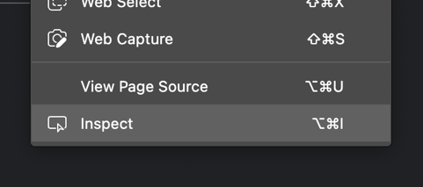

1. Make sure the screens button is selected and click on different devices to emulate.

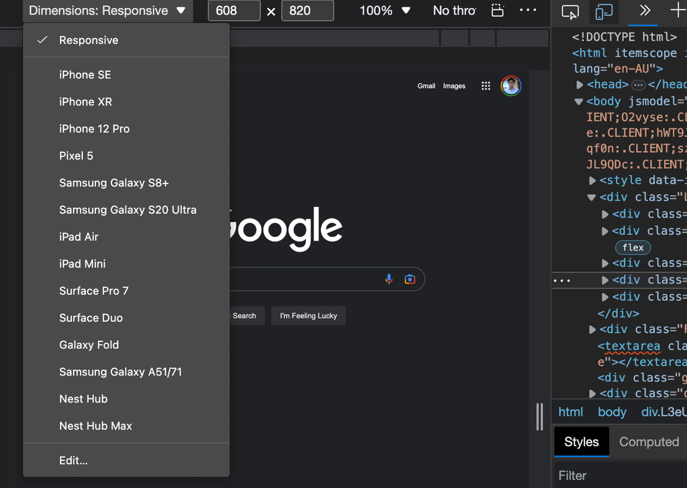

1. Does your website look as expected? Is your website still usable?
2. Spend some time fixing the look and feel of the website to ensure it’s usable across different screen sizes.

HINT: Try adjusting sizes to % or Viewport-width. (vw) in your CSS to ensure that your elements resize with the screen size accordingly.

Ask your tutor if you would like more hints on how to build a responsive website.

1. **JavaScript Advanced (*COMP6780 students essential, COMP1710 students feel free to follow along or spend some time working on your storyboards and videos from last week*)**

In this section we will continue building on JavaScript interactivity to your website.

We will be adding a modal pop-up when a user first browses to your website.

1. Open your JavaScript file called script.js
2. Create a variable and call it ‘modal’
3. Make ‘modal’ equal to the HTML DOM element with the id ‘welcomeModal’ (*Which we will create later on*)
4. Create a Function called ‘modalOpen()’
5. Inside this function, set the style display for the ‘modal’ variable to ‘block’
6. Now create a new Function called ‘modalClose()’
7. Inside this function, set the style display for the ‘modal’ variable to ‘none’

We have just created a function for opening the modal and one for closing the modal.

1. Now open your HTML file and create a button with the onclick method ‘modalOpen()’ which we created in step 4. This will open the modal.
2. Now create a Div for your modal, make sure to include the id ‘welcomeModal’ and any content you wish to include in your modal.
3. Add a button inside the div for the close button and this time add the onclick method ‘modalClose()’
4. Add some CSS to style your modal. ***Hint:*** *You might want to play with the z-index of your modal div and set the background to a dark colour.*
5. Open your HTML file in your browser and watch what your modal does.
6. Add some relevant comments to your JavaScript code.
7. **Keep working on your Assignment**

For the remainder of the lab use this time to work on your assignment and/or to ask questions to your tutor about the assignment.