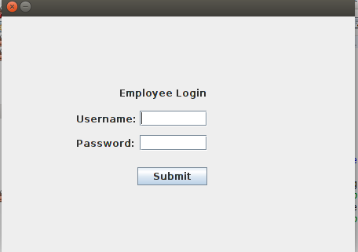

Login GUI. Waits for username and password to be entered.

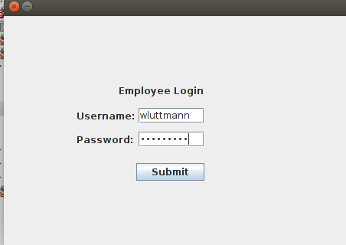

Once correct login information has been entered, the client GUI displays

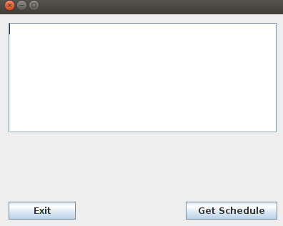

User clicks on get schedule to see the server’s information

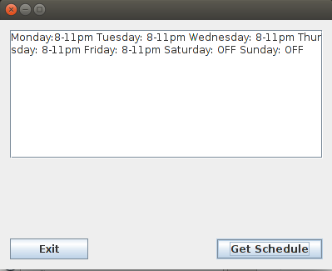

User then clicks exit to close the frame and end communications