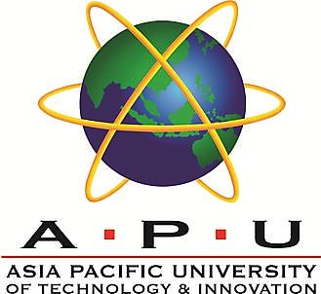

ASIA PACIFIC UNIVERSITY
TECHNOLOGY & INNOVATION

EE014-3-3-ENGINEER IN SOCIETY

NAME & STUDENT ID | ORDANE KABENGELE MUSAU - TP071558
INTAKE | APD4F2601EEE
LECTURER | IR. TS. SUBHASHINI GOPAL KRISHNAN
DATE | 22/09/2026

TABLE OF CONTENTS

LIST OF FIGURES 3
LIST OF TABLES 3
SECTION A – INDUSTRIAL VISIT REPORT 4
A.1 - INTRODUCTION & COMPANY OVERVIEW 4
A.2 - VISIT EXPERIENCE & KNOWLEDGE GAINED 5
A.3 - PROFESSIONALISM PRACTICED AND LIFELONG LEARNING 7
A.4 – CONCLUSION 8
SECTION B – E-PORTFOLIO 9
B.1 - SELF-INTRODUCTION (PROFESSIONAL IDENTITY) 9
B.2 - SWOT ANALYSIS (PLO-BASED REFLECTION) 10
B.3 - PROGRAMME LEARNING OUTCOMES (PO) ATTAINMENT & EVALUATION 11
B.4 – CONCLUSION 14
APPENDIX A - RESUME 15
APPENDIX B – ADDITIONAL PICTURES 15
APPENDIX C – CERTIFICATE OF ATTENDANCE 21

LIST OF FIGURES

Figure 1: Visit briefing at the German-Malaysian Institute (GMI) on 3 December 2025. 4
Figure 2: Demonstration of the automation line at GMI's Smart Factory Lab. 5
Figure 3: Robot arm demonstration showing physical teaching mode and coordinate recording. 6
Figure 4: Official PLO attainment profile. 13
Figure 5: Briefing by Ms. Salwani Abu Bakar. 16
Figure 6: FESTO pneumatic training setup. 16
Figure 7: Mini Cooper training platform. 18
Figure 8: Final-year project exhibition. 18
Figure 9: Final-year project (Reverse Engineering). 19
Figure 10: Professionalism and safety practices observed during the demonstrations. 20
Figure 11: Group photo taken at GMI. 21
LIST OF TABLES
Table 1: Selected portfolio evidence and PLO mapping 9
Table 2: SWOT analysis linked to learning evidence 10
Table 3: Programme Learning Outcome attainment and evaluation 11
Table 4: Priority continuous-development plan 14

SECTION A – INDUSTRIAL VISIT REPORT

A.1 – INTRODUCTION & COMPANY OVERVIEW

The industrial visit was done on 3 December 2025 at the German-Malaysian Institute (GMI) in Kajang, Malaysia. The visit covered a few different labs, mainly the Additiv Zentrum Lab and the Smart Factory Lab under the Mechanical Engineering Department, and the FESTO Pneumatic Lab under the Electrical Engineering Department. These labs were chosen because they represent the technical side of GMI’s training approach, which focuses heavily on hands-on learning and also because of the time constraint of not being able to visit all 22 of their centres.
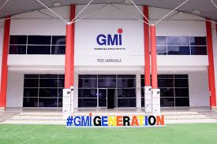
Figure 1: Visit briefing at the German-Malaysian Institute (GMI) on 3 December 2025.
GMI was introduced as a place that combines industry training, applied engineering education, and German-standard technical practices. It was explained that the institute has a long history, going all the way back to when it was first developed in 1991, with its first student intake in 1992. Over the years, it shifted between several ministries in Malaysia before becoming what it is today. The students were also told about its close collaborations with the German-Malaysian Chamber of Commerce, the German Embassy and other partners from Germany who helped shape the institute’s teaching culture and technical standards.
Most of the briefing was done by Ms. Salwani Abu Bakar who walked the students through how GMI operates and why it has a strong reputation in Malaysia’s technical education scene. She explained how GMI follows the German style of learning, where a bigger portion of the teaching is focused on practical skills rather than theory. This approach positions GMI as a key training hub that supports local industries, prepares students for technical roles, and maintains strong ties to both Malaysian and international engineering sectors. A photo of the briefing session led by Ms. Salwani Abu Bakar has been included in Appendix B (Figure A4).

A.2 – VISIT EXPERIENCE & KNOWLEDGE GAINED

During the visit, a few different technologies and setups were shown to us, mainly from the Additiv Zentrum Lab, the Smart Factory Lab, and the FESTO Pneumatic Lab. The main things demonstrated were the automation lines, pneumatic systems, 3D printing machines, IoT 4.0/5.0 setups, and several types of robot arms. Even though there was no hands-on activity, the explanations and demonstrations were clear enough to understand how these systems work in real industry settings.
The automation lines were interesting because they showed how different machines and sensors work together to form a full production sequence. It was explained how each part of the line communicates with the others and how the whole system can detect errors, sort items, or react to changes automatically. This is something that isn’t available at APU in the same way, so seeing an actual working setup made it easier to understand how automation in factories is usually managed.
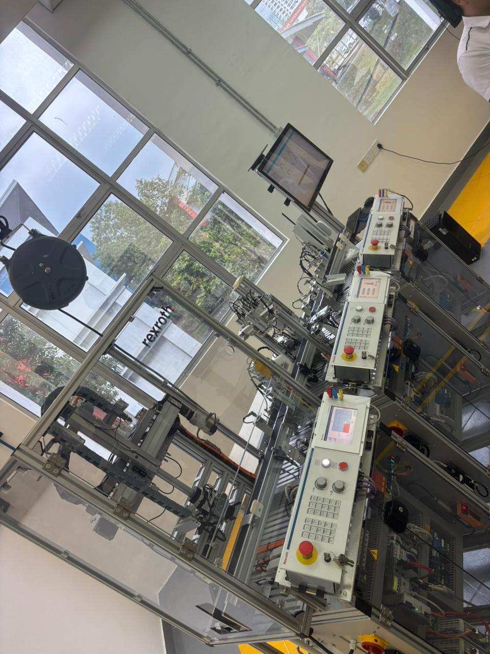
Figure 2: Demonstration of the automation line at GMI’s Smart Factory Lab.
The pneumatic systems were also demonstrated mainly using FESTO trainers. They showed how air pressure can be used to control movement in different mechanical components. The setups were simple but practical, and the instructor explained how these systems are used in many industries because they are reliable, easy to maintain and fast to respond. More details of the FESTO pneumatic setup that was shown during the visit can be seen in Appendix B (Figure 6).
One of the highlights of the visit was the robot arms. The type of robot GMI had was different from what we use at APU. Instead of only coding the robot, the arm could actually be moved by hand to record positions. Once these points were saved, the robot could repeat the motions on its own between the positions that were set. Seeing it shift smoothly between preset coordinates made it easier to understand how modern robots are taught tasks in real production lines.
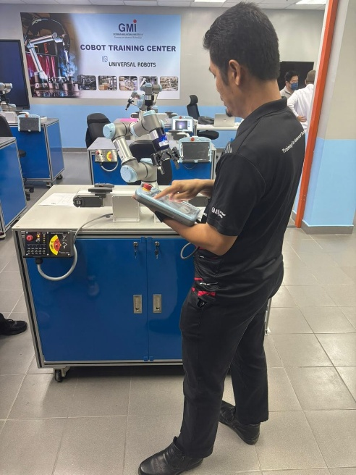
Figure 3: Robot arm demonstration showing physical teaching mode and coordinate recording.
Another surprising part of the visit was when GMI showed a full car, a Mini Cooper. It was used to teach students how software and hardware interact inside a real vehicle. This kind of full-scale training equipment isn’t available at APU, so it gave a better idea of how automotive diagnostics and engineering concepts are taught in places with strong technical setups. A full view of the Mini Cooper training platform is shown in Appendix B (Figure 7).
The cohort was also invited to see a Final Year Project exhibition where some of their students displayed reverse engineering work. GMI explained how students usually take an existing design, study it, change about 40% of it and then turn it into their own solution. This gave a clearer picture of how applied learning is encouraged in their curriculum. Examples from the FYP showcase are included in Appendix B (Figure 8). An example of the reverse-engineering work displayed by the students can also be found in Appendix B (Figure 9).
Throughout the tour, the instructors also explained how their programmes are shaped directly by industry needs. GMI mentioned that technical content takes up around 60–70% of their teaching, while the rest is theoretical. It was also mentioned that GMI is currently being rebranded into GMI University College of Applied Sciences (GMI-UcAS), which further shows their direction towards more industry-aligned and application-focused education.

A.3 – NAFEMS PROFESSIONALISM PRACTICED AND LIFELONG LEARNING

Throughout the visit, a few things stood out in terms of how professionalism was practiced at GMI. The instructors showed a strong sense of safety and responsibility while demonstrating the equipment. Even during simple explanations, care was taken to keep everyone at a safe distance from the machines, and clear reminders were given before any system was turned on. This made it easy to see that safety was treated seriously, the same way it would be in a real industrial environment. An example of the professionalism and safety practices observed during the demonstrations is shown in Appendix B (Figure 10).
Their way of working also showed a lot of discipline and confidence. The instructors explained things calmly and clearly and the instructors were very used to handling industry-level machines. Even when switching between labs or demonstrations, the whole process was done in a steady and organised manner. It gave the impression that GMI follow a structured working style which the lecturers said was based on the German approach GMI try to adopt in their day-to-day operations.
Lifelong learning was also talked about quite a lot. GMI explained how their board of directors includes people from industry, which helps keep their content updated. It was also mentioned that industry professionals regularly come back to GMI to refresh old skills or learn new ones, even if they have already been working for years. That part made it clear that learning doesn’t stop once someone starts working; it keeps going, especially in fields like automation, robotics and manufacturing where things change fast.
There was also some discussion about how GMI works closely with German institutions and how the staff try to follow the same applied-learning culture. GMI said that their programmes allow students to have opportunities for exchanges or further studies in Germany, which encourages students to keep improving themselves. This showed how much GMI value continuous growth, not just for students but also for people already working in the industry.
Professionalism was also seen in how GMI encouraged open discussion with us. Even though documentation was not formally shown, the staff did take photos constantly, which seemed to be part of how the direction keep records during visits and events. GMI’s communication with the students was respectful, patient and encouraging, which created a positive learning atmosphere and showed how professionals interact with visitors or trainees.
Overall, the visit showed that professionalism at GMI is not just something that’s talked about. It is practiced in the teaching, how behaviour should be around industrial equipment and how critical the need to keep learning throughout one’s career is.

A.4 – CONCLUSION

The visit to GMI gave a much clearer picture of what applied engineering actually looks like in a real technical environment. Their way of operating, especially how closely they follow the German style of learning, was very different from what is usually seen at APU. At APU, most learning is done through theory and simulations, but at GMI almost everything is connected to real machines, industry setups, and hands-on systems. Seeing that difference in approach helped show how much practical exposure can influence the way engineering concepts are understood.
The visit also helped show how engineering is not just about solving problems but also about how people work, learn and grow in the field. Watching how the instructors handled the systems, explained concepts and kept a strong focus on safety made engineering feel more connected to real responsibilities, not just classroom exercises. It gave a better idea of what professionalism looks like in daily practice.
It also changed how the future of learning was viewed. Seeing the full automation lines, the robot arms that could be taught by simply moving them around, and the large-scale training setups like the Mini Cooper made it clear that engineering tools are evolving fast. This naturally pushed the interest to learn more about areas like automation, PLCs, robotics and applied mechanical systems, especially since these skills are becoming more important in industry.
Overall, the visit was helpful in seeing the bigger picture of what engineering training can be. It showed how applied learning, technical discipline and continuous skill-building all come together to prepare someone for real work in the engineering world. The experience also encouraged aiming for more hands-on skills in the future, not just theoretical understanding, to be better prepared for future engineering challenges. A group photo taken at the end of the industrial visit has been added in Appendix B (Figure 11).

SECTION B – E-PORTFOLIO

B.1 – SELF-INTRODUCTION (PROFESSIONAL IDENTITY)
I am Ordane Kabengele Musau, a final-year Bachelor of Engineering (Hons) Electrical and Electronic Engineering student at Asia Pacific University of Technology & Innovation (APU), enrolled in the dual-degree programme with De Montfort University. As a bilingual French- and English-speaking student from the Democratic Republic of the Congo, I bring an international perspective, adaptability, and respect for inclusive teamwork to engineering practice. My main interests are renewable energy, sustainable development, smart sensing, and connected systems.
My professional identity has developed through the combination of engineering analysis, prototype development, experimental investigation, and industrial practice. I approach engineering work with attention to safety, accurate reporting, responsible decision-making, and the practical constraints of cost, reliability, maintainability, and environmental impact. My sixteen-week internship with BRACONGO's Direction Technique, Fluides & Energies strengthened this outlook by exposing me to industrial power distribution, motors, generator operation, instrumentation, refrigeration, and safe maintenance procedures in a production environment.
My projects show how I have progressed from applying established methods to integrating several technologies into complete engineering solutions. In the Smart Cold Chain Guardian group project, I co-developed an ESP32- and Raspberry Pi 5-based monitoring and control prototype using environmental and motion sensors, automated ventilation, and edge artificial intelligence for produce-quality assessment. In my final-year project, I designed and fabricated an electromagnetic acoustic-noise energy harvester and compared its behaviour with a piezoelectric mechanism through controlled testing. These experiences required creativity, iteration, data interpretation, troubleshooting, and adaptation when early designs or assumptions did not produce the expected result.
Independent learning has been essential to this development. I have extended my knowledge through MATLAB and Simulink, Python, C/C++, LTspice, Arduino IDE, embedded hardware, IoT platforms, and basic edge-AI workflows. I also earned the Cisco Certified Network Associate (CCNA) certification and a Lean Six Sigma Green Belt, which broadened my understanding of connected systems, structured improvement, and evidence-based problem solving. I see graduation as the beginning of continued professional development rather than the end of formal learning.

Selected portfolio evidence
Evidence | Technologies / context | Attainment demonstrated | Related PLOs
Smart Cold Chain Guardian | ESP32, Raspberry Pi 5, SHT31, BME688, SCD30, MPU6050, actuator control, MobileNetV3-Small | Co-developed an integrated monitoring and control prototype; achieved 99.7% Stage-1 and 88.3% four-class image-classification accuracy. | PLO2, PLO3, PLO5, PLO7, PLO9, PLO10, PLO11
Acoustic-Noise Energy Harvesting (Final-Year Project) | Electromagnetic and piezoelectric transduction, 340+ turn SWG36 coil, experimental test rig | Designed and fabricated a harvester; investigated frequency response, air gap, SPL, load and repeatability; identified 2.5 Ω as the best tested load. | PLO1, PLO2, PLO3, PLO4, PLO5, PLO7, PLO10, PLO12
MATLAB Speech-Enhancement Application | Spectral subtraction, Wiener filtering, spectrograms, audio I/O | Implemented and compared two noise-reduction methods in an interactive application with visual and audible outputs. | PLO1, PLO2, PLO3, PLO5, PLO10, PLO12
Power-Flow and Circuit Analysis | Newton–Raphson 10-bus analysis; two-stage 0.18 µm CMOS op-amp simulation in LTspice | Applied numerical and simulation tools, evaluated convergence and specification gaps, and treated unsuccessful results as evidence for redesign. | PLO1, PLO2, PLO4, PLO5, PLO12
BRACONGO Industrial Internship | Power-factor compensation, generator cooling, motor faults, industrial cabling, drawings and safety | Supported a 1,100 kVAr Schneider installation, generator operation, fault investigation and 100+ m of power/instrumentation cabling under supervision. | PLO1, PLO2, PLO5, PLO6, PLO7, PLO8, PLO9, PLO10, PLO11

This evidence will later form the core of my online e-portfolio. Each web project page will include a concise problem statement, my individual contribution, methods and tools, verified results, reflection, and supporting media such as diagrams, photographs, code excerpts, or certificates, subject to academic integrity and confidentiality requirements.

B.2 – SWOT ANALYSIS (PLO-BASED REFLECTION)
The following SWOT analysis evaluates my present PLO attainment rather than only listing personal traits. It links strengths and limitations to evidence from coursework, projects, certifications, and industrial practice, and identifies actions that can support continuous professional growth.
SWOT | Critical analysis | Evidence and PLO implication
Strengths | Cross-disciplinary integration of electrical engineering, embedded systems, IoT and data analysis; systematic experimentation and troubleshooting; safety awareness and accountability; bilingual and multicultural teamwork. | Cold-chain prototype, energy-harvesting investigation, BRACONGO internship and technical reports show strong PLO1–PLO5 and PLO7–PLO9 attainment.
Weaknesses | My PLO8 attainment of 0.67 shows that I need to strengthen the explicit application and documentation of ethical principles, professional codes, confidentiality, safety accountability, and responsible decision-making in complex engineering situations. I also need deeper PCB and power-electronics design experience, stronger statistical validation, and more disciplined project documentation. | Although I followed safety procedures, reported results accurately, and respected confidentiality during projects and industrial training, I need to demonstrate ethical reasoning more explicitly by identifying dilemmas, consulting professional codes and standards, considering affected stakeholders, and documenting the basis of important engineering decisions.
Opportunities | Graduate study and entry-level work in renewable energy, smart grids, energy monitoring, industrial automation or connected sensing; a public e-portfolio and GitHub repository; professional bodies, short courses and vendor certifications. | These routes can convert existing project evidence and CCNA/Lean Six Sigma learning into deeper PLO5, PLO10–PLO12 capability and industry visibility.
Threats | Rapid technology change, cybersecurity and safety obligations, limited access to specialised equipment, competition for graduate roles, and the risk of spreading effort across too many technical areas. | A focused development plan, ethical use of AI/tools, standards awareness, reproducible documentation and regular skills review are necessary to remain competent and credible.

The official attainment values below provide a quantitative indication of performance, while evidence from projects and industrial training explains what these values mean in practice. A score of 1.00 represents strong attainment, 0.83 indicates substantial attainment with room for consolidation, and 0.67 identifies an area requiring focused development. The evaluation remains reflective: everything shows the need of continuous professional improvement.

B.3 – PROGRAMME LEARNING OUTCOMES (PO) ATTAINMENT & EVALUATION
The official attainment values below provide a quantitative indication of performance, while the project and internship evidence explains what the values mean in practice. A score of 1.00 is treated as strong attainment, 0.83 as substantially attained with room for consolidation, and 0.50 as a priority performance gap. The evaluation remains reflective: successful outputs demonstrate competence, while failed iterations, convergence problems and incomplete specifications identify where professional improvement is required.
PLO | Area | Score | Evidence-based evaluation | Continuous-improvement action
PLO1 | Engineering knowledge | 1.00 | Applied circuit, signal, power-system and transduction principles in the op-amp, speech, power-flow and energy-harvesting work. | Deepen power electronics and renewable-energy conversion through advanced study and design exercises.
PLO2 | Problem analysis | 0.83 | Analysed sensor behaviour, harvester parameters, motor faults and numerical convergence using measured or simulated evidence. | Use clearer fault trees, assumptions, uncertainty analysis and root-cause documentation before selecting solutions.
PLO3 | Design/development of solutions | 1.00 | Integrated sensing, control and edge AI in the cold-chain prototype and fabricated an electromagnetic harvester. | Complete more end-to-end designs including PCB, protection, enclosure, verification and user requirements.
PLO4 | Investigation | 1.00 | Planned repeatable tests of frequency, SPL, air gap and load; compared mechanisms and interpreted experimental limitations. | Add statistical treatment, uncertainty budgets and larger repeat samples to future investigations.
PLO5 | Modern tool usage | 1.00 | Used MATLAB/Simulink, Python, LTspice, ESP32, Raspberry Pi, sensors and edge-AI tools with awareness of their limits. | Improve version control, automated testing, cybersecurity practice and reproducible data pipelines.
PLO6 | Engineer and society | 1.00 | Considered food-loss reduction, access to reliable energy, production continuity and safe industrial operation. | Evaluate stakeholders, accessibility, standards and social consequences explicitly in design requirements.
PLO7 | Environment and sustainability | 1.00 | Explored harvested energy, cold-chain efficiency, power-factor correction and industrial resource management. | Quantify life-cycle energy, emissions, maintainability and end-of-life impacts in future projects.
PLO8 | Ethics | 0.67 | Followed industrial safety procedures, maintained confidentiality, reported results accurately, and accepted responsibility for assigned work. However, ethical considerations were not always explicitly analysed or documented in academic projects. | Study applicable engineering codes and document ethical, safety and data-privacy decisions.
PLO9 | Individual and team work | 1.00 | Contributed within multidisciplinary academic and industrial teams and adapted to multicultural working environments. | Seek leadership responsibility and improve task allocation, peer feedback and conflict-resolution practice.
PLO10 | Communication | 1.00 | Communicated technical information effectively through written reports, presentations, diagrams, teamwork, and bilingual French–English communication during industrial training. | Maintain this strength by adapting technical content to different audiences and developing concise, visually supported project case studies for my online portfolio.
PLO11 | Project management and finance | 1.00 | Worked within schedules and component constraints; observed cost, downtime and replace-versus-repair decisions; applied Lean Six Sigma thinking. | Use formal risk registers, budgets, milestones and whole-life-cost comparisons in every major project.
PLO12 | Life-long learning | 1.00 | Independently learned tools across embedded systems, networking, simulation and AI; completed CCNA and Lean Six Sigma certification. | Maintain a quarterly learning plan focused on renewable energy, standards and demonstrable project outcomes.

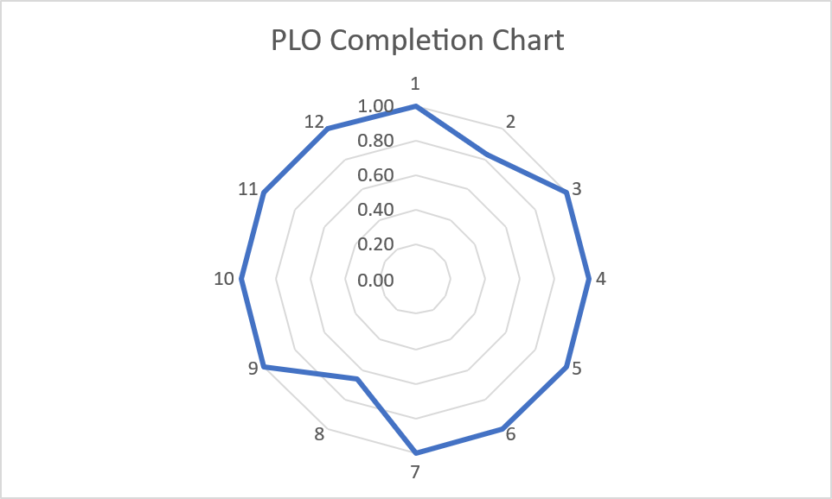
Figure 4: Official PLO attainment profile
The attainment profile is strong overall, with PLO8 at 0.67 representing the principal development priority and PLO2 at 0.83 being the next area to consolidate. The PLO8 result does not suggest an absence of ethical conduct; my projects and internship demonstrate safety awareness, accountability, accurate reporting, and respect for confidentiality. Instead, it shows that I need to make ethical reasoning more explicit by applying professional codes, identifying affected stakeholders, assessing possible risks and consequences, and documenting the justification for engineering decisions. My PLO10 score of 1.00 reflects strong written, verbal, visual, and bilingual communication, which I will continue developing for different technical and non-technical audiences.
Professional and inclusive practice has developed through collaboration with classmates from different backgrounds and with technicians, engineers, and operators during my internship. Working in French and English helped me adapt explanations to different audiences. Inclusive engineering also requires listening to operators and users, recognising differences in technical experience, and designing solutions that can be understood, maintained, and used safely rather than optimising technical performance alone.
Emerging technology has been most valuable when connected to a genuine engineering need. Edge AI in the cold-chain project supported local quality assessment, while networked sensors enabled condition monitoring and control. However, using advanced tools responsibly requires checking data quality, model limitations, cybersecurity, energy consumption, privacy, and failure modes. My future work will therefore combine innovation with verification, safety, sustainability, and ethical judgement.

Priority continuous-development plan
Priority | Reason | Action | Evidence of progress
Communication development | Maintain PLO10 strength | Continue producing concise technical briefings, visual explanations, and audience-appropriate project case studies. | Three polished web portfolio case studies and one recorded briefing by graduation.
Structured problem analysis | PLO2: 0.83 | Use requirements, fault trees, test plans, assumptions logs and uncertainty analysis before design decisions. | A complete analysis record for the next major project, reviewed against results.
Sustainable-energy depth | Career direction | Study power electronics, renewable integration and smart-grid fundamentals; apply learning in a measured prototype or simulation. | One renewable-energy project with efficiency, safety and life-cycle evaluation.
Professional readiness | PLO8, PLO11, PLO12 | Maintain CPD records, review standards and ethical codes, use version control, and document risk, schedule and cost. | Quarterly CPD review and evidence-based updates to the online portfolio.

B.4 – CONCLUSION
This e-portfolio demonstrates that I have developed a sound foundation for professional electrical and electronic engineering practice. My strongest attainment is evidenced by the integration of engineering knowledge, design, investigation, modern tools, sustainability awareness, ethical responsibility, and teamwork across the cold-chain, energy-harvesting, signal-processing, circuit-analysis, and industrial internship experiences. These activities moved my learning beyond theoretical completion toward decisions that consider safety, reliability, maintainability, users, cost, and environmental consequences.
The reflection also identifies a genuine area for improvement. My PLO8 attainment of 0.67 makes ethical and professional judgement my highest development priority, while the 0.83 score for PLO2 calls for continued improvement in structured and reproducible problem analysis. In contrast, my PLO10 score of 1.00 demonstrates strong communication through reports, presentations, teamwork, and bilingual industrial interaction. Professional competence requires more than obtaining a technical result; it also requires communicating clearly, recognising ethical implications, considering stakeholders, and providing a transparent justification for decisions.
I am prepared to continue learning as technologies, standards, and societal needs evolve. My immediate plan is to deepen my knowledge of renewable energy and sustainable systems, strengthen my design-to-validation workflow, and communicate my work through a carefully evidenced online portfolio. With bilingual and international experience, industrial exposure, and a commitment to ethical continuous improvement, I am ready to enter the engineering profession and contribute to reliable technologies that improve efficiency and expand access to electricity.

APPENDIX A - RESUME

ORDANE KABENGELE MUSAU
Electrical and Electronic Engineering Student

Education
Bachelor of Engineering (Hons) Electrical and Electronic Engineering, Asia Pacific University of Technology & Innovation (APU), dual-degree programme with De Montfort University.

Selected project experience
Smart Cold Chain Guardian — ESP32/Raspberry Pi monitoring, actuator control and MobileNetV3-Small produce-quality classification. Acoustic-Noise Energy Harvesting — electromagnetic harvester design, fabrication and comparison with piezoelectric conversion. MATLAB Speech Enhancement — spectral subtraction and Wiener filtering application. Power-flow and analogue-circuit analysis — Newton–Raphson and LTspice.

Industrial experience
BRACONGO, Direction Technique, Fluides & Energies — 16-week internship (29 September 2025 to 16 January 2026). Supported power-factor compensation, generator operation, motor-fault investigation, industrial cabling, drawings, instrumentation and safe maintenance activities.

Technical skills
MATLAB/Simulink, Python, C/C++, LTspice, Arduino IDE, ESP32, Raspberry Pi, IoT and edge AI; power-system analysis, sensors and instrumentation, schematic interpretation, experimental testing, fault diagnosis, technical reporting and data analysis.

Languages and credentials
French and English (bilingual); Lingala (native); Swahili (intermediate); Tshiluba (basic). Cisco Certified Network Associate (CCNA); Lean Six Sigma Green Belt; TOEFL, SAT and Duolingo English Test.

