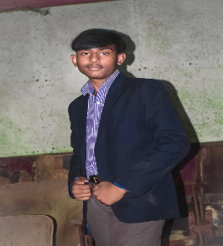**RESUME**

OMM PRAKASH SAHOO

S/o- Amiya kumar sahoo

At-siaria,Po-siaria ,Ps-kanapur

Dist-cuttack Pin-754037, Odisha

Mob-6371353799

Adhaarcard No-912840805387

Email ID –ommprakashsahooomm5@gmail.com

***OBJECTIVE :***

Intend to build my career at an esteemed organization which would tell my knowledge, help to achieve my goals and to move ahead in this competitive world while being resourceful, innovative and flexible.

***EDUCATIONAL QUALIFICATION :***

* persuing B.tech in Gandhi Institute of Excellent Technocrats in Bhubaneswar.
* Passed regional h s school, sanda in the year 2023
* Passed H.S.C from Raghunath bidyapitha, siaria in the year 2021

***COMPUTER SKILLS :***

* Well versed with MS Word, Excel, Power Point, Outlook and Windows 2007 .
* Completed core Java , HTML , CSS , Java script , react , C , DSA , mysql .

***PERSONAL TRAITS :***

* Self motivated with a positive attitude.
* The ability to work in a team.
* Adaptable to the changes in my surroundings.
* I take initiative to improving the things and convince others to join me.
* Interested in exploiting my theoretical knowledge as practical.

***EXPERIENCE :***

* Lab Assistance in Sai Trishna Computer Care,
* Making salesforce UI using HTML,CSS ,JAVASCRIPT
* Making tic tac game JAVA with DSA

***PERSONAL DETAILS :***

Name : Omm Prakash sahoo

Father’s Name : Amiya kumar sahoo

Date of Birth : 21.03.2006

Marital Status : Unmarried

Languages Known : Oriya, Hindi & English,

Nationality : Indian

Religion : Hindu

Gender : Male

***DECLARATION :***

I consider myself fit and efficient for all type of situations and conditions. I am also confident of my ability to work in a team as I have proved it in my school, college and work field.

I hereby declare that the information furnished above is true to the best of my knowledge.

**Omm *Prakash* sahoo**