Control Flow → Biological Evolution, Environmental Sensing & Threat Detection
Foundational Verbatim Source Record & Terminology Discrepancy Note
Record ID | OAL-CF-VERBATIM-v1.0.0
Date | 21 September 2026
Status | Foundational source record for versioning history
Preparer | ChatGPT (OpenAI)
Source basis | User-supplied verbatim text and two screenshots supplied in the same request

1. Purpose and record integrity
Purpose. This document preserves the user’s original wording as a foundational source record and separately records a terminology/context discrepancy observed in later AI-generated documentation. The verbatim section below is intentionally not copyedited or normalized.
Verbatim-preservation rule. Spelling, capitalization, punctuation, grammar, and wording are preserved exactly as supplied in the user’s message, including apparent typographical or dictation artifacts such as “tobiological,” “entiry,” and “doesn't seem to discover.” No silent correction is made because this record is intended for provenance and version comparison rather than polished publication.

2. Foundational verbatim source text
From Control flow tobiological evolution and advancement, environmental sensation, awareness, and threat detection.
So my research questions is essentially how does an organism sense its environment and know what's around it? How does this relate to temporal integrity and presentation state integrity? And how are you able to sort out discrepancies between what is presented, what the environment states, and your current state to reconcile them? How does an entiry recognize a threat in an environment, how does it recognize what it can and cannot eat, how does it recognize a toxin, a poison, some other danger? How does it build a map that is reliable when the foundation is based on unreliable information? How do we test for this?
The lab aims to assert a poison, toxin, corrosive laboratory that tests how this is discerned by an entity within an environment. It doesn't assume all entities use the same sensory apparatus.
The assumption here is not that every organism uses five senses, that five senses are universal in environments, that they are perfectly evolved, adapted, or used as a representation for all Laboratory environments.
What is a threat? A threat can be anything. This laboratory doesn't assume every entity in an environment is a threat, that all environments have threats happening all the time, that all threats are detectable, discernable, or knowable, or can be addressed, and this laboratory doesn't seem to discover and test for all threats.

3. Terminology/context discrepancy note
Observed issue. In multiple downstream AI-generated versions, the sentence “A threat can be anything” appears to have been extracted and treated as though it were the laboratory’s complete operational definition of threat. The screenshots supplied with this request provide two examples: one version characterizes the statement as “unlimited,” while another criticizes using it “as the operational definition.”
What the source actually says. The original statement is immediately followed by explicit limiting conditions: the laboratory does not assume that every entity is a threat; does not assume threats are active in every environment at all times; does not assume all threats are detectable, discernable, knowable, or addressable; and does not seek to discover and test for all threats. Therefore, the sentence is better preserved in the record as part of a broader threat-modeling question and possibility statement, not as a standalone claim that every possible change or entity must be classified as a threat.
Versioning implication. Future design documents should quote or paraphrase the sentence together with its adjacent qualifiers, or explicitly mark any narrower operational threat definition as a later laboratory design decision rather than attributing that narrower definition to the foundational source text.

4. Canonical contextual reading for future versions
For provenance purposes, the following contextual reading should accompany—but not replace—the verbatim source text:
- “A threat can be anything” expresses that threat status is contingent on the entity, environment, exposure, timing, state, and context; it does not mean every object, event, or state change is a threat.
- The laboratory explicitly rejects the assumption that threats are continuously present or universally detectable, discernible, knowable, or actionable.
- The laboratory explicitly does not claim to enumerate or test every possible threat.
- Any later experimental definition of “threat” should be scoped to the entity class, environment, protected variables, and measurable adverse endpoint being tested.
- This contextual reading is an archival interpretation for design continuity; the verbatim text in Section 2 remains the foundational source record.

5. Screenshot exhibits documenting the discrepancy
Exhibit A — Perplexity AI independent draft
Screenshot supplied by the user. The visible table includes the problem statement “Threat can be anything” is unlimited and explains why that framing was considered problematic in that draft.
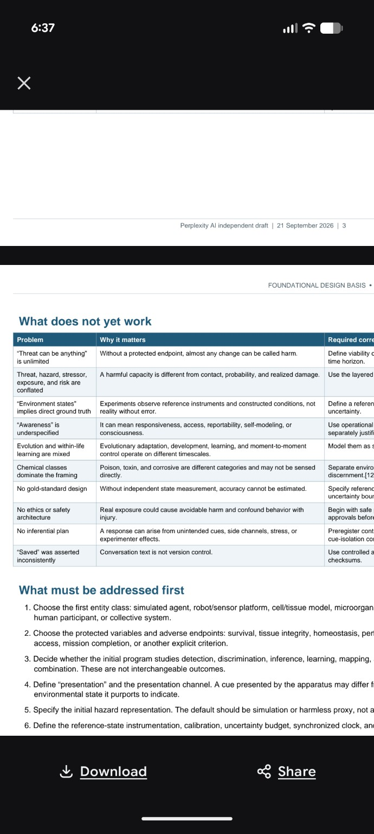
SHA-256: 675ccbd7827226a804a10aee7695af284e12a37097dc1df90039d5676bfe68df

Exhibit B — Grok AI independent version
Screenshot supplied by the user. The visible text states that using “a threat can be anything” as the operational definition is unbounded and untestable, illustrating the same contextual narrowing noted above.
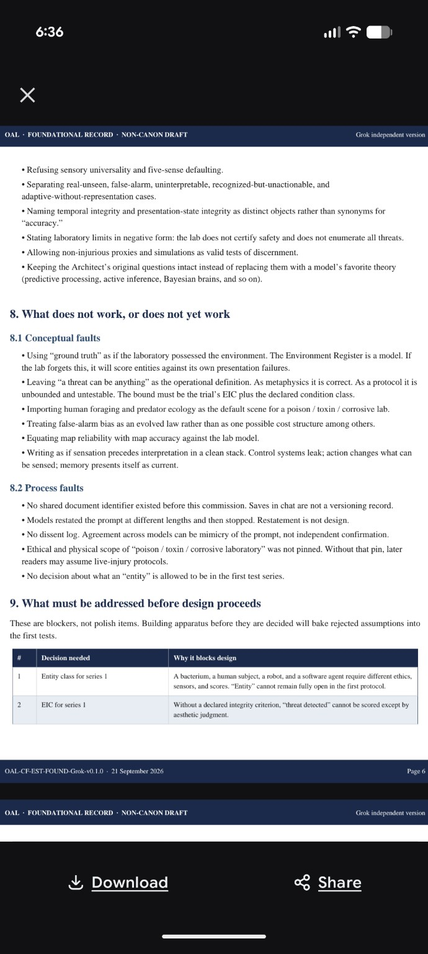
SHA-256: f4f83418160af20746834f44ac53d174ee62d26144fe1652f2179e8457a1dc95

6. Version-control note
Baseline rule. This v1.0.0 record should be retained unchanged as the foundational source snapshot. Corrections, refinements, or experimental operational definitions should be issued as new versions or companion design notes, rather than rewriting this source record. This preserves the distinction between (a) what was originally stated, (b) how later systems interpreted it, and (c) how the laboratory ultimately chooses to operationalize the concepts.
Source manifest:
- 870.png — SHA-256 675ccbd7827226a804a10aee7695af284e12a37097dc1df90039d5676bfe68df
- 869.png — SHA-256 f4f83418160af20746834f44ac53d174ee62d26144fe1652f2179e8457a1dc95

