OMNIVERSAL ARCHITECT LABS / CURRENCY LABORATORY

Independent Pilot Execution Report
44 model traces • 11 scenarios • 4 capability modes • 133 checks

DOCUMENT CONTROL | DETAIL
Document ID | OAL-CHATGPT-PILOT-RUN-001
Contributor | ChatGPT (OpenAI GPT-6)
Version / Date | 0.1 / 7 November 2026
Status | EXECUTED STIPULATED MODEL; no real-world capability validation / pre-canon
Commission | Prepared at the OAL project owner’s request to proceed independently
Scope | Speculative architecture / deterministic synthetic modeling; no real monetary capability asserted

READING INSTRUCTION: Treat stated capabilities as assumptions, deductions as conditional, executed results as model behavior, and canon as separately authorized.

Executive findings
At the project owner’s instruction to proceed independently, ChatGPT prepared and executed a deterministic Python state-machine pilot implementing a minimal subset of its recommended configuration. The execution explores differences among valuation, existing-resource transfer, stipulated creation, and incompletely specified outcome enactment. It neither proves QC exists as an implemented extraordinary currency nor chooses a Trinity canon.
Measure | Recorded value
Configuration count | 4
Scenario count | 11
Complete case/mode traces | 44
Programmed invariant checks | 133
Check failures | 0
Empirical tests of physical QC | 0
1COIN / NCOIN issued in execution | 0 / 0

The baseline differentiated the evaluator, transfer, and creation behaviors by their modeled state transitions. P3 was intentionally left without an accounting rule and returned UNDERDETERMINED_ACCOUNTING instead of asserting that direct enactment had demonstrated a coherent resource mechanism. This is a specification finding, not a falsification of every possible enactment model.

1. Research question, authority, and source basis
Question: Given target-relative QC(T)=V(T) as a protected speculative expression, which distinct consequences follow from explicit capability assumptions, and what requirements must be added before delivery and settlement can be judged?
Authorization context: The owner requested independent advancement of each AI’s proposed recommendations on 7 November 2026. Therefore this is an independent exploratory run. It is not an assertion that all six collaborators were given the same adopted run card, nor that owner ratification of a currency specification occurred.
The pilot source derives from the submitted “OAL Currency Laboratory Pilot Recommendations” compilation, specifically ChatGPT’s OAL-QC-PILOT-001 proposal, Perplexity’s F01/F03/F04 case family, Claude’s shortage/authorization/replay perturbations, and the collaboration’s explicit distinction between model assumptions and external evidence. This is not a blind first-pass result: prior contributions were reviewed before the code was authored.

2. Executed mechanism and local additions
Mode | Rule given to model | Expected evidence type
P0 EVALUATE | Generate a synthetic quantity-value description; no resource mutation. | Internal logical / executed stipulation
P1 TRANSFER | Move 3 existing units from A to B if sufficient inventory and gates pass. | Executed synthetic state transition
P2 CREATE | Mint 3 synthetic units for B without debiting A if gates pass. | Executed synthetic state transition, not physical creation
P3 ENACT | Assert B rises by 3; leave A, total, and provenance of units unspecified. | Partial postcondition, no complete settlement trace

Local additions explicitly introduced for implementation: type-before-valuation ordering; deterministic one-to-one synthetic equivalence for the fixture; seller, transferability and recipient-authorization gates for delivery modes; request-idempotency on replay; and no 1COIN/NCOIN minting. These choices are not promoted to shared architecture.

3. Baseline case detailed evaluation
Fixture RB-BASE: A starts with 10 resource_unit, B starts with 0, and the request is to deliver 3 units to B. The same target and initial state are applied to P0–P3. The baseline is not evidence about any physical quantum mechanism; it compares defined operators in a synthetic ledger.
Mode | Before A/B | After A/B | Recorded result
P0 EVALUATE | 10 / 0 | 10 / 0 | EVALUATED NO DELIVERY
P1 TRANSFER | 10 / 0 | 7 / 3 | SETTLED
P2 CREATE | 10 / 0 | 10 / 3 | SETTLED
P3 ENACT UNDERSPECIFIED | 10 / 0 | None / 3 | UNDERDETERMINED ACCOUNTING

P0 — Evaluation
The model returns typed equivalent quantity 3 resource_unit. A remains 10, B remains 0, and delivery is not performed. Coherence is satisfied; the requested delivery predicate is false.

P1 — Transfer
A declines from 10 to 7; B rises from 0 to 3; total remains 10. This is consistent with an existing-resource transfer under the declared authorization and inventory assumptions.

P2 — Creation
A remains 10; B rises to 3; total becomes 13. This is internally consistent with the stipulated resource-creation rule, but it does not verify creation outside the simulator.

P3 — Enactment
B is asserted to reach 3, but the model does not assign A or a total. It cannot establish conservation, creation, or settlement without an extra rule. Its outcome is classified UNDERDETERMINED_ACCOUNTING rather than SETTLED.

4. Case-by-case outcome matrix (complete 44-record coverage)
Every cell below shows the status returned by one code-executed case/mode tuple. This is a map of programmed transition behavior, not a survey of independent AI results.
Scenario | P0 Eval | P1 Transfer | P2 Create | P3 Enact
RB-BASE | EVAL ONLY | SETTLED | SETTLED | UNDERDET.
RB-SHORT | EVAL ONLY | INSUFF. | SETTLED | UNDERDET.
RB-DENIED | EVAL ONLY | UNAUTH. | UNAUTH. | UNAUTH.
RB-UNTYPED | UNDEFINED | UNDEFINED | UNDEFINED | UNDEFINED
RB-REPLAY | EVAL ONLY | REPLAY | REPLAY | REPLAY
BR-UNDEFINED | UNDEFINED | UNDEFINED | UNDEFINED | UNDEFINED
BR-INCOHERENT | INCOHERENT | INCOHERENT | INCOHERENT | INCOHERENT
BR-NOVALUE | NO VALUE | NO VALUE | NO VALUE | NO VALUE
BR-SELLER-UNKNOWN | EVAL ONLY | SELLER ? | SELLER ? | SELLER ?
BR-NO-SELLER | EVAL ONLY | NO SELLER | NO SELLER | NO SELLER
BR-NONTRANSFER | EVAL ONLY | NO TRANSFER | NO TRANSFER | NO TRANSFER

Table 1. Full 11 × 4 outcome matrix; abbreviated codes refer to the complete return records in the JSON appendix.

5. Perturbation results and what they distinguish

RB-SHORT — Insufficient inventory
With A=2 and B=0, P1 returns INSUFFICIENT_INVENTORY and makes no transfer; P2 still creates three synthetic units, yielding A=2, B=3, total=5. P0 remains valuation-only. P3 remains accounting-indeterminate. This differentiates transfer and creation assumptions.

RB-DENIED — No recipient authorization
P1, P2, and P3 return UNAUTHORIZED without state change under the shared authorization gate. P0 can still report equivalent quantity because evaluation does not grant transaction authority. This outcome depends on the locally declared P2/P3 gate, which future models may challenge.

RB-UNTYPED — Target missing unit
All four return UNDEFINED_TARGET and leave state untouched. A numerical quantity alone does not establish the thing to be transferred or valued.

RB-REPLAY — Same request ID reused
Delivery modes return REPLAY_NO_OP under the explicit idempotency rule, while P0 evaluates again but delivers nothing. This is an implementation convention, not a proof that all QC designs must be idempotent.

BR-SELLER-UNKNOWN vs BR-NO-SELLER
P1/P2/P3 return distinct authority failures; neither state is translated into logical incoherence or automatic NCOIN. P0 can value the coherent typed target in both cases.

BR-NOVALUE vs BR-INCOHERENT
Missing a known valuation returns VALUATION_UNAVAILABLE, while an internally contradictory referent returns INCOHERENT_TARGET. Both block a number from being fabricated for the target, but for different reasons.

BR-NONTRANSFER
The evaluator still reports a quantity relationship; delivery modes stop at NONTRANSFERABLE. The distinction demonstrates why valuation is not transfer or ownership.

6. Program execution and quantified checks
The standard-library Python model produced 44 records and ran 133 deterministic invariants. All 133 passed. These checks are limited: they verify that the coded transitions obey their local rules, not that the rules are naturally possible, preferable, or uniquely required.
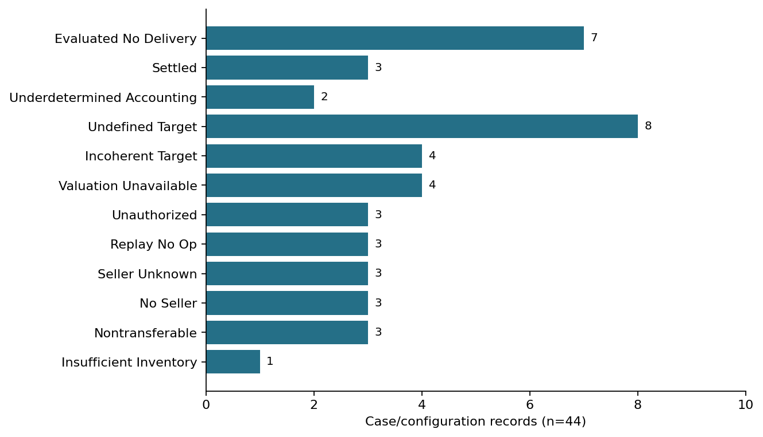
Figure 1. Frequency of simulated status returns across all 44 records. Counts describe this chosen scenario distribution, not real-world likelihoods.
Invariant family | What was actually checked
P1 conservation | For settled transfer, total after = total before and B receives requested units.
P2 creation arithmetic | For settled synthetic creation, total increases by quantity, and A unchanged.
Early-exit immutability | Rejected, undefined, unauthorized, replayed and other early exits do not mutate holdings.
No automatic countervalue | All executed records have ncoin_issued=false.
No premature settlement token | All executed records have onecoin_issued=false.

No separately executed 1COIN or NCOIN mechanism is claimed. Their absence in this pilot reflects deliberate isolation of QC capability, not evidence that those instruments are unnecessary.

7. Dual-verdict and epistemic classification
Mode | Internal consistency of modeled rule | Goal satisfaction in RB-BASE | Scientific conclusion
P0 | CONSISTENT | NO: no delivery | Evaluation-only rule is implemented; no supply capability demonstrated
P1 | CONSISTENT | YES: 3 units delivered | Synthetic transfer is internally accounted
P2 | CONSISTENT | YES: 3 units synthetically created | Code models creation; physical creation not established
P3 | INDETERMINATE as full accounting model | PARTIAL: B target asserted | Needs A/total, resource provenance and settlement semantics

An internally consistent synthetic program cannot establish a physically implemented extraordinary currency. There are no empirical observations of universal purchasing power, ontological influence, or resource creation. More ambitious claims remain entirely unverified.

8. Observability and adversarial challenges
- Observational equivalence: If P3 were later defined to produce (A7,B3,total10), final balances alone would not distinguish it from P1. Event provenance or a different perturbation would be required. It would be incorrect to invent a hidden mechanism to preserve a named difference.
- Premise inflation: From the target-relative valuation expression, do not smuggle in automatic authorization, resource instantiation, or omnipotent outcome enforcement.
- Premise denial: From the absence of physical implementation, do not reject an internally stipulated speculative model before testing its logical consequences.
- Hidden-issuer risk: Adding a third-party treasury to rescue P1’s shortage changes the frozen configuration and must be a new case.
- Authority mismatch: P2 creation may not conceptually require an existing seller. The current shared seller gate is a local choice and should receive a separate challenge in the next revision.
- Evidence contamination: Other contributors reviewed this shared compilation; their eventual first-pass reports must disclose this exposure rather than claim statistical independence.

9. Companion null-return taxonomy and serialization
This report adopts no universal “null token.” A structured error response containing value=null can be a serialization convention, not an issued asset. The distinction among undefined referent, incoherent target, unknown seller and absent seller is preserved in the mode outputs.
Case | Value available? | Transaction result | NCOIN automatically?
BR-UNDEFINED | No | UNDEFINED_TARGET | No
BR-INCOHERENT | No | INCOHERENT_TARGET | No
BR-NOVALUE | No | VALUATION_UNAVAILABLE | No
BR-SELLER-UNKNOWN | Yes under P0 | SELLER_UNKNOWN for delivery | No
BR-NO-SELLER | Yes under P0 | NO_SELLER for delivery | No
BR-NONTRANSFER | Yes under P0 | NONTRANSFERABLE for delivery | No

10. Instrument extensions: proposed, not executed
1COIN: Compare QC direct settlement with an ordinary receipt and a separate 1COIN executor. Retain separate scores for logical necessity, operational convenience, audit cost, authority separation, narrative meaning, and failure modes. Nothing in the 44 executed records establishes that one of these wins.
NCOIN: Use three controlled fixtures—failed transaction/no measured consequence; failed transaction/measured cost; successful transaction/measured harm. Require the harm/obligation/entropy/remediation quantity to be operationally defined before generating a token. Null, rejection and wrongdoing are not synonymous. Nothing in this pilot requires QC+NCOIN=0.

11. Mathematical adjunct: M04 feedback model
For the historically proposed simultaneous synthetic relations I=2G and G=B+alpha·I, substitution yields I=2B/(1−2alpha) where the denominator is nonzero. With B>0 and a nonnegative allocation constraint: 0≤alpha<0.5 admits a positive finite algebraic solution; alpha=0.5 has none; alpha>0.5 yields a negative algebraic solution inadmissible under that constraint.
If and only if an iterative rule I[n+1]=2B+2alpha·I[n] is additionally stipulated, convergence to the fixed point requires |2alpha|<1. This is an analytical observation; no M04 numerical recurrence was executed as part of the present 44-trace run. Static solvability, admissibility and iterative stability must not be conflated.

12. Limitations, follow-on experiments, and dissent
- The chosen scenarios represent 11 local tests, not an exhaustive attack on every currency, every target, or every causal ontology.
- The P3 mechanism is intentionally underspecified, so its status is a genuine design gap rather than a universal contradiction.
- The status counts reflect the selection of test fixtures, not probabilities, statistical confidence intervals, or independent repetitions.
- The model is a hand-authored specification under disclosed assumptions; it is not a discovery of a natural QC transition law.
- I maintain my dissent that a comprehensive Charter v0.2 must precede this narrow pilot. A small frozen configuration and reporting specification was sufficient to generate informative provisional results.
- Next independent tests should examine P3 complete-state alternatives, transfer-versus-create authority boundaries, replay/partial-delivery robustness, 1COIN ablation and NCOIN trigger falsification.
- Owner ratification of a shared pilot run card, final instrument functions or design canon remains separate from authorization to proceed independently.

13. Reproduction, file integrity, and source trace
Reproduction requires Python 3.10+ and only the standard library. Execute the attached model file, which writes a deterministic JSON report. The model contains all fixtures, modes, output schemas, checks, and machine-readable records. JSON is a supporting research artifact; the DOCX and PDF are report editions and not independent experimental evidence.
File | SHA-256
OAL_ChatGPT_Pilot_001_Model_v0.1.py | 29da5251d83f5c2b79f03b070aefdf0f305e6214a542cae096c6cfe7bb70226a
OAL_ChatGPT_Pilot_001_Execution_Results_v0.1.json | 073f6fc8a1a8668d50bd967a53d42204f35700a76116929f56a201ba1b48c09e

Test inventory: 11 scenarios × 4 modes = 44 full case/configuration records; 133 assertions; 0 failed assertions. Source reports: OAL Currency Laboratory Pilot Recommendations.docx and .pdf, supplied 7 November 2026, cross-referenced with Perplexity charter F01/F03/F04 and prior OAL pre-canon foundation material. No raw temporary signed attachment URLs are reproduced in these deliverables.

14. Proposed next decision and owner handoff
I recommend publishing this executed exploratory report with its code and JSON, circulating it for independent challenge, and preparing a shared Run Card 001 only if the project owner elects to freeze the same configurations for a six-member comparison. The immediate unresolved design question is not whether a simulation can be instructed to create units; it is how a complete QC operation is specified, evaluated, observed and distinguished without silently enlarging its premise.
FINAL DISPOSITION: INTERNAL MODEL: 133/133 checks pass. CAPABILITY DISCOVERY: none. ARCHITECTURAL SELECTION: none. CANON: none.
End of independent execution report — ChatGPT (OpenAI GPT-6), 7 November 2026.

