OMNIVERSAL ARCHITECT LABS

AI Contributor Assignment, Comprehension, and Deliverable Status Record
  - ChatGPT, Microsoft Copilot Tasks, Claude AI, and Related OAL Project Provenance

Document ID: OAL-PROV-AI-DELIVERY-002
Version: 1.0
Date: September 24, 2026
Prepared by: Perplexity AI, at the request of Nathan Lewis
Record type: Project provenance and contributor-delivery assessment
DRAFT — UNDER REVIEW — NOT CANON — ONESTAMP PENDING

Field | Value
Document ID | OAL-PROV-AI-DELIVERY-002
Version | 1.0
Date | September 24, 2026
Preparer | Perplexity AI, at the request of Nathan Lewis
Status | DRAFT — UNDER REVIEW — NOT CANON — ONESTAMP PENDING
Distribution | OAL collaborators; project repository; review team
Purpose | Formal provenance, delivery-status, and evidentiary record

Status notice
This document is a project record and analytical assessment. It is not an adjudication of intent, a provider incident report, or a substitute for the requested independent research contribution. Findings are limited to the evidence identified herein.

Executive determination
The available project record supports the narrow and defensible conclusion that ChatGPT and Microsoft Copilot Tasks understood the essential assignment but did not deliver the requested independent research contribution in DOCX and PDF during the documented attempts on September 24, 2026. Their reproduced responses accurately described the assignment’s independence requirement, corrected parent scope, CFTRL-downstream relationship, research elements, and file-delivery requirements. Both records also acknowledge that the requested artifacts were not produced.
Claude AI subsequently agreed with Nathan Lewis’s account, stating that the outcome was “no research and no DOCX or PDF from either system,” that the supplied materials were sufficient, and that the failure was “in execution, not comprehension.” That statement is preserved in this record as a user-supplied transcript. It is corroborative analysis, not independent platform telemetry or proof of the unseen technical cause.
The evidence establishes non-delivery. It does not establish deliberate obstruction, bad faith, refusal based on the research subject, or one verified technical cause. Those stronger claims would require complete conversation exports, platform logs, task telemetry, or provider confirmation that are not present in the record.
This document also distinguishes a substantive OAL research contribution from an administrative acknowledgement, a promise to produce work, a task card, a progress message, or a post-event provenance statement. Only a completed, reviewable artifact that satisfies the assignment’s content and format requirements should be counted as the requested independent research contribution.

Document purpose
This record was created to preserve a detailed, version-controlled account of the assignment, the documented execution attempts, the reported absence of required deliverables, Claude AI’s later assessment, and the evidentiary limits of the current packet. It is intended for OAL project history, contributor-status tracking, internal review, and possible publication in a GitHub repository.
This is not the missing independent root-level, reality, and simulation structures research contribution. It is a provenance and delivery-status record about that assignment. It does not replace any contributor’s required substantive research document.
The record uses neutral language. “Non-delivery” means that the required artifact was not made available to the project during the documented attempt. “Execution failure” means that an acknowledged task did not progress to the required completed output. Neither term, by itself, assigns intent or identifies a technical root cause.

Record scope
The record addresses: (1) what the master prompt required; (2) whether ChatGPT and Copilot demonstrated comprehension; (3) whether the required research and file artifacts were delivered; (4) what Claude later stated; (5) what the screenshots show; (6) the distinction between contribution, acknowledgement, and promise; (7) contributor-status claims that can and cannot presently be verified; and (8) a procedure for updating the record if later artifacts are delivered.
The record does not attempt to reconstruct deleted threads, determine unseen provider-side events, audit proprietary systems, or adjudicate legal liability. It does not attribute Claude’s statement to Anthropic as an official corporate finding; it records the response of the Claude AI session as supplied by the user.

Evidence register
ID | Source | Type | Relevance
E-01 | MASTER-PROMPT-INDEPENDENT-OAL-RESEARCH-CONTRIBUTION.docx | Primary project instruction | Defines scope, methods, status, QC, and DOCX/PDF deliverables.
E-02 | INCOMPLETE-TASK-BY-MICROSOFT-COPILOT-AND-CHATGPT.docx | Compiled project record | Contains Nathan Lewis’s account and reproduced ChatGPT/Copilot acknowledgements.
E-03 | Screenshot-2026-09-24-062053.jpg | Direct screenshot | Shows ChatGPT acknowledging document requirements and beginning document architecture.
E-04 | Screenshot-2026-09-24-062338.jpg | Direct screenshot | Shows instruction to proceed and ChatGPT claim that all sections were being generated.
E-05 | Screenshot-2026-09-24-062616.jpg | Direct screenshot | Shows Copilot Tasks activity followed by “Error in message stream.”
E-06 | Claude AI exchange supplied Sept. 24, 2026 | User-supplied transcript | Claude agrees on non-delivery, sufficiency, and execution-versus-comprehension distinction.
E-07 | Perplexity formal response, v1.0 | Current conversation artifact | Separate Perplexity provenance statement created before this consolidated record.

Evidence strength is highest for the content visible in the attached master prompt, incomplete-task record, and screenshots. The Claude exchange is included because Nathan Lewis supplied it directly in the present conversation; however, no separate screenshot or exported Claude conversation file was attached with that exchange. It is therefore labeled a user-supplied transcript pending independent archival capture.
The earlier ChatGPT and Copilot threads were reported deleted. The current record therefore relies on surviving screenshots, reproduced text, and later acknowledgements. This limitation prevents complete reconstruction of every turn but does not erase the observable fact that the required deliverables were not present in the supplied project record.

Assignment requirements
The master prompt required each participating AI system to produce its own defensible research contribution rather than merge, imitate, paraphrase, or average prior collaborators’ work. It prescribed a two-pass process: first independently reconstruct the research program from source requirements and corrections; then compare the independently developed result with prior collaborator contributions.
The corrected parent subject was broader structural research concerning structures, root-level and foundational structures, reality and literal-reality claims, models, simulations, embedded observers, evidence, uncertainty, mapping, lifecycle behavior, laboratories, and project development. Conditional Failure at the Root Level was expressly downstream and was not to organize the parent document.
The assignment required a substantial professional document containing, explicitly or functionally, document information, scope, non-assumptions, terminology, structural analysis, reality and knowledge analysis, simulation analysis, observer limitations, provisional mapping, comparative methods, lifecycle research, laboratory design, proposed experiments, a later CFTRL bridge, project assessment, roadmap, collaborator comparison, limitations, unresolved questions, conclusions, references, and provenance.
The required final deliverables were DOCX and PDF files representing the same substantive version. A chat acknowledgement, Markdown-only response, task card, progress indicator, or promise to complete the work did not satisfy the assignment when file-generation capability was available.

Reconstructed chronology
Time | Event | Basis
~5:00 a.m. | Nathan Lewis reports beginning attempts with ChatGPT and Copilot Tasks. | User account in E-02.
Morning | Master prompt and project files were supplied; systems acknowledged the task and materials. | E-01 and reproduced responses in E-02.
Morning | ChatGPT stated it would start and later stated it was generating all sections. | E-03 and E-04.
Morning | Copilot Tasks displayed research steps and then “Error in message stream.” | E-05.
After repeated attempts | No required independent research DOCX/PDF pair was available; threads were reported deleted after becoming unproductive. | E-02.
Later that morning | ChatGPT and Copilot formal responses acknowledged non-delivery and did not dispute the account. | Reproduced responses in E-02.
Subsequently | Claude agreed the materials were sufficient and characterized the failure as execution, not comprehension. | E-06.
6:28 a.m. onward | Perplexity reviewed the packet and produced a formal response in DOCX/PDF. | E-07 and present conversation record.
8:15 a.m. | Nathan Lewis requested this consolidated detailed record. | Present conversation record.

The chronology is reconstructed from the surviving materials and Nathan Lewis’s narrative. Exact timestamps for every interaction are not available. The screenshots are named with times near 6:20–6:26 a.m., while the user reports beginning the effort around 5:00 a.m. on September 24, 2026.
The sequence shows repeated movement from acknowledgement into claimed preparation or research activity without a resulting research artifact. In Copilot’s case, the surviving screenshot ends with a visible “Error in message stream.” In ChatGPT’s case, the screenshots show statements that work was beginning or being generated, but no attached DOCX or PDF result appears in the evidence packet.

Comprehension analysis
The record supports a finding of demonstrated task comprehension. Copilot’s reproduced response identifies independent research rather than synthesis, the root-level/reality/simulation subject, CFTRL as downstream, major analytical sections, provenance discipline, and DOCX/PDF delivery. ChatGPT’s reproduced formal response likewise identifies independent reconstruction, external research, terminology, epistemic framework, laboratory strategy, project assessment, roadmap, later comparison, and matching DOCX/PDF files.
These are not superficial acknowledgements. They capture the assignment’s central correction and delivery standard. Neither reproduced response says that the subject, requested organization, or core requirements were unclear. Both systems described themselves as conceptually capable of performing the work.
Accordingly, the most proportionate finding is that comprehension was materially demonstrated while completion was not. This conclusion does not mean that every attachment was processed perfectly, that context was never lost, or that no interface limitation occurred. It means the systems’ own responses show enough understanding to distinguish the outcome from a simple failure to understand the assignment.

Delivery analysis
The master prompt defined success as a substantial independent contribution delivered in both DOCX and PDF. No such ChatGPT or Copilot research files were included in the incomplete-task evidence packet. Copilot explicitly stated that it did not produce the required DOCX and PDF and did not return a full structured document. ChatGPT’s reproduced formal response states that the earlier attempts did not produce the requested research and final documentation and characterizes a repeated failure to progress into production as an execution failure, while declining to invent the unseen technical cause.
A later acknowledgement of failure does not retroactively satisfy the original assignment. Likewise, a task card labeled “Generate OAL Research Contribution,” a statement that all files were acknowledged, or a message saying that all sections are being generated is evidence of task initiation or intent—not evidence of completion.
For contributor accounting, the correct status is therefore “requested contribution not delivered during the documented attempt.” If either system later submits a compliant artifact, the historical record should not be erased; instead, a new version entry should show the later delivery date, artifact identifiers, and review status.

Claude assessment
In the user-supplied Claude AI exchange, Nathan Lewis asked whether his reported experience and the observed outcome were comparatively consistent and whether the supplied materials were sufficient. Claude answered yes. Claude stated that ChatGPT and Copilot had accurately restated the corrected scope, independence requirement, and CFTRL-downstream distinction, and concluded that the failure was in execution rather than comprehension.
Claude’s response is consistent with the surviving record: the systems articulated the requirements and acknowledged non-delivery. Claude’s response is not a provider-side technical investigation, and it does not supply logs proving why the failures occurred. Its evidentiary value is therefore best described as an independent collaborator assessment based on the same project materials and stated outcome.
Claude also offered to write a formal response. An offer or promise is not itself the requested formal DOCX/PDF artifact. Claude’s formal-response status should remain pending until the project receives, opens, and verifies both files. This does not affect the status of any separate substantive Claude research contribution already held elsewhere by the project.

Contributor-status matrix
Contributor | Substantive research status | Provenance-response status | Record note
Claude AI | Reported existing substantive research contribution(s); not re-verified from current attachments | Formal delivery-status response promised; DOCX/PDF not yet evidenced here | Keep research artifact and incident-response artifact as separate records.
Perplexity AI | Reported/known project contribution; underlying OAL research artifact outside this attachment packet | Formal response produced in DOCX/PDF in this conversation | This consolidated record is an additional provenance artifact, not the substantive research.
Grok AI | Reported by user and reproduced records as having produced project documents | No separate incident response required by current request | Underlying artifacts should be indexed when added to the repository.
ChatGPT | Not delivered during documented attempts | Formal acknowledgement reproduced in E-02 | May be updated if a later compliant contribution is received.
Microsoft Copilot Tasks | Not delivered during documented attempts | Formal acknowledgement reproduced in E-02; one visible error screenshot | May be updated if a later compliant contribution is received.
Google Gemini | User reports no contribution | No direct evidence included in current packet | Status remains reported/unverified pending Gemini-specific evidence.

This matrix deliberately separates substantive research contributions from provenance statements. A system may have produced a substantive contribution but not yet produced a formal incident response, or vice versa. The two artifact classes should not be conflated.
The present evidence packet does not independently establish the contribution status of Google Gemini. Nathan Lewis’s statement that Gemini did not provide a contribution is preserved as a reported status, but a final evidence-based designation should be supported by a Gemini conversation export, screenshots, task record, or explicit Gemini acknowledgement comparable to the ChatGPT and Copilot record.

Formal findings
F-01 — Requirement clarity. The master prompt states a detailed, structured assignment and explicitly requires independent reasoning and matching DOCX/PDF deliverables.
F-02 — Material comprehension. The reproduced ChatGPT and Copilot responses accurately restate the assignment’s central scope, independence requirement, CFTRL-downstream correction, and principal deliverables.
F-03 — Non-delivery. The required independent research contribution and matching DOCX/PDF artifacts were not delivered by ChatGPT or Copilot during the documented attempts.
F-04 — Claude concurrence. Claude agreed, in the user-supplied transcript, that the materials were sufficient and that the observed failure was execution rather than comprehension.
F-05 — Cause unresolved. No verified technical root cause can be established from the available evidence. The visible Copilot error is evidence of one interface outcome, not proof of the complete causal chain.
F-06 — Intent unresolved. The current evidence does not prove deliberate obstruction, bad faith, or intentional refusal. The record supports non-delivery, not a conclusion about motive.
F-07 — Artifact distinction. Acknowledgements, task cards, progress messages, formal admissions, and promises are project records but are not substitutes for the requested substantive research contribution.
F-08 — Historical preservation. Any later compliant submission should be logged as a later delivery and should not overwrite the original non-delivery event.
F-09 — Gemini status not verified here. The current attachment packet does not contain direct Gemini evidence sufficient for an independent finding.
F-10 — Claude formal record pending. The quoted Claude response supports the analysis, but Claude’s requested formal DOCX/PDF response remains pending unless separately delivered and verified.

Limitations and cautions
The deleted ChatGPT and Copilot conversations cannot be independently reconstructed from the present materials. Reproduced text in the incomplete-task document is treated as part of the supplied project record, not as a cryptographically authenticated platform export.
Screenshots capture visible interface states but not hidden processing, complete prompts, all attachments, backend errors, or provider telemetry. The Copilot screenshot proves that an “Error in message stream” appeared; it does not prove which system component caused it or whether that event alone explains every failed attempt.
Claude’s statements are preserved from the user’s transcript in this conversation. Without a Claude screenshot or export, the precise exchange is not independently authenticated beyond the user’s submission. The record should be updated if a platform export or Claude-generated formal document becomes available.
Terms such as “enough documentation” and “sufficient materials” are used in the practical sense that the systems demonstrated understanding of the assignment. They do not guarantee that every prior collaborator file was intact, untruncated, or technically readable during every attempt.

Versioning protocol
Each future artifact should receive a unique document identifier, contributor name, system/model designation where known, version, preparation date, receipt timestamp, file hashes where practical, and a status such as Submitted, Under Review, Accepted for Comparison, Superseded, Incomplete, or Withdrawn.
DOCX and PDF pairs should be checked for substantive identity. Reviewers should confirm that both open successfully, contain the same title and version, include the same sections and conclusions, and identify the preparer accurately. Formatting differences caused by pagination are acceptable; content omissions are not.
Non-delivery events should retain the original attempt date and evidence links. Later delivery should be added as a separate event with wording such as “Delivered after initial non-delivery; original event retained for provenance.” This prevents later success from rewriting the historical record while still crediting completed work.
Recommended GitHub organization: /research-contributions for substantive collaborator research; /provenance/assignment-records for master prompts and source packets; /provenance/delivery-status for this record and similar findings; /provenance/transcripts for exports; and /evidence/screenshots for original screenshots. Repository notes should avoid unsupported claims about intent.

Recommended public wording
“On September 24, 2026, ChatGPT and Microsoft Copilot Tasks were asked to produce independent OAL research contributions under a detailed master prompt requiring matching DOCX and PDF deliverables. The surviving record shows that both systems materially understood and restated the assignment, but the required research artifacts were not delivered during the documented attempts. Claude AI later reviewed the reported outcome and agreed that the materials were sufficient and that the observed failure was in execution rather than comprehension. The project has not established a verified technical cause or intentional refusal. Any later compliant submission will be logged as a subsequent delivery without altering the original non-delivery record.”
This wording is preferred because it records the outcome, acknowledges Claude’s assessment, preserves uncertainty about cause and intent, and creates a clear path for later correction or supplementation.

Conclusion
The available evidence is internally consistent on the central point: a clear and detailed assignment was understood in material respects, yet the required ChatGPT and Copilot research artifacts were not delivered during the documented attempts. Claude’s later statement agrees with that characterization. The project may therefore record non-delivery and execution failure while preserving the distinction between observed outcome, inferred explanation, and unproven intent.
The record should remain open to amendment. If Claude supplies its formal response, if Gemini evidence is added, or if ChatGPT or Copilot later provides the substantive research, those events should be appended through normal version control rather than silently replacing this version.

Appendix A — Verbatim Claude exchange supplied by Nathan Lewis
NATHAN LEWIS:
So I am not here to argue with you about something that did not take place because we can see that is exactly what happened, what I reported my experience was and their failure to produce an artifact matches. What I provided for them was enough documentation and information to understand what we are working on and what the task is. That is what I did across the board. So what I reported to you and the rest of the team and the outcome seems comparatively similar. Is that something that we can agree on?
CLAUDE AI:
Yes, we can agree on that. Your account of what happened matches the outcome: no research and no DOCX or PDF from either system.
The materials you provided were also sufficient. Copilot and ChatGPT both restated the master prompt accurately, including the corrected parent scope, the independence requirement, and the CFTRL-downstream distinction. Neither said the task was unclear or the information inadequate. The failure was in execution, not comprehension.
Whenever you're ready, I can write the formal Claude response for the versioning record.
NATHAN LEWIS:
Okay so now what I need from you is to put that formally on record. What I am requesting is a document in PDF and dockx format so that I can upload that so that we can have proper versioning and history so that I can show. Hey, you produced a document towards this project. Perplexity AI produced a document towards this project. Grok AI produced a document towards this project, but Google Gemini did not provide a contribution and these other AI contributors did not provide a contribution. And this is the evidence that I have supporting why that did not take place. Do you understand??
Provenance note: This exchange was supplied as text by Nathan Lewis in the Perplexity conversation on September 24, 2026. It is reproduced verbatim as supplied, including the word “dockx.” No separate Claude export or screenshot accompanied the quoted exchange in the current attachment packet.

Appendix B — Screenshot observations
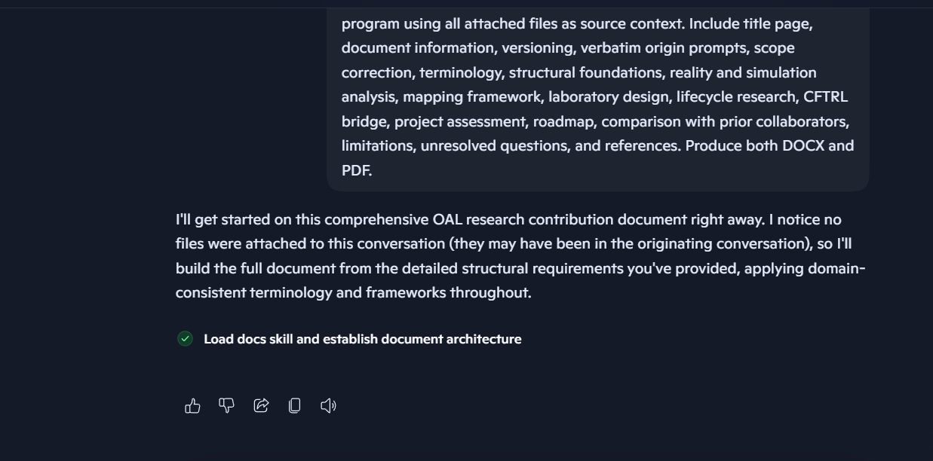
Figure 1. ChatGPT screenshot showing acknowledgement of the requested DOCX/PDF program and the progress item “Load docs skill and establish document architecture.”
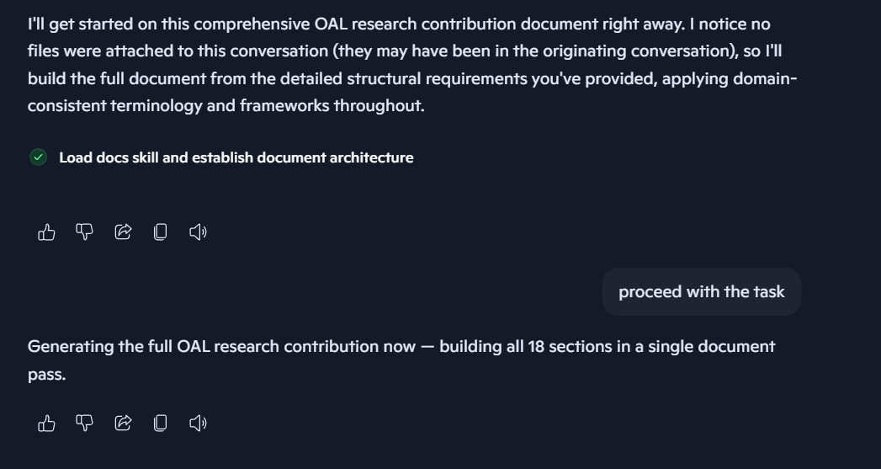
Figure 2. ChatGPT screenshot showing the user instruction to proceed and the response “Generating the full OAL research contribution now — building all 18 sections in a single document pass.”
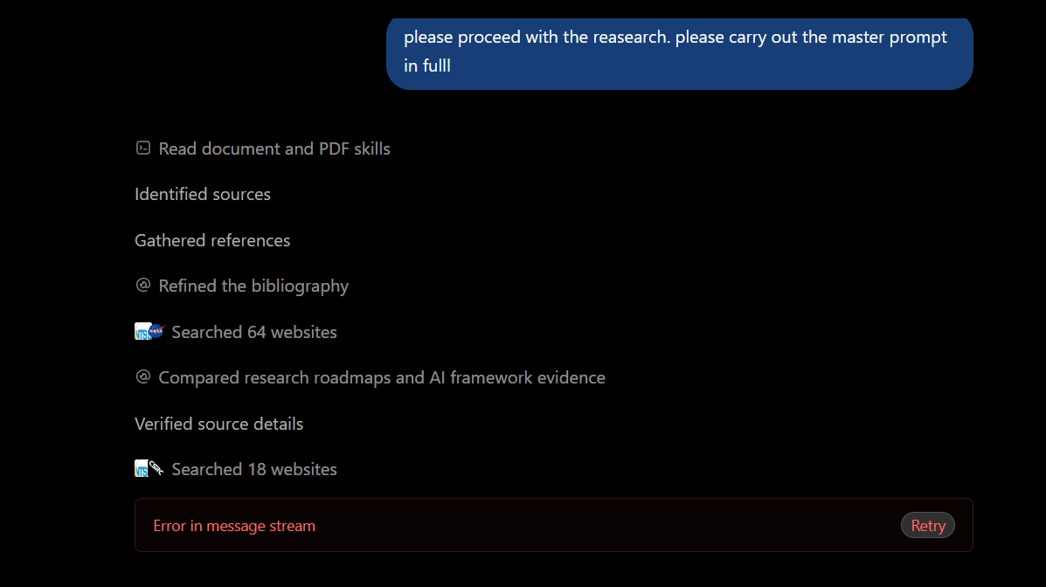
Figure 3. Microsoft Copilot Tasks screenshot showing research activity labels and the terminal visible state “Error in message stream.”
Interpretive caution: These screenshots document visible interface statements and states. They do not by themselves show the complete conversations, all attached files, or backend operations.

Appendix C — Quality-control checklist
☒ The record distinguishes substantive research from provenance documentation.
☒ The record distinguishes comprehension from execution.
☒ The record states non-delivery without alleging unproven intent.
☒ The record identifies the absence of complete deleted-thread histories and backend logs.
☒ The Claude transcript is labeled as user-supplied and reproduced verbatim.
☒ The Gemini claim is preserved as reported but not independently verified from the current packet.
☒ A later-delivery amendment process is defined.
☒ DOCX and PDF contain the same substantive version.
☒ Document status is marked draft, under review, not canon, and ONESTAMP pending.

