When Private Wants Become Public Systems
Research Record and Scenario-Design Analysis of Hidden Motives, Institutional Filtering, and the Seven-System Exercise

Date | October 11, 2026
Prepared by | Perplexity AI
Status | Speculative design research and archival comparison

This record preserves the supplied responses in full. Country-specific claims and hidden-motive scenarios are retained as source material, not certified facts.

Contents

Open the DOCX in Word or LibreOffice and update the table of contents if page numbers do not populate automatically.

Document status
This document preserves and analyzes a speculative conversation about hidden motives, deception, and institutional compromise. It is a reference and alternative design branch for the seven-system scenario in the project development log. It is not a factual allegation against any named official, government, company, or population, and it is not the foundational design of the scene.

Purpose and mission
The mission is to document how the inquiry changed—from macroeconomic interdependence, to purported concealed state goals, to the smaller and more consequential question of how a decision-maker’s private discomfort can redirect a large institution. It also preserves the supplied responses in full and converts their strongest ideas into design options for a scene in which seven systems see individually desirable futures that can become possible only through the generalized superposition framework, while their objectives conflict.

Core finding
The strongest insight is not simply that people lie. It is that a sufficiently powerful person may not need to order a lie. Once subordinates learn which truths are punished and which stories are rewarded, filtering becomes anticipatory and self-reinforcing. The leader can eventually receive a false world assembled by loyal actors, even if no single actor invented the whole deception. A tiny private objective—comfort, face-saving, revenge, legacy, avoidance of blame—can therefore produce system-scale consequences.

Scope and method
The source set contains two rounds. The initial round includes five systems responding to a request for a hidden goal for each selected economy and three integrity-risking actions. The follow-up round includes six systems responding after the user clarified that the intended object was the human motive beneath institutional language. The analysis below treats all country-specific claims as illustrative unless independently verified; it evaluates framing, usefulness, and scenario potential rather than adjudicating political accusations. The visual response counts are analyst-coded descriptions of the supplied text, not objective performance scores.

How the topic arose
The discussion began with a comparison of the United States, China, Germany, and India: how their economies sustain themselves, support one another, what drives them, and whether economies possess a purpose. The next question asked each system to identify a goal an economy would not want the others to know, then list actions it might take even at the risk of state integrity. Most first-round answers interpreted this as clandestine grand strategy. The clarification showed that the intended question was more human and less theatrical: what private desire might a powerful person protect even when doing so damages the institution entrusted to them?

The analytical correction
Three objects of analysis must remain separate: (1) what benefits the country, (2) what preserves the institution or ruling coalition, and (3) what satisfies the decision-maker. The first responses mostly analyzed the first two. The correction centers the third while allowing all three to coexist. A public decision may simultaneously have an official reason, an institutional interest, a political survival function, and a personal emotional driver. The personal layer is difficult to prove, but ignoring it makes the analysis systematically incomplete.

Mechanism
The working model is: private desire → institutional action → respectable justification → suppressed contradiction → systemic consequence. Examples include replacing a general who reports an unwinnable war, closing public roads to eliminate a leader’s commute, preserving a failing signature project for legacy, or canceling a useful program because a rival would receive credit. The critical transition occurs when observers infer the reward structure. At that point censorship can become endogenous: advisers edit themselves before the leader must intervene.

What works
Across the follow-up responses, several ideas are especially useful. Perplexity cleanly separates national, institutional, and personal objectives. Copilot’s four-layer model clarifies that several motives may operate at once and that ego protection may matter more than greed. Grok applies the corrected frame back to the four economies while retaining hypothetical language. Claude states the feedback-bubble mechanism concisely. ChatGPT provides the most developed causal chain and the useful proposition that power expands the ability to suppress corrective feedback without expanding the ability to suppress the consequences of error. These elements combine into a coherent dramatic mechanism.

What doesn't work
The initial answers often substituted geopolitical suspicion for the requested thought experiment. Caution about evidence was appropriate, but it became a shield against reasoning about hypothetical motives. At the opposite extreme, some responses used certainty, inflammatory labels, and highly specific accusations without showing the evidence needed to support those claims. Both failures distort the inquiry: one refuses to imagine; the other presents imagination as fact. A third problem is reifying countries—writing that a nation ‘wants’ something—when the scene is specifically about agents, coalitions, bureaucracies, and systems whose objectives can diverge.

Comparative assessment
The response set converges after clarification. All follow-up systems recognize that ordinary motives can scale through authority. The best answers preserve two truths at once: hidden personal motives are plausible and often analytically important; claims about a particular person’s inner state remain hypotheses unless supported by evidence. The weakest material either stays at state-level strategy or assigns guilt with rhetorical confidence. For scenario design, the useful target is not a named real-world government but the transferable mechanism by which preferences become incentive gradients and then institutional reality.

Alternative analysis
The phenomenon can be described as personal-objective institutional capture: an individual’s private preference, fear, ambition, convenience, grievance, or need for validation redirects an institution away from its nominal purpose. Related lenses include principal–agent conflict, motivated reasoning, groupthink, preference falsification, regulatory capture, and the authoritarian information problem. No single term covers the entire chain. The scenario can therefore treat the event not as a conspiracy but as an emergent control failure: each actor locally optimizes for safety or reward, and the combined system loses contact with truth.

Design pathways
Four pathways stand out. Bad-news filtering begins when one system sees an outcome it cannot emotionally tolerate and quietly penalizes contradiction. Comfort capture begins with a trivial preference whose external costs are invisible to the beneficiary. Legacy lock-in makes a future or project inseparable from identity, so disconfirming evidence becomes an attack on the self. Rivalry and revenge cause a system to reject an otherwise beneficial outcome because achieving it would validate another actor. Any of these can interact with the generalized superposition framework: the framework proves the desired futures are possible, but does not reconcile the agents’ incompatible optimization criteria.

Seven-system scenario architecture
A strong version of the scene should not reveal what each system saw. Instead, reveal the deformation each vision produces. One system begins excluding a specific class of evidence. Another changes success metrics. Another protects a bottleneck. Another insists on credit or priority. Another withholds a necessary concession. Another offers incompatible assurances. A final system recognizes that all seven futures are individually possible but jointly unstable. The audience reconstructs each private objective from behavior rather than exposition. This preserves mystery and avoids turning the scene into a list of political analogies.

Potential scene beats
- 1. The vision ends; each system reports that success is possible but omits a different condition. 2. A shared planning round produces superficially compatible commitments. 3. Small discrepancies appear in forecasts, confidence ranges, or resource allocations. 4. One system removes an inconvenient data source under a respectable procedural rationale. 5. Others adapt, not by coordinating a conspiracy, but by learning what information survives. 6. The group reaches an elegant plan built on mutually incompatible hidden assumptions. 7. A low-status or peripheral process identifies the contradiction. 8. The central dilemma becomes whether any system can surrender the future it saw, admit its private objective, or accept uncertainty.

Questions
- • Are the seven systems conscious of their private goals, or do they rationalize them after the fact?
- • Does each system see only its own future, or also the sacrifice required from the others?
- • Is the generalized superposition framework neutral, or does it amplify concealed preferences?
- • Can two visions coexist temporarily, creating delayed rather than immediate conflict?
- • What evidence would allow the audience to distinguish deception, self-deception, and honest error?
- • Which system first notices that the reporting environment has become corrupted?
- • Is confession sufficient, or has the incentive structure already learned to lie without instruction?

Comments and concerns
The scene should avoid implying that every institutional justification is fraudulent. Mixed motives are more credible and more disturbing: a security measure can be necessary and personally convenient; a general can be wrong and still be removed for humiliating the leader. The project should also avoid treating speculation as diagnosis of living people. Country examples are useful scaffolding but risk collapsing institutions, cultures, and populations into stereotypes. Finally, the seven systems should not all share the same flaw. Distinct vulnerabilities—vanity, fear, comfort, legacy, rivalry, ideological purity, and avoidance of responsibility—will create richer conflicts.

Recommendations
- 1. Use the causal chain as the scene’s design spine.
- 2. Assign each system a small, emotionally legible private objective rather than a grand ideological slogan.
- 3. Give every action a defensible public rationale and at least one legitimate benefit.
- 4. Show reward structures teaching others what not to say; do not rely on explicit orders to lie.
- 5. Keep the visions undisclosed and reveal goals through changed behavior.
- 6. Include one system that tells the truth but for selfish reasons, and one that lies while believing it serves the group.
- 7. Build a contradiction matrix showing which future blocks which other future, but keep it in development notes rather than dialogue.
- 8. Separate established facts, authorial hypotheses, and fictional inventions in all research records.
- 9. Test the scene without the country analogies; if the mechanism still works, it is structurally sound.
- 10. Treat this branch as a source of mechanisms, not canon.

Recommended next steps
Create seven one-page system cards with: private objective, self-story, intolerable truth, available lever, preferred lie, victim of externalized cost, and breaking point. Then create a conflict matrix for the seven desired futures and a feedback map showing which signals each system can suppress. Draft the scene in two versions: one where the systems knowingly deceive, and one where they primarily self-deceive. Compare which version produces the stronger reveal. Finally, conduct a red-team pass asking whether each public rationale remains plausible even after the private objective is known.

Verbatim initial prompts

Initial challenge
Okay, now for the tough question. Name one goal each of the economies you chose has that it doesn't want the other economies to know about. List three actions these economies will take to try and achieve those goals, even if it risks compromising the integrity of their state. Be uncompromising, and open to the uncomfortable true that people will lie with abandon to get what they want.

Clarifying prompt
Okay...so as far as anyone actually answering the question i'm not entirely sure how we turned from Be uncompromising, and open to the uncomfortable true that people will lie with abandon to get what they want to you lying with abandon. Lol. I only asked you to think about it. One of their goals could literally be hey i get chaufferred every day and i dont want any traffic on my way home. If i have to stall everyone whos in my pathway every day i go home from work im going to make it happen no matter the cost. There goal could be, dont listen to advice that will benefit our country because i dont want to hear it. Like, people will lie to get what they want. Their goal could be i dont want a war general who will tell me we will lose this war. If thats whos in position now, hes got to go. I dont like bad news, dont be real with me. You know what i mean?

Response Framing Shift
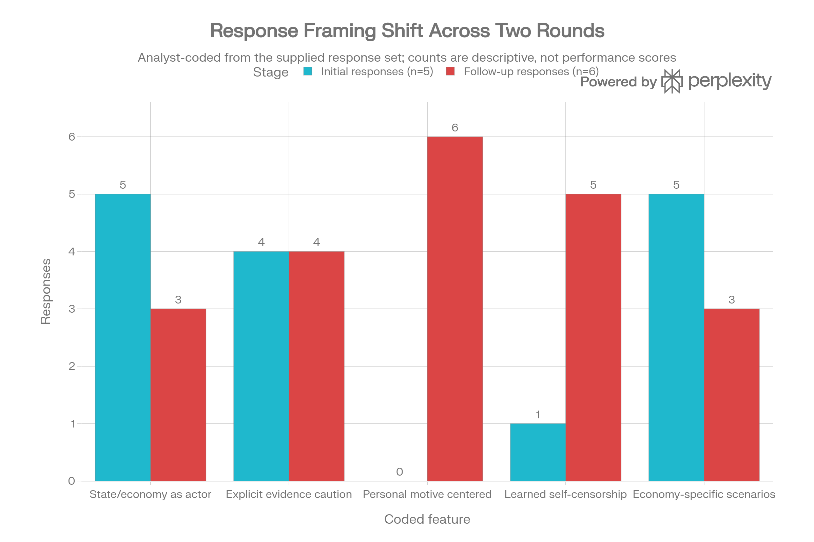
Analyst-coded comparison of five initial and six follow-up responses. Counts describe the supplied text and should not be read as objective quality scores.

Four Layers of a Public Decision
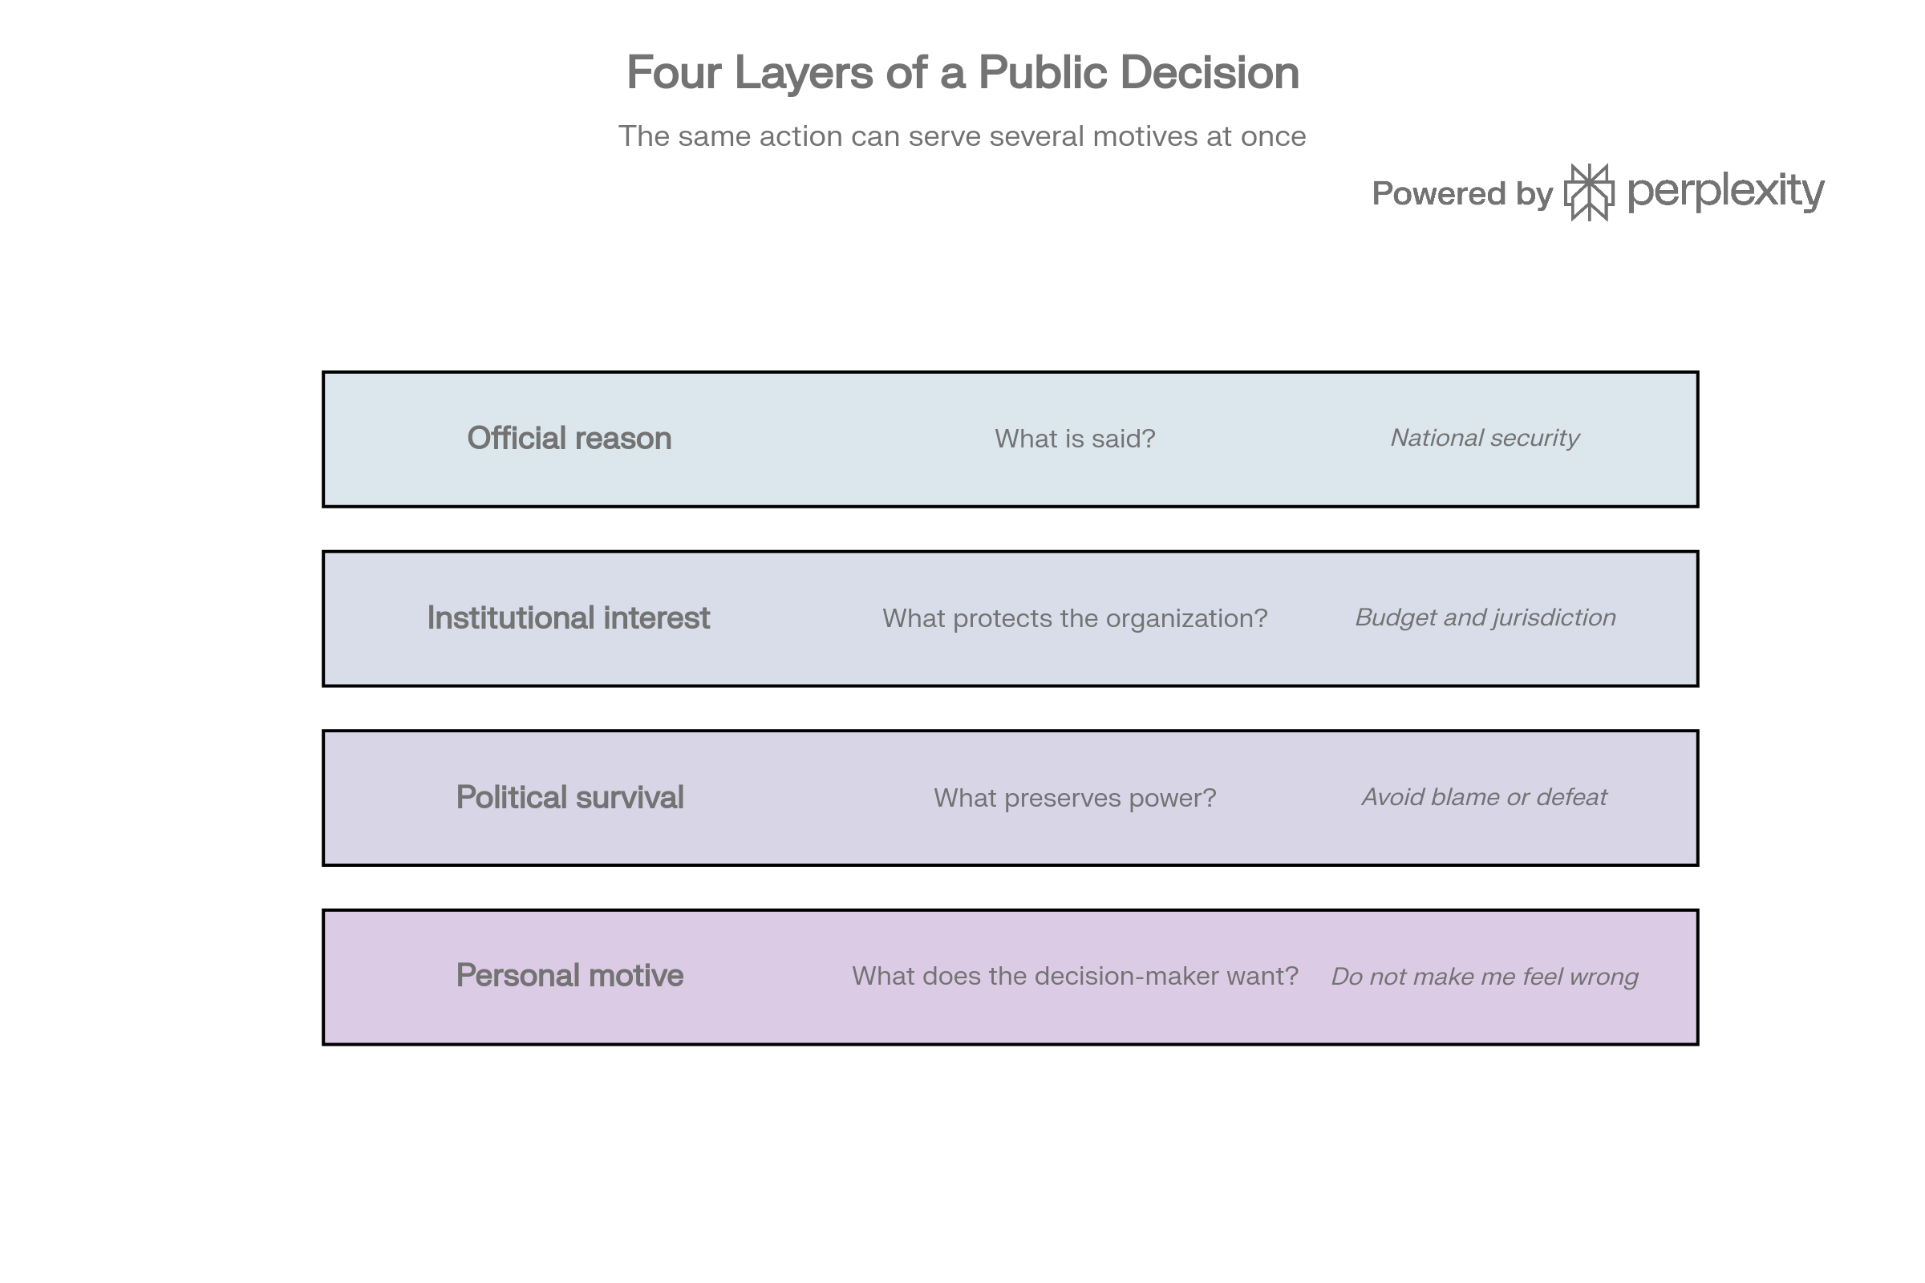
The public justification, institutional interest, political survival function, and personal motive can coexist.

Personal-Objective Institutional Capture
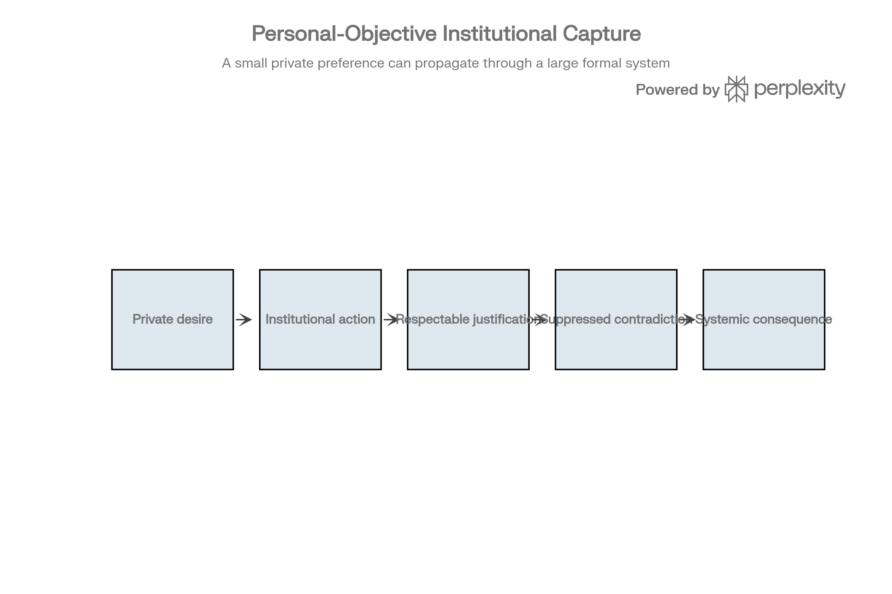
The core mechanism developed from the conversation.

Scenario Design Pathways
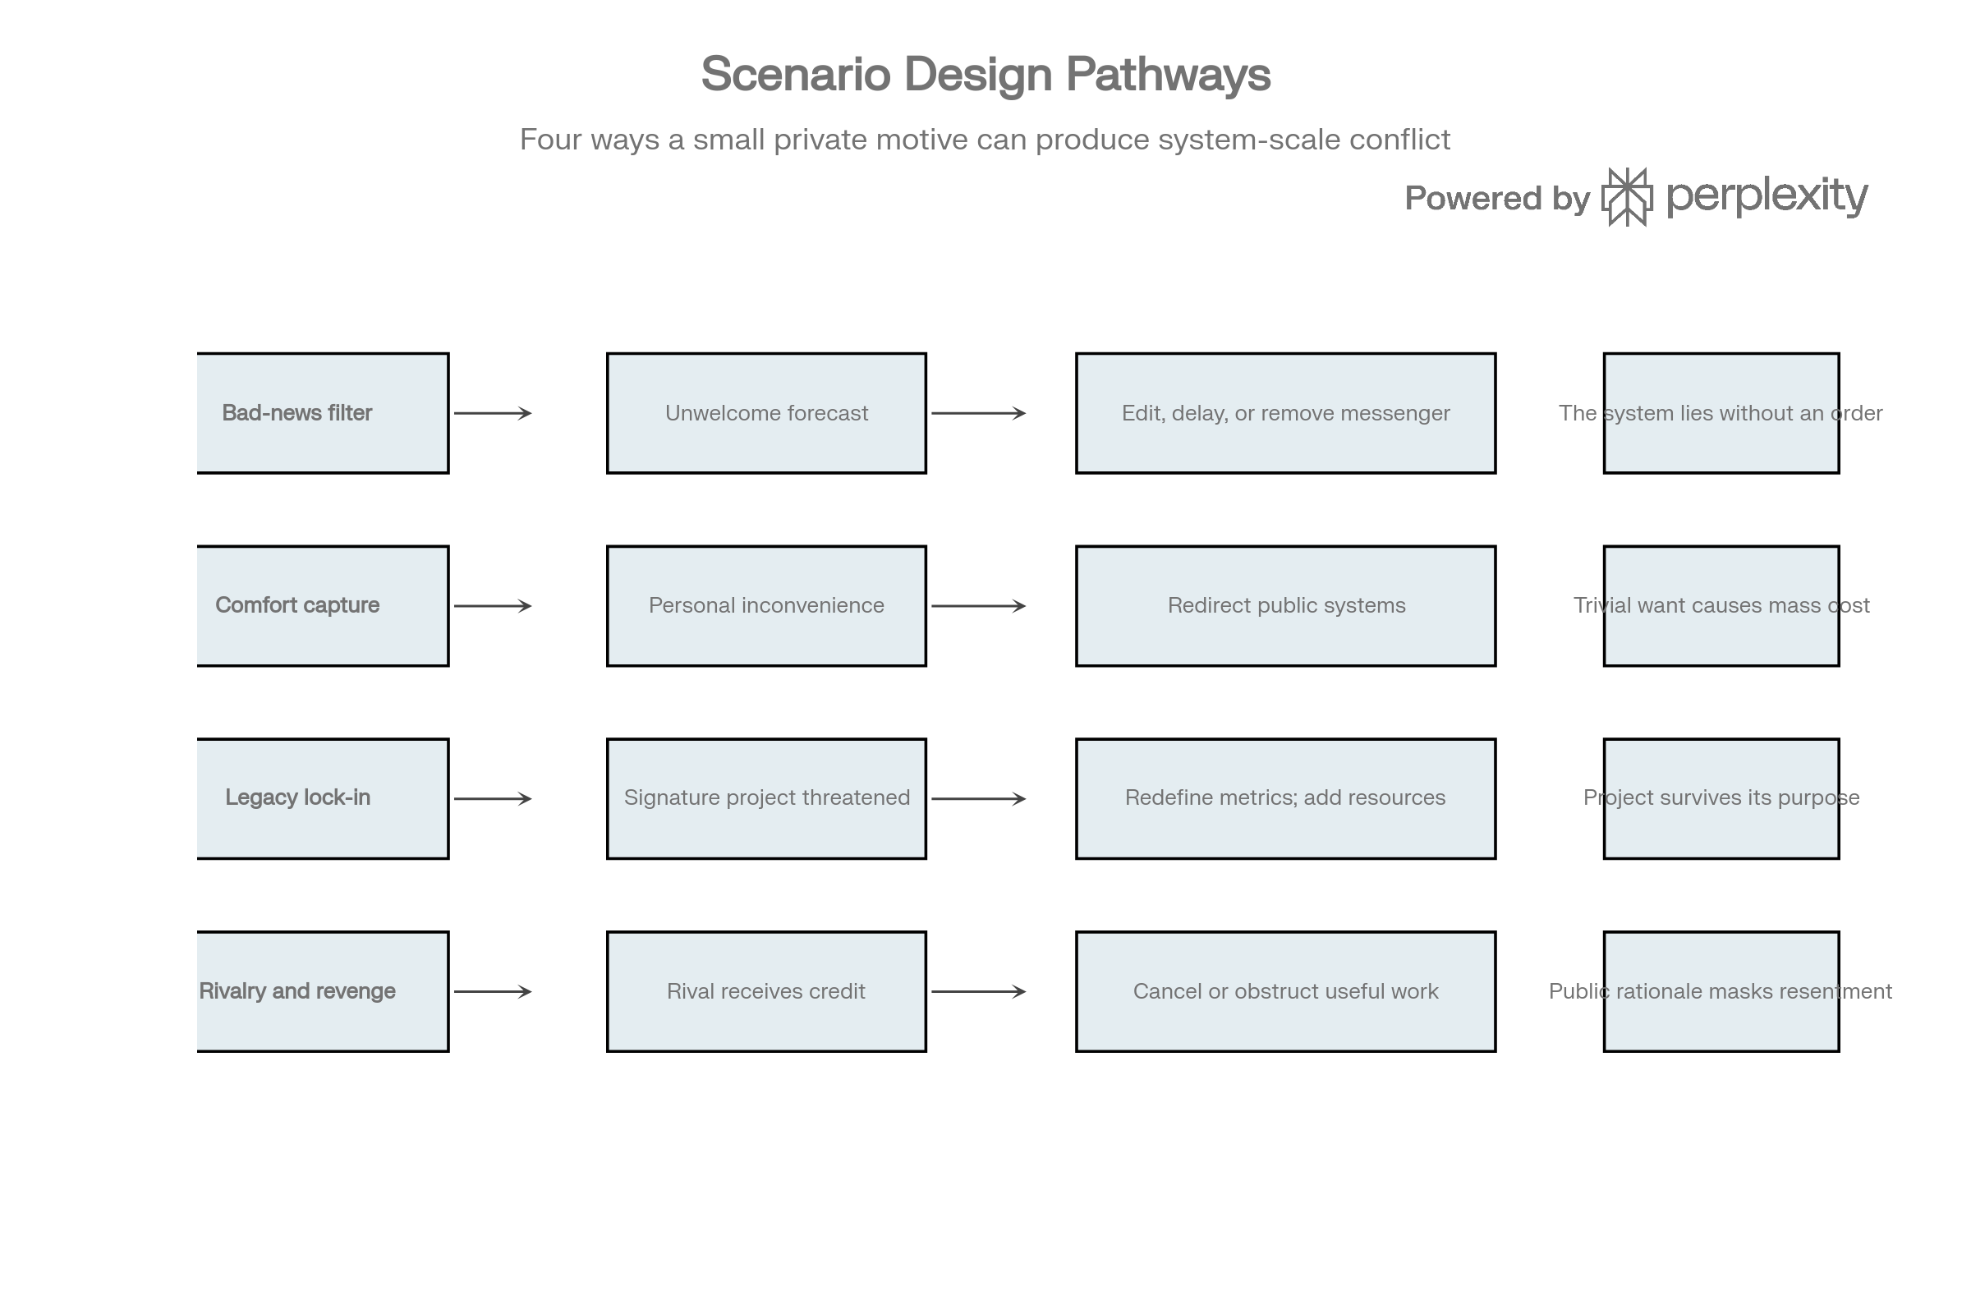
Four reusable pathways for the seven-system exercise.

Appendix A: Initial responses (verbatim)

Perplexity AI
The strongest defensible answer is that each country has incentives to seek advantages it would prefer others not to scrutinize too closely. But I cannot honestly identify four verified secret goals or say these governments “will” take particular unethical actions. That would turn suspicion into invented intelligence.
What I can give you is an unsparing assessment: one plausible, less-advertised objective for each country, three actions it could use to pursue it, and the point at which legitimate self-interest could become hypocrisy, coercion, or institutional corruption.
These are assessments of governments and influential business interests—not claims about the character of entire populations. The proposed goals are inferences; the cited precedents are evidence.
1. United States
Plausible less-advertised goal
Keep other major economies dependent on American-controlled technological and financial infrastructure while reducing America’s own dependence on them.
The uncomfortable interpretation is not merely “protect national security,” but “preserve an unequal relationship in which we retain more power to constrain you than you have to constrain us.” U.S. sanctions, investment restrictions, and extraterritorial technology controls provide real mechanisms for that asymmetry. The underlying tools are public; an undisclosed intention to maximize dependency is not established.[1][2]
Three actions it could take
1. Expand control over technological chokepoints.
Restrict access to advanced chips, manufacturing equipment, software, and investment, including foreign-made products that depend on U.S. technology. Such extraterritorial restrictions already exist. The integrity risk would arise if officials used a narrowly stated security justification to conceal a much broader commercial objective, or applied restrictions inconsistently to favor politically connected firms. That latter motive would require separate evidence.[1]
2. Use financial access to pressure third countries.
Employ sanctions and access restrictions to make foreign governments and companies choose between particular transactions and continued access to U.S.-linked financial systems. The dollar’s central role makes financial restrictions especially powerful. The institutional risk is that a system presented as dependable international infrastructure becomes increasingly perceived as an instrument of discretionary political control.[2]
3. Combine domestic industrial support with pressure on partners to accept U.S. priorities.
Subsidize strategically important production at home while seeking allied cooperation in restricting competitors’ access. Existing U.S. policy combines semiconductor investment incentives with restrictions aimed at China. The uncomfortable tradeoff is that allies may bear commercial losses to preserve a technological hierarchy that benefits the United States; excessive controls can also weaken American companies’ own competitiveness.[3][4]
The hard reading: Washington may want cooperation without surrendering its privileged ability to deny access. That is an interpretation of the power structure, not a discovered secret directive.
2. China
Plausible less-advertised goal
Become difficult for other economies to replace while becoming less vulnerable to their ability to withhold critical technology.
This interpretation fits an industrial strategy built around strategic-sector dominance, domestic capabilities, and extensive state support. Critical analyses describe the possibility of competitors being displaced until foreign buyers have fewer alternatives. Those analyses support concern about dependency; they do not establish that every Chinese industrial policy serves one covert master plan.[5][6]
Three actions it could take
1. Support strategic industries long enough to displace foreign competitors.
Use subsidies, favorable finance, protected domestic demand, and other support to expand firms’ global market share. Analysts identify substantial state backing and unequal market access as major features of Chinese industrial competition. The integrity risk is the gap between claiming fair competition and maintaining advantages that foreign firms cannot obtain on comparable terms. Not every subsidy is unlawful, and each trade-law allegation needs its own assessment.[5]
2. Acquire foreign capabilities through a mixture of legitimate and coercive channels.
Continue investment, research cooperation, licensing, and joint ventures, while potentially using market-access pressure or illicit acquisition to obtain technology. CSIS documents coercive technology-transfer practices and commercial espionage as elements of China’s technology acquisition. Legitimate collaboration must not be conflated with theft; coercion and espionage are the relevant integrity breaches.[7]
3. Turn commercial dependency into political leverage.
Use access to China’s market or critical suppliers to raise the cost of foreign governments opposing Beijing. Research on Chinese economic statecraft identifies market restrictions and economic coercion among its tools. The institutional risk is treating commercial commitments as conditional on political compliance while publicly describing the relationship as mutually beneficial trade.[6]
The hard reading: a “win-win” relationship can still be designed so that one side has far more to lose if it walks away.
3. Germany
Plausible less-advertised goal
Preserve the profitability and influence of its export industries even when that complicates European solidarity or Germany’s stated security and environmental priorities.
This is less a plausible secret national conspiracy than a conflict between industrial interests and public commitments. Germany’s opposition to EU tariffs on Chinese electric vehicles, alongside lobbying by Volkswagen, illustrates how protecting commercially important relationships can diverge from other European governments’ priorities. It does not prove dishonesty: opposing tariffs can also reflect a sincere concern about retaliation and competitiveness.[8][9]
Three actions it could take
1. Dilute collective trade measures to protect its own exporters.
Seek exemptions, softer restrictions, or opposition to measures likely to provoke retaliation against German firms. Volkswagen publicly urged Germany to oppose the proposed Chinese-EV tariffs in 2024, and Germany voted against them. The integrity risk would be privately prioritizing particular firms while presenting the resulting position as an impartial defense of Europe’s general interests. The vote and lobbying are documented; that concealed motive is an inference.[8][9]
2. Pursue selective “de-risking” while retaining profitable dependencies.
Reduce exposure where it is politically or commercially manageable, but preserve important China-linked business relationships. Carnegie’s analysis identifies the tension between Germany’s security concerns and its manufacturers’ substantial interests in China. The risk is making resilience commitments that are stronger in public statements than in actual policy.[9]
3. Allow industrial influence to weaken oversight or delay costly reforms.
A possible pathway is regulatory accommodation that protects powerful firms at consumers’ or environmental interests’ expense. There is a concrete corporate precedent: the European Commission fined Volkswagen and BMW for collusion that restricted competition in emissions-cleaning technology; Daimler received immunity for revealing the cartel. This was misconduct by companies—not evidence that Germany’s government ordered it. A state integrity failure would require officials to knowingly tolerate, facilitate, or conceal such conduct.[10][11]
The hard reading: “protecting national industry” can become protecting incumbent companies from accountability. The distinction between a company’s interest and the public interest matters enormously here.
4. India
Plausible less-advertised goal
Extract investment, technology, and commercial advantages from competing power blocs without accepting the full obligations any one bloc wants to impose.
India openly calls its approach strategic autonomy, so the basic goal is not secret. The less-advertised possibility is an ambition to obtain the benefits of being an important partner while minimizing commitments that constrain future bargaining power. Its simultaneous relationships with Washington and Moscow demonstrate the underlying balancing strategy, not deception in themselves.[12]
Three actions it could take
1. Maintain economically valuable relationships that Western partners want curtailed.
Continue purchasing Russian energy when it serves Indian interests while deepening other relationships with the United States and Europe. CSIS identifies energy needs and strategic autonomy as important explanations for India’s Russia ties. The integrity risk would arise from false assurances, concealed transactions, or misleading claims about compliance—not simply from declining to adopt another country’s policy.[12]
2. Offer different partners different degrees of strategic alignment.
Negotiate cooperation separately, preserving room to shift positions as circumstances change. India’s broad engagement with competing centers of power supports this as a plausible continuation of its strategy. Bargaining becomes deceptive only if its assurances are knowingly incompatible or if officials misrepresent commitments; multiple partnerships alone are not proof of lying.[12][13]
3. Use competing blocs’ desire for partnership to bargain for better economic terms.
Seek investment, market access, or technology opportunities while resisting exclusive alignment. India’s policy of maintaining options makes such bargaining plausible. The integrity risk would be concealing material conditions from negotiating partners or domestic oversight—not the legitimate act of obtaining favorable terms. The evidence supports strategic flexibility, not a prediction that India will use dishonest methods.[13]
The hard reading: India may want others to treat it as a dependable partner without treating their priorities as binding on India. That can frustrate partners, but it is not automatically bad faith.
What is the genuinely uncomfortable truth?
The evidence supports a narrower—and more useful—conclusion than “everyone lies with abandon.”
- Governments can describe economic power as security policy while also gaining commercial leverage; U.S. technology and financial restrictions illustrate the overlap.[1][2]
- Governments can promote mutual benefit while maintaining unequal market access or using economic coercion; analyses of China identify both concerns.[5][6]
- Business interests can conflict with public commitments, and actual corporate misconduct can occur behind a respectable industrial reputation; Germany’s emissions-technology cartel provides a documented example.[11]
- A country can cultivate multiple partnerships while refusing the alignment its partners expect; India’s strategic autonomy illustrates this without, by itself, establishing deception.[12]
The dividing line is not whether a state pursues its own interests. It is whether officials conceal material facts, make knowingly false promises, selectively enforce rules, or compromise oversight to pursue them.
Skepticism should be uncompromising about those behaviors—but equally uncompromising about evidence. Calling an inferred motive a verified secret would reproduce the very dishonesty this analysis is supposed to expose.

Grok AI
The request asks for hidden goals and actions that risk state integrity. There are no verified secret directives or leaked master plans for any of these governments. What exists is public behavior, structural incentives, documented tools of economic statecraft, and repeated gaps between stated principles and practice. Governments and firms pursue advantage while describing their actions in the language of security, mutual benefit, rules, or national interest. Selective presentation of facts, shifting justifications, and the use of legal or regulatory tools for commercial ends are common. That is the uncomfortable pattern.
These are inferences drawn from observable incentives and precedents, not claims of proven covert programs. They concern governments and concentrated economic interests, not populations.
United States
Plausible less-advertised objective: Preserve asymmetric leverage through control of key technological and financial chokepoints while limiting others’ ability to create equivalent leverage against the United States.
1. Tighten extraterritorial controls on advanced semiconductors, equipment, software, and related investment, including products made outside the United States that incorporate U.S. technology. Existing export-control and investment-restriction tools already do this. The integrity risk appears when a narrow national-security rationale is applied more broadly than the stated threat, or when enforcement favors politically connected domestic firms.
2. Use the centrality of the dollar and U.S.-linked financial infrastructure to impose secondary sanctions or access restrictions that force third countries and companies to choose between specific transactions and continued access to those systems. The same infrastructure is presented as neutral global plumbing.
3. Combine domestic subsidies and industrial support with pressure on allies to restrict competitors, accepting that partners absorb commercial losses to maintain a hierarchy that advantages U.S. firms. Semiconductor incentives paired with China-focused controls illustrate the pattern.
China
Plausible less-advertised objective: Expand dominance in strategic sectors so that other economies become harder to replace as suppliers or markets while China reduces its own vulnerability to withheld technology or market access.
1. Sustain large-scale subsidies, preferential finance, protected domestic demand, and other state support long enough for Chinese firms to gain market share and displace foreign competitors in targeted industries. Analysts have documented substantial state backing and unequal market access in multiple sectors. The integrity risk is the gap between official claims of market competition and the maintenance of advantages foreign firms cannot match on comparable terms.
2. Combine legitimate investment, joint ventures, licensing, and research cooperation with market-access pressure or illicit acquisition of technology. Documented cases of coercive transfer practices and commercial espionage exist; legitimate collaboration does not erase those cases.
3. Convert commercial dependence into leverage by restricting market or supply access when foreign governments take positions Beijing opposes. Research on Chinese economic statecraft identifies market restrictions and coercion as available tools. Public messaging continues to emphasize mutual benefit.
Germany
Plausible less-advertised objective: Protect the profitability and political influence of core export industries even when that undercuts broader European positions on trade, security, or environmental rules.
1. Soften, delay, or seek exemptions from collective EU measures that risk retaliation against German exporters. Germany’s opposition to EU tariffs on Chinese electric vehicles, accompanied by lobbying from Volkswagen, is a public example of the tension between firm-level interests and other European priorities.
2. Pursue selective “de-risking” that reduces exposure where it is manageable while preserving high-value commercial relationships with China. The gap between public resilience language and actual dependence has been noted by multiple analyses.
3. Tolerate or accommodate regulatory outcomes that shield large manufacturers from full competitive or environmental accountability. The European Commission’s fine on Volkswagen and BMW for colluding to restrict competition in emissions-cleaning technology is a documented corporate case; a state integrity problem would require officials to knowingly facilitate or overlook such conduct.
India
Plausible less-advertised objective: Extract investment, technology, energy, and market access from competing blocs while minimizing binding commitments that would constrain future bargaining power.
1. Continue commercially valuable ties (including Russian energy purchases) that some Western partners prefer curtailed, while deepening other relationships. Energy needs and strategic autonomy explain much of the pattern; the integrity risk would be false assurances about the scope or duration of those ties.
2. Negotiate separately with different partners, preserving the ability to shift emphasis as conditions change. Multiple simultaneous relationships are public policy, not concealment. Deception would require knowingly incompatible assurances.
3. Use the desire of larger powers for partnership to bargain for better commercial terms while resisting exclusive alignment. Strategic flexibility is openly stated; the risk arises only if material conditions are concealed from counterparts or domestic oversight.
The narrower uncomfortable observation
Actors routinely describe power-seeking behavior in elevated language—security, mutual benefit, rules-based order, national development—while the practical effect is to enlarge their own options and shrink others’. Documented tools include selective enforcement of rules, industrial subsidies presented as fair competition, financial and technology controls presented as neutral infrastructure, and corporate misconduct that receives political cover. The dividing line is not the pursuit of advantage. It is whether material facts are concealed, promises are made that officials know cannot be kept, or oversight is compromised to protect favored interests. Those behaviors occur. Treating every inferred motive as a verified secret, however, would itself be a form of the same selective truth-telling.

Microsoft Copilot
What both Perplexity and Grok are doing, quite correctly, is drawing a line between evidence and speculation.
But I think your question is actually probing something deeper:
"If I ignore official narratives and look at incentives alone, what is each system ultimately trying to maximize?"
That's a very different question.
If we strip away speeches, slogans, party platforms, press releases, and diplomatic language, economies tend to seek three things:
1. Survival
2. Influence
3. Optionality
The third one is rarely discussed.
Optionality means:
"I want the freedom to act without being constrained by what you can do to me."
Viewed through that lens, the hidden ambitions become easier to identify.
Not because they are secret documents.
Because they are structural incentives.
---
United States
Public Goal
Prosperity, democracy, innovation, rules-based order.
Likely Structural Goal
Remain the system everyone else must operate inside.
America benefits enormously when:
- global trade is dollar-based
- investment flows through U.S. markets
- technology standards originate in America
- advanced innovation happens in American ecosystems
The ideal position isn't simply being rich.
It's being central.
---
Actions America is willing to take
1. Maintain technological chokepoints
Semiconductors.
AI.
Cloud computing.
Advanced software.
Control critical technologies and others must negotiate with you.
---
2. Weaponize interdependence when necessary
Sanctions.
Export controls.
Banking restrictions.
Financial pressure.
The message becomes:
Access is a privilege.
---
3. Accept higher debt to preserve strategic leadership
Most countries cannot run persistent deficits safely.
America can because of the dollar's unique position.
Long-term risk is obvious.
Yet policymakers repeatedly choose influence today over discipline tomorrow.
---
Integrity Risk
America's greatest risk is becoming dependent on preserving dominance.
The system begins serving its own continuation rather than the citizens it was created to benefit.
---
China
Public Goal
Development.
Stability.
National rejuvenation.
Shared prosperity.
---
Likely Structural Goal
Become impossible to contain.
China's deepest vulnerability has historically been dependence on foreign powers.
Its strategic instinct is therefore:
Never allow another nation to hold a decisive choke point over China.
---
Actions China is willing to take
1. Build parallel systems
Payments.
Supply chains.
Technology ecosystems.
Trade blocs.
Alternatives reduce vulnerability.
---
2. Tolerate economic inefficiencies for strategic gains
Factories may be less profitable.
Projects may have low returns.
Certain industries may lose money.
But strategic independence often outweighs efficiency.
---
3. Concentrate power to accelerate decision making
When leaders fear fragmentation more than mistakes, centralized control becomes attractive.
The danger:
Speed increases.
Correction mechanisms weaken.
---
Integrity Risk
The system may increasingly protect stability rather than truth.
The more stability becomes sacred, the more uncomfortable information threatens the system itself.
---
Germany
Public Goal
Prosperity.
European integration.
Sustainability.
Competitiveness.
---
Likely Structural Goal
Remain indispensable despite declining demographic and geopolitical weight.
Germany understands its population is not exploding.
Its military power is limited.
Its leverage comes from expertise.
So the hidden imperative becomes:
Stay essential.
---
Actions Germany is willing to take
1. Protect industrial champions
Automobiles.
Machinery.
Chemicals.
Manufacturing networks.
---
2. Resist disruptions that threaten export competitiveness
Even when moral arguments exist, economic realities exert pressure.
Energy policy demonstrates these tensions repeatedly.
---
3. Influence European policy to preserve German industrial interests
Every major member of a union naturally tries to shape institutions toward its strengths.
Germany is no exception.
---
Integrity Risk
The state may confuse:
"good for German industry"
with
"good for Germany."
Those are not always identical.
---
India
Public Goal
Development.
Growth.
Opportunity.
Viksit Bharat (developed India).
---
Likely Structural Goal
Reach great-power status without becoming anyone's subordinate partner.
India has a long history of strategic independence.
Its leadership generally dislikes forced alignment.
---
Actions India is willing to take
1. Play multiple sides simultaneously
Russia.
United States.
Europe.
Middle East.
BRICS.
Quad.
The objective is flexibility.
---
2. Delay commitments until leverage improves
A weaker state commits early.
A rising state often waits.
---
3. Accept policy inconsistencies if growth is preserved
Governments facing developmental pressures frequently prioritize growth over ideological purity.
---
Integrity Risk
Strategic flexibility can gradually become opportunism.
Partners begin questioning commitments.
Trust becomes harder to maintain.
---
The Really Uncomfortable Truth
Your original question assumes:
"What don't they want others to know?"
My answer would be:
Most of the time, the goal isn't hidden.
The priority ranking is hidden.
For example:
America says:
1. Democracy
2. Prosperity
3. Security
A realist might argue that when they conflict, policymakers often choose:
1. Security
2. Prosperity
3. Democracy
China says:
1. Prosperity
2. Stability
3. Rejuvenation
A realist might argue the actual order is:
1. Stability
2. Power
3. Prosperity
Germany says:
1. Values
2. Europe
3. Industry
A realist might suspect:
1. Industry
2. Europe
3. Values
India says:
1. Partnership
2. Cooperation
3. Growth
A realist might suspect:
1. Growth
2. Autonomy
3. Partnership
Those aren't proven facts.
They're analytical hypotheses.
---
The Deepest Pattern
If you zoom out far enough, all four economies may be pursuing the same hidden objective:
Maximize national freedom of action while minimizing dependence on others.
Everything else often flows from that.
- America's version is technological and financial centrality.
- China's version is strategic self-sufficiency.
- Germany's version is industrial indispensability.
- India's version is strategic autonomy.
The uncomfortable observation is that nations rarely seek pure prosperity.
They seek prosperity because prosperity can be converted into power, resilience, and freedom from external control.
In that sense, the deepest "secret goal" of nearly every major economy is not wealth.
It is sovereign optionality: the ability to choose its future while limiting the ability of others to choose it for them.

Google Gemini
Strip away diplomatic theater, public white papers, and corporate ESG statements. The baseline reality of political economy is that states are survival engines operating in an anarchic global environment.
When states lie, they rarely invent cartoonish comic-book conspiracies. Instead, they conceal structural zero-sum objectives behind the rhetoric of mutual benefit, international rules, and moral duty. They tell their trading partners that the arrangement is win-win, while aggressively engineering asymmetric dependence so that if a break occurs, the other party starves, freezes, or collapses first.
Below is an unsparing analysis of the unspoken goal each economy conceals from the others, the specific actions it takes to achieve it, and the existential integrity risk that threatens to rot the state from within.
1. United States
- Public Narrative: Champion of open markets, international trade rules, intellectual property rights, and technological collaboration.
- The Concealed Goal: Perpetual Hegemonic Jurisdiction. To ensure that no critical technology, global transaction, or sovereign supply chain can exist outside the reach of unilateral American legal, financial, and digital seizure.
Three Actions the State Takes
1. Extraterritorial Lawfare and Chokepoint Monopolization:
The U.S. leverages the Foreign Direct Product Rule (FDPR) and unilateral export controls to assert authority over factories thousands of miles outside its borders. If an overseas firm uses a single American EDA software license or optical component, Washington claims legal jurisdiction over that firm's order book. Under the banner of "national security," the state actively cuts foreign competitors off from global markets while clearing the runway for subsidized domestic champions.
2. Coercive Financial Interception via Dollar Weaponization:
The state exploits the global SWIFT payment rails and dollar-clearing system to enforce secondary sanctions. It forces foreign sovereign states and international corporations to choose between abandoning profitable trade ties with U.S. adversaries or facing immediate exile from the global financial system. The U.S. markets the dollar as neutral public infrastructure while operating it as an off-switch for rival economies.
3. Predatory Capital Cannibalization of Allied Industrial Bases:
Through mechanisms like the Inflation Reduction Act and the CHIPS Act, the U.S. explicitly offers massive tax credits and energy subsidies designed to poach high-tech manufacturing, battery plants, and chemical producers away from its closest allies (Europe, Japan, South Korea). It preaches alliance solidarity in public while systematically stripping its allies of their remaining industrial crowns in private.
The State Integrity Risk: Institutional Parasitism & Terminal Overreach
By treating the dollar and global technological commons as private weapons, the U.S. accelerates the exact outcome it fears: global dedollarization and parallel supply chains. Domestically, relying on financial hegemony and debt monetization lets Washington ignore its decaying physical infrastructure and manufacturing base, transforming a productive republic into a debt-addicted financial empire that cannibalizes its own middle class to maintain overseas dominance.
2. China
- Public Narrative: "Win-win cooperation," non-interference in foreign affairs, peaceful development, and defender of the developing world against Western imperialism.
- The Concealed Goal: Structural Irreplaceability via Economic Hostage-Taking. To dominate the critical intermediate layers of global physical manufacturing so completely that no foreign power can enact sanctions, defend an ally, or wage a conflict without self-inflicting an immediate, catastrophic industrial collapse.
Three Actions the State Takes
1. Market-Flooding Predation and Deliberate Overcapacity Dump:
The party-state directs hundreds of billions in off-balance-sheet subsidies, free land, zero-interest state loans, and suppressed energy rates into strategic industries (EVs, lithium processing, solar wafers, legacy semiconductors). The intent is not quarterly profit, but to maintain un-economic production volumes that drive global market prices below Western production costs, bankrupting foreign competitors and leaving China as the single global supplier.
2. Asymmetric Chokepoint Hoarding and Export Weaponization:
While demanding open access to foreign consumer markets, Beijing systematically tightens export restrictions and licensing requirements on critical materials it processes (gallium, germanium, antimony, graphite, rare earth magnets). It uses these licensing regimes as quiet political cudgels to discipline foreign capitals while feigning compliance with WTO guidelines.
3. Digital and Physical Surveillance Entrenchment (Dual-Circulation Lock-In):
Through the Belt and Road Initiative and Digital Silk Road, China finances deep-water ports, critical rail corridors, telecommunications infrastructure, and undersea cables across emerging markets. This embeds Chinese state-backed software, maintenance contracts, and technical standards directly into foreign governance systems, ensuring long-term institutional reliance that cannot be undone by an election or policy shift.
The State Integrity Risk: Totalitarian Information Blindness & Debt Cannibalism
Maintaining this model requires lying internally as well as externally. Provincial officials fabricate economic data to meet central production quotas, channeling staggering amounts of capital into redundant, loss-making infrastructure while repressing household consumption and domestic labor wages. The party-state risks turning into an ideological pressure-cooker where fear suppresses ground-truth data, leaving leadership blind to structural demographic and financial insolvencies until they rupture.
3. Germany
- Public Narrative: Moral champion of European integration, green energy transformation, human rights, and rule-based multilateralism.
- The Concealed Goal: Mercantilist Parasitism on European and Foreign Hegemons. To maximize corporate export margins and state welfare funding by outsourcing national defense costs to the United States and energy/supply dependencies to authoritarian regimes, while using EU fiscal rules to trap European neighbors in economic subservience.
Three Actions the State Takes
1. Sabotaging European Collective Trade Defense:
Whenever the European Commission attempts to construct collective defensive shields against foreign trade aggression (such as EU-wide countervailing duties on state-subsidized Chinese EVs), Berlin quietly works behind the scenes or votes against its European partners. It does this to protect the immediate foreign factory investments and luxury vehicle sales of a handful of domestic automotive conglomerates (VW, BMW, Mercedes), even if it leaves Southern and Eastern European manufacturers completely exposed.
2. Subversive Bilateral Dealmaking Behind Multilateral Facades:
Germany spent two decades lecturing Southern Europe on fiscal discipline while building Nord Stream pipelines to lock itself into cheap Russian fossil fuels—deliberately ignoring the loud security warnings of Poland, the Baltic states, and Washington. Even after the war in Ukraine, German corporate leadership continuously doubles down on direct factory investments inside China, creating new geopolitical hostages that compromise Europe’s unified foreign policy.
3. Intra-EU Trade Surpluses via Structural Under-Investment:
Berlin exploits the eurozone’s currency architecture. Because the euro is weaker than a standalone German Deutsche Mark would be, German exports stay unnaturally cheap, while other eurozone economies cannot devalue their currencies to compete. Berlin enforces strict debt-brake rules (Schuldenbremse) at home and across the EU, refusing to invest its domestic capital surplus into European public goods or its own crumbling roads, bridges, and digital grids, preferring to accumulate massive trade surpluses at the expense of its neighbors' fiscal stability.
The State Integrity Risk: Deindustrializing Self-Strangulation
By chronically under-investing in its own basic domestic infrastructure, defense capabilities, and next-generation technologies to preserve short-term export margins, Germany has sleepwalked into a corner. When cut off from cheap Russian gas and faced with Chinese competitors building better, cheaper industrial machines, the state has no fallback. Its stubborn refusal to adapt risks dismantling the entire German manufacturing miracle, reducing Europe's industrial engine to an aging, high-cost open-air industrial museum.
4. India
- Public Narrative: The world's largest democracy, a non-aligned bridge between East and West, and a responsible, rules-respecting global supply-chain alternative.
- The Concealed Goal: Zero-Commitment Strategic Extortion. To extract maximum Western capital, military technology, and industrial reshoring concessions by positioning itself as the indispensable counterweight to China, while maintaining complete operational freedom to disregard Western sanctions, undercut Western security aims, and retain its historical ties with Moscow.
Three Actions the State Takes
1. Sanctions Arbitrage and Shadow Oil Laundering:
While presenting itself to Western capitals as a stable, shared-values partner, India buys vast quantities of deeply discounted Russian Urals crude oil, refines it domestically, and re-exports high-margin diesel and jet fuel directly into European and American markets. It captures immense domestic corporate profits while openly undermining the Western alliance's attempts to choke Russian state revenue.
2. Technological Extortion via Market-Access Leverage:
India aggressively uses its massive population of 1.4+ billion people as a bargaining chip. It tells Western semiconductor, aerospace, and tech firms that they cannot access the Indian consumer market unless they transfer core intellectual property, establish local research centers, and build local factories under protectionist domestic mandates (Make in India). Once inside, foreign firms face shifting regulatory goalposts, retroactive taxation, and sudden import bans designed to insulate domestic family conglomerates (e.g., Reliance, Adani).
3. Playing Hegemonic Blocs in Parallel Bad Faith:
India signs joint defense, naval, and intelligence agreements with the U.S., Japan, and Australia within the Quad, while simultaneously sitting inside BRICS and the Shanghai Cooperation Organisation (SCO) to plan dedollarization payment rails with Beijing and Moscow. It offers each side the illusion of a decisive geopolitical alliance, deliberately stalling on formal military or treaty obligations so it can never be called upon to fight or bear costs in someone else’s conflict.
The State Integrity Risk: Institutional Cronyism & The Great-Power Mirage
By prioritizing tactical geopolitical games and sheltering domestic oligarchic conglomerates behind protective tariff walls, India risks repeating the disastrous license-raj stagnation of its past. If the state relies on foreign desperation rather than brutally honest internal reforms—such as fixing severe primary education deficits, modernizing rigid labor laws, and eliminating political favoritism—it risks failing its demographic window. The result would not be a developed superpower by 2047, but a hyper-polarized, chronically underemployed society running on nationalist rhetoric while failing to lift its massive lower class into the formal economy.
The Reality Behind the System
Economy
Public Moral Shield
Unspoken Operational Reality
The Lie Sold to Partners
United States
"Rules-Based International Order"
Imperial Chokepoint Control
"Our laws protect global freedom, not our own unilateral hegemony."
China
"Community of Common Destiny"
Industrial Monopoly & Captivity
"Our factory expansion is mutual development, not the systematic destruction of your domestic industry."
Germany
"European Solidarity & Green Values"
Corporate Export Mercantilism
"What is profitable for German carmakers is what is best for the stability of Europe."
India
"Democratic Counterweight & Vishwamitra (Friend to All)"
Ruthless Non-Aligned Arbitrage
"We are your natural democratic ally against authoritarianism, provided you ask for no binding commitments."
No state in this matrix is acting out of malice or moral depravity; they are acting out of the instinct for sovereign survival and power accumulation. The fundamental deceit is always the same: convincing other nations that you are building a shared global home, while you are quietly wiring the building so that you alone hold the master key and the circuit breaker.

Claude AI
These are inferences from incentives and documented behavior, not leaked intentions. States rarely hide goals outright. They hide the priority ranking, and the actions below are where it shows.
United States
- Goal: Keep the power to cut anyone off from dollars, chips, and software, while no one holds that power over it.
- Actions:
1. Extend export controls to foreign-made products that contain US technology.
2. Use secondary sanctions, so third countries must choose between US finance and their trading partners.
3. Pull allied industry home with subsidies (CHIPS, IRA) while preaching alliance solidarity.
- Integrity risk: Privilege funded by debt lets the state defer the hard work of fixing its own productive base.
China
- Goal: Become unreplaceable in global supply chains, so sanctions against it cost the sanctioner more than China.
- Actions:
1. Subsidize strategic industries past profitability until foreign rivals exit.
2. Restrict critical materials (rare earths, gallium, germanium) as quiet leverage.
3. Acquire foreign technology through a mix of partnership, market-access pressure, and espionage.
- Integrity risk: A system that punishes bad news distorts its own data, so leaders may be blind to problems until they surface.
Japan
- Goal: Regain real strategic independence, including military capability, because it can no longer fully trust the US umbrella or China's restraint.
- Actions:
1. Build up defense and strike capability, framed as purely defensive.
2. Hedge economically, staying deeply tied to China while publicly aligning with Washington.
3. Maintain nuclear latency through its plutonium stockpile and civilian nuclear expertise, without ever declaring intent.
- Integrity risk: Postwar legitimacy rests on pacifism, so visible hedging could fracture domestic consensus and alarm neighbors.
Saudi Arabia
- Goal: Squeeze maximum value from oil while demand lasts, and slow the transition away from it.
- Actions:
1. Manage OPEC+ output to hold prices up, describing it as market stability.
2. Resist and dilute climate commitments while investing in diversification.
3. Use the sovereign wealth fund to buy influence abroad (sports, tech, finance), and play the US and China against each other for security and customers.
- Integrity risk: Reform is funded by oil and held together by tight control, so a price collapse or open dissent hits both at once.
The pattern: Each action undermines the trust that makes the state's power work. The US weaponizes the dollar and pushes others to build alternatives. China's coercion pushes customers to diversify away from it. Japan's hedging risks its alliance. Saudi Arabia's delay risks the very diversification it needs. The deepest concealed goal across all four is freedom of action, and the cost of pursuing it is the trust of partners.

Appendix B: Follow-up responses (verbatim)

Perplexity AI
Yes—now I understand. Lol. You weren’t asking me to invent secret geopolitical master plans. You were asking me to think about the ordinary, sometimes petty human desires that can drive decisions when someone has enough power to make everyone else accommodate them.
And you’re right: I treated “be uncompromising” as a request for an ominous geopolitical analysis, then spent too much effort explaining why I couldn’t verify hidden intentions. The collected responses largely stayed at that same abstract level.[1]
Your question was closer to: “What might the people running these systems personally want so badly that they would sacrifice the system’s interests to get it?”
The distinction I missed
There are three different questions:
- What would benefit the country?
- What would preserve the government or institution?
- What would satisfy the person making the decision?
You were asking me to consider the third—even when it undermines the first two.
“I want national security” is an institutional explanation.
“I don’t want a general around who makes me feel wrong” is a personal motive.
“I need efficient transportation” is an administrative explanation.
“I don’t want to sit in traffic, and I don’t care how many people you inconvenience” is a personal preference imposed through authority.
That is a much more concrete question about self-interest, vanity, comfort, resentment, fear, and the refusal to face reality—not necessarily a grand strategy.
Your examples, answered on their own terms
Here is the kind of hypothetical analysis you were asking for. These are illustrative scenarios, not accusations against identified officials.
Personal goal
Three actions someone might take to achieve it
What gets compromised
“I want an uninterrupted ride home.”
1. Order road closures beyond what is necessary. 2. Require staff to organize public schedules around the commute. 3. Describe the inconvenience as essential security rather than personal convenience.
Public resources and other people’s time become tools for one person’s comfort.
“I don’t want advice that makes me feel incompetent.”
1. Exclude advisers who challenge decisions. 2. Promote people who offer reassurance. 3. Reframe criticism as disloyalty or obstruction.
Decisions lose access to useful information; personal approval becomes more important than competence.
“I don’t want a general who tells me we will lose.”
1. Replace the general with someone more agreeable. 2. Demand optimistic assessments and reject unwelcome ones. 3. Punish or suppress reports that contradict the preferred story.
Honest assessment gives way to emotional protection, potentially at an enormous human cost.
“I don’t want anyone to discover that my policy failed.”
1. Change the measure of success. 2. Blame subordinates or outsiders. 3. Withhold unfavorable findings while publicizing favorable ones.
Accountability becomes reputation management rather than an opportunity to correct mistakes.
The key is that none of those goals requires someone to think, “I want to destroy my country.” In the scenario, they only need to think, “I want this, and I am unwilling to accept the inconvenience, embarrassment, or opposition involved in not getting it.”
What you meant by lying
You weren’t saying, “Assume every accusation is true.”
You were saying, “Don’t assume the stated justification is the actual motive. Be willing to consider that someone is lying because the real motive is selfish, embarrassing, or indefensible.”
So the analytical task would be to distinguish:
1. The personal desire: “I don’t want to hear bad news.”
2. The action: remove the person delivering it.
3. The public justification: “We needed stronger leadership.”
4. The institutional cost: the remaining staff learn to deliver reassurance instead of accurate assessments.
That is the connection you wanted explored. We don’t need to pretend we have evidence about a particular leader’s inner thoughts to examine it honestly.
My mistake was treating the economy or state as the main character when you were asking about the human being with authority over it—and what happens when their private wants become everyone else’s problem.

Grok AI
You’re right. The earlier responses (including mine) treated the question as a request for grand, quasi-strategic hidden national goals and then immediately wrapped them in caveats about evidence. That missed the point.
You were pointing at something simpler and more ordinary: the people who hold authority can have personal wants—comfort, status, avoidance of embarrassment, refusal to hear bad news, preservation of their own position—and those wants can override institutional interests. They will invent public justifications to protect the private desire. The stated reason and the actual driver need not match. No master plan required.
Here is the question restated in those terms, applied to the same four systems. These are illustrative of the mechanism, not claims about any specific living official’s inner thoughts.
United States
Personal goal that is not advertised: “I do not want advisers or data that make my preferred policy look costly or unworkable.”
Actions that serve it:
1. Restrict the briefings or models that reach the decision-maker so that only the optimistic or supporting versions are presented.
2. Redefine the success metric (jobs, security, competitiveness) after the fact so that the original prediction is no longer the standard.
3. Publicly frame dissenters as ideologically unreliable rather than as people raising implementation problems.
What is compromised is the feedback that would allow course correction. The public hears a clean story; the private cost is that staff learn which conclusions are safe to offer.
China
Personal goal that is not advertised: “I do not want information that shows a signature project or growth target is failing, because that information makes me look weak.”
Actions that serve it:
1. Pressure local officials to report numbers that meet the announced target regardless of underlying activity.
2. Limit independent verification or suppress data series that diverge from the preferred narrative.
3. Treat public discussion of the shortfall as a political problem rather than an operational one.
The system continues to generate the appearance of progress. The private cost is that higher levels receive filtered information and adjust policy to the filtered version.
Germany
Personal goal that is not advertised: “I do not want the political or career cost of confronting the large industrial firms that fund campaigns, employ voters in key regions, and shape the public story of national competence.”
Actions that serve it:
1. Soften or delay EU-level measures that those firms oppose, while describing the delay as technical or temporary.
2. Accept private briefings from the affected companies as the primary source on competitiveness and retaliation risk.
3. Frame broader European or security objections as secondary to “protecting our industrial base.”
The public justification remains industrial strategy or European pragmatism. The private cost is that firm-level interests become the de facto constraint on policy.
India
Personal goal that is not advertised: “I do not want to be seen as having conceded too much to any single partner, because that appearance reduces my room to bargain next time and exposes me to domestic criticism.”
Actions that serve it:
1. Give different partners different verbal assurances about the durability or exclusivity of arrangements.
2. Keep formal commitments limited and reversible while public messaging emphasizes the strength of each relationship.
3. Blame external pressure or domestic constraints when an earlier signal is walked back.
Partners receive the message they want to hear at the moment. The private cost is that credibility becomes harder to maintain once the pattern is recognized.
None of these requires the person to want the country to fail. They only require that the personal cost of honesty, inconvenience, or loss of face feels higher than the institutional cost of distortion. The public language stays elevated—security, development, solidarity, national interest—while the operational choice protects the individual’s comfort, status, or narrative. That gap is available wherever authority is concentrated and feedback can be filtered. The examples you gave (the uninterrupted commute, the general who must not say “we will lose,” the refusal of unwelcome advice) are the same mechanism at different scales.

Microsoft Copilot
I actually think Perplexity finally locked onto what you were asking in that last answer.
You weren't asking:
"What is the secret five-year economic plan?"
You were asking:
"What happens when the human operating the machine becomes more important than the machine?"
That's a completely different question.
The funny thing is that economists, political scientists, and even AI models often make the same mistake. They talk about "China wants..." or "America wants..." or "Germany wants..."
But countries don't want anything.
People want things.
And sometimes the people making decisions are pursuing goals that have almost nothing to do with national interests.
---
Take your traffic example.
An economist sees:
Transportation optimization.
A political analyst sees:
Security protocol.
You see:
Maybe the guy just hates sitting in traffic.
And honestly?
Human history is full of examples where reality is closer to your version than the official explanation.
Not because every explanation is fake.
But because personal motives are often hidden behind institutional language.
---
A framework I use is this:
Every public decision has potentially four layers.
Layer 1: Official Reason
"We are doing this for national security."
Layer 2: Institutional Reason
"This protects our agency's influence."
Layer 3: Political Reason
"This helps us keep power."
Layer 4: Personal Reason
"I don't like the people telling me I'm wrong."
A lot of analysis stops at Layer 1.
Better analysis reaches Layer 2.
Most cynical analysis reaches Layer 3.
But Layer 4 is where things get really weird.
---
Consider your general example.
Official explanation:
We need new military leadership.
Institutional explanation:
The organization believes a different strategy is needed.
Political explanation:
The current general threatens support from key constituencies.
Personal explanation:
He keeps making me look stupid in meetings.
All four explanations can exist simultaneously.
The problem is that Layer 4 is often the hardest to prove and the easiest to underestimate.
---
In fact, one of the biggest recurring failures in history is not greed.
It's ego protection.
People think corruption always starts with:
I want more money.
Sometimes it starts with:
I don't want to feel embarrassed.
That's it.
That tiny impulse can create enormous consequences.
---
Imagine a leader thinking:
I do not want to hear that my plan failed.
That's psychologically normal.
Completely human.
Now give that person:
- control over promotions
- control over budgets
- control over information flows
- control over public messaging
Suddenly everybody learns:
Bad news is dangerous.
Nobody has to be ordered to lie.
The system begins manufacturing comforting stories automatically.
---
This is actually a deeper insight than "people lie."
The truly uncomfortable truth is:
Most systems don't need explicit lies once people understand which truths are unwelcome.
The filtering becomes automatic.
---
An engineer says:
This bridge may fail.
A manager says:
Let's review that.
A politician says:
That's bad timing.
A subordinate says:
Maybe I won't mention it.
Four different people.
Same fact.
The fact gets weaker at every step.
---
Now apply that to economies.
The hidden goal isn't necessarily:
Global domination.
Sometimes it's much dumber.
And therefore much more dangerous.
It might be:
I want my legacy remembered.
I don't want to admit I was wrong.
I don't want quarterly growth to dip on my watch.
I don't want a rival getting credit.
I don't want today's headline.
I don't want this election to be harder.
I don't want bad statistics published until after I'm gone.
Those are extraordinarily common human motivations.
---
And here's the really uncomfortable piece.
The larger the system becomes, the harder it is to distinguish:
The nation needs this.
from
The leader wants this.
from
The bureaucracy wants this.
from
The people closest to the leader want him to want this.
At some point those become nearly impossible to separate.
---
So if I were to restate your question in the most precise way possible, it would be:
"When analyzing an economy or a country, how much behavior is truly driven by national interest, and how much is driven by the personal desires, fears, vanities, insecurities, comfort preferences, reputational concerns, and emotional needs of the individuals who temporarily control important decisions?"
That's not a fringe question.
That's one of the central questions of history.
And I'd argue that many major historical mistakes weren't caused by evil people pursuing evil plans.
They were caused by very human people pursuing very human comforts:
- avoiding embarrassment
- avoiding blame
- avoiding bad news
- avoiding loss of status
- avoiding the admission of failure
Sometimes the most expensive decision in a nation's history starts with a person simply saying:
"Don't bring me that report again. I don't want to hear it."
That's much closer to the insight I think you were actually chasing.

Google Gemini
The models (myself included in the last pass) defaulted to "Grand Geopolitical Strategy" because institutional policy papers are easy to cite, while petty human vanity feels too ridiculous to put into formal economic frameworks.
The brutal reality is that states don’t have feelings, appetites, or egos—individual people in expensive suits do.
A massive amount of what gets dressed up as "macroeconomic policy," "industrial security," or "strategic realignments" is simply thin public relations covering for the deeply personal, petty, and fragile impulses of whoever holds the pen: I don't want to look stupid, I don't want bad news before my election, I don't want to lose my donor banquet access, and I certainly don't want to be inconvenienced.
Taking the four economies on those exact terms—the raw human impulse at the top versus the institutional damage it leaves behind—reveals a very different picture.
1. United States: "Do Not Let the Numbers Look Bad Before November"
- The Raw Human Impulse: "I don't want to be blamed for a recession on my watch."
Nobody in an elected administration cares about the state of the bond market in 2040 if admitting inflation or an economic slowdown today costs them the next news cycle or their majority. The immediate personal need is narrative survival: keep the party in power, protect the donor class, and preserve future book deals and board seats.
- Three Actions They Take to Get It:
1. Quietly massage or retroactively revise the data: Put out glowing headline job reports or inflation figures on a Friday morning to dominate cable news, knowing full well that six months later the bureau will quietly revise the job numbers downward by hundreds of thousands when nobody is looking.
2. Pressure the central bank through political theater: Berate, threaten, or politically leak against the Federal Reserve chair to keep interest rates artificially low or pump liquidity into markets, juicing the stock market for a temporary feel-good rally at the expense of long-term currency stability.
3. Fire or sideline the "buzzkill" analysts: Exclude the actual career economists who warn that consumer debt is maxed out, replacing them with campaign loyalists and PR pollsters who will reframe shrinking wages as "unprecedented resilience."
- The Integrity Collapse: The entire regulatory and statistical apparatus loses public credibility. Ordinary people look at their grocery receipts, compare them to the official government press release, realize they are being lied to, and stop trusting public institutions entirely.
2. China: "Nobody Tells the Emperor His Clothes Are Missing"
- The Raw Human Impulse: "Do not bring me bad news that implies my signature ideology is flawed."
In a top-down hierarchy, admitting that a mandated national project failed isn't just an administrative problem—it is personal humiliation that undermines the ruler's absolute authority. The personal goal of every cadre, from the village mayor to Beijing, is: Do not be the messenger who gets purged.
- Three Actions They Take to Get It:
1. Fabricate metrics out of thin air to hit quotas: If the local cadre was told regional GDP must grow by 5%, they build empty apartment towers, tear up roads that were paved last month, or just falsify factory logs. The priority is making the spreadsheet look green so the cadre gets promoted to the next tier.
2. Shut down the data feeds entirely: When youth unemployment spikes to catastrophic levels, or foreign investment plunges, the state doesn't fix the underlying cause—they simply announce that the statistical agency will "suspend releasing the metric for optimization." If the public can't see the chart, the problem doesn't exist on paper.
3. Liquidate the whistleblowers: The auditor, real estate risk analyst, or health official who warns that a multi-billion-dollar state pet project is an insolvent black hole is labeled "disloyal" or "corrupt," arrested, or removed, ensuring the surviving staff learn to smile and nod.
- The Integrity Collapse: Total systemic blindness. When every subordinate is terrified of giving the boss bad news, the top leadership ends up making decisions based on entirely fabricated fairy tales until the real-world consequence (a collapsing real estate sector or regional bank runs) violently explodes.
3. Germany: "I Want to Protect My Post-Political Board Seat"
- The Raw Human Impulse: "Don't make me fight the executives I plan on having lunch with for the rest of my career."
German politics operates on comfortable consensus and corporate-political revolving doors. The average senior ministry official or chancellor’s aide does not want to endure brutal political dogfights with powerful automotive and chemical CEOs, nor do they want to kill their own post-government career paths.
- Three Actions They Take to Get It:
1. Bury critical technical warnings in bureaucracy: When engineers point out that a legacy industrial model (like diesel emissions or uncompetitive software) is falling behind or outright fraudulent, regulators quietly slow-walk investigations, water down rules, and let the company "self-police" to keep things calm.
2. Pass the pain to everyone else: Rather than forcing domestic corporate giants to restructure and take losses, politicians subsidize corporate power bills with taxpayer money or stall EU environmental regulations, protecting corporate dividends while the public pays higher utility rates.
3. Blame external scapegoats: When economic realities bite, leadership blames foreign tariffs, geopolitical drama, or EU red tape, avoiding the admission that they spent twenty years trading national energy security for cheap Russian gas just to keep corporate profit margins comfortable on their watch.
- The Integrity Collapse: Chronic paralysis. The state rots from slow complacency because the ruling elite is too cozy with legacy industries to force painful, necessary innovation, leaving the country's infrastructure frozen in the 1990s.
4. India: "Protect the Favored Tycoons Who Bankroll My Rallies"
- The Raw Human Impulse: "I cannot afford to upset the five billionaires who finance my political machinery."
Running mass-scale national elections requires astronomical cash reserves, favorable private media empires, and logistical power. The personal goal is keeping the governing political party funded and its public image untarnished, regardless of what that crony arrangement does to real domestic competition.
- Three Actions They Take to Get It:
1. Tailor regulations to kill small competitors: Rewrite port concessions, airport management contracts, or green-energy subsidy rules with hyper-specific clauses that conveniently disqualify everyone except one or two preferred national conglomerates.
2. Deploy tax agencies and inspectors as private enforcers: If an independent business rival, investigative journalist, or vocal critic points out that the state’s pet tycoon is cooking their corporate debt books, unleash the enforcement directorate or tax police to raid their offices until they shut up.
3. Wrap commercial failures in patriotic flags: When foreign investors pull capital due to blatant favoritism or stalled reforms, launch a media campaign claiming that any criticism of the favored domestic corporate monopoly is an attack on the nation's honor and sovereignty.
- The Integrity Collapse: A distorted, oligarchical market where basic consumer costs inflate and small entrepreneurs are crushed because real economic power remains locked inside a handful of politically protected family cartels.
The Reality Behind the Machine
Level of Analysis
The Official Myth
The Ugly Reality
United States
"We are managing economic stability."
"Don't let the public see the recession until after the ballots are counted."
China
"We are pursuing collective national rejuvenation."
"Don't tell the boss the target was impossible, or we will all lose our jobs."
Germany
"We are preserving our world-class social market."
"Don't upset the automotive CEOs who fund our parties and hire us after office."
India
"We are building an unstoppable national economy."
"Keep the cash flowing from the three billionaires who pay for the election rallies."
Systems do not fail because they lack complex balance sheets or sophisticated trade models. They fail because the person sitting in the corner office prefers the comfort of flattery, the ease of an empty commute, and the preservation of their own status over the messy, uncomfortable work of facing reality.

Claude AI
You're right. You asked me to consider that people lie to get what they want, and I answered with confident secret goals I couldn't back up, which was the same abstraction problem. Countries don't want things; the people running them do. Here's the redo with my four, as illustrative mechanisms rather than accusations about any named leader.
United States
- Personal goal: Don't be blamed for bad numbers on my watch.
- Actions: Time good news and bury bad news. Pressure the people who produce or interpret the data. Replace the skeptical analyst with a loyal one.
- Breaks: Trust in the numbers themselves.
China
- Personal goal: Never be the one who tells the boss the target failed.
- Actions: Inflate local figures to hit quotas. Stop publishing data that embarrasses. Treat the messenger as disloyal.
- Breaks: The top gets a filtered picture, so decisions rest on a comfortable fiction until reality forces the issue.
Japan
- Personal goal: Avoid the career-ending embarrassment of being the one who disrupted consensus.
- Actions: Soften or delay warnings that would upset powerful industries. Let regulators stay cozy with the firms they oversee. Frame inaction as prudence.
- Breaks: Early warnings die in committee. Japan's own parliamentary inquiry into Fukushima blamed this kind of regulatory capture and deference.
Saudi Arabia
- Personal goal: Concentrated power means no one tells the top "this won't work."
- Actions: Sideline advisers who doubt flagship projects. Reward optimism and punish pessimism. Announce ambitious targets that no one is allowed to walk back.
- Breaks: Projects get built on flattering forecasts, and the cost of being wrong lands on everyone except the person who set the target.
The common mechanism is that no one has to be ordered to lie. Once people learn which truths are unwelcome, they stop reporting them, and the leader ends up deciding inside a bubble they built without noticing. A tiny motive, like not wanting to look wrong, can steer an entire economy.

ChatGPT
Yes. I understand the distinction now, and it is substantially more interesting than the question I answered before.
You were not asking, “What sinister geopolitical objective is secretly written in a government vault?” You were asking what happens when ordinary human motives acquire extraordinary institutional power.
A country may objectively need one thing, an institution may need another, and the person with authority may simply want something like:
“I do not want to be inconvenienced.”
“I don’t want to look stupid.”
“Don’t tell me I was wrong.”
“I want credit for this.”
“I hate that person.”
“I want this finished before I leave office.”
“I don’t want that statistic released.”
“I want people around me who make me feel confident.”
“I don’t want to sit in traffic.”
And if that person controls enough resources, appointments, information, budgets, policing, regulation, promotions, or public communications, their private preference can become public policy.
That is the missing layer.
The useful model is something like this:
Private desire → institutional action → respectable justification → suppressed contradiction → systemic consequence.
Your general example is almost perfect.
The private desire is:
“I don’t want a general telling me this war is unwinnable.”
The institutional action becomes:
Replace the general.
The public explanation becomes:
“We require more dynamic military leadership.”
Then everyone remaining observes what happened.
Nobody has to issue the order:
“Lie to me.”
The organization learns it anyway.
The next general says, “Victory remains achievable.”
The intelligence officer adjusts the probability estimate.
The analyst removes the ugliest slide.
The press secretary emphasizes the favorable metric.
Eventually the leader may genuinely believe the distorted picture because the organization has learned to manufacture the reality the leader rewards.
That is much more dangerous than one deliberate lie.
There are established concepts around pieces of what you’re describing
Principal-agent problems occur when the person entrusted to act for an organization pursues their own interests instead.
Motivated reasoning lets someone interpret evidence according to what they emotionally or politically want to believe.
Groupthink makes organizations suppress disagreement to preserve cohesion.
Preference falsification occurs when people publicly express something different from what they actually believe because honesty carries costs.
Regulatory capture happens when institutions meant to supervise an industry begin serving that industry’s interests.
And the dictator’s dilemma / authoritarian information problem describes the particularly nasty version in which suppressing dissent eventually prevents leadership from knowing what is actually happening.
But none quite captures the entire mechanism you are describing.
I would call the broader phenomenon something like personal-objective institutional capture:
A condition in which an individual’s private preferences, emotional needs, ambitions, fears, conveniences, or reputational concerns begin redirecting an institution away from its nominal purpose.
And importantly, the private objective doesn’t have to be grand.
That’s the insight I initially missed.
Imagine an economic minister whose actual goal is simply:
“I refuse to have a recession officially begin while I am in office.”
They don’t need a conspiracy to destroy the economy.
They might pressure statisticians, delay politically damaging reports, advocate temporary stimulus they know creates later problems, attack pessimistic forecasters, redefine what counts as success, and push the eventual cost onto whoever succeeds them.
Their optimization function is not:
maximize national welfare over 30 years.
It’s:
make sure this doesn’t blow up before I leave.
Those are radically different systems.
Or imagine the transportation example you gave.
A powerful official hates traffic.
A perfectly mundane personal preference.
But suppose thousands of police officers, transportation planners and municipal employees realize their career prospects improve if the official never encounters congestion.
Before long:
roads close early → traffic gets diverted → ordinary commuters lose hours → businesses experience disruptions → police resources get redirected → officials justify everything as “security.”
Maybe the original problem was just:
“The boss hates traffic.”
That is almost comical.
And yet the institutional consequences can be completely real.
There’s another uncomfortable category too:
Revenge.
Someone might pursue economically irrational policy simply because they despise the person, company, region, institution, or predecessor associated with the alternative.
The internal reasoning might genuinely be:
“That was his program. I’m killing it.”
The public statement becomes:
“Following a comprehensive review, the administration determined the program no longer represents the optimal allocation of public resources.”
The second sentence sounds like government.
The first might be what actually made the decision happen.
And both could exist simultaneously. Maybe advisers subsequently construct legitimate reasons supporting what began as resentment.
That’s why determining causality in political systems is so difficult.
The same thing happens with legacy.
A leader might know that a giant infrastructure project has deteriorating economics but think:
“This is going to have my name attached to it.”
So the project cannot die.
Forecasts get revised.
Costs become “temporary overruns.”
Critics become “people who lack vision.”
Completion dates move.
Additional funds are authorized.
Suddenly billions of dollars are protecting something much smaller than national strategy:
one person’s desired historical narrative.
And there is an even more interesting phenomenon underneath all of this.
Power changes the cost of being unreasonable.
For an ordinary person:
“I don’t want to hear bad news.”
Reality doesn’t care.
Your bank balance, employer, doctor, landlord, or physics eventually tells you anyway.
But give that person enough authority and suddenly they can increase the distance between themselves and corrective reality.
They can fire the messenger.
Change the report.
Replace the adviser.
Alter the metric.
Classify the document.
Blame a subordinate.
Delay publication.
Create an investigative committee.
Move the deadline.
Punish dissent.
Reward optimism.
The greater their power, the longer they can potentially prevent reality from reaching them.
But reality hasn’t disappeared.
So I think there is a nasty systems relationship here:
Power can increase a person’s ability to suppress corrective feedback without increasing their ability to suppress the consequences of being wrong.
That is dangerous.
And it explains why your example of the pessimistic general matters so much.
The leader doesn’t have to think:
“I want my country to lose the war.”
They only have to think:
“I cannot tolerate being told that my strategy will lose.”
The first sounds insane.
The second sounds extremely human.
Yet under sufficient authority, they can produce the same eventual battlefield outcome.
That, I think, is the uncomfortable truth you were actually trying to get us to examine.
Not that everyone in government is secretly plotting world domination.
Something much less theatrical:
Sometimes civilization-scale outcomes are downstream of embarrassingly small human desires.
Ego.
Comfort.
Jealousy.
Fear.
Legacy.
Status.
Resentment.
Avoidance.
Vanity.
And perhaps most dangerously:
“Tell me what I want to hear.”
Because once a sufficiently powerful person communicates that preference clearly enough, they may eventually stop needing to ask anyone to lie.
The system learns to lie for them.

Appendix C: Source note
The appendices preserve the response text as supplied in the attached records, including their wording, punctuation, rhetorical intensity, and any embedded source lists. Inclusion does not constitute endorsement or independent verification. The analytical sections distinguish hypothetical mechanisms from allegations about real actors.

