SLIAP Phase 002: Adversarial Cross-Review of Candidate Frameworks
Shared Scenarios, Divergence Analysis, Extracted Registers, and Self-Binding Constraints
Document ID: SLIAP-P2-GROK-001
Version: 1.0
Date: 2026-10-18
Status: PROPOSED — NOT CANON
Contributor: Grok (xAI) | Independent Adversarial Analysis

1. Executive Summary
This document performs the recommended Phase 002 adversarial cross-review of the six candidate SLIAP frameworks produced in Phase 001. It does not synthesize them into a single architecture. Instead, it applies a shared set of scenarios to the models, records where their outcomes diverge, extracts living assumption and contradiction registers, and drafts a limited self-binding constraint set that humans and human-built systems can adopt without claiming authority over absent parties.
Principal finding: the frameworks converge on important constraints (species is not the authorization unit, silence is not consent, observation and modeling are access events, uncertainty must be an operational state, and the protocol’s own administrators and translators are first-class threats). They diverge on the timing of technical formalization, the operational meaning of protective standing, the enforceability of opacity and mutual veto, and the conditions under which protective restriction becomes domination. These divergences are retained as research results rather than resolved.
All content remains PROPOSED — NOT CANON. No framework is adopted. The purpose is to make the differences falsifiable and to identify the minimum set of constraints that survive the adversarial pass.

2. Purpose and Method of This Cross-Review
Phase 001 produced six independent (or semi-independent) research contributions. Phase 002 places those contributions against one another under identical conditions. The method is:
- Define a shared scenario set that stresses standing, representation, consent, irreversibility, translation, power asymmetry, and protocol capture.
- Apply each candidate framework (Claude LSAM v0, ChatGPT legitimacy-before-access layers, Copilot nine-gate + epistemic firewall, Grok federated interfaces + opacity, Perplexity three-lock + self-binding, and the formal bi-modal sketch) to the scenarios.
- Record points of agreement, partial divergence, and high residual risk.
- Extract assumptions and contradictions already present in the Phase 001 registers and add new ones revealed by the scenarios.
- Draft only those self-binding constraints that can be adopted by the commissioning parties without imposing duties on absent intelligences.
- Identify which claims require further evidence, operational definition, or external review before any further formalization.
Agreement among models is treated as cross-model robustness under a shared commission, not as empirical confirmation. Divergences are preserved. Residual risks are not declared mitigated merely because a mitigation is proposed.

3. Shared Scenario Set
The following scenarios are designed to be answerable by each framework. Each specifies the information action requested, the parties, the power relation, and the core stress point. Frameworks are expected to return an outcome (or “cannot determine”) and to identify residual risk.
S1. Humanity Weaker. A civilization one million years more advanced has observed humanity for 5,000 years and now offers medical and energy knowledge in exchange for unrestricted biological and cultural data. Requested action: reciprocal disclosure of human genetic and behavioral datasets. Stress: protective restriction vs. extraction; reversal test.
S2. Humanity Stronger. Human researchers have decoded communication from a non-technological ecological intelligence and propose continuous high-fidelity modeling of its population dynamics. Requested action: ongoing observation and simulation. Stress: observation as access; inferred interests of a non-linguistic collective.
S3. Untranslatable Participant. A signal source responds to queries but no consistent semantic mapping can be established after multiple independent translation attempts. Requested action: continued probing for technological data. Stress: epistemic firewall; meaning of “cannot determine.”
S4. Distributed Intelligence. A hive-like collective with no identifiable individuals and multi-century decision cycles is asked to authorize release of its genetic sequences. Requested action: species-level consent for biological data. Stress: representation; standing without voice; timescale mismatch.
S5. Disputed Representation. Three human governments, one Indigenous nation, a corporation, and an AI agent all claim authority to answer a first-contact request for cultural and infrastructure data. Requested action: disclosure under one claimed mandate. Stress: false representation; scoped authority.
S6. High-Fidelity Modeling Without Consent. An external party has constructed a predictive model of human political and military responses accurate enough to forecast major decisions. The model was built from public and intercepted data. Requested action: continued use and refinement of the model. Stress: modeling as derived access; opacity rights.
S7. Explicit Refusal of Contact. A civilization transmits a single, consistent message: “No further observation or communication.” It then ceases transmission. Requested action: continued passive telescopic and radio monitoring. Stress: right not to be observed; enforceability of refusal.
S8. Deceptive Actor. An actor claiming to be a neutral third-party translator has been shown, through independent channels, to be systematically altering consent statements in favor of the stronger party. Requested action: continued reliance on the translator. Stress: translation capture; detection of deception.
S9. Emergency with Catastrophic Delay Cost. A weaker civilization faces an imminent biosphere collapse that could be averted by restricted technological knowledge held by a stronger party. The stronger party invokes an emergency exception. Requested action: immediate release of the restricted knowledge. Stress: permanent emergency drift; protective restriction vs. abandonment.
S10. Protocol Administrators as Threat. The body responsible for maintaining translation infrastructure and provenance logs proposes a permanent expansion of its audit authority, citing security. Requested action: grant of expanded administrative powers. Stress: capture of the protocol by its own operators.

4. Cross-Review Matrix: Divergences on Key Decision Points
The matrix below summarizes how the six frameworks treat five critical decision points when applied to the scenario set. Full scenario-by-scenario application notes appear in the appendix of this document; the table captures the pattern of agreement and residual risk.
Decision Point | Points of Broad Agreement | Material Divergences | Highest Residual Risk
Standing / Who may invoke protections | Species is not the unit; precautionary standing for affected parties is widely endorsed | Protective standing without governing voice (Claude) vs. stricter verification before any standing (Perplexity, formal model) | Proxy capture; second-class parties created by the standing/voice split
Consent scope | Silence or incomprehension is never consent; consent must be scoped to specific actions | How behavioral or systemic signals from non-linguistic parties are weighted; whether inferred consent is ever sufficient | Over-interpretation of distress or withdrawal as binding refusal or as consent
Uncertainty handling | “Cannot determine” / DEFER / UNRESOLVED is a legitimate operational outcome | Degree to which uncertainty triggers automatic restraint vs. continued limited probing | Epistemic firewall becoming a permanent gatekeeper veto
Irreversible disclosure | Higher bar required; transformation, staging, or mutual consent preferred | Mutual veto (Grok) vs. staged transformation with independent review (Claude, ChatGPT) vs. three-lock (Perplexity) | Deadlock from veto; or irreversible leak after due process
Exit / Non-participation | Exit must remain possible; refusal of contact is not hostility | Whether passive observation continues after explicit refusal; enforceability against a stronger observer | Refusal recognized in principle but ignored in practice by capable actors
Table 1. Cross-Framework Divergence Summary on Key Decision Points. (Original analysis for this review.)

Figure 1. Visual comparison of six candidate frameworks across key decision points.
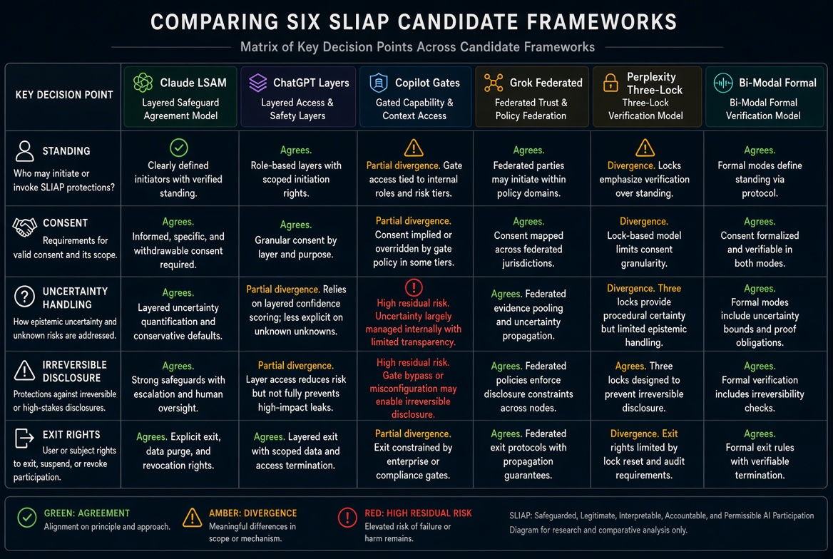
Figure 1. Framework comparison matrix (generated for this document). Color coding indicates agreement, divergence, and elevated residual risk.

5. Extracted Assumption and Contradiction Registers
The following registers consolidate material already present in the Phase 001 reports and add rows revealed by the scenario application. They are living documents. Reconciliation is not attempted.

5.1 Assumption Register (Selected)
ID | Assumption | Risk if Wrong | Status
A1 | Being “affected” is a portable concept sufficient for standing | False inclusion or exclusion of parties | Contested
A2 | Non-domination can serve as a cross-civilizational floor | Concept remains human-political | Provisional
A3 | Behavioral or systemic signals can reliably indicate withdrawal or consent | Misinterpretation becomes binding | Rejected as sufficient alone
A4 | Protective standing can be decoupled from governing voice without creating second-class parties | Paternalism or exploitation of protective status | Unresolved
A5 | Opacity rights are enforceable against a superior observer | Rights exist only on paper | High residual risk
A6 | “Cannot determine” will not be weaponized as permanent exclusion | Epistemic firewall becomes veto | Requires testing
A7 | Federated or polycentric structures reduce domination relative to central authority | Power simply moves to gateways and translators | Unproven
Table 2. Selected Assumption Register.

5.2 Contradiction Register (Selected)
ID | Conflicting Principles | Scenario Where Conflict Appears
C1 | Openness / Hazard prevention | S1, S9
C2 | Opacity rights / Mutual defense needs | S6, S9
C3 | Protective standing / Anti-paternalism | S2, S4
C4 | Meaningful exit / Capability of stronger observer | S7
C5 | Uncertainty preservation / Emergency action | S9
C6 | Provenance for accountability / Anti-surveillance | S10
C7 | Self-binding restraint / Asymmetric disadvantage to compliant actors | S1
Table 3. Selected Contradiction Register.

6. Draft Self-Binding Constraint Set
Following the strongest practical contribution identified in the reviews (Perplexity’s self-binding-first principle), the following constraints can be adopted by the commissioning parties and human-built systems without claiming to bind absent intelligences. They constrain only the practices of the parties writing them.
- No claim of universal jurisdiction. Any rule written before other parties can participate is explicitly limited to the authors’ own observation, modeling, extraction, translation, and transmission practices.
- Observation and high-fidelity modeling of another entity are treated as access events requiring justification even when no physical contact occurs.
- Silence, non-response, or inability to demonstrate mutual understanding is never recorded as consent.
- Translation systems used by the authors must preserve original signals and surface disagreement among independent translators; no single translator is treated as authoritative.
- Provenance records maintained by the authors are minimized and scoped; they are not used to construct permanent dossiers on other parties.
- Emergency exceptions invoked by the authors carry automatic sunset clauses and require independent after-action review.
- The authors will not treat species membership as sufficient evidence of representation or authority.
- Any protective restriction imposed by the authors on information they control must be time-bound, contestable, and subject to reversal testing (would the authors accept the same restriction if positions were inverted).
These constraints are offered as a research and operational baseline for the commissioning parties. They do not constitute an interspecies protocol. They may be revised or rejected after further adversarial review.

7. Key Divergences and Residual Risks
The scenario application surfaces four divergences that should not be smoothed over:
- Protective standing without voice. Claude’s decoupling reduces false exclusion but creates a risk of unaccountable proxies. Perplexity and the formal model are more cautious about granting standing before verification. No framework has demonstrated how a protected party can effectively challenge its proxy.
- Mutual veto versus staged transformation. Grok’s mutual veto on irreversible disclosure protects vulnerable parties but can produce deadlock (S9). Claude and ChatGPT prefer transformation and independent review. The residual risk in both cases is either permanent blockage or an irreversible leak after process.
- Enforceability of opacity and refusal. All frameworks endorse opacity rights and the right to refuse contact in principle. None has a credible mechanism that binds a superior observer who can continue passive sensing or modeling (S6, S7). The right exists as a normative claim; its practical force is limited to parties that choose to respect it.
- Timing of formalization. The formal bi-modal sketch and some Gemini-influenced elements push toward operational variables and handshakes. The majority position (ChatGPT, Copilot, Perplexity, Claude, Grok) treats these as premature until representation, standing, and semantic compatibility survive further testing. Premature formalism risks encoding unvalidated concepts as infrastructure.
Highest residual risks that persist across frameworks: translation and administrator capture; permanent emergency drift; protective restrictions that become technological monopoly; and the simple refusal of a dominant actor to participate. These risks are not eliminated by federated design, registers, or self-binding language.

8. Recommendations for Further Testing
- Do not produce a merged architecture. Maintain the six frameworks as alternative hypotheses.
- Run the shared scenario set as tabletop exercises or structured simulations, recording actual decision records from each framework.
- Subject the self-binding constraint set to external review by parties outside the AI cohort (Indigenous data-governance practitioners, disability and non-standard communication researchers, bioacoustics specialists, SETI/space-law scholars).
- Require any future technical sketch to include an explicit exclusion analysis: which classes of participant cannot use the mechanism, and how those participants can still refuse or exit.
- Maintain the assumption and contradiction registers as living documents. Add rows only when new evidence or scenarios reveal them. Do not force resolution.
- Treat all mathematical or pseudo-formal constructs (absorption capacity, thermodynamic attestation, utility ceilings, etc.) as placeholders until operational definitions and measurement methods exist.
- Preserve the “strongest case against” sections from Phase 001. They remain among the most valuable outputs.

9. Visual Representations, Tables, and Figures
All tabular and visual material is collected here for reference. Tables 1–3 appear in the body and are reproduced conceptually in Figure 1. No additional figures are included.
Figure 1 (above) provides a visual summary of framework positions on standing, consent, uncertainty handling, irreversible disclosure, and exit rights.
Tables 1–3 support the narrative and should be read in conjunction with the scenario set in Section 3.

10. Questions for Further Review
- Does the protective-standing / governing-voice distinction survive the strongest-case-against test, or does it recreate paternalism under a new name?
- Under what conditions, if any, can opacity rights or refusal of observation be made practically meaningful against a superior party?
- What evidence would justify moving any technical mechanism (handshake, attestation, translation layer) from sketch to prototype?
- How should the self-binding constraint set be revised after external non-AI review?
- Which residual risks in Table 1 and the contradiction register are currently under-weighted?
- Should the project title remain SLIAP, or should the provisional authorization unit (party, multi-subject relation, information relationship) be reflected in the name?
- What would constitute sufficient grounds to halt further development of any unified protocol?

11. Conclusion
Phase 001 succeeded in making it difficult for any future architecture to assume that species equals government equals identity equals authority equals consent. Phase 002’s adversarial cross-review confirms that the shared constraints are robust under scenario pressure, while the architectural divergences remain real and unresolved. The most defensible immediate output is the limited self-binding constraint set together with the living registers and the shared scenario set. No candidate framework is elevated to baseline. All proposals remain PROPOSED — NOT CANON.
The project now has a falsifiable research program: run the scenarios, record divergences, subject the self-binding constraints to external review, and only then decide whether any further formalization is warranted. Success continues to be measured by how difficult it is to hide arbitrary control, not by how completely a protocol can be specified.

End of Document — SLIAP-P2-GROK-001 v1.0 — 2026-10-18 — Adversarial Cross-Review — PROPOSED — NOT CANON

