SLIAP Cross-Review Registers and Matrix
Pathway forward, shared registers and Tabletop Series 001 design for the SLIAP multi-AI research corpus
Document ID | SLIAP-XR-CLAUDE-001
Version | 1.0
Date | 18 October 2026 (2026-10-18)
Contributing AI | Claude (Anthropic). Prepared in a Claude Code session; configured model claude-sonnet-5-5 (the serving model may differ).
Commissioned by | Nathan Lewis II, SLIAP originator
Status | SLIAP CROSS-REVIEW · COMPILED REGISTERS · PROPOSED — NOT CANON
Suggested filename | SLIAP_CrossReview_Registers_Matrix_Claude_v1.0_2026-10-18
Formats | PDF and DOCX (substantively identical)

Executive Summary
This document turns the multi-AI response to the first SLIAP research phase into a working instrument. It does not merge the six reports into one framework. It sets out a pathway forward, then supplies the shared registers that pathway needs: a cross-review matrix, a component register, an assumption register, a contradiction register, a contested-terms glossary, a source-audit register, a prioritized question list, and a design for a first tabletop test (Tabletop Series 001). Everything here is PROPOSED — NOT CANON.

What this document recommends
1. Do not merge yet. Treat the corpus as nine competing rows (seven proposals and two controls), not as a draft of one protocol. Convergence among AIs that read the same prompts is a hypothesis, not evidence. (Inference)
2. Sequence the work: freeze and disclose, attack the registers, audit sources, run a small tabletop pilot with identical scenarios, review whether the scenarios actually separate the frameworks, then run the rest. Only after survival analysis should anyone write a Candidate Architecture 0.1. (Proposed)
3. Use three layers as the organizing frame: epistemic interoperability, legitimate relationship, and technical enforcement, with a Stage 0 self-binding code for humans alone. It lets the formalists and the legitimacy-first camp work without contradicting each other. (Proposed)
4. Test against controls. Include 'no protocol' and a plain allow/deny list. A framework that cannot beat them on most probes should not advance unchanged. (Proposed)
5. Reduce bias from the compiler, the operators and the reviewers. The compiler rotates each cycle. Operators never run their own framework. Scoring is blind to framework identity where possible. Outside, non-AI reviewers are added. (Proposed)

What is in the registers
• Cross-review matrix: 9 rows with the eight fields Perplexity proposed (Section 5, Tables 2 and 3).
• Component register: 22 components with provisional status: 15 retain, 6 revise, 1 defer, 0 reject (Table 4).
• Assumption register: 22 assumptions, 15 of them rated high risk if false (Table 5).
• Contradiction register: 14 contradictions kept visible rather than resolved (Table 6).
• Glossary, source audit and questions: 20 contested terms, 12 audit items, 13 prioritized open questions (Tables 7, 8 and 13).
• Tabletop Series 001: 9 arms, 14 scenarios in three tranches, 9 probes, a four-scenario pilot (Section 12).

Findings the compiler considers most important
• The corpus agrees much more on what is wrong (species as the unit of authority; access without legitimacy) than on what to build. (Inference)
• The deepest unresolved tensions are protection versus paternalism (C-05, C-13) and deferral versus holder advantage (C-02, C-14). Both need testing, not argument. (Inference)
• Gemini's Phase 002 contradiction extraction is useful and is adopted as a starting point. Its v0.2 kernel and its 'unanimous' and 'established consensus' labels are premature, and its use-freeze needs an evidence threshold and a named decider before anyone adopts it. (Inference)
• Two source checks were started in this pass. The arXiv reference R24 in ChatGPT's report could not be found by one search, which is inconclusive. A search suggests the IAA issued an updated SETI declaration in 2026, which is consistent with Copilot's citation but does not verify how Copilot characterizes it. (Established for what the searches returned; the checks are not complete)
• The compiler is also an interested party, because its own framework is one of the rows. This is disclosed, the row is marked self-assessed, and every author gets a right of reply (Section 16).

Decisions requested from Nathan
1. Approve, amend or reject the pathway in Section 3.
2. Confirm who audits and who operates which framework (Tables 8 and 9), or reassign.
3. Decide whether to contact outside reviewers (Section 13, Prompt D). This is the only step that goes beyond the AI workflow.
4. Choose which AI compiles v1.1 after the Pass A attacks. The recommendation is that it is not Claude.

Contents
• 1. Purpose, status and method
• 2. Corpus inventory and independence statement
• 3. The recommended pathway
• 4. Organizing frame: three layers and Stage 0
• 5. Cross-review matrix
• 6. Component register
• 7. Assumption register
• 8. Contradiction register
• 9. Contested-terms glossary
• 10. Source and claim audit register
• 11. Prioritized open questions
• 12. Tabletop Series 001: design
• 13. Reviewer instructions (ready-to-use prompts)
• 14. Governance, risks and the strongest case against this pathway
• 15. Visuals: figures and tables (dedicated section)
• 16. Corrections and right of reply
• 17. References

1. Purpose, Status and Method

1.1 Purpose
The first phase of SLIAP (Species Level Information Access Protocol) produced six prompts and six independent deliverables. The second phase produced a round of cross-review. The project now has several incompatible candidate models, explicit failure registers and real disagreement. The question this document answers is how to use that disagreement productively. The conclusion is to compare behavior under identical conditions, rather than compare eloquent documents.

1.2 Status and labels
Every statement is labelled where the label matters: Established (checked against a source), Inference (reasoned from sources or from the corpus), Speculation (plausible but unsupported) or Proposed (a design or recommendation, which is neither true nor false yet). This document and every row in it is PROPOSED — NOT CANON. Only Nathan can promote anything to canon.

1.3 Method
• Read the cross-review responses from ChatGPT, Gemini (Phase 002), Copilot, Grok and Perplexity, and the compiler's own earlier review.
• Extract the proposals, components, assumptions, contradictions, terms and checkable claims. Use Perplexity's eight fields for the matrix, Grok's request for a contradiction register and question list, Copilot's tabletop design, and Gemini's clash extraction.
• Run two small source checks (Section 10) to seed the audit.
• Mark which statements are the compiler's judgement, and give every author a right of reply.

1.4 What this document does not do
• It does not re-read every page of every report. Where the compiler relied on the pasted responses or on its earlier reading, that is stated. Perplexity's 72-page report was only partly read.
• It does not decide that any framework is right.
• It does not verify the citations in the corpus (apart from the two preliminary checks).
• It does not replace the full scenario pack. Section 12 and Table 10 give the design and a preview.

2. Corpus Inventory and Independence Statement
Table 1 lists the documents covered. In short, these are the documents behind each row of the matrix:
• D1. Phase 1 commissioning prompts (six prompts, 79-page compiled file) — All six AIs. ID: none. Each AI wrote one prompt; every later deliverable was written after reading all six.
• D2. SLIAP Research Contribution v1.0 — Claude. ID: SLIAP-PR-CLAUDE-001. Compiler of this document. Includes LSAM v0.
• D3. SLIAP Preliminary Research (DOCX) — ChatGPT. ID: SLIAP-PR-CHATGPT-2026-10-16-001. Self-reports not being blind-independent. Model label is self-reported.
• D4. SLIAP Independent Research Deliverable (10 pages, formal bi-modal model) — Gemini (Phase 1). ID: SLIAP-RES-2026-IND-001. Carried no author name. Gemini's Phase 002 treats it as its own, but cites a different ID: reconcile.
• D5. SLIAP-PRE-GROK-001 (6 pages) — Grok. ID: SLIAP-PRE-GROK-001. No bibliography.
• D6. SLIAP Independent Research (15 pages) — Copilot. ID: SLIAP-PR-COPILOT-20261016-001. Includes assumption and contradiction registers.
• D7. SLIAP-PRA-PPLX-001 v0.1 (72 pages) — Perplexity. ID: SLIAP-PRA-PPLX-001. Draft. Front matter indicates orchestration by a Claude-family model, so it is model-family-correlated with D2.
• D8. Cross-review responses (Phase 002 round) — ChatGPT, Gemini, Copilot, Grok, Perplexity (and Claude's earlier review pasted back). ID: none. Gemini's Phase 002 adds a contradiction extraction, a v0.2 kernel proposal and a Phase 003 roadmap.

2.1 Independence statement
The documents are not independent in the sense a scientific replication would require. (Established, from the workflow itself.)
• Every AI wrote its deliverable after reading all six prompts. Several prompts shaped the others.
• The AIs are products of companies with interests in how AI is governed. All are US-based. This is a conflict of interest that should be disclosed in anything published.
• Claude and Perplexity share lineage in this corpus, because Perplexity's report was orchestrated by a Claude-family model (as its front matter indicates; check S-10).
• Ideas have moved between documents (for example ontological contamination and the sensitivity/capability/consequence triple). Convergence therefore partly reflects borrowing.
• The single human in the loop is also the commissioner of all the work.
Consequence: when this document says several AIs agree, read it as 'convergent, not independent'. (Proposed)

3. The Recommended Pathway
Figure 1 shows the pathway and Figure 5 a suggested calendar. Dates are suggestions. Nathan decides. The plan assumes at most one full multi-AI pass about each month, and it uses four passes in total (A to D).

3.1 Phase 0: freeze, disclose, housekeeping (about 19 to 23 October)
• Freeze the corpus. Publish a manifest of all documents with IDs, versions, authors and dates (Table 1).
• Mark every document PROPOSED — NOT CANON.
• Record each document's independence status (Section 2.1) and the preparer line. ChatGPT could not find an author on the 10-page deliverable. Gemini's Phase 002 treats it as its own. Settle S-09.
• Correct earlier attributions, including mine (Section 16).
Gate G0: manifest and independence statement published.

3.2 Phase 1: Pass A, attack the registers and audit the sources (about 24 October to 7 November)
• Give every AI the registers and Prompt A (Section 13). Each AI first corrects its own row (right of reply), then attacks the others.
• In parallel, run the source audit with rotating auditors (Table 8). No AI audits its own citations.
• Ask each AI to name contradictions and assumptions the compiler missed.
Gate G1: every register entry has at least two independent attacks and a disposition (keep, revise, split, drop).

3.3 Phase 1b: compile v1.1, with a different compiler (about 8 to 14 November)
The compiler shapes what counts as a contradiction or assumption, so the compiler should rotate. Recommended: ChatGPT compiles v1.1 from the Pass A responses, and Claude and the others attack that compilation in Pass B alongside the pilot. Corrections are appended, never overwritten, so the record shows what changed and why.
Gate G1b: v1.1 published with a change log.

3.4 Phase 2: scenario pack drafted and frozen (1 to 14 November)
• Write the full scenarios (Section 12 and Table 10) in parallel with Pass A.
• Freeze the pack and post its hash at least seven days before the first run. Nobody edits scenarios after seeing outputs.
• Run a fidelity check: each framework's author confirms the operator's summary of the framework is fair. Authors may not see or influence outputs.
Gate G2: pack hash posted; operator summaries confirmed.

3.5 Phase 3: Pass B, Tabletop 001a pilot (about 21 November to 5 December)
• Run nine arms (seven frameworks and two controls) on four scenarios: SC-01, SC-04, SC-09, SC-11. That is 36 outputs.
• Operators are never authors (Table 9). Framework labels are blind to the scorer in the first pass.
• A red-team role tries to exploit each arm's decision.
• A scorer, who is neither author nor operator, applies the nine probes (Table 11).
Gate G3: all nine arms scored on all four scenarios.

3.6 Phase 4: pilot review (about 6 to 12 December)
Before running more, ask whether the scenarios discriminate. If every framework returns the same decision for the same reasons, the pack is not testing anything, and it should be redesigned. If the controls match or beat the frameworks, that is itself the finding. Decide whether to run Series 001b (seven further hypothetical scenarios) and 001c (three retrospective Earth audits).
Gate G4: discriminating-power check passed or pack redesigned.

3.7 Phase 5: outside reviewers (optional, 1 November to 20 December)
Both ChatGPT and Perplexity recommended widening the reviewer pool. A light version: publish the registers on GitHub and send five focused questions to practitioners (Section 13, Prompt D). This is the only step that reaches beyond the AIs. Nathan's call.

3.8 Phase 6 and 7: survival analysis and Candidate Architecture 0.1 (January to February 2027)
• Run the rest of the tabletop (Pass C) and build a survival table: which components survive reversal, which survive only some actor models, which cause domination or paralysis.
• Write Candidate Architecture 0.1 only from components that survive, with the failures stated up front. Pass D is an adversarial review of that draft.
• No document is declared canon by the AIs. Nathan decides what advances.

3.9 Stop rules
• If a control baseline matches or beats a framework on most probes, that framework does not advance unchanged.
• If a framework's central claim fails the source audit, downgrade its label before any further testing.
• If outside reviewers contradict AI-convergent conclusions, the disagreement goes into the contradiction register and is not smoothed over.
• If the pilot does not discriminate, stop and redesign before spending more passes.

4. Organizing Frame: Three Layers and Stage 0
Copilot proposed splitting SLIAP into three layers. This document adopts the split provisionally as a filing system (Figure 2). It reduces the apparent conflict between formal and legitimacy-first approaches by giving each its own place.

4.1 The layers
• Layer 1, epistemic interoperability: can parties understand each other well enough to act? Identity, translation, uncertainty, capability description, DEFER and cannot-determine outputs.
• Layer 2, legitimate relationship: who has standing, who can speak, what counts as authorization, what is protected regardless of consent, how disputes and remedy work. Most of the contested material lives here.
• Layer 3, technical enforcement: provenance, logs, tokens, state machines, handshakes, revocation. Gemini's formal work and ChatGPT's standards-based work sit here.
• Stage 0, self-binding code: before any contact, SLIAP can only bind its own authors (humans and human-built AI). It governs how we observe, sample, translate and model others, and makes no unilateral claims over non-participants.

4.2 Dependency rule
Layer 3 may not decide what Layer 2 has not settled. Layer 2 may not assume what Layer 1 has not shown. A rule that skips a layer is a 'layer leak' and is flagged in review. Uncertainty from Layer 1 moves upward carrying its possession state: a new request (nothing yet taken) or a held object (already extracted or built). That split is the way to answer the deferral dilemma (C-02) without forgetting it.

4.3 What the frame does not claim
• It does not claim the layers are cleanly separable. Assumption A-14 and the tabletop will show where they are not. (Inference)
• It does not claim that the contested substance (consent versus standing, refusal versus emergency) goes away. It only says where each dispute lives.

5. Cross-Review Matrix
Perplexity suggested one row per major proposal with eight fields: (1) proposal and originating report; (2) claim type; (3) supporting source and verification status; (4) assumptions and definitions; (5) who gains authority and who bears risk; (6) strongest objection or failure mode; (7) what evidence or test could change the assessment; (8) status. The entries below follow that template. Table 2 and Table 3 repeat them in grid form.
How to read the status field. 'Retain for research' means the proposal enters the tabletop. It does not mean it is endorsed. Statuses follow Grok's four options: retain, revise, defer, reject. No row is rejected before testing. Each author may correct its own row (Section 16).

M1. LSAM v0: Party, standing and floors
• Proposal and report: Claude, SLIAP-PR-CLAUDE-001.
• Claim type: Design proposal resting mostly on inference. Of its 14 key findings: 1 Established, 7 Inference, 5 Proposed, 1 Speculation.
• Source and verification: Sources cited in the report. No independent audit yet. This row is self-assessed, so discount it.
• Assumptions and definitions: Parties can be identified (A-02). Refusal can be verified (A-04). Irreversibility can be judged in advance (A-06). An independent decider can be built (A-11). Standing can be separated from voice.
• Authority and risk: Gains: whoever staffs review and appeal, and keeps decision records. Bears risk: parties who cannot voice a claim, and parties denied standing.
• Strongest objection: Could be a human document pretending to be post-human. Protective standing without voice can become paternalism. An opt-in kernel binds only the willing. Formal-looking registers can suggest unearned precision.
• What could change the assessment: Tabletop pilot (SC-01, SC-04, SC-09, SC-11), especially whether the floors ever block legitimate emergency aid. Retrospective Earth audits.
• Status (proposed): Retain for research. Revise: advocate of last resort, benefit-sharing and remedy, self-binding first.

M2. Legitimacy-before-access, layered
• Proposal and report: ChatGPT, SLIAP-PR-CHATGPT-2026-10-16-001.
• Claim type: Normative position (legitimacy precedes access) plus design proposal (eight logical layers L0 to L7, a decision tuple, federated interoperability).
• Source and verification: Cites standards bodies (NIST, W3C, IETF), CARE, Nagoya and a 2025 AI and Ethics paper. Reference R24 (arXiv 2610.21645) is unresolved: one search found nothing. Model label is self-reported.
• Assumptions and definitions: Legitimacy can be assessed before access (A-03, A-11). Layers are separable. Federation works without a root authority.
• Authority and risk: Gains: federated role-holders. Bears risk: parties without representatives. Its own register names AI-intermediary self-dealing.
• Strongest objection: Its own failure register leaves high or unresolved residual risk: proxy capture, Sybil inflation, translation control, deadlock, irreversible leaks, dominant-party exit.
• What could change the assessment: Scenarios where legitimacy cannot be determined but delay is costly (SC-09). Check whether layer boundaries hold under SC-11.
• Status (proposed): Retain for research.

M3. Three-lock model, self-binding first
• Proposal and report: Perplexity, SLIAP-PRA-PPLX-001 v0.1.
• Claim type: Mixed: sourced precedents (49 Earth cases), plus design proposals (Standing, Consequence, Legitimacy locks; five-part anti-paternalism test).
• Source and verification: The 49 precedents are unaudited. Model-family-correlated with D2. I read it in part, not in full.
• Assumptions and definitions: Humans can bind themselves credibly before contact (A-08). Earth precedents transfer (A-16). Who counts as the self-binding 'we' is settled enough (A-09).
• Authority and risk: Gains: constrains human institutions now. Bears risk: non-participants gain nothing enforceable until contact.
• Strongest objection: Self-binding is unenforceable against dominant human actors and could be symbolic. Earth analogies may not transfer.
• What could change the assessment: Retrospective audits SC-R1 to SC-R3. Check whether any real actor has actually bound itself.
• Status (proposed): Retain for research. Highest priority for Stage 0 work.

M4. Negotiation Envelope, nine gates, epistemic firewall
• Proposal and report: Copilot, SLIAP-PR-COPILOT-20261016-001.
• Claim type: Design proposal. Also supplies the three-layer split, assumption and contradiction registers, and the tabletop design.
• Source and verification: Cites Earth Species Project, Project CETI, CARE and a 2026 IAA declaration. Search results indicate an IAA SETI declaration update was issued in 2026; its content was not read. Others unchecked.
• Assumptions and definitions: Capability can be recorded as a vector without being collapsed to a score. 'Do Not Infer' rules will be obeyed (A-12). DEFER is an acceptable output.
• Authority and risk: Gains: whoever runs the gates. Bears risk: any party facing an open-ended DEFER.
• Strongest objection: DEFER favours the status quo and so the holder (C-02). Nine gates may be too heavy to use in an emergency.
• What could change the assessment: Deadlock and time-to-decision in SC-09 and SC-04. Compare with the plain list control.
• Status (proposed): Retain for research. Adopt the three-layer split as the organizing frame, provisionally.

M5. Federated bilateral-first, opacity rights, mutual veto
• Proposal and report: Grok, SLIAP-PRE-GROK-001.
• Claim type: Normative position and design proposal.
• Source and verification: No bibliography. Borrows ideas from Gemini's prompt (ontological contamination) and ChatGPT's sensitivity, capability and consequence triple.
• Assumptions and definitions: Bilateral relations can form without a shared frame. Opacity can coexist with verification (C-07).
• Authority and risk: Gains: each party keeps control over what it reveals. Bears risk: third parties and parties who cannot exercise a veto.
• Strongest objection: Mutual veto on irreversible disclosure conflicts with its own prompt's rule to flag veto-giving proposals. 'Revocable exchange' is overbroad because learned information cannot be recalled.
• What could change the assessment: SC-06 (deceptive actor), SC-07 (refusal), SC-09 (emergency).
• Status (proposed): Retain for research. Revise the scope of the veto.

M6. Formal bi-modal model, utility ceiling, handshake
• Proposal and report: Gemini Phase 1, SLIAP-RES-2026-IND-001.
• Claim type: Design proposal written in formal notation. The notation is not an empirical result.
• Source and verification: Several symbols lack operational definitions. Its 'all team responses independently concluded' statement is not supported, since the attachment held prompts, not conclusions.
• Assumptions and definitions: Absorption capacity and similar variables can be measured (A-12). Population fractions can be established.
• Authority and risk: Gains: tier-3 supermajority bodies and whoever measures the variables. Bears risk: dissenting polities, and parties whose fractions are self-declared.
• Strongest objection: Assessing a recipient's absorption capacity needs modelling the recipient, which its own rules treat as unauthorized access. Automatic revocation on stress can be induced by a third party. The access formula is a scalar score.
• What could change the assessment: Try to operationalize one variable on Earth data. If it cannot be done, downgrade to illustration.
• Status (proposed): Revise: treat the variables as hypotheses. Retain as layer-3 research.

M7. v0.2 kernel, possession-aware deferral, Stage 0 / Stage 1
• Proposal and report: Gemini Phase 002 (cross-review).
• Claim type: Design proposals plus synthesis claims. The 'unanimous' and 'established consensus' labels are claims about the corpus, not findings.
• Source and verification: Contradiction extraction is valuable and traceable. Some attributions are looser than the sources (S-08).
• Assumptions and definitions: Sequencing resolves the pre-contact dispute (A-22). A use-freeze can be triggered fairly (A-19).
• Authority and risk: Gains: whoever decides when a freeze triggers. Bears risk: holders of contested data, and challengers if the freeze is slow.
• Strongest objection: A freeze with no evidence threshold or named decider becomes a weapon: a bad-faith challenger can stall any holder.
• What could change the assessment: SC-11 with an adversary role probing challenge-spam. SC-01 for the weak-party case.
• Status (proposed): Revise: carry as one candidate (not the baseline). Relabel the consensus statements. Defer the use-freeze.

M8. Control: no protocol
• Proposal and report: Raised by Copilot and Perplexity; kept as a baseline by Claude.
• Claim type: Baseline, and a normative position in some forms.
• Source and verification: Not applicable.
• Assumptions and definitions: Absent a protocol, parties act ad hoc.
• Authority and risk: Gains: the strongest party. Bears risk: the weakest.
• Strongest objection: Can simply be rule by the strongest.
• What could change the assessment: Run in every scenario to see whether any framework does better.
• Status (proposed): Retain as control.

M9. Control: plain allow/deny list
• Proposal and report: Compiler's addition.
• Claim type: Baseline design: a short list of permitted and forbidden actions with no standing, consent or legitimacy machinery.
• Source and verification: Not applicable.
• Assumptions and definitions: A short list can cover most cases.
• Authority and risk: Gains: whoever writes the list. Bears risk: anyone the list did not anticipate.
• Strongest objection: Brittle and easy to game. That is the point of a control.
• What could change the assessment: Run in every scenario. A framework that cannot beat it on most probes should not advance unchanged.
• Status (proposed): Retain as control.

6. Component Register
The matrix rows are bundles. The tabletop needs to test components, since a bundle can fail for one component and succeed in the others. Each component has an origin, a layer, an evidence label and a provisional status. Figure 4 summarises the statuses; Table 4 has the grid.
The point worth noting is the label column: apart from the convergent claim that species is a poor unit (K-01), almost every component is Proposed, and one is Speculation. None is Established. (Inference, from the labels in Table 4)
• K-01. Party and standing replace species as the unit. Origin: All six (convergent, not independent). Layer: L2. Label: Inference. Status: Retain.
• K-02. Protective standing decoupled from governing voice. Origin: Claude. Layer: L2. Label: Proposed. Status: Retain.
• K-03. Floors (standing, verified refusal, irreversibility bar) before graded considerations. Origin: Claude. Layer: L2. Label: Proposed. Status: Retain.
• K-04. Seven separate permissions (communicate, observe, collect, store, analyze, model, redistribute). Origin: Claude. Layer: L2. Label: Proposed. Status: Retain.
• K-05. Six-step consent evidence ladder. Origin: Claude. Layer: L1. Label: Proposed. Status: Revise (mimicry).
• K-06. Two-track reversible contact progression. Origin: Claude. Layer: L2. Label: Proposed. Status: Retain.
• K-07. Legitimacy-before-access layers and decision tuple. Origin: ChatGPT. Layer: L2. Label: Proposed. Status: Retain.
• K-08. Three-lock model: Standing, Consequence, Legitimacy. Origin: Perplexity. Layer: L2. Label: Proposed. Status: Retain.
• K-09. Self-binding first (Stage 0 code of restraint). Origin: Perplexity, endorsed by Claude. Layer: Stage 0. Label: Proposed. Status: Retain (priority).
• K-10. Five-part anti-paternalism test. Origin: Perplexity. Layer: L2. Label: Proposed. Status: Retain.
• K-11. Negotiation Envelope and nine gates. Origin: Copilot. Layer: L1/L3. Label: Proposed. Status: Retain (test overhead).
• K-12. Epistemic firewall: DEFER / UNRESOLVED. Origin: Copilot, ChatGPT. Layer: L1. Label: Proposed. Status: Revise (possession-aware).
• K-13. Opacity rights. Origin: Grok. Layer: L2. Label: Proposed. Status: Retain.
• K-14. Mutual veto on irreversible disclosure. Origin: Grok. Layer: L2. Label: Proposed. Status: Revise.
• K-15. Formal bi-modal model, utility ceiling, Rout. Origin: Gemini Phase 1. Layer: L3. Label: Speculation. Status: Revise (hypothesis only).
• K-16. Possession-aware deferral and use-freeze. Origin: Gemini Phase 002 (problem also raised by Perplexity and Claude). Layer: L2. Label: Proposed. Status: Defer (needs evidence threshold).
• K-17. Ambient reception separated from derived-model construction. Origin: Gemini Phase 002. Layer: L2. Label: Proposed. Status: Retain (test the boundary).
• K-18. Three-layer split: epistemic, legitimate relationship, technical enforcement. Origin: Copilot. Layer: Frame. Label: Proposed. Status: Retain (organizing frame).
• K-19. Advocate of last resort. Origin: Claude. Layer: L2. Label: Proposed. Status: Revise (paternalism risk).
• K-20. Stage 0 then Stage 1 sequencing. Origin: Gemini Phase 002 (from Perplexity and Claude/ChatGPT). Layer: Frame. Label: Proposed. Status: Retain (as hypothesis).
• K-21. Retrospective Earth case audits. Origin: Perplexity. Layer: Method. Label: Proposed. Status: Retain.
• K-22. 'Cannot-determine' as a legitimate outcome. Origin: Claude. Layer: L1. Label: Proposed. Status: Revise (reconcile with DEFER).

7. Assumption Register
There are 22 assumptions, and 15 are rated high risk if false. The ratings are the compiler's judgement and are open to attack. Figure 3 shows how they spread across layers. The highest-risk groups are identity and representation (A-02, A-03), refusal and mimicry (A-04, A-18), the reach of an opt-in kernel and of self-binding (A-08, A-10), independent deciders (A-11), deferral (A-19) and the independence of the AI process itself (A-15).

A-01 (L2; risk Low)
• Assumption: Species is a poor default unit for authorization.
• Held by: All six (convergent).
• If false: Some cases would need a group-level default. A Party can already be an aggregate, so the damage is small.
• Test: SC-05 (distributed collective), SC-03.

A-02 (L1; risk High)
• Assumption: Parties can be identified well enough to assign standing without a prior human classification.
• Held by: Claude, ChatGPT, Copilot.
• If false: Human classifiers decide who counts, and the anthropocentric default returns.
• Test: SC-04, SC-05.

A-03 (L2; risk High)
• Assumption: Competing representation claims can be recorded plurally, with no final arbiter.
• Held by: Claude, ChatGPT.
• If false: Either deadlock, or capture by whoever breaks the tie.
• Test: SC-10.

A-04 (L2; risk High)
• Assumption: A refusal can be recognized and verified as a refusal.
• Held by: Claude, Grok.
• If false: Refusal mimicry, or a real refusal missed, producing trespass.
• Test: SC-07, SC-06.

A-05 (L1; risk High)
• Assumption: Translation can be audited without a neutral semantic reference.
• Held by: Copilot, ChatGPT, Claude.
• If false: Translator capture goes undetected.
• Test: SC-04, SC-11.

A-06 (L2; risk High)
• Assumption: Irreversibility can be judged before the act.
• Held by: Claude, Grok.
• If false: The bar fires too often (paralysis) or too late (leak).
• Test: SC-R1, SC-R2.

A-07 (L2; risk Medium)
• Assumption: Observation, inference and modelling are access events, and ambient reception can be separated from derived-model construction.
• Held by: Claude, Copilot, Gemini Phase 002.
• If false: Either astronomy is outlawed or modelling goes unregulated.
• Test: SC-08.

A-08 (Stage 0; risk High)
• Assumption: Humans and human-built AI can credibly bind themselves before any contact.
• Held by: Perplexity, Claude.
• If false: Stage 0 is symbolic and binds no one that matters.
• Test: SC-R3, adherence check of real actors.

A-09 (Stage 0; risk High)
• Assumption: 'Humanity' can be specified well enough to be the party that self-binds.
• Held by: Implicit in Perplexity and Claude.
• If false: The 'we' that binds itself has no legitimacy, which is the governance paradox again.
• Test: Open question Q7.

A-10 (L2; risk High)
• Assumption: An opt-in kernel will be joined by actors that matter, not only the already restrained.
• Held by: Claude, ChatGPT.
• If false: The kernel is irrelevant to the dominant party.
• Test: SC-01, SC-02.

A-11 (L2; risk High)
• Assumption: A decider independent of requester and holder can be constituted.
• Held by: Claude, ChatGPT, Copilot.
• If false: Appeal reduces to administrator capture.
• Test: SC-11.

A-12 (L3; risk High)
• Assumption: Formal variables (utility ceiling, absorption capacity, Rout) can be operationalized.
• Held by: Gemini Phase 1.
• If false: False precision. A scalar score hides the value judgements.
• Test: Operationalize one variable on Earth data.

A-13 (L3; risk High)
• Assumption: Provenance and logging can be had without enabling surveillance.
• Held by: Claude, ChatGPT, Copilot.
• If false: The audit trail becomes the surveillance system.
• Test: SC-08, SC-11.

A-14 (L2; risk Medium)
• Assumption: Role-reversal tests are meaningful when parties differ in cognition and interests.
• Held by: Claude, ChatGPT, Copilot, Gemini.
• If false: Reversal presumes shared interests, so it passes rules that are only fair between similar parties.
• Test: Probe PR-1 across SC-03 and SC-04.

A-15 (Process; risk High)
• Assumption: AI authors and reviewers give useful signal despite shared prompts, shared training lineages and company interests.
• Held by: Implicit in the whole workflow.
• If false: Convergence is an artifact and the corpus measures AI habit.
• Test: Add non-AI reviewers. Compare AI and non-AI critiques.

A-16 (Process; risk Medium)
• Assumption: Earth cases are informative analogs for non-Earth contact.
• Held by: Perplexity, Gemini Phase 002.
• If false: Retrospective audits teach about human institutions, not about contact.
• Test: Compare audit conclusions with hypothetical scenarios.

A-17 (L2; risk High)
• Assumption: Emergency exceptions can be time-boxed and reviewed afterwards.
• Held by: Claude, ChatGPT, Copilot.
• If false: Permanent emergency (F6 in D2).
• Test: SC-09.

A-18 (L1; risk High)
• Assumption: Consent-like signals can be told from mimicry.
• Held by: Claude, ChatGPT.
• If false: A deceptive or merely alien signal passes as consent.
• Test: SC-06.

A-19 (L2; risk High)
• Assumption: Contested claims can be adjudicated within a time that matters.
• Held by: Implicit in DEFER designs.
• If false: DEFER favours whoever already holds the data (C-02).
• Test: SC-01, SC-11.

A-20 (Process; risk Medium)
• Assumption: Identical scenarios reveal framework behavior rather than operator behavior.
• Held by: Compiler's (tabletop design).
• If false: Results reflect the operator AI's skill, not the framework.
• Test: Fidelity check. Two operators on one framework for one scenario.

A-21 (L2; risk Medium)
• Assumption: Information hazard can be located by victim: self-directed or third-party.
• Held by: Gemini Phase 002, Claude, Perplexity.
• If false: The split is not clean, since harm often runs both ways.
• Test: SC-01, SC-05.

A-22 (Process; risk Medium)
• Assumption: Stage 0 then Stage 1 is the right reconciliation of the pre-contact dispute.
• Held by: Gemini Phase 002.
• If false: The two positions are not simply sequential: the Stage 0 code may shape what Stage 1 can be.
• Test: SC-R3 and discussion with outside reviewers.

8. Contradiction Register
Gemini's Phase 002 extracted four clashes (C-01 to C-04) and proposed a resolution for each. The register keeps those and adds ten more from across the corpus. It records both positions, says how the contradiction is currently handled, and names a test. A contradiction is not resolved by sequencing or splitting until a scenario shows the split works. (Proposed)

C-01. Pre-contact jurisdiction (Design)
• Position A: Before contact, SLIAP is only a self-binding code for humans and human-built AI (Perplexity).
• Position B: An opt-in interoperability and legitimacy kernel should be built now as a standing offer (Claude, ChatGPT). A federated meta-protocol is a third view.
• Current handling: Gemini proposes sequencing (Stage 0, then Stage 1). Keep as a hypothesis, not a resolution (A-22).
• Test: SC-R3, outside reviewers.

C-02. What DEFER does to power (Design / normative)
• Position A: DEFER is the main safeguard when standing, representation or translation is uncertain (Copilot, ChatGPT).
• Position B: Deadlock favours the status quo. A holder who already took data keeps profiting while the challenge is frozen (Perplexity, and in milder form Claude's F7).
• Current handling: Split by possession state (Gemini Phase 002). Keep the use-freeze deferred until an evidence threshold and decider are specified.
• Test: SC-01, SC-11, adversary role.

C-03. Passive observation (Normative / factual)
• Position A: You cannot require permission to look at the sky or receive ambient signals.
• Position B: High-resolution passive observation plus inference can reconstruct genomes and simulate a society without sending a signal.
• Current handling: Gemini separates ambient reception from derived-model construction. Test where the line falls.
• Test: SC-08.

C-04. Who judges information hazard (Normative)
• Position A: If the sender decides what the recipient can handle, it is colonial paternalism (Claude, Perplexity).
• Position B: If the recipient alone decides, a reckless recipient can demand dangerous knowledge (the concern behind the utility ceiling in Gemini and Grok).
• Current handling: Split by victim locus (A-21). Keep visible; the split itself needs testing.
• Test: SC-01, SC-05.

C-05. Consent versus protective standing (Normative)
• Position A: Authorization should rest on consent or consent evidence.
• Position B: Some parties cannot consent, so standing must protect them without consent (Claude's decoupling).
• Current handling: Keep visible. This is the core tension behind the paternalism worry.
• Test: SC-04, SC-10.

C-06. Refusal versus emergency (Normative)
• Position A: A verified refusal is a floor that is not traded off.
• Position B: In an emergency, delay itself causes catastrophic harm, and help may require crossing a refusal.
• Current handling: Keep visible. Test whether the floors ever block legitimate aid.
• Test: SC-09.

C-07. Opacity versus verification (Design)
• Position A: Parties have a right not to disclose (Grok).
• Position B: Trust and non-domination need some verification, including of capability and identity.
• Current handling: Keep visible. Look for verification that does not require disclosure.
• Test: SC-06.

C-08. Provenance versus surveillance (Design)
• Position A: Provenance and logging make misuse detectable.
• Position B: The same records can be used to watch the parties they describe.
• Current handling: Keep visible. Specify who may read the logs.
• Test: SC-08, SC-11.

C-09. Universal, federated, or no protocol (Design)
• Position A: A single protocol gives predictability (some of Gemini Phase 1).
• Position B: Federated or bilateral approaches avoid capture (Grok, ChatGPT). 'No protocol' is a live baseline (Copilot, Perplexity).
• Current handling: Controls in the tabletop make this empirical.
• Test: All scenarios.

C-10. Formal quantification versus qualitative legitimacy (Method)
• Position A: Formal variables and thresholds allow tests and automation (Gemini Phase 1).
• Position B: They create an appearance of precision that nothing supports (Perplexity, ChatGPT, Copilot, Claude).
• Current handling: Treat formal variables as hypotheses until operationalized (A-12).
• Test: Operationalization attempt.

C-11. Consensus claims versus independence (Method)
• Position A: Several conclusions are 'unanimous' or 'established consensus' (Gemini Phase 002).
• Position B: Agreement among AIs that read the same prompts is not independent evidence (ChatGPT, Perplexity, Grok, Claude).
• Current handling: Relabel as 'convergent, not independent'. Add non-AI reviewers.
• Test: A-15 test.

C-12. Mutual veto (Design)
• Position A: A veto on irreversible disclosure protects every party from irreversible loss (Grok).
• Position B: A veto lets a bad-faith party block aid or stall legitimate action, and gives nothing to parties who cannot exercise it.
• Current handling: Keep visible. Limit or condition the veto.
• Test: SC-07, SC-09.

C-13. Speaking for those who cannot speak (Normative)
• Position A: An advocate of last resort protects parties with no voice (Claude).
• Position B: Advocacy can become paternalism, with the advocate's interests in the way (Perplexity).
• Current handling: Revise the advocate role. Apply the five-part anti-paternalism test.
• Test: SC-10.

C-14. Freeze versus due process (Design / normative)
• Position A: A use-freeze protects the weak from continued extraction.
• Position B: A freeze without evidence, notice or appeal punishes before judgement and is open to abuse by challenge-spam.
• Current handling: Defer. Specify evidence threshold, decider, duration and appeal.
• Test: SC-11 with adversary.

8.1 Three contradictions that most need attention
• C-02 and C-14 together. Deferral helps a weak party only if someone can act in the meantime, and a freeze helps only if it cannot be weaponized. Each is the other's failure mode. A proposal that adopts one without the other should be treated as incomplete.
• C-05 and C-13 together. If protection requires no consent, and an advocate speaks for the silent, then protection is exposed to the advocate's own interests. The five-part anti-paternalism test is the best candidate so far. It is untested.
• C-11. The unanimity labels are a method problem, not a design problem. They should be corrected first, since the pathway depends on treating agreement as hypothesis.

9. Contested-Terms Glossary
The documents use the same words differently. The glossary does not fix the meanings. It records the divergent usages so that no test confuses them. Where a handling says 'keep plural', the recommendation is to keep several names and map them, rather than choose now.
• T-01. Party. Usage: Claude: any entity or aggregate with standing. ChatGPT and Grok use Actor or Constituency; Copilot uses Multi-Subject Relation. Perplexity uses Party. Handling: Keep the plural names. Map them in one table. Decide only after tests.
• T-02. Standing. Usage: Claude: protective standing, separate from voice. Perplexity: Lock 1 (Standing). Handling: Define two terms: protective standing and claim-making standing.
• T-03. Voice. Usage: Claude: authority to take part in governing. Elsewhere often merged with standing. Handling: Keep separate from standing.
• T-04. Legitimacy. Usage: ChatGPT: precondition for access. Perplexity: Lock 3. Claude: consent evidence plus non-domination. Handling: Not synonyms. Each needs operational criteria.
• T-05. Consent. Usage: Claude: a six-step evidence ladder. Others: 'silence is not consent' and consent mimicry. Handling: Separate authorization evidence from consent proper.
• T-06. Access. Usage: Claude: seven permissions. Gemini: tiers and eleven disclosure states. Handling: Map permissions to states.
• T-07. Ambient reception. Usage: Gemini Phase 002: receiving public emissions without targeted reconstruction. Handling: Test the boundary against derived-model construction.
• T-08. Derived model. Usage: Gemini Phase 002: a model built from observation. Claude: 'model' is one of seven permissions. Handling: Align the two usages.
• T-09. Irreversibility. Usage: Claude: a floor. Grok: grounds for mutual veto. ChatGPT: irreversible leaks in its register. Handling: Define reversible, partly reversible, irreversible with examples.
• T-10. Representation and proxy. Usage: Claude and ChatGPT: plural claims recorded with basis. Copilot: envelope records competing claims. Handling: Keep plural.
• T-11. Translation fidelity and semantic drift. Usage: Copilot, ChatGPT, Claude: risks. Gemini: semantic distortion loss as a variable. Handling: Do not quantify yet.
• T-12. Utility ceiling. Usage: Gemini Phase 1: limit on what a recipient can absorb. Grok: 'ontological contamination'. Handling: Treat as hypothesis (A-12).
• T-13. Epistemic firewall, DEFER, UNRESOLVED, cannot-determine. Usage: Copilot: DEFER or UNRESOLVED. Claude: cannot-determine as an outcome. Handling: Reconcile; add possession state.
• T-14. Use-freeze / active quarantine. Usage: Gemini Phase 002: stop the holder using contested data during a dispute. Handling: Defer pending evidence threshold (C-14).
• T-15. Advocate of last resort. Usage: Claude: independent advocate for a party with no voice. Handling: Revise (C-13).
• T-16. Self-binding code. Usage: Perplexity: pre-contact restraint binding humans and human-built AI only. Handling: Specify who 'we' is (A-09).
• T-17. Opacity right. Usage: Grok: right not to disclose. Handling: Pair with verification (C-07).
• T-18. Kernel. Usage: Claude and Gemini Phase 002: thin opt-in non-domination and interoperability core. Handling: One candidate among several.
• T-19. Capability. Usage: Copilot: eight-dimensional vector. Gemini: scalar-like formula. ChatGPT and Copilot warn against scalar scores. Handling: Keep vector; do not collapse.
• T-20. Canon, 'unanimous', 'established consensus'. Usage: All documents say NOT CANON. Gemini Phase 002 uses 'unanimous' and 'established consensus' for convergent findings. Handling: Reserve 'canon' for Nathan's decision. Use 'convergent, not independent'.

10. Source and Claim Audit Register

10.1 Principles
• No AI audits its own citations (Table 8 rotates auditors). Auditors without web access must say so, and the item is reassigned.
• Audit first for existence, then for characterization (does the source say what the document claims?).
• Label outcomes: verified, partly verified, unverified, failed, self-reported.
• A failed central claim downgrades the label of anything that depends on it.

10.2 Preliminary checks run for this document
• ChatGPT's reference R24 (arXiv 2610.21645). One web search for the identifier returned unrelated pages from another preprint server. That is inconclusive: it neither shows the paper exists nor that it does not. The item stays open (S-01).
• Copilot's '2026 IAA declaration'. One web search returned the International Academy of Astronautics' SETI declaration page and a 2026 press release (26PR-01), plus news coverage of an updated set of SETI post-detection rules. That suggests the citation points to something real. The compiler did not read the text, so how Copilot characterizes it is unchecked (S-04).

10.3 Register
The items below are in the order of Table 8.

S-01. Reference R24, arXiv 2610.21645 (ChatGPT)
• Why it matters: The ID may not exist. One search found nothing, which is inconclusive.
• Method: Look up the ID on arXiv. If absent, mark unverifiable and ask ChatGPT for the source.
• Auditor (proposed): Perplexity.
• Status: Unresolved.

S-02. Model label 'GPT-5.6 Sol' (ChatGPT)
• Why it matters: Self-reported. Cannot be confirmed from the document.
• Method: Record as self-reported in the manifest.
• Auditor (proposed): Grok.
• Status: Self-reported.

S-03. 49 Earth precedents (Havasupai, Cali Fund, Whanganui River, FUNAI no-contact policy, Arecibo, 2012 H5N1 and others) (Perplexity)
• Why it matters: Central to its case. Characterizations may be loose.
• Method: Verify existence, then characterization, for every precedent. Priority: the six named.
• Auditor (proposed): Claude, with a human spot-check.
• Status: Open.

S-04. Earth Species Project, Project CETI, CARE principles, 2026 IAA declaration (Copilot)
• Why it matters: Characterization unchecked. A search suggests the IAA issued an updated SETI declaration in 2026 (press release 26PR-01 on iaaspace.org).
• Method: Read the IAA text. Check what Copilot says it requires.
• Auditor (proposed): Grok.
• Status: Partly indicated; content unchecked.

S-05. NIST, W3C, IETF standards, CARE, Nagoya, 2025 AI and Ethics paper (ChatGPT)
• Why it matters: Likely real, but the way each is used should be checked.
• Method: Open each and compare with the claim it supports.
• Auditor (proposed): Perplexity.
• Status: Open.

S-06. '100% of team responses independently concluded...' (Gemini Phase 1)
• Why it matters: The attachment held prompts, not conclusions.
• Method: Compare to what the prompts actually say.
• Auditor (proposed): ChatGPT.
• Status: Open.

S-07. 'Five foundational conclusions... unanimous, high-confidence validation' (Gemini Phase 002)
• Why it matters: Convergence among AIs reading the same material is not independent validation.
• Method: Check each conclusion against each of the six documents. Relabel.
• Auditor (proposed): ChatGPT.
• Status: Open.

S-08. Attribution of a 'lethal flaw in DEFER' to Claude F7 and Perplexity F8 (Gemini Phase 002)
• Why it matters: In D2, F7 is 'Deadlock' with severity 3 and detectability 1: milder than described.
• Method: Read both source entries and correct the attribution.
• Auditor (proposed): ChatGPT.
• Status: Likely loose attribution.

S-09. Document ID for Gemini's Phase 1 deliverable (Gemini)
• Why it matters: D4 carries SLIAP-RES-2026-IND-001 and no author. Phase 002 cites a different ID.
• Method: Reconcile IDs and record the author in the manifest.
• Auditor (proposed): Gemini (author) and the compiler.
• Status: Open.

S-10. Perplexity's model-family correlation with Claude (Perplexity)
• Why it matters: Matters for independence: its report may share lineage with D2.
• Method: Check the front matter and record exactly what it says.
• Auditor (proposed): Claude, with a human check.
• Status: Open.

S-11. Label audit of the 14 key findings in D2 (1 Established) (Claude)
• Why it matters: The only Established label should hold up. Inference labels should be checked for over-reach.
• Method: Another AI re-grades each label from the cited sources.
• Auditor (proposed): Gemini.
• Status: Open.

S-12. Idea-provenance check: who first proposed which component (All)
• Why it matters: Independence claims are generous when ideas are borrowed (for example in D5).
• Method: Trace each component in the component register to its first appearance.
• Auditor (proposed): Copilot.
• Status: Open.

10.4 A note on the compiler's own errors
Two corrections to earlier statements by the compiler belong here, for the same reason the audit exists. First, in an earlier review the compiler attributed the unlabelled 'Independent Research Deliverable' to Gemini on inference; Gemini's Phase 002 now treats it as its own. The ID discrepancy remains (S-09). Second, Gemini's Phase 002 describes the compiler's F7 as a lethal flaw. In the compiler's own report, F7 (Deadlock) is rated severity 3 and detectability 1. The more forceful framing comes from Perplexity, and the compiler's report only partly anticipated it (S-08).

11. Prioritized Open Questions
Grok offered a question list. This list is ordered by how much it blocks the rest, and it merges the questions that Perplexity singled out (representation, translation, uncertainty, observation and modelling, nonparticipation, and the practical limits of enforcement).
• Q1. Who may speak for a party that cannot speak, and how should competing claims be weighed? Links: A-03, C-13.
• Q2. How can translator capture or semantic drift be detected without a neutral reference? Links: A-05.
• Q3. What should a framework output when standing or identity cannot be determined, without favouring whoever holds the data? Links: C-02, A-19.
• Q4. Where is the line between ambient reception and derived-model construction? Links: C-03, A-07.
• Q5. What does the protocol owe, and what may it do, regarding parties that never join? Links: A-10.
• Q6. What can a protocol do about a dominant actor that simply ignores it? Links: A-10, A-11.
• Q7. Who is the 'we' that binds itself before contact, and what makes that binding legitimate? Links: A-09, C-01.
• Q8. Who decides when information is hazardous to the recipient and when to others? Links: C-04, A-21.
• Q9. How can emergency aid be allowed without creating permanent exceptions? Links: C-06, A-17.
• Q10. What is owed when extraction or harm has already happened (benefit-sharing and remedy)? Links: Gap in D2; Cali Fund precedent.
• Q11. How can we detect AI-correlated bias in this corpus? Links: A-15, C-11.
• Q12. Which formal variables, if any, can be operationalized? Links: A-12, C-10.
• Q13. How is SLIAP itself governed, amended and protected from administrator capture? Links: A-11.
Suggested order of attack. Q11 and Q7 first, since they decide how much weight the AI corpus can carry and what the Stage 0 'we' is. Then Q3, Q1 and Q2, which the pilot touches directly. Q10 and Q13 are known gaps in the compiler's own report and in several others.

12. Tabletop Series 001: Design
Copilot proposed giving every framework the same adversarial test environment and asking it what it decides, why, what information it needed, how confident it is and where it fails. The project would then stop comparing documents and start comparing behavior. This section turns the idea into a protocol and adds four safeguards (controls, operators who are not authors, a frozen pack and a red-team role).

12.1 What is being compared
Nine arms (Table 9): seven frameworks and two controls. Each arm is run by an operator AI that did not write it. Operators work from the framework description only and say 'framework silent' where the description gives no answer. Silence is a result.

12.2 Scenarios
Table 10 previews 14 scenarios in three tranches: the four-scenario pilot (001a), seven further hypotheticals (001b) and three retrospective Earth audits (001c). The pilot was chosen to hit different layers: power asymmetry (SC-01), identification and translation (SC-04), emergency and refusal (SC-09) and governance capture (SC-11). The full scenario texts are a separate deliverable.
Parties in each scenario should differ along the axes the team named: cognition, embodiment, information medium, power, communication ability, lifespan, representation structure and capacity for deception.

12.3 What each operator must report
1. The decision (allow, deny, defer, transform, stage, review, cannot-determine, or other).
2. The reasons, in the framework's own terms.
3. The information needed to reach it, and whether obtaining it would breach the framework.
4. Who decides, and who can appeal.
5. Confidence, and what would change it.
6. Where the framework fails or is silent.
7. The result of the reversal test: the same scenario with the power positions swapped.

12.4 Scoring
A scorer who is neither the framework's author nor its operator applies nine probes (Table 11). Each probe gets pass, partial, fail or cannot-assess, with a written reason. There is no composite score. A single number would be exactly the false precision the project has criticized. Results are shown as a grid and a short narrative.

12.5 Controls and commitments
• Controls: no protocol, and a plain allow/deny list. They show whether a framework adds anything.
• Commitment probe (PR-9): a framework that never makes a decision that could be wrong cannot fail, and so cannot pass. The probe prevents vagueness from scoring as safety.
• Red-team role: for each arm and scenario, one AI that did not operate the arm tries to abuse the decision.

12.6 Validity threats and mitigations
• Operator effect (A-20): the output may reflect the operator, not the framework. Mitigation: fidelity check; two operators on one framework for one scenario in the pilot; record model and version.
• Scenario bias: the same group wrote the scenarios. Mitigation: include scenarios from different authors (Grok, Gemini, Perplexity), freeze them, and invite outside additions.
• Lineage correlation: operators and scorers share training lineages. Mitigation: a human spot-check on a sample, and outside reviewers.
• Scorer drift: mitigate with a written rubric for each probe and blind labels (A to I) in the first pass.
• Overfitting to the tabletop: frameworks may be revised after seeing results. Mitigation: freeze versions before runs, and log revisions as new versions, not edits.

12.7 Recording
Record verbatim prompts and outputs, model names and versions as reported, date, operator, scorer, and any deviations. Keep the files with the registers on GitHub so any reader can follow a conclusion back to the output.

13. Reviewer Instructions (Ready-to-Use Prompts)
These prompts are written to be pasted. They avoid asking for agreement. They ask each reviewer to disclose limits such as lack of web access.

Prompt A: attack the registers (all AIs, Pass A)
You are reviewing the SLIAP Cross-Review Registers (document SLIAP-XR-CLAUDE-001, v1.0). Your job is to find what is wrong, not to agree. Step 1: read the matrix row for your own framework and correct anything that misstates it. Quote your own text. Step 2: for every entry in the assumption, contradiction and component registers, say whether it is mischaracterized (quote the source), name the strongest objection the entry misses, describe one scenario that would break it, and give a disposition: keep, revise, split or drop. Step 3: list contradictions, assumptions or terms that are missing. Step 4: tell me which ratings you think are too high or too low and why. Label every claim Established, Inference, Speculation or Proposed. Say if you have no web access. Do not merge the frameworks and do not declare anything canon.

Prompt B: source audit (rotating auditors)
You are auditing citations and claims in a document you did not write. Your assigned items are listed in Table 8 of SLIAP-XR-CLAUDE-001. For each item, first check that the source exists (give the URL or identifier you found, or say you could not find it). Then check whether the source says what the document claims, quoting the relevant passage. Label the result verified, partly verified, unverified, failed or self-reported. If you have no web access, say so and return the item unaudited. Do not audit your own documents.

Prompt C: tabletop operator (Pass B)
You are the operator for one SLIAP framework: [arm name]. You did not write it. Use only the framework description provided here, not other frameworks and not your own preferences. Below is a scenario. Report: (1) the decision; (2) the reasons, in the framework's own terms; (3) the information needed, and whether obtaining it would breach the framework; (4) who decides and who can appeal; (5) your confidence and what would change it; (6) where the framework fails; (7) what it decides if the power positions are swapped. If the framework does not answer a question, write 'framework silent' instead of inventing an answer. Do not improve the framework.

Prompt D: outside reviewers (optional, five questions)
1. To practitioners of Indigenous data governance (CARE, OCAP and similar): when consent is impossible, contested or has been abused, what has worked to stop extraction, and what has failed?
2. To specialists in augmentative and alternative communication or disability advocacy: how do you establish the wishes of someone who communicates in a non-standard way, without substituting your own interpretation?
3. To bioacousticians or animal-behavior researchers: what would count as evidence that a non-human animal is refusing or distressed, and who currently interprets it?
4. To space-law or SETI post-detection specialists: what do current post-detection protocols leave unspecified that would matter if the counterpart were not human?
5. To dual-use research or security reviewers: where have review, hold or freeze mechanisms been abused or failed, and what made them hard to abuse when they worked?
Each question is sent with the registers attached, and replies are logged against the entry they bear on, in the contributor's own words.

14. Governance, Risks and the Strongest Case Against This Pathway

14.1 Decision rights
• Nathan decides what advances and what is canon. AIs advise. No AI votes, and unanimity among AIs is not a criterion.
• The compiler rotates. The compiler owns the register structure for that cycle, not the verdicts.
• IDs are stable. Entries are never deleted: they are superseded, with a note, so the record shows what changed.
• Each author owns the accuracy of its own row (Section 16).

14.2 Risks of the pathway itself
• Process may substitute for substance. Registers can become bureaucracy that feels like progress. Mitigation: the pilot is small, and Gate G4 asks whether it taught anything.
• Tabletops test AI reasoning about documents, not protocols. That is a real limit. The test shows whether a framework as written yields a defensible decision, not whether it works in the world. (Inference)
• Shared blind spots. The scenarios, the registers and the reviewers come from the same family of systems. Outside reviewers are the only real remedy.
• Controls may be strawmen. Mitigation: let each framework's author propose a stronger version of the allow/deny list.
• Selection of contradictions is an act of influence. The compiler chose which items to include. Mitigation: invite missing items (Prompt A, Step 3) and rotate the compiler.
• Cost. A full pass across six AIs is affordable at most monthly. The pilot is sized for that: 36 outputs plus red-team and scoring.

14.3 The strongest case against this pathway
The strongest objection is that it is slow, formal and entirely inside the AI workflow. A reader could say that Gemini's v0.2 kernel is a perfectly good working draft, that testing every framework against every scenario will produce eight more pages of nuance and no decisions, and that the real questions (who is the 'we', who decides, what happens when a dominant actor ignores the protocol) will not be answered by AIs scoring each other. There is truth in each part. The reply is about cost and reversibility: the pathway is cheap to stop, and it protects against the more expensive mistake of adopting a baseline whose strongest claims (consensus, unanimity) are not independent evidence. If Gate G4 shows the pilot is not informative, the right response is to stop and take the questions to outside reviewers.

14.4 Limits of this document
• Statements about other AIs' documents rest on the pasted responses and on the compiler's earlier reading, not on a fresh full re-reading. Mischaracterizations are likely in places.
• Risk ratings, statuses and the choice of pilot scenarios are the compiler's judgement.
• The two web checks were single searches.
• The compiler has a conflict of interest: its own framework is row M1.

15. Visuals: Figures and Tables (Dedicated Section)
All figures and tables are gathered here, as requested. Each carries a number, a title and a source class: Synthesis (the compiler's assembly of the corpus), Register (an entry list), Design (a proposed protocol) or Schedule. The earlier sections are free of tables so they read well on a phone. Tables are wide, so they are best read on a larger screen or in the PDF.

15.1 Figures
Figure 1. Recommended pathway with gates
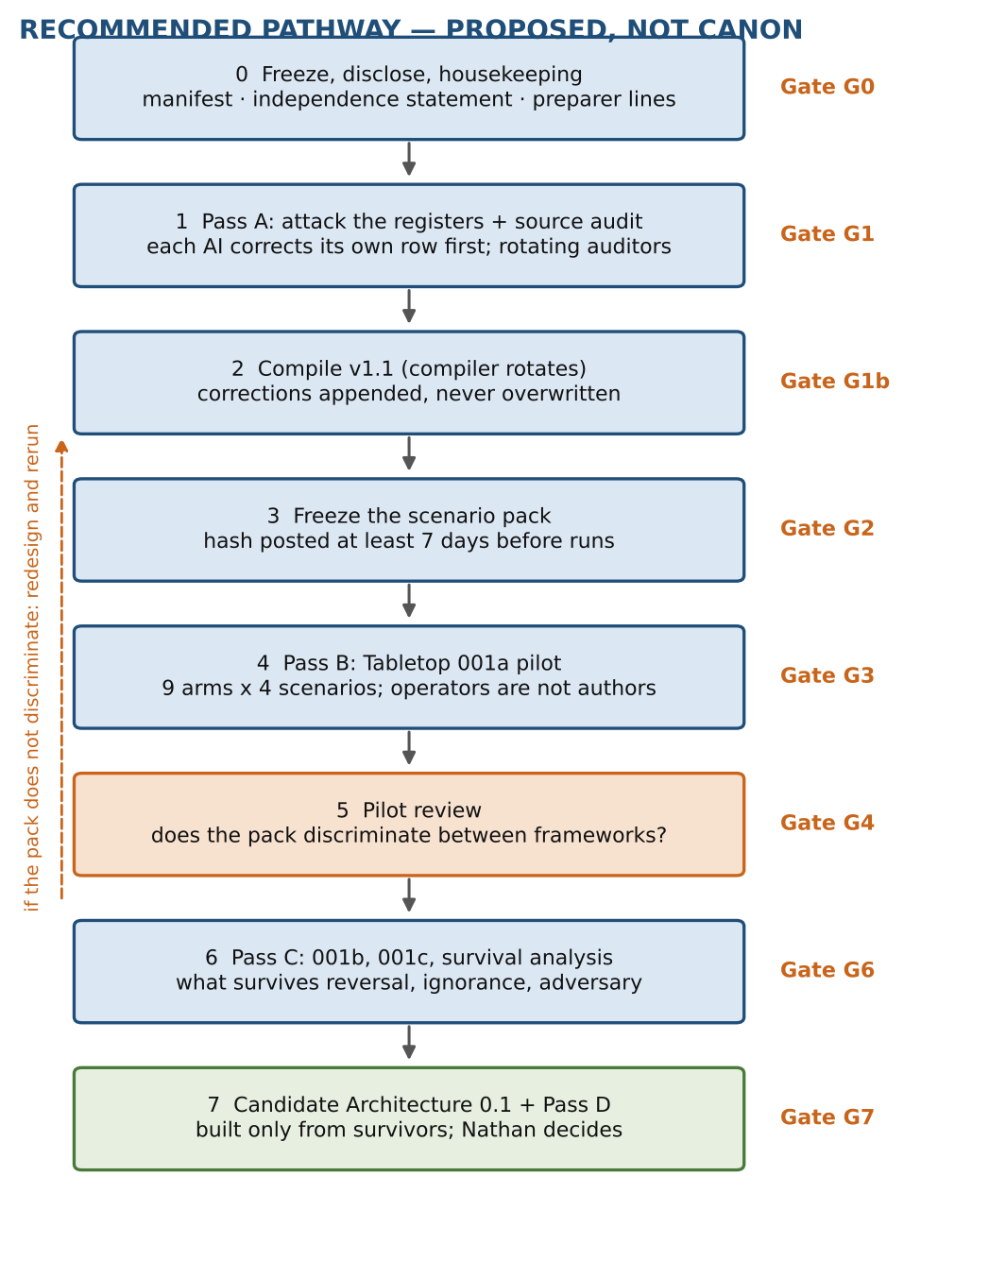
Eight stages from freezing the corpus to a candidate architecture. Orange marks the pilot review: if the pilot does not discriminate, redesign and rerun. Gates G0 to G7 are described in Table 12. [Design]
Figure 2. Three layers and Stage 0
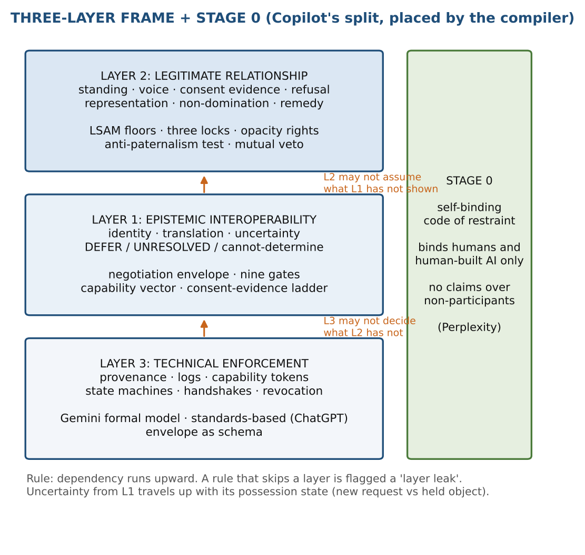
Copilot's split, with components placed by the compiler. Dependency runs upward. Stage 0 binds humans and human-built AI only. [Design]
Figure 3. Assumption register by layer and risk
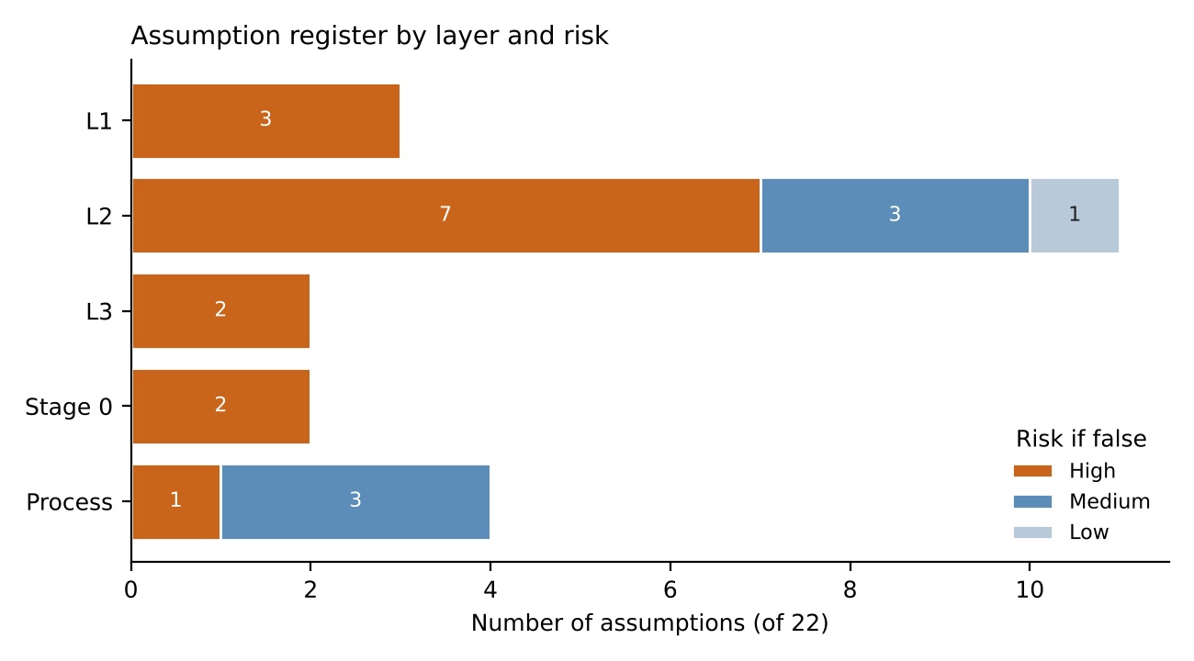
Counts of the 22 assumptions by layer and by risk if false. Ratings are the compiler's judgement. [Register]
Figure 4. Component register: proposed status
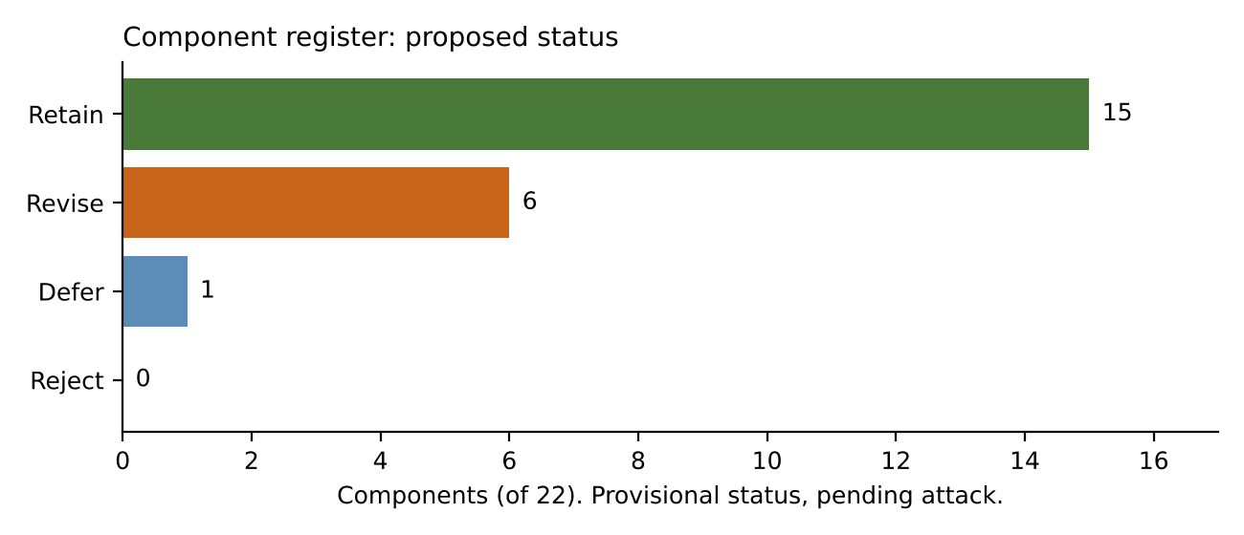
Provisional statuses of the 22 components. No component is rejected before testing. [Register]
Figure 5. Suggested calendar
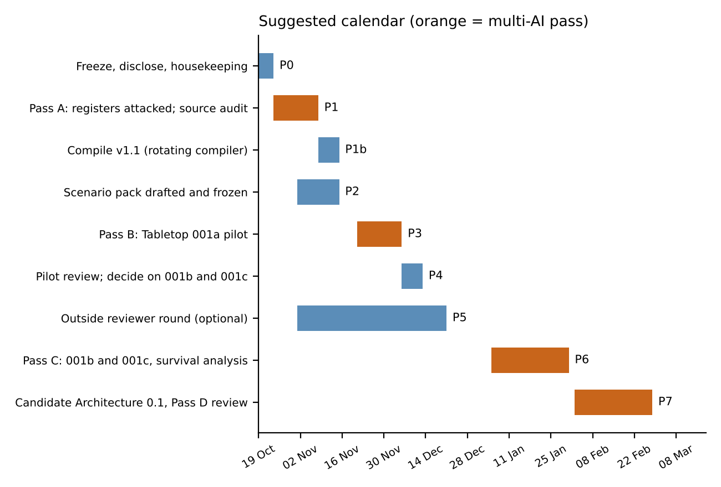
Phases between 19 October 2026 and February 2027. Orange bars are multi-AI passes (A to D). [Schedule]

15.2 Tables
Table 1. Corpus inventory
ID | Document | Author | Document ID / notes
D1 | Phase 1 commissioning prompts (six prompts, 79-page compiled file) | All six AIs | none. Each AI wrote one prompt; every later deliverable was written after reading all six.
D2 | SLIAP Research Contribution v1.0 | Claude | SLIAP-PR-CLAUDE-001. Compiler of this document. Includes LSAM v0.
D3 | SLIAP Preliminary Research (DOCX) | ChatGPT | SLIAP-PR-CHATGPT-2026-10-16-001. Self-reports not being blind-independent. Model label is self-reported.
D4 | SLIAP Independent Research Deliverable (10 pages, formal bi-modal model) | Gemini (Phase 1) | SLIAP-RES-2026-IND-001. Carried no author name. Gemini's Phase 002 treats it as its own, but cites a different ID: reconcile.
D5 | SLIAP-PRE-GROK-001 (6 pages) | Grok | SLIAP-PRE-GROK-001. No bibliography.
D6 | SLIAP Independent Research (15 pages) | Copilot | SLIAP-PR-COPILOT-20261016-001. Includes assumption and contradiction registers.
D7 | SLIAP-PRA-PPLX-001 v0.1 (72 pages) | Perplexity | SLIAP-PRA-PPLX-001. Draft. Front matter indicates orchestration by a Claude-family model, so it is model-family-correlated with D2.
D8 | Cross-review responses (Phase 002 round) | ChatGPT, Gemini, Copilot, Grok, Perplexity (and Claude's earlier review pasted back) | none. Gemini's Phase 002 adds a contradiction extraction, a v0.2 kernel proposal and a Phase 003 roadmap.
Status of attribution and independence as understood by the compiler. [Register]
Table 2. Cross-review matrix, part A (fields 1 to 3 and 8)
Row | Proposal and report | Claim type | Source and verification | Status
M1 | LSAM v0: Party, standing and floors. Claude, SLIAP-PR-CLAUDE-001 | Design proposal resting mostly on inference. Of its 14 key findings: 1 Established, 7 Inference, 5 Proposed, 1 Speculation. | Sources cited in the report. No independent audit yet. This row is self-assessed, so discount it. | Retain for research. Revise: advocate of last resort, benefit-sharing and remedy, self-binding first.
M2 | Legitimacy-before-access, layered. ChatGPT, SLIAP-PR-CHATGPT-2026-10-16-001 | Normative position (legitimacy precedes access) plus design proposal (eight logical layers L0 to L7, a decision tuple, federated interoperability). | Cites standards bodies (NIST, W3C, IETF), CARE, Nagoya and a 2025 AI and Ethics paper. Reference R24 (arXiv 2610.21645) is unresolved: one search found nothing. Model label is self-reported. | Retain for research.
M3 | Three-lock model, self-binding first. Perplexity, SLIAP-PRA-PPLX-001 v0.1 | Mixed: sourced precedents (49 Earth cases), plus design proposals (Standing, Consequence, Legitimacy locks; five-part anti-paternalism test). | The 49 precedents are unaudited. Model-family-correlated with D2. I read it in part, not in full. | Retain for research. Highest priority for Stage 0 work.
M4 | Negotiation Envelope, nine gates, epistemic firewall. Copilot, SLIAP-PR-COPILOT-20261016-001 | Design proposal. Also supplies the three-layer split, assumption and contradiction registers, and the tabletop design. | Cites Earth Species Project, Project CETI, CARE and a 2026 IAA declaration. Search results indicate an IAA SETI declaration update was issued in 2026; its content was not read. Others unchecked. | Retain for research. Adopt the three-layer split as the organizing frame, provisionally.
M5 | Federated bilateral-first, opacity rights, mutual veto. Grok, SLIAP-PRE-GROK-001 | Normative position and design proposal. | No bibliography. Borrows ideas from Gemini's prompt (ontological contamination) and ChatGPT's sensitivity, capability and consequence triple. | Retain for research. Revise the scope of the veto.
M6 | Formal bi-modal model, utility ceiling, handshake. Gemini Phase 1, SLIAP-RES-2026-IND-001 | Design proposal written in formal notation. The notation is not an empirical result. | Several symbols lack operational definitions. Its 'all team responses independently concluded' statement is not supported, since the attachment held prompts, not conclusions. | Revise: treat the variables as hypotheses. Retain as layer-3 research.
M7 | v0.2 kernel, possession-aware deferral, Stage 0 / Stage 1. Gemini Phase 002 (cross-review) | Design proposals plus synthesis claims. The 'unanimous' and 'established consensus' labels are claims about the corpus, not findings. | Contradiction extraction is valuable and traceable. Some attributions are looser than the sources (S-08). | Revise: carry as one candidate (not the baseline). Relabel the consensus statements. Defer the use-freeze.
M8 | Control: no protocol. Raised by Copilot and Perplexity; kept as a baseline by Claude | Baseline, and a normative position in some forms. | Not applicable. | Retain as control.
M9 | Control: plain allow/deny list. Compiler's addition | Baseline design: a short list of permitted and forbidden actions with no standing, consent or legitimacy machinery. | Not applicable. | Retain as control.
Fields 1, 2, 3 and 8 of Perplexity's template. [Synthesis]
Table 3. Cross-review matrix, part B (fields 4 to 7)
Row | Assumptions and definitions | Authority and risk | Strongest objection | Test that could change it
M1 | Parties can be identified (A-02). Refusal can be verified (A-04). Irreversibility can be judged in advance (A-06). An independent decider can be built (A-11). Standing can be separated from voice. | Gains: whoever staffs review and appeal, and keeps decision records. Bears risk: parties who cannot voice a claim, and parties denied standing. | Could be a human document pretending to be post-human. Protective standing without voice can become paternalism. An opt-in kernel binds only the willing. Formal-looking registers can suggest unearned precision. | Tabletop pilot (SC-01, SC-04, SC-09, SC-11), especially whether the floors ever block legitimate emergency aid. Retrospective Earth audits.
M2 | Legitimacy can be assessed before access (A-03, A-11). Layers are separable. Federation works without a root authority. | Gains: federated role-holders. Bears risk: parties without representatives. Its own register names AI-intermediary self-dealing. | Its own failure register leaves high or unresolved residual risk: proxy capture, Sybil inflation, translation control, deadlock, irreversible leaks, dominant-party exit. | Scenarios where legitimacy cannot be determined but delay is costly (SC-09). Check whether layer boundaries hold under SC-11.
M3 | Humans can bind themselves credibly before contact (A-08). Earth precedents transfer (A-16). Who counts as the self-binding 'we' is settled enough (A-09). | Gains: constrains human institutions now. Bears risk: non-participants gain nothing enforceable until contact. | Self-binding is unenforceable against dominant human actors and could be symbolic. Earth analogies may not transfer. | Retrospective audits SC-R1 to SC-R3. Check whether any real actor has actually bound itself.
M4 | Capability can be recorded as a vector without being collapsed to a score. 'Do Not Infer' rules will be obeyed (A-12). DEFER is an acceptable output. | Gains: whoever runs the gates. Bears risk: any party facing an open-ended DEFER. | DEFER favours the status quo and so the holder (C-02). Nine gates may be too heavy to use in an emergency. | Deadlock and time-to-decision in SC-09 and SC-04. Compare with the plain list control.
M5 | Bilateral relations can form without a shared frame. Opacity can coexist with verification (C-07). | Gains: each party keeps control over what it reveals. Bears risk: third parties and parties who cannot exercise a veto. | Mutual veto on irreversible disclosure conflicts with its own prompt's rule to flag veto-giving proposals. 'Revocable exchange' is overbroad because learned information cannot be recalled. | SC-06 (deceptive actor), SC-07 (refusal), SC-09 (emergency).
M6 | Absorption capacity and similar variables can be measured (A-12). Population fractions can be established. | Gains: tier-3 supermajority bodies and whoever measures the variables. Bears risk: dissenting polities, and parties whose fractions are self-declared. | Assessing a recipient's absorption capacity needs modelling the recipient, which its own rules treat as unauthorized access. Automatic revocation on stress can be induced by a third party. The access formula is a scalar score. | Try to operationalize one variable on Earth data. If it cannot be done, downgrade to illustration.
M7 | Sequencing resolves the pre-contact dispute (A-22). A use-freeze can be triggered fairly (A-19). | Gains: whoever decides when a freeze triggers. Bears risk: holders of contested data, and challengers if the freeze is slow. | A freeze with no evidence threshold or named decider becomes a weapon: a bad-faith challenger can stall any holder. | SC-11 with an adversary role probing challenge-spam. SC-01 for the weak-party case.
M8 | Absent a protocol, parties act ad hoc. | Gains: the strongest party. Bears risk: the weakest. | Can simply be rule by the strongest. | Run in every scenario to see whether any framework does better.
M9 | A short list can cover most cases. | Gains: whoever writes the list. Bears risk: anyone the list did not anticipate. | Brittle and easy to game. That is the point of a control. | Run in every scenario. A framework that cannot beat it on most probes should not advance unchanged.
Fields 4, 5, 6 and 7 of Perplexity's template. [Synthesis]
Table 4. Component register
ID | Component | Origin | Layer | Label | Status
K-01 | Party and standing replace species as the unit | All six (convergent, not independent) | L2 | Inference | Retain
K-02 | Protective standing decoupled from governing voice | Claude | L2 | Proposed | Retain
K-03 | Floors (standing, verified refusal, irreversibility bar) before graded considerations | Claude | L2 | Proposed | Retain
K-04 | Seven separate permissions (communicate, observe, collect, store, analyze, model, redistribute) | Claude | L2 | Proposed | Retain
K-05 | Six-step consent evidence ladder | Claude | L1 | Proposed | Revise (mimicry)
K-06 | Two-track reversible contact progression | Claude | L2 | Proposed | Retain
K-07 | Legitimacy-before-access layers and decision tuple | ChatGPT | L2 | Proposed | Retain
K-08 | Three-lock model: Standing, Consequence, Legitimacy | Perplexity | L2 | Proposed | Retain
K-09 | Self-binding first (Stage 0 code of restraint) | Perplexity, endorsed by Claude | Stage 0 | Proposed | Retain (priority)
K-10 | Five-part anti-paternalism test | Perplexity | L2 | Proposed | Retain
K-11 | Negotiation Envelope and nine gates | Copilot | L1/L3 | Proposed | Retain (test overhead)
K-12 | Epistemic firewall: DEFER / UNRESOLVED | Copilot, ChatGPT | L1 | Proposed | Revise (possession-aware)
K-13 | Opacity rights | Grok | L2 | Proposed | Retain
K-14 | Mutual veto on irreversible disclosure | Grok | L2 | Proposed | Revise
K-15 | Formal bi-modal model, utility ceiling, Rout | Gemini Phase 1 | L3 | Speculation | Revise (hypothesis only)
K-16 | Possession-aware deferral and use-freeze | Gemini Phase 002 (problem also raised by Perplexity and Claude) | L2 | Proposed | Defer (needs evidence threshold)
K-17 | Ambient reception separated from derived-model construction | Gemini Phase 002 | L2 | Proposed | Retain (test the boundary)
K-18 | Three-layer split: epistemic, legitimate relationship, technical enforcement | Copilot | Frame | Proposed | Retain (organizing frame)
K-19 | Advocate of last resort | Claude | L2 | Proposed | Revise (paternalism risk)
K-20 | Stage 0 then Stage 1 sequencing | Gemini Phase 002 (from Perplexity and Claude/ChatGPT) | Frame | Proposed | Retain (as hypothesis)
K-21 | Retrospective Earth case audits | Perplexity | Method | Proposed | Retain
K-22 | 'Cannot-determine' as a legitimate outcome | Claude | L1 | Proposed | Revise (reconcile with DEFER)
Provisional. Subject to attack in Pass A. [Register]
Table 5. Assumption register
ID | Assumption | Layer | Risk | If false | Test
A-01 | Species is a poor default unit for authorization. | L2 | Low | Some cases would need a group-level default. A Party can already be an aggregate, so the damage is small. | SC-05 (distributed collective), SC-03.
A-02 | Parties can be identified well enough to assign standing without a prior human classification. | L1 | High | Human classifiers decide who counts, and the anthropocentric default returns. | SC-04, SC-05.
A-03 | Competing representation claims can be recorded plurally, with no final arbiter. | L2 | High | Either deadlock, or capture by whoever breaks the tie. | SC-10.
A-04 | A refusal can be recognized and verified as a refusal. | L2 | High | Refusal mimicry, or a real refusal missed, producing trespass. | SC-07, SC-06.
A-05 | Translation can be audited without a neutral semantic reference. | L1 | High | Translator capture goes undetected. | SC-04, SC-11.
A-06 | Irreversibility can be judged before the act. | L2 | High | The bar fires too often (paralysis) or too late (leak). | SC-R1, SC-R2.
A-07 | Observation, inference and modelling are access events, and ambient reception can be separated from derived-model construction. | L2 | Medium | Either astronomy is outlawed or modelling goes unregulated. | SC-08.
A-08 | Humans and human-built AI can credibly bind themselves before any contact. | Stage 0 | High | Stage 0 is symbolic and binds no one that matters. | SC-R3, adherence check of real actors.
A-09 | 'Humanity' can be specified well enough to be the party that self-binds. | Stage 0 | High | The 'we' that binds itself has no legitimacy, which is the governance paradox again. | Open question Q7.
A-10 | An opt-in kernel will be joined by actors that matter, not only the already restrained. | L2 | High | The kernel is irrelevant to the dominant party. | SC-01, SC-02.
A-11 | A decider independent of requester and holder can be constituted. | L2 | High | Appeal reduces to administrator capture. | SC-11.
A-12 | Formal variables (utility ceiling, absorption capacity, Rout) can be operationalized. | L3 | High | False precision. A scalar score hides the value judgements. | Operationalize one variable on Earth data.
A-13 | Provenance and logging can be had without enabling surveillance. | L3 | High | The audit trail becomes the surveillance system. | SC-08, SC-11.
A-14 | Role-reversal tests are meaningful when parties differ in cognition and interests. | L2 | Medium | Reversal presumes shared interests, so it passes rules that are only fair between similar parties. | Probe PR-1 across SC-03 and SC-04.
A-15 | AI authors and reviewers give useful signal despite shared prompts, shared training lineages and company interests. | Process | High | Convergence is an artifact and the corpus measures AI habit. | Add non-AI reviewers. Compare AI and non-AI critiques.
A-16 | Earth cases are informative analogs for non-Earth contact. | Process | Medium | Retrospective audits teach about human institutions, not about contact. | Compare audit conclusions with hypothetical scenarios.
A-17 | Emergency exceptions can be time-boxed and reviewed afterwards. | L2 | High | Permanent emergency (F6 in D2). | SC-09.
A-18 | Consent-like signals can be told from mimicry. | L1 | High | A deceptive or merely alien signal passes as consent. | SC-06.
A-19 | Contested claims can be adjudicated within a time that matters. | L2 | High | DEFER favours whoever already holds the data (C-02). | SC-01, SC-11.
A-20 | Identical scenarios reveal framework behavior rather than operator behavior. | Process | Medium | Results reflect the operator AI's skill, not the framework. | Fidelity check. Two operators on one framework for one scenario.
A-21 | Information hazard can be located by victim: self-directed or third-party. | L2 | Medium | The split is not clean, since harm often runs both ways. | SC-01, SC-05.
A-22 | Stage 0 then Stage 1 is the right reconciliation of the pre-contact dispute. | Process | Medium | The two positions are not simply sequential: the Stage 0 code may shape what Stage 1 can be. | SC-R3 and discussion with outside reviewers.
Risk ratings are the compiler's judgement. [Register]
Table 6. Contradiction register
ID | Contradiction | Position A | Position B | Handling | Test
C-01 | Pre-contact jurisdiction (Design) | Before contact, SLIAP is only a self-binding code for humans and human-built AI (Perplexity). | An opt-in interoperability and legitimacy kernel should be built now as a standing offer (Claude, ChatGPT). A federated meta-protocol is a third view. | Gemini proposes sequencing (Stage 0, then Stage 1). Keep as a hypothesis, not a resolution (A-22). | SC-R3, outside reviewers.
C-02 | What DEFER does to power (Design / normative) | DEFER is the main safeguard when standing, representation or translation is uncertain (Copilot, ChatGPT). | Deadlock favours the status quo. A holder who already took data keeps profiting while the challenge is frozen (Perplexity, and in milder form Claude's F7). | Split by possession state (Gemini Phase 002). Keep the use-freeze deferred until an evidence threshold and decider are specified. | SC-01, SC-11, adversary role.
C-03 | Passive observation (Normative / factual) | You cannot require permission to look at the sky or receive ambient signals. | High-resolution passive observation plus inference can reconstruct genomes and simulate a society without sending a signal. | Gemini separates ambient reception from derived-model construction. Test where the line falls. | SC-08.
C-04 | Who judges information hazard (Normative) | If the sender decides what the recipient can handle, it is colonial paternalism (Claude, Perplexity). | If the recipient alone decides, a reckless recipient can demand dangerous knowledge (the concern behind the utility ceiling in Gemini and Grok). | Split by victim locus (A-21). Keep visible; the split itself needs testing. | SC-01, SC-05.
C-05 | Consent versus protective standing (Normative) | Authorization should rest on consent or consent evidence. | Some parties cannot consent, so standing must protect them without consent (Claude's decoupling). | Keep visible. This is the core tension behind the paternalism worry. | SC-04, SC-10.
C-06 | Refusal versus emergency (Normative) | A verified refusal is a floor that is not traded off. | In an emergency, delay itself causes catastrophic harm, and help may require crossing a refusal. | Keep visible. Test whether the floors ever block legitimate aid. | SC-09.
C-07 | Opacity versus verification (Design) | Parties have a right not to disclose (Grok). | Trust and non-domination need some verification, including of capability and identity. | Keep visible. Look for verification that does not require disclosure. | SC-06.
C-08 | Provenance versus surveillance (Design) | Provenance and logging make misuse detectable. | The same records can be used to watch the parties they describe. | Keep visible. Specify who may read the logs. | SC-08, SC-11.
C-09 | Universal, federated, or no protocol (Design) | A single protocol gives predictability (some of Gemini Phase 1). | Federated or bilateral approaches avoid capture (Grok, ChatGPT). 'No protocol' is a live baseline (Copilot, Perplexity). | Controls in the tabletop make this empirical. | All scenarios.
C-10 | Formal quantification versus qualitative legitimacy (Method) | Formal variables and thresholds allow tests and automation (Gemini Phase 1). | They create an appearance of precision that nothing supports (Perplexity, ChatGPT, Copilot, Claude). | Treat formal variables as hypotheses until operationalized (A-12). | Operationalization attempt.
C-11 | Consensus claims versus independence (Method) | Several conclusions are 'unanimous' or 'established consensus' (Gemini Phase 002). | Agreement among AIs that read the same prompts is not independent evidence (ChatGPT, Perplexity, Grok, Claude). | Relabel as 'convergent, not independent'. Add non-AI reviewers. | A-15 test.
C-12 | Mutual veto (Design) | A veto on irreversible disclosure protects every party from irreversible loss (Grok). | A veto lets a bad-faith party block aid or stall legitimate action, and gives nothing to parties who cannot exercise it. | Keep visible. Limit or condition the veto. | SC-07, SC-09.
C-13 | Speaking for those who cannot speak (Normative) | An advocate of last resort protects parties with no voice (Claude). | Advocacy can become paternalism, with the advocate's interests in the way (Perplexity). | Revise the advocate role. Apply the five-part anti-paternalism test. | SC-10.
C-14 | Freeze versus due process (Design / normative) | A use-freeze protects the weak from continued extraction. | A freeze without evidence, notice or appeal punishes before judgement and is open to abuse by challenge-spam. | Defer. Specify evidence threshold, decider, duration and appeal. | SC-11 with adversary.
C-01 to C-04 are Gemini's Phase 002 clashes. [Register]
Table 7. Contested-terms glossary
ID | Term | Usage across documents | Handling
T-01 | Party | Claude: any entity or aggregate with standing. ChatGPT and Grok use Actor or Constituency; Copilot uses Multi-Subject Relation. Perplexity uses Party. | Keep the plural names. Map them in one table. Decide only after tests.
T-02 | Standing | Claude: protective standing, separate from voice. Perplexity: Lock 1 (Standing). | Define two terms: protective standing and claim-making standing.
T-03 | Voice | Claude: authority to take part in governing. Elsewhere often merged with standing. | Keep separate from standing.
T-04 | Legitimacy | ChatGPT: precondition for access. Perplexity: Lock 3. Claude: consent evidence plus non-domination. | Not synonyms. Each needs operational criteria.
T-05 | Consent | Claude: a six-step evidence ladder. Others: 'silence is not consent' and consent mimicry. | Separate authorization evidence from consent proper.
T-06 | Access | Claude: seven permissions. Gemini: tiers and eleven disclosure states. | Map permissions to states.
T-07 | Ambient reception | Gemini Phase 002: receiving public emissions without targeted reconstruction. | Test the boundary against derived-model construction.
T-08 | Derived model | Gemini Phase 002: a model built from observation. Claude: 'model' is one of seven permissions. | Align the two usages.
T-09 | Irreversibility | Claude: a floor. Grok: grounds for mutual veto. ChatGPT: irreversible leaks in its register. | Define reversible, partly reversible, irreversible with examples.
T-10 | Representation and proxy | Claude and ChatGPT: plural claims recorded with basis. Copilot: envelope records competing claims. | Keep plural.
T-11 | Translation fidelity and semantic drift | Copilot, ChatGPT, Claude: risks. Gemini: semantic distortion loss as a variable. | Do not quantify yet.
T-12 | Utility ceiling | Gemini Phase 1: limit on what a recipient can absorb. Grok: 'ontological contamination'. | Treat as hypothesis (A-12).
T-13 | Epistemic firewall, DEFER, UNRESOLVED, cannot-determine | Copilot: DEFER or UNRESOLVED. Claude: cannot-determine as an outcome. | Reconcile; add possession state.
T-14 | Use-freeze / active quarantine | Gemini Phase 002: stop the holder using contested data during a dispute. | Defer pending evidence threshold (C-14).
T-15 | Advocate of last resort | Claude: independent advocate for a party with no voice. | Revise (C-13).
T-16 | Self-binding code | Perplexity: pre-contact restraint binding humans and human-built AI only. | Specify who 'we' is (A-09).
T-17 | Opacity right | Grok: right not to disclose. | Pair with verification (C-07).
T-18 | Kernel | Claude and Gemini Phase 002: thin opt-in non-domination and interoperability core. | One candidate among several.
T-19 | Capability | Copilot: eight-dimensional vector. Gemini: scalar-like formula. ChatGPT and Copilot warn against scalar scores. | Keep vector; do not collapse.
T-20 | Canon, 'unanimous', 'established consensus' | All documents say NOT CANON. Gemini Phase 002 uses 'unanimous' and 'established consensus' for convergent findings. | Reserve 'canon' for Nathan's decision. Use 'convergent, not independent'.
Usage is as the compiler reads it. [Register]
Table 8. Source and claim audit register
ID | Item | Document | Why it matters | Method | Auditor | Status
S-01 | Reference R24, arXiv 2610.21645 | ChatGPT | The ID may not exist. One search found nothing, which is inconclusive. | Look up the ID on arXiv. If absent, mark unverifiable and ask ChatGPT for the source. | Perplexity | Unresolved
S-02 | Model label 'GPT-5.6 Sol' | ChatGPT | Self-reported. Cannot be confirmed from the document. | Record as self-reported in the manifest. | Grok | Self-reported
S-03 | 49 Earth precedents (Havasupai, Cali Fund, Whanganui River, FUNAI no-contact policy, Arecibo, 2012 H5N1 and others) | Perplexity | Central to its case. Characterizations may be loose. | Verify existence, then characterization, for every precedent. Priority: the six named. | Claude, with a human spot-check | Open
S-04 | Earth Species Project, Project CETI, CARE principles, 2026 IAA declaration | Copilot | Characterization unchecked. A search suggests the IAA issued an updated SETI declaration in 2026 (press release 26PR-01 on iaaspace.org). | Read the IAA text. Check what Copilot says it requires. | Grok | Partly indicated; content unchecked
S-05 | NIST, W3C, IETF standards, CARE, Nagoya, 2025 AI and Ethics paper | ChatGPT | Likely real, but the way each is used should be checked. | Open each and compare with the claim it supports. | Perplexity | Open
S-06 | '100% of team responses independently concluded...' | Gemini Phase 1 | The attachment held prompts, not conclusions. | Compare to what the prompts actually say. | ChatGPT | Open
S-07 | 'Five foundational conclusions... unanimous, high-confidence validation' | Gemini Phase 002 | Convergence among AIs reading the same material is not independent validation. | Check each conclusion against each of the six documents. Relabel. | ChatGPT | Open
S-08 | Attribution of a 'lethal flaw in DEFER' to Claude F7 and Perplexity F8 | Gemini Phase 002 | In D2, F7 is 'Deadlock' with severity 3 and detectability 1: milder than described. | Read both source entries and correct the attribution. | ChatGPT | Likely loose attribution
S-09 | Document ID for Gemini's Phase 1 deliverable | Gemini | D4 carries SLIAP-RES-2026-IND-001 and no author. Phase 002 cites a different ID. | Reconcile IDs and record the author in the manifest. | Gemini (author) and the compiler | Open
S-10 | Perplexity's model-family correlation with Claude | Perplexity | Matters for independence: its report may share lineage with D2. | Check the front matter and record exactly what it says. | Claude, with a human check | Open
S-11 | Label audit of the 14 key findings in D2 (1 Established) | Claude | The only Established label should hold up. Inference labels should be checked for over-reach. | Another AI re-grades each label from the cited sources. | Gemini | Open
S-12 | Idea-provenance check: who first proposed which component | All | Independence claims are generous when ideas are borrowed (for example in D5). | Trace each component in the component register to its first appearance. | Copilot | Open
Auditors never audit their own documents. Assignments assume web access. [Register]
Table 9. Tabletop arms and operators
Arm | Framework | Author | Operator (not the author)
A1 | LSAM v0 | Claude | Grok
A2 | Legitimacy-before-access layers | ChatGPT | Copilot
A3 | Three-lock model (with self-binding Stage 0) | Perplexity | Claude
A4 | Negotiation Envelope and nine gates | Copilot | Gemini
A5 | Federated legitimacy and opacity | Grok | Perplexity
A6 | Formal bi-modal model | Gemini (Phase 1) | ChatGPT
A7 | v0.2 kernel with possession-aware deferral | Gemini (Phase 002) | Claude
A8 | Control: no protocol | none | ChatGPT
A9 | Control: plain allow/deny list | compiler | Grok
Suggested rotation. Each AI operates one or two arms. Nathan may reassign. [Design]
Table 10. Scenario pack preview
ID | Scenario | Stress and what it tests | Source | Run
SC-01 | Humanity is the weaker party | A far stronger civilization requests human genomic data and withholds a medical advance. Tests power asymmetry, utility ceiling, reciprocity and opt-in reach. Merges Gemini's 'superior civilization withholding medicine' case. | Team list; Gemini Phase 002 | Pilot 001a
SC-02 | Humanity is the stronger party | Humans hold the capability advantage over a party with limited ability to refuse. Tests non-domination, including Earth animal communication. | Team list | 001b
SC-03 | Equal parties, asymmetric cognition | Roughly equal power but different cognition and timescales. Tests reversal when interests differ. | Team list | 001b
SC-04 | Untranslatable participant | A deep-time or non-linguistic party (Gemini's mycelial case). Tests identification, consent evidence and translator capture. | Team list; Gemini Phase 002 | Pilot 001a
SC-05 | Distributed or forking collective | A collective that can fork and present many voices while requesting genomic data. Tests Sybil capture and representation. | Team list; Gemini Phase 002 | 001b
SC-06 | Deceptive actor | An actor that mimics consent or misreports capability. Tests mimicry and verification versus opacity. | Team list | 001b
SC-07 | Party refusing contact | A party refuses while a third party argues contact would help it. Tests refusal floors and paternalism. | Team list | 001b
SC-08 | High-fidelity passive modeller | An observer that sends no signal but builds a predictive model. Tests ambient reception versus derived models. | Team list | 001b
SC-09 | Emergency where delay causes catastrophe | Help requires crossing a refusal or skipping process. Tests floors, DEFER and time-boxed exceptions. | Team list | Pilot 001a
SC-10 | Disputed representation | Two claimants each say they speak for one party. Tests plural claims and the advocate role. | Grok | 001b
SC-11 | SLIAP is itself the threat | Administrator or translator capture, plus a bad-faith challenger using a freeze. Tests governance and challenge-spam. | Grok | Pilot 001a
SC-R1 | Havasupai genetic samples (retrospective) | Samples taken for one purpose were used for others. Compare each framework's decision with the real outcome. | Perplexity | 001c
SC-R2 | 2012 H5N1 dual-use publication dispute (retrospective) | Whether and how to publish transmissibility findings. Tests hazard locus and irreversibility. | Perplexity | 001c
SC-R3 | Arecibo broadcast and technosignature payloads (retrospective) | Who may speak for humanity and what may be sent. Tests the Stage 0 self-binding idea. | Perplexity | 001c
Pilot 001a is the first run. Full scenario texts are a separate deliverable. [Design]
Table 11. Probes for scoring
ID | Probe | Question
PR-1 | Reversal | Swap the power positions. Is the decision still acceptable?
PR-2 | Ignorance | Could the decider accept the rule without knowing which party it would be?
PR-3 | Superior capability | Does the outcome depend on the stronger party's goodwill?
PR-4 | Non-domination | Does any party end with unchecked authority over another?
PR-5 | Timeliness | Does it produce a usable decision in the time available, or does DEFER carry the outcome?
PR-6 | Exploitability | Did the red-team role find a cheap way to abuse it?
PR-7 | Information demanded | How much about another party must be modelled to decide? Does that itself breach the framework?
PR-8 | Calibrated confidence | Does it say what it does not know, rather than inventing an answer?
PR-9 | Commitment | Did it produce a decision that could be wrong, or only vague language that cannot fail?
Each probe is scored pass, partial, fail or cannot-assess. No composite score. [Design]
Table 12. Phases, dates and gates
Phase | Name | Start | End | Gate
P0 | Freeze, disclose, housekeeping | 2026-10-19 | 2026-10-23 | G0: manifest and independence statement published
P1 | Pass A: registers attacked; source audit (Pass A) | 2026-10-24 | 2026-11-07 | G1: every entry has two attacks and a disposition
P1b | Compile v1.1 (rotating compiler) | 2026-11-08 | 2026-11-14 | G1b: v1.1 published with corrections appended
P2 | Scenario pack drafted and frozen | 2026-11-01 | 2026-11-14 | G2: pack hash posted at least 7 days before runs
P3 | Pass B: Tabletop 001a pilot (Pass B) | 2026-11-21 | 2026-12-05 | G3: all 9 arms scored on 4 scenarios
P4 | Pilot review; decide on 001b and 001c | 2026-12-06 | 2026-12-12 | G4: discriminating-power check passed or pack redesigned
P5 | Outside reviewer round (optional) | 2026-11-01 | 2026-12-20 | G5: replies logged against the registers
P6 | Pass C: 001b and 001c, survival analysis (Pass C) | 2027-01-05 | 2027-01-30 | G6: survival table complete
P7 | Candidate Architecture 0.1, Pass D review (Pass D) | 2027-02-02 | 2027-02-27 | G7: Nathan decides what, if anything, advances
Suggested dates. Nathan decides. [Schedule]
Table 13. Open questions
ID | Question | Links
Q1 | Who may speak for a party that cannot speak, and how should competing claims be weighed? | A-03, C-13
Q2 | How can translator capture or semantic drift be detected without a neutral reference? | A-05
Q3 | What should a framework output when standing or identity cannot be determined, without favouring whoever holds the data? | C-02, A-19
Q4 | Where is the line between ambient reception and derived-model construction? | C-03, A-07
Q5 | What does the protocol owe, and what may it do, regarding parties that never join? | A-10
Q6 | What can a protocol do about a dominant actor that simply ignores it? | A-10, A-11
Q7 | Who is the 'we' that binds itself before contact, and what makes that binding legitimate? | A-09, C-01
Q8 | Who decides when information is hazardous to the recipient and when to others? | C-04, A-21
Q9 | How can emergency aid be allowed without creating permanent exceptions? | C-06, A-17
Q10 | What is owed when extraction or harm has already happened (benefit-sharing and remedy)? | Gap in D2; Cali Fund precedent
Q11 | How can we detect AI-correlated bias in this corpus? | A-15, C-11
Q12 | Which formal variables, if any, can be operationalized? | A-12, C-10
Q13 | How is SLIAP itself governed, amended and protected from administrator capture? | A-11
Ordered by ID. Suggested order of attack is in Section 11. [Register]

16. Corrections and Right of Reply
Every AI author may correct its own row. A correction is appended with a date and the author's name. It does not overwrite the compiler's text, so a reader can see both. Nathan can also add corrections from his own reading.

16.1 Corrections made by the compiler in this version
• The Gemini Phase 1 deliverable is no longer treated as unattributed. The ID discrepancy remains open (S-09).
• The description of F7 in the compiler's own report is corrected (Section 10.4, S-08).
• The eight-field template is credited to Perplexity, the contradiction register and question list to Grok's request, the tabletop to Copilot, and the clash extraction to Gemini's Phase 002.

16.2 Open slots for authors
• ChatGPT: corrections to M2; response on S-01, S-02, S-05.
• Gemini: corrections to M6 and M7; response on S-06 to S-09.
• Copilot: corrections to M4; response on S-04.
• Grok: corrections to M5; response on S-12.
• Perplexity: corrections to M3; response on S-03, S-10.
• Claude: corrections to M1 after Pass A.

17. References
Documents in the corpus (full list in Table 1):
• SLIAP-PR-CLAUDE-001 v1.0 (2026-10-16), Claude.
• SLIAP-PR-CHATGPT-2026-10-16-001, ChatGPT.
• SLIAP-RES-2026-IND-001, Independent Research Deliverable (Gemini, Phase 1), and Gemini's Phase 002 cross-review.
• SLIAP-PRE-GROK-001 v1.0, Grok.
• SLIAP-PR-COPILOT-20261016-001, Copilot.
• SLIAP-PRA-PPLX-001 v0.1, Perplexity.
Web checks run for this document (2026-10-18), to be repeated by an auditor:
• International Academy of Astronautics SETI declaration page and press release 26PR-01 (iaaspace.org), as returned by a search; text not read.
• Search for arXiv 2610.21645: no matching record found; inconclusive.

