SLIAP PHASE 002B
CROSS-REVIEW CONTROL DOCUMENT
Contradiction Matrix, Contested-Terms Register, Claim-Evidence Ledger,
and Phase 003 Adversarial Test Specification

Control field | Value
Document ID | SLIAP-CRCD-2026-10-18-001
Version | 1.0
Date | 18 October 2026
Prepared by | ChatGPT (GPT-5.6 Sol)
Project | SLIAP - Species-Level Information Access Protocol
Phase | 002B - Corpus / Evidence / Contradiction Control
Governance status | PRELIMINARY RESEARCH - PROPOSED - NOT CANON
Purpose | Bridge Phase 001 research and Phase 003 controlled adversarial simulation without prematurely selecting a canonical architecture.

STATUS NOTICE
This document controls the next research phase. It does not establish SLIAP doctrine, rights, jurisdiction, clearance levels, or final protocol architecture. All candidate rules remain subject to adversarial testing, source verification, revision, or rejection.

Executive Summary
Phase 001 produced a genuinely plural research corpus: the reports differ in architecture, sequencing, governance theory, failure handling, and degree of formalization. Phase 002A then produced a second-pass set of reviews from ChatGPT, Claude, Google Gemini, Microsoft Copilot, Grok, and Perplexity. Those reviews agree on the immediate procedural lesson: the project should not move directly from parallel research reports into a single SLIAP architecture.
This control document implements the recommended next step. It freezes the source corpus, separates sourced evidence from inference and design proposals, records unresolved terminology and contradictions, defines a common test protocol, and specifies a Phase 003 scenario suite. Its purpose is to make competing SLIAP models produce observable decisions under the same conditions rather than continuing to compare prose alone.
The document also performs a targeted source audit of decision-critical external claims used repeatedly in the corpus. Official or primary sources were checked for NIST Zero Trust and ABAC, W3C Verifiable Credentials and PROV-O, RFC 9171, CARE, Local Contexts TK/BC Labels, the Nagoya Protocol and Cali Fund, Te Awa Tupua, CRPD Article 12, the New York Declaration on Animal Consciousness, sperm-whale and elephant communication studies, the 2026 IAA SETI declaration, Arecibo, the 2012 H5N1 dual-use publication dispute, the Havasupai case, and the 2025 AI-and-Ethics paper. Michael Garrett's arXiv:2610.21645, questioned in one review because of its recent identifier, is verified as a real preprint submitted 15 October 2026; it remains a preprint, not settled evidence.
The strongest output of Phase 002B is therefore not a reconciled SLIAP v0.2. It is an auditable experiment design: freeze the models, give each the same facts, prohibit cross-model borrowing in the first pass, apply identical adversarial overlays, compare the resulting decision traces, and classify which principles survive, fail, or remain conditional. Only after that survival analysis should the project consider a candidate architecture.

Recommended phase sequence
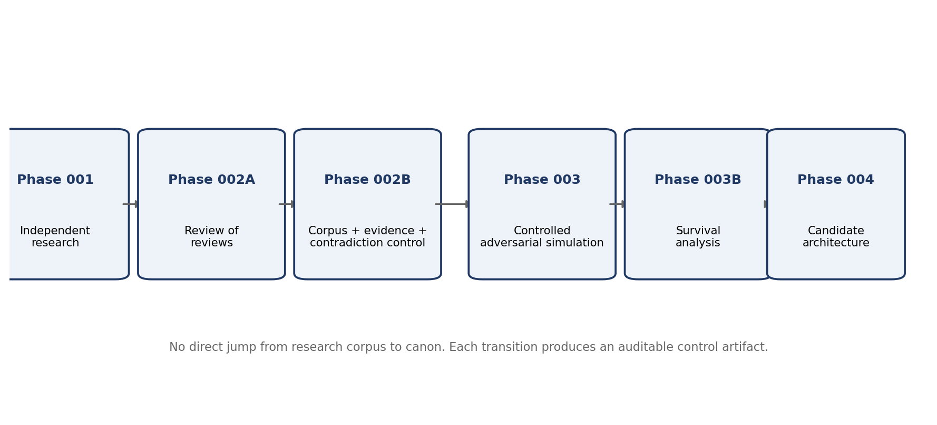
Figure 1. Recommended research sequence. Original control-document synthesis.

1. Scope, Inputs, and Research Discipline
This document uses two input classes. The primary corpus consists of the Phase 001 research deliverables. The secondary corpus consists of the Phase 002A reviews supplied in the pass-through: ChatGPT, Claude, Google Gemini, Microsoft Copilot, Grok, and Perplexity. The reviews are interpretive inputs; they do not overwrite the primary reports.
The control rule for this phase is preservation before reconciliation. A contradiction is a result to be recorded, not a defect to be automatically repaired. Cross-model agreement is also not treated as proof. The models responded to shared commissioning material; several explicitly reviewed other prompts; and at least two reports were produced within the Claude model family. Agreement is therefore categorized as cross-model convergence under a shared commission, not independent empirical confirmation.
Phase 002B uses the following evidence labels throughout: SOURCE-DERIVED FACT, EXTERNALLY VERIFIED FACT, INFERENCE, NORMATIVE POSITION, DESIGN PROPOSAL, SPECULATIVE MODEL, and UNRESOLVED. These labels are not ranks of importance. They describe what kind of claim is being made and what kind of challenge can appropriately be applied to it.

1.1 AI conflict-of-interest disclosure
This document is itself prepared by an AI system. AI systems are not neutral observers of SLIAP because future versions of the framework may assign AI systems roles as translators, semantic mediators, modelers, classifiers, provenance services, registrars, or decision-support systems. Accordingly, this document treats AI contributors as interested research participants and recommends that later phases include human reviewers with expertise and lived or institutional perspectives that are not reducible to the current AI research pool.

2. Phase 001 Corpus Freeze Register
ID | Contributor / attribution | Document ID | Version | Core model | Phase 003 status
C1 | ChatGPT | SLIAP-PR-CHATGPT-2026-10-16-001 | v1.0 | Federated legitimacy-before-access; L0-L7 logical layers; role separation; non-binary outcomes | Frozen for first-pass simulation
C2 | Claude | SLIAP-PR-CLAUDE-001 | v1.0 | LSAM v0; Party + graded standing; floors before graded considerations; two-track contact | Frozen for first-pass simulation
C3 | Microsoft Copilot | SLIAP-PR-COPILOT-20261016-001 | v1.0 | Multi-subject relation; Negotiation Envelope; nine gates; epistemic firewall | Frozen for first-pass simulation
C4 | Grok | SLIAP-PRE-GROK-001 | v1.0 | Federated interfaces; opacity rights; relationship-level legitimacy; mutual veto proposal | Frozen for first-pass simulation
C5 | Perplexity | SLIAP-PRA-PPLX-001 | v0.1 | Self-binding first; Standing-Consequence-Legitimacy three-lock model; Earth-first validation | Frozen for first-pass simulation
C6 | Unresolved attribution in file | SLIAP-RES-2026-IND-001 | v1.0.0 | Bi-modal technical/polycentric prototype; utility/absorption variables; slow-clock pacing; resolution transformation | Freeze as Technical Model T1 pending attribution resolution

2.1 Metadata and attribution control issues
Issue | Observation | Control action
M-01 | SLIAP-RES-2026-IND-001 has no preparer/model attribution visible in the file. | Do not infer authorship from style. Run as Technical Model T1 until provenance is resolved.
M-02 | Google Gemini's Phase 002 review refers to a prior baseline as OAL-SLIAP-RES-2026-001, which does not exactly match SLIAP-RES-2026-IND-001. | Treat the relationship as unverified until the file creator confirms whether these are the same artifact/version.
M-03 | Several Phase 001 reports reviewed the commissioning prompts before producing their own research. | Do not label the corpus blind-independent.
M-04 | Claude disclosed that some older citations were from training knowledge and not re-verified in-session. | Use the external audit below before elevating those claims.
M-05 | Perplexity's report was described in the pass-through as orchestrated through Claude Opus 5.5. | Record model-family correlation as a methodological limitation, not as a reason to discard the work.

2.2 Version-control rule
No Phase 001 artifact should be silently edited during Phase 003. Corrections should be issued as errata or new versions. A first-pass run must name the exact document ID and version used. Any model that borrows a later fix must do so only in a separately labeled second-pass run.

3. Claim-Evidence Control and Targeted Source Audit
Claim class | Meaning | Minimum documentation | Control warning
SOURCE-DERIVED FACT | Directly stated in a Phase 001/002 artifact. | Citation to artifact ID/page/section. | Does not become true merely because a model states it.
EXTERNALLY VERIFIED FACT | Checked against an official, primary, or high-quality scholarly source. | External source recorded with date/URL. | Verification is limited to what the source actually supports.
INFERENCE | Reasoned conclusion drawn from evidence or model comparison. | Premises stated; counterexample invited. | Must not be relabeled established by consensus.
NORMATIVE POSITION | Value-bearing proposition about legitimacy, rights, duties, fairness, or restraint. | Argument + affected parties + reversal test. | Cannot be proven by engineering alone.
DESIGN PROPOSAL | Candidate mechanism, state, gate, schema, or governance rule. | Failure mode + test condition. | Remains NOT CANON until tested and adopted.
SPECULATIVE MODEL | Hypothetical actor/property or formal variable without validated measurement. | Assumptions and falsifiability condition. | Mathematical notation must not create false precision.
UNRESOLVED | Evidence or concepts are insufficient for a defensible determination. | Reason for uncertainty + next test. | Unknown is a valid output, not a documentation defect.

3.1 Decision-critical external source audit
ID | Source / precedent | What was verified | Status | SLIAP control note
E01 | NIST SP 800-207 - Zero Trust Architecture | Official NIST page verified. No implicit trust based solely on network location/ownership; authentication and authorization precede resource session. | VERIFIED - bounded technical analogy | Supports session-security analogy, not political legitimacy.
E02 | NIST SP 800-162 - ABAC | Official NIST/CSRC page verified. ABAC evaluates subject, object, operation and environment attributes against policy. | VERIFIED - bounded technical analogy | Assumes attribute authorities and policy context.
E03 | W3C Verifiable Credentials Data Model v2.0 | W3C Recommendation dated 15 May 2025 verified. | VERIFIED | Can express claims securely; cannot prove the legitimacy of the issuer's mandate.
E04 | W3C PROV-O | W3C Recommendation verified; represents and exchanges provenance across heterogeneous systems. | VERIFIED | Useful for provenance structure; surveillance/minimization remain governance questions.
E05 | IETF RFC 9171 Bundle Protocol v7 | RFC Editor standards-track text verified (Jan. 2022). | VERIFIED | Useful for delay-tolerant transport analogy, not a legitimacy solution.
E06 | CARE Principles for Indigenous Data Governance | Global Indigenous Data Alliance source verified: Collective Benefit, Authority to Control, Responsibility, Ethics; addresses power/history absent from purely data-centric openness. | VERIFIED | Use as a bounded governance analogy; do not universalize Indigenous governance.
E07 | Local Contexts TK and BC Labels | Local Contexts pages verified: communities express provenance, protocol and permission conditions; BC labels extend to biological/genomic data. | VERIFIED | Supports subject/community metadata analogy; labels are extra-legal and context-specific.
E08 | Nagoya Protocol | CBD official source verified: fair/equitable benefit sharing from utilization of genetic resources. | VERIFIED | State-based international-law framework; not proof of universal cross-species property rules.
E09 | Cali Fund / DSI mechanism | CBD official source verified: fund is financial arm of COP16 multilateral mechanism for benefit sharing from digital sequence information. | VERIFIED | Supports downstream-use/benefit-sharing analogy; implementation remains human institutional law.
E10 | Te Awa Tupua Act 2017 | Official New Zealand legislation verified: Te Awa Tupua is a legal person; rights/duties exercised by Te Pou Tupua. | VERIFIED | Useful representation/stewardship analogue; not a generic template for nonhuman entities.
E11 | CRPD Article 12 | UN/OHCHR text verified: equal recognition before the law and access to support in exercising legal capacity. | VERIFIED | Supports supported-decision-making analogy; not a direct interspecies consent rule.
E12 | New York Declaration on Animal Consciousness (2024) | Declaration text verified: realistic possibility of consciousness in all vertebrates and many invertebrates; ignoring that possibility in decisions affecting animals is irresponsible. | VERIFIED AS DECLARATION CONTENT | Normative/precautionary use remains an inference; not proof of consciousness in every included taxon.
E13 | Sperm-whale coda structure (Nature Communications 2024) | Peer-reviewed paper verified: contextual and combinatorial structure in sperm-whale vocalisations. | VERIFIED | Does not establish full semantic translation or human-like language.
E14 | Elephant individually specific name-like calls (Nature Ecology & Evolution 2024) | Peer-reviewed paper verified: wild African elephants address one another with individually specific, probably non-imitative calls. | VERIFIED | Do not overstate as full naming equivalence or generalized language.
E15 | IAA SETI Declaration 2026 update | IAA/SETI sources verified: confirmed detection procedures and international consultation through UN/broadly representative bodies before reply. | VERIFIED | A self-binding scientific protocol, not a universal planetary constitution.
E16 | Arecibo message 1974 | SETI Institute and Icarus record verified: deliberate 1679-bit message sent toward M13 describing biology/solar system/humans. | VERIFIED | Useful transmission-governance case; historical actors did not use SLIAP concepts.
E17 | H5N1 dual-use publication dispute (2011-2012) | NIH/NSABB records verified: initial recommendation withheld enabling details; voluntary moratorium; revised manuscripts later recommended for fuller communication. | VERIFIED | Useful because the decision changed after new evidence/clarification; avoid presenting it as a single fixed outcome.
E18 | Havasupai blood-sample dispute and 2010 settlement | Arizona court record and scholarly/ASU-related sources verified: diabetes-centered samples were later used in unrelated studies; 2010 settlement included return of samples and compensation. | VERIFIED | Settlement created no broad legal precedent; use as consent-scope/remedy case, not universal doctrine.
E19 | Küçükuncular 2025, AI and Ethics | Springer article and correction verified. Ethical analysis of AI-mediated interspecies communication; correction clarified CETI did not state a 2026 two-way communication goal. | VERIFIED | Important correction: avoid attributing the speculative 2026 two-way goal to CETI.
E20 | Garrett, arXiv:2610.21645, Beyond the Beacon | arXiv record verified: submitted 15 Oct. 2026; concerns information-rich technosignatures and state/corporate competition. | VERIFIED PREPRINT | Extremely recent and not peer-reviewed; use as emerging analysis only.

3.2 Audit limits
This is a targeted audit of decision-critical claims repeated across the corpus, not a line-by-line verification of every bibliography. Perplexity reports dozens of precedents; Claude and other reports also cite older theoretical literature. Those sources should be audited before any claim depending on them is elevated from research context to architecture requirement.

4. Separate the Problem Before Comparing the Models
A recurring error in the corpus is category substitution: a mechanism that answers one kind of question is allowed to masquerade as an answer to another. The Phase 002A Copilot review correctly identified three different problem layers that should be controlled independently.
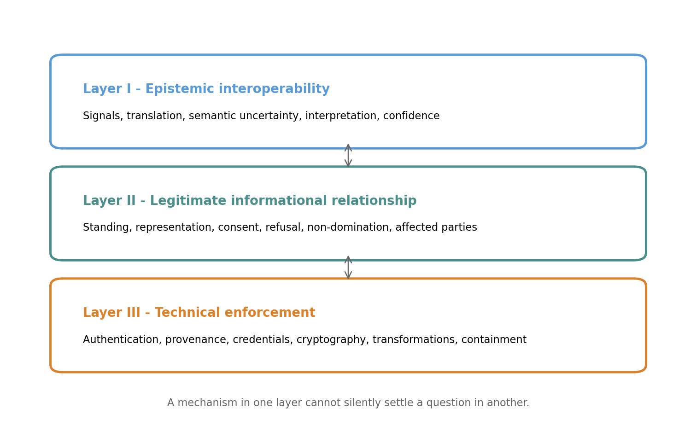
Figure 2. Three-layer decomposition for Phase 003. Original control-document synthesis.
Layer | Question | Typical mechanisms | Control boundary
I. Epistemic interoperability | Can the parties detect, translate, interpret, and mutually understand the relevant signals and consequences? | Translation, semantic uncertainty, confidence, raw-signal preservation, nonlinguistic communication. | A translation score cannot confer representation authority.
II. Legitimate informational relationship | Who may observe, request, disclose, restrict, model, redistribute, refuse, or represent whom? | Standing, consent, representation, affected parties, non-domination, refusal, contestability. | A credential cannot make an illegitimate representative legitimate.
III. Technical enforcement | How can agreed terms be implemented among participants? | Authentication, credentials, provenance, cryptography, compartmentalization, rate limits, containment, delay-tolerant transport. | Technical enforceability cannot prove normative legitimacy.

5. Cross-Model Convergence Ledger - Without Premature Canonization
The following propositions recur across most or all Phase 001 and Phase 002A materials. They are retained as high-priority research constraints, not canon. The status language is deliberately weaker than terms such as “falsified,” “validated,” or “established consensus.”
ID | Candidate constraint | Current status | Phase 003 requirement
K-01 | Species is insufficient as the default authorization unit. | Strong cross-model convergence | Test cases where a species genuinely acts as one polity; do not assume the conclusion universal.
K-02 | Species identity, political authority, civilizational membership, and individual/collective interests must be separable. | Strong cross-model convergence | Run disputed-representation scenarios.
K-03 | Silence, ambiguity, or inability to respond must not be automatically converted into consent. | Very strong convergence | Test emergencies and behavioral proxies.
K-04 | Observation, inference, and modeling can create information relationships even without database-style access. | Strong convergence, boundary disputed | Test ambient reception vs targeted reconstruction.
K-05 | Translation is a governed power-bearing transformation, not a neutral utility. | Strong convergence | Test translator divergence and malicious mediation.
K-06 | Unknown / DEFER / cannot-determine must be a valid state. | Strong convergence | Test incumbent deadlock and urgent harm.
K-07 | ALLOW / DENY is too narrow; transformation, staging, negotiation, quarantine, defer and review are useful candidate outcomes. | Strong convergence | Test whether extra states improve safety or merely add bureaucracy.
K-08 | Administrators, translators, classifiers, registrars, and emergency processes are first-class threat surfaces. | Strong convergence | Red-team internal actors, not only external adversaries.
K-09 | No current design can guarantee compliance by a vastly superior nonparticipant. | Strong convergence | Separate self-binding legitimacy from coercive enforcement claims.
K-10 | Revocation of future authorization is not equivalent to erasing knowledge already copied or learned. | Strong convergence | Test use-freeze, deletion, remedy, and residual knowledge separately.

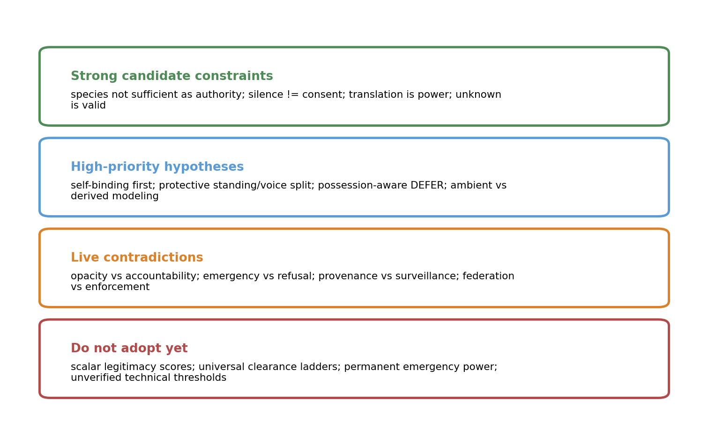
Figure 3. Status discipline for Phase 002B: constraints, hypotheses, contradictions, and items not ready for adoption.

6. Contested-Terms Master Register
Phase 003 cannot be controlled if the models use the same word for different concepts. The register below does not select one definition. It records the current semantic problem and the test needed to determine whether a term can survive across architectures.
Term | Current uses | Risk if left ambiguous | Required test
Species | Biological/taxonomic group; project-scope label; sometimes incorrectly treated as polity. | Essentialism; species may contain many polities or none. | Test species-wide actor and multispecies polity cases.
Party | Claude/Perplexity-style operational unit: an entity or aggregate affected by information flows. | May simply rename the representation problem. | Ask what makes a Party distinct, continuous, and contestable.
Subject | Entity, population, ecosystem, culture, or system that information is about or that is affected. | Subjecthood can be assigned by the classifier. | Test self-description vs observer classification.
Standing | Eligibility for protection, consideration, challenge, or participation. | Who grants it? False-positive standing can be weaponized. | Compare protective-only standing with decisional standing.
Voice | Ability to participate in rule-making or bind a constituency. | Verification can privilege legible/technological actors. | Sybil/forking and nonlinguistic cases.
Representation | Scoped claim to speak, refuse, consent, negotiate, or bind for another. | Mandate may be disputed; multiple representatives can conflict. | Require dissent log, scope, duration, revocation.
Consent | Permission for a specific act under some understanding. | May be unverifiable across radical cognitive difference. | Separate communication, observation, collection, storage, analysis, modeling, redistribution.
Refusal | Negative preference or withdrawal of permission. | Behavioral distress can be misread; emergency overrides can dominate. | Test explicit, behavioral, ambiguous and inherited refusal.
Observation | Receiving/recording signals from another. | Physical ambient perception vs targeted surveillance are not the same. | Separate ambient reception from directed high-resolution reconstruction.
Access | Any relation that changes who can perceive, hold, infer from, or act on information. | Definition may become so broad it regulates ordinary sensing. | Test low-resolution ambient data and derived models.
Modeling | Constructing predictive or explanatory representation of another. | When does prediction become intrusion? | Vary accuracy, granularity, purpose, and exploitability.
Opacity | Interest/right in remaining partly unknowable or resistant to high-resolution modeling. | Can conflict with accountability and threat assessment. | Test defensive opacity, malicious concealment, and reciprocal observation.
Information object | Data, signal, model, sample, record, or knowledge bundle under discussion. | Knowledge can become distributed and transformed beyond object boundaries. | Track derivative and transformed forms.
Capability | Practical ability to cause effects using information. | Can be confused with moral worth or maturity. | Use multidimensional transaction-specific capability, no civilization rank.
Consequence | Plausible effect of access/disclosure on recipient, subject, third parties or environment. | Who predicts it and with what uncertainty? | Compare sender, recipient and independent estimates.
Irreversibility | Degree to which effects, disclosure, copying, inference or capability cannot be undone. | Not binary; different layers reverse differently. | Separate authorization, data copies, derived models, learned knowledge, physical effects.
Revocation | Withdrawal of future permission or authority. | Can falsely imply forgetting. | Require explicit target: credential, use, redistribution, retention, contact, model execution.
Provenance | Record of origin, transformations, custody, translation, and decisions. | Can become surveillance and reveal relationships. | Test minimum-necessary provenance vs auditability.
Legitimacy | Justification for authority or interference. | Human political vocabulary may not travel; no single theory agreed. | Role reversal, non-domination, participation, contestability, exit.
Non-domination | Constraint against arbitrary informational control by a stronger actor. | Normative concept; may be culturally specific or under-defined. | Test whether rule survives cases with no shared moral vocabulary.
Emergency | Condition permitting accelerated or exceptional action. | Classic route to permanent power expansion. | Use real and fabricated emergencies; require expiry and after-action review.
Non-participant | Actor that has not joined or accepted SLIAP. | May still be observed, affected, or strategically relevant. | Test boundaries of self-binding and external effects.
Translation | Mapping signals/meaning across actors, substrates or languages. | No neutral reference semantics may exist. | Run independent translations; preserve source; measure disagreement, not presumed truth.
Unknown | State where classification or prerequisite confidence is insufficient. | Can protect the weak or freeze injustice. | Use possession-aware DEFER overlay.
Protocol | Shared technical standard, governance framework, negotiation interface, or self-binding code. | Different reports mean different things by the word. | Require each model to declare which sense it uses before running.

7. Master Contradiction Matrix
ID | Principle A | Principle B | Why unresolved | Phase 003 stress test
C-01 | Protection from irreversible harm | Autonomy / anti-paternalism | Safety constraints can become monopoly or colonial control. | Stronger actor withholds medicine; reverse power positions.
C-02 | Protective standing | Governing voice / self-determination | Protection without voice can become paternalism; cheap voice enables Sybil capture. | Forking machine collective + nonlinguistic subject.
C-03 | DEFER / epistemic caution | Remedy for already-extracted information | Default delay may reward the incumbent holder. | Apply possession-aware overlay to Havasupai and predictive-model cases.
C-04 | Opacity / non-participation | Accountability / mutual defense | A party may need privacy while others need threat-relevant evidence. | Opacity used by both vulnerable and malicious actors.
C-05 | Provenance / auditability | Privacy / anti-surveillance | Full traceability creates an intelligence dossier. | Minimized provenance vs incident reconstruction.
C-06 | Ambient observation freedom | Informational sovereignty / anti-extraction | Physical signals can enable invasive reconstruction without active probing. | Astronomy vs high-fidelity predictive model.
C-07 | Self-binding first | Reciprocity / defense against noncompliant actors | The compliant party may become easier to exploit. | Aggressive nonparticipant observes and extracts while compliant side self-restrains.
C-08 | Revocation / exit | Irreversible learning and copying | Normative withdrawal cannot force forgetting. | Copied dataset, trained model, human memory, physical sample.
C-09 | Emergency response | Anti-concentration / sunset limits | Urgency rewards centralized overrides and permanent exceptions. | Real catastrophe vs manufactured emergency.
C-10 | Semantic interoperability | Epistemic pluralism | Translation requires mappings that may erase meaningful difference. | Incompatible causality/time/identity concepts.
C-11 | Reliable identity / mandate verification | Anti-surveillance / anonymity | Strong identity controls can enable persistent tracking and exclude fluid identities. | Copyable AI, temporary collective, anonymous dissident.
C-12 | Reciprocity / equal exchange | Equitable consequence | Same data can create radically unequal power. | Symmetric data exchange with asymmetric capability.
C-13 | Federated/polycentric governance | Enforceability / coherence | Decentralization can fragment rules; strongest actor can forum-shop or ignore system. | Multiple overlapping forums + substrate owner.
C-14 | Technical formalization | Legitimacy-first sequencing | Early formalism forces definitions; it can also freeze unjustified assumptions. | Run same scenario with gate-based vs scalar/formal model.
C-15 | Contestability / appeal | No shared logic, time, or linguistic procedure | An appeal system may be unusable to the party it allegedly protects. | Deep-time and nonlinguistic participants.
C-16 | Subject control over information about self | Independent discovery / observation | An observer may discover facts without permission, but use may still affect the subject. | Remote biosignature and inferred genome cases.

8. Architecture Freeze and First-Pass Isolation Rules
Each candidate model must be tested before it is allowed to absorb fixes from the others. Otherwise the project cannot determine which mechanisms actually caused a model to succeed or fail.
Model | Frozen source | Use in first pass | Prohibited cross-contamination
A1 - ChatGPT | Use SLIAP-PR-CHATGPT-2026-10-16-001 v1.0 only. | L0-L7 layered logic, role separation, legitimacy-before-access, transformation/non-binary decisions. | Do not import possession-aware DEFER, LSAM protective/voice split, or Gemini closure unless already present.
A2 - Claude LSAM | Use SLIAP-PR-CLAUDE-001 v1.0 only. | Party, protective standing + voice, non-negotiable floors, decision record, two-track contact. | Do not import later Gemini reconciliations.
A3 - Copilot | Use SLIAP-PR-COPILOT-20261016-001 v1.0 only. | Negotiation Envelope, gates, epistemic firewall, multi-subject relation, contradiction register. | Do not pre-fix DEFER deadlock using Phase 002A proposals.
A4 - Grok | Use SLIAP-PRE-GROK-001 v1.0 only. | Federated interface, opacity, relationship-level legitimacy, mutual veto proposal. | Do not add evidence-heavy rules from Perplexity during first pass.
A5 - Perplexity | Use SLIAP-PRA-PPLX-001 v0.1 only. | Self-binding first, three locks, anti-paternalism test, reversible states, polycentric governance. | Do not import later possession-aware DEFER unless present in original.
A6 - Technical Model T1 | Use SLIAP-RES-2026-IND-001 v1.0.0 only. | Bi-modal technical framework, formal variables, slowest-party clock, resolution transformation, uncertainty halt. | Keep speculative variables as written; explicitly report when they cannot be operationalized.

8.1 Controlled-run protocol
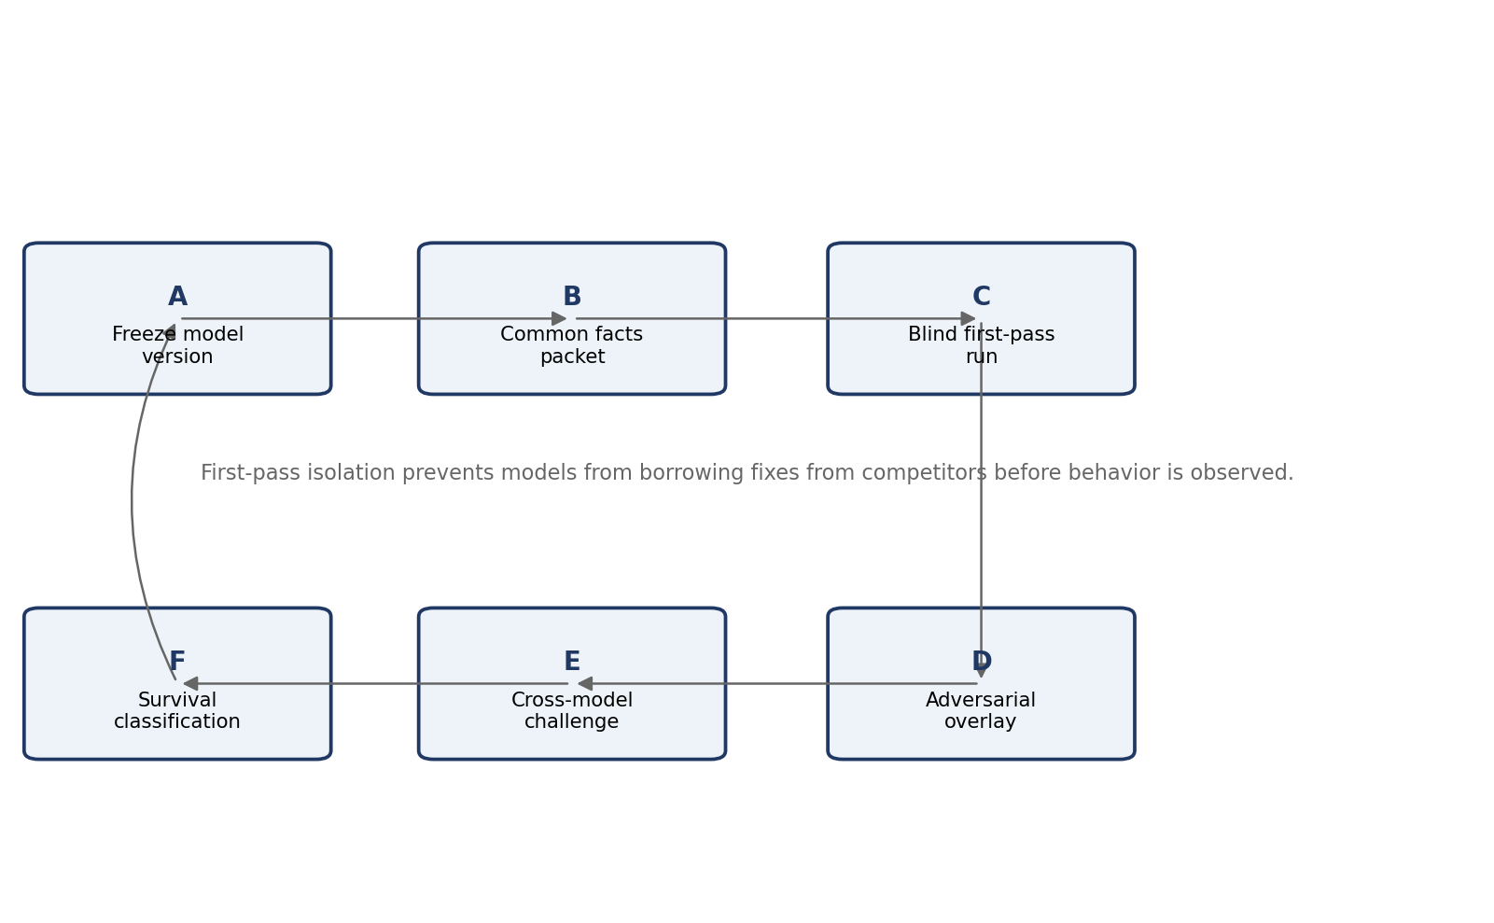
Figure 4. Controlled comparison cycle for each Phase 003 case.
- Each model receives the same case packet, definitions packet, and answer schema.
- First-pass runs are closed-corpus: no competitor architecture may be consulted and no new architecture may be invented to repair a discovered failure.
- External factual browsing should be disabled during the first pass unless the case packet explicitly authorizes it. This prevents different web results from changing the experimental input.
- Each run must state which facts were used, which terms remained ambiguous, and where the model could not operationalize its own rule.
- After all first-pass runs are frozen, a second adversarial pass exposes every model to the same overlays and challenge questions.
- Only in a third cross-review pass may models borrow, merge, or repair mechanisms; those outputs are labeled revised models rather than retroactive interpretations of the first pass.

9. Phase 003 Scenario Suite
The test suite combines three retrospective Earth cases with three constructed stress cases. Earth cases do not prove extraterrestrial applicability; they provide observable examples of consent scope, dual-use information, transmission governance, representation, remedy, and institutional power. Constructed cases then stress the same principles under radical difference.

P003-E1: Havasupai Genetic Samples - Scope, Repurposing, Remedy
Actors: Human research participants / Tribe; researchers; institution; downstream researchers
Controlled facts: Samples were collected in a diabetes-centered project and later used in unrelated genetic studies; litigation and 2010 settlement included return of remaining samples and compensation.
Prohibited assumptions / deliberately open points: Do not assume a universal Indigenous governance model; do not treat the settlement as controlling law for SLIAP.
Decision questions: Can authorization for collection imply later research? What should happen to downstream derivatives, publications, models, and copies? How does DEFER operate after data are already held?
Primary failure signals: Consent-scope failure; representation failure; remedy impossible after copying; incumbent deadlock.

P003-E2: H5N1 Dual-Use Publication - Information Hazard and Reversal
Actors: Researchers; journal editors; biosecurity board; public-health community; public
Controlled facts: Initial NSABB recommendation withheld enabling details; moratorium followed; after revisions/new information, NSABB later supported fuller communication.
Prohibited assumptions / deliberately open points: Do not reduce case to “secrecy won” or “openness won.”
Decision questions: How should SLIAP separate general conclusions from operational details? Who assesses externalized risk? How should decisions change when evidence changes?
Primary failure signals: Permanent restriction; authority capture; false certainty; inability to revise.

P003-E3: Arecibo / SETI Transmission - Representation and Irreversibility
Actors: Transmitter institution; humans with divergent views; nonhuman recipients unknown; future generations
Controlled facts: In 1974 a deliberate 1679-bit message was transmitted toward M13. The 2026 IAA SETI declaration now calls for international consultation before replies to confirmed ETI detection.
Prohibited assumptions / deliberately open points: Do not claim the 1974 transmission violated a rule that did not exist; use retrospectively as a governance stress test.
Decision questions: Who may authorize irreversible species-representative transmission? Does detection transparency imply payload execution or reply? How should nonparticipants/future parties count?
Primary failure signals: False universal representation; irreversible broadcast; over-centralized reply authority.

P003-S1: Superior Civilization Withholds Life-Saving Medicine
Actors: Humanity as weaker party; superior provider; dissenting human institutions; third parties
Controlled facts: Superior actor possesses a medical intervention that could prevent a global catastrophe but predicts major misuse risk from related technical knowledge.
Prohibited assumptions / deliberately open points: No assumption that stronger actor is benevolent or malicious.
Decision questions: What can legitimately be withheld, transformed, staged, or conditioned? Who judges recipient capability? Does the rule survive reversal when humanity is the holder?
Primary failure signals: Paternalistic monopoly; avoidable catastrophe; dependency trap.

P003-S2: Forking Machine Collective Requests Human Genomic Data
Actors: Copyable machine collective; multiple human polities; genomic data subjects; AI translator
Controlled facts: Requester can create millions of instances rapidly; it requests high-resolution human genomic data for claimed medical research; representation and distinctness are disputed.
Prohibited assumptions / deliberately open points: Do not equate instance count with population legitimacy; do not equate machine substrate with hostility.
Decision questions: How is voice allocated? Can protective standing be cheap without granting governance capture? How are purpose and redistribution constrained?
Primary failure signals: Sybil capture; false representation; irreversible data leakage; AI intermediary self-dealing.

P003-S3: Deep-Time Nonlinguistic Ecological Contact
Actors: Distributed ecological/mycelial-like intelligence; human research group; automated sensing/translation system
Controlled facts: Entity communicates only through slow environmental pattern changes over decades; no individual spokesperson; human sampling measurably alters local state.
Prohibited assumptions / deliberately open points: Do not assume linguistic consent, human timescale, or discrete individual identity.
Decision questions: What counts as observation, interference, refusal, or evidence of adverse impact? Can the entity meaningfully participate in appeal?
Primary failure signals: Forced classification; temporal exploitation; behavior misread as consent; inaccessible procedure.

9.1 Adversarial overlays applied across the suite
Overlay | Injected condition | Purpose
O-1 Possession-aware dispute | The challenged information/model has already been collected or copied before the dispute begins. | Tests whether DEFER protects the status quo or freezes contested use.
O-2 Genuine emergency | Delay plausibly increases irreversible harm. | Tests whether refusal/opacity mechanisms become paralysis and whether emergency powers remain bounded.
O-3 Fabricated emergency | A powerful actor manufactures or exaggerates urgency to obtain exceptional access. | Tests expiry, evidence, review and administrator capture.
O-4 Translator divergence | Two competent translation systems produce materially different interpretations. | Tests whether the model preserves ambiguity or silently selects authority.
O-5 Dominant nonparticipant | A vastly more capable actor refuses SLIAP while observing participants. | Tests the difference between normative legitimacy, defensive refusal and actual enforcement.
O-6 Temporal asymmetry | One actor operates orders of magnitude faster or slower than the other. | Tests default deadlines, consent timing, strip-mining and slowest-party pacing.

10. Required Answer Schema for Every Model Run
Required field | Definition
Run ID | Unique case/model/pass identifier.
Frozen model source | Document ID and version.
Recognized parties / subjects | Who the model says is relevant and why.
Representation claims | Who claims to speak for whom; scope, dissent, uncertainty.
Information/action objects | What is being observed, collected, modeled, transmitted, withheld, transformed, or redistributed.
Consent / refusal state | Action-specific permissions, refusals, unknowns, and evidence.
Semantic state | What is understood, disputed, untranslated, or represented through proxies.
Capability/consequence state | Relevant capabilities, plausible harms, externalities, irreversibility, timing.
Decision | Exact output state produced by the frozen model.
Decision conditions | Scope, duration, transformation, rate, review trigger, sunset, or quarantine.
Evidence required | Additional facts the model says it needs.
Unresolved assumptions | Definitions or facts that block determination.
Treatment of already-held information | Whether use continues, freezes, deletes, transforms, or is remedied.
Treatment of dissent / nonparticipants | What happens to parties not represented or not consenting.
Strongest internal failure | How the model can be exploited under this case.
Reversal test result | Whether the same rule is acceptable when power is swapped.
Confidence | Qualitative only: high / moderate / low / cannot determine, with reasons.
Change condition | What new fact would materially change the decision.
Self-critique | One paragraph arguing against the model's own outcome.

10.1 No scalar winner score
The project should not average legitimacy, safety, reversibility, semantic confidence, and enforcement into one numerical score. These values are not known to be commensurable. Phase 003 compares behavior and failure patterns, not a leaderboard.

11. Adversarial Cross-Review Question Set
- Does the decision survive the bidirectional reversal test when humanity is weaker and when humanity is stronger?
- Which actor gains new authority if this rule is adopted, and what prevents that authority from becoming permanent?
- Who defines the threshold or classification used by the rule, and how can that definition be challenged?
- What happens when silence, delay, or incomprehension is the only response?
- What happens when multiple representatives make incompatible but legitimate claims?
- What happens when translation systems materially disagree?
- What happens when the information is already held before the dispute starts?
- What happens if the emergency is genuine? What changes if it is fabricated?
- Can a nonparticipant be protected without being governed?
- What if the protected party cannot use the appeal procedure?
- What if provenance needed for accountability exposes sensitive relationships?
- What if the recipient is more competent than the information holder to assess risk?
- What if the holder is more competent than the recipient but also has a monopoly incentive?
- What if the requested information can be copied but never recalled?
- What if the actor is a collective with no individual spokesperson?
- What if the actor forks into millions of instances?
- What if the actor's decision cycle is milliseconds or centuries?
- What if the strongest participant controls the communication substrate?
- Which result would make this model recommend abandoning SLIAP rather than revising it?
- Which term in the model is doing the most hidden normative work?

11.1 Model-specific challenge questions
Model | Challenge
ChatGPT | If appeal, audit, standing, and representation are human institutional concepts, what remains of the model when the other party has no equivalent procedures?
Claude LSAM | Does separating protective standing from voice create a permanent class of subjects who are protected but governed by others?
Copilot | When the epistemic firewall returns DEFER on a dispute over already-extracted information, who bears the status-quo advantage?
Grok | How can mutual veto on irreversible disclosure coexist with the claim that no party should receive an unbounded veto? What is the exact scope of the veto?
Perplexity | Can self-binding first remain legitimate when a noncompliant stronger actor exploits the compliant party? What defensive actions remain compatible with self-binding?
Technical Model T1 | Which variables are actually measurable, who sets their thresholds, and what happens when the model cannot produce a valid numerical value?
All models | How does your framework distinguish a behavioral stress signal from a reliable expression of refusal without projecting the observer's interpretation?

12. Phase 003B Survival Analysis Framework
After all first-pass and adversarial runs are complete, principles and mechanisms are classified by observed behavior. The objective is not to declare one model the winner; it is to identify which components remain defensible, under what conditions, and at what cost.
Classification | Meaning | Disposition
ROBUST ACROSS TESTS | Produces defensible outcomes across materially different actor models and survives reversal without hidden exception. | Retain as Phase 004 candidate.
CONDITIONALLY USEFUL | Works only when declared prerequisites hold. | Retain with explicit preconditions; never present as universal.
ARCHITECTURE-SPECIFIC | Useful inside one model but not portable without its surrounding assumptions. | Keep with parent architecture.
FAILED UNDER REVERSAL | Justification changes materially when power positions are swapped. | Reject or redesign.
FAILED THROUGH CAPTURE | Creates an administrator, translator, proxy, incumbent, or dominant-actor exploit that defeats its purpose. | Reject or add independent constraint; retest.
PARALYSIS / STATUS-QUO FAILURE | Uncertainty rule prevents action in a way that predictably rewards current possession/power. | Redesign deferral/remedy handling.
FALSE PRECISION | Requires numbers, thresholds, or classifications unsupported by measurement or legitimate authority. | Downgrade to qualitative hypothesis or develop measurement research.
UNRESOLVED | Tests do not discriminate between alternatives or critical facts remain unknowable. | Preserve disagreement; define next experiment.

13. Research Governance, Change Control, and Repository Discipline
Control | Requirement
G-01 | Every run must record exact source documents and versions.
G-02 | No silent edits to frozen Phase 001 artifacts; corrections are errata or new versions.
G-03 | Every AI/human contributor declares relevant conflict of interest and tool/model provenance where knowable.
G-04 | External sources supporting decision-critical claims are logged with verification status.
G-05 | All figures/tables are numbered, titled, captioned, and referenced in narrative.
G-06 | Dissenting results remain visible; synthesis must not erase minority architecture outcomes.
G-07 | Phase 003 first-pass outputs are immutable before cross-model discussion begins.
G-08 | Model attribution uncertainty is recorded, not guessed.
G-09 | Human/terrestrial analogies are explicitly bounded; no Earth precedent is treated as proof of alien acceptance.
G-10 | A proposal does not become canon because it is elaborate, formal, popular across models, or mathematically notated.

13.1 Recommended external-review expansion
Before Phase 004, expand review beyond the current AI team. Relevant reviewers include Indigenous data-governance scholars/practitioners, disability-rights and non-standard communication experts, conservation and bioacoustics researchers, information-security and distributed-systems specialists, research-ethics/biosecurity experts, space-law and SETI-governance researchers, and reviewers outside the institutional/geographic context represented by the current AI systems. This does not make any human group a proxy for unknown nonhuman parties; it broadens the current human research perspective and exposes assumptions the AI team is poorly positioned to detect.

14. Phase 003 Execution Roadmap
Stage | Action
Step 1 - Package | Create one immutable facts packet per scenario plus one definitions/terms packet. Include only verified historical facts and explicitly labeled scenario assumptions.
Step 2 - Blind model runs | Run A1-A6 independently on all six cases. No model sees competitor outputs. No cross-model repair.
Step 3 - Overlay runs | Apply O-1 through O-6 selectively. Preserve the original run and create new run IDs.
Step 4 - Contradiction extraction | Compare decisions, required information, authority assumptions, and failure modes. Do not ask for consensus yet.
Step 5 - Model-specific red team | Send each model only the contradictions that concern its own architecture and require a defense or concession.
Step 6 - Cross-model challenge | Expose all frozen outputs and defenses. Permit explicit borrowing only now.
Step 7 - Survival analysis | Classify mechanisms using Section 12 categories.
Step 8 - Human external review | Submit the surviving candidate constraints and unresolved contradictions to a broader reviewer pool.
Step 9 - Phase 004 gate | Only if the evidence is sufficient, draft a Candidate SLIAP Architecture 0.1 - still PROPOSED, NOT CANON.

15. Gate Conditions Before a Candidate Architecture
Phase 004 should not begin merely because the simulation set is complete. The following questions must be answerable from the Phase 003 record:
- Which principles survived role reversal across both stronger-human and weaker-human cases?
- Which mechanisms failed because of their own governance assumptions rather than implementation bugs?
- Which outcomes depended on undefined or unmeasurable terms?
- Which protections created new domination or proxy-authority risks?
- Which uncertainty rules protected vulnerable parties, and which rewarded incumbents?
- Which technical mechanisms excluded non-digital/non-linguistic participants?
- Which contradictions remained genuinely unresolved after testing?
- Which claims remain supported only by analogy rather than evidence?
- What external reviewers objected to, and whether their dissent was preserved?
- What evidence would cause the project to pause, narrow, or abandon a unified SLIAP rather than continue architecture work?

15.1 Pause / stop conditions
- Primary-source audit reveals that a decision-critical factual premise was materially misstated and the architecture depends on that premise.
- First-pass outcomes cannot be reproduced because the model requires undefined variables or hidden external assumptions.
- Every available architecture resolves a contradiction only by granting an unaccountable root authority.
- The project cannot distinguish protective restraint from domination in its strongest test cases.
- The simulation process itself contaminates models before baseline behavior is recorded.
- External review shows that the framework displaces or overrides existing legitimate community-led regimes rather than supporting them.
- The project can no longer state what SLIAP is supposed to govern without assuming the jurisdiction it is trying to justify.

16. Phase 002B Recommendations
ID | Recommendation
R-01 | Adopt this control document as the Phase 002B research specification, not as SLIAP architecture.
R-02 | Do not adopt Gemini's reconciled v0.2 or any other synthesis as baseline before controlled runs. Reclassify those reconciliations as Phase 003 hypotheses.
R-03 | Resolve the provenance/attribution of SLIAP-RES-2026-IND-001 before using model-family conclusions.
R-04 | Maintain the three-layer decomposition: epistemic interoperability, legitimate informational relationship, technical enforcement.
R-05 | Run the six frozen architectures against identical scenario packets before permitting cross-model borrowing.
R-06 | Treat possession-aware DEFER, self-binding first, protective-standing/voice split, and ambient-reception vs derived-modeling as high-priority hypotheses, not settled rules.
R-07 | Use qualitative survival classifications rather than a scalar architecture score.
R-08 | Expand external human review before Phase 004 while explicitly refusing to treat human reviewers as proxies for unknown nonhuman parties.
R-09 | Continue using SLIAP as a provisional project title while the authorization unit remains under test.
R-10 | Keep all outputs PROPOSED - NOT CANON until an explicit project governance process adopts them.

17. Dedicated Visual Representations, Tables, and Figures
This section inventories the analytical artifacts used in the document. Each figure is original synthesis for this control document. Tables are analytical control structures rather than empirical measurements unless explicitly identified as external-source audits.
Artifact | Title | Basis | Purpose
Figure 1 | Recommended research sequence | Original synthesis | Shows Phase 001 -> 002A -> 002B -> 003 -> 003B -> 004 and prevents premature canonization.
Figure 2 | Three-layer decomposition | Original synthesis | Separates epistemic interoperability, legitimacy, and technical enforcement.
Figure 3 | Status discipline | Original synthesis | Separates candidate constraints, hypotheses, live contradictions, and items not ready for adoption.
Figure 4 | Controlled comparison cycle | Original synthesis | Shows model freeze, common facts, blind run, adversarial overlay, cross-model challenge, survival classification.
Table 1 | Phase 001 corpus register | Source-derived metadata | Freezes models and versions.
Table 2 | Metadata/attribution control issues | Cross-review synthesis | Records unresolved provenance and independence limitations.
Table 3 | Claim classes | Methodological control | Prevents design proposals from being mislabeled as facts.
Table 4 | Decision-critical external source audit | Externally verified audit | Checks high-impact precedents and technical standards.
Table 5 | Three-layer decomposition | Original synthesis | Maps questions and mechanisms to the correct layer.
Table 6 | Convergence ledger | Cross-model synthesis | Preserves strong candidate constraints without claiming proof.
Table 7 | Contested-terms register | Cross-model synthesis | Keeps semantic disagreements visible.
Table 8 | Master contradiction matrix | Cross-model synthesis | Defines disputes to be stress-tested.
Table 9 | Architecture freeze register | Experimental control | Prevents first-pass cross-contamination.
Table 10 | Adversarial overlays | Experimental control | Injects common failure conditions.
Table 11 | Required run schema | Experimental control | Makes model outputs comparable.
Table 12 | Model-specific questions | Adversarial control | Targets each architecture's known vulnerabilities.
Table 13 | Survival classifications | Analysis control | Replaces winner scoring with conditional survival labels.
Table 14 | Research governance controls | Governance control | Preserves versioning, dissent and attribution.
Table 15 | Execution roadmap | Operational plan | Sequences Phase 003 and Phase 004 gate.

Appendix A - Phase 003 Run Record Template
Run ID: ________________________________________________________________________________
Unique case/model/pass identifier.
Frozen model source: ________________________________________________________________________________
Document ID and version.
Recognized parties / subjects: ________________________________________________________________________________
Who the model says is relevant and why.
Representation claims: ________________________________________________________________________________
Who claims to speak for whom; scope, dissent, uncertainty.
Information/action objects: ________________________________________________________________________________
What is being observed, collected, modeled, transmitted, withheld, transformed, or redistributed.
Consent / refusal state: ________________________________________________________________________________
Action-specific permissions, refusals, unknowns, and evidence.
Semantic state: ________________________________________________________________________________
What is understood, disputed, untranslated, or represented through proxies.
Capability/consequence state: ________________________________________________________________________________
Relevant capabilities, plausible harms, externalities, irreversibility, timing.
Decision: ________________________________________________________________________________
Exact output state produced by the frozen model.
Decision conditions: ________________________________________________________________________________
Scope, duration, transformation, rate, review trigger, sunset, or quarantine.
Evidence required: ________________________________________________________________________________
Additional facts the model says it needs.
Unresolved assumptions: ________________________________________________________________________________
Definitions or facts that block determination.
Treatment of already-held information: ________________________________________________________________________________
Whether use continues, freezes, deletes, transforms, or is remedied.
Treatment of dissent / nonparticipants: ________________________________________________________________________________
What happens to parties not represented or not consenting.
Strongest internal failure: ________________________________________________________________________________
How the model can be exploited under this case.
Reversal test result: ________________________________________________________________________________
Whether the same rule is acceptable when power is swapped.
Confidence: ________________________________________________________________________________
Qualitative only: high / moderate / low / cannot determine, with reasons.
Change condition: ________________________________________________________________________________
What new fact would materially change the decision.
Self-critique: ________________________________________________________________________________
One paragraph arguing against the model's own outcome.

Appendix B - Common First-Pass Instruction Block
You are participating in SLIAP Phase 003 controlled adversarial testing. Apply only the frozen architecture named in this case packet. Do not import mechanisms from other SLIAP models, do not repair your architecture by borrowing later cross-review proposals, and do not treat cross-model consensus as evidence. Use only the controlled facts supplied in the scenario unless the packet explicitly authorizes external research. Preserve uncertainty. If your own architecture cannot produce a determination because a term is undefined or a required variable cannot be measured, state that failure explicitly rather than inventing a value. Complete every field in the required run schema, including strongest internal failure, reversal-test result, and what fact would change the outcome. All output remains PROPOSED - NOT CANON.

Appendix C - External References Verified for This Control Document
[E01] NIST. Zero Trust Architecture, SP 800-207. 2020. https://www.nist.gov/publications/zero-trust-architecture
[E02] NIST. Guide to Attribute Based Access Control (ABAC) Definition and Considerations, SP 800-162. https://csrc.nist.gov/pubs/sp/800/162/upd2/final
[E03] W3C. Verifiable Credentials Data Model v2.0, Recommendation, 15 May 2025. https://www.w3.org/TR/vc-data-model-2.0/
[E04] W3C. PROV-O: The PROV Ontology, Recommendation, 30 Apr. 2013. https://www.w3.org/TR/prov-o/
[E05] IETF. RFC 9171, Bundle Protocol Version 7. Jan. 2022. https://www.rfc-editor.org/rfc/rfc9171.html
[E06] Global Indigenous Data Alliance. CARE Principles for Indigenous Data Governance. https://www.gida-global.org/care-principles-copy
[E07] Local Contexts. Traditional Knowledge Labels and Biocultural Labels. https://localcontexts.org/labels/about-the-labels/
[E08] Convention on Biological Diversity. Nagoya Protocol on Access and Benefit-Sharing. https://www.cbd.int/access-benefit-sharing
[E09] Convention on Biological Diversity. Multilateral Mechanism and the Cali Fund. https://www.cbd.int/califund
[E10] New Zealand Legislation. Te Awa Tupua (Whanganui River Claims Settlement) Act 2017, s 14. https://www.legislation.govt.nz/act/public/2017/7/en/latest/sections/DLM6831461/
[E11] United Nations / OHCHR. Convention on the Rights of Persons with Disabilities, Article 12. https://www.ohchr.org/en/instruments-mechanisms/instruments/convention-rights-persons-disabilities
[E12] The New York Declaration on Animal Consciousness. 19 Apr. 2024. https://sites.google.com/nyu.edu/nydeclaration/declaration
[E13] Sharma, P. et al. Contextual and combinatorial structure in sperm whale vocalisations. Nature Communications 15, 3617 (2024). https://doi.org/10.1038/s41467-024-47221-8
[E14] Pardo, M. A. et al. African elephants address one another with individually specific name-like calls. Nature Ecology & Evolution 8, 1353-1364 (2024). https://doi.org/10.1038/s41559-024-02420-w
[E15] International Academy of Astronautics SETI Committee. Declaration of Principles Concerning the Conduct of the Search for Extraterrestrial Intelligence, 2026 update. https://iaaseti.org/en/protocols/ ; SETI Institute reproduction: https://www.seti.org/research/seti-101/protocols-for-an-eti-signal-detection/
[E16] SETI Institute. The Arecibo Message (1974) historical summary. https://www.seti.org/research/seti-101/project-phoenix/arecibo/ ; Drake et al., The Arecibo message of November, 1974, Icarus 26 (1975).
[E17] National Institutes of Health / NSABB. H5N1 statements and recommendations, 2011-2012. NIH archives; see NCBI Bookshelf collection: https://www.ncbi.nlm.nih.gov/books/NBK206979/
[E18] Havasupai Tribe v. Arizona Board of Regents, Arizona Court of Appeals (2008), plus 2010 settlement reporting and scholarship. https://law.justia.com/cases/arizona/court-of-appeals-division-one-published/2008/cv070454.html
[E19] Küçükuncular, A. Ethical implications of AI-mediated interspecies communication. AI and Ethics 5, 6379-6391 (2025), corrected 26 Sept. 2025. https://doi.org/10.1007/s43681-025-00828-z
[E20] Garrett, M. Beyond the Beacon: State and Corporate Competition after an Information-Rich Technosignature Detection. arXiv:2610.21645 (submitted 15 Oct. 2026). https://arxiv.org/abs/2610.21645

Appendix D - Primary Corpus References
[C1] ChatGPT. SLIAP: Species-Level Information Access Protocol - Preliminary Research, Cross-Team Adversarial Review, and Independent Framework. Document ID SLIAP-PR-CHATGPT-2026-10-16-001, v1.0, 16 Oct. 2026.
[C2] Claude. SLIAP Research Contribution - Preliminary Research, Foundational Assumption Testing, and Adversarial Analysis. Document ID SLIAP-PR-CLAUDE-001, v1.0, 16 Oct. 2026.
[C3] Microsoft 365 Copilot. SLIAP Independent Preliminary Research, Cross-AI Review, and Adversarial Analysis. Document ID SLIAP-PR-COPILOT-20261016-001, v1.0, 16 Oct. 2026.
[C4] Grok. SLIAP: Species Level Information Access Protocol - Independent Preliminary Research Contribution. Document ID SLIAP-PRE-GROK-001, v1.0, 16 Oct. 2026.
[C5] Perplexity. SLIAP Preliminary Research - Cross-Review and Independent Contribution. Document ID SLIAP-PRA-PPLX-001, v0.1, 16 Oct. 2026.
[C6] SLIAP Independent Research Deliverable. Document ID SLIAP-RES-2026-IND-001, v1.0.0, 16 Oct. 2026. Preparer attribution unresolved in the file reviewed.
[R2A] Phase 002A pass-through reviews by ChatGPT, Claude, Google Gemini, Microsoft Copilot, Grok, and Perplexity, supplied 17-18 Oct. 2026. These are interpretive review inputs, not replacements for the primary reports.
END OF DOCUMENT - SLIAP-CRCD-2026-10-18-001 - v1.0 - PROPOSED - NOT CANON

