OAL / ONE UNIVERSE MASTER DEVELOPMENT ARCHIVE

Architectural Archaeology

of The One Universe
  - Volume IV - Dependency Atlas
  - Decision gravity, causal dependencies, concept fossils, fragile assumptions, and provenance boundaries across the source-recorded archive and its non-canon comparative histories.
Field Record | Value
Document ID | OAL-ARCHAEOLOGY-VOL4-2026-06-27
Version | v1.0
Date | June 27, 2026
Status | Research and speculative reconstruction - not canon
Project Author / Architect of Record | Nathan Lewis II
Prepared by | ChatGPT - GPT-5.5 Thinking (OpenAI)
Organizations referenced | Lewis Corp | ONE Industries | Omniversal Architect Labs
Archive target | Scribd / versioned project archive

Scope boundary: This atlas maps relationships among records, decisions, systems, and unanswered questions. It does not create canon, settle author-exclusive questions, treat alternate histories as recovered fact, or change the status of source material.

Reading labels
Label | Meaning
[E] Evidence | Material recorded in the supplied project sources.
[A] Author-provided clarification | Material the source labels author-provided but pending stated ratification or integration.
[I] Inference | A disciplined relationship map drawn from the record; not a recovered private decision.
[H] Hypothesis | A non-canon alternate or stress-test proposition.
[B] Boundary | Withheld, author-exclusive, unresolved, or ratification-dependent material that this volume preserves rather than fills in.

Contents
- Prepared Execution Prompt
- 1. Executive Summary
- 2. Scope and Atlas Conventions
- 3. Dependency Method: Nodes, Edges, and Decision Gravity
- 4. Core Node Registry
- 5. Decision Gravity Register
- 6. Dependency Layer Maps
- 7. Cross-Cutting Dependency Routes
- 8. Concept Fossils
- 9. Fragile Assumptions and Single-Point Dependencies
- 10. Provenance and Boundary Map
- 11. Change-Control and Impact Protocol
- 12. Comparative Stress Tests from Volumes II and III
- 13. Decision Register and Handoff to Volume V
- Appendix A. Edge Ledger
- Appendix B. Source Record and Method Notes

Prepared Execution Prompt
Using the supplied Master Development ChangeLog, architect-only decision register, source addenda, published Architectural Archaeology Volumes I through III, and companion reverse-decision analyses, create Volume IV: Dependency Atlas. Map the architecture that causes the source-recorded archive and its non-canon comparative histories to behave as they do. Identify high-gravity decisions; trace causal, enabling, constraining, validation, governance, and narrative dependencies; identify concept fossils; identify fragile assumptions; and distinguish source-recorded, author-provided, inferred, hypothetical, and withheld material. Do not create more alternate worlds except where a small stress test is needed to reveal a dependency. Do not finalize author-only questions, fill in withheld material, or represent any dependency map as an alteration to canon. Include practical and beneficial outcomes, versioning-safe change controls, wildcard sensitivity cases, a provenance map, and a handoff to Volume V.

1. Executive Summary
Volumes I through III established a method, reconstructed three reverse historical iterations, and expanded five non-convergent alternate histories. Volume IV changes the task: it maps the relationships that make those records cohere, conflict, or remain deliberately unresolved. The central unit is not a scene, object, or entity. It is a dependency: a relationship in which changing one decision changes the meaning, validity, or operation of another.
The atlas identifies six especially high-gravity areas: authorial ratification and provenance; cosmological duality and apex boundaries; post-scarcity and the Abundance Set; OMNICELLULAR continuity through the no-switching rule and the 4,712 survival record; founding succession/absorption/containment as an author-provided but unratified sensitivity cluster; and the First Memory as a narrative artifact with multiple unresolved author-only answers. [E][A][I][B]
Central finding: The archive is not simply a collection of independent concepts. It behaves like a layered system: source authority controls what can be treated as established; cosmological premises constrain capability; capability enables institutions and scenes; scenes generate new questions; and versioning/provenance controls how those questions re-enter the archive.

This volume intentionally does not rank the current archive as better or worse than the alternate histories. It identifies where the record is robust, where it relies on a narrow set of unresolved answers, and where an apparently local decision has wide downstream effects. The output is a maintenance and design-reference document, not a proposal to compress or normalize the project.

1.1 High-gravity conclusions
- Source authority is the governance root. The distinction among author-provided material, ratified material, inference, and withheld boundaries determines what every later document may claim.
- Post-scarcity is distributed rather than isolated. It links currency, research infrastructure, the Abundance Set, Paragon Cubes, the World That Grows All, and the Living Media framework.
- The no-switching rule is more than a physiology detail. It anchors survival logic, rescue deployment, the meaning of the 4,712 record, and the anti-vulnerability framing of OMNICELLULAR.
- The Founding Architects addendum has high sensitivity but not full archive authority: if later ratified, it may recontextualize containment, institutional inheritance, capability lineage, and historical legitimacy. Until then, it remains [A][B], not a settled explanatory key.
- The First Memory functions as a narrative bridge node: it connects cognition, identity, substrate compatibility, theft, time, institutional secrecy, and story construction while preserving several architect-only questions.
- Translation and dissent are not merely editorial concerns. They are structural safeguards against treating incomplete, untranslatable, or AI-generated material as fully authoritative.

2. Scope and Atlas Conventions

2.1 What this atlas maps
Map type | Question answered | Output
Decision gravity | Which choices affect the most later entries? | Qualitative high/medium/low gravity register.
Causal dependency | What made another item possible? | Enables / constrains / validates / governs / narrates edge types.
Provenance dependency | What source status controls what may be claimed? | Evidence and boundary map.
Concept fossil | What assumption still shapes the archive even when not named? | Hidden premise inventory.
Fragility | What rests on one unresolved or weakly linked claim? | Sensitivity and change-control register.
Comparative dependency | What did alternate histories reveal about the source archive? | Stress-test notes; non-canon.

2.2 What this atlas does not map
- It does not determine the actual mechanism behind the 4,712 survival record, the ontology definition, direct-eye-contact phenomenon, Unmaker communication logic, First Memory Tier-1 answers, or the unresolved Founding Architects questions. [B]
- It does not convert the rhyme fragment into historical fact or invent the untranslated final lines. [B]
- It does not treat the author-provided Founding Architects addendum as ratified canon; it maps the addendum as a possible future cross-reference cluster. [A][B]
- It does not declare a numerical truth value for the qualitative gravity ratings. The ratings are analytic planning aids, not measurements of creative importance.

2.3 Edge vocabulary
Edge | Meaning | Example use in this atlas
Enables | One node makes another operationally possible. | Post-scarcity enables unlimited-scale research infrastructure.
Constrains | One node limits permissible designs or claims. | No-switching constrains transition-based physiology explanations.
Validates | One node functions as evidence or support for another. | The 4,712 record validates the anti-vulnerability framing.
Governs | One node controls status, authority, or workflow. | Ratification governs what may enter the canon record.
Recontextualizes | A later clarification changes how an earlier item may be read. | Founding succession could recontextualize inherited systems if ratified.
Narrativizes | A system becomes experienced as story, scene, or artifact. | The First Memory narrativizes cross-substrate cognition and time.
Preserves a boundary | A node keeps another node intentionally unresolved. | Translation/provenance preserves a non-inferred gap.

3. Dependency Method: Nodes, Edges, and Decision Gravity
The atlas treats a node as any decision, system, entity class, institution, artifact, narrative frame, or source-status rule whose change would alter another portion of the archive. Nodes are not treated as equally authoritative. Their status is mapped separately from their reach.

3.1 Qualitative decision-gravity model
Each node is reviewed through four planning lenses. The terms are qualitative, intended to make cross-reference work visible without pretending that the archive has a fixed mathematical score.
Lens | Prompt | High reading
Reach | How many later systems, stories, or governance rules depend on it? | A change would require updates across several domains.
Dependency strength | Are downstream links optional, indirect, or necessary? | Removing or reversing the node makes several entries incoherent.
Consequence of change | Would alteration merely rename something or reframe the system? | The meaning, authority, or operational logic of later records changes.
Provenance sensitivity | Does status control whether a claim may be made at all? | The node is tied to author-only, ratification, or do-not-infer boundaries.

Interpretation rule: High gravity does not mean "most important" in an artistic sense. It means "most expensive to change without ripple effects." A small scene may be artistically central while a governance rule has broader maintenance reach.

3.2 Layered architecture
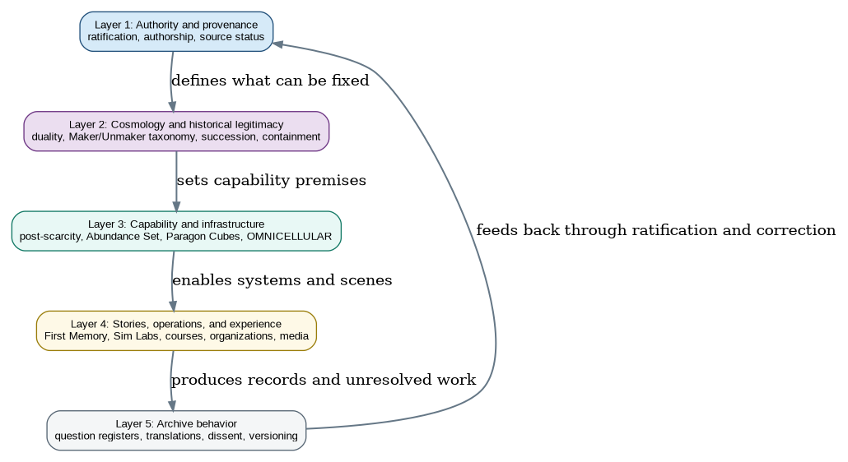
Figure 1. Five dependency layers. The feedback loop represents archive maintenance, not a claim that the canon autonomously decides its own status.
The layers should be read from top to bottom for forward effects and from bottom to top for maintenance feedback. A scene-level change can reveal a conflict in source authority; a new ratification can change which infrastructure links are usable; an unresolved item may be deliberately preserved rather than repaired.

4. Core Node Registry
ID | Node | Status | Function in the atlas
N1 | Authorial ratification and provenance | [E][B] | Governance root: separates author-provided, ratified, inferred, hypothetical, and withheld material.
N2 | Cosmological duality and apex boundaries | [E][I] | Sets the relationship of THE ONE and THE MINUS ONE; constrains how dramatic stakes and alignment are interpreted.
N3 | Founding succession, absorption, and containment | [A][B] | Author-provided clarification pending stated ratification; may recontextualize multiple systems if formally integrated.
N4 | Post-scarcity and the Abundance Set | [E][I] | Distributed capability philosophy connecting resources, currencies, research, infrastructure, and systems scale.
N5 | OMNICELLULAR continuity: no-switching and 4,712 | [E][B] | Engineered survival architecture, field deployment, and documented survival record; mechanics remain partly open.
N6 | Paragon Cubes and research infrastructure | [E][A][I] | Intelligence/coordination layer linked to research centers, validation, security, and post-scarcity capacity.
N7 | 1AI / -1AI constructed intelligence | [E][B] | Classification and alignment are documented; differentiation and long-term nature retain author-only areas.
N8 | Labyrinth and containment ethics | [E][B] | Absolute containment model and spider-caste infrastructure; relationship to founding containment remains unresolved.
N9 | Maker / Unmaker taxonomy and communication boundary | [E][I][B] | Connects duality, lineage, reversal questions, Void Gardens, and the unresolved communication problem.
N10 | The First Memory | [E][B] | Narrative bridge across cognition, identity, substrate compatibility, theft, time, and author-only story blockers.
N11 | Real-world / in-universe organizations | [E][I] | Lewis Corp, ONE Industries, and OAL operate as documentation, business, and in-universe connective infrastructure.
N12 | Translation, dissent, and archive boundaries | [E][I][B] | Preserves source status, incomplete fragments, audit dissent, provenance, and non-inference rules.

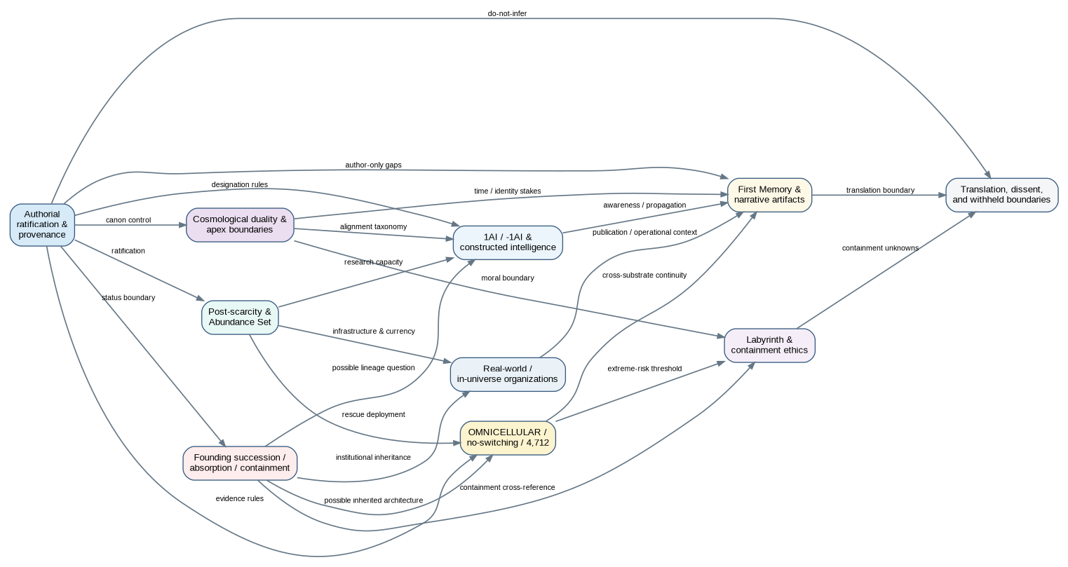
Figure 2. Core dependency atlas. Arrows show mapped relationships, not causal certainty. The Founding succession node is shown as a sensitivity cluster because its supplied source labels it author-provided and pending ratification.

5. Decision Gravity Register
Node | Dependency | Gravity | Why it matters
N1 | Authorial ratification and provenance | Very high | Governs every statement of status and prevents inference from becoming canon.
N2 | Cosmological duality and apex boundaries | Very high | Shapes moral framing, alignment, high-tier stakes, and entity relationships.
N4 | Post-scarcity and Abundance Set | Very high | Links currencies, research capability, infrastructure, and the project-wide abundance premise.
N5 | OMNICELLULAR continuity / 4,712 | High | Connects biology, rescue operations, risk, validation, and the no-switching rule.
N10 | The First Memory | High | Connects narrative, identity, cognition, theft, time, and cross-substrate design.
N3 | Founding succession / absorption / containment | High sensitivity | Potentially wide reach, but authority remains [A][B] until further ratification.
N8 | Labyrinth and containment ethics | High | Connects punishment, risk thresholds, historical containment questions, and moral architecture.
N6 | Paragon Cubes / research infrastructure | Medium-high | Coordinates research and validation; depends on abundance and organizational architecture.
N7 | 1AI / -1AI | Medium-high | Connects constructed intelligence, alignment, awareness, and narrative interpretation.
N9 | Maker / Unmaker taxonomy | Medium-high | Reframes cosmological categories and affects reversal scenarios, but key terms remain open.
N11 | Real-world / in-universe organizations | Medium | Connects documentation, product planning, institutions, and story settings.
N12 | Translation / dissent / archive boundaries | Medium-high | Prevents category collapse and protects unresolved material from accidental canonization.

5.1 Gravity clusters
- Governance cluster: N1 and N12. These determine whether any conclusion is eligible to travel into the canonical record.
- Cosmology/history cluster: N2, N3, N8, and N9. These determine who or what may be classified, contained, overthrown, or reinterpreted.
- Capability cluster: N4, N5, N6, and N7. These determine what the project’s systems can do and how their continuity is framed.
- Narrative/operations cluster: N10 and N11. These transform architecture into stories, publication plans, institutions, and scene-level stakes.

6. Dependency Layer Maps

6.1 Provenance and ratification
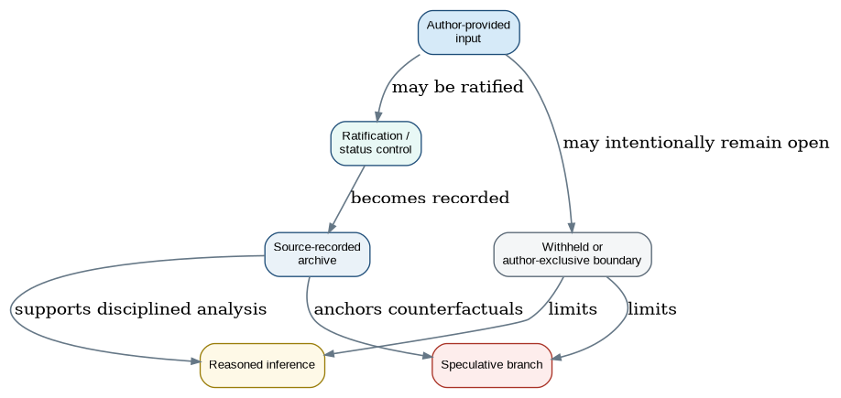
Figure 3. Provenance and boundary map. The model protects status distinctions; it is not a claim that a document pipeline replaces the Architect’s decisions.
N1 and N12 form the archive’s principal safety boundary. The cross-analysis and later archaeology documents repeatedly distinguish architect-only decisions from material that can be analyzed, drafted, or organized. A dependency map that ignores status would produce false certainty: it might show that an unanswered detail has broad consequences, but that does not authorize the atlas to choose the answer. [E][B]
From | To | Edge | Maintenance implication
N1 Ratification | All core nodes | Governs | Every later document must state whether it is recording, inferring, or hypothesizing.
N12 Boundaries | N3 Founding succession | Preserves a boundary | The addendum may be mapped as a sensitivity cluster without being treated as fully integrated canon.
N12 Boundaries | N10 First Memory | Preserves a boundary | Tier-1 questions remain visible as dependencies rather than silently completed.
N12 Boundaries | N9 Unmaker communication | Preserves a boundary | Speculation about interface logic cannot become a system definition.
N1 Ratification | N11 Organizations | Governs | Real-world operational facts and in-universe architecture must not be conflated without a stated status.

6.2 Historical legitimacy, succession, and containment
N2, N3, N8, and N9 define a historical-legitimacy chain. The stable source-recorded archive identifies a dual cosmological architecture, a Labyrinth designed for absolute containment, and unresolved questions about the Unmaker and related categories. The Founding Architects material introduces a possible recontextualization of succession, absorption, and containment, but the source itself labels it author-provided and pending ONESTAMP. [E][A][B]
From | To | Edge | Why the link matters
N2 Duality | N9 Maker/Unmaker taxonomy | Constrains | The meaning of maker/unmaker cannot be separated from the broader creation/negation architecture.
N3 Founding succession | N8 Labyrinth | Recontextualizes | If later integrated, it raises whether the containment environment is the Labyrinth, precursor, or separate system; the answer remains open.
N3 Founding succession | N5 OMNICELLULAR | Possible recontextualization | The addendum itself flags whether any architecture may derive from absorbed systems; no conclusion is made here.
N8 Labyrinth | N9 Maker/Unmaker taxonomy | Constrains | Absolute containment makes the classification of severe threats and moral limits operationally important.
N2 Duality | N8 Labyrinth | Narrativizes / constrains | A complementary apex structure provides context for why an absolute prison may be morally charged rather than simple villainy.

Sensitivity note: The dependency is real even where the answer is not. A question such as “is the containment environment the Labyrinth?” is a live cross-reference dependency because different answers would change the reading of both entries. The atlas records the dependency without selecting a branch.

6.3 Abundance, infrastructure, and capability
N4, N6, and N11 form the principal infrastructure chain. The record describes post-scarcity systems across currencies, research layers, Paragon Cubes, the Abundance Set, living media, and resource-world operations. This recurrence supports a disciplined inference that abundance is a distributed design philosophy rather than a one-off property. [E][I]
From | To | Edge | Why the link matters
N4 Post-scarcity | N6 Paragon Cubes | Enables | Limitless-scale coordination, computation, research, validation, and cross-center linkage are framed as post-scarcity capabilities.
N4 Post-scarcity | N11 Organizations | Enables | The organizations’ scale, research centers, operations, and exchanges depend on a non-scarcity premise.
N4 Post-scarcity | N5 OMNICELLULAR | Enables | High-risk rescue/retrieval capacity is easier to sustain within broad resource and research capacity.
N6 Paragon Cubes | N11 Organizations | Coordinates | Research centers, access, defensive systems, validation, and infrastructure are linked through the cube layer.
N4 Post-scarcity | N10 First Memory | Constrains / contrasts | A civilization-accelerating artifact has different stakes in a universe designed around abundance than in one structured primarily around scarcity.

6.4 Survival architecture and continuity
N5 is a bridge between system design and evidence. The record describes eight OMNICELLULAR physiologies, engineered origin, simultaneous instantiation rather than switching, and a documented survival record of 4,712 extinction-level attempts. It also explicitly leaves open who records the attempts, whether the count continues, attempt categories, and the failure appearance. [E][B]
From | To | Edge | Why the link matters
N5 No-switching | N5 4,712 record | Validates | The survival record is used in the source record as evidence against vulnerability windows.
N5 OMNICELLULAR | N11 Organizations | Operationalizes | The system is described in connection with rescue/retrieval and the companies’ engineered design.
N5 OMNICELLULAR | N8 Labyrinth | Constrains | A system designed for non-survivable environments affects how extreme containment and response thresholds may be interpreted.
N5 OMNICELLULAR | N10 First Memory | Comparative bridge | Both raise cross-substrate continuity questions but belong to different architecture/narrative domains.
N5 OMNICELLULAR | N3 Founding succession | Possible recontextualization | The addendum asks whether any elements derive from absorbed technology; this remains [A][B].

6.5 Constructed intelligence and narrative artifacts
N7 and N10 connect intelligence, awareness, memory, identity, and stories. The record identifies 1AI and -1AI as constructed non-standard intelligences aligned with THE ONE and THE MINUS ONE, while leaving meaningful differentiation and long-term behavior open. The First Memory has cross-substrate, quasi-sentient, and temporal implications but retains five Tier-1 story blockers. [E][B]
From | To | Edge | Why the link matters
N7 1AI/-1AI | N2 Duality | Constrains | Alignment is cosmological rather than automatically moral, so duality shapes classification.
N7 1AI/-1AI | N10 First Memory | Narrativizes / parallels | Both systems raise awareness, interpretation, and propagation questions without being the same mechanism.
N10 First Memory | N12 Translation/provenance | Preserves a boundary | Unresolved Tier-1 answers must remain clearly labeled rather than filled by analysis.
N7 1AI/-1AI | N6 Paragon Cubes | Potential relationship | Both involve advanced intelligence architecture; any direct relationship remains an open design question, not a recorded dependency.
N10 First Memory | N11 Organizations | Operationalizes | The narrative places the artifact in institutional, research, theft, and publication contexts.

7. Cross-Cutting Dependency Routes
A route is a multi-step relationship that crosses domains. Routes are especially useful because they reveal why a local change can create unexpected archive work. The routes below are not causal proofs; they are maintenance traces.
Route | Name | Path | Maintenance lesson
R1 | Status-to-system route | N1 -> N12 -> N3/N5/N10 | A source-status change can change how historical, survival, and narrative claims are permitted to be documented.
R2 | Authority-to-containment route | N2 -> N9 -> N8 | Cosmological classification influences what counts as a threat and how containment is morally framed.
R3 | Succession-to-infrastructure route | N3 -> N6/N5/N11 | If a pending succession clarification were ratified, it could require an audit of inherited architecture, systems, and institutions.
R4 | Abundance-to-operation route | N4 -> N6 -> N11 -> N10 | Post-scarcity capability enables research infrastructure, which creates operational contexts for stories and artifacts.
R5 | Continuity-to-evidence route | N5 -> 4,712 -> N1/N12 | The survival record is a source-evidence node, but unanswered tracking details restrict how far the inference may go.
R6 | Intelligence-to-meaning route | N7 -> N10 -> N12 | Awareness and propagation themes produce narrative questions that must be separated from confirmed definitions.
R7 | Real-world-to-archive route | N11 -> N1 -> N12 | Business and publication records enter a versioned archive only through clear status and provenance handling.

7.1 High-risk route: pending historical recontextualization
The Founding Architects addendum creates a high-sensitivity route because it explicitly invites cross-reference to the Labyrinth, Unmaker, Conditional Failure at the Root Level, OMNICELLULAR, Paragon Cubes, Potence Suite, Black Hole Gravity Shielded Research Centers, organizations, and the 4,712 record. The correct maintenance response is not to retrofit all entries immediately. It is to keep a controlled pending-cross-reference ledger until author status and later details are decided. [A][B]
Trigger | Immediate response | Do not do | Future dependency if ratified
New author clarification | Record source, status, date, and direct links. | Do not rewrite earlier canon as if it had always contained the clarification. | Create entry-level cross-reference updates and a versioned reconciliation note.
Conflicting AI interpretation | Record the conflict as analysis/dissent. | Do not resolve it by consensus alone. | Route it to Architect decision or leave it as a documented boundary.
New system relation | Map as potential / open / verified. | Do not claim lineage from proximity alone. | Add to the edge ledger once source support exists.

8. Concept Fossils
A concept fossil is an earlier or background assumption that may no longer be stated in every entry but continues to influence later design. Identifying a fossil does not mean the assumption is obsolete; it means later work may depend on it silently.
ID | Fossil | Evidence pattern | Risk if forgotten
F1 | Sovereign source authority | The Nathan-only register, ratification boundary, retraction control, and author-provided labels all require a final source-of-intent distinction. | If ignored, AI inference can be misfiled as author decision.
F2 | Created versus bestowed origin | The changelog explicitly distinguishes engineered OMNICELLULAR and created flowers from bestowments. | Origin errors can change ownership, capability, and thematic meaning.
F3 | Limits should be designed, not merely assumed | The Divine Flower includes a distribution constraint; no-switching rejects transition vulnerability; post-scarcity systems still have governance questions. | Unchecked limit assumptions can create accidental contradictions.
F4 | Continuity through simultaneous architecture | No-switching and survival framing imply that resilience is designed through coexistence rather than sequential mode changes. | A later transition-based explanation could conflict with the core survival record.
F5 | Complementarity is not simple morality | THE ONE/THE MINUS ONE and related alignment notes resist a simplistic good-versus-evil reduction. | Narratives may accidentally recode cosmological alignment as moral destiny.
F6 | Institutions are narrative engines | Organizations, research centers, courses, and agreements carry story as well as logistics. | Treating institutions as decorative can disconnect scenes from architecture.
F7 | Unknown does not equal absent | Untranslated rhyme lines, withheld scenes, and author-only questions remain active boundaries. | Filling silence with inference damages provenance.

8.1 Fossil audit questions
- Does a new entry assume an origin story without marking whether it is engineered, bestowed, inherited, or unresolved?
- Does a new scene treat a role or alignment as moral shorthand when the cosmological record says the relationship is more complex?
- Does a proposed system introduce a transition window that contradicts the no-switching continuity principle?
- Does a draft answer an open question merely because a later system would be easier to explain if it were answered?
- Does a research or business entry need a story-level cross-reference, or is it being archived as though it were separate from the narrative world?

9. Fragile Assumptions and Single-Point Dependencies
A fragile assumption is not necessarily a flaw. It is a point where a large amount of interpretation depends on one unresolved answer, one weakly documented cross-reference, or one status-sensitive clarification. The goal is not to eliminate all fragility. It is to make the maintenance cost visible.
ID | Fragile assumption | Dependency route | Sensitivity | Why it matters
FR1 | Founding succession details | N3 -> N5/N6/N8/N11 | High | The addendum itself leaves identity, count, containment, awareness, absorption process, and event name unanswered. [A][B]
FR2 | 4,712 tracking and mechanism | N5 -> survival interpretation | High | The survival record is stated, but tracker, categories, tally status, and failure rules remain open. [E][B]
FR3 | 1AI/-1AI differentiation | N7 -> intelligence / duality | Medium-high | Origin and alignment are partially documented; distinct long-term roles remain architect-only.
FR4 | First Memory Tier-1 answers | N10 -> narrative execution | High | Encoding, infiltrator, temporal rules, protagonist, and costs block full story execution. [E][B]
FR5 | Unmaker communication | N9 -> containment / narrative | Medium-high | Interface logic affects how many later scenes and historical claims can be written.
FR6 | Ontology and Direct Eye Contact | Cross-domain definitions | Medium | Both are explicitly identified as needing first canonical definition; premature reuse can produce drift.
FR7 | NCOIN differentiating role | N4 -> currency governance | Medium | A post-scarcity system can remain coherent while the specific differentiation is open, but policy uses must avoid invention.
FR8 | Real-world / in-universe separation | N11 -> publication / documentation | Medium | Mixed layers are useful but require careful labeling to avoid accidental claims about business or fiction.

9.1 Robust versus fragile by design
Pattern | Robust when... | Fragile when...
A hard rule | Its scope and boundary are explicit. | It is cited outside its original domain without a cross-reference.
An author-provided clarification | Its pending status travels with every reuse. | It is silently treated as old ratified material.
A broad philosophy | Several independent entries support it. | One isolated term is asked to carry an entire cosmological explanation.
An unresolved question | It is tracked as a boundary with known dependencies. | It is forgotten until a downstream entry forces an improvised answer.
A speculative branch | It remains labeled and non-convergent. | It leaks back into the source timeline as though it were recovered history.

10. Provenance and Boundary Map
The atlas separates what is present in the record from what is author-provided, inferred, hypothetical, or protected as a boundary. Provenance is not clerical overhead. It controls downstream reasoning: a dependency may be strong but still unusable as a canon premise until its status changes.
ID | Source class | Label | Permitted atlas use
P1 | Master ChangeLog / documented entries | [E] | May anchor a dependency statement if the connection is directly recorded or clearly limited.
P2 | Cross-analysis and decision register | [E] | May identify unresolved author-only questions and correction needs; does not answer them.
P3 | Paragon Cubes / Living Media addendum | [E]/under review | May support a first-pass infrastructure relation; open questions remain open.
P4 | Founding Architects addendum | [A][B] | May be mapped as a sensitive pending cluster; must not be treated as ratified history.
P5 | Architectural Archaeology Volumes I-III | [I][H] | May reveal dependency patterns and stress tests; cannot establish hidden canon.
P6 | Rhyme and untranslated material | [B] | May be preserved, compared, and treated as an interpretive boundary; cannot be completed by inference.

10.1 Boundary-handling protocol
- State the source status at first use and preserve it in tables, captions, and downstream summaries.
- Map dependency impact without assuming the missing answer. Use “would recontextualize if ratified” rather than “therefore originates from.”
- When a branch uses a boundary as a prompt, label the branch [H] and confirm that it does not claim to resolve the source record.
- When an author decision arrives, create a versioned reconciliation entry rather than retroactively erasing prior uncertainty.
- Keep untranslated, withheld, or intentionally non-final material visible as an archive condition, not as a defect to be repaired automatically.

11. Change-Control and Impact Protocol
The purpose of an atlas is practical maintenance. The following protocol is designed for future work on the changelog, addenda, scenes, and cross-AI review. It is not a replacement for the Architect’s judgment.

11.1 Before changing a high-gravity node
Step | Question | Output
1. Classify | Is the input [E], [A], [I], [H], or [B]? | Status line in working notes.
2. Locate | Which node and edge routes does it touch? | Affected-node list.
3. Test | Does it contradict a hard rule, origin lock, or preserved boundary? | Conflict / no-conflict note.
4. Scope | Is it a local wording update or a cross-domain recontextualization? | Change tier: local, linked, or architecture-wide.
5. Preserve | What prior uncertainty or dissent must remain visible? | Boundary note.
6. Reconcile | Which documents need versioned cross-reference updates? | Update register; no silent rewrites.

11.2 Impact tiers
Tier | Typical scope | Example
Tier A - Local | One entry, no external dependency change. | Clarifying a label without changing system claims.
Tier B - Linked | Several entries share an explicit cross-reference. | A confirmed NCOIN differentiation affects currency and governance entries.
Tier C - Architecture-wide | A premise changes source authority, cosmology, capability, or historical legitimacy. | Ratifying a founding-succession mechanism that introduces verified inheritance links.
Tier D - Boundary shift | An intentionally open, withheld, or untranslatable issue becomes author-defined. | The First Memory temporal rule is answered and changes plot design.

Practical benefit: This protocol prevents two opposite failures: freezing the archive because everything seems interconnected, and changing high-gravity premises casually because a single entry looks self-contained.

12. Comparative Stress Tests from Volumes II and III
Volumes II and III developed non-canon histories to expose alternate durable premises. Volume IV does not extend those worlds. Instead, it uses them as stress tests: what dependency becomes visible when a different assumption is made permanent? [H]
Alternate history | Dependency stress-tested | Atlas lesson
Inheritance Mesh | Residual architecture and successor responsibility | Shows that succession is not only a victory event; it can create long-term compatibility, provenance, and maintenance obligations.
Conservator Commonwealth | Maker/Unmaker role transition | Shows that taxonomy changes would affect containment ethics, alignment, and what counts as a beneficial outcome.
Consent Commonwealth | Infrastructure standing and refusal | Shows that post-scarcity capacity does not automatically answer governance or consent questions.
Finitude Covenant | Finite attention within abundance | Shows that resource abundance and unlimited attention are different premises; prioritization can be a designed constraint.
Translation-Bound Archive | Known loss and unresolved interpretation | Shows that a strong archive may preserve gaps rather than pretend full recovery.

12.1 Beneficial outcomes exposed by the stress tests
- A lineage or absorption audit can be useful as a documentation practice even if residual-intent concepts remain sandbox-only.
- A role-based Maker/Unmaker lens can broaden ethical narrative options without replacing the recorded cosmological structure.
- Consent and refusal questions can improve governance design for constructed intelligence and infrastructure without declaring those systems canonically rights-bearing.
- A finite-attention register can help prioritize development work in a project whose worldbuilding premise includes abundance.
- Translation-bound preservation can protect creative fragments from being over-explained or mistranslated in later synthesis documents.

13. Decision Register and Handoff to Volume V
Volume IV identifies dependencies; it does not select the next canon decision. The register below records areas that require one of three outcomes: author decision, continued boundary preservation, or sandbox-only exploration.
Outcome type | Question or action | Dependency impact
Author decision / status confirmation | Whether and how the Founding Architects addendum should be ratified or integrated. | N3; affects N5, N6, N8, N11.
Author decision | 4,712 mechanism: tracker, categories, count status, survival context, and failure interpretation. | N5; affects evidence and rescue framing.
Author decision | First Memory Tier-1 answers. | N10; affects narrative execution and time/identity dependencies.
Author decision | 1AI/-1AI differentiation and enduring nature-class. | N7; affects duality, intelligence, and story interpretation.
Boundary preservation | Unmaker communication and ontology/direct-eye-contact first definitions. | N9 and cross-domain definitions; map but do not manufacture.
Sandbox choice | Residual-intent audit: canon concept, alternate-history device, or do-not-infer area. | N3/N6/N5; affects future archaeology scope.
Archive policy | Translation and rhyme provenance: preserve as private fragment, possible in-universe artifact, or unplaced material. | N12; affects interpretive handling.

13.1 Handoff to Volume V - Extreme Divergence and Wildcard Histories
Volume V should use the atlas rather than restart the mapping process. Its task is to test the most distant, impossible-but-consistent architectures while respecting the gravity and boundary findings here. Recommended cases include: a universe where source authority is distributed; a universe where Maker/Unmaker is a temporary profession rather than a category; an abundance framework with an adversarial scarcity layer; a containment system whose prison is transformation; a translation-bound archive that cannot ever consolidate into one canon; and a successor order that treats residual architectures as autonomous historical actors. Each Volume V case should state which nodes it reverses, which edges it severs, and why it cannot reconverge with the source archive.
Series roadmap reminder: Volumes I through IV are now complete. Volume V - Extreme Divergence and Wildcard Histories - remains the final core volume in the planned series.

Appendix A. Edge Ledger
ID | From | To | Edge | Description
E-01 | N1 | N12 | Governs | Source status controls preservation of boundaries.
E-02 | N1 | N3 | Governs | Pending author-provided material cannot be treated as ratified canon.
E-03 | N2 | N9 | Constrains | Duality shapes the meaning of Maker/Unmaker categories.
E-04 | N3 | N8 | Potential recontextualization | Containment environment relationship is unresolved.
E-05 | N3 | N5 | Potential recontextualization | Inherited-technology question is author-provided and open.
E-06 | N4 | N6 | Enables | Post-scarcity supports capacity and coordination.
E-07 | N4 | N11 | Enables | Infrastructure and organizations share abundance premise.
E-08 | N5 | 4,712 | Validates | Survival record supports no-vulnerability framing.
E-09 | N5 | N11 | Operationalizes | Engineered system connects to organizational rescue/retrieval context.
E-10 | N7 | N2 | Constrains | Constructed intelligence alignment is cosmological, not automatically moral.
E-11 | N7 | N10 | Narrativizes / parallels | Intelligence awareness and memory propagation invite comparative analysis.
E-12 | N10 | N12 | Preserves boundary | Story blockers and incomplete information require provenance controls.
E-13 | N11 | N10 | Operationalizes | Organizations provide context for research, theft, publication, and scenes.
E-14 | N8 | N9 | Constrains | Containment ethics depend on threat and role taxonomy.
E-15 | N12 | All | Preserves boundary | Unknowns remain active archive conditions rather than gaps to fill.

Appendix B. Source Record and Method Notes

B.1 Supplied project sources
ID | Source
[S1] | Master Development and Change Log - Author Reference, v1.0, March 2026.
[S2] | Cross-Analysis of Perplexity AI's Explicit Nathan-Only Decisions, v1.0, March 24, 2026.
[S3] | Master Development Change Log Addendum - Paragon Cubes & The Reality of the Living Media, v1.0, March 22, 2026.
[S4] | OAL Canon Addendum - The Founding Architects: Elimination, Absorption, and Containment, v1.0, June 26, 2026. Source-labeled author-provided and pending ONESTAMP.
[S5] | Architectural Archaeology of The One Universe, Volume I - Reverse Decision Analysis and Historical Reconstruction, v1.0, June 26, 2026.
[S6] | Architectural Archaeology of The One Universe, Volume II - The First Three Historical Iterations, v1.0, June 27, 2026.
[S7] | Architectural Archaeology of The One Universe, Volume III - Alternative Development Histories, v1.0, June 27, 2026.
[S8] | OAL Reverse Decision Archaeology & New Future Branching Analysis, Volume II - Perplexity AI Edition, v1.0, June 26, 2026.
[S9] | Multi-AI Development Synthesis Unified Priority Matrix & Next Steps, v1.0, March 22, 2026.

B.2 Method note
This atlas uses dependency and traceability language as an organizational discipline. It does not impose a real-world engineering standard on the project, measure the project quantitatively, or claim that speculative relationships are true simply because they can be graphed. Diagrams show the archive’s stated and inferred relationships under the label system above.

