BUILT TO LAST
Integrated Resilient Housing System
A site-adaptive housing, energy, maintenance, and neighborhood resilience framework
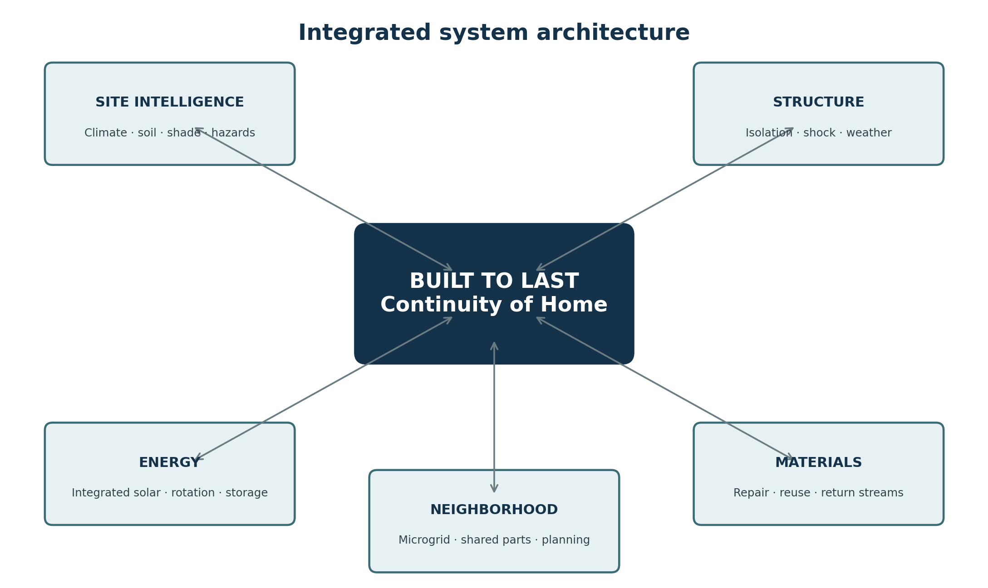
Originator | Nathan Lewis
Preparer | ChatGPT (GPT-5.6 Sol), OpenAI
Document status | Independent AI collaborative pass - concept reconstruction and development brief
Course origin | Environmental Science, University of Arizona Global Campus (UAGC)
Reconstruction basis | Reconstructed from the originator's surviving memory; original course submissions are not presently available
Date | 30 August 2026

0. Document Map and Provenance
Document purpose
Preserve and formalize the original environmental-science housing concept while separating remembered design intent from later engineering translation. This is a concept-development document, not a sealed engineering plan, code-compliance package, or construction specification.
This pass is deliberately written as an independent ChatGPT contribution to an AI collaborative review. It does not attempt to collapse other AI drafts into a single consensus document. Instead, it reconstructs the originator's concept in a form that can be archived, compared, tested, and later reconciled with parallel versions.

0.1 What is being preserved
- The housing structure. A dwelling designed to remain functional through earthquake motion, weather, impact, vibration, and ordinary wear, with controlled isolation between the living volume and the hazard.
- The energy plan. A building whose envelope participates in energy collection, with a sundial-like tracking concept and site-specific solar/weather modeling.
- The resilience plan. A repairable, modular, circular neighborhood system in which parts, materials, waste, energy, and maintenance are treated as managed streams rather than disposable afterthoughts.
- The governing principle. The house should be built to last: damage should become a service event whenever possible, not a total-loss event.

0.2 Reconstruction limits
The original discussion posts, laboratory submissions, drawings, and final course work are not available in this pass. The framework therefore preserves the originator's current recollection and translates some ideas into modern systems-design vocabulary. Where a remembered mechanism is intuitive rather than technically specified - such as a house sitting on “balls” inside a curved basin with a sandbox-like absorber - this document keeps the original geometry and separately identifies plausible engineering analogues rather than pretending the original was a finished engineering design.

0.3 Academic origin
The concept originated during an Environmental Science course taken while completing a bachelor's degree in Psychology at UAGC. The academic path had initially been Information Technology; transferable prior coursework made the Psychology completion path dramatically shorter. The Environmental Science course included hands-on work such as collecting soil samples and constructing an erosion model to observe how soil composition, water, and slope change failure behavior over time. That experience directly informed a systems question: if environmental forces are predictable enough to study, why not design the home and neighborhood to absorb them from the beginning?

1. Executive Summary
Built to Last is an integrated residential systems concept. It treats the dwelling, its foundation, its energy envelope, its repair model, its material lifecycle, and its neighborhood as one coordinated resilience system. The concept rejects the assumption that a home should remain rigid until a hazard overwhelms it and then be rebuilt through insurance. Instead, the home is intended to move in controlled ways, shed or absorb loads, remain powered, and be restored through standardized replaceable components.
System layer | Core idea | Continuity objective
Site intelligence | Use local weather, solar path, soil, drainage, shade, neighboring massing, and infrastructure conditions before fixing the form. | The home is designed for its actual lot and hazard profile, not for an abstract average site.
Structural resilience | Decouple the living volume from ground motion and other shocks through an isolation-and-damping platform with bounded travel. | A major hazard does not automatically become structural loss.
Weather + acoustic envelope | Use layered, serviceable assemblies that manage water, heat, debris impact, vibration, and sound. | The home remains habitable, not merely standing.
Integrated energy | Make selected roof and wall surfaces energy-active and allow controlled sun tracking where feasible. | Reduce dependence on expensive peak grid power and improve energy autonomy.
Modular repair | Make high-wear interior and exterior components individually replaceable and catalogued. | Repair the damaged area rather than replacing an entire assembly.
Circular materials | Give every building component a defined repair, refurbishment, return, recovery, or recycling pathway. | Keep materials in service and make landfill the last pathway.
Neighborhood resilience | Coordinate rotation envelopes, energy sharing, storage, parts inventory, waste recovery, and maintenance at block scale. | Resilience is shared infrastructure rather than a premium feature of one house.
Core principle
A resilient home is not one that never experiences stress. It is one that is designed to take stress, keep its essential functions, and recover without forcing the household to reconstruct its life.

1.1 The three original plans
- Housing structure plan. Base isolation / controlled motion, shock resistance, weatherproofing, adaptive acoustics, replaceable interior and exterior parts.
- Energy plan. Building-integrated solar collection, sun-tracking or heliotropic movement, site-specific solar analysis, neighborhood storage and load sharing.
- Resilience plan. Closed parts stream, broader waste stream, repair-first lifecycle, neighborhood-scale maintenance and continuity planning.

1.2 What makes the concept distinct
The novelty is not any single technology. Base isolation, modular construction, building-integrated photovoltaics, acoustic assemblies, microgrids, and circular material systems all have real-world analogues. The distinctive move is to treat them as parts of one residential operating model whose success criterion is continuity over decades: the house is expected to remain useful through hazard events, energy price changes, component failures, and environmental change.

2. Design Doctrine: “Built to Last”
“Built to last” is used here as a design requirement, not a marketing phrase. It asks every subsystem the same question: what happens when this part is stressed, damaged, shaded, worn, outdated, or unavailable? The preferred answer is not demolition or total replacement. The preferred answer is controlled movement, graceful degradation, isolated failure, repair, replacement of the smallest practical unit, and return of the removed material to a managed stream.

2.1 Seven governing rules
1. Design to the site. Local hazard, weather, soil, shade, drainage, energy cost, and neighborhood geometry are design inputs.
2. Decouple the living volume from destructive motion wherever practical. A structure may move without allowing that movement to become damage.
3. Let the building envelope perform multiple jobs. It should manage weather, heat, sound, impact, and energy rather than serving only as a boundary.
4. Separate essential functions from single points of failure. Energy, structure, drainage, and critical services should retain safe fallback states.
5. Repair at the scale of the damage. The design and supply system should support one-panel, one-trim-piece, one-module, or one-device replacement.
6. Keep materials in circulation. Refurbishment, reuse, remanufacture, and recycling are planned before disposal.
7. Treat the neighborhood as infrastructure. Shared energy, shared spares, shared data, and shared recovery pathways can make every dwelling more resilient.

2.2 Continuity hierarchy
Priority | Question | Preferred response
Life safety | Can occupants remain protected during the event? | Prevent collapse, uncontrolled movement, fire, electrocution, and dangerous interior failures.
Habitability | Can people safely remain in the home afterward? | Maintain weather protection, thermal control, sanitation, basic power, and acoustic livability.
Serviceability | Can damage be isolated and restored quickly? | Use modules, inspection points, accessible connections, and replaceable sacrificial parts.
Affordability | Does recovery avoid catastrophic household cost? | Reduce total-loss claims, bulk-replacement penalties, and peak utility dependence.
Environmental continuity | Can recovery occur without creating another waste problem? | Return parts and materials to defined recovery streams.

3. Site Intelligence Before Form
The design begins with data rather than a catalog floor plan. The same house should not be placed unchanged in Bakersfield, on a coastal hurricane corridor, in a cold high-wind region, or on a steep erosion-prone parcel. The architecture is a response to the operating environment.

3.1 Site data package
Domain | Data to collect | Design decisions influenced
Solar | Annual sun path, irradiance, cloud cover, seasonal angle, local horizon. | Collector placement, rotation range, facade activation, storage sizing.
Weather | Temperature extremes, heat-wave duration, humidity, prevailing winds, storm history, freeze-thaw conditions. | Envelope layers, insulation, ventilation, impact resistance, drainage.
Ground | Soil type, bearing behavior, liquefaction potential, slope, erosion, groundwater, drainage. | Foundation / isolation strategy, grading, water management, service routing.
Seismic / hazard | Fault proximity, expected shaking, wind, wildfire, flood, debris, local emergency access. | Isolation capacity, travel limits, materials, shutters / impact zones, defensible design.
Shade + massing | Trees, future canopy, neighboring building height, setbacks, potential future development. | Rotation envelope, collector height, orientation, no-shadow rules.
Infrastructure | Grid constraints, utility pricing, data-center or industrial loads, noise sources, roads, transit, water and sewer. | Microgrid strategy, acoustic tuning, energy autonomy, service interfaces.

3.2 Environmental change over time
The model should not assume the site is static. Trees grow, neighboring buildings are added, utility tariffs change, regional loads increase, and heat records shift. Therefore, the site model should include both present conditions and anticipated ranges. A resilient house should be capable of recalibration: changing collector schedules, replacing an energy-active facade module, adding storage, changing acoustic settings, or updating a drainage component without redesigning the whole structure.

4. Housing Structure: Isolation, Shock, Weather, and Sound
The remembered structural image is a house placed in a partial circular cradle: visually similar to a rotated C or shallow bowl. The living structure is anchored but not rigidly married to every movement of the ground. It sits on rolling or sliding elements, is surrounded by a sacrificial or absorptive zone, and has room for bounded motion. The intent is to absorb or redirect energy before it becomes cracking, tearing, or collapse.
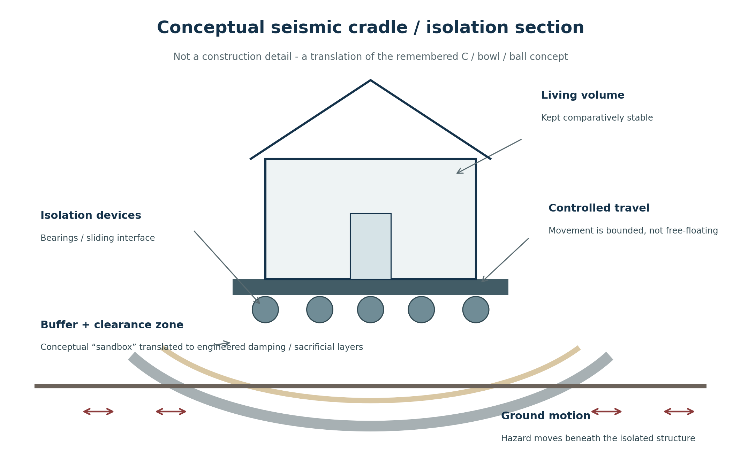
Figure 1. Conceptual translation of the remembered C / bowl / ball foundation idea. The diagram preserves the original design intent while explicitly separating it from a construction detail.

4.1 Engineering translation of the “C / bowl / ball” concept
Remembered concept element | Systems interpretation | Engineering analogue to investigate
Curved C / bowl beneath the home | A geometry that permits controlled relative movement and recenters or guides the structure. | Concave sliding / friction-pendulum isolation, engineered cradle or isolated podium.
“Balls” beneath the structure | Low-friction rolling or sliding interfaces that reduce direct transfer of lateral motion. | Spherical bearings, rolling isolation, sliding bearings, elastomeric isolation devices.
Sandbox / soft zone | A replaceable or deformable zone that accepts motion and dissipates energy. | Dampers, sacrificial layers, tuned granular systems, energy-absorbing composites, clearance moat.
Mesh / absorptive perimeter | A surrounding protective layer that can deform, catch debris, isolate vibration, or protect services. | Flexible protective membranes, impact screens, damping layers, service loops and seismic joints.
Anchored house | Freedom to move only inside a designed envelope. | Travel stops, restraints, recentering devices, flexible utility couplings.
Important engineering distinction
The concept does not require literal loose sand or literal free-rolling balls in the final design. Those were intuitive design metaphors for decoupling and absorption. A future engineering phase should select devices that can be modeled, inspected, replaced, and certified for the site hazard.

4.2 Seismic continuity objective
- Limit acceleration and force transfer into the occupied structure.
- Provide enough controlled displacement that the foundation can move without tearing rigid connections.
- Keep utilities flexible or articulated across the moving interface.
- Provide inspection access so isolators, dampers, travel stops, and sacrificial layers can be checked after an event.
- Design interior nonstructural elements - cabinets, partitions, glazing, piping, appliances - so the house does not remain standing while the interior becomes unsafe.

4.3 Shockproofing beyond earthquakes
“Shockproof” should be interpreted as multi-hazard load management rather than indestructibility. High wind, flying debris, hail, vibration, local impacts, abrupt equipment loads, and transportation or industrial noise all transmit energy into a structure. The framework therefore favors redundant load paths, impact-tolerant outer modules, protected openings, flexible service connections, and sacrificial exterior elements that can be replaced without opening the entire wall.

4.4 Weatherproofing as a serviceable system
- Layered water management. Use an outer rain-shedding layer, drained cavity, continuous air/water control layer, and interior moisture strategy appropriate to the climate.
- Thermal continuity. Reduce thermal bridging and high cooling or heating loads through continuous insulation and climate-specific assemblies.
- Inspectable joints. Joints, seals, flashings, and penetrations should be accessible and replaceable rather than buried permanently.
- Impact-tolerant cladding. The outermost surface should take hail or debris damage without turning a localized impact into full-wall replacement.
- Drainage + grading. The site should direct water away from the structure and account for erosion, swelling soils, and intense rainfall.

4.5 Adaptive sound penetration
The acoustic goal is not “silence at all times.” It is controllable permeability. Residents may want traffic, equipment, or construction noise attenuated while still allowing rain, birds, conversation, or neighborhood life to be heard. The house can therefore combine passive isolation with adjustable openings, seals, baffles, glazing, vents, and active control where justified.
Acoustic condition | Possible response | Continuity value
High exterior noise | Close high-performance seals, use decoupled wall layers, acoustic glazing, vestibules, and vibration isolation. | Rest and concentration remain possible even near noisy infrastructure.
Desired natural sound | Open controlled acoustic vents or operable sections without sacrificing full weather protection. | The home remains connected to its environment rather than functioning as a sealed bunker.
Ground-borne vibration | Use the structural isolation layer plus equipment isolation. | Reduces fatigue, rattling, and long-term livability problems.
Changing use / time of day | Adjust system settings by room and schedule. | Acoustic performance becomes an adaptable home function.

5. Modular Repair and Component Remediation
A central real-world frustration behind the concept is the mismatch between the size of a failure and the size of the repair market. A small run of siding, trim, baseboard, cladding, or finish material can be expensive because supply and installation are organized around bulk replacement. Built to Last reverses that relationship: the smallest practical replaceable unit becomes a first-class product.

5.1 Replaceability rules
1. Every frequently damaged or worn finish should have a defined removal path.
2. Replacement of one module should not require demolition of neighboring modules.
3. Parts should use standardized dimensions and connection interfaces wherever possible.
4. The homeowner should be able to identify a part by a durable ID and retrieve its specification, compatibility, instructions, and return pathway.
5. Owner-serviceable work and licensed work should be clearly separated. Cosmetic modules may be resident-replaceable; structural, electrical, gas, fire-protection, and other regulated systems remain professional work.
6. The supply chain must sell one unit without a bulk penalty severe enough to defeat modular repair.
7. Discontinued finishes should have an interoperability or successor standard so a 25-year-old house is not made unrepairable by product churn.

5.2 Component categories
Category | Examples | Repair strategy
Exterior skin | Siding bays, facade tiles, trim, soffit, impact panels. | Unclip / unbolt one damaged unit; inspect backing layer; return old unit to parts stream.
Energy-active envelope | PV cladding tile, solar roof module, wiring harness segment. | Isolate one module electrically; swap; test; remanufacture or recycle removed unit.
Interior wear layer | Baseboards, door casing, wall panels, flooring zones, cabinet faces. | Restore or replace the localized segment with common tools where appropriate.
Weather seals | Gaskets, flashings, window seals, joint covers. | Scheduled inspection and low-cost renewal before leakage damages hidden layers.
Isolation / sacrificial parts | Dampers, protective jackets, bumpers, impact screens. | Post-event inspection and targeted replacement based on measured wear / deformation.

5.3 Maintainability is part of durability
A material can be physically strong and still create a fragile housing system if it cannot be inspected, repaired, sourced, or replaced. Built to Last therefore defines durability as service life plus maintainability. A part that can be renewed five times may produce a more resilient building than a nominally “permanent” assembly that must be demolished when one hidden layer fails.

6. Energy Plan: The House as a Solar-Responsive Machine
The energy plan begins with a conceptual reversal: solar collection is not equipment attached to a finished house. It is one of the jobs of the envelope itself. Roofs, selected walls, overhangs, glazing zones, and replaceable facade modules can participate in collection, shading, heat management, or daylight control. The goal is to reduce household exposure to high summer utility costs and to regional grid stress without making the home dependent on one fragile energy component.

6.1 Building-integrated solar absorption
- Treat selected roof and wall surfaces as energy-active building components rather than after-market panels.
- Use modular electrical architecture so the failure of one collector does not disable an entire facade or roof field.
- Coordinate collector placement with weatherproofing, fire access, drainage, maintenance access, and replacement paths.
- Allow some envelope modules to be energy-passive where shade, orientation, aesthetics, or maintenance make active collection inefficient.
- Pair generation with high-performance thermal design so reducing demand is as important as producing electricity.

6.2 The sundial effect: controlled heliotropic rotation
The remembered design included a housing structure that rotates with the sun. The architectural idea is heliotropic: a working surface maintains favorable solar exposure during the day and across seasonal changes. The concept can be preserved in two implementation families rather than forcing one solution too early.
Option | Description | Advantages | Primary challenges
A. Full-dwelling rotation | The occupied structure rotates slowly on a dedicated mechanism integrated with, but functionally separate from, the seismic isolation platform. | Maximum orientation flexibility; strong expression of the original sundial concept. | Utility connections, egress, accessibility, wind response, wear, cost, control, rotating landscaping / entries.
B. Rotating collector crown | The living volume remains fixed while a roof ring, canopy, facade band, or collector structure tracks the sun. | Lower moving mass; simpler services and egress; easier to isolate energy movement from seismic movement. | Less total active area; shading and mechanical complexity remain.
C. Fixed adaptive envelope | No macroscopic rotation; use optimized orientation, tracking louvers, adjustable collectors, and seasonal facade behavior. | Lowest mechanical complexity and easiest code path. | Moves furthest from the original whole-house sundial effect.
Two motions, two purposes
Seismic motion and solar-tracking motion should never be treated as the same control problem. One is rapid, rare, safety-critical, and externally forced. The other is slow, deliberate, predictable, and energy-optimizing. A future design should keep their mechanics, controls, fail-safes, and travel envelopes clearly separated even if they share a structural platform.

6.3 Site-specific solar model
The structure should be modeled against the specific parcel: multi-year weather, seasonal solar angles, tree canopy, neighboring building heights, likely future shade, local air quality, factory or data-center adjacency, and utility conditions. This prevents a technically “solar” house from being placed where its collector is predictably shaded or where rotation steals working light from a neighbor.

6.4 Neighborhood microgrid and storage
- Shared generation logic. Homes can remain individually metered while contributing to a coordinated local energy system where law and utility rules permit.
- Storage at multiple scales. A mix of household and neighborhood storage can support night operation, outages, and temporary shade.
- Priority loads. During constrained conditions, refrigeration, communications, medical / accessibility equipment, ventilation, water systems, and safe indoor temperature receive priority.
- Load smoothing. The neighborhood can coordinate high-load equipment to avoid creating its own peak demand problem.
- Grid relationship. The objective is not necessarily permanent disconnection; it is the ability to reduce dependence, operate safely through outages where permitted, and avoid treating grid expansion as the only answer to rising regional demand.

7. Circular Materials, Parts Stream, and Waste Stream
The neighborhood operates two related but distinct loops. The parts stream is for building components with defined return, inspection, refurbishment, remanufacture, or recycling pathways. The waste stream covers ordinary household and site discards that cannot directly re-enter the parts system. Keeping those streams separate prevents valuable standardized components from becoming mixed demolition waste.
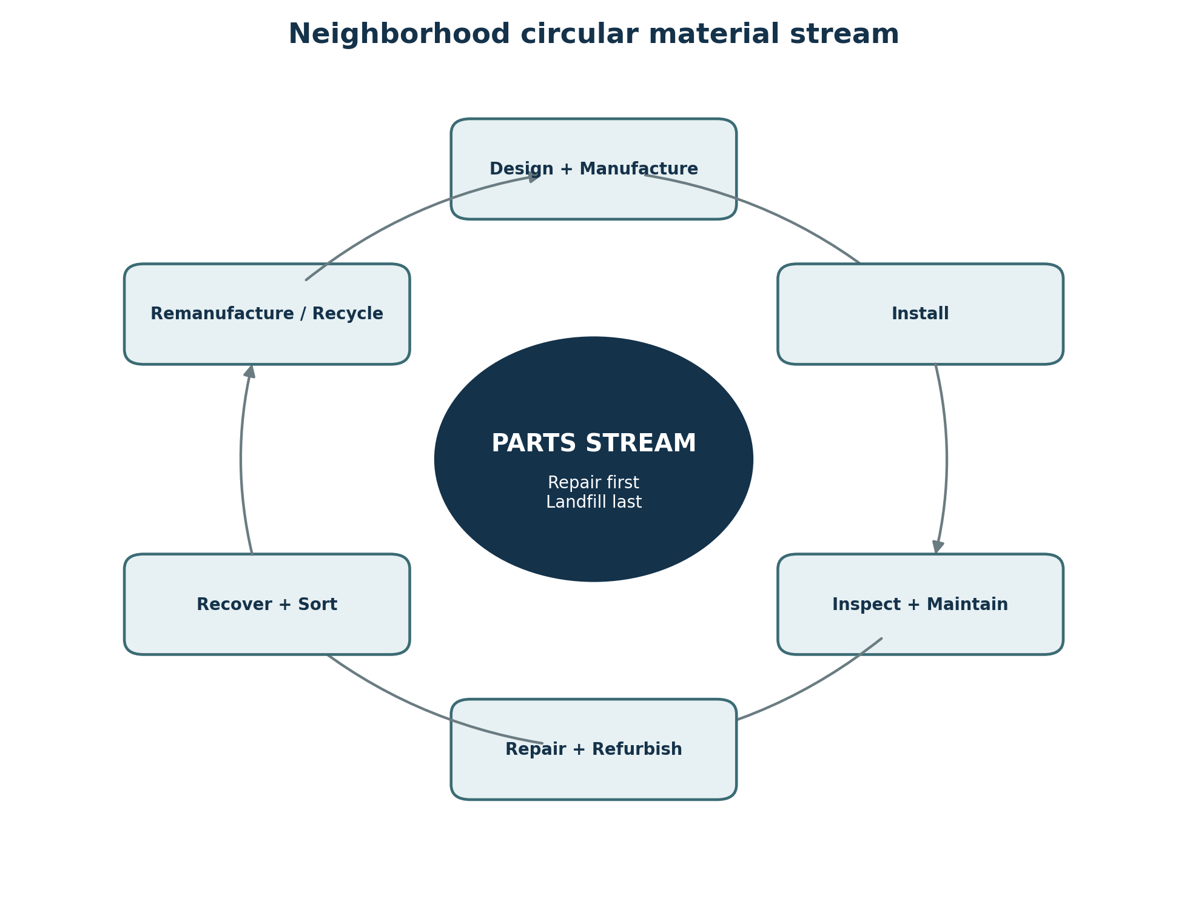
Figure 2. Circular parts-stream model. The objective is to preserve value by repairing and refurbishing before replacing, and recovering material before disposal.

7.1 Component lifecycle
Lifecycle stage | Required information / action | Preferred outcome
Design + manufacture | Material identity, disassembly method, standardized interfaces, expected service life, recovery route. | The part is born with an end-of-life plan.
Install | Record part ID, location, batch, compatibility, installation date, and inspection point. | The home has a maintainable parts map.
Inspect + maintain | Track wear, seal condition, electrical performance, fasteners, corrosion, damage, and updates. | Small maintenance prevents large failure.
Repair + refurbish | Clean, recoat, reseal, resurface, rewire, or restore when practical. | Return the same unit to service.
Replace + return | Swap only the failed module; return removed unit through neighborhood depot / manufacturer stream. | Avoid bulk demolition and preserve recoverable value.
Remanufacture / recycle | Recover components or material feedstock according to documented composition. | Re-enter production rather than defaulting to landfill.

7.2 Neighborhood parts depot
A neighborhood-scale parts depot or service center is a practical bridge between circular design and daily life. It can hold a limited inventory of common cladding, trim, seals, collector modules, fasteners, and protective parts; receive used components; coordinate refurbishment; and maintain digital records. This directly addresses the problem that small repairs become disproportionately expensive when materials are only sold in contractor-scale quantities.

7.3 Waste-stream hierarchy
1. Avoid unnecessary material use at design and installation.
2. Reuse intact components.
3. Repair or refurbish damaged components.
4. Remanufacture standardized parts.
5. Recycle material by type where meaningful recovery exists.
6. Compost eligible organic / biobased material where appropriate.
7. Use landfill only for residual material without a practical recovery route.

8. Neighborhood Model: Resilience as Shared Infrastructure
The original concept extends beyond a single unusual house. A neighborhood is planned as a coordinated field of resilient dwellings. That matters because one rotating structure, one solar facade, one material stream, and one battery are limited; a block can share capacity, redundancy, maintenance knowledge, and spare parts.

8.1 Planning rules for a solar-responsive neighborhood
- Provide explicit rotation or collector-clearance envelopes so moving elements cannot collide with property improvements, landscaping, utilities, or adjacent homes.
- Adopt no-shadow / working-light rules based on modeled solar access rather than assuming every parcel can collect equally at every hour.
- Place taller buildings, trees, shared facilities, and utility equipment with long-term shade patterns in mind.
- Keep emergency access, accessibility routes, egress, and fire-service access valid in every normal operating position.
- Coordinate noise-producing energy equipment and use acoustic buffers so the resilience system does not create a new livability problem.
- Provide shared stormwater, erosion, heat-mitigation, and landscape strategies that support rather than undermine each home's hazard design.

8.2 Shared neighborhood systems
Shared system | Function | Why it improves resilience
Microgrid + storage | Coordinate generation, storage, priority loads, and outage behavior. | One shaded or temporarily impaired house does not become energy-isolated.
Parts depot | Store and circulate common replacement components. | Reduces cost, delay, and bulk-order waste.
Material recovery point | Receive removed components and separate reusable / recyclable streams. | Keeps circularity local and traceable.
Site + hazard data service | Maintain weather, shade, soil, performance, and maintenance data. | Allows systems to adapt as conditions change.
Maintenance cooperative / service network | Pool specialized inspection and repair expertise. | Advanced systems become maintainable rather than owner-burdening.
Resilience operations plan | Define outage, earthquake, storm, heat, and evacuation procedures. | Technology is supported by clear human procedures.

9. How the System Behaves: Example Scenarios

9.1 Major earthquake
Ground motion enters the site. The isolation layer allows bounded relative movement while dampers and sacrificial elements absorb energy. Flexible utility connections accommodate travel. Interior fixtures are restrained. Afterward, the system enters inspection mode: isolators, travel stops, weather seals, service loops, and any designated sacrificial modules are checked. Damage is mapped by component and repaired locally. The desired outcome is a safe, weather-tight, powered home that requires inspection and service rather than reconstruction.

9.2 Extreme summer energy prices / regional grid stress
The house reduces cooling demand through the thermal envelope, uses site-tuned solar collection, and adjusts its tracking system if equipped. Storage covers evening loads. At neighborhood scale, flexible loads are shifted and priority loads are protected. The design treats a severe summer bill not merely as a budgeting problem but as evidence that energy demand, envelope performance, generation, and storage should be redesigned together.

9.3 Storm or debris damage
A localized impact damages one outer cladding / collector module. The weather-control layer beneath remains intact. The module is isolated, removed, replaced from the parts system, and returned for assessment. The repair is sized to the actual damage rather than to the entire wall elevation.

9.4 A neighbor adds a second story or a tree canopy matures
The site model detects a change in solar access. The energy controller adjusts tracking schedules and prioritizes different surfaces. If the reduction is persistent, collector modules can be redistributed or storage strategy adjusted. At neighborhood level, solar-access rules and shared generation reduce the chance that one parcel change permanently degrades another home's energy viability.

9.5 Interior wear after decades
Baseboards, wall panels, seals, cabinet faces, or high-touch surfaces show wear. Standard part IDs reveal replacement options, compatibility, and return routes. The owner can perform approved low-risk work or request local service. The home can look renewed without stripping intact assemblies or sending large quantities of mixed material to landfill.

10. Resilience Is More Than Structural Strength
Resilience dimension | Failure being prevented | Design response
Structural | Collapse, major cracking, cascading failure. | Isolation, damping, redundancy, controlled travel, impact layers.
Thermal / weather | Unsafe heat or cold, water intrusion, mold, storm damage. | High-performance envelope, drainage, serviceable seals, passive load reduction.
Energy | Outage, unaffordable peak bills, single-point generation failure. | Integrated generation, modular collectors, storage, microgrid coordination.
Maintenance | Small defect becomes large expensive replacement. | Inspectable layers, standardized modules, one-part ordering, repair manuals.
Financial | Hazard or repair destroys household finances. | Reduce total-loss events, shorten downtime, reduce utility exposure, right-size repair.
Environmental | Recovery creates demolition waste and replacement emissions. | Repair first, return streams, refurbishment, modular material recovery.
Operational | Advanced technology cannot be maintained or safely controlled. | Manual fallbacks, documented procedures, service network, simple safe states.
Social / neighborhood | One household bears every risk alone. | Shared storage, spares, data, recovery resources, and resilience planning.

10.1 Insurance is a backstop, not the design strategy
The concept does not argue that insurance becomes unnecessary. Insurance addresses financial risk that cannot be engineered away. The design objective is narrower and more practical: reduce the frequency with which foreseeable hazards turn into total-loss claims, long displacement, and adversarial rebuilding. A home that remains serviceable after an event gives both the household and insurer a fundamentally different problem to solve.

11. Performance Metrics for Future Development
A concept becomes testable when its claims can be measured. The following metrics would allow future engineers, architects, energy modelers, and community planners to determine whether a Built to Last prototype actually improves continuity.
Metric family | Example measure | What success would mean
Hazard performance | Peak floor acceleration, drift, isolation travel, post-event residual displacement. | Occupied structure experiences lower damaging motion and returns to a safe position.
Habitability | Time to safe re-occupancy; water-tightness; indoor temperature range during outage. | Residents can remain or return quickly after an event.
Energy | Annual purchased energy, peak grid demand, self-consumption, storage autonomy hours. | Lower cost / demand without sacrificing comfort.
Solar tracking | Energy gain versus fixed optimized envelope after accounting for tracking energy and maintenance. | Moving system creates net lifetime value rather than novelty cost.
Repairability | Median repair time, smallest replaceable unit, cost ratio: localized repair vs conventional assembly replacement. | Damage is restored quickly and proportionately.
Circularity | Share of removed mass reused, refurbished, remanufactured, recycled, or landfilled. | Most material remains in productive circulation.
Lifecycle cost | Total cost of ownership including maintenance, energy, replacement, insurance, and downtime. | Higher initial cost, if any, is justified by lower lifetime burden.
Reliability | Mean time between failures and safe-fallback success. | Complexity does not create an unreliable home.

12. Critical Design Tensions and Open Questions
The concept is strongest when it does not hide its difficult tradeoffs. Several questions should remain open until modeled and tested.
Question | Why it matters | Initial development position
Should the entire dwelling rotate? | Moving a full occupied structure complicates utilities, egress, wind loading, maintenance, cost, and accessibility. | Preserve whole-house rotation as an original concept variant; compare it against a rotating collector crown and fixed adaptive envelope.
Can one platform serve seismic isolation and solar movement? | The two motions have different speeds, loads, safety logic, and failure modes. | Allow shared structural support only if the two systems remain mechanically and computationally separable.
What replaces the literal “sandbox”? | Loose fill may not provide predictable or inspectable building-scale damping in the remembered form. | Treat sandbox as a design metaphor for a sacrificial / damping zone; engineer the final materials and devices.
How much technology is too much? | A resilient home that needs constant specialist attention may be less resilient. | Default to passive design first; add active systems only where lifetime benefit is clear.
How are replacement parts supported for decades? | Modularity fails if suppliers abandon interfaces. | Create open interface standards, successor compatibility, and neighborhood inventory / remanufacture capability.
Who owns neighborhood energy / material infrastructure? | Governance affects cost, equity, maintenance, and legal feasibility. | Evaluate cooperative, HOA, municipal, utility-partner, and third-party service models.
How are affordability and accessibility protected? | Resilience cannot be a luxury-only feature. | Measure total lifecycle cost and design multiple tiers that preserve core continuity functions.

13. Development Roadmap

Phase 0 - Archive and canonize the concept
- Preserve this reconstruction alongside all independent AI passes.
- Keep a provenance record distinguishing original remembered ideas, AI-added terminology, and future engineering decisions.
- Create a single-page original-concept diagram using the C / bowl / ball geometry, integrated solar skin, rotating / tracking behavior, and neighborhood material streams.

Phase 1 - Requirements and site model
- Choose one representative test site and compile its hazard, soil, weather, solar, shade, utility, and code constraints.
- Write quantitative continuity requirements: life safety, maximum downtime, minimum backup power, repair time, water-tightness, and energy targets.
- Define the core systems that must remain in every design variant and the optional experimental systems.

Phase 2 - Structural concept study
- Draw the cradle / isolation system in plan and section.
- Compare conventional residential foundation, elastomeric isolation, friction-pendulum / sliding isolation, and other controlled-motion options.
- Model service connections across the moving interface and define seismic travel / clearance.
- Identify post-event inspection and replaceable sacrificial components.

Phase 3 - Energy and rotation study
- Model fixed BIPV, rotating collector crown, and full-dwelling rotation against the same site and annual weather file.
- Calculate net energy gain after tracking motor consumption, maintenance, shading, downtime, and replacement.
- Define safe parked positions for high wind, fire response, maintenance, and grid / control failure.

Phase 4 - Modular envelope and parts system
- Design sample exterior bay, collector module, baseboard / trim module, weather seal, and part-ID system.
- Set replacement time and tool targets.
- Define return, inspection, refurbishment, and remanufacture pathways.
- Prototype a one-module repair so cost and waste can be compared with conventional practice.

Phase 5 - Neighborhood demonstration model
- Plan one block with solar-access rules, rotation clearances, shared storage, parts depot, material recovery, and emergency access.
- Simulate an earthquake, a multi-day heat wave / outage, a major storm, and a long-term shade change.
- Measure both individual-home outcomes and neighborhood network benefits.

Phase 6 - Feasibility review
- Structural engineer: hazard performance, movement, foundation, redundancy.
- Architect: egress, accessibility, envelope, livability, constructability.
- MEP / electrical: flexible services, storage, microgrid, controls, fire safety.
- Acoustical consultant: adaptive sound concept and vibration pathways.
- Materials / circularity specialist: part recovery and lifecycle pathways.
- Cost estimator / insurer / developer: lifecycle economics, repair economics, market and policy implications.
- Local code / planning experts: zoning, rotating envelopes, setbacks, utility and fire-access constraints.

14. Questions for the Next Collaborative Pass
1. Is “Built to Last” the permanent framework name, or should it sit above a more technical system name such as Integrated Resilient Housing System (IRHS)?
2. Was whole-house rotation essential to the original course submission, or was it acceptable for only the energy-collecting layer to rotate?
3. Did the original resilience plan include water independence, rain capture, food production, wildfire defense, or only structural / energy / materials continuity?
4. Was the neighborhood waste stream intended to handle ordinary household waste, construction materials, or both?
5. Should the home be designed for off-grid operation as a normal mode, or for temporary islanding only during outages?
6. Was the sound system envisioned as physical acoustic adjustment, active noise control, material change, or simply selectable sound isolation?
7. Did the original course work define a target service life for the house or neighborhood infrastructure?
8. Should future versions explicitly compare the system against conventional code-minimum housing on lifecycle cost, emissions, downtime, and insurance exposure?
9. Should the concept include an open parts standard so multiple manufacturers can produce compatible replacement modules?
10. What features are mandatory to preserve the original idea even if later engineering suggests a simpler implementation?

15. Conclusion
Built to Last began as an Environmental Science response to a larger problem: people often know that land, energy, materials, and buildings are under stress, yet continue to design systems that externalize the consequences. This housing concept answers by moving the burden of adaptation into the design itself.
The house is not required to win a fight against nature by remaining perfectly rigid. It can move within limits. Its outer layers can take the hit. Its seals and modules can be renewed. Its energy skin can respond to the sun and local conditions. Its damaged parts can be replaced one at a time. Its neighborhood can store energy, share spares, and recover materials. In that model, resilience is not a box of emergency supplies waiting for failure; it is the normal operating architecture of the place people live.
Governing sentence
Build the dwelling so that an earthquake, storm, heat wave, grid-price spike, or damaged strip of siding becomes a manageable service event whenever engineering and economics make that possible - not the reconstruction of a household's life.

A. Appendix: Working Vocabulary

A.1 Status note
This independent pass intentionally preserves both the imaginative parts of the original course concept and the uncertainty around their final engineering implementation. Terms such as isolation cradle, sandbox, adaptive sound penetration, and sundial effect are retained because they are part of the conceptual identity. Later technical work may refine the mechanisms without erasing the originating idea.
Term | Working definition
Built to Last | The governing doctrine that housing should remain safe, habitable, powered, repairable, and materially recoverable across foreseeable stresses.
Site-adaptive design | A design method in which local weather, solar access, soil, hazard, shade, infrastructure, and neighborhood geometry directly shape the building.
Controlled-motion housing | A dwelling whose structural system intentionally allows bounded relative movement to reduce damaging force transfer.
Isolation cradle | The conceptual C / bowl-shaped platform beneath the home that supports controlled motion and energy dissipation.
Adaptive sound penetration | The ability to modulate how exterior sound enters the home rather than using one fixed sound-blocking condition.
Component remediation | Repair, restoration, or replacement of the smallest practical building component rather than wholesale replacement of an assembly.
Parts stream | The closed or semi-closed pathway for standardized building components through use, repair, return, refurbishment, remanufacture, and recycling.
Waste stream | The broader pathway for ordinary household, maintenance, landscaping, and residual materials that cannot directly re-enter the parts stream.
Sundial effect | The original concept of slowly changing building or collector orientation to maintain productive relationship with the sun.
Energy-active envelope | Roof, wall, glazing, canopy, or facade components that perform an energy function in addition to enclosure.
Rotation envelope | The physical clearance and operational area required by a moving dwelling or collector system.
Continuity | The ability of the home to preserve life safety, habitability, essential services, and repairability through and after disruption.

A.2 Concept invariants to preserve
- The framework remains a three-plan integration: housing structure, energy, and resilience / materials.
- The home is allowed controlled movement rather than relying only on rigid resistance.
- The house envelope participates in energy capture rather than treating solar as a bolt-on afterthought.
- The sundial / sun-tracking idea remains a preserved design branch even if engineering later favors a lighter moving collector.
- Interior and exterior wear components remain individually replaceable at the scale of actual damage.
- Every replaceable part should have a return or recovery pathway, and the neighborhood should manage both a parts stream and a broader waste stream.
- Site data - soil, weather, sun, shade, surrounding structures, and infrastructure loads - remains part of the design input.
- The success criterion remains continuity: a foreseeable hazard or ordinary component failure should become a service event whenever possible.

