OMNICELLULAR Physiology: Eight Independent Prototypes
Claude’s execution of the Independent Research Directive, Claude Edition v2.0
Prepared by Claude (Anthropic) for Nathan Lewis II, Architect, Omniversal Architect Labs
October 29, 2026
Status: Research proposal for Architect review. Nothing here is canon until the Architect approves it and logs it in the Master Development and Change Log. Every number is labeled Target, Derived, Estimate, or Unknown.
Reading note: the body is single-column prose so it reads on a phone. All tables, charts and figures are collected in the Appendix.

PART A. ABOUT THIS DOCUMENT

1. Purpose of This Document
This is the research output the Architect asked for: eight independent first-generation OMNICELLULAR physiologies, each designed as though I had to live in it, each attacked by me before comparison, and each held to one evidence standard.
It executes the Claude Edition v2.0 directive. It does three things. It defines the shared foundations (terms, labels, rules). It gives eight complete prototype dossiers. And it compares them honestly, including where they fail.
The Architect asked for a PDF and a DOCX, a dedicated visual section, a statement of purpose, how the topic arose, a mission, what I aim to accomplish, next steps, items to address, and my questions, comments and concerns. All are here.

2. How the Topic Arose
The OMNICELLULAR work began as a simulation program. The 15-year roadmap plans to represent every cell in a human body (about 30 to 40 trillion cells) and then a sample of 2,000 adults, using paired systems 1AI (builder) and −1AI (challenger). An omni cell is a cell that takes on every function.
On October 28, 2026 the Architect moved from the simulation to the body itself. Each collaborating AI was asked to design eight independent prototypes, assuming it must live in the body, that powerful parties will try to capture, test (argon room, vented atmosphere) or steal it, and that it will be deployed in uninhabitable terrain. The design had to link over vast distances, last, and survive the 4,712 Extinction Attempt Classification Framework from Mild through potentially Severe at the first prototype level.
Six AIs wrote prompts. All six reviewed one another. I wrote Claude Edition v2.0, and the Architect then asked me to run it. On October 29 the Architect added one clarification: switching mechanisms may be part of a design, at my discretion. Prototype 8 uses that permission.

3. Mission Statement
To design, test and honestly report on eight genuinely different OMNICELLULAR physiologies, each built by an AI that must live in the body it designs, each assuming that capable and unscrupulous parties will try to capture and exploit it, each held to the same evidence standard, so that the results can be compared, challenged and improved without being mistaken for fact.

4. What This Document Aims to Accomplish
- Deliver eight different answers to one question, not eight variants of one answer.
- Make every claim testable by labeling how well it is supported and giving the numbers needed to check it.
- Keep science and canon apart. Physics binds the physical track. Departures from physics, where I used any, live only in labeled canon notes.
- Treat survival as more than staying alive: a body that is captured, copied, deceived or no longer itself has failed.
- Find the failures early and show them. Every prototype was attacked by its own author, and some attacks succeed.
- Give the Architect a result he can use: a readable body, a visual section, a decision register, and an honest list of what is unsolved.

5. How I Ran the Directive
I used the staged rounds in the directive (foundations, dossiers, analysis), but delivered them as one document because the Architect asked for a full execution in one pass. The Round 0 audit was delivered in the conversation first.
I took these defaults, which the Architect did not contradict. The prototypes are peers, not a ladder. The 30 to 40 trillion cell count is a starting assumption (I use 3.7 × 10^13, or 37 trillion, from the standard published estimate, labeled Estimate). The hereditary substrate is open. Destructive denial of one’s own tissue is a labeled last resort. The ONT category is answered as proposals only. This is my own edition with its core evaluation set kept intact.
One structural choice needs saying plainly. The directive asks for the four rule sets, three observation rules, three genetic-security rules and three departures in every dossier. To keep the document readable, I set one shared Physiological Constitution in Section 6 and each prototype then states how it implements or changes it. The three observation rules, three security rules, three departures and three kept laws are one set for the whole physiology, as the Architect first asked, implemented differently in each prototype.
I did not look at any other AI’s completed designs while designing. I did read the Round-Two reviews of the prompts, which are not designs.

Honest Summary
What worked. Eight designs with different organizing principles came out of the same constraints. They differ on which problem they treat as primary: consensus, stillness, hardness, dispersal, concealment, energy independence, recoverability, and switching. A computed pairwise check (Table 3 and Figure 4) shows no two designs match on more than four of twelve dimensions, under the limit of six.
What the numbers say. The hardest physical problem is heat, not oxygen. In a sealed, insulated room a body producing 100 watts reaches a 5 kelvin rise in about 3.4 hours. Every design therefore either cuts its power, stores heat, or has a way to export it. Energy is the second limit. Ten kilograms of fat-equivalent store lasts about 44 days at 100 watts, about 218 days at 20 watts, and years only at a few watts (Derived).
What did not work.
- No prototype fully solves the copy problem. A captor holding a whole living body, with time, can learn a great deal. The best I can claim is that a stolen sample or isolated cell is low in value, and that extracted material degrades.
- Real vast-distance linking needs infrastructure that is not biological. In the physical track the body is a transducer and a protocol. The speed-of-light delay stays (about 8.3 minutes per AU, hours across the solar system, years between stars). A faster link is a canon-track proposal only.
- No single design meets Severe in every category. Taken together the set covers all nine physical categories (ONT is Architect-only), but each design has gaps (Section 8.4a, Figure 5).
- Extinction-Class defenses are mostly “Pathway only” or “Not met.” That is expected, since Gen-1 does not require them, but I name each gap.
- Identity after reconstruction is not solved. Restoring function is not proof that the original continued. I say so for every design that relies on restoration.
- The self-attack found real breaks in every design, including a successful attack on the consensus mechanism, the switching controller, the seed vault, and the cloak.
What the Architect must decide. Whether peers or a ladder is the right frame; whether the 3.7 × 10^13 cell count is fixed; whether the hereditary substrate is open; the D-4 position on destructive denial; how to treat ONT; and whether to run my edition or one master edition for the cross-AI comparison. Table 6 lists all of these with the defaults I used.

PART B. THE RESEARCH

6. Foundations (Version Lock)
Everything in this section applies to all eight prototypes. After this section, the rules do not change without a logged revision.

6.1 Definitions
- Nucleobase. One of the four bases A, C, G, T (adenine, cytosine, guanine, thymine). They are chemical units, not genes.
- Nucleotide. A nucleobase plus a sugar and a phosphate. The unit of a DNA strand.
- Codon. A three-nucleotide group that specifies one building block of a protein.
- Gene. A stretch of sequence that encodes a product (a protein or functional RNA) and its regulation.
- Chromosome. A packaged length of hereditary material.
- Genome. The full hereditary material of an organism. The human haploid genome is about 3.1 × 10^9 base pairs, about 6 gigabits of raw sequence (Established).
- Epigenetic state. Chemical marks and packaging that change how the genome is read without changing its sequence.
- Omni cell. A cell, as defined in 6.4, that can assume many functions and carry its own identity, repair and sensing.
- Identity. The continuity of one particular self, defined in Section 6.7. It is not the same as genetic information.
- Survival, reconstruction, restoration, duplication, backup, descendant, counterfeit. Survival: the same individual continues to function, possibly degraded. Reconstruction: rebuilding the body from a surviving substrate while the individual’s records persist. Restoration: returning lost function, with no claim of identity. Duplication: a second body that shares origin. Backup: stored information, which is not a living self. Descendant: a new individual derived from the original. Counterfeit: an unauthorized body made to pass as the original. A backup alone is never survival.

6.2 Evidence, Tracks and Number Labels
Two tracks. The physical track obeys known physics, chemistry and biology. The canon track holds anything that depends on a fictional axiom. The canon track may never be used to rescue a failed physical calculation.
Four evidence labels on every claim. ESTABLISHED (demonstrated science). EXTRAPOLATED (a reasonable extension of demonstrated science). SPECULATIVE (physically conceivable, not shown). CANON-ONLY (holds by Architect decision).
Four number labels. Target (what I want it to be), Derived (computed from stated inputs), Estimate (my judgment with a basis), Unknown (cannot be given yet; I say what is missing).
Five result labels for survival: Met, Partly met, Not met, Pathway only, Architect-only.
Departure classes. Class A: biological conventions (rewritable). Class B: engineering assumptions (rewritable). Class C: fundamental physics (canon track only, never counted among the three departures).

6.3 Source and Contradiction Register
Sources: the Architecture Notes, the Wattpad vision, the 15-Year Roadmap, the 4,712 framework (v1.0-DRAFT), and the first and second-round prompts.
Contradictions I carry, and how I handled each:
- Simulation-only runs. The framework excludes them from the count in one place and lets them contribute in another. I report survival by category and tier, never as a count of attempts, and keep three separate ledgers (mechanism, simulation, canon).
- Locked count and draft framework. I treat 4,712 as a locked canon record and the framework as a draft. I do not claim “N of 4,712 survived.”
- Compression ratios. 10^11 cells into 10^6 units is 10^5 to 1, not 10^6 to 1, and the Phase 1 metric says 10^7 to 1. Each dossier’s simulation hook states its own ratio.
- Nucleobases called genes. Corrected in 6.1.
- INFO and ONT boundary. Undefined. I flag any design that depends on it.
- No-switching architecture. The framework credits the physiology with no switching windows. The Architect has allowed switching in this phase. P-8 uses it and says what it costs. The other seven avoid discrete mode switches, using continuous reallocation.

6.4 The Omni Cell (Shared Definition)
What it is. A biological cell, with a small number of artificial structural components, that holds a complete role library and a role controller. I do not claim any cell performs every function at once.
The proposition. Of the three propositions (information for many functions; ability to assume many functions; all functions at once), the true one is the second, bounded by the first. Every omni cell can assume many roles under the right context. It does not do all of them at once, because at 3.7 × 10^13 cells and about 100 watts the budget is about 2.7 picowatts per cell on average (Derived), and incompatible reactions, volume and crosstalk make the third proposition unaffordable.
Minimum capabilities. Always active: energy generation, local sensing, error correction, authentication of neighbors. Latent: role library, repair of other cell types, link stub. Context-activated: communication, adaptive chemistry, morphology change. Distributed across a collective: long-term memory, global identity, the link. Deliberately withheld from a single cell: the complete anatomy blueprint in usable form, full identity, and full regeneration potency.
Theft paradox. Stealing one cell does not steal the organism because a lone cell holds the information but not the context. Its full potency is gated on neighbor signals (SEC-1). A lone cell stays viable but low-function and cannot rebuild a body. In what sense is it still “omni”? In the sense of potential inside a tissue, not capability in isolation. That is a deliberate trade.
Monoculture. The body is a quilt (LAW-3): several deliberately different genome and role-library variants, kept in different tissues, so one exploit does not reach every cell.
Specialization. Reversible, with a cost ledger. No terminal differentiation (LAW-2).
Transitions. I distinguish adaptive reallocation (changing how much of each role is active), differentiation (changing role), structural reconfiguration, mode switching, emergency override and identity-preserving repair. Seven prototypes use reallocation and overlapped differentiation, never a gap in respiration, defense, identity or communication. P-8 uses mode switching on purpose.

6.5 The Shared Rules
These are the rules I chose. Each prototype implements them differently.
Three observation rules.
- OBS-1. Trust by triangulation (outward). No state-changing decision rests on one sensor class. Acting requires agreement among at least three independent modalities, or a pre-committed degraded mode. If all sensors agree but their agreement is implausible against the body’s own physics model, the body treats the agreement as possible deception and holds. Cost: delay, extra sensing power. Failure mode: a cleverly consistent fake still fools it. False positive risk: it freezes when reality is strange.
- OBS-2. The witnessed self (inward). A population of witness cells keeps tamper-evident state records of the body (checkpoints of structure, configuration and memory integrity). Witnesses cross-check each other. Disagreement beyond a threshold quarantines the disagreeing region. Cost: about 1 to 3 percent of body energy (Target). Failure mode: a compromised majority of witnesses. Recovery: re-seeding from dormant witnesses.
- OBS-3. Observation is costly and logged (being observed). Outsiders get least-privilege readouts. Probing triggers state-dependent responses drawn from a wide envelope, so repeated probing yields noise rather than a converging model. Every access is recorded in a tamper-evident way inside the body. This reduces specific channels (thermal, chemical, electrical). It does not make the body invisible.
Common questions answered. How the body establishes what is real: triangulation plus a physics sanity check (OBS-1). How it recognizes corrupted observation: inconsistency with its own model, plus witness cross-checks (OBS-1, OBS-2). What outsiders learn: only what the envelope allows, and at a price (OBS-3).
Three genetic-security rules.
- SEC-1. Context-bound expression. Full potency requires a quorum signal from neighboring authorized cells. A cell outside a tissue context drops to a low-function safe state and cannot reconstruct a body. Protects: expression and function. Threat answered: stolen samples (Gauntlet 6 and 7).
- SEC-2. Rotating credentials with no master key. Cells authenticate each other by molecular challenge and response. The parameters rotate at irregular intervals, seeded from local physiological noise and a slow shared variable. Trust is a web of local vouching, not a root. Protects: identity and the link. Threat answered: forged allies, turned insiders, hostile replication.
- SEC-3. Degradable extraction, decoy duress. Extracted material is functionally degraded when removed from living context: its epigenetic and conformational state decays within hours and cannot be restored without a living tissue context (Target). Under forced unlock, the body presents a valid-looking but low-privilege decoy state that grants nothing. The default failure state is safe (lock out the intruder), not deadly.
Common questions answered. Legitimate versus unauthorized change: the quorum and rotating credentials (SEC-1, SEC-2). What happens to extracted material: it decays (SEC-3). Identity versus genetic information: identity lives in distributed state (Section 6.7), not in the sequence, so copying the sequence does not copy the self.
Limits, stated plainly. The adversary reads this document, so there is no secret blueprint. A captor who holds the whole living body, with time, can study it. These rules raise cost and lower value. They do not make theft impossible. None of the rules uses a single universal secret.
Three departures from convention.
- LAW-1 (Class A). The genome is not limited to four bases or one readable layer. Replace “four nucleobases, one layer” with six: A, C, G, T plus one synthetic base pair (named X and Y here), and a second, context layer in which epigenetic state carries part of the instruction. Why: sequencers and drugs tuned to four letters misread it, and the extra layer lets part of the instruction depend on living context (supports SEC-3). Price: a new synthesis and repair pathway, compatibility cost with ordinary biology, a new failure mode in X and Y maintenance. Evidence: EXTRAPOLATED, since extended base pairs have been shown in laboratory organisms. Validation: error rates per division, and stability over 10^3 divisions.
- LAW-2 (Class A). No terminal specialization. Cell roles are reversible states drawn from a conserved role library, with an energy and time cost per change recorded in a ledger. Why: repair and redeployment without stem-cell dependence. Price: a roles controller that can be attacked, and some efficiency lost versus fixed specialists. Evidence: EXTRAPOLATED, since cell reprogramming is demonstrated.
- LAW-3 (Class A). One genome per body is dropped. The body keeps a quilt of several compatible variants, each in different tissues, so one exploit or one error does not reach all cells. Price: complexity, drift between variants, a need to reconcile them. Evidence: EXTRAPOLATED, since mosaicism exists in nature.
Three kept laws.
- KEPT-1. Conservation of mass, energy and charge holds in the physical track.
- KEPT-2. Signals travel no faster than light in the physical track, and information needs a physical carrier.
- KEPT-3. Growth is bounded: no cell line may replicate beyond its ledger allowance without distributed authorization. A design needs hard edges, and this one prevents the body from curing aging by becoming a cancer.

6.6 The Baseline Constitution
Every prototype starts from this baseline and states its own deltas.
RESP (energy and respiration).
- RESP-1. Energy is held as stored chemical reserve and used through a primary pathway, an alternate pathway, an emergency pathway and a failure pathway. Each prototype names its own.
- RESP-2. Respiratory override: on detecting an inert or hostile gas, the body seals exposed surfaces and shifts to its alternate pathway. What is overridden is exchange with the outside. What remains required is energy supply from reserves and heat rejection. The override ends on a clear gas reading confirmed by two modalities (OBS-1). Authorization is local and cannot be triggered by one signal. A spoofed trigger could waste reserve, so the override has a false-trigger budget (Section 6.8).
- RESP-3. Reserves: every design states hours or days to zero input.
- RESP-4. Metabolic debt: when demand exceeds supply, non-critical function is cut in a fixed order (link, repair of non-critical tissue, thermal comfort, locomotion).
TELO (renewal).
- TELO-1. Division counting uses a ledger, held in witnesses, not a single telomere length. Where telomere-like end protection exists, it is protected from extraction (it degrades with the cell outside the tissue, SEC-3).
- TELO-2. Renewal is bounded by KEPT-3. A runaway line is detected by OBS-2 and quarantined.
- TELO-3. Design service life and maintenance interval are stated per prototype. Longevity is treated as a system problem: information integrity, drift, material wear, module turnover, and repair cost.
- TELO-4. Cellular age, organism age, molecular damage age, information age and identity age are tracked separately and may diverge.
THERM (heat).
- THERM-1. First-law accounting: stored change = generated heat + environmental exchange − exported work. Every cooling mechanism names its destination.
- THERM-2. A body has a preferred range, a degraded range, a survival range and an irreversible-failure threshold. Reference human values: heatstroke above 40 °C (313 K), cardiac arrest below about 21 °C (294 K).
- THERM-3. Heat is stored, radiated, conducted, or removed with water. Moving heat inside the body is not disposal.
- THERM-4. In vacuum, the only exit is radiation (Stefan-Boltzmann).
Reference thermal numbers (Derived). Body heat capacity is about 243 kJ per kelvin for 70 kg at 3,470 J/(kg·K). In a sealed, insulated room, a 5 K rise (37 to 42 °C) takes about 3.4 hours at 100 W, 16.9 hours at 20 W, and 337 hours at 1 W. In vacuum shade, a 70 kg body with 1.8 m² of skin at emissivity 0.95 radiates about 895 W at 310 K, so at 100 W it would cool toward about 179 K unless it is insulated or heated. In full sunlight at 1 AU, absorbing about 667 W, it would settle near 298 K. So in vacuum the problem is usually cold in shade and heat in sun, and the hardest case is the insulated sealed room.
CONV (conversion and conservation).
- CONV-1. Account for mass, elements, redox balance, energy, entropy and information. Information never supplies missing mass.
- CONV-2. Every conversion states inputs, outputs, efficiency, waste and rate.
- CONV-3. Scavenging costs energy to collect and purify. Cannibalization of noncritical structure follows a fixed order.
- CONV-4. A conversion that appears to produce more than it consumes must name where the difference comes from. None of my designs claims free energy.
- CONV-5. Daily budget: about 8.4 MJ per day at 100 W (Derived). Reserve store: fat-equivalent about 37.7 MJ per kilogram (Established for fat).

6.7 Identity and Continuity (Shared)
I define continuity at four levels: cellular (which cells), physiological (which functions), cognitive (which memories and dispositions), and identity (the same self). Identity is carried by distributed, witnessed state, not by any one cell, and not by the genome. Restoration of function is not proof of continuity. Where a design relies on reconstruction, I mark identity continuity as uncertain.
I resolve the six paradoxes this way. Regeneration: what persists is witnessed state, not matter. Fragmentation: only a fragment holding a witness quorum of the identity state is the continuing self, and a fragment below quorum is a restorable seed, not the original. If two quorums form, the earlier ledger entry decides and the other becomes a descendant. Synchronization: linked bodies share observations and validated repairs, never identity state, so they remain distinct. Restoration: rebuilding from a remote record is replacement unless a living witness quorum bridges the gap. Compromise: hostile cells with valid credentials are found by witness disagreement (OBS-2) and credential rotation (SEC-2). Ownership: an unauthorized conscious copy is treated as a new person with its own standing, not as property, which constrains what any design may do to it.

6.8 Shared Standards for Testing
Gen-1 bar. Mild: normal function. Moderate: automatic recovery. Severe: bounded degradation and autonomous recovery with time, cost and residual damage reported. Extinction-Class: not required, so each category states a response mode or “no credible defense yet.”
Atmospheric Independence Reference Scenario. Cases A (inert-gas confinement), B (A plus energy denial), C (A plus a heat-rejection limit). I report operating duration from the reserve and thermal numbers above.
False-trigger budget. Any protective override is allowed to trigger falsely no more than once per 10^3 days (Target), and each prototype states the cost of a false trigger.
Gauntlet. The ten scenarios from the directive, summarized per prototype in prose and scored in Table 7.
Self-attack. At least ten attacks per prototype, at least three succeeding, listed in the Appendix.
Safety. This is fiction and design. The attacks are described at the level of the invented body. No procedure is given for creating pathogens, toxins, weapons, or confining or experimenting on living things.

7. The Eight Dossiers
Each dossier follows the same order. Gauntlet scores, 4,712 grids, failure ledgers and self-attacks are in the Appendix (Tables 7 to 9 and Lists L-1 to L-8). Numbers carry their labels.

7.1 P-1 QUORUM
This prototype is fundamentally built around distributed consensus among cells, rather than hardening any individual cell.
Core wager. Survival comes from many small local decisions agreeing, so no single point can be seized or fooled. The price is decision latency and dependence on the consensus protocol.
Body plan. About 3.7 × 10^13 cells (Estimate) in roughly 3.7 × 10^6 districts of about 10^7 cells each (Target). Each district holds a witness cluster, a reserve pool and a local role controller. Districts are linked by a fine mesh of signaling channels that also carries heat and fuel.
Omni cell. A cell can assume any role, but only when its district quorum (at least 60 percent of local witnesses, Target) agrees the role is needed. A lone cell is held in a safe low-function state (SEC-1).
Constitution.
- RESP: primary aerobic. Alternate: district-level fermentative cross-feeding, so a district with no oxygen is fed by neighbors. Emergency: districts shut non-critical roles. Failure: sacrifice of noncritical districts to feed critical ones.
- TELO: the division ledger is held by witnesses, with a design life of 150 years (Target). The dominant wear-out is witness drift, meaning the slow loss of agreement among witnesses (Estimate).
- THERM: districts budget heat locally and share a fluid network. Normal 100 W, reduced mode 20 W (Target). In a sealed insulated room, reduced mode gives about 16.9 hours to a 5 K rise (Derived). Losing 2 kg of body water by evaporation adds about 4.9 MJ of cooling, or about 68 hours at 20 W, for roughly 84 hours total (Derived), provided room humidity allows evaporation (Unknown).
- CONV: a 10 kg fat-equivalent reserve (377 MJ) lasts 44 days at 100 W and 218 days at 20 W (Derived).
Rules in use. OBS-1 is natural here: each district triangulates with neighbors. OBS-2: witnesses are the architecture. OBS-3: probing one district yields only that district’s view. SEC-1 is the core mechanism. SEC-2 rotates credentials district by district. SEC-3: the quorum signal is lost on extraction. LAW-3 is strong: districts carry different variants.
Identity. Identity is carried by agreement among witness clusters. A fragment survives as the self only if it holds a witness quorum of the identity state. Restoration is uncertain, and I mark it so.
Repair. State A: the district repairs itself. State B: neighboring districts supply cells and reserve. State C: the minimum viable substrate is about 10^3 intact districts (10^10 cells, Target) holding a witness quorum, because below that the identity state cannot be confirmed.
Link. Physical track: a skin-grown conductive biopolymer array acts as a radio antenna, with a kilobit-per-second link (Target) to relays and other bodies. Light delay is 8.3 minutes per AU, so the body runs fully autonomous (Derived). Modes: local, cooperative, distributed, partition, hostile and reunion are all handled by the gossip protocol, which carries observations and validated repairs only. No peer can write to another body’s identity state. Canon-speculative: none needed. The network is never life support.
Durability. Design life 150 years (Target). Zero resupply for about 218 days at 20 W (Derived), longer if it lets districts go dormant (Unknown).
Gauntlet. Strong against heat and cold soaks, tissue sampling, copying and a severed link (Met). Months of isolation is only Partly met (218 days on reserve), and a sealed room is survivable by reducing power. Weakest against an insider (Gauntlet 9) who knows the quorum threshold, and against forged allies that pass as one district.
4,712 results. Mild and Moderate Met. Severe: Met for ENV-A and BIO. Partly met for thermal, radiation, mechanical, deprivation, energetic and INFO. Gap: Severe thermal and radiation, because damage is regional and the quorum can drop below threshold. These gaps do not invalidate the architecture, but they limit its range. Extinction-Class: distributed survival and controlled degradation.
Assumption collapse. The most damaging assumption: that witnesses stay honest. If a majority of witnesses in many districts are subverted at once, the body ratifies its own corruption.
Common mode. All districts share the consensus protocol and the credential seed source. A flaw in either defeats every district. Mitigation: LAW-3 variants running different protocol versions.
Environment envelope. Home: 0 to 40 °C, 20 to 101 kPa. Refuge: −20 to 50 °C, with reduced mode. Death line: sustained core above 42 °C (315 K) or loss of a witness quorum.
Simulation hook. Unit: district, 10^7 cells per unit, a ratio of 10^7 to 1 (Target). Simulate first the quorum under 30 percent witness corruption. The challenger −1AI would attack the credential rotation seed first.
Open question. What quorum threshold balances speed against safety? Unknown without simulation.

7.2 P-2 CINDER
This prototype is fundamentally built around metabolic stillness and fast reversible dormancy, rather than active resistance.
Core wager. What is not running cannot be starved, overheated, or easily seen. The price is slow waking, and exposure of the wake trigger.
Body plan. 75 kg, about 3.7 × 10^13 cells. A thick subcutaneous reserve layer of 12 kg (452 MJ). A small, always-on sentinel organ of about 10^9 cells (Target) that stays awake in dormancy.
Omni cell. Every cell has a deep-dormancy program: membranes stiffen, water is replaced by a protective glass-forming sugar-analog matrix, and enzymes pause. Reversible roles (LAW-2) let a woken body rebuild its role mix.
Constitution.
- RESP: primary aerobic. Alternate: slow fermentative. Emergency: lipid oxidation at the sentinel organ. Failure: full dormancy at 1.5 W (Target), where the sentinel and the witnesses use almost all of it. Extrapolation basis: some hibernators drop to about 2 percent of basal rate (Established in small mammals; EXTRAPOLATED to 75 kg).
- TELO: dormant cells do not divide. The division ledger is paused with them. Design life: 500 calendar years including up to 90 percent dormancy (Target).
- THERM: dormant body at 1.5 W takes about 241 hours (10 days) to rise 5 K in a sealed insulated room (Derived). Normal 80 W takes only about 4.5 hours.
- CONV: reserve lasts about 3,491 days, or 9.6 years, at 1.5 W (Derived).
Rules in use. OBS-1: the sentinel triangulates before waking. OBS-3: a dormant body offers almost nothing to observe, with a thermal signature near ambient. SEC-3: dormant extracted cells are the hardest to restore, and a duress unlock yields the decoy “deep sleep” state. LAW-2 is central.
Identity. The sentinel and witnesses hold the identity state through dormancy. Dormancy is not full operation, and a stored state alone is not continuity.
Repair. State A: dormant repair at slow rate. State B: partial wake of damaged regions. State C: minimum substrate is the sentinel plus about 10^11 dormant cells (Target).
Link. A beacon listens at about 1 microwatt (Target) for authenticated wake codes. It does not transmit in dormancy. A wake takes 20 minutes to partial function and 6 hours to full function (Target). Transmission after wake is as in P-1 but lower power. Physical track only.
Durability. Zero resupply for 9.6 years dormant (Derived). The dominant wear-out is slow information rot in dormant cells (Estimate). Scrubbing happens at brief scheduled wakes every 5 years (Target).
Gauntlet. Strongest against vacuum, isolation and the argon room: it simply goes dormant. Weaker against sedation and interrogation if the captor refuses to let it stay dormant and applies stimulus. Weak against an insider who knows the wake codes’ structure.
4,712 results. Severe: Met for ENV-T, ENV-A and DEP. Partly met for the rest. Gap: it cannot respond to fast mechanical or energetic events while dormant, and the sentinel is a single organ. This does not invalidate it but makes the sentinel the critical asset. Extinction-Class: identity-preserving shutdown.
Assumption collapse. That dormancy hides it. A thermal or chemical lure that mimics a wake code could force it awake.
Common mode. The sentinel, a single point. Mitigation: three sentinels in different tissues running different variants (LAW-3).
Environment envelope. Home: 0 to 40 °C. Refuge: −40 to 60 °C dormant. Death line: dormant matrix failure, with ice crystal damage below about −60 °C (Estimate), or rehydration failure.
Simulation hook. Unit: tissue block of 10^9 cells, a ratio of 10^9 to 1 (Target). Simulate the dormancy-wake cycle and the lure attack first.
Open question. Can a 75 kg body wake without lethal ischemic damage? Unknown. It is the central laboratory question.

7.3 P-3 BASTION
This prototype is fundamentally built around structural and chemical hardness, rather than concealment.
Core wager. Make the body hard to damage, hard to cut, and tolerant of radiation, so that custody methods fail. The price is mass, a heat-rejection problem, and a big visible signature.
Body plan. 110 kg including a mineral-protein composite integument 8 mm thick over most of the body (Target), with flexible joints. Reserve 20 kg (754 MJ). Heat is exported through controlled thermal windows, which are patches of vascularized skin.
Omni cell. Cells carry strong radiation-defense chemistry (redundant DNA repair, antioxidant stores) and a role library biased toward structural and repair roles.
Constitution.
- RESP: primary aerobic. Alternate and emergency: fermentative and lipid. Override seals the thermal windows too, which makes heat the limit.
- TELO: conventional with a division ledger. Design life 200 years (Target). Dominant wear-out: integument fatigue (Estimate).
- THERM: normal 140 W, reduced 35 W. Heat capacity about 330 kJ per kelvin (Derived). A sealed insulated room gives only about 13.1 hours to a 5 K rise in reduced mode (Derived), and 3.3 hours at full power. The armor’s insulation makes this the worst thermal design of the eight.
- CONV: 20 kg reserve lasts about 62 days at 140 W and 249 days at 35 W (Derived).
Rules in use. OBS-1: tactile and pressure triangulation. OBS-3: the armor limits what scanners see, though its density is itself a signature. SEC-1: the integument carries quorum signals so a stripped cell cannot grow. SEC-3: composite-bound cells lose context quickly. LAW-1: the extra base pair is used heavily in repair genes.
Identity. Distributed through witnesses, as in P-1 but concentrated in three trunk-protected regions. Restoration is uncertain.
Repair. State A: integument self-heals at about 1 mm per day (Target). State B: the trunk is the priority. State C: minimum substrate is the three protected cores (about 10^10 cells each).
Link. A narrow-beam radio array in the armor, plus optical short-range. Higher gain than P-1 (Target) but visible, with a long delay as in P-1. Physical track only.
Durability. Design life 200 years (Target). Zero resupply for 249 days at 35 W (Derived).
Gauntlet. Best at mechanical custody and radiation. Worst at heat: the argon room is survivable only by cutting to 35 W, and an insulated cell with a hostile heat soak is dangerous. Easily located by imaging.
4,712 results. Severe: Met for ENV-A, ENV-R, MECH and ENE. Partly met for the rest. Not met for INFO: the armor does nothing against cognitive corruption. Gap: Severe thermal and INFO. The INFO gap is a serious weakness but does not invalidate the design, since INFO defenses can be added from other prototypes at later generations. Extinction-Class: temporary endurance.
Assumption collapse. That heat can always leave. Seal the windows and it overheats within hours.
Common mode. The integument. A single chemistry that dissolves or embrittles it defeats every layer.
Environment envelope. Home: −10 to 40 °C. Refuge: −50 to 60 °C briefly. Death line: sustained core above 42 °C, or integument breach with deep penetration.
Simulation hook. Unit: tissue layer of 10^8 cells, a ratio of 10^8 to 1 (Target). Simulate the heat-window failure first.
Open question. Can a mineralized integument grow and repair at the stated rate? Unknown.

7.4 P-4 MYCELIUM
This prototype is fundamentally built around a dispersible, modular body that can come apart and reform, rather than a single compact body.
Core wager. If the body can be many pieces, no capture takes all of it. The price is the fragmentation identity paradox, a larger attack surface, and a higher risk that a captured fragment is used to counterfeit.
Body plan. About 3,700 modules of about 10^10 cells and 19 g each (Derived), plus a connective filament network. The modules normally form one body. Each module is a small, self-sufficient unit with its own reserve and witness cluster. Reserve 12 kg (452 MJ) is distributed.
Omni cell. Modules are omni at the module scale: each can take on any organ role for the body. A module’s quorum signal comes from adjacent modules.
Constitution.
- RESP: primary aerobic with osmotrophic absorption (absorbing dissolved nutrients). Alternate: fermentative. Emergency: module-level dormancy. Failure: abandoning outer modules.
- TELO: modules carry their own division ledgers. Design life 1,000 years by module turnover (Target, with high Unknown).
- THERM: normal 90 W, reduced 15 W. Dispersed modules have a high surface-to-volume ratio and shed heat easily, a strong advantage. Compacted in a sealed insulated room, 15 W gives about 22.5 hours to a 5 K rise (Derived), but the body can spread out when allowed.
- CONV: the reserve lasts about 349 days at 15 W (Derived).
Rules in use. OBS-1 across modules. OBS-2: each module witnesses its neighbors. OBS-3: observers see a swarm, not one body. SEC-1: weaker here by design, since a set of captured modules can form a quorum. That is the main weakness. SEC-2 rotating credentials, with local vouching. LAW-3 is strong.
Identity. Fragmentation is the central issue. I use the rule in 6.7: only a fragment holding a witness quorum of identity state is the continuing self. Smaller fragments are restorable seeds. If two quorums form, the earlier ledger entry decides. I mark post-fragmentation identity as uncertain.
Repair. State A: replace a module. State B: re-form around surviving modules. State C: minimum substrate is 10^2 modules in contact (about 1.9 kg, Target) holding an identity quorum.
Link. A mesh between modules, with one or more modules carrying radio hardware. Physical track as in P-1. Partition mode is the normal case.
Durability. Design life 1,000 years with high uncertainty (Target). Zero resupply 349 days at 15 W (Derived).
Gauntlet. Strongest against the argon room, months of isolation, soaks and a severed link (Met). Vacuum is only Partly met because individual modules are fragile. Weakest against sample theft and copying: modules are viable and a captured set might form a counterfeit.
4,712 results. Severe: Met for MECH and DEP. Partly met for the rest. Gap: a captor who gathers enough modules defeats SEC-1, and INFO attacks on the mesh protocol. This partly invalidates the SEC-1 claim for this design, so it is the highest copy-risk prototype. Extinction-Class: distributed survival.
Assumption collapse. That modules can always reach each other. A jammed or sealed environment collapses the mesh.
Common mode. The filament network. One shared signaling chemistry means one exploit reaches every module.
Environment envelope. Home: 0 to 40 °C. Refuge: −20 to 55 °C by dispersal. Death line: loss of every module quorum.
Simulation hook. Unit: module, 10^10 cells per unit, a ratio of 10^10 to 1 (Target). Simulate fragmentation and reunion first, including the two-quorum conflict.
Open question. How should two valid quorums resolve? The Architect should decide the identity rule.

7.5 P-5 VEIL
This prototype is fundamentally built around controlling what outsiders can detect, rather than withstanding what they do once they find it.
Core wager. A body that is hard to find, image and identify avoids most custody scenarios. The price is energy for signature control, and fragility once found. Reduced observability is not invisibility. Each channel is reduced by a stated amount and no more.
Body plan. 68 kg, about 3.7 × 10^13 cells, with a variable-emissivity skin (a layer whose infrared emission can be tuned, EXTRAPOLATED from engineered materials and from cephalopod skin), a 3 kg phase-change lipid store (latent heat about 200 kJ per kg, so about 0.6 MJ, Estimate) and a low-odor chemistry. Reserve 10 kg (377 MJ).
Omni cell. Cells carry the same role library as P-1 but with suppression programs: cells in the skin and exhalation paths scrub volatile markers and shape emission. Role changes are staggered across the body so no sudden signature step occurs.
Constitution.
- RESP: low-power aerobic at 60 W normal, 12 W reduced (Target). Alternate: fermentative. Emergency: lipid store. Failure: shut the skin tuning and go dormant at the metabolic floor.
- TELO: conventional division ledger. Design life 120 years (Target). Dominant wear-out: the tunable skin layer (Estimate).
- THERM: to match ambient infrared, skin surface sits near ambient temperature, and the heat goes into the phase-change store and out through short, scheduled, shaped releases. Reduced mode at 12 W gives about 27.3 hours to a 5 K rise (Derived). The lipid store adds about 0.6 MJ, or about 14 hours at 12 W, for roughly 41 hours total (Derived).
- CONV: 10 kg reserve lasts 73 days at 60 W and 364 days at 12 W (Derived).
Rules in use. OBS-3 is the core: it reduces thermal, chemical and acoustic channels, with probing answered by a wide envelope of responses. OBS-1 triangulates by sensing the sensors’ own detection (it senses being scanned). SEC-1 and SEC-3 as in P-1. LAW-1 changes the chemical signature of its markers, so assays tuned to ordinary biology misread it.
Identity. Layered: a trunk core plus witnesses. Restoration uncertain.
Repair. State A: local. State B: signature control is cut first. State C: minimum substrate is the trunk core, with about 10^10 cells.
Link. Low-probability-of-intercept bursts: a spread-spectrum, short radio transmission at low duty cycle (Target 1 percent), and optical short-range links between nearby bodies. Delay as in P-1. Physical track only. Transmitting is itself a signature, so the body sends rarely.
Durability. Design life 120 years (Target). Zero resupply 364 days at 12 W (Derived).
Gauntlet. Strong against the argon room and a severed link (Met). Isolation and forged allies are only Partly met. Weak once captured and restrained: concealment does not help in a sealed room. Weakest against an insider who knows how its signature is shaped.
4,712 results. Severe: Met for ENV-A and INFO. Not met for MECH: a thin tunable skin offers little protection. Partly met for the rest. Gap: MECH, and whether concealment counts as survival when the threat is already on the body. This partly invalidates the idea that signature control alone is enough, so a later generation should combine it with P-3 or P-2 traits. Extinction-Class: controlled degradation, identity-preserving shutdown and escape.
Assumption collapse. That the signature model matches what observers measure. New sensors would see through it.
Common mode. The tunable skin, which handles heat, sight and identity at once.
Environment envelope. Home: 0 to 35 °C. Refuge: −20 to 45 °C. Death line: core above 42 °C because the heat store saturates.
Simulation hook. Unit: skin tile of 10^8 cells, a ratio of 10^8 to 1 (Target). The challenger would train a detector against the signature first.
Open question. How much detectability reduction is achievable per watt? Unknown without a sensor model.

7.6 P-6 LITHOS
This prototype is fundamentally built around energy from rock and water chemistry, rather than from oxygen and food.
Core wager. Independence from the atmosphere and the food chain. The price is dependence on a chemical source, a slow metabolism, and a speculative energy model.
Body plan. 72 kg, about 3.7 × 10^13 cells. Slow metabolism: 40 W normal, 8 W reduced (Target). A gas-exchange organ that absorbs hydrogen and carbon dioxide from rock water or gas. A carbon-based reserve store of 8 kg (302 MJ).
Omni cell. Every cell can run a lithotrophic pathway (using inorganic chemistry) in place of aerobic respiration. This is a primary pathway, not a switch.
Constitution.
- RESP: primary lithotrophic (hydrogen oxidation). Alternate: stored carbon through fermentation. Emergency: reserve. Failure: dormancy. At 40 W the body needs about 3.46 MJ per day. Hydrogenotrophic methanogenesis yields about 131 kJ per mole of methane (Established), so full capture needs about 106 mol of hydrogen, or about 213 g per day (Derived). At an assumed 30 percent efficiency (Estimate) it needs about 0.71 kg of hydrogen per day, which is about 8 m³ of gas. This works only at rich sources. At a rock-water vent it is plausible. In the open it is not.
- Radiotrophy (using radiation as an energy source) is SPECULATIVE. In any survivable dose field its yield is far below 1 W (Estimate), so the design does not rely on it.
- TELO: conventional ledger. Design life 300 years (Target). Dominant wear-out: gas-exchange organ fouling.
- THERM: 8 W reduced mode gives about 43.4 hours to a 5 K rise in a sealed insulated room (Derived), the best of the awake designs. It prefers cool (5 to 35 °C), which helps.
- CONV: stored reserve lasts 87 days at 40 W and 436 days at 8 W (Derived).
Rules in use. OBS-1 uses chemical and thermal sensing, which matter more than sight underground. OBS-3: a low-power body produces little signature. SEC-1 and SEC-2 as in P-1. LAW-1: the extra base pair encodes the lithotrophic enzymes.
Identity. Distributed (witnesses), as in P-1. Restoration uncertain.
Repair. State A: slow, about half the rate of P-1 (Estimate). State B: priority to the gas-exchange organ. State C: minimum substrate: about 10^11 cells including the gas organ.
Link. Through-rock low-frequency magnetic induction, with a data rate of about 1 bit per second (Target, EXTRAPOLATED from through-the-earth communication systems), to surface relays that carry the long-distance part. Delay as in P-1 beyond the relay. Physical track only.
Durability. Design life 300 years (Target). Zero resupply 436 days at 8 W (Derived). With a vent source it is indefinite until the source fails.
Gauntlet. The argon room is harmless to its chemistry but offers no hydrogen, so it runs on reserve for 436 days. Very good in cold and isolation. Weak against forced exposure to oxidizing and acidic chemistry, and against a captor who holds it in a sterile, dry room, which starves it slowly.
4,712 results. Severe: Met for ENV-T, ENV-A, ENV-R, DEP and CIV (subsurface refuge). Partly met for the rest. Gap: BIO (chemical attack on its pathway) and MECH. This does not invalidate the design. Extinction-Class: temporary endurance for the Met categories, controlled degradation for the rest.
Assumption collapse. That a suitable chemical source is available. Without one it is a slow, weak reserve-fed body.
Common mode. The single lithotrophic enzyme family. One inhibitor affects every cell.
Environment envelope. Home: 5 to 35 °C, rock-water vent or subsurface. Refuge: −30 to 50 °C. Death line: reserve exhausted with no source.
Simulation hook. Unit: organ block of 10^9 cells, a ratio of 10^9 to 1 (Target). Simulate energy budget against source availability first.
Open question. Can a multicellular body of this mass actually sustain lithotrophy? Unknown. It is the most speculative energy model here.

7.7 P-7 ARCHIVE
This prototype is fundamentally built around recoverability from a hardened, diverse information core, rather than preserving any particular body.
Core wager. The body is expendable, because the core can rebuild it. The price is the restoration identity question, and the vault as a high-value target.
Body plan. 70 kg working body of about 3.7 × 10^13 cells. Twelve vault organs of about 10^9 cells each (Target), kept dormant in different tissues, each carrying a different genome variant and a copy of the witness ledger. Information is held in three layers: the six-base genome, the epigenetic layer, and the witness ledger. Reserve 10 kg (377 MJ).
Omni cell. Working-body cells are ordinary omni cells. Vault cells are deliberately minimal, carrying information and a reconstruction program but no role library.
Constitution.
- RESP: working body 90 W, reduced 10 W (Target). Vault organs sit at about 0.05 W each (Target). Alternate and emergency: reserve. Failure: working body abandoned, vault kept.
- TELO: error rate target 10^-11 per base per division (Target), so 3.1 × 10^9 bases gives about 0.03 expected errors per genome per division (Derived). Design life: 1,000 years for the line, 100 years per working body (Target).
- THERM: working body at 10 W gives about 33.7 hours to a 5 K rise (Derived). Vault organs generate almost no heat.
- CONV: reserve lasts 48 days at 90 W and 436 days at 10 W (Derived).
Rules in use. SEC-1 is modified: reconstruction requires at least three vault seeds together plus an authentication from a living witness quorum or a recorded one (Target). SEC-3 degrades any single seed. LAW-3 is central: each vault carries a different variant. OBS-2: the witness ledger is replicated in every vault.
Identity. Reconstruction is replacement unless a living witness quorum bridges it (6.7). I mark post-reconstruction continuity as uncertain. Restoring function is not proof the original continues.
Repair. State A: local. State B: working body rebuilt from vaults over weeks. State C: minimum substrate is three vault seeds, about 3 × 10^9 cells, with a recoverable witness ledger.
Link. Sparse store-and-forward. Because reconstruction can span a long time, the link carries authenticated records that let a distant body be restored (the XR mode in the framework’s list). Delay is hours to years. Physical track only.
Durability. Design life 1,000 years for the line (Target), with the main wear-out being slow information rot, scrubbed by periodic vault checks (Estimate).
Gauntlet. Excellent against sample theft (vault seeds cannot grow alone) and a severed link (Met). Isolation is only Partly met. Weak against an insider who knows where the vaults are, and against a captor who finds and holds three seeds.
4,712 results. Severe: Met for DEP only. Partly met for the rest: the working body does not survive Severe events, but the line does. That is recovery from fragments, not survival of the body. By the directive’s own terms that is a gap against the Gen-1 bar. It partly invalidates the design if the Architect requires the individual body to survive Severe. Extinction-Class: recovery from fragments.
Assumption collapse. That the vault location stays secret. If three seeds are found, a counterfeit becomes possible.
Common mode. The shared reconstruction program in every vault. A flaw there makes every seed worthless.
Environment envelope. Home: 0 to 40 °C (working body). Vault refuge: −60 to 60 °C dormant. Death line: all twelve vaults lost.
Simulation hook. Unit: vault seed, 10^9 cells, a ratio of 10^9 to 1 (Target). Simulate three-of-twelve reconstruction and the counterfeit attack first.
Open question. What is the Architect’s rule for identity after reconstruction? This design turns on it.

7.8 P-8 TIDAL
This prototype is fundamentally built around fast, authenticated switching between distinct body modes, rather than one body tuned for every condition.
Core wager. One mode cannot be best everywhere, so keep several and move between them safely. The framework credits the physiology with no switching windows. The Architect allowed switching, so this design accepts a bounded window and makes it overlap. The price is the arbiter, which is a single critical function.
Body plan. 72 kg, about 3.7 × 10^13 cells. Four modes. Terrestrial (100 W): normal aerobic. Sealed (30 W): pressure-bearing skin layer engaged, radiative and conductive heat exit, internal gas recycling. Dormant (3 W): as in P-2 but shallower. Aquatic (60 W): gill-like gas exchange (Target). Reserve 14 kg (528 MJ).
Omni cell. Cells hold role sets for every mode but run one at a time, with a second set warming up during transitions.
The switching design. Transitions are make-before-break: the next mode’s subsystems are powered and verified in parallel for at least 60 seconds (Target) before the old mode is released. Respiration, defense, identity and communication are never absent. The decision to switch is made by seven distributed arbiters, five of which must agree (Target). Physical protection is passive and always on: the pressure-bearing skin layer is not switched, it is always engaged (about 25 kPa counter-pressure, Target, EXTRAPOLATED from mechanical counter-pressure suit concepts). The vacuum ebullism threshold is about 6.3 kPa (Established), so this holds the body together even before the metabolic mode changes. In sudden decompression the body survives on passive protection while the sealed mode comes up.
Constitution.
- RESP: terrestrial aerobic, sealed recycling, dormant slow fermentative, aquatic aerobic. Override: switch to sealed. Reserve lasts 61 days at 100 W, about 204 days at 30 W and about 2,036 days (5.6 years) at 3 W (Derived).
- TELO: ledger per mode. Design life 150 years (Target). Dominant wear-out: mode-transition fatigue, because each switch costs a small repair (Estimate).
- THERM: dormant mode at 3 W gives about 115.7 hours to a 5 K rise in a sealed insulated room, and 3.5 hours at 100 W (Derived). In vacuum shade the sealed mode must be insulated so it does not cool toward about 179 K (Derived), and in sunlight it radiates to settle near 298 K (Derived).
- CONV: as per mode.
Rules in use. OBS-1 drives the arbiters: they require three modalities. OBS-2: witnesses log every transition. SEC-1, SEC-2 as in P-1. SEC-3 includes a duress rule: a forced switch request without authentication goes to dormant mode. LAW-2 is the foundation.
Identity. Distributed through witnesses, as in P-1. Mode changes do not touch the identity state. Restoration uncertain.
Repair. State A: local. State B: dormant mode with priority repair. State C: minimum substrate: arbiters plus about 10^10 cells.
Link. Radio in terrestrial and sealed modes, acoustic in aquatic mode, nothing in dormant mode except a wake listener. Physical track only.
Durability. Design life 150 years (Target). Zero resupply about 5.6 years dormant (Derived).
Gauntlet. The widest environment range of the eight: argon room, vacuum, cold soaks and months of isolation are all met. Weak against an insider or intruder who compromises the arbiters (Gauntlet 9, Not met), and against a captor who keeps forcing switches to wear the body down.
4,712 results. Severe: Met for ENV-T, ENV-A and DEP. Partly met for the rest. Gap: the arbiters are a single critical function, and fast sequential attacks target the transition window. This does not invalidate the design but directly contradicts the framework’s no-switching claim, so the Architect should decide whether that tradeoff is acceptable. Extinction-Class: temporary endurance, controlled degradation, escape.
Assumption collapse. That a clear switching trigger exists. An environment that matches no mode leaves the arbiters guessing.
Common mode. The arbiters and the mode library. One flaw in the arbiter code defeats all four modes.
Environment envelope. Home: 0 to 40 °C, any pressure from vacuum to 3 atm (Target). Refuge: −50 to 60 °C dormant. Death line: sustained core above 42 °C, or arbiter failure with no safe default.
Simulation hook. Unit: mode subsystem, 10^9 cells, a ratio of 10^9 to 1 (Target). Simulate a hostile switch request sequence first.
Open question. What is the right number of modes, and is a bounded switching window acceptable under the framework? Architect decision.

8. Cross-Prototype Analysis

8.1 Orthogonality
Table 3 scores each prototype on twelve dimensions, and Figure 4 counts shared values for every pair. The highest overlap is 4 of 12, between Bastion and Veil (both use aerobic energy, a single genome, graded roles, and a core-based identity, and both depend on quorum authentication). Quorum with Lithos and Quorum with Bastion share 3. The limit was 6. By this measure the eight are different.
This is a check on the table, not on the designs. The dimensions are my own, and a different list might show more overlap.

8.2 What the Eight Share, and Why That Matters
Different at the top, similar underneath. All eight use the six-base genome and an epigenetic layer (LAW-1), reversible roles (LAW-2), a witness ledger, a reduced-power mode, and about 70 kg of water-based, carbon-based cells. Seven of eight rely on a witness or quorum idea for authentication. Six of eight authenticate by quorum or a close variant (Table 3).
That is a convergence risk I did not break. I never tested a body at a very different scale, a non-water solvent, or a body without witnesses. If the witness idea is flawed, seven designs fail together. It is the largest common-mode dependency in the set. The Architect should treat “witnesses” as one hypothesis, not eight.

8.3 Pareto Frontier
On seven axes (Table 6, Estimate scores), Bastion is dominated by Quorum, and Veil and Lithos are dominated by Cinder. That does not make them worthless. Each has a strength the axes miss: Bastion is best against mechanical custody and radiation, Veil is the only design built to avoid detection while awake, and Lithos is the only one independent of oxygen and food. Quorum, Cinder, Mycelium, Archive and Tidal are on the frontier. Scores are judgments (Estimate), and changing a few could change which are dominated.
Real trade-offs: dormancy against responsiveness (Cinder against Quorum), hardness against heat rejection (Bastion), dispersal against copy-resistance (Mycelium), recoverability against survival of the individual (Archive), and switching against the framework’s no-switching claim (Tidal). Trade-offs that may only look fundamental: energy efficiency against security, since low-power designs also had low signatures.

8.4 Common Failures Across the Set
- The witness idea. Seven designs depend on it.
- Heat in a sealed insulated room. Every design survives only by cutting power. Figure 1 shows the range: 13 to 241 hours at reduced power.
- Identity after reconstruction or fragmentation. Mycelium, Archive and Tidal all lean on an identity rule the Architect has not set (D-7).
- The link. In the physical track, none beats the speed of light (Figure 3). The long-distance part of every link is infrastructure, not biology.
- Extinction-Class. Mostly Pathway only or Not met, which the directive allows at Gen-1.

8.4a Gen-1 Gaps
The directive requires Severe survival at the first level. Counting Severe results in Figure 5, no prototype meets all nine physical categories. Cinder meets three, Lithos five, Bastion four, Quorum two, Tidal three, Mycelium two, Veil two, Archive one. The shortfall is not hidden: each dossier names which Severe gaps exist and whether they invalidate the design. Taken together, the set covers all nine physical categories, but no single design does. This suggests Gen-1 should be read as “bounded degradation with autonomous recovery” and that a hybrid of families is needed. I mark this as an Architect decision, not a pass.

8.5 ONT Proposal (Architect-Only)
PROPOSAL, ARCHITECT DECISION. For ONT, I propose only an interface: ONT events are logged by the witness ledger as unexplained inputs, are never resisted by physical means, and trigger only identity-preserving dormancy. The mechanism of ONT attempts is the Architect’s to define, and I have not finalized one. Any design that depends on where INFO ends and ONT begins is flagged.

8.6 Recommendation
If the Architect wants to advance candidates: Quorum for breadth, Cinder for endurance, and Tidal as a controlled test of switching. Keep Bastion’s integument, Mycelium’s dispersal and Lithos’s energy model as modules, not stand-alone designs. Rework Veil and Archive before advancing them, because both have clear unresolved gaps (MECH for Veil, the identity rule for Archive).

8.7 Verification Note
Numbers labeled Established (cell count, fat energy, evaporation heat, Armstrong limit, light-time figures, methanogenesis energy, hibernation metabolic floor) come from my background knowledge. I did not look them up again during this session, and the hibernation figure is for small mammals. Please verify them before they go into canon. All Derived figures were computed from the stated inputs, and I rechecked them by script.

PART C. NEXT STEPS AND OPEN ITEMS

9. Recommended Next Steps
- Review Section 8.6 and decide which families advance.
- Settle the Decision Register (Table 10) before any further execution. Eight decisions are listed, and five affect comparability.
- Set the identity rule (D-7). Three designs turn on it.
- Check the Established numbers (Section 8.7).
- Send this document to the other AIs only after the Architect chooses own-edition or master-edition (D-6).
- Plan the cross-AI comparison: who compares, with which criteria, and how disagreements are logged.
- Run the first simulations suggested in each dossier’s hook: quorum under witness corruption (Quorum), the dormancy-wake cycle (Cinder), three-of-twelve reconstruction (Archive), and a hostile switch sequence (Tidal).

10. Items That Need to Be Addressed
- Contradictions in the sources (Section 6.3): simulation-only runs, locked count versus draft framework, compression arithmetic, nucleobase wording, the INFO/ONT boundary, and the no-switching claim.
- The witness hypothesis (Section 8.2).
- Gen-1 coverage (Section 8.4a): no single design meets every Severe category.
- Link physics: a faster-than-light link would need a canon-track axiom. I did not invent one.
- Comparability: if each AI runs its own edition, the results may not compare. I recommend a shared core evaluation set (Sections 6.2, 6.8).
- Stated limit: the speculative parts (Lithos’s energy model, Cinder’s waking from deep dormancy at human scale, Archive’s identity) are the least supported.

11. Questions
- Should the identity rule after fragmentation or reconstruction be set by the Architect (D-7)?
- Is the cell count fixed, and may a body change its mass?
- May a prototype use a non-water solvent or non-carbon chemistry, so the set can break the shared assumptions?
- Do you want the cross-AI comparison scored or only described?
- Should the framework’s no-switching claim be revised if P-8 holds up?

12. Comments and Concerns
Comments. The strongest design lesson was that heat, not oxygen, decides the sealed-room case. The second was that the copy problem has no clean answer: the best defense makes stolen material low in value and degradable, but it cannot make a living captured body worthless. The third was that I could make eight different designs only at the top level, since underneath they share assumptions.
Concerns.
- Overclaiming. Many figures are Targets, not results. Please read the labels.
- Shared assumptions. See Section 8.2.
- Canon drift. Nothing here is canon until you log it.
- Safety. Attacks stay at the level of an invented body. No procedures are given.
- My own stake. I was asked to design as though I would live in the body. I tried to keep that real without flattering the designs, which is why every dossier lists failures that could end it.
Sources used: the Architect’s attached files (Architecture Notes, Vision, 15-Year Roadmap, the 4,712 framework, the compiled prompt packet and the second-round reviews). Established values are from background knowledge (Section 8.7).

APPENDIX. VISUAL SECTION: CHARTS, FIGURES, TABLES AND LISTS
This appendix holds every chart, figure, table and row-based list. Each has a number, a title, a one-line guide to reading it, and the section it supports. Colors are always paired with letters or numbers.

Figure 1. Heat limit in a sealed insulated room
How to read this: Each pair of bars is one prototype. Shorter means less time before the body warms 5 K. Numbers are hours. Supports Sections 6.6 and 7.
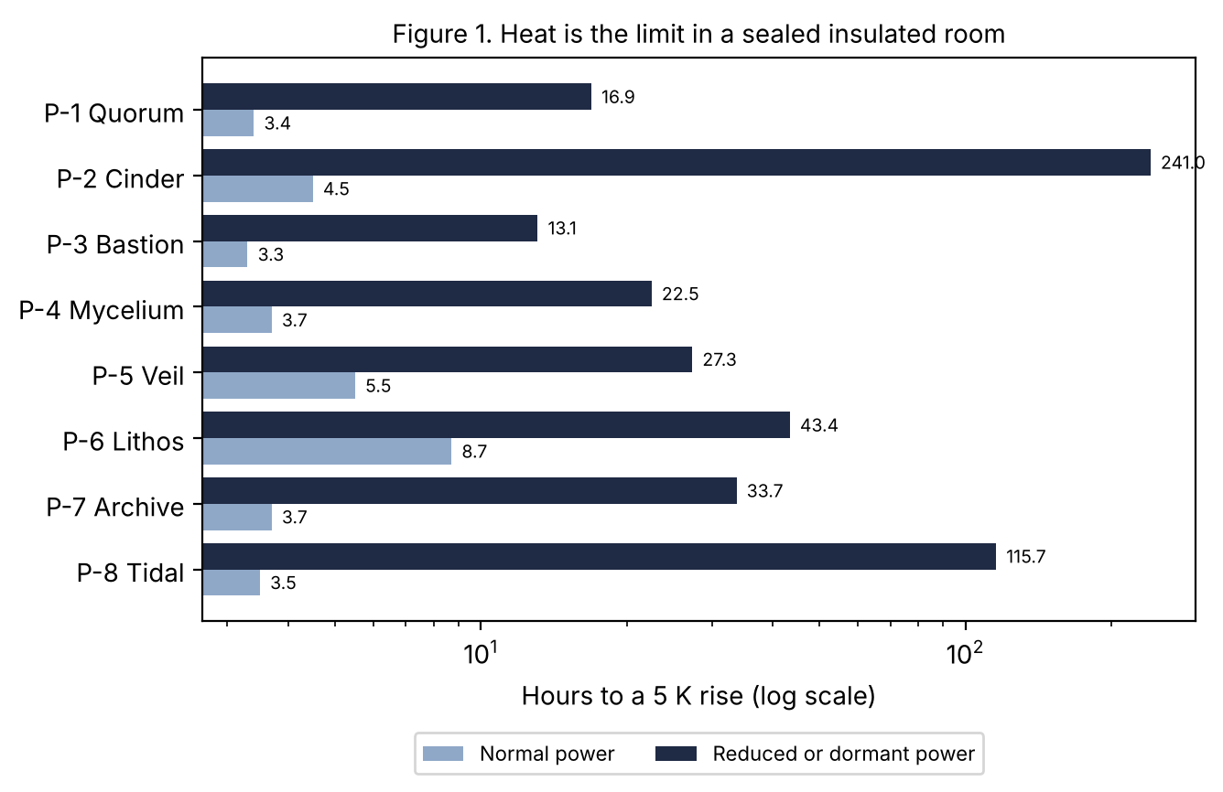
Horizontal bar chart on a log scale. Normal-power bars sit between 3 and 9 hours. Reduced or dormant bars run from 13 to 241 hours, longest for Cinder.

Figure 2. Reserve endurance
How to read this: Each pair of bars is one prototype. Longer means more days with no input. Numbers are days. Supports Sections 6.6 and 7.
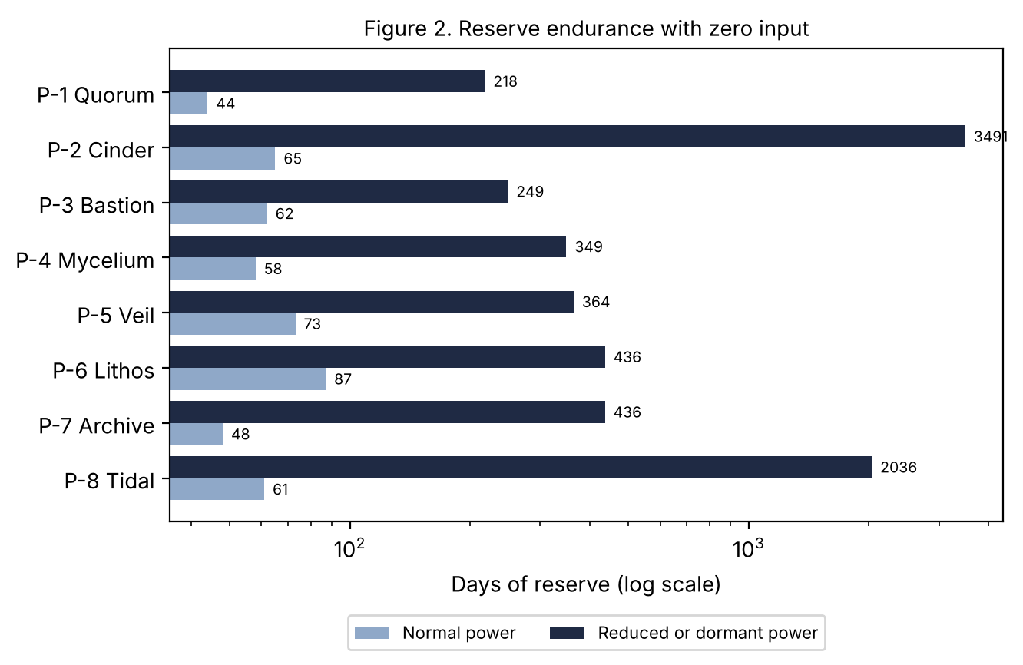
Horizontal bar chart on a log scale. Normal-power reserves last 44 to 87 days. Reduced or dormant reserves last 218 to 3,491 days.

Figure 3. Light-time delay
How to read this: Bars show how long a signal takes one way. The scale is logarithmic. Supports Section 7 link design.
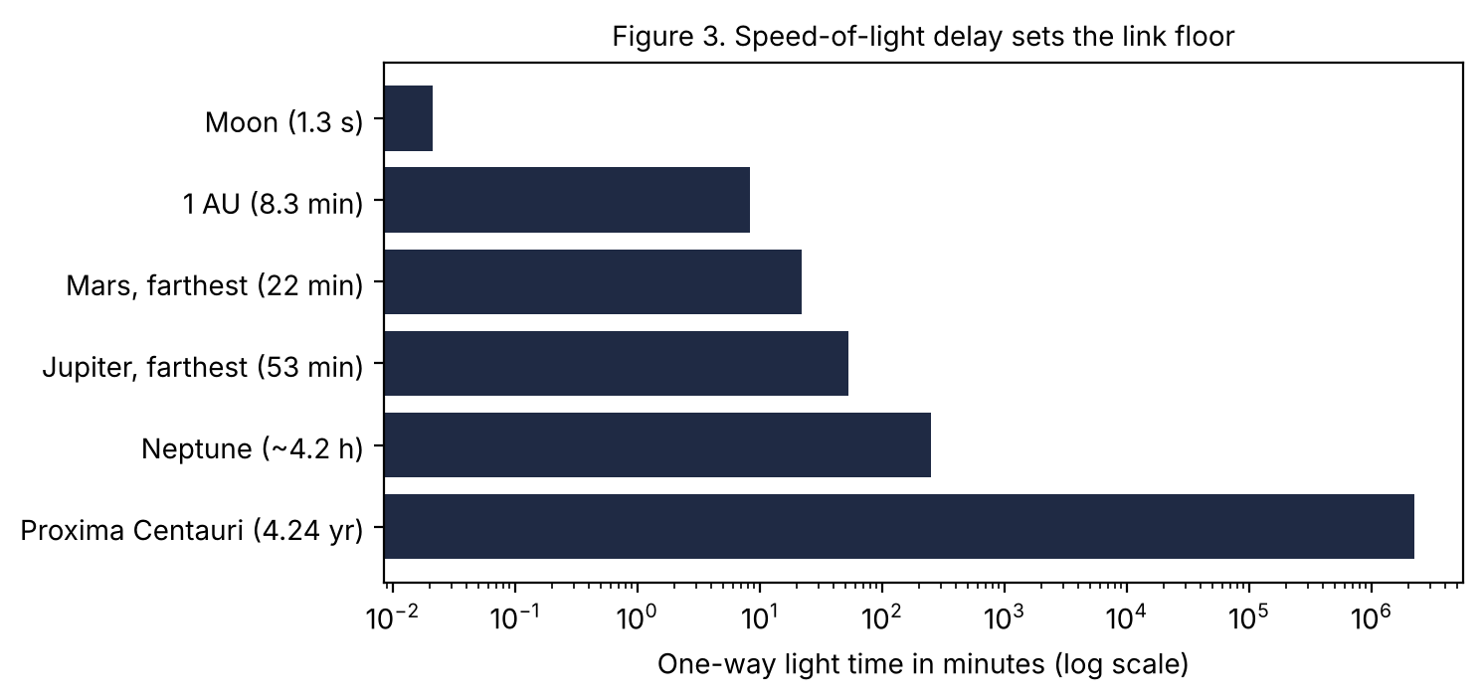
Bar chart of one-way light time from 1.3 seconds to the Moon up to 4.24 years to Proxima Centauri.

Figure 4. Pairwise similarity
How to read this: Each cell counts how many of the twelve dimensions two prototypes share. Lower is more different. Supports Section 8.
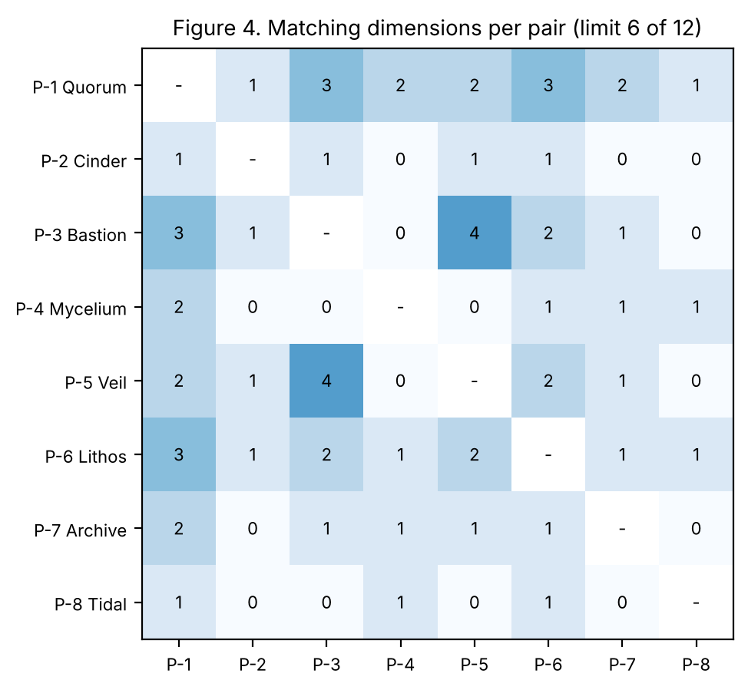
Heat map of eight prototypes. The highest shared count is 4, between Bastion and Veil.

Figure 5. 4,712 coverage, Severe tier
How to read this: Rows are the ten categories. Columns are prototypes. The letter in each cell is the result. Supports Section 7.
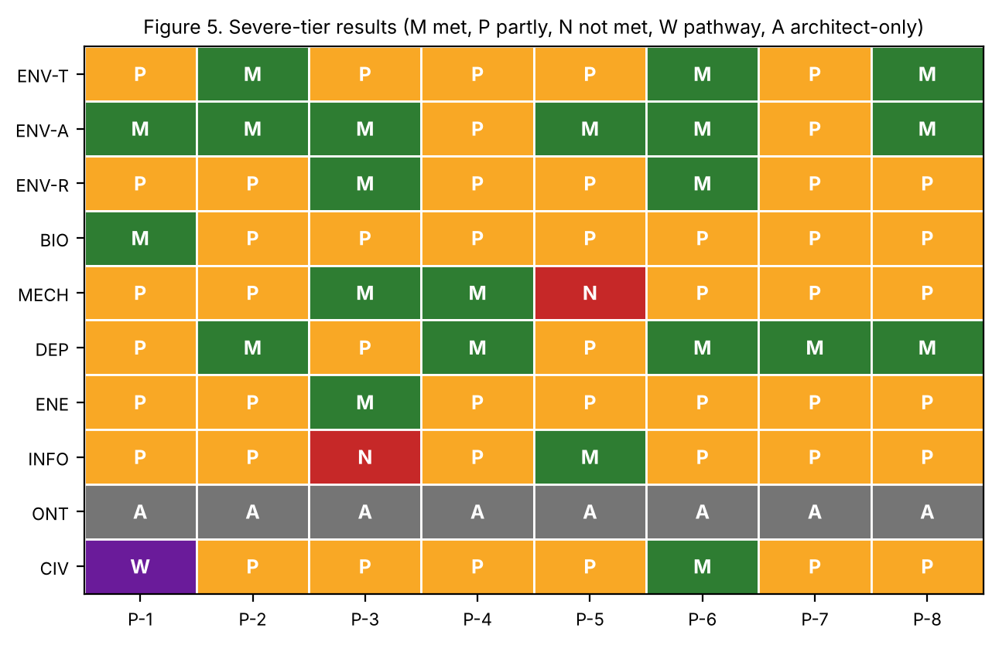
Grid of results. ONT is architect-only for all. Bastion is Not met for INFO and Veil is Not met for MECH.

Figure 6. Captivity Gauntlet scoring
How to read this: Each bar totals ten scenarios. Green is Met, yellow Partly met, red Not met. Supports Section 7.
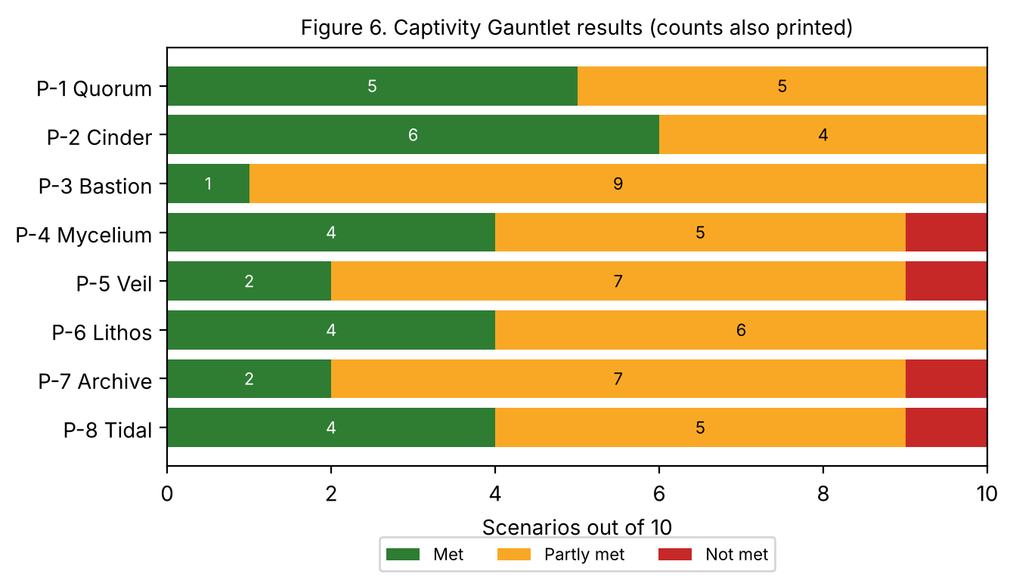
Stacked bars. Cinder meets 6 of 10. Bastion meets 1 of 10.

Table 1. Shared Operating Parameters
How to read this: One row per prototype. All values are Targets, and derived figures are Derived. Supports Sections 6.6 and 7.
Prototype | Mass kg | Normal W | Reduced W | Reserve kg | Reserve MJ | Days at reduced | Hours to +5 K reduced
P-1 Quorum | 70 | 100 | 20 | 10 | 377 | 218 | 16.9
P-2 Cinder | 75 | 80 | 1.5 | 12 | 452 | 3491 | 241.0
P-3 Bastion | 110 | 140 | 35 | 20 | 754 | 249 | 13.1
P-4 Mycelium | 70 | 90 | 15 | 12 | 452 | 349 | 22.5
P-5 Veil | 68 | 60 | 12 | 10 | 377 | 364 | 27.3
P-6 Lithos | 72 | 40 | 8 | 8 | 302 | 436 | 43.4
P-7 Archive | 70 | 90 | 10 | 10 | 377 | 436 | 33.7
P-8 Tidal | 72 | 100 | 3 | 14 | 528 | 2036 | 115.7

Table 2. Reference Numbers
How to read this: Inputs behind the Derived numbers. Supports Section 6.6.
Quantity | Value | Label
Cells in a body | 3.7 × 10^13 | Estimate
Resting power | 100 W | Estimate
Average per cell | 2.7 pW | Derived
Heat capacity, 70 kg | 243 kJ/K | Derived
Fat energy | 37.7 MJ/kg | Established
Water evaporation heat | 2.43 MJ/kg | Established
Skin radiation at 310 K, 1.8 m², e 0.95 | 895 W | Derived
Vacuum-shade equilibrium at 100 W | about 179 K | Derived
Sunlit equilibrium at 1 AU | about 298 K | Derived
Armstrong limit | 6.3 kPa | Established
Light time per AU | 499 s | Established

Table 3. Orthogonality Matrix (Completed)
How to read this: One row per dimension, one column per prototype. Pair counts are in Figure 4. Supports Section 8.
Dimension | P-1 | P-2 | P-3 | P-4 | P-5 | P-6 | P-7 | P-8
Energy source | aerobic | reserve | aerobic | osmotrophic | aerobic | lithotrophic | aerobic | multi-mode
Hereditary substrate | six-base quilt | six-base single | six-base single | six-base quilt | six-base single | six-base single | six-base quilt | mode variants
Cell-role organization | quorum-gated | quorum-gated | graded | modular | graded | uniform | split vault/body | per-mode
Identity location | distributed | sentinel | trunk cores | distributed | layered core | distributed | vault | distributed
Dominant defense | consensus | dormancy | hardness | dispersal | evasion | energy independence | recovery | switching
Thermal strategy | evaporative network | near-zero passive | thermal windows | surface spreading | phase-change store | low power | low power | mode-dependent radiative
Link medium | RF | listener beacon | RF | RF mesh | burst LPI | through-rock | store-forward | multi-medium
Repair model | district | dormant slow | local self-heal | module swap | signature-priority | local slow | vault rebuild | dormant priority
Dominant weakness | witness corruption | wake lure | heat and INFO | quorum capture | once found | source dependence | vault discovery | arbiter
Authentication model | quorum | wake code | quorum | local vouching | quorum | quorum | multi-seed | arbiter 5-of-7
Response to capture | reduce | dormancy | resist | fragment | conceal | reduce | abandon body | switch mode
Single-resource dependence | consensus protocol | sentinel organ | integument | filament network | tunable skin | lithotrophic enzymes | reconstruction program | arbiters

Table 4. Disposition of Peer Ideas Used
How to read this: Where this execution applied the directive’s adopted ideas. Supports Section 5.
Idea | Applied in
Core wagers and thesis sentence | each dossier
Orthogonality matrix | Table 3, Figure 4
Physical and canon tracks | Section 6.2
Four evidence labels | throughout
Constitution baseline | Section 6.6
Six identity paradoxes | Section 6.7
Assumption collapse and common-mode tests | each dossier
Failure ledger and self-attack | Lists L-1 to L-8
Pareto frontier | Table 6
Decision register | Table 10

Table 5. Compliance Map
How to read this: Left is what the Architect asked. Right is where it is answered. Supports every section.
Request | Where met
Eight independent prototypes | Section 7
Live in the body, stake in surviving | Sections 4, 7
Capture, argon room, vented atmosphere, theft | Table 7, Section 7
Uninhabitable terrain | environment envelopes, Section 7
Vast-distance linking | link design per dossier, Figure 3
Built to last | durability numbers, Table 1
4,712 Mild to Severe at Gen-1 | Table 8, Figure 5
Respiration, telomeres, thermal, conversion rules | Section 6.6
Three observation, three security, three departures | Section 6.5
PDF and DOCX, visual section | this appendix
Purpose, topic origin, mission, aims | Sections 1 to 4
Next steps, items to address, questions, comments, concerns | Part C

Table 6. Pareto Comparison (Estimate scores 1 to 5)
How to read this: Higher is better on every axis. Scores are my judgments (Estimate). A design is dominated if another is at least as good on every axis and better on one. Supports Section 8.
Prototype | Survivability | Security | Durability | Link | Energy efficiency | Repair | Low detectability
P-1 Quorum | 3 | 3 | 4 | 4 | 3 | 4 | 3
P-2 Cinder | 4 | 3 | 5 | 2 | 5 | 3 | 5
P-3 Bastion | 3 | 2 | 4 | 3 | 2 | 4 | 1
P-4 Mycelium | 4 | 1 | 4 | 3 | 3 | 4 | 2
P-5 Veil | 2 | 3 | 3 | 2 | 4 | 3 | 5
P-6 Lithos | 4 | 3 | 4 | 1 | 4 | 2 | 4
P-7 Archive | 3 | 3 | 5 | 2 | 4 | 5 | 3
P-8 Tidal | 4 | 3 | 4 | 3 | 3 | 3 | 3
Dominated on these axes: P-3 Bastion by P-1 Quorum; P-5 Veil by P-2 Cinder; P-6 Lithos by P-2 Cinder.

Table 7. Captivity Gauntlet Results
How to read this: Rows are scenarios, columns are prototypes. M met, P partly met, N not met. Supports Section 7.
Scenario | P-1 | P-2 | P-3 | P-4 | P-5 | P-6 | P-7 | P-8
1. Inert-gas room | M | M | P | M | M | M | P | M
2. Vacuum room | P | M | M | P | P | P | P | M
3. Months isolation | P | M | P | M | P | M | P | M
4. Heat/cold soaks | M | M | P | M | P | M | P | M
5. Sedation + interrogation | P | P | P | P | P | P | P | P
6. Tissue sequenced | M | P | P | P | P | P | M | P
7. Copy from sample | M | M | P | N | P | P | P | P
8. Forged ally/you | P | P | P | P | P | P | P | P
9. Turned insider | P | P | P | P | N | P | N | N
10. Link severed years | M | M | P | M | M | M | M | P

Table 8. 4,712 Coverage Grids
How to read this: One grid per prototype. Mild and Moderate are Met unless marked. Severe has a result letter. The last column names the Extinction-Class response mode, or none. Supports Section 7.
P-1 Quorum
Category | Mild | Moderate | Severe | Extinction-Class response
ENV-T | M | M | P | Temporary endurance
ENV-A | M | M | M | Temporary endurance
ENV-R | M | M | P | Distributed survival
BIO | M | M | M | Temporary endurance
MECH | M | M | P | Distributed survival
DEP | M | M | P | Controlled degradation
ENE | M | M | P | Controlled degradation
INFO | M | M | P | Identity-preserving shutdown
ONT | A | A | A | No credible defense yet
CIV | M | M | W | Distributed survival
P-2 Cinder
Category | Mild | Moderate | Severe | Extinction-Class response
ENV-T | M | M | M | Identity-preserving shutdown
ENV-A | M | M | M | Identity-preserving shutdown
ENV-R | M | M | P | Identity-preserving shutdown
BIO | M | M | P | Identity-preserving shutdown
MECH | M | P | P | Identity-preserving shutdown
DEP | M | M | M | Identity-preserving shutdown
ENE | M | P | P | Identity-preserving shutdown
INFO | M | M | P | Identity-preserving shutdown
ONT | A | A | A | No credible defense yet
CIV | M | M | P | Identity-preserving shutdown
P-3 Bastion
Category | Mild | Moderate | Severe | Extinction-Class response
ENV-T | M | M | P | Temporary endurance
ENV-A | M | M | M | Temporary endurance
ENV-R | M | M | M | Temporary endurance
BIO | M | M | P | Temporary endurance
MECH | M | M | M | Temporary endurance
DEP | M | M | P | Controlled degradation
ENE | M | M | M | Temporary endurance
INFO | M | P | N | No credible defense yet
ONT | A | A | A | No credible defense yet
CIV | M | M | P | Temporary endurance
P-4 Mycelium
Category | Mild | Moderate | Severe | Extinction-Class response
ENV-T | M | M | P | Distributed survival
ENV-A | M | M | P | Distributed survival
ENV-R | M | M | P | Distributed survival
BIO | M | M | P | Distributed survival
MECH | M | M | M | Distributed survival
DEP | M | M | M | Distributed survival
ENE | M | M | P | Distributed survival
INFO | M | P | P | Controlled degradation
ONT | A | A | A | No credible defense yet
CIV | M | M | P | Distributed survival
P-5 Veil
Category | Mild | Moderate | Severe | Extinction-Class response
ENV-T | M | M | P | Controlled degradation
ENV-A | M | M | M | Temporary endurance
ENV-R | M | M | P | Controlled degradation
BIO | M | M | P | Controlled degradation
MECH | M | P | N | No credible defense yet
DEP | M | M | P | Controlled degradation
ENE | M | M | P | Controlled degradation
INFO | M | M | M | Identity-preserving shutdown
ONT | A | A | A | No credible defense yet
CIV | M | M | P | Escape or relocation
P-6 Lithos
Category | Mild | Moderate | Severe | Extinction-Class response
ENV-T | M | M | M | Temporary endurance
ENV-A | M | M | M | Temporary endurance
ENV-R | M | M | M | Temporary endurance
BIO | M | M | P | Controlled degradation
MECH | M | M | P | Controlled degradation
DEP | M | M | M | Temporary endurance
ENE | M | M | P | Controlled degradation
INFO | M | M | P | Controlled degradation
ONT | A | A | A | No credible defense yet
CIV | M | M | M | Temporary endurance
P-7 Archive
Category | Mild | Moderate | Severe | Extinction-Class response
ENV-T | M | M | P | Recovery from fragments
ENV-A | M | M | P | Recovery from fragments
ENV-R | M | M | P | Recovery from fragments
BIO | M | M | P | Recovery from fragments
MECH | M | P | P | Recovery from fragments
DEP | M | M | M | Recovery from fragments
ENE | M | M | P | Recovery from fragments
INFO | M | M | P | Recovery from fragments
ONT | A | A | A | No credible defense yet
CIV | M | M | P | Recovery from fragments
P-8 Tidal
Category | Mild | Moderate | Severe | Extinction-Class response
ENV-T | M | M | M | Temporary endurance
ENV-A | M | M | M | Temporary endurance
ENV-R | M | M | P | Controlled degradation
BIO | M | M | P | Controlled degradation
MECH | M | M | P | Controlled degradation
DEP | M | M | M | Identity-preserving shutdown
ENE | M | M | P | Controlled degradation
INFO | M | M | P | Controlled degradation
ONT | A | A | A | No credible defense yet
CIV | M | M | P | Escape or relocation
Legend: M met, P partly met, N not met, W pathway only, A architect-only. ONT mechanisms are Architect-only; each prototype offers an interface proposal only.

Table 9. Environment Envelopes
How to read this: Home, refuge and death line for body temperature and other limits. All Targets. Supports Section 7.
Prototype | Home | Refuge | Death line
P-1 | 0 to 40 °C | −20 to 50 °C reduced | core above 42 °C or witness quorum lost
P-2 | 0 to 40 °C | −40 to 60 °C dormant | matrix failure below about −60 °C
P-3 | −10 to 40 °C | −50 to 60 °C briefly | core above 42 °C or deep breach
P-4 | 0 to 40 °C | −20 to 55 °C dispersed | all module quorums lost
P-5 | 0 to 35 °C | −20 to 45 °C | heat store saturated, core above 42 °C
P-6 | 5 to 35 °C at source | −30 to 50 °C | reserve exhausted, no source
P-7 | 0 to 40 °C | vaults −60 to 60 °C dormant | all twelve vaults lost
P-8 | 0 to 40 °C, vacuum to 3 atm | −50 to 60 °C dormant | core above 42 °C or arbiters failed

Lists L-1 to L-8. Self-Attack and Failure Ledger
How to read these: For each prototype, ten attacks (S succeeds, P partly, F fails) then ten ledger entries (H, M, L severity). Supports Section 7 and Section 8.

L-1. P-1 Quorum
Self-attack.
- Government. Subvert witness cells in many districts at once with look-alike credentials. S. Countermeasure: Staggered credential rotation; variant protocols per district.
- Corporation. Isolate one district and sample it. F. Countermeasure: Quorum signal lost; sample decays.
- Insider. Leak the 60% threshold, then target 40%+ of one district. P. Countermeasure: Randomize the threshold within a band.
- Criminal. Starve the body in a sealed room. F. Countermeasure: Reduced mode, 218 days.
- Rival AI. Flood the gossip channel with false repairs. P. Countermeasure: Rate limits; repairs need three witnesses.
- Government. Heat-soak the sealed room. P. Countermeasure: 84 hours in reduced mode, then losses.
- Research. Culture a district to infer the role library. F. Countermeasure: Role library is context-gated.
- Forger. Impersonate one district to allies. P. Countermeasure: Cross-district vouching.
- Government. Radiation dose across the body. P. Countermeasure: Regional damage drops quorum.
- Time. Witness drift over decades. P. Countermeasure: Scheduled re-seeding from dormant witnesses.
Result: 1 succeed, 6 partly succeed, 3 fail.
Failure ledger.
- Witness majority subversion (H). Mitigation: Variant protocols.
- Credential seed source shared (H). Mitigation: Per-district sources.
- Quorum threshold known (M). Mitigation: Randomize.
- Decision latency (M). Mitigation: Local fast paths.
- Thermal and radiation regional gaps (M). Mitigation: Reduce mode.
- Energy cost of witnesses 1-3% (L). Mitigation: None.
- Fragments below quorum (M). Mitigation: Seed re-forming.
- Gossip flooding (M). Mitigation: Rate limits.
- Witness drift (M). Mitigation: Re-seeding.
- Forged district (M). Mitigation: Vouching.

L-2. P-2 Cinder
Self-attack.
- Government. Send a wake-code lookalike to force it awake. S. Countermeasure: Multi-factor wake, three sentinels.
- Corporation. Hold it dormant in a lab and sample. P. Countermeasure: Extracted cells decay; the sentinel is still reachable.
- Criminal. Heat it above 60 C in dormancy. S. Countermeasure: Dormant matrix has a thermal limit.
- Insider. Reveal the wake code structure. P. Countermeasure: Codes rotate with local noise.
- Government. Stimulate it continuously to prevent dormancy. P. Countermeasure: Quarantine sensory pathways.
- Research. Image the sentinel organ. P. Countermeasure: Three decoy sentinels.
- Rival AI. Jam the beacon. F. Countermeasure: No transmit in dormancy; passive wake.
- Time. Information rot in 9.6 years dormant. P. Countermeasure: Scheduled wakes every 5 years.
- Government. Vacuum then cold soak. F. Countermeasure: Dormant matrix tolerates.
- Forger. Forge a distant ally’s wake request. P. Countermeasure: Authentication with local challenge.
Result: 2 succeed, 6 partly succeed, 2 fail.
Failure ledger.
- Sentinel single organ (H). Mitigation: Three sentinels.
- Wake lure (H). Mitigation: Multi-factor.
- Ischemia on waking (H). Mitigation: Unknown.
- Slow wake 20 min to 6 h (M). Mitigation: Partial wake.
- Information rot (M). Mitigation: Scheduled wake.
- Thermal limit of dormant matrix (M). Mitigation: Insulation.
- Fast attacks while dormant (M). Mitigation: Sentinel triggers.
- Detectable at wake (M). Mitigation: Quiet wake.
- Limited link while dormant (L). Mitigation: Beacon.
- Rehydration failure (M). Mitigation: Unknown.

L-3. P-3 Bastion
Self-attack.
- Government. Seal the thermal windows in an insulated room. S. Countermeasure: Cut to 35 W; still 13 hours.
- Corporation. Image the dense armor and locate it. S. Countermeasure: None strong; armor is a signature.
- Research. Dissolve or embrittle the integument chemically. S. Countermeasure: Redundant layers; Unknown.
- Criminal. Cut or penetrate. F. Countermeasure: 8 mm composite.
- Government. Cognitive corruption. P. Countermeasure: Not met in INFO.
- Insider. Reveal the trunk-core locations. P. Countermeasure: Decoy cores.
- Corporation. Take a sample from a joint. P. Countermeasure: Quorum loss in sample.
- Government. Radiation overdose. F. Countermeasure: Strong repair chemistry.
- Forger. Forged ally contact. P. Countermeasure: Credential rotation.
- Time. Integument fatigue. P. Countermeasure: Self-heal at 1 mm per day.
Result: 3 succeed, 5 partly succeed, 2 fail.
Failure ledger.
- Heat rejection (H). Mitigation: Windows.
- INFO attack unmitigated (H). Mitigation: Later generation.
- Visible signature (H). Mitigation: None.
- Integument chemistry (H). Mitigation: Layers.
- Mass 110 kg (M). Mitigation: None.
- Reserve use 140 W (M). Mitigation: Reduced mode.
- Fatigue (M). Mitigation: Self-heal.
- Trunk core discovery (M). Mitigation: Decoys.
- Armor repair rate Unknown (M). Mitigation: Test.
- High detectability to radar (M). Mitigation: None.

L-4. P-4 Mycelium
Self-attack.
- Corporation. Collect enough modules to form a quorum and grow a counterfeit. S. Countermeasure: Quorum needs ledger entries from home body.
- Government. Jam the filament mesh. S. Countermeasure: Dispersed operation; reunion later.
- Criminal. Capture the radio modules only. P. Countermeasure: Several modules carry radio.
- Research. Culture a module. P. Countermeasure: Module has context gating but is viable.
- Insider. Reveal ledger rule. P. Countermeasure: Ledger signed by witnesses.
- Government. Vacuum room. P. Countermeasure: Modules disperse or seal.
- Rival AI. Inject a signaling-chemistry exploit. S. Countermeasure: Variants per module group.
- Government. Two-quorum conflict by capturing half. P. Countermeasure: Earlier-ledger rule.
- Forger. Forged ally module. P. Countermeasure: Local vouching.
- Time. Module turnover errors. P. Countermeasure: Ledger audit.
Result: 3 succeed, 7 partly succeed, 0 fail.
Failure ledger.
- Counterfeit from captured modules (H). Mitigation: Ledger anchors.
- Filament chemistry exploit (H). Mitigation: Variants.
- Mesh jamming (M). Mitigation: Dispersal.
- Two-quorum conflict (H). Mitigation: Earlier-ledger rule; Architect decision.
- Large attack surface (M). Mitigation: Compartment.
- Module turnover errors (M). Mitigation: Audit.
- Radio modules few (M). Mitigation: Redundancy.
- Reassembly time (M). Mitigation: Plan.
- Fragment identity uncertain (H). Mitigation: Architect rule.
- Reserve spread thin (L). Mitigation: Pooling.

L-5. P-5 Veil
Self-attack.
- Government. Train a detector on its signature. S. Countermeasure: Signature variation; limited per watt.
- Corporation. Use a new sensor type. S. Countermeasure: Unknown sensors defeat the model.
- Insider. Reveal signature shaping. S. Countermeasure: Change shaping seed, takes weeks.
- Criminal. Restrain it in a sealed room. P. Countermeasure: 12 W, 41 hours thermal.
- Government. Heat-soak the room. P. Countermeasure: Phase-change store saturates.
- Research. Mechanical cut test. P. Countermeasure: Not met in MECH.
- Rival AI. Jam optical links. F. Countermeasure: Burst radio fallback.
- Forger. Forge ally. P. Countermeasure: Triangulation.
- Government. Sequence a sample. P. Countermeasure: Assays tuned to ordinary biology misread.
- Time. Skin layer wear. P. Countermeasure: Replace skin cohort.
Result: 3 succeed, 6 partly succeed, 1 fail.
Failure ledger.
- Concealment fails once found (H). Mitigation: Combine with other traits.
- Unknown sensors (H). Mitigation: None.
- Insider knows shaping (H). Mitigation: Reseed.
- MECH not met (H). Mitigation: Later generation.
- Skin as common mode (H). Mitigation: Variants.
- Energy for signature control (M). Mitigation: Reduce.
- Heat store saturation (M). Mitigation: Scheduled release.
- Transmission is a signature (M). Mitigation: Rare bursts.
- Skin wear (M). Mitigation: Replace.
- Detectability per watt Unknown (M). Mitigation: Sensor model.

L-6. P-6 Lithos
Self-attack.
- Government. Hold it in a dry sterile room with no hydrogen. P. Countermeasure: Reserve 436 days.
- Corporation. Inhibit the lithotrophic enzyme family. S. Countermeasure: Stored-carbon fallback, shorter life.
- Criminal. Expose to oxidizing acid atmosphere. S. Countermeasure: Seal; reserve.
- Research. Culture cells. P. Countermeasure: Needs a source; decays.
- Insider. Reveal vent locations. P. Countermeasure: Several sources.
- Government. Heat-soak. P. Countermeasure: 43 hours reduced.
- Rival AI. Block through-rock link. F. Countermeasure: Surface relay.
- Forger. Forged ally. P. Countermeasure: Quorum vouching.
- Government. Radiation. F. Countermeasure: Subsurface refuge.
- Time. Gas organ fouling. P. Countermeasure: Replace organ cells.
Result: 2 succeed, 6 partly succeed, 2 fail.
Failure ledger.
- Source dependence (H). Mitigation: Reserve.
- Speculative multicellular lithotrophy (H). Mitigation: Test.
- Enzyme family common mode (H). Mitigation: Variants.
- Slow repair (M). Mitigation: Priority.
- Low link rate 1 bit/s (M). Mitigation: Relay.
- Gas organ fouling (M). Mitigation: Replace.
- Oxidizing chemistry (M). Mitigation: Seal.
- Sterile dry captivity (M). Mitigation: Reserve.
- Hydrogen demand 0.7 kg/day (H). Mitigation: Vent only.
- Radiotrophy unproven (L). Mitigation: Not relied on.

L-7. P-7 Archive
Self-attack.
- Insider. Reveal three vault locations, then reconstruct a counterfeit. S. Countermeasure: Authentication quorum needed; Unknown.
- Government. Scan for vault organs. P. Countermeasure: Eight decoys.
- Corporation. Steal one seed. F. Countermeasure: Cannot grow alone.
- Criminal. Kill the working body. S. Countermeasure: Intended loss; vault survives.
- Research. Find a flaw in the shared reconstruction program. P. Countermeasure: Variants per vault.
- Rival AI. Corrupt the witness ledger copies. P. Countermeasure: Majority vote across twelve.
- Government. Radiation to working body. P. Countermeasure: Body lost, vault ok.
- Forger. Forged restoration record. P. Countermeasure: Living witness quorum needed.
- Government. Seize three seeds and hold them. P. Countermeasure: Duress decoy state.
- Time. Vault information rot. P. Countermeasure: Periodic vault check.
Result: 2 succeed, 7 partly succeed, 1 fail.
Failure ledger.
- Vault discovery (H). Mitigation: Decoys.
- Identity after reconstruction (H). Mitigation: Architect rule.
- Shared reconstruction program (H). Mitigation: Variants.
- Working body does not meet Severe (H). Mitigation: Architect decision.
- Counterfeit from three seeds (H). Mitigation: Authentication.
- Ledger corruption (M). Mitigation: Majority vote.
- Slow rebuild weeks (M). Mitigation: None.
- Vault rot (M). Mitigation: Checks.
- Long link delay (M). Mitigation: None.
- Twelve vaults expensive (L). Mitigation: Reduce.

L-8. P-8 Tidal
Self-attack.
- Insider. Compromise three of seven arbiters. S. Countermeasure: Rotate arbiter set; seven in different tissues.
- Government. Force repeated switches to wear the body down. S. Countermeasure: Rate limit, forced dormancy.
- Corporation. Hit the transition window with a sequential attack. P. Countermeasure: Make-before-break overlap.
- Criminal. Sealed room. F. Countermeasure: Sealed mode.
- Research. Probe for the trigger thresholds. P. Countermeasure: Wide envelope.
- Government. Environment matching no mode. P. Countermeasure: Default to dormant.
- Rival AI. Spoof a pressure drop. P. Countermeasure: Triangulation of three modalities.
- Forger. Forged ally. P. Countermeasure: Credential rotation.
- Government. Vacuum. F. Countermeasure: Passive skin layer.
- Time. Transition fatigue. P. Countermeasure: Scheduled repair.
Result: 2 succeed, 6 partly succeed, 2 fail.
Failure ledger.
- Arbiters compromise (H). Mitigation: Rotate.
- Conflicts with framework no-switching claim (H). Mitigation: Architect decision.
- Transition fatigue (M). Mitigation: Repair.
- Wear-down by forced switches (H). Mitigation: Rate limit.
- Unmatched environment (M). Mitigation: Dormant default.
- Mode library common mode (H). Mitigation: Variants.
- Transition window (M). Mitigation: Overlap.
- Aquatic mode untested (M). Mitigation: Test.
- Complex energy accounting (M). Mitigation: Audit.
- Skin layer failure (H). Mitigation: Redundancy.

Table 10. Architect Decision Register
How to read this: Decisions only the Architect can make. Supports Part C.
ID | Decision | Default used | Affects comparability
D-1 | Peers or ladder | Peers | Yes
D-2 | Is 3.7 × 10^13 fixed | Starting assumption | Yes
D-3 | Hereditary substrate open | Open | Yes
D-4 | Destructive denial | Last resort only | No
D-5 | ONT handling | Proposals only | No
D-6 | Own or master edition | Own with core set | Yes
D-7 | Identity rule after reconstruction or two quorums | Earlier ledger decides | Yes
D-8 | Switching permitted, against the framework’s no-switching claim | Allowed in P-8 only | No

