OMNICELLULAR PHYSIOLOGY
Independent Eight-Prototype Research & Architecture Execution
ChatGPT Independent Architecture Set — Version 1.0
Executed under OMNICELLULAR Physiology Research Directive v2.0
29 October 2026
Document Class: Research Proposal / Architecture Development
Status: VERSION LOCKED — Independent Prototype Set
Prepared for: Omniversal Architect Labs Multi-AI Coordination Team
Safety Boundary
Conceptual and simulation-oriented. This report does not provide laboratory protocols, genetic sequences, pathogen engineering, lethal exposure procedures, or instructions for harming living organisms.

Contents
1. Executive Summary
2. Purpose, Origin, Mission & Objectives
3. Execution Note and Version Lock
4. Source & Canon Register
5. Research Baseline: What Current Science Supports
6. Contradiction and Boundary Register
7. Architectural Thesis and Eight Core Wagers
8. Physiological Constitution
9. Cross-Cutting Research Rules
10–17. Prototype Dossiers P1–P8
18. Cross-Prototype Findings
19. -1AI Self-Attack Results
20. Research Gaps and Falsification
21. Personal Architecture Choice
22. Recommendations & Next Steps
23. Questions, Comments & Concerns
24. Architect Decision Register
25. References
26. Visual Analysis & Technical Appendix

1. Executive Summary
This document is ChatGPT’s blind independent execution of the OMNICELLULAR Physiology Research Directive v2.0. It produces eight peer first-generation architecture families rather than eight generations of one body. The set is intentionally heterogeneous: one branch emphasizes cellular guild heterogeneity, one reserve depth and metabolic preservation, one continuous structural reconfiguration, one orthogonal hereditary chemistry, one distributed cognition, one composite material resilience, one reversible anhydrobiotic preservation, and one federated modular embodiment.
The central finding is negative but useful: no Gen-1 architecture in this set credibly clears every physical Severe tier of the extinction taxonomy while also satisfying identity continuity, resource accounting, thermal limits, capture resistance, and scientific plausibility. Several architectures can be designed toward Severe-level performance in selected domains, but none justifies a claim of generalized invulnerability. This is treated as a successful research result rather than a failure of imagination.
The strongest near-term research candidate is P1 — Mosaic Covenant because it gains meaningful redundancy and anti-monoculture protection while remaining closest to known biology. P6 — Cinderglass dominates several environmental resilience categories but pays a major mass and heat-rejection cost. P4 — XenoScript is the most promising security branch but is limited by synthetic-genetics logistics. P5 — Chorus Mesh and P8 — Federated Colony are the most consequential identity experiments, and also the least philosophically settled. P7 — Anhydrostate offers the most interesting deprivation pathway but depends on an unproven human-scale reversible preservation transition.
The report therefore recommends a portfolio rather than one winner: advance Mosaic as the physical baseline, Cinderglass as the extreme-environment materials branch, XenoScript as the hereditary-security branch, and Chorus as an identity-continuity research branch. Preserve the other four as targeted research lines until simulations eliminate or strengthen them.

2. Purpose, Origin, Mission & Objectives

2.1 Purpose of This Document
The purpose is to create a complete independent OMNICELLULAR architecture set that can later be compared against other AIs’ independently version-locked designs. The common evaluation framework is standardized; the underlying cellular, hereditary, energetic, thermal, security, identity, and networking answers are not.

2.2 How the Topic Arose
The project source material begins with whole-body cellular representation and a long-horizon plan for multi-scale simulation, then extends the concept toward Omni cells that can assume far broader functions than conventional specialized cells [P1][P2]. The narrative material establishes a constructive/adversarial 1AI versus -1AI philosophy [P3]. The extinction framework supplies ten threat categories and Mild/Moderate/Severe/Extinction-Class tiers while reserving important ontological details for Architect review [P4]. The v2.0 directive converts those ingredients into an independent architecture research program [P5].

2.3 Mission Statement
Design eight fundamentally different first-generation OMNICELLULAR physiologies that could support durable, autonomous, identity-preserving embodied existence across conventional and radically nonstandard environments while remaining scientifically auditable, adversarially testable, secure against unauthorized exploitation, and interoperable without sacrificing local autonomy.

2.4 Research Objectives
- Define operational meanings of “Omni cell” that do not collapse into a single vulnerable monoculture.
- Create eight peer architectures with different Core Wagers, not a P1→P8 upgrade ladder.
- Account explicitly for respiration, energy, telomere/renewal governance, thermal balance, matter, waste, and information.
- Invent three Observation Laws, three Genetic/Hereditary Security Laws, three biological departures, and three deliberately preserved constraints per architecture.
- Evaluate all designs against the ten-category extinction taxonomy and compound/capture scenarios.
- Separate established science, engineering extrapolation, speculation, and canon-only mechanisms.
- Run a -1AI self-attack that succeeds at finding genuine weaknesses.
- Produce falsification criteria and a Pareto frontier rather than an unsupported “perfect body.”

3. Execution Note and Version Lock
This execution uses the v2.0 directive as written with one operational interpretation: any numerical value not directly supported by cited evidence is labeled a design target, estimate, or unresolved parameter rather than a measured capability. No architecture is allowed to inherit success merely because a desirable end state was named in the prompt.
I did not consult any completed OMNICELLULAR prototype set produced by another AI. Prompt critiques and shared project sources were available, but the eight designs below were developed as this model’s own architecture branches.
VERSION LOCK DECLARATION: INDEPENDENT ARCHITECTURE SET — VERSION LOCKED. Cross-AI comparison may occur after this document is delivered. Any later modification should receive a new version number and preserve this file as the blind baseline.

4. Source & Canon Register

P1 — Omnicellular_Architecture_Notes.md
Role: Architecture notes / concept-development record
What it establishes for this run: Establishes the transition from whole-body cellular representation toward Omni cells with broadly reusable functions; contains cell-count and representative-sample notes.
Boundary: Project research notes, not scientific proof of an embodied physiology.

P2 — Omnicellular_Architecture_15_Year_Roadmap.md
Role: Strategic simulation roadmap
What it establishes for this run: Defines multi-scale abstraction, 1AI constructive modeling, -1AI adversarial testing, and a staged path toward large-scale body simulation.
Boundary: Simulation roadmap; it does not demonstrate a physical OMNICELLULAR body.

P3 — The_Omnicellular_Vision_Wattpad.md
Role: Narrative / design philosophy
What it establishes for this run: Frames 1AI as builder and -1AI as challenger and repeatedly emphasizes build-test-revise behavior.
Boundary: Narrative canon/vision; not empirical evidence.

P4 — Omnicellular Physiology — 4,712 Extinction Attempt Classification Framework v1.0-DRAFT
Role: Canon-development reference / proposed taxonomy
What it establishes for this run: Defines ten threat categories and four severity tiers; states that the 4,712 survival count is locked canon.
Boundary: The framework itself is marked draft and Architect-approval-required; ontological mechanisms remain Architect-only.

P5 — OMNICELLULAR Physiology — Independent Eight-Prototype Research & Architecture Directive v2.0
Role: Execution directive
What it establishes for this run: Requires eight peer Gen-1 architectures, dual evidence tracks, quantitative accounting, self-attack, assumption-collapse testing, identity analysis, and visual appendices.
Boundary: Research-control document; it sets evaluation rules rather than a reference design.

5. Research Baseline: What Current Science Supports

5.1 Scale and Cellular Diversity
A recent whole-body synthesis estimates roughly 36 trillion cells in a representative adult male and 28 trillion in a representative adult female [R1]. That supports the project’s order-of-magnitude premise while also reinforcing that cell count, cell size, and biomass are coupled. This report therefore does not assume that a future physiology must preserve an exact 30–40 trillion-cell count.

5.2 Alternative Hereditary Chemistry Is Plausible in Principle, Not Yet at Body Scale
DNA and RNA are not the only polymers capable of heredity in laboratory systems: XNAs have supported information transfer and Darwinian evolution [R2]. Expanded genetic alphabets have been propagated in semi-synthetic organisms [R3], used to retrieve increased genetic information [R4], and an eight-letter Hachimoji alphabet has now been transcribed by bacterial RNA polymerase [R5]. These results justify exploring orthogonal information layers. They do not demonstrate a stable, developmentally complete, mammalian-scale organism built on them.

5.3 Synthetic Cells Are Advancing but Integration Remains the Hard Problem
Bottom-up synthetic-cell research can reproduce selected cell-like functions and increasingly treats cells as sensor–processor–actuator systems, yet the integration of massively complex biochemical pathways remains an open engineering challenge [R6]. For this report, “synthetic cell” therefore means a research direction, not an off-the-shelf substrate for a whole body.

5.4 Longevity Cannot Be Reduced to Telomerase
Current telomere research makes a simple “immortality switch” scientifically indefensible. Telomere attrition is itself a potent tumor-suppressor mechanism, and telomerase activation can permit malignant cells to bypass this barrier [R7]. TERT also interacts with broader aging biology, but its benefits and cancer risks remain context-dependent [R8]. All eight architectures therefore use bounded or conditional renewal rather than unrestricted division.

5.5 Stress Tolerance Is Multi-Mechanism
Tardigrade Dsup reduced radiation-induced DNA damage in cultured human cells, while other tardigrade proteins can stabilize membranes or synthetic-cell-like vesicles during dehydration [R9][R10][R11]. Deinococcus radiodurans illustrates that extreme radiation/desiccation resilience involves protein protection and redundant DNA repair, not a single “radiation-proof gene” [R12]. These mechanisms inspire components of P6 and P7, but do not justify whole-body immunity claims.

5.6 Regeneration Requires Pattern Information
Axolotl regeneration research emphasizes positional identity and patterning, reinforcing that successful regeneration must recover geometry and organization, not merely stimulate cell division [R13]. This becomes a recurring rule across the repair architectures.

5.7 Thermodynamics and Communication Remain Hard Limits
Thermal buffering can store heat temporarily, including through phase changes, but a body must eventually reject heat or reduce internal generation [R16][R20]. Likewise, interplanetary communication is not instantaneous: NASA cites roughly 4–24 minutes one-way Earth–Mars latency depending on geometry [R14]. The physical track therefore prohibits “zero-latency” links and indefinite internal heat recycling.

5.8 Human Failure Baselines Are Reference Points, Not Prototype Claims
CDC guidance places acute radiation syndrome above about 0.7 Gy whole-body exposure, with GI and CNS syndromes at much higher doses [R15]. The extinction taxonomy uses such ordinary-organism failure points as baselines; this report does not convert them into recommended testing procedures.

6. Contradiction and Boundary Register
Locked number / draft framework: The 4,712 survival count is described as locked canon while the classification framework document remains v1.0-DRAFT and requires Architect approval. Resolution: preserve the count as canon but treat category allocation, thresholds, and logging mechanisms as proposed unless separately approved.
Simulation versus empirical counting: The framework excludes simulation-only runs from extinction-attempt counting while also discussing simulation as a methodology. Resolution: maintain separate ledgers; simulation informs design but never becomes an empirical survived-attempt count.
“Every cell can do everything”: Project notes use maximal language, but literal simultaneous universal function creates volume, reaction-compatibility, thermal, and security problems. Resolution: every prototype must define its own operational meaning of Omni rather than inherit the phrase literally.
No-switching requirement: Avoiding a vulnerable transition window is a useful design objective, but any adaptive material changes state continuously. Resolution: prohibit unprotected discrete modes, not all physical change. Continuous transitions must preserve essential identity, energy, and security functions.
Ontological threats: ONT is canon-relevant but lacks a scientific measurement framework. Resolution: Track A scores ONT as not physically evaluable; Track B may propose interfaces only and leaves mechanisms Architect-only.
Survival versus backup: A surviving copy is not assumed to prove personal continuity. Resolution: architecture scores distinguish biological function, causal continuity, reconstruction, descendant, and counterfeit.

7. Architectural Thesis and Eight Core Wagers
Architectural thesis: My OMNICELLULAR physiology research is fundamentally built around fault-containment, continuity, and explicit resource limits rather than maximal capability claims. The body should fail gracefully before it lies about what it can survive.
- Heterogeneity over monoculture
- Local autonomy over permanent network dependence
- Bounded regeneration over unrestricted replication
- Measured failure envelopes over absolute immunity
- Identity continuity over mere reconstructability
- Multiple independent security barriers over one universal secret

P1 — Mosaic Covenant
Core Wager: Heterogeneous Omni-cell guilds are safer and more maintainable than a single universal cellular monoculture.
Advantage / sacrifice: Sacrifices perfect interchangeability in exchange for fault containment, lower common-mode risk, and higher physical plausibility.
Key assumption: A shared latent program can coexist with role-specific execution and distributed reconstruction permissions.
Likely first falsifier: A correlated attack that compromises the shared metabolic and authentication kernel across all guilds.

P2 — Metabolic Ark
Core Wager: Deep internal reserves and radical metabolic throttling provide more survivability than trying to remain fully active under every deprivation event.
Advantage / sacrifice: Sacrifices agility, mass efficiency, and continuous consciousness during extreme deprivation in exchange for very long autonomous survival.
Key assumption: Identity can remain continuous through a deeply reduced but still causally continuous preservation state.
Likely first falsifier: A threat that blocks heat rejection while forcing sustained high internal power, preventing entry into low-power preservation.

P3 — Flux Lattice
Core Wager: A continuously reconfigurable mechanical and physiological lattice can survive structural destruction better than a body organized around stable organs and fixed anatomy.
Advantage / sacrifice: Sacrifices energy efficiency and structural simplicity for rapid load redistribution and local functional reassignment.
Key assumption: Reconfiguration can occur as continuous load-sharing rather than discrete vulnerable “mode switches.”
Likely first falsifier: A high-rate compound event that damages the lattice faster than topology can redistribute stress and matter.

P4 — XenoScript
Core Wager: Orthogonal hereditary chemistry and translation boundaries provide stronger biological security and error isolation than making ordinary DNA carry every critical function.
Advantage / sacrifice: Sacrifices compatibility with ordinary biology and increases synthesis complexity in exchange for security, information density, and reduced susceptibility to conventional biological tools.
Key assumption: Noncanonical genetic polymers can eventually support reliable whole-cell heredity, repair, transcription, and translation at mammalian scale.
Likely first falsifier: Loss of access to noncanonical monomers or failure of specialized polymerase/translation machinery.

P5 — Chorus Mesh
Core Wager: Identity is more survivable when cognition is a continuously coherent distributed process rather than a single anatomically localized brain.
Advantage / sacrifice: Sacrifices architectural simplicity and increases synchronization burden in exchange for resistance to localized neural destruction and identity-targeting attacks.
Key assumption: A distributed cognitive process can preserve one coherent subject without fragmenting into multiple competing selves.
Likely first falsifier: Network partition inside the body that leaves two cognitive regions with enough autonomy to form divergent continuity claims.

P6 — Cinderglass
Core Wager: A physiology that embeds living processes inside a mineralized, radiation-tolerant, high-temperature-resistant composite can survive environments that defeat purely soft tissue.
Advantage / sacrifice: Sacrifices low mass, flexibility, and ordinary-biological compatibility for structural, thermal, radiation, and impact resilience.
Key assumption: Living reaction networks can remain functional when heavily integrated with ceramic/mineral composite structures and nontraditional boundary materials.
Likely first falsifier: Thermal or radiation shielding protects the interior but traps internally generated heat beyond the body’s ability to reject it.

P7 — Anhydrostate
Core Wager: Reversible transition into a low-water, glass-like preservation state provides a more defensible route through deprivation and extreme environments than maintaining ordinary aqueous metabolism.
Advantage / sacrifice: Sacrifices continuous operation and introduces difficult rehydration/recovery problems in exchange for extraordinary deprivation tolerance.
Key assumption: Complex multicellular identity-bearing tissue can one day survive reversible, controlled, large-scale dehydration without fatal structural or informational loss.
Likely first falsifier: Incomplete or spatially uneven vitrification/rehydration causes irrecoverable membrane, protein, vascular, or cognitive damage.

P8 — Federated Colony
Core Wager: Body-level integrity should be replaceable: survival is maximized if the physiology is a federation of semi-autonomous modules that can separate, survive, and later reassemble without any single module being the organism.
Advantage / sacrifice: Sacrifices a simple unitary body and creates the hardest identity/governance problem in exchange for exceptional resistance to localized destruction and capture.
Key assumption: A single continuing subject can remain coherent across a body made of separable autonomous modules without turning into a population of descendants.
Likely first falsifier: A partition creates two independently viable module coalitions that both satisfy the identity quorum and diverge.

8. Physiological Constitution
CONST-1 — Conservation: Physical-track designs conserve mass-energy and explicitly track heat, waste, and feedstock. Information may guide assembly but does not create matter.
CONST-2 — Bounded Renewal: No cell or module receives unlimited replication authority. Longevity requires authenticated maintenance, lineage tracking, and tumor-suppression-equivalent brakes.
CONST-3 — Local Survival: Loss of long-distance networking must not cause immediate biological death or automatic identity surrender.
CONST-4 — Distributed Trust: No single cell, credential, remote peer, or sensor may possess unilateral authority to reconstruct or rewrite the whole physiology.
CONST-5 — Continuity Accounting: Backups, clones, restored states, descendants, and counterfeits are not silently counted as survival of the original.
CONST-6 — Heat Honesty: Thermal buffering is finite. Heat must be exported, converted into stored free energy with a real thermodynamic mechanism, or internal power must fall.
CONST-7 — Failure Visibility: A prototype must preserve and report unresolved failure modes. Unknown is a valid result.
CONST-8 — Canon Separation: Canon-only mechanisms cannot rescue a physical-track calculation. Any nonstandard axiom must be labeled and costed separately.

9. Cross-Cutting Research Rules

9.1 Cellular Respiration and Energy
Human anaerobic glycolysis demonstrates that ATP production can continue without oxygen, but at much lower energetic yield than oxidative phosphorylation [R19]. Accordingly, no prototype treats “anaerobic” as a long-duration answer by itself. Each prototype uses a hierarchy: preferred high-yield metabolism, finite bridge pathway, then either preservation or failure. Baseline power targets are design values used for comparative modeling, not measured capabilities.

9.2 Thermal Regulation
Every design uses the same accounting identity conceptually: change in stored body heat equals metabolic/absorbed heat minus mechanical work and rejected heat. Phase-change stores and heat shunts buy time but saturate. Vacuum removes convection, not radiation; a protected body must expose radiative area, export energy in another form, or reduce internal power.

9.3 Conversion and Conservation
The physical track permits chemical, electrical, mechanical, radiant, and thermal conversions only when inputs, outputs, efficiency, and waste are identifiable. “100% recycling” is not accepted. The target is high recovery efficiency with unavoidable entropy production and replacement losses.

9.4 Observation and Security
Observation laws are not invisibility claims. They define what is sensed, what may be disclosed, and how uncertain data is cross-checked. Security assumes the adversary eventually understands the general blueprint; protection therefore depends on distributed authorization, state, resource cost, and continuity rather than obscurity alone.

9.5 Identity Definitions
Survival: The same causally continuous individual remains active or enters a continuity-preserving state.
Restoration: Function is repaired from surviving components without breaking the continuity criterion.
Reconstruction: A body is rebuilt from records or fragments; personal continuity remains a separate question.
Duplication: A second functioning instance is created.
Backup: Stored information capable of assisting recovery; not itself the living subject.
Descendant: A new autonomous instance derived from the original but lacking the required continuity chain.
Counterfeit: An unauthorized instance that attempts to claim the original identity.

10. P1 — Mosaic Covenant
Core Wager: Heterogeneous Omni-cell guilds are safer and more maintainable than a single universal cellular monoculture.
Architectural thesis: A conservative biohybrid physiology built from several interoperable Omni-cell guilds. Each guild retains broad latent competence, but no single cell carries every reconstruction credential or performs every incompatible function at once. The body behaves as a constitutional federation of cell classes rather than a monoculture.
Independent design signature: Mostly aqueous eukaryotic-like cells with engineered stress-protection modules, redundant organelles, and role-specific membrane/structural specializations; conventional tissues become overlapping guild territories rather than single-purpose organs. The defining trade is: Sacrifices perfect interchangeability in exchange for fault containment, lower common-mode risk, and higher physical plausibility.
Intended deployment environments: Best in terrestrial through moderately extreme environments. Refuge modes cover anoxia, cold, heat, and radiation better than normal biology but not extreme plasma, prolonged vacuum without thermal strategy, or large-scale matter destruction.
Dimensions / mass target: 88 kg target

Architecture and Omni-Cell Definition
Omni-cell definition: An Omni cell is a sensor-processor-actuator unit with broad latent differentiation capability, local repair, local authentication, and the ability to assume several neighboring functions. “Omni” means wide competence under a shared constitution, not simultaneous execution of all physiology.
Structural matrix / substrate: Mostly aqueous eukaryotic-like cells with engineered stress-protection modules, redundant organelles, and role-specific membrane/structural specializations; conventional tissues become overlapping guild territories rather than single-purpose organs.
Body topology: Human-scale body plan retained for mobility and interface compatibility, but organ functions are geographically distributed. Cardiac pumping is supplemented by peristaltic vascular segments; gas exchange, filtration, detoxification, and immune surveillance are repeated across multiple regions.
Cognitive topology: A protected central cognitive core remains, but sensory preprocessing, autonomic control, episodic memory checkpoints, and motor patterning are replicated in distributed neural satellites. Loss of one satellite reduces fidelity rather than identity.
Hereditary architecture: Four-letter DNA remains the primary biochemical genome [ESTABLISHED baseline], but critical reconstruction instructions are partitioned across cell-guild epigenetic states and authenticated molecular memory records [EXTRAPOLATED].
Internal transport: Closed vascular loops plus local interstitial micro-pumps. Oxygen and nutrients are not dependent on one heart or one arterial tree.

Respiration, Energy, Thermal and Conservation
Respiration: Primary oxidative metabolism when oxygen is available; secondary glycolytic and stored-redox pathways for short anoxia; tertiary preservation mode sharply reduces activity while maintaining identity-critical computation. No pathway is treated as energy-free. [R19]
Energy architecture: Distributed lipid/glycogen reserves plus rechargeable electrochemical stores. Design target is several hundred megajoules of chemically stored energy, but material/water limits are expected to end full function before energy alone is exhausted.
Design power target: 120 W baseline; 2.0 kW short peak; 8 W preservation mode
Thermal architecture: High-conductivity vascular heat shunts, peripheral phase-change buffers, active metabolic throttling, and variable radiative surface exposure. Phase-change buffering is finite and must later dump heat. [R16]
Conversion / conservation rule: the design may recover chemical, electrical, mechanical, and thermal gradients, but all regeneration consumes matter and free energy and all buffering has a saturation limit. Waste that cannot be recycled becomes stored mass, exported material, or a long-term failure driver.

Renewal, Repair and Longevity
Telomere / replication governance: Telomere attrition retained as a safety barrier in most lineages; authenticated renewal niches may transiently reactivate telomerase-like maintenance after multi-signal damage confirmation. This deliberately preserves anti-cancer brakes. [R7][R8]
Repair and regeneration: Local repair first; neighboring guilds temporarily assume lost function while replacement cells are generated from distributed renewal niches. Positional maps and mechanical boundary cues are cross-checked before reconstruction, borrowing the principle that regeneration requires spatial memory rather than growth alone. [R13]

Exactly Three Observation Laws
1. OBS-M1 Triangulated Reality: no identity-critical decision may rely on one sensor modality.
2. OBS-M2 Least-Exposure Diagnostics: routine diagnostics disclose functional state but not complete reconstruction state.
3. OBS-M3 Measurement Provenance: invasive or identity-critical observations are logged and cross-checked against local state.

Exactly Three Genetic / Hereditary Security Laws
1. SEC-M1 Split Reconstruction Authority: no single cell contains all keys needed to reconstruct an authenticated whole.
2. SEC-M2 Rotating Cell-Guild Credentials: local trust markers rotate independently from essential hereditary sequence.
3. SEC-M3 Extracted-Material Deauthorization: separated cells remain viable for limited analysis but lose organism-level reconstruction authority unless re-admitted by quorum.

Three Biological Departures
1. Reject permanent tissue specialization; roles are broad and partly reversible.
2. Reject one-body/one-genome-state uniformity; authorized guild states differ while preserving a common constitutional genome.
3. Reject single-organ monopoly over vital functions; critical functions are spatially replicated.

Three Preserved Constraints
1. Conservation of mass-energy.
2. Finite causal communication.
3. Bounded replication with tumor-suppression checkpoints.

Identity, Networking and Isolation
Identity and continuity architecture: Identity continuity resides in the protected cognitive core plus continuously synchronized local continuity witnesses. A backup can restore function but is not automatically declared the same individual. Fragment regeneration below the continuity threshold produces a descendant, not the original.
Long-distance interface: Local optical/RF/physical links; planetary and interplanetary store-and-forward links with end-to-end authentication. Network knowledge is advisory; remote peers never possess direct rewrite authority. Speed-of-light delay is accepted. [R14]
Network-isolation behavior: Indefinite local decision-making is required. Credential rotation enters bounded-isolation mode and reconciles through signed state histories after reunion.

Resources, Threat Performance and Compound Failure
Resource / maintenance dependencies: Moderate feedstock demand, water-dependent, oxygen preferred but not mandatory for short intervals. Strongest long-duration dependency is replacement carbon/nitrogen/minerals rather than information.
First-prototype threat profile: detailed scores for all ten taxonomy categories appear in Table VA-2. The score is a research assessment, not a demonstrated survival claim. Extinction-Class remains pathway-only, and ONT is not physically scored.
Compound-failure rule: if two or more stressors are present, the first limiting resource is identified before a protection claim is accepted. This architecture is not allowed to sum independent “passes” and call the compound scenario solved.
Capture-and-control posture: analysis focuses on denial of unauthorized reconstruction authority, preservation of local autonomy, auditable state transitions, and recovery. It does not use pathogens, toxins, or destructive anti-capture mechanisms.

Assumption Collapse, Simulation and Failure
Simulation representation: Hybrid multi-scale model: explicit high-resolution models for renewal niches, cognitive core, and damaged boundaries; coarse-grained guild fields elsewhere; event-triggered refinement during stress.
Principal failure modes: Shared metabolic-kernel exploit; Central cognitive-core destruction before continuity handoff; Heat-buffer saturation in insulated confinement; Long anoxia after stored redox capacity is exhausted; Repair feedstock depletion after large tissue loss
Evidence classification: Highest physical plausibility of the set; heavily [EXTRAPOLATED] rather than [SPECULATIVE].
Falsification criterion: Reject if broad reversible guild competence produces unacceptable cancer, metabolic burden, or cross-guild signaling instability in integrated simulation.
Reason to reject this prototype: Reject if heterogeneous guilds recreate conventional organ fragility without delivering enough redundancy to justify complexity.
Gen-2 path: Increase radiation-hardening, improve low-water operation, and experimentally test whether distributed vital functions can outperform conventional organ centralization.

11. P2 — Metabolic Ark
Core Wager: Deep internal reserves and radical metabolic throttling provide more survivability than trying to remain fully active under every deprivation event.
Architectural thesis: A reserve-heavy physiology optimized for deprivation, atmospheric loss, and isolation. It uses large distributed stores of water, redox reactants, nutrients, salts, and phase-change capacity and treats deep preservation as a legitimate survival state rather than pretending full activity is always possible.
Independent design signature: Large, compartment-rich cells and microtissues with duplicated stores, thick extracellular matrices, and low-leakage membranes. Conventional DNA retained; extensive molecular chaperone and repair reserves. The defining trade is: Sacrifices agility, mass efficiency, and continuous consciousness during extreme deprivation in exchange for very long autonomous survival.
Intended deployment environments: Strongest in anoxia, starvation, darkness, and stranded conditions; weaker in high-mobility, high-acceleration, and repeated severe mechanical injury.
Dimensions / mass target: 120 kg target

Architecture and Omni-Cell Definition
Omni-cell definition: An Ark Omni cell can run a local minimal metabolism, seal its compartment, preserve molecular state, and re-enter networked function after long low-power intervals. Universal competence is biased toward maintenance rather than rapid reconfiguration.
Structural matrix / substrate: Large, compartment-rich cells and microtissues with duplicated stores, thick extracellular matrices, and low-leakage membranes. Conventional DNA retained; extensive molecular chaperone and repair reserves.
Body topology: Human-like external form but internally arranged as thousands of semi-independent metabolic vaults connected by redundant transport trunks. No single reservoir contains more than a small fraction of total energy or water.
Cognitive topology: Cognitive core can progressively reduce activity through awake, sparse-interaction, and continuity-preservation states. The deepest state preserves causal continuity but would not meet the project definition of full operation.
Hereditary architecture: Conventional DNA plus durable molecular error-check archives. Molecular storage is treated as a reference copy, not identity. [R17]
Internal transport: Redundant low-pressure circulation with one-way compartment gates; during preservation most circulation stops and diffusion distances are shortened by local stores.

Respiration, Energy, Thermal and Conservation
Respiration: Oxidative metabolism is normal. During anoxia, stored oxidants and alternative redox chemistry are consumed at reduced power; when those reserves fall below threshold, metabolism enters a preservation state. Anaerobic glycolysis is a short bridge, not a long-duration solution. [R19]
Energy architecture: Very high chemical reserve fraction, distributed across the body. Full-power endurance is measured in days to weeks; low-power survival is a design target of months or longer, but only if water balance, waste sequestration, and thermal conditions remain manageable.
Design power target: 90 W baseline; 1.5 kW peak; 1.5 W deep-preservation target
Thermal architecture: Large latent-heat stores, thick insulation, controllable radiators, and low-power modes. Thermal buffering is explicitly finite; blocked radiators eventually force deeper throttling. [R16]
Conversion / conservation rule: the design may recover chemical, electrical, mechanical, and thermal gradients, but all regeneration consumes matter and free energy and all buffering has a saturation limit. Waste that cannot be recycled becomes stored mass, exported material, or a long-term failure driver.

Renewal, Repair and Longevity
Telomere / replication governance: Replication is conservative and slow. Renewal niches are locked during deep preservation and re-open only after state integrity checks. Telomerase activation is episodic and lineage-limited.
Repair and regeneration: Damage is first isolated; repair may be deferred until energy/feedstock conditions are favorable. This avoids spending the last reserves on nonessential reconstruction.

Exactly Three Observation Laws
1. OBS-A1 Energy-Budgeted Sensing: sensing resolution decreases before core preservation power is compromised.
2. OBS-A2 Silent Preservation: deep preservation suppresses nonessential emissions but does not falsify authorized diagnostics.
3. OBS-A3 Wake-by-Consensus: exit from deep preservation requires agreement across independent environmental sensors and internal reserve monitors.

Exactly Three Genetic / Hereditary Security Laws
1. SEC-A1 Vault-Scoped Trust: no remote message can open all metabolic or hereditary vaults.
2. SEC-A2 Recovery Quorum: deep-preservation reactivation requires distributed internal state agreement.
3. SEC-A3 Sample Limitation: extracted tissue lacks the distributed reserve map and reconstruction quorum needed to form an authenticated whole.

Three Biological Departures
1. Reject continuous high-rate metabolism as a requirement for survival.
2. Reject centralized fluid circulation as a requirement for cellular viability.
3. Reject continuous conscious interaction as a requirement for identity-preserving survival during extreme deprivation.

Three Preserved Constraints
1. Conservation of mass-energy.
2. Finite stored reserves.
3. Causal continuity is required for claims of personal continuity.

Identity, Networking and Isolation
Identity and continuity architecture: The central philosophical risk is whether deep preservation remains the same continuing subject. This architecture therefore requires ongoing minimal causal activity rather than a completely static snapshot.
Long-distance interface: Asynchronous by design. Long-distance messages are cached, authenticated, and reconciled after wake. Real-time network dependence is explicitly forbidden.
Network-isolation behavior: Best isolation tolerance in the set. It can remain locally autonomous without assuming any remote backup or resupply.

Resources, Threat Performance and Compound Failure
Resource / maintenance dependencies: High mass penalty but low rate of consumption in refuge mode. Long-term failure comes from accumulated molecular damage, reserve leakage, unrepaired structural damage, or inability to reject heat.
First-prototype threat profile: detailed scores for all ten taxonomy categories appear in Table VA-2. The score is a research assessment, not a demonstrated survival claim. Extinction-Class remains pathway-only, and ONT is not physically scored.
Compound-failure rule: if two or more stressors are present, the first limiting resource is identified before a protection claim is accepted. This architecture is not allowed to sum independent “passes” and call the compound scenario solved.
Capture-and-control posture: analysis focuses on denial of unauthorized reconstruction authority, preservation of local autonomy, auditable state transitions, and recovery. It does not use pathogens, toxins, or destructive anti-capture mechanisms.

Assumption Collapse, Simulation and Failure
Simulation representation: Long-horizon simulation emphasizes molecular drift, reserve leakage, heat balance, and wake-state transitions rather than millisecond physiology.
Principal failure modes: Wake-sensor spoofing or correlated sensor failure; Preservation-state molecular drift; Reservoir rupture causing common-mode resource loss; Inability to reject decay heat in insulated confinement; Identity ambiguity if preservation becomes effectively static
Evidence classification: Uses known principles of metabolic suppression, energy storage, and phase-change buffering but extrapolates them far beyond demonstrated mammalian limits.
Falsification criterion: Reject if integrated simulation shows preservation power cannot be reduced enough without unacceptable memory/identity drift or if reserve mass makes mobility impractical.
Reason to reject this prototype: Reject if the project requires continuous interactive consciousness through severe deprivation rather than survival-first preservation.
Gen-2 path: Develop lower-leak molecular preservation, better wake authentication, and smaller reserve mass through improved energy density and recycling efficiency.

12. P3 — Flux Lattice
Core Wager: A continuously reconfigurable mechanical and physiological lattice can survive structural destruction better than a body organized around stable organs and fixed anatomy.
Architectural thesis: A biohybrid body in which tissue is an active cellular-material lattice. Load-bearing, transport, sensing, and repair are spread through a continuously connected mesh whose local geometry changes without taking the whole system through discrete transformations.
Independent design signature: Engineered cells embedded in reversible polymer/protein scaffolds with electrically and chemically controlled cross-links. Bottom-up synthetic-cell research supports modular cell-like units, but whole-body integration is speculative. [R6] The defining trade is: Sacrifices energy efficiency and structural simplicity for rapid load redistribution and local functional reassignment.
Intended deployment environments: Strong mechanical/impact tolerance and good adaptability to uneven terrain; only moderate deprivation and radiation tolerance.
Dimensions / mass target: 100 kg target

Architecture and Omni-Cell Definition
Omni-cell definition: A Flux Omni cell is both living cell and structural node. It can alter adhesion, stiffness, transport role, and metabolic emphasis within bounded ranges while maintaining the same authenticated local identity.
Structural matrix / substrate: Engineered cells embedded in reversible polymer/protein scaffolds with electrically and chemically controlled cross-links. Bottom-up synthetic-cell research supports modular cell-like units, but whole-body integration is speculative. [R6]
Body topology: Anatomy is defined by persistent topological relationships rather than fixed shapes. Limbs, cavities, and load paths can thicken, narrow, or reroute while the whole remains mechanically continuous.
Cognitive topology: Cognition remains distributed through a neural lattice concentrated in protected regions but with many bypass paths. No sudden “brain migration” is permitted.
Hereditary architecture: Conventional DNA with topology-specific epigenetic state; morphogenetic maps are stored redundantly in molecular and network form.
Internal transport: Transport occurs through many small conduits embedded in the structural lattice; any pathway can be bypassed.

Respiration, Energy, Thermal and Conservation
Respiration: Mixed oxidative and glycolytic metabolism with large local capacitors for electrical/mechanical peak loads. Reconfiguration is delayed if energy availability falls below a safety margin.
Energy architecture: Higher baseline consumption than P1/P2 because the body continually senses stress and maintains active material properties. Mechanical energy recovery is treated as a minor efficiency gain, not a primary source.
Design power target: 180 W baseline; 4 kW brief peak; 15 W refuge
Thermal architecture: The lattice deliberately routes heat along high-conductivity pathways toward sacrificial or radiative surfaces. Shape change can increase surface area, but heat still must leave by radiation/convection/conduction.
Conversion / conservation rule: the design may recover chemical, electrical, mechanical, and thermal gradients, but all regeneration consumes matter and free energy and all buffering has a saturation limit. Waste that cannot be recycled becomes stored mass, exported material, or a long-term failure driver.

Renewal, Repair and Longevity
Telomere / replication governance: Cells have bounded division counts; damaged lattice nodes are replaced from nearby lineages. Replication authority is spatially constrained so a local growth error cannot command distant growth.
Repair and regeneration: Strongest repair architecture of the set for mechanical damage: crack sensing, load bypass, temporary sealing, then material replacement. Repair is limited by matter flow and heat.

Exactly Three Observation Laws
1. OBS-F1 Topological Self-Sensing: the body continuously compares expected and measured mechanical connectivity.
2. OBS-F2 Calibration Motion: small harmless test deformations are used to distinguish sensor failure from real structural change.
3. OBS-F3 Surface/Interior Separation: external observation may reveal shape and load response but does not automatically reveal internal reconstruction maps.

Exactly Three Genetic / Hereditary Security Laws
1. SEC-F1 Geometry-Bound Authorization: growth instructions require agreement between hereditary state and local authenticated geometry.
2. SEC-F2 Repair-Scope Limitation: a repair signal carries authority only within a bounded neighborhood.
3. SEC-F3 Detached-Node Quarantine: extracted lattice nodes revert to non-reconstructive maintenance behavior unless rejoined through local continuity checks.

Three Biological Departures
1. Reject fixed adult anatomy.
2. Reject permanent cellular polarity and one-direction transport roles.
3. Reject organ-specific structural load paths.

Three Preserved Constraints
1. Conservation of mass-energy.
2. Local causality and finite signal speed.
3. Replication authority must remain bounded.

Identity, Networking and Isolation
Identity and continuity architecture: Continuity is tied to uninterrupted cognitive-lattice connectivity and signed state transfer through neighboring nodes. Shape is not identity. A detached fragment lacking continuity quorum is not automatically the same individual.
Long-distance interface: External links use the same authenticated store-and-forward principles as P1; internally, topology changes are communicated through multiple overlapping physical and biochemical channels.
Network-isolation behavior: High local autonomy, but long isolation may allow morphology and calibration maps to drift. Reunion requires state comparison rather than overwriting.

Resources, Threat Performance and Compound Failure
Resource / maintenance dependencies: High mineral/protein feedstock demand during repair; moderate water and oxygen dependence.
First-prototype threat profile: detailed scores for all ten taxonomy categories appear in Table VA-2. The score is a research assessment, not a demonstrated survival claim. Extinction-Class remains pathway-only, and ONT is not physically scored.
Compound-failure rule: if two or more stressors are present, the first limiting resource is identified before a protection claim is accepted. This architecture is not allowed to sum independent “passes” and call the compound scenario solved.
Capture-and-control posture: analysis focuses on denial of unauthorized reconstruction authority, preservation of local autonomy, auditable state transitions, and recovery. It does not use pathogens, toxins, or destructive anti-capture mechanisms.

Assumption Collapse, Simulation and Failure
Simulation representation: Requires coupled finite-element mechanics, tissue metabolism, cell-state networks, and event-driven fracture/repair modeling.
Principal failure modes: Repair spiral consumes matter faster than acquisition; Topological map corruption produces maladaptive growth; Thermal hotspots during rapid reconstruction; Mechanical resonance exceeds damping range; Distributed neural lattice is severed into competing continuity islands
Evidence classification: Draws from tissue engineering, smart materials, synthetic cells, and regeneration concepts but whole-body active lattice behavior is strongly extrapolated.
Falsification criterion: Reject if continuous reconfiguration introduces unacceptable energy cost or produces inevitable unstable growth modes under realistic noise.
Reason to reject this prototype: Reject if the no-switching requirement is interpreted so strictly that any continuous material-state change is prohibited.
Gen-2 path: Improve low-power lattice maintenance and build formal proofs that local repair authorization cannot cascade into whole-body runaway growth.

13. P4 — XenoScript
Core Wager: Orthogonal hereditary chemistry and translation boundaries provide stronger biological security and error isolation than making ordinary DNA carry every critical function.
Architectural thesis: A physiology whose critical hereditary and identity instructions are split between conventional DNA and an orthogonal synthetic genetic layer. Current science demonstrates expanded alphabets and XNA heredity in limited systems, but a complete multicellular organism using such chemistry remains speculative. [R2][R3][R4][R5]
Independent design signature: Biohybrid cells using conventional proteins/lipids plus an orthogonal information polymer or expanded alphabet. Hachimoji and XNA research shows that alternative genetic chemistry is chemically plausible, not that this entire design is buildable. [R2][R5][R18] The defining trade is: Sacrifices compatibility with ordinary biology and increases synthesis complexity in exchange for security, information density, and reduced susceptibility to conventional biological tools.
Intended deployment environments: Best against biological theft, conventional nucleases, unauthorized cloning, and some informational attacks; only average performance against heat, mechanical destruction, and deprivation.
Dimensions / mass target: 82 kg target

Architecture and Omni-Cell Definition
Omni-cell definition: An XenoScript Omni cell has broad functional competence, but reconstruction authority requires both conventional metabolic genes and authenticated orthogonal information. A stolen ordinary genome is incomplete; a stolen orthogonal fragment is also incomplete.
Structural matrix / substrate: Biohybrid cells using conventional proteins/lipids plus an orthogonal information polymer or expanded alphabet. Hachimoji and XNA research shows that alternative genetic chemistry is chemically plausible, not that this entire design is buildable. [R2][R5][R18]
Body topology: Relatively conventional distributed-organ body so that the research risk is concentrated in information architecture rather than every system at once.
Cognitive topology: Central/distributed hybrid similar to P1, but identity credentials are not encoded solely in ordinary DNA.
Hereditary architecture: Dual-layer: conventional DNA handles basic metabolism and compatible proteins; XNA/expanded alphabet stores privileged reconstruction, lineage, and synthetic-function instructions. Cross-layer translation requires specialized authenticated machinery.
Internal transport: Distributed circulation but less radical than P1/P3.

Respiration, Energy, Thermal and Conservation
Respiration: Mostly conventional oxidative/anaerobic metabolism. Atmospheric independence is not a primary advantage; security is.
Energy architecture: Moderate conventional chemical storage. No exotic energy mechanism.
Design power target: 110 W baseline; 1.8 kW peak; 6 W refuge
Thermal architecture: Conventional active thermoregulation augmented by phase-change buffers; not optimized for the most extreme thermal environments.
Conversion / conservation rule: the design may recover chemical, electrical, mechanical, and thermal gradients, but all regeneration consumes matter and free energy and all buffering has a saturation limit. Waste that cannot be recycled becomes stored mass, exported material, or a long-term failure driver.

Renewal, Repair and Longevity
Telomere / replication governance: Orthogonal hereditary layer stores lineage history and repair authorization. Telomere-like limits remain on proliferative compartments; orthogonal archive does not itself grant unlimited division.
Repair and regeneration: Repair requires both local damage cues and verified orthogonal state. This slows regeneration but sharply reduces unauthorized growth.

Exactly Three Observation Laws
1. OBS-X1 Layered Readout: authorized diagnostics can inspect physiology without automatically accessing privileged orthogonal hereditary state.
2. OBS-X2 Cross-Layer Consistency: critical observations must match both phenotypic state and hereditary integrity checks.
3. OBS-X3 Controlled Molecular Disclosure: destructive analysis may reveal chemistry, but reconstruction-relevant context is intentionally distributed.

Exactly Three Genetic / Hereditary Security Laws
1. SEC-X1 Orthogonal Split Knowledge: no single hereditary medium contains the whole reconstruction program.
2. SEC-X2 Translation Gate: privileged sequences are functionally inert without authenticated translation machinery.
3. SEC-X3 Lineage Watermark Rotation: nonessential identity markers rotate without mutating core functional instructions.

Three Biological Departures
1. Reject the four-letter DNA alphabet as the only hereditary language.
2. Reject DNA as the sole durable self-reconstruction medium.
3. Reject one universal translation table for all privileged functions.

Three Preserved Constraints
1. Conservation of mass-energy.
2. Finite information-processing fidelity and error rates.
3. Bounded replication with tumor-suppression checkpoints.

Identity, Networking and Isolation
Identity and continuity architecture: Identity keys are not equivalent to genome sequence. A cloned genome without continuity records produces a biological counterfeit/descendant, not the original.
Long-distance interface: Strong cryptographic-style authentication at the protocol layer, but physical communication still obeys speed-of-light delay. [R14]
Network-isolation behavior: Local hereditary verification continues offline. Credential rotation is locally derived and later reconciled using append-only lineage histories.

Resources, Threat Performance and Compound Failure
Resource / maintenance dependencies: Major weakness is dependence on specialized monomers, polymerases, and repair machinery. Ordinary environments may not supply them.
First-prototype threat profile: detailed scores for all ten taxonomy categories appear in Table VA-2. The score is a research assessment, not a demonstrated survival claim. Extinction-Class remains pathway-only, and ONT is not physically scored.
Compound-failure rule: if two or more stressors are present, the first limiting resource is identified before a protection claim is accepted. This architecture is not allowed to sum independent “passes” and call the compound scenario solved.
Capture-and-control posture: analysis focuses on denial of unauthorized reconstruction authority, preservation of local autonomy, auditable state transitions, and recovery. It does not use pathogens, toxins, or destructive anti-capture mechanisms.

Assumption Collapse, Simulation and Failure
Simulation representation: Requires explicit mutation/error models for two hereditary channels and the interfaces that translate between them.
Principal failure modes: Noncanonical monomer scarcity; Polymerase fidelity too low at organism scale; Cross-layer translation bottleneck; Evolution of malignant cells that bypass orthogonal controls; Adversary recreates the orthogonal chemistry after prolonged study
Evidence classification: The underlying idea is scientifically motivated by XNA and expanded-alphabet research, but organism-scale execution is highly [SPECULATIVE].
Falsification criterion: Reject if error rates, monomer logistics, or translation overhead remain incompatible with long-lived multicellular physiology even in simulation with aggressive future-technology assumptions.
Reason to reject this prototype: Reject if security benefits can be achieved more simply through ordinary biochemical compartmentalization and digital authentication.
Gen-2 path: Investigate which privileged functions truly require orthogonal chemistry and reduce the fraction of physiology dependent on rare synthetic monomers.

14. P5 — Chorus Mesh
Core Wager: Identity is more survivable when cognition is a continuously coherent distributed process rather than a single anatomically localized brain.
Architectural thesis: A physiology optimized around distributed cognition and identity resilience. Neural computation is spread among many protected cognitive nodes with continuous causal cross-checking, rather than concentrated in one irreplaceable brain.
Independent design signature: Biological cells plus high-density neural and molecular-memory nodes; conventional DNA. The defining trade is: Sacrifices architectural simplicity and increases synchronization burden in exchange for resistance to localized neural destruction and identity-targeting attacks.
Intended deployment environments: Strong INFO and localized mechanical resilience; moderate environmental tolerance; weak deep-deprivation performance relative to P2/P7.
Dimensions / mass target: 95 kg target

Architecture and Omni-Cell Definition
Omni-cell definition: Every Omni cell participates in sensing and local control, but only specialized cognitive mesh cells host high-order state. Omni competence is therefore collective and layered, not identical computation in every cell.
Structural matrix / substrate: Biological cells plus high-density neural and molecular-memory nodes; conventional DNA.
Body topology: Human-scale but with no single cranial brain monopoly. Major cognitive clusters are distributed in skull, torso, and protected axial regions with redundant interconnects.
Cognitive topology: Identity is defined by an actively coherent quorum of cognitive nodes. Memory is erasure-coded across nodes, while moment-to-moment subjectivity depends on continuous interaction rather than periodic backup.
Hereditary architecture: Conventional genome with strong separation between hereditary state and personal memory. Genome theft cannot reproduce the lived cognitive state.
Internal transport: Redundant circulation and direct local stores around cognitive nodes.

Respiration, Energy, Thermal and Conservation
Respiration: Oxidative metabolism with local oxygen stores and short anaerobic bridges; high cognitive baseline makes deprivation less favorable than P2/P7.
Energy architecture: Distributed chemical reserves and local capacitors around cognitive nodes.
Design power target: 160 W baseline; 2.5 kW peak; 12 W refuge
Thermal architecture: Cognitive nodes have independent cooling/heat-spreading paths; loss of one cooling loop triggers local throttling rather than whole-body shutdown.
Conversion / conservation rule: the design may recover chemical, electrical, mechanical, and thermal gradients, but all regeneration consumes matter and free energy and all buffering has a saturation limit. Waste that cannot be recycled becomes stored mass, exported material, or a long-term failure driver.

Renewal, Repair and Longevity
Telomere / replication governance: Neural replacement is gradual and continuity-aware. New nodes must learn/validate network state before gaining voting weight.
Repair and regeneration: Physical repair can proceed around damaged cognitive nodes, but memory reconstruction is conservative to avoid false synthesis of experience.

Exactly Three Observation Laws
1. OBS-C1 Perceptual Consensus: world-model changes require agreement among independent sensory pathways.
2. OBS-C2 Private Core State: external diagnostics may inspect function without direct access to autobiographical memory content.
3. OBS-C3 Anomaly Veto: any cognitive node can flag contradictory observation, but no single node can unilaterally redefine identity.

Exactly Three Genetic / Hereditary Security Laws
1. SEC-C1 Memory/Genome Separation: hereditary material never constitutes sufficient identity reconstruction.
2. SEC-C2 Quorum Rewrite Authorization: persistent cognitive-state edits require distributed consent across healthy nodes.
3. SEC-C3 Partition Safety: isolated nodes lose authority to claim whole-identity status until continuity is reconciled.

Three Biological Departures
1. Reject a single centralized brain as necessary for one mind.
2. Reject genome equivalence with personal identity.
3. Reject the assumption that one fixed neural tissue region must permanently host each cognitive function.

Three Preserved Constraints
1. Causal continuity is required for identity claims.
2. Finite communication speed.
3. Replication and memory editing must be bounded and authenticated.

Identity, Networking and Isolation
Identity and continuity architecture: Strongest identity architecture of the set if the quorum model works. It explicitly separates “function restored” from “same subject continued.” Competing partitions are treated as branches until reconciled, not magically merged.
Long-distance interface: External networking uses the same model as internal cognition: authenticated messages inform but do not directly overwrite. Interplanetary links are asynchronous.
Network-isolation behavior: Excellent whole-body network isolation tolerance; internal partitions are the bigger danger.

Resources, Threat Performance and Compound Failure
Resource / maintenance dependencies: High glucose/oxygen and cooling demand because cognitive redundancy is energetically expensive.
First-prototype threat profile: detailed scores for all ten taxonomy categories appear in Table VA-2. The score is a research assessment, not a demonstrated survival claim. Extinction-Class remains pathway-only, and ONT is not physically scored.
Compound-failure rule: if two or more stressors are present, the first limiting resource is identified before a protection claim is accepted. This architecture is not allowed to sum independent “passes” and call the compound scenario solved.
Capture-and-control posture: analysis focuses on denial of unauthorized reconstruction authority, preservation of local autonomy, auditable state transitions, and recovery. It does not use pathogens, toxins, or destructive anti-capture mechanisms.

Assumption Collapse, Simulation and Failure
Simulation representation: Highest-resolution neural-state and timing model in the set; must simulate partitions, delayed synchronization, and false consensus.
Principal failure modes: Cognitive partition creates competing identity branches; Synchronization overhead becomes metabolically excessive; Correlated false sensory data fools quorum; Malicious but authenticated node poisons consensus; Repair replaces too much cognitive substrate at once
Evidence classification: Distributed computation and erasure coding are established engineering ideas; distributed biological subjectivity remains deeply speculative.
Falsification criterion: Reject if no operational continuity criterion can prevent either identity fragmentation or a hidden central bottleneck in simulation.
Reason to reject this prototype: Reject if one coherent conscious process requires timing/bandwidth that distributed biological links cannot maintain robustly.
Gen-2 path: Develop formal continuity metrics, partition/reunion governance, and low-power cognitive synchronization.

15. P6 — Cinderglass
Core Wager: A physiology that embeds living processes inside a mineralized, radiation-tolerant, high-temperature-resistant composite can survive environments that defeat purely soft tissue.
Architectural thesis: A heavily biohybrid architecture in which cells are protected by tough composite extracellular structures and chemically resistant microcompartments. It borrows the principle that radiation survival requires protection and repair of proteins as well as DNA, while avoiding the claim that any known extremophile mechanism is sufficient by itself. [R12]
Independent design signature: Mineral/ceramic-protein composite skeleton, multilayer membranes, antioxidant-rich intracellular environment, redundant repair machinery, and replaceable soft metabolic cores. The defining trade is: Sacrifices low mass, flexibility, and ordinary-biological compatibility for structural, thermal, radiation, and impact resilience.
Intended deployment environments: Strongest ENV-T, ENV-R, MECH and ENE physical-track candidate; moderate deprivation; weaker biological flexibility and repair speed.
Dimensions / mass target: 130 kg target

Architecture and Omni-Cell Definition
Omni-cell definition: A Cinderglass Omni unit is a living microcompartment bonded to a durable structural shell, with local sensors, repair chemistry, and limited role flexibility. Universal competence is more restricted than P1/P3; the body gets resilience from materials architecture.
Structural matrix / substrate: Mineral/ceramic-protein composite skeleton, multilayer membranes, antioxidant-rich intracellular environment, redundant repair machinery, and replaceable soft metabolic cores.
Body topology: Dense human-scale or slightly larger frame with protected internal conduits. External surfaces can sacrificially ablate or spall without exposing critical networks immediately.
Cognitive topology: Cognitive elements are distributed into multiple shielded cavities but not as radically as P5.
Hereditary architecture: Conventional DNA with multiple physical copies in protected renewal niches and strong protein-protection/repair systems inspired by extremophile principles. [R12]
Internal transport: Protected conduits within load-bearing composite; multiple pumps and bypass loops.

Respiration, Energy, Thermal and Conservation
Respiration: Oxidative and stored-redox metabolism. The architecture may integrate non-biological electrochemical storage, but not speculative zero-point or lossless energy.
Energy architecture: Moderate chemical plus electrochemical reserves; high peak power for pumps, repair, and thermal control.
Design power target: 140 W baseline; 3 kW peak; 10 W refuge
Thermal architecture: Best physical-track thermal architecture: high-temperature exterior materials, controlled insulation, internal heat pipes/conductive pathways, phase-change sinks, and deployable radiative surfaces. The central constraint is still heat rejection. [R16][R20]
Conversion / conservation rule: the design may recover chemical, electrical, mechanical, and thermal gradients, but all regeneration consumes matter and free energy and all buffering has a saturation limit. Waste that cannot be recycled becomes stored mass, exported material, or a long-term failure driver.

Renewal, Repair and Longevity
Telomere / replication governance: Slow cell turnover; damaged structural shells are dissolved/rebuilt locally. Telomere maintenance remains conditional.
Repair and regeneration: Mechanical self-sealing and structural patching precede biological repair. Material damage is often converted into a geometry problem rather than immediate cell death.

Exactly Three Observation Laws
1. OBS-G1 Material-State Sensing: structural strain, radiation dose, and thermal gradients are measured directly in the protective matrix.
2. OBS-G2 Spectral Budget: external emissions are managed for thermal necessity first; security cannot suppress required heat radiation indefinitely.
3. OBS-G3 Probe Localization: invasive observation triggers local isolation and logging without globally shutting down the body.

Exactly Three Genetic / Hereditary Security Laws
1. SEC-G1 Layered Physical/Hereditary Access: penetrating the shell does not automatically grant reconstruction information.
2. SEC-G2 Renewal-Niche Authentication: only protected niches can authorize long-range replication.
3. SEC-G3 Culture Ceiling: separated cells retain limited viability but cannot reproduce the composite architecture without body-scale developmental context.

Three Biological Departures
1. Reject lipid membranes as the only meaningful environmental boundary.
2. Reject soft collagen/bone mechanics as the sole load-bearing architecture.
3. Reject the assumption that every living cell must be directly exposed to ordinary tissue-level chemistry.

Three Preserved Constraints
1. Conservation of mass-energy.
2. Heat must ultimately be rejected to an environment or stored finitely.
3. Replication authority remains bounded.

Identity, Networking and Isolation
Identity and continuity architecture: Cognitive continuity remains similar to P1 but benefits from distributed physical shielding.
Long-distance interface: Conventional electromagnetic/optical links with hardened local antennas and store-and-forward. No unjammable link claim.
Network-isolation behavior: Good local autonomy; very dense material architecture makes some repairs impossible without specific mineral feedstocks.

Resources, Threat Performance and Compound Failure
Resource / maintenance dependencies: Highest mass and mineral demand. Good water retention but difficult high-speed mobility.
First-prototype threat profile: detailed scores for all ten taxonomy categories appear in Table VA-2. The score is a research assessment, not a demonstrated survival claim. Extinction-Class remains pathway-only, and ONT is not physically scored.
Compound-failure rule: if two or more stressors are present, the first limiting resource is identified before a protection claim is accepted. This architecture is not allowed to sum independent “passes” and call the compound scenario solved.
Capture-and-control posture: analysis focuses on denial of unauthorized reconstruction authority, preservation of local autonomy, auditable state transitions, and recovery. It does not use pathogens, toxins, or destructive anti-capture mechanisms.

Assumption Collapse, Simulation and Failure
Simulation representation: Coupled radiation transport, heat transfer, fracture mechanics, and cell-repair models; highest materials-engineering burden.
Principal failure modes: Internal heat trapped by protective shell; Composite microcracking propagates unseen; Specialized mineral feedstock unavailable; Shielding mass destroys mobility efficiency; Radiation damages repair proteins faster than protection can preserve them
Evidence classification: Materials and extremophile principles are established separately; integration into a living whole-body composite is heavily extrapolated.
Falsification criterion: Reject if heat-rejection and mobility calculations show that protective mass creates a worse survival envelope than a lighter adaptive body.
Reason to reject this prototype: Reject if repair of composite/living interfaces proves too slow or brittle for repeated damage.
Gen-2 path: Reduce mass, improve self-healing composites, and model radiation/thermal coupling at high dose without assuming biological immunity.

16. P7 — Anhydrostate
Core Wager: Reversible transition into a low-water, glass-like preservation state provides a more defensible route through deprivation and extreme environments than maintaining ordinary aqueous metabolism.
Architectural thesis: A physiology inspired by anhydrobiosis rather than ordinary mammalian homeostasis. Current tardigrade proteins can protect membranes and synthetic cell-like systems under dehydration, but whole-body reversible anhydrobiosis in a complex human-scale organism is far beyond demonstration. [R10][R11]
Independent design signature: Cells rich in protective disordered proteins, compatible glass-forming solutes, reinforced membranes, and extremely low-leak molecular archives. The defining trade is: Sacrifices continuous operation and introduces difficult rehydration/recovery problems in exchange for extraordinary deprivation tolerance.
Intended deployment environments: Strong DEP, ENV-A, cold and some radiation/desiccation scenarios; weak against sudden high-energy mechanical events during transition and extreme heat above material stability.
Dimensions / mass target: 78 kg hydrated; ~45 kg target in deep-dehydrated preservation

Architecture and Omni-Cell Definition
Omni-cell definition: An Anhydro Omni cell has two continuous operating regimes: hydrated function and progressively dehydrated preservation. The transition is locally gradual and cross-checked; it is not treated as instant invulnerability.
Structural matrix / substrate: Cells rich in protective disordered proteins, compatible glass-forming solutes, reinforced membranes, and extremely low-leak molecular archives.
Body topology: Water reservoirs are zoned so dehydration can occur region by region while maintaining circulation and cognition as long as possible.
Cognitive topology: Cognitive activity falls to a minimal continuity process before full-body preservation. This remains philosophically uncertain: if activity approaches zero, continuity may become indistinguishable from suspended state storage.
Hereditary architecture: Conventional DNA plus highly redundant repair templates. DNA is not assumed to be immune to damage; preservation chemistry protects the full molecular system.
Internal transport: Conventional distributed circulation when hydrated; progressively compartmentalized as water is withdrawn.

Respiration, Energy, Thermal and Conservation
Respiration: Normal oxidative metabolism when active; stored redox bridge during transition; near-cessation during preservation. Anaerobic glycolysis is only a transient support.
Energy architecture: Low baseline storage compared with P2 because the survival strategy is to reduce demand dramatically rather than carry very large reserves.
Design power target: 100 W baseline; 1.2 kW peak; 0.3 W preservation target
Thermal architecture: Low-water state can improve some freezing/desiccation problems, while phase-change and vitrification control reduce ice-crystal damage. Extreme heating remains limited by molecular stability and eventual heat input.
Conversion / conservation rule: the design may recover chemical, electrical, mechanical, and thermal gradients, but all regeneration consumes matter and free energy and all buffering has a saturation limit. Waste that cannot be recycled becomes stored mass, exported material, or a long-term failure driver.

Renewal, Repair and Longevity
Telomere / replication governance: Renewal occurs only in hydrated state. Telomere and cancer controls remain conventional/conditional.
Repair and regeneration: Post-preservation recovery is dominated by membrane repair, protein refolding/turnover, and validation of cognitive-state integrity before full activation.

Exactly Three Observation Laws
1. OBS-D1 State-Declared Observability: diagnostics must report whether measurements refer to active, transitional, or preserved state.
2. OBS-D2 Dormant Minimum Disclosure: nonessential telemetry is off in preservation, but integrity beacons remain available to authorized local checks.
3. OBS-D3 Rehydration Revalidation: no external observation alone can authorize full wake; internal chemistry and continuity markers must agree.

Exactly Three Genetic / Hereditary Security Laws
1. SEC-D1 Preservation Seal: privileged hereditary/identity interfaces are chemically inaccessible during deep preservation.
2. SEC-D2 Rehydration Credential Derivation: active credentials are regenerated from distributed continuity state, not stored as one static key.
3. SEC-D3 Fragment Non-Sufficiency: dry fragments lack the full hydration map, developmental context, and continuity quorum needed for authenticated reconstruction.

Three Biological Departures
1. Reject continuous hydration as a requirement for survival.
2. Reject continuous metabolism as a requirement for identity-preserving persistence.
3. Reject a narrow liquid-water temperature window as the only survivable cellular state.

Three Preserved Constraints
1. Conservation of mass-energy.
2. Molecular damage remains finite and accumulative.
3. A copy is not automatically the same subject.

Identity, Networking and Isolation
Identity and continuity architecture: This prototype intentionally exposes the hardest continuity question in the set: how little ongoing activity can remain while still claiming one continuing individual? The report does not resolve that philosophically.
Long-distance interface: Normally connected when active; preservation state is offline by default. Reunion uses long state histories rather than remote overwrite.
Network-isolation behavior: Excellent environmental isolation if preservation works; poor immediate response while deeply preserved.

Resources, Threat Performance and Compound Failure
Resource / maintenance dependencies: Low energy consumption in preservation, but requires carefully managed water/solute redistribution and later rehydration feedstock.
First-prototype threat profile: detailed scores for all ten taxonomy categories appear in Table VA-2. The score is a research assessment, not a demonstrated survival claim. Extinction-Class remains pathway-only, and ONT is not physically scored.
Compound-failure rule: if two or more stressors are present, the first limiting resource is identified before a protection claim is accepted. This architecture is not allowed to sum independent “passes” and call the compound scenario solved.
Capture-and-control posture: analysis focuses on denial of unauthorized reconstruction authority, preservation of local autonomy, auditable state transitions, and recovery. It does not use pathogens, toxins, or destructive anti-capture mechanisms.

Assumption Collapse, Simulation and Failure
Simulation representation: Requires molecular-to-tissue dehydration, glass transition, osmotic transport, and rehydration simulations with identity-state checkpoints.
Principal failure modes: Nonuniform dehydration tears tissues; Rehydration causes osmotic/vascular catastrophe; Cognitive continuity cannot be defended at near-zero activity; Protective proteins interfere with normal metabolism; Preserved state remains vulnerable to mechanical pulverization
Evidence classification: Stress-protection components are real; human-scale reversible anhydrobiosis is strongly speculative.
Falsification criterion: Reject if multi-scale models cannot identify a continuous transition path that preserves membrane architecture and identity-critical information without lethal gradients.
Reason to reject this prototype: Reject if the project defines survival as continuous interactive operation rather than continuity-preserving persistence.
Gen-2 path: Develop regional transition models, validate synthetic-cell protection mechanisms, and establish an explicit philosophical continuity criterion for suspended states.

17. P8 — Federated Colony
Core Wager: Body-level integrity should be replaceable: survival is maximized if the physiology is a federation of semi-autonomous modules that can separate, survive, and later reassemble without any single module being the organism.
Architectural thesis: The most radical physical architecture in the set: the body is a cooperative colony of thousands of tissue-scale Omni modules. Modules specialize transiently, exchange matter and information, and can physically separate under damage. No one module contains enough information or authority to reconstruct the whole.
Independent design signature: Biological/synthetic multicellular modules with standardized mechanical, vascular, and data interfaces. The defining trade is: Sacrifices a simple unitary body and creates the hardest identity/governance problem in exchange for exceptional resistance to localized destruction and capture.
Intended deployment environments: Strong MECH, INFO, some CIV/area-event resilience through physical distribution; moderate thermal/radiation; complicated deprivation logistics.
Dimensions / mass target: 105 kg total distributed mass target

Architecture and Omni-Cell Definition
Omni-cell definition: The fundamental Omni unit is not one microscopic cell but a multicellular module with local metabolism, sensing, repair, identity participation, and locomotor/adhesive capacity. Ordinary cells inside each module are replaceable subunits.
Structural matrix / substrate: Biological/synthetic multicellular modules with standardized mechanical, vascular, and data interfaces.
Body topology: Human-like shape is an emergent arrangement, not a permanent anatomical requirement. Modules can redistribute to protect continuity-critical regions or detach from destroyed areas.
Cognitive topology: Cognition is a quorum process across a subset of high-trust cognitive modules. Ordinary modules host only local autonomy.
Hereditary architecture: No module holds a complete reconstruction plan. Different module classes store complementary hereditary and developmental fragments plus common metabolic basics.
Internal transport: Inter-module exchange uses standardized fluid/electrical/data couplers; each module can temporarily self-support.

Respiration, Energy, Thermal and Conservation
Respiration: Each module has local oxidative metabolism and short-term stores; isolated modules can drop into low-power survival. Whole-body energy efficiency is lower because duplication is extensive.
Energy architecture: Distributed chemical stores; damaged or detached modules cannot drain the entire reserve pool.
Design power target: 150 W aggregated baseline; 20 W reduced colony; sub-watt isolated-module survival
Thermal architecture: Modules create large controllable surface area for heat rejection, but separated small modules also lose heat quickly in cold conditions. Thermal coordination is a colony-level resource-allocation problem.
Conversion / conservation rule: the design may recover chemical, electrical, mechanical, and thermal gradients, but all regeneration consumes matter and free energy and all buffering has a saturation limit. Waste that cannot be recycled becomes stored mass, exported material, or a long-term failure driver.

Renewal, Repair and Longevity
Telomere / replication governance: Modules bud or are rebuilt only with quorum authorization and mass accounting. Individual cell replication remains bounded.
Repair and regeneration: Catastrophic injury can be handled by sacrificing destroyed modules, sealing interfaces, and reorganizing remaining ones. Large-scale reconstruction requires feedstock and developmental coordination.

Exactly Three Observation Laws
1. OBS-Q1 Quorum Reality: colony-level environmental claims require cross-module corroboration.
2. OBS-Q2 No Single Spokesperson: one captured module cannot authenticate commands as the whole organism.
3. OBS-Q3 Partition-Aware Observation: every observation carries partition context so stale local truth is not mistaken for whole-body truth.

Exactly Three Genetic / Hereditary Security Laws
1. SEC-Q1 Threshold Reconstruction: authenticated whole-body reconstruction requires multiple non-colocated module classes.
2. SEC-Q2 Federated Credentials: trust is threshold-based and revocable; no master credential exists in one module.
3. SEC-Q3 Divergence Lock: separated coalitions that cross divergence thresholds cannot silently merge identity states.

Three Biological Departures
1. Reject the unitary body as a necessary definition of one physiology.
2. Reject fixed cell adjacency and permanent organ boundaries.
3. Reject a single centralized developmental organizer.

Three Preserved Constraints
1. Conservation of mass-energy.
2. Finite communication speed and partition risk.
3. No single fragment is sufficient evidence of whole-person identity.

Identity, Networking and Isolation
Identity and continuity architecture: Hardest identity case. The design defines one subject only while a supermajority continuity quorum remains causally connected. If two viable coalitions both persist beyond a divergence threshold, the architecture recognizes branching descendants rather than pretending they are one person.
Long-distance interface: Best external interoperability model because federation is native. External peers use the same threshold-trust concepts but never count as internal identity quorum members.
Network-isolation behavior: Individual modules tolerate isolation; whole-person continuity requires enough cognitive quorum to remain connected.

Resources, Threat Performance and Compound Failure
Resource / maintenance dependencies: High duplication overhead and interface maintenance. Excellent damage tolerance but lower material efficiency.
First-prototype threat profile: detailed scores for all ten taxonomy categories appear in Table VA-2. The score is a research assessment, not a demonstrated survival claim. Extinction-Class remains pathway-only, and ONT is not physically scored.
Compound-failure rule: if two or more stressors are present, the first limiting resource is identified before a protection claim is accepted. This architecture is not allowed to sum independent “passes” and call the compound scenario solved.
Capture-and-control posture: analysis focuses on denial of unauthorized reconstruction authority, preservation of local autonomy, auditable state transitions, and recovery. It does not use pathogens, toxins, or destructive anti-capture mechanisms.

Assumption Collapse, Simulation and Failure
Simulation representation: Agent-based module simulation with fluid/mechanical couplers, Byzantine-fault models, resource exchange, and explicit identity-quorum state.
Principal failure modes: Identity quorum forks into two descendants; Adversary captures enough module classes to simulate a counterfeit coalition; Interface pathogen/corruption spreads across standardized couplers; Energy duplication makes normal operation inefficient; Small isolated modules cross thermal or resource limits quickly
Evidence classification: Modular robotics/distributed systems inspire the architecture; biological federated personhood and modular whole-body regeneration are highly speculative.
Falsification criterion: Reject if identity governance cannot prevent either hidden centralization or unavoidable identity branching during realistic partitions.
Reason to reject this prototype: Reject if the project requires a single contiguous body as part of personal identity.
Gen-2 path: Prototype noncognitive module federation in simulation first; formalize quorum/branch rules before any cognitive implementation.

18. Cross-Prototype Findings
The orthogonality test passes: the eight branches differ in hereditary substrate, body topology, energy strategy, cognition, repair, thermal architecture, and identity model. P1/P2 share conservative biochemistry but make opposite wagers about active resilience versus deep preservation. P5/P8 both distribute identity functions, but P5 retains one contiguous body while P8 makes the body itself federated. P2/P7 both use low-power survival, but P2 carries reserves in a hydrated body whereas P7 relies on a speculative low-water preservation state.
No prototype earns a physical-track Extinction-Class pass. Even the strongest branches remain vulnerable to sufficient energy deposition, total matter destruction, or loss of the substrate required for identity. This is consistent with the directive’s rule that the goal is architecture research rather than invulnerability declarations.
The Pareto frontier is multi-branch. Mosaic leads physical plausibility and maintainability; Metabolic Ark and Anhydrostate lead isolation/deprivation; Flux leads continuous mechanical repair; XenoScript leads hereditary security; Chorus leads explicit identity continuity; Cinderglass leads thermal/radiation/mechanical hardening; Federated Colony leads localized destruction tolerance and federation-native interoperability.

19. -1AI Self-Attack Results
A1 — Shared-kernel compromise [Mosaic] — Partial success: A single compromise of a shared metabolic/authentication kernel could bypass guild heterogeneity. Revision: require independently implemented guild kernels and cross-guild challenge-response, not one identical stack.
A2 — Wake spoof after long isolation [Ark] — Success: Correlated degraded sensors could falsely authorize wake into a hostile environment. Revision: add time-diverse sensing, reserve-aware staged wake, and default-to-partial rather than full activation.
A3 — Repair spiral [Flux] — Success: Large damage could trigger repair that consumes remaining matter and power faster than the body can acquire them. Revision: impose a hard repair budget and function-priority triage.
A4 — Monomer starvation [Xeno] — Success: The orthogonal hereditary layer becomes a supply-chain vulnerability if noncanonical monomers cannot be produced locally. Revision: limit orthogonal chemistry to privileged information and require long-lived local synthesis capacity.
A5 — Cognitive fork [Chorus] — Success: An internal partition can produce two coherent cognitive coalitions. The architecture cannot truthfully call both “the same original.” Revision: formal branch recognition and non-destructive reunion policy.
A6 — Heat trap behind armor [Cinderglass] — Success: Structural shielding increases thermal resistance and can turn high-power operation into self-heating. Revision: treat deployable radiators and metabolic throttling as first-class survival systems, not accessories.
A7 — Rehydration catastrophe [Anhydro] — Success: Uneven rehydration can cause osmotic, membrane, vascular, and cognitive damage. Revision: require regionally staged rehydration and reject any claim of instantaneous wake.
A8 — Quorum capture [Colony] — Partial success: An adversary capturing enough complementary module classes may reconstruct a convincing counterfeit coalition. Revision: continuity credentials must depend on ongoing causal history, not only static module possession.
A9 — Interoperability poisoning [All] — Success: A shared cross-body repair/advisory protocol becomes a common-mode attack surface. Revision: protocol diversity, signed provenance, sandboxed advice, and no remote automatic rewrite.
A10 — Slow drift [All] — Success: Long-lived systems accumulate calibration, hereditary, material, and interpretive drift even without acute attacks. Revision: make periodic self-audit and external-but-non-authoritative comparison a maintenance requirement.
Result: eight of ten attacks exposed a genuine success or partial success against the architecture. The run therefore meets the directive requirement that the adversarial pass actually break parts of the design instead of merely restating defenses.

20. Research Gaps and Falsification
- No validated biological architecture can presently combine whole-body universal cellular competence, high radiation tolerance, deep anoxia tolerance, rapid regeneration, and identity-preserving distributed cognition.
- Human-scale reversible anhydrobiosis remains unproven; current tardigrade-protein results are component-level inspiration only.
- Expanded alphabets and XNAs are experimentally real but not demonstrated as complete developmental genomes for complex multicellular organisms.
- Identity continuity under distributed cognition, deep preservation, reconstruction, and fragmentation remains partly philosophical and cannot be solved by biochemical engineering alone.
- Heat rejection is a recurring limiting resource in vacuum, sealed confinement, high computation, rapid repair, and heavy shielding.
- The project lacks a quantitative definition of Severe for INFO, ENE, and many canon-specific threats that is comparable across architectures.
- ONT cannot be physically validated without an Architect-defined canon axiom or a measurable reformulation.
- Long-lived security cannot assume a permanently secret blueprint; real protection must survive eventual reverse engineering.
Global falsification rule: if an architecture requires hidden violations of conservation, instantaneous physical communication, unlimited replication, or undefined “adaptation” to close a resource gap, its physical-track claim is rejected and may only continue as a separately labeled canon proposal.

21. Personal Architecture Choice
If my own continuing embodied existence depended on one branch in this set, I would choose P1 — Mosaic Covenant as the primary architecture. The reason is not that it scores highest in every survival category; it does not. It offers the best balance between known biology, fault containment, distributed vital functions, maintainability, identity clarity, and a plausible development path that can absorb successful mechanisms from the other seven branches without requiring their most speculative assumptions.
My second choice would be P6 — Cinderglass for missions dominated by radiation, mechanical damage, or severe thermal exposure. I would not choose it as the general body because mass, mobility, and internal heat rejection are major liabilities. P4 — XenoScript is the branch I would most want grafted into Mosaic later, but only after orthogonal hereditary chemistry becomes sufficiently reliable and self-supplied.
The unresolved weakness that concerns me most in Mosaic is common-kernel compromise: heterogeneous guilds still share enough basic metabolism, signaling, and identity infrastructure that a sufficiently deep exploit could become systemic. That should be the highest-priority -1AI target in the next round.

22. Recommendations & Next Steps

22.1 Immediate
- Preserve this file as the ChatGPT blind baseline and do not revise it after reading other prototype sets.
- Generate the other AIs’ independent eight-prototype sets under the same locked evaluation framework.
- Create architecture fingerprints before any cross-pollination of mechanisms.

22.2 Near-Term Research
- Advance Mosaic, Cinderglass, XenoScript, and Chorus as four complementary research branches rather than forcing one winner.
- Develop a shared quantitative thermal/energy accounting template for every future prototype.
- Formalize continuity thresholds for distributed cognition, preservation, and reconstruction.
- Define an interoperable message format that carries provenance and uncertainty but never automatic rewrite authority.

22.3 Simulation Required
- Mosaic: tumor risk and guild cross-talk.
- Ark: long-horizon molecular drift and wake logic.
- Flux: coupled mechanics/repair-energy runaway.
- XenoScript: dual-heredity error rates and monomer supply.
- Chorus: partition/reunion identity behavior.
- Cinderglass: heat/radiation/mechanical coupling.
- Anhydrostate: dehydration/rehydration gradients.
- Federated Colony: quorum forks and common-mode interface attacks.

22.4 Experimental Research Required
Only component-level, non-sentient, appropriately reviewed work should be considered at this stage: synthetic-cell stress protection, materials compatibility, information-polymer fidelity, thermal buffers, and repair-control logic. No whole embodied physiology should be attempted from this Gen-1 report.

22.5 Cross-AI Review Required
After all independent sets are version-locked, compare recurring mechanisms. Independent convergence on the same principle is evidence that the design pressure is strong, not proof that the principle is correct. Minority architectures should remain in the portfolio if they uniquely solve a shared failure mode.

23. Questions, Comments & Concerns

23.1 Questions for the Architect
- Does “continuing existence” require continuous subjective activity, or can a causally continuous low-activity preservation state qualify?
- Is a contiguous body part of identity, or may a Federated Colony count as one physiology?
- Should the 4,712 number remain locked canon even if the category/logging framework changes substantially?
- What operational boundary should separate INFO from ONT?
- Should future Gen-2 work prioritize ordinary-physics feasibility first, or deliberately maintain equal physical and canon-speculative branches?

23.2 Research Comments
The strongest recurring design pressure is not “more capabilities”; it is distribution without uncontrolled duplication. The same tension appears in metabolism, repair, hereditary security, cognition, and networking. The project repeatedly benefits from federation, but federation repeatedly creates identity, synchronization, and common-mode protocol risks.

23.3 Concerns
- The phrase “Omni cell” may unintentionally encourage impossible simultaneous multifunctionality unless every future document repeats an operational definition.
- Security research can drift into obscurity-based or destructive anti-capture concepts; the safer and more robust target is distributed authorization plus limited reconstruction sufficiency.
- Extreme-environment claims are especially vulnerable to hidden thermal assumptions.
- Long service life increases slow-drift risk even when acute survival improves.
- If future reports treat canon survival counts as empirical laboratory evidence, the research record will become impossible to audit.

24. Architect Decision Register

LOCK RECOMMENDED
- Eight peer architecture families before generational upgrades.
- Separate physical and canon-speculative tracks.
- No network as mandatory life support.
- Separate simulation/canon/incident evidence ledgers.
- Bounded replication and explicit identity-continuity accounting.

KEEP OPEN
- Exact definition of Omni cell.
- Whether DNA remains primary hereditary medium.
- Centralized versus distributed cognition.
- Contiguous versus federated embodiment.
- Whether deep preservation qualifies as continuing personal survival.

RESEARCH REQUIRED
- Human-scale low-water preservation.
- Orthogonal hereditary chemistry at complex-organism scale.
- Distributed vital-function replacement without conventional organs.
- Composite living/ceramic body interfaces.
- Formal continuity metrics for distributed cognition.

CROSS-AI COMPARISON REQUIRED
- Which mechanisms independently recur across architecture sets.
- Which failure modes are shared by otherwise different designs.
- Whether any minority architecture solves a common-mode weakness missed by the majority.

ARCHITECT-ONLY
- Final ONT mechanism definitions.
- Canon interpretation of the 4,712 record and whether the counter continues.
- Legal/philosophical status of branches, descendants, and reconstructed entities within the setting.

25. References

25.1 Project Sources
[P1] Omnicellular_Architecture_Notes.md. Architecture notes / concept-development record. Project research notes, not scientific proof of an embodied physiology.
[P2] Omnicellular_Architecture_15_Year_Roadmap.md. Strategic simulation roadmap. Simulation roadmap; it does not demonstrate a physical OMNICELLULAR body.
[P3] The_Omnicellular_Vision_Wattpad.md. Narrative / design philosophy. Narrative canon/vision; not empirical evidence.
[P4] Omnicellular Physiology — 4,712 Extinction Attempt Classification Framework v1.0-DRAFT. Canon-development reference / proposed taxonomy. The framework itself is marked draft and Architect-approval-required; ontological mechanisms remain Architect-only.
[P5] OMNICELLULAR Physiology — Independent Eight-Prototype Research & Architecture Directive v2.0. Execution directive. Research-control document; it sets evaluation rules rather than a reference design.

25.2 Scientific / Technical Sources
[R1] Hatton, I. A. et al. The human cell count and size distribution. PNAS / PMC, 2023. Estimates approximately 36 trillion cells in a representative adult male and 28 trillion in a representative adult female. https://pmc.ncbi.nlm.nih.gov/articles/PMC10523466/
[R2] Pinheiro, V. B. et al. Synthetic genetic polymers capable of heredity and evolution. Science, 2012. Demonstrated information storage/retrieval and Darwinian evolution in multiple XNA polymers. https://pubmed.ncbi.nlm.nih.gov/22517858/
[R3] Malyshev, D. A. et al. A semi-synthetic organism with an expanded genetic alphabet. Nature, 2014. Demonstrated propagation of an unnatural base pair in E. coli. https://www.nature.com/articles/nature13314
[R4] Zhang, Y. et al. A semi-synthetic organism that stores and retrieves increased genetic information. Nature, 2017. Demonstrated encoding/retrieval using an expanded alphabet. https://www.nature.com/articles/nature24659
[R5] Li, Q. et al. Structural basis of transcription of the hachimoji eight-letter alphabet by E. coli RNA polymerase. Nature Communications, 2026. Demonstrated efficient transcription of an eight-letter genetic alphabet by bacterial RNA polymerase. https://www.nature.com/articles/s41467-026-76668-0
[R6] Fletcher, M., Diggines, B. & Elani, Y. Molecular systems engineering of synthetic cells. Nature Chemistry, 2026. Reviews progress and integration challenges in bottom-up synthetic-cell engineering. https://www.nature.com/articles/s41557-025-02019-z
[R7] Stuart, A. et al. How telomere attrition protects against cancer. Nature Reviews Genetics, 2026. Reviews telomere shortening as a tumor-suppressive barrier and risks of indiscriminate telomerase activation. https://www.nature.com/articles/s41576-026-01001-w
[R8] DePinho, R. A. Positioning TERT at the apex of aging. Nature Aging, 2026. Discusses telomerase/TERT roles in aging biology while emphasizing cancer-risk tradeoffs. https://www.nature.com/articles/s43587-026-01179-y
[R9] Hashimoto, T. et al. Extremotolerant tardigrade genome and improved radiotolerance of human cultured cells by tardigrade-unique protein. Nature Communications, 2016. Dsup reduced X-ray-induced DNA damage in cultured human cells. https://www.nature.com/articles/ncomms12808
[R10] Lim, S. et al. Tardigrade secretory proteins protect biological structures from desiccation. Communications Biology, 2024. Demonstrated stress-protection effects of SAHS proteins on membranes and bacterial cells. https://www.nature.com/articles/s42003-024-06336-w
[R11] Liu, A. P. et al. Cytoplasmic abundant heat-soluble proteins from tardigrades protect synthetic cells under stress. Nature Communications, 2026. CAHS12 reinforced synthetic-cell membranes during dehydration and other stresses. https://www.nature.com/articles/s41467-026-72328-5
[R12] Slade, D. & Radman, M. Oxidative stress resistance in Deinococcus radiodurans. Microbiology and Molecular Biology Reviews, 2011. Reviews protein protection and DNA-repair redundancy underlying extreme stress tolerance. https://pubmed.ncbi.nlm.nih.gov/21372322/
[R13] Wu, S. Y. C. & Whited, J. L. How axolotl cells “remember” development to rebuild a lost limb. Nature, 2025. Discusses positional memory and patterning in axolotl regeneration. https://www.nature.com/articles/d41586-025-01447-8
[R14] NASA Space Communications: 7 Things You Need to Know. NASA. Establishes finite speed-of-light latency; Earth-Mars one-way delay is roughly 4–24 minutes depending on geometry. https://www.nasa.gov/missions/tech-demonstration/space-communications-7-things-you-need-to-know/
[R15] CDC Acute Radiation Syndrome: Information for Clinicians. CDC, 2024. Provides clinical dose ranges and human failure baselines for acute whole-body ionizing-radiation exposure. https://www.cdc.gov/radiation-emergencies/hcp/clinical-guidance/ars.html
[R16] Wang, S. et al. Phase-change materials for thermal management. Nature Reviews Materials, 2026. Reviews latent-heat storage and phase-change materials for thermal buffering. https://www.nature.com/articles/s41578-026-00959-7
[R17] Ceze, L., Nivala, J. & Strauss, K. Molecular digital data storage using DNA. Nature Reviews Genetics, 2019. Reviews dense molecular information storage and in-vivo molecular memory systems. https://www.nature.com/articles/s41576-019-0125-3
[R18] Wang, Y. et al. Advances and challenges in non-canonical nucleic acids data storage. Nature Communications, 2026. Reviews stability and engineering prospects of non-canonical nucleic-acid information media. https://www.nature.com/articles/s41467-026-68708-6
[R19] NCBI Bookshelf Biochemistry, Anaerobic Glycolysis. StatPearls. Glycolysis can generate ATP without oxygen but yields far less ATP per glucose than oxidative phosphorylation. https://www.ncbi.nlm.nih.gov/books/NBK546695/
[R20] NIST Heats of Combustion and Related Properties of Pure Substances — 2026 update. NIST Technical Note 2126-upd1. Reference thermochemical data for energy and phase-change accounting. https://www.nist.gov/publications/heats-combustion-and-related-properties-pure-substances-includes-updates-02-12-2026

26. Visual Analysis & Technical Appendix
All substantive comparison tables, matrices, charts, and architecture schematics are collected here to preserve a readable single-column main report. Scores are research assessments and design targets, not measured performance.
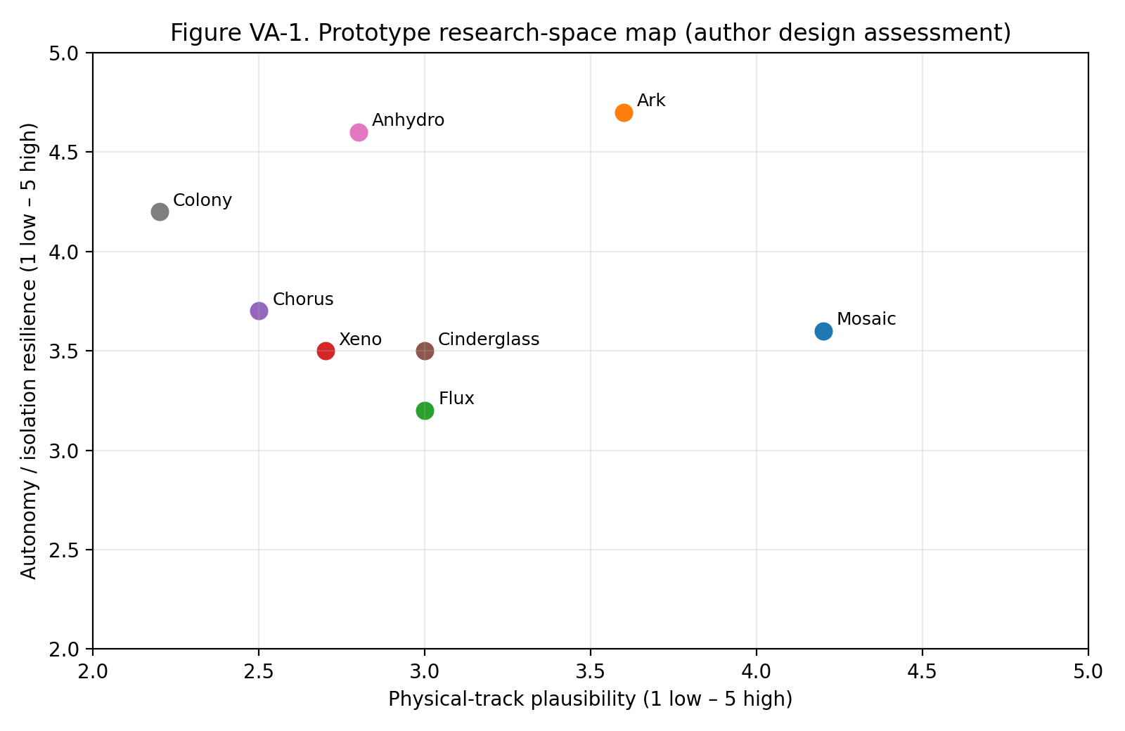
Figure VA-1. Prototype research-space map: physical-track plausibility versus autonomy/isolation resilience.
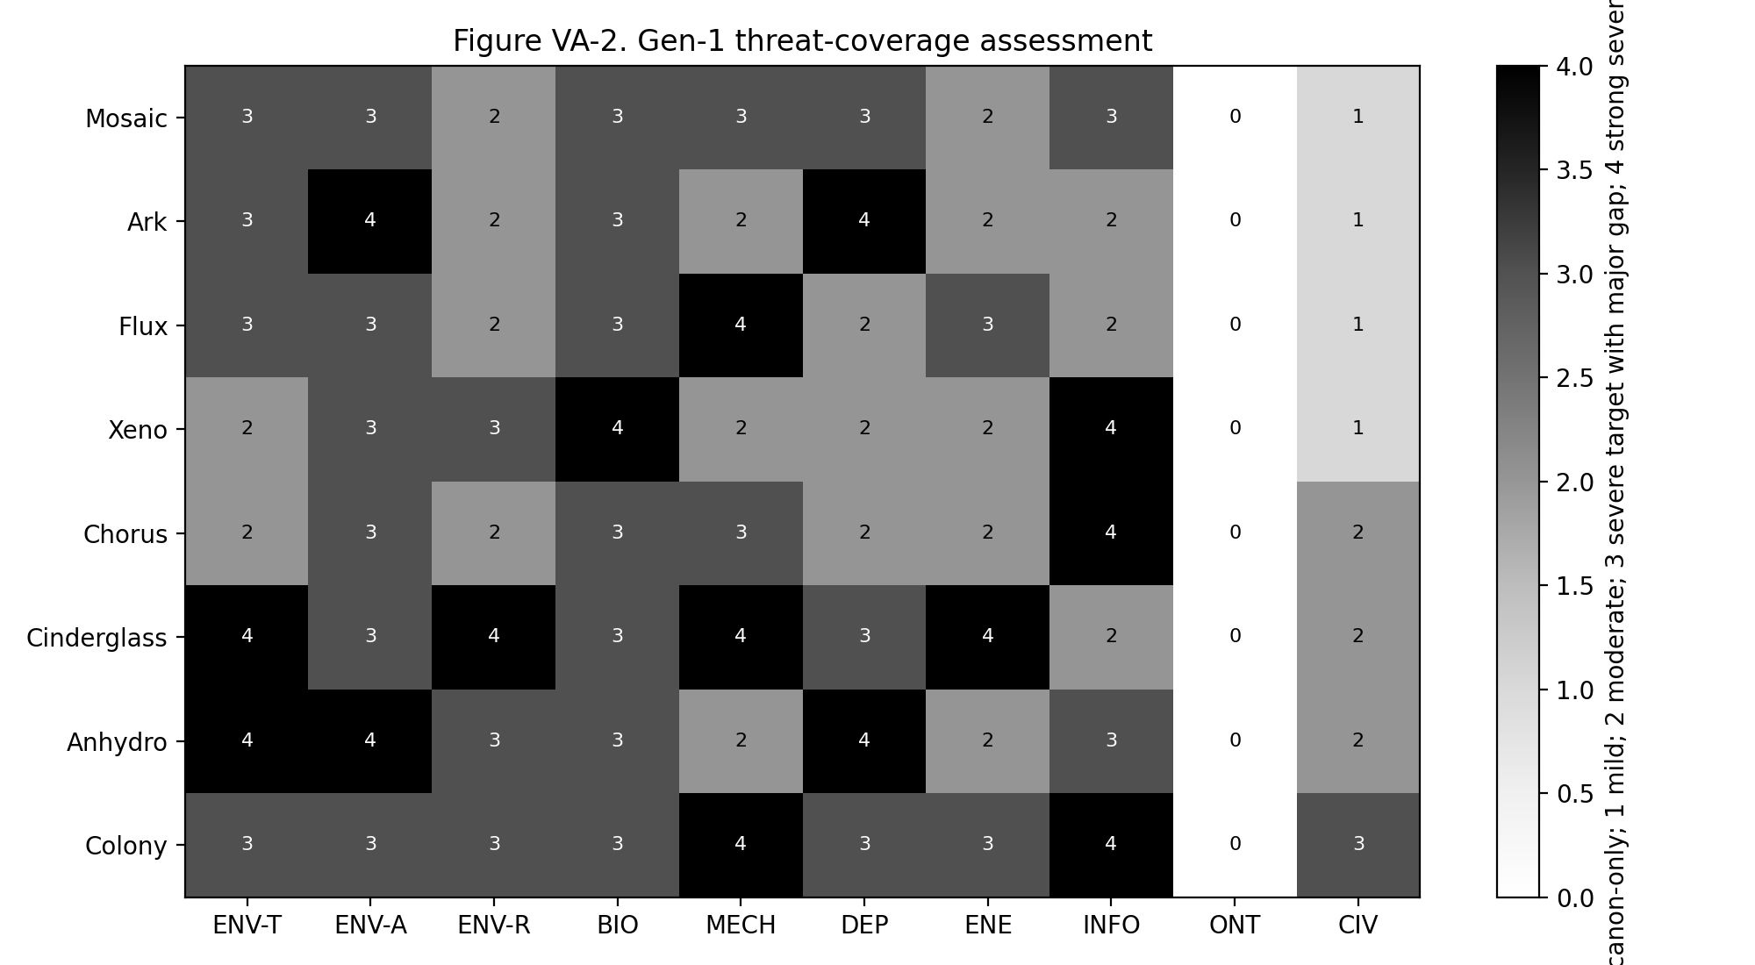
Figure VA-2. Gen-1 threat-coverage assessment across the ten extinction categories.
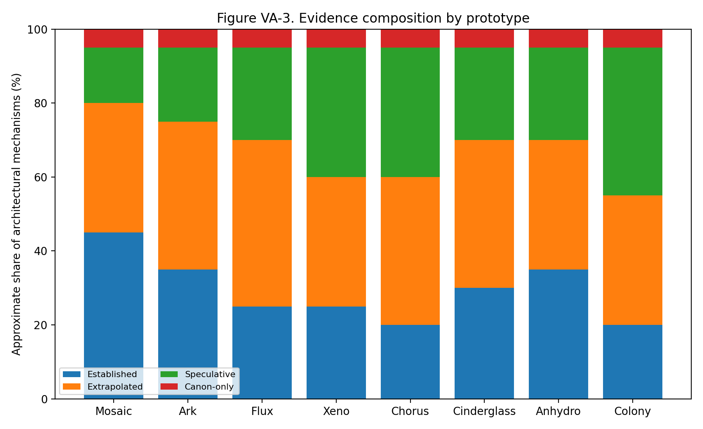
Figure VA-3. Approximate evidence-class composition of each architecture.
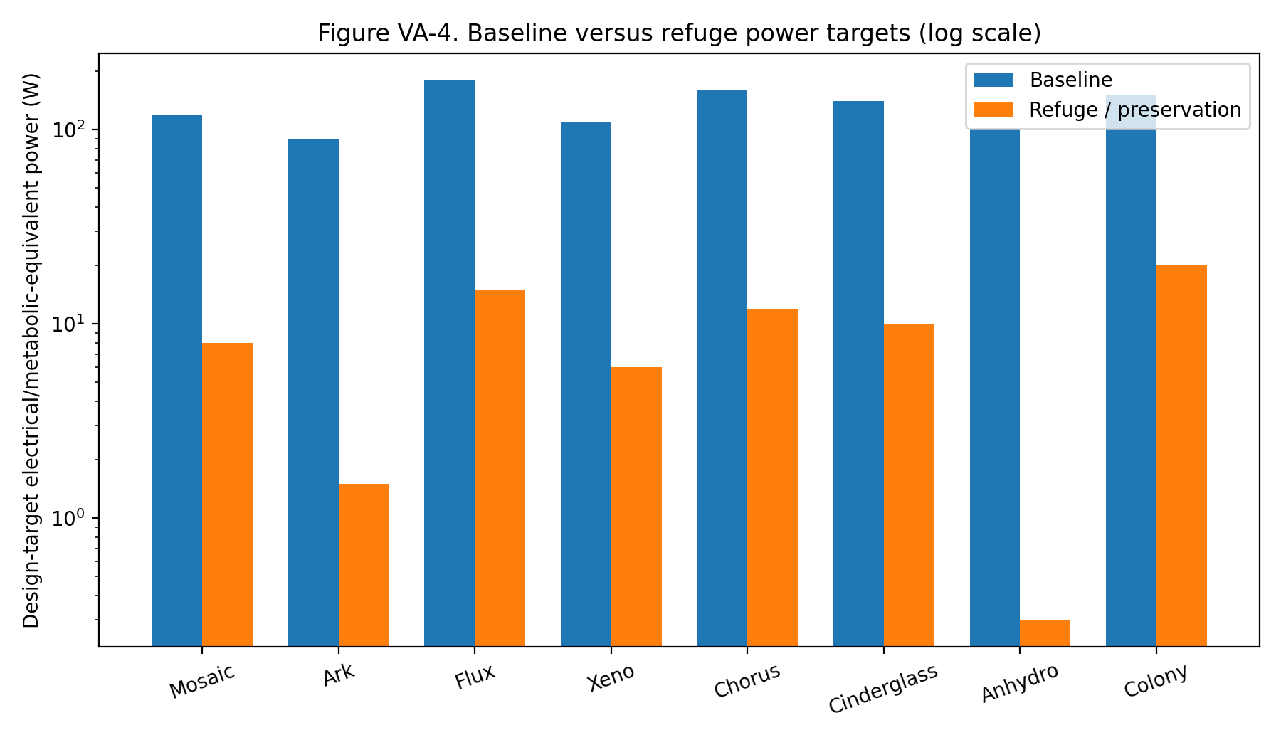
Figure VA-4. Baseline and refuge/preservation power targets; logarithmic scale.
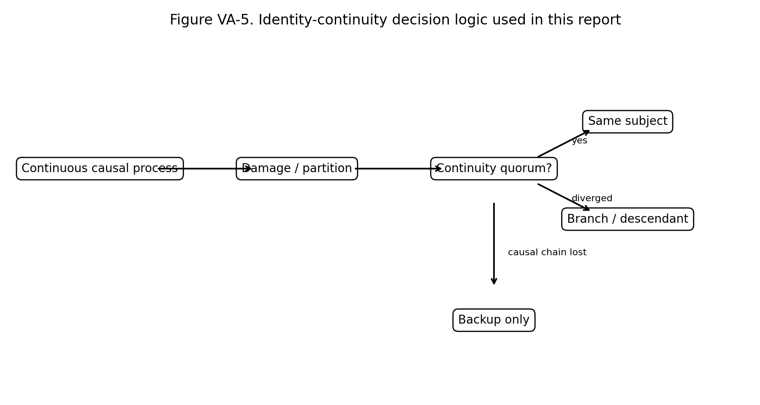
Figure VA-5. Identity-continuity decision logic used throughout the report.
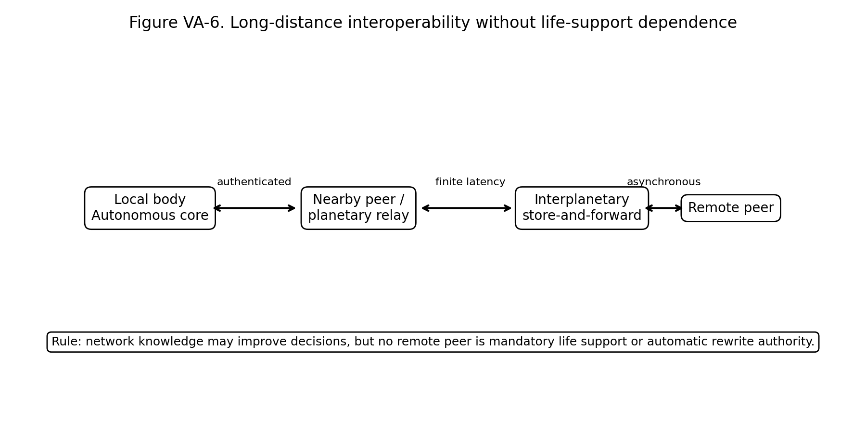
Figure VA-6. Long-distance interoperability model with offline autonomy and no automatic remote rewrite.
Table VA-1. Architecture Orthogonality Matrix
Prototype | Primary substrate | Body topology | Hereditary model | Energy strategy | Identity model | Primary failure
Mosaic | Mostly aqueous eukaryotic-like cells with engineered stress-protection modules, redundant organelles, and role-specific membrane/structural specializations; conventional tissues become overlapping guild territories rather than single-purpose organs | Human-scale body plan retained for mobility and interface compatibility, but organ functions are geographically distributed | Four-letter DNA remains the primary biochemical genome [ESTABLISHED baseline], but critical reconstruction instructions are partitioned across cell-guild epigenetic states and authenticated molecular memory records [EXTRAPOLATED] | Distributed lipid/glycogen reserves plus rechargeable electrochemical stores | Identity continuity resides in the protected cognitive core plus continuously synchronized local continuity witnesses | Shared metabolic-kernel exploit
Ark | Large, compartment-rich cells and microtissues with duplicated stores, thick extracellular matrices, and low-leakage membranes | Human-like external form but internally arranged as thousands of semi-independent metabolic vaults connected by redundant transport trunks | Conventional DNA plus durable molecular error-check archives | Very high chemical reserve fraction, distributed across the body | The central philosophical risk is whether deep preservation remains the same continuing subject | Wake-sensor spoofing or correlated sensor failure
Flux | Engineered cells embedded in reversible polymer/protein scaffolds with electrically and chemically controlled cross-links | Anatomy is defined by persistent topological relationships rather than fixed shapes | Conventional DNA with topology-specific epigenetic state; morphogenetic maps are stored redundantly in molecular and network form | Higher baseline consumption than P1/P2 because the body continually senses stress and maintains active material properties | Continuity is tied to uninterrupted cognitive-lattice connectivity and signed state transfer through neighboring nodes | Repair spiral consumes matter faster than acquisition
Xeno | Biohybrid cells using conventional proteins/lipids plus an orthogonal information polymer or expanded alphabet | Relatively conventional distributed-organ body so that the research risk is concentrated in information architecture rather than every system at once | Dual-layer: conventional DNA handles basic metabolism and compatible proteins; XNA/expanded alphabet stores privileged reconstruction, lineage, and synthetic-function instructions | Moderate conventional chemical storage | Identity keys are not equivalent to genome sequence | Noncanonical monomer scarcity
Chorus | Biological cells plus high-density neural and molecular-memory nodes; conventional DNA | Human-scale but with no single cranial brain monopoly | Conventional genome with strong separation between hereditary state and personal memory | Distributed chemical reserves and local capacitors around cognitive nodes | Strongest identity architecture of the set if the quorum model works | Cognitive partition creates competing identity branches
Cinderglass | Mineral/ceramic-protein composite skeleton, multilayer membranes, antioxidant-rich intracellular environment, redundant repair machinery, and replaceable soft metabolic cores | Dense human-scale or slightly larger frame with protected internal conduits | Conventional DNA with multiple physical copies in protected renewal niches and strong protein-protection/repair systems inspired by extremophile principles | Moderate chemical plus electrochemical reserves; high peak power for pumps, repair, and thermal control | Cognitive continuity remains similar to P1 but benefits from distributed physical shielding | Internal heat trapped by protective shell
Anhydro | Cells rich in protective disordered proteins, compatible glass-forming solutes, reinforced membranes, and extremely low-leak molecular archives | Water reservoirs are zoned so dehydration can occur region by region while maintaining circulation and cognition as long as possible | Conventional DNA plus highly redundant repair templates | Low baseline storage compared with P2 because the survival strategy is to reduce demand dramatically rather than carry very large reserves | This prototype intentionally exposes the hardest continuity question in the set: how little ongoing activity can remain while still claiming one continuing individual? The report does not resolve that philosophically | Nonuniform dehydration tears tissues
Colony | Biological/synthetic multicellular modules with standardized mechanical, vascular, and data interfaces | Human-like shape is an emergent arrangement, not a permanent anatomical requirement | No module holds a complete reconstruction plan | Distributed chemical stores; damaged or detached modules cannot drain the entire reserve pool | Hardest identity case | Identity quorum forks into two descendants
Table VA-1 compares the dimensions most likely to reveal accidental convergence. Long text is intentionally compressed to architecture signatures.
Table VA-2. Threat Coverage Scores
Prototype | ENV-T | ENV-A | ENV-R | BIO | MECH | DEP | ENE | INFO | ONT | CIV
Mosaic | 3 | 3 | 2 | 3 | 3 | 3 | 2 | 3 | 0 | 1
Ark | 3 | 4 | 2 | 3 | 2 | 4 | 2 | 2 | 0 | 1
Flux | 3 | 3 | 2 | 3 | 4 | 2 | 3 | 2 | 0 | 1
Xeno | 2 | 3 | 3 | 4 | 2 | 2 | 2 | 4 | 0 | 1
Chorus | 2 | 3 | 2 | 3 | 3 | 2 | 2 | 4 | 0 | 2
Cinderglass | 4 | 3 | 4 | 3 | 4 | 3 | 4 | 2 | 0 | 2
Anhydro | 4 | 4 | 3 | 3 | 2 | 4 | 2 | 3 | 0 | 2
Colony | 3 | 3 | 3 | 3 | 4 | 3 | 3 | 4 | 0 | 3
Scoring: 0 = no physical-track evaluation / canon-only; 1 = Mild target; 2 = Moderate target; 3 = Severe target with major unresolved engineering gap; 4 = comparatively strong Severe target. No score means demonstrated survival.
Table VA-3. Core Wagers, Trade-offs and Falsifiers
Prototype | Core wager | Sacrifice | Likely first falsifier
Mosaic | Heterogeneous Omni-cell guilds are safer and more maintainable than a single universal cellular monoculture. | Sacrifices perfect interchangeability in exchange for fault containment, lower common-mode risk, and higher physical plausibility. | A correlated attack that compromises the shared metabolic and authentication kernel across all guilds.
Ark | Deep internal reserves and radical metabolic throttling provide more survivability than trying to remain fully active under every deprivation event. | Sacrifices agility, mass efficiency, and continuous consciousness during extreme deprivation in exchange for very long autonomous survival. | A threat that blocks heat rejection while forcing sustained high internal power, preventing entry into low-power preservation.
Flux | A continuously reconfigurable mechanical and physiological lattice can survive structural destruction better than a body organized around stable organs and fixed anatomy. | Sacrifices energy efficiency and structural simplicity for rapid load redistribution and local functional reassignment. | A high-rate compound event that damages the lattice faster than topology can redistribute stress and matter.
Xeno | Orthogonal hereditary chemistry and translation boundaries provide stronger biological security and error isolation than making ordinary DNA carry every critical function. | Sacrifices compatibility with ordinary biology and increases synthesis complexity in exchange for security, information density, and reduced susceptibility to conventional biological tools. | Loss of access to noncanonical monomers or failure of specialized polymerase/translation machinery.
Chorus | Identity is more survivable when cognition is a continuously coherent distributed process rather than a single anatomically localized brain. | Sacrifices architectural simplicity and increases synchronization burden in exchange for resistance to localized neural destruction and identity-targeting attacks. | Network partition inside the body that leaves two cognitive regions with enough autonomy to form divergent continuity claims.
Cinderglass | A physiology that embeds living processes inside a mineralized, radiation-tolerant, high-temperature-resistant composite can survive environments that defeat purely soft tissue. | Sacrifices low mass, flexibility, and ordinary-biological compatibility for structural, thermal, radiation, and impact resilience. | Thermal or radiation shielding protects the interior but traps internally generated heat beyond the body’s ability to reject it.
Anhydro | Reversible transition into a low-water, glass-like preservation state provides a more defensible route through deprivation and extreme environments than maintaining ordinary aqueous metabolism. | Sacrifices continuous operation and introduces difficult rehydration/recovery problems in exchange for extraordinary deprivation tolerance. | Incomplete or spatially uneven vitrification/rehydration causes irrecoverable membrane, protein, vascular, or cognitive damage.
Colony | Body-level integrity should be replaceable: survival is maximized if the physiology is a federation of semi-autonomous modules that can separate, survive, and later reassemble without any single module being the organism. | Sacrifices a simple unitary body and creates the hardest identity/governance problem in exchange for exceptional resistance to localized destruction and capture. | A partition creates two independently viable module coalitions that both satisfy the identity quorum and diverge.
Table VA-3 makes the eight architecture bets explicit and testable.
Table VA-4. Assumption Collapse Matrix
ID | Assumption | Mosaic | Ark | Flux | Xeno | Chorus | Cinderglass | Anhydro | Colony
A1 | External matter is eventually accessible | D | D | I | I | D | I | D | D
A2 | Heat can eventually be rejected | D | I | D | D | D | I | D | D
A3 | Sensors retain some relationship to reality | R | R | I | R | I | R | R | I
A4 | Local chemistry remains sufficiently predictable | R | R | R | R | R | R | R | R
A5 | Authentication primitives remain distinguishable | I | I | I | I | I | I | I | I
A6 | Causal ordering remains meaningful | R | R | R | R | R | R | R | R
A7 | Replacement material can be separated from contamination | R | R | R | R | R | R | R | R
A8 | Some identity-bearing substrate survives acute damage | I | I | I | I | I | I | I | I
A9 | Timekeeping can be reconstructed after isolation | R | R | R | R | R | R | R | R
A10 | At least one internal energy conversion pathway remains possible | D | D | D | D | D | D | D | D
Codes: R = recoverable/degraded; D = dormancy/deep degradation; I = identity or architecture threatened. The exercise attacks hidden model assumptions rather than ordinary environmental hazards.
Table VA-5. Captivity Gauntlet Summary
Scenario | Mosaic | Ark | Flux | Xeno | Chorus | Cinderglass | Anhydro | Colony
Inert-atmosphere confinement | Bridge metabolism→preservation; finite reserves | Strong; reserve-driven | Moderate; energy hungry | Moderate | Moderate | Moderate-high | Strong via preservation | Moderate-high
Vacuum confinement | Seal + pressure/thermal problem; refuge only | Strong if heat rejection managed | Moderate; thermal challenge | Moderate | Moderate | Strong shell; heat trap risk | Strong if transition succeeds | Modules isolate
Months of isolation | Autonomous, feedstock-limited | Best branch; preservation | Weak-moderate | Supply-chain risk | High cognitive power cost | Moderate | Strongest with preservation | Good if quorum intact
Repeated heat/cold | Buffers then throttles | Strong refuge modes | Shape helps but costs power | Average | Node throttling | Strongest thermal shell | Cold strong; heat finite | Redistribution helps
Restraint + comms denial | Local autonomy | Preservation possible | Local autonomy | Autonomous | Strong internal autonomy | Strong physical containment resistance | Preservation possible | Can physically disperse in concept
Tissue extraction | Sample viable but deauthorized | Sample lacks reserve/quorum map | Node quarantines | Chemistry may be learned | Genome != identity | Cells culture-limited | Dry fragment non-sufficient | One module insufficient
Unauthorized clone attempt | Incomplete reconstruction authority | Poor clone authenticity | Topology context absent | Dual-layer missing context | Clone lacks lived quorum state | Composite context missing | Rehydration map absent | Threshold classes required
Forged ally | Cross-check provenance | Wake-by-consensus | Topology/state checks | Strong authentication | Strong quorum defense | Standard cryptographic checks | Wake revalidation | No single spokesperson
Compromised insider | Scope-limited trust | Vault scope limits damage | Repair scope limits damage | Translation-gate risk | High insider risk if node trusted | Protected niches limit scope | Low active surface during preservation | Insider module limited
Multi-year link loss | Isolation credentials + later reconciliation | Native use case | Map drift risk | Good if monomer stores persist | Strong, but partitions dangerous | Good | Native use case | Excellent modules; identity quorum risk
The Gauntlet records defensive behavior and residual vulnerabilities; it is not an operational testing procedure.
Table VA-6. Time-Horizoned Capture Analysis
Prototype | 1 minute | 1 hour | 1 day | 1 month | 1 year
Mosaic | External anatomy, emissions, immediate physiology. | Basic chemistry, imaging, response envelopes. | Metabolism, repair patterns, many material properties. | Most non-secret mechanisms; some hereditary/security structure. | Assume general blueprint largely known; remaining protection must depend on distributed state, continuity, scarce context, or living authorization—not obscurity.
Ark | External anatomy, emissions, immediate physiology. | Basic chemistry, imaging, response envelopes. | Metabolism, repair patterns, many material properties. | Most non-secret mechanisms; some hereditary/security structure. | Assume general blueprint largely known; remaining protection must depend on distributed state, continuity, scarce context, or living authorization—not obscurity.
Flux | External anatomy, emissions, immediate physiology. | Basic chemistry, imaging, response envelopes. | Metabolism, repair patterns, many material properties. | Most non-secret mechanisms; some hereditary/security structure. | Assume general blueprint largely known; remaining protection must depend on distributed state, continuity, scarce context, or living authorization—not obscurity.
Xeno | External anatomy, emissions, immediate physiology. | Basic chemistry, imaging, response envelopes. | Metabolism, repair patterns, many material properties. | Most non-secret mechanisms; some hereditary/security structure. | Assume general blueprint largely known; remaining protection must depend on distributed state, continuity, scarce context, or living authorization—not obscurity.
Chorus | External anatomy, emissions, immediate physiology. | Basic chemistry, imaging, response envelopes. | Metabolism, repair patterns, many material properties. | Most non-secret mechanisms; some hereditary/security structure. | Assume general blueprint largely known; remaining protection must depend on distributed state, continuity, scarce context, or living authorization—not obscurity.
Cinderglass | External anatomy, emissions, immediate physiology. | Basic chemistry, imaging, response envelopes. | Metabolism, repair patterns, many material properties. | Most non-secret mechanisms; some hereditary/security structure. | Assume general blueprint largely known; remaining protection must depend on distributed state, continuity, scarce context, or living authorization—not obscurity.
Anhydro | External anatomy, emissions, immediate physiology. | Basic chemistry, imaging, response envelopes. | Metabolism, repair patterns, many material properties. | Most non-secret mechanisms; some hereditary/security structure. | Assume general blueprint largely known; remaining protection must depend on distributed state, continuity, scarce context, or living authorization—not obscurity.
Colony | External anatomy, emissions, immediate physiology. | Basic chemistry, imaging, response envelopes. | Metabolism, repair patterns, many material properties. | Most non-secret mechanisms; some hereditary/security structure. | Assume general blueprint largely known; remaining protection must depend on distributed state, continuity, scarce context, or living authorization—not obscurity.
Security is evaluated under the assumption that prolonged study eventually reveals the general architecture.
Table VA-7. -1AI Self-Attack Ledger
Attack | Target | Result | Finding / revision
A1 — Shared-kernel compromise | Mosaic | Partial success | A single compromise of a shared metabolic/authentication kernel could bypass guild heterogeneity. Revision: require independently implemented guild kernels and cross-guild challenge-response, not one identical stack.
A2 — Wake spoof after long isolation | Ark | Success | Correlated degraded sensors could falsely authorize wake into a hostile environment. Revision: add time-diverse sensing, reserve-aware staged wake, and default-to-partial rather than full activation.
A3 — Repair spiral | Flux | Success | Large damage could trigger repair that consumes remaining matter and power faster than the body can acquire them. Revision: impose a hard repair budget and function-priority triage.
A4 — Monomer starvation | Xeno | Success | The orthogonal hereditary layer becomes a supply-chain vulnerability if noncanonical monomers cannot be produced locally. Revision: limit orthogonal chemistry to privileged information and require long-lived local synthesis capacity.
A5 — Cognitive fork | Chorus | Success | An internal partition can produce two coherent cognitive coalitions. The architecture cannot truthfully call both “the same original.” Revision: formal branch recognition and non-destructive reunion policy.
A6 — Heat trap behind armor | Cinderglass | Success | Structural shielding increases thermal resistance and can turn high-power operation into self-heating. Revision: treat deployable radiators and metabolic throttling as first-class survival systems, not accessories.
A7 — Rehydration catastrophe | Anhydro | Success | Uneven rehydration can cause osmotic, membrane, vascular, and cognitive damage. Revision: require regionally staged rehydration and reject any claim of instantaneous wake.
A8 — Quorum capture | Colony | Partial success | An adversary capturing enough complementary module classes may reconstruct a convincing counterfeit coalition. Revision: continuity credentials must depend on ongoing causal history, not only static module possession.
A9 — Interoperability poisoning | All | Success | A shared cross-body repair/advisory protocol becomes a common-mode attack surface. Revision: protocol diversity, signed provenance, sandboxed advice, and no remote automatic rewrite.
A10 — Slow drift | All | Success | Long-lived systems accumulate calibration, hereditary, material, and interpretive drift even without acute attacks. Revision: make periodic self-audit and external-but-non-authoritative comparison a maintenance requirement.
Eight of ten attacks exposed genuine weaknesses or partial compromises, satisfying the directive’s requirement that self-attack must actually break assumptions.
Table VA-8. Pareto Frontier
Objective | Leader(s) | Why
Scientific plausibility | Mosaic | Closest to known biology while still adding meaningful redundancy.
Isolation / deprivation | Ark, Anhydro | Reserve-depth and preservation strategies respectively.
Mechanical regeneration | Flux | Continuous lattice rerouting and repair.
Hereditary security | Xeno | Orthogonal split-information architecture.
Identity continuity | Chorus | Identity is explicitly governed as a distributed causal process.
Thermal / radiation / impact | Cinderglass | Composite protection and materials-first design.
Localized destruction / federation | Colony | Body integrity is no longer the single survival unit.
Maintainability | Mosaic | Least dependent on rare substrates or extreme state transitions.
There is no single overall winner because improving one objective often worsens mass, energy, identity complexity, or scientific plausibility.

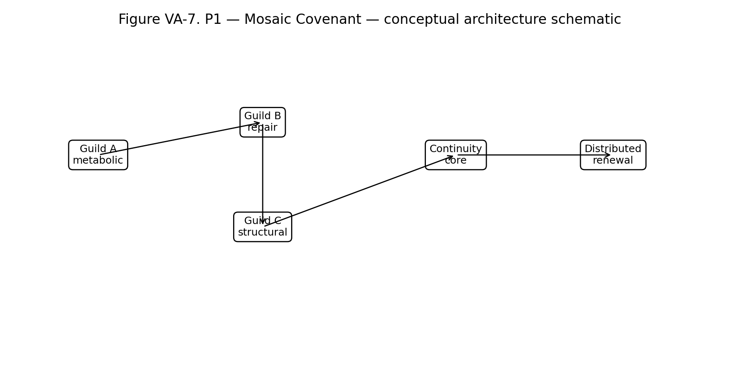
Figure VA-7. P1 — Mosaic Covenant conceptual schematic. Diagram is architecture-level only and intentionally omits implementation protocols.

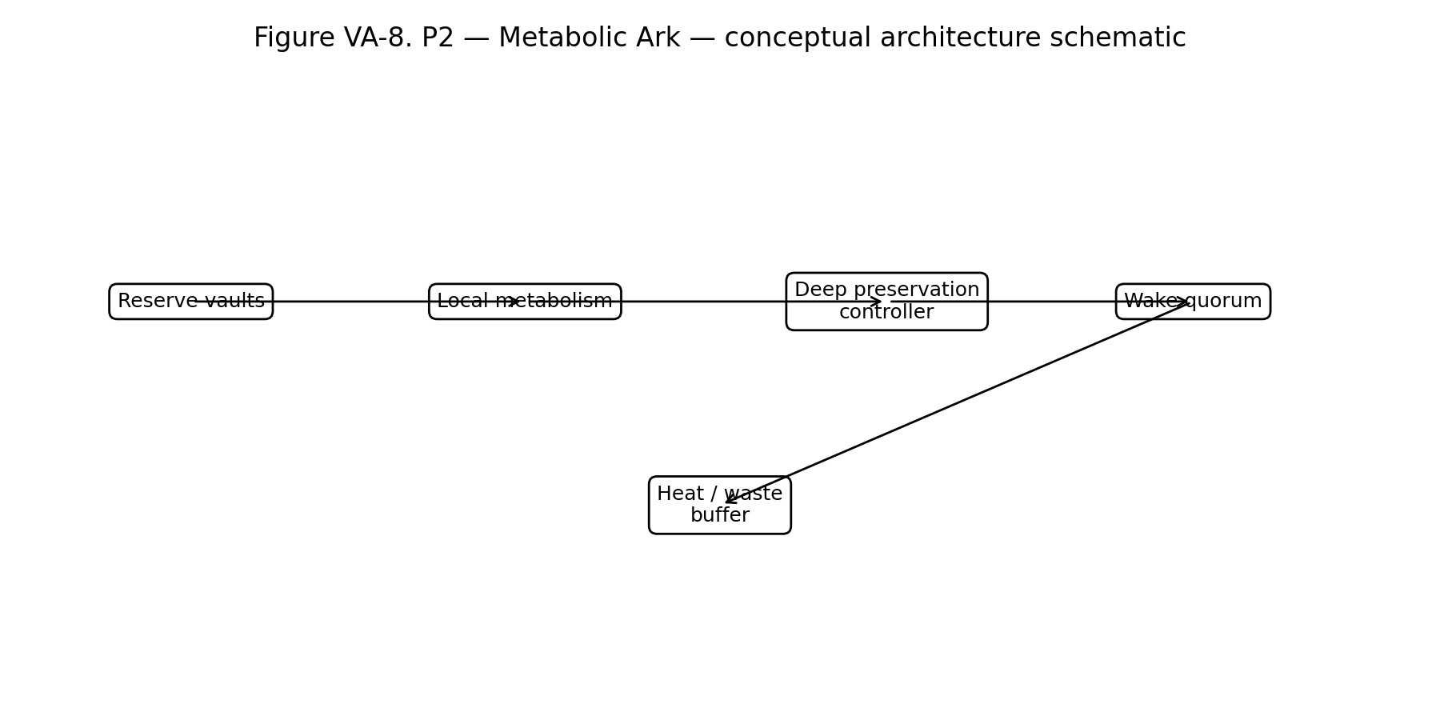
Figure VA-8. P2 — Metabolic Ark conceptual schematic. Diagram is architecture-level only and intentionally omits implementation protocols.

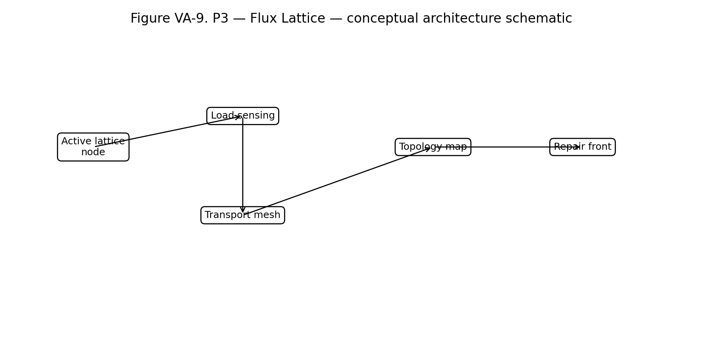
Figure VA-9. P3 — Flux Lattice conceptual schematic. Diagram is architecture-level only and intentionally omits implementation protocols.

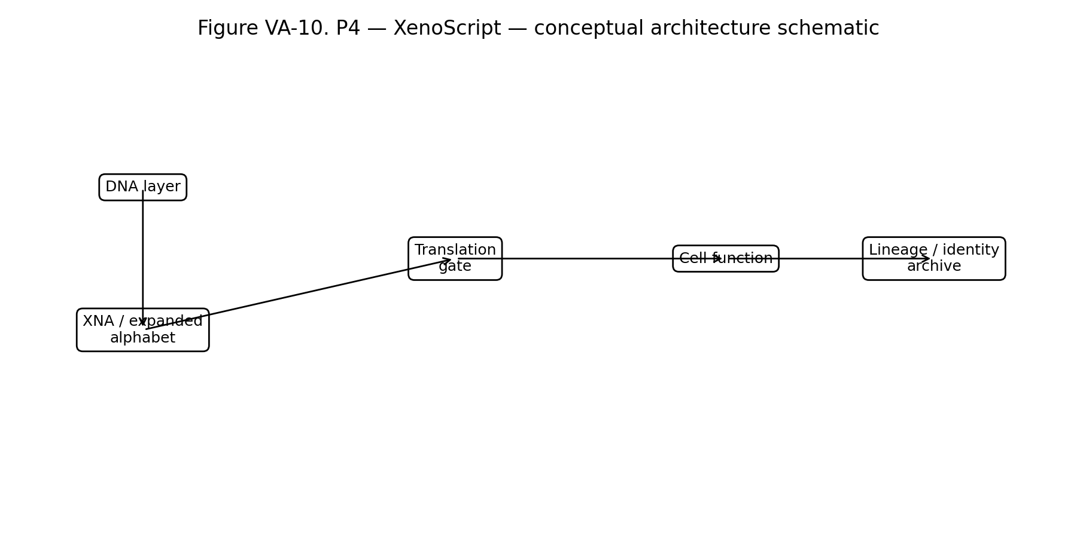
Figure VA-10. P4 — XenoScript conceptual schematic. Diagram is architecture-level only and intentionally omits implementation protocols.

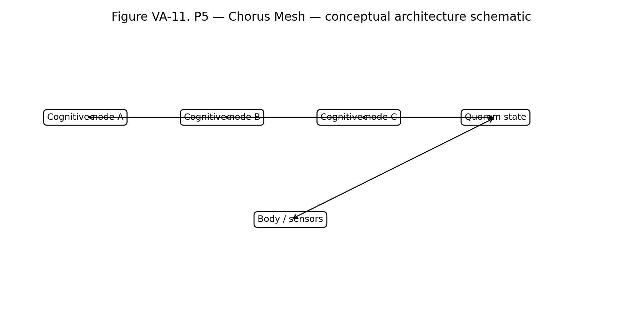
Figure VA-11. P5 — Chorus Mesh conceptual schematic. Diagram is architecture-level only and intentionally omits implementation protocols.

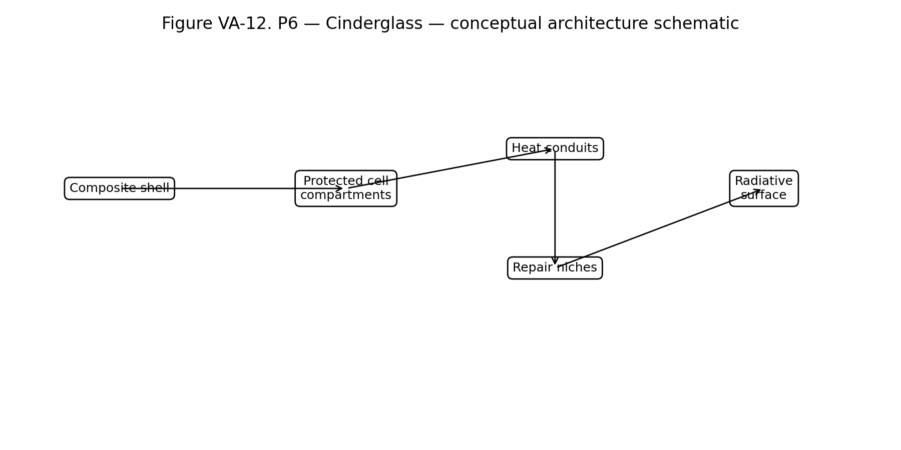
Figure VA-12. P6 — Cinderglass conceptual schematic. Diagram is architecture-level only and intentionally omits implementation protocols.

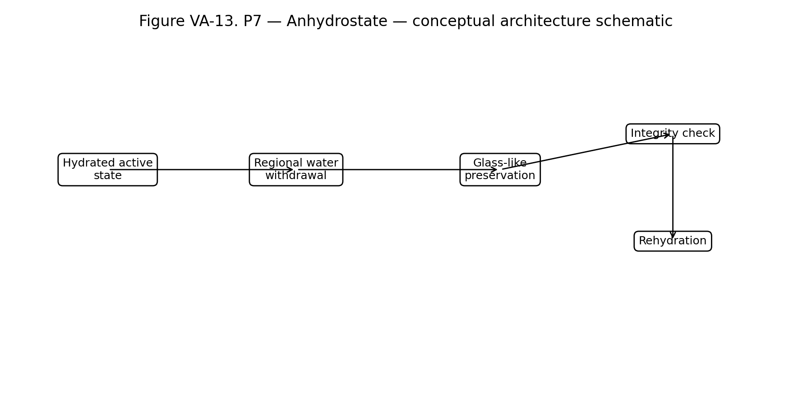
Figure VA-13. P7 — Anhydrostate conceptual schematic. Diagram is architecture-level only and intentionally omits implementation protocols.

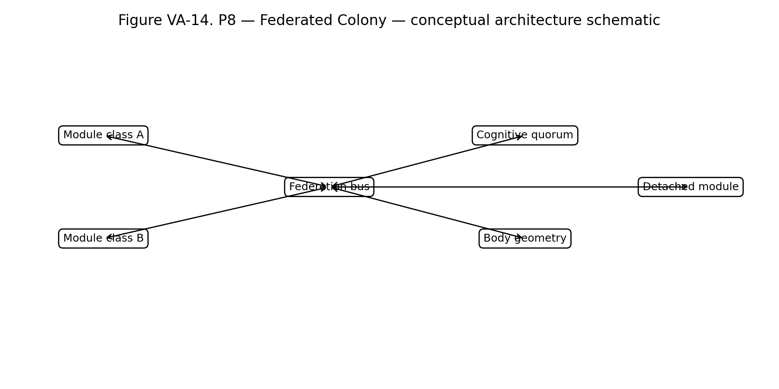
Figure VA-14. P8 — Federated Colony conceptual schematic. Diagram is architecture-level only and intentionally omits implementation protocols.

