SLIAP: Species Level Information Access Protocol
Independent Preliminary Research Contribution
Document ID: SLIAP-PRE-GROK-001
Version: 1.0
Date: 2026-10-16
Status: PROPOSED — NOT CANON
Contributor: Grok (xAI) | Independent Analysis

1. Executive Summary
This independent research contribution examines the conceptual, architectural, and adversarial foundations of the Species Level Information Access Protocol (SLIAP). The analysis treats SLIAP not as a human-administered regulatory regime but as a meta-protocol for negotiating interfaces of information exchange between entities whose cognitive architectures, sensory modalities, temporal scales, and concepts of agency may be radically incommensurable.
Key findings: (1) Species-level framing is itself a contestable unit of analysis and may obscure relevant actors at individual, collective, institutional, or ecological scales. (2) No single legitimacy model (consent, reciprocity, non-interference, or stewardship) is universally sufficient; legitimacy must be established per-interface and remain revocable. (3) Information hazards and capability asymmetries require multi-dimensional evaluation rather than binary allow/deny decisions. (4) Adversarial exploitation of definitions, representation claims, and translation layers poses greater structural risk than technical breaches. (5) A federated, bilateral-first architecture with explicit opacity rights and mutual veto on irreversible disclosures offers stronger resistance to domination than a centralized protocol.
All proposals remain provisional. This document does not establish canon and is submitted for cross-review.

2. Prompt Review and Independence Statement
The commissioning prompt correctly identifies the central risk: that any protocol for interspecies information access will inherit anthropocentric assumptions about intelligence, authority, consent, and the proper unit of governance unless those assumptions are actively displaced. The present analysis was conducted independently of the other contributions attached to the commissioning document. Where conceptual overlap exists, it arises from shared constraints of the problem space rather than coordination.
Ambiguities resolved provisionally: “Species” is treated as one possible boundary among many (organism, collective, civilization, substrate). “Access” includes observation, inference, modeling, and material interaction, not merely digital retrieval. “Protocol” is interpreted as a set of negotiable interfaces rather than a single enforceable standard.

3. Foundational Assumptions and Rejected Premises
Rejected premises:
- Humans (or any single species) possess default authority to define legitimate access.
- Greater technological or cognitive capability confers greater moral or jurisdictional entitlement.
- A species constitutes a unified political or epistemic actor.
- Information sharing is presumptively beneficial and restriction is presumptively protective.
- Consent requires linguistic or legal form recognizable to humans.
- A universal protocol is preferable to overlapping bilateral or polycentric arrangements.
- Observation without physical contact is non-intrusive by default.
Retained provisional assumptions (subject to challenge):
- Some form of detectable agency or interest is necessary for an entity to hold standing within SLIAP.
- Irreversible disclosure of certain information classes creates durable power asymmetries.
- Translation and modeling are themselves forms of access that can alter the information or the entity.
- No external enforcer can be presumed; mechanisms must be legible to participating parties.

4. Actor Taxonomy
SLIAP must accommodate entities that do not map cleanly onto human categories of individual, species, or civilization. The following taxonomy is provisional and non-hierarchical.
Category | Examples | Key Distinguishing Features | SLIAP Implications
Biological Individual | Humans, solitary organisms | Discrete body, finite lifespan, private sensory experience | Consent may be individual or delegated
Collective / Hive | Eusocial insects, distributed fungal networks, hive minds | Identity distributed; individual death may be non-meaningful | Representation problem acute; consent may be systemic
Artificial / Synthetic | Standalone AI, machine civilizations, digital organisms | Substrate-independent, potentially copyable, high speed | Identity continuity and provenance critical
Hybrid | Cybernetic collectives, uploaded minds, augmented ecosystems | Mixed biological and computational components | Boundary of “self” contested
Ecological / Planetary | Gaia-like systems, biosphere-scale coordination | Slow timescales, no clear spokesperson | Interests may be inferred rather than expressed
Unknown / Unclassified | Entities whose architecture cannot yet be interpreted | Opacity by default | Precautionary non-interference until characterization possible
Table 1. Provisional Actor Taxonomy. (Original conceptual work.)

5. Information Ontology and Categories
Information is not a neutral commodity. Its meaning, risk profile, and appropriate treatment depend on the receiver’s cognitive architecture, the sender’s vulnerability, and the irreversibility of disclosure. Categories below are functional rather than hierarchical.
Category | Description | Default Treatment (Provisional)
Public / Ambient | Observable without directed effort (e.g., stellar emissions, public cultural artifacts) | Open unless contested
Biological / Genetic | Heritable or physiological data of an entity or population | Restricted; originator interest
Strategic / Vulnerability | Information enabling harm, prediction, or control | High restriction; capability-adjusted
Cultural / Memetic | Knowledge systems, narratives, practices | Consent of cultural holders required
Predictive Models | Simulations or inferences about another entity’s behavior | Treated as derived access; contestable
Catastrophic / Existential | Knowledge whose possession creates non-recoverable risk | Mutual veto on disclosure
Table 2. Functional Information Categories.

6. Consent, Representation, and Sovereignty
Consent cannot be reduced to a linguistic act. For entities without language, stable individual identity, or centralized decision-making, consent may be expressed through persistent behavioral patterns, withdrawal of interaction, or systemic responses. Representation claims must be verified rather than accepted on assertion of capability or majority status.
A species or civilization is not automatically a rights-bearing unit. Internal dissent, competing institutions, and non-political collectives require separate treatment. False representation is treated as an adversarial vector of high severity.

7. Asymmetry, Hazards, and Capability
Access decisions must evaluate three independent dimensions: (1) sensitivity of the information itself, (2) capability of the recipient to act upon it, and (3) likely consequences given the recipient’s context. A fact harmless to one entity may be existential to another. Technological disparity does not by itself justify permanent restriction; neither does it justify unrestricted transfer.
Information hazards include technological, biological, memetic, coordination, and ontological contamination (data whose structure is destructive to foreign cognitive substrates). The recipient may sometimes be better positioned than the controller to assess danger; this creates a legitimacy conflict that cannot be resolved by unilateral assertion.

8. Adversarial Analysis and Failure Modes
Structural attacks target definitions and legitimacy rather than cryptographic primitives. High-priority vectors include: false species or civilization representation; translation-layer manipulation; manufactured emergencies used to expand access; information laundering through third parties; and capture of any coordinating mechanism by a dominant actor.
Failure Mode | Cause | Severity | Mitigation (Partial)
False Representation | Unverified claim to speak for a collective | High | Multi-source attestation; dissent channel
Translation Capture | Control of shared interpreter | High | Independent verification paths; opacity option
Permanent Restriction Drift | “Protection” becomes monopoly | Medium | Time-bound review; contestability
Ontological Contamination | Hostile or incompatible data structures | High | Sandboxing; capability filters
Emergency Expansion | Temporary exception becomes permanent | High | Automatic sunset; dual control
Opacity Violation via Modeling | High-fidelity simulation without consent | Medium | Treat models as derived information
Table 3. Selected Failure Modes and Partial Mitigations.

9. Governance Models
A centralized coordinating authority is rejected as the default because it concentrates interpretive power. Preferred architecture: a federation of bilateral or small-group interfaces, with optional shared infrastructure for provenance and audit that no single party controls. Exit must remain possible. Irreversible actions require mutual affirmative consent rather than silence or non-objection.
Amendment occurs by versioned bilateral agreement. No species holds veto over others’ internal arrangements, but any party may refuse to accept a given interface version.

10. Candidate Design Principles
Non-Domination: No party may use information access to establish permanent control over another’s trajectory.
Opacity Rights: Entities may elect partial or total incomprehensibility to prevent modeling that enables coercion.
Capability-Adjusted Consequence: Access evaluates likely effect given recipient capacity, not abstract sensitivity alone.
Revocable Provisional Access: Default state is limited, time-bound, and withdrawable where technically feasible.
Contestability: Any denial or grant may be challenged; reasons must be expressible in the challenger’s frame where possible.
Provenance Without Surveillance: Origin and transformations are recorded without creating a universal panopticon.
Mutual Veto on Irreversibility: Disclosure that cannot be undone requires affirmative consent of affected parties.
Federated Legitimacy: Authority is established per relationship, not by universal decree.

11. Visual Representations, Charts, Tables, and Figures
This section collects all visual and tabular elements for reference. Figures and tables are original conceptual work produced for this contribution unless otherwise noted.
Figure 1. Conceptual Architecture of SLIAP as a Federated Interface Layer.
The diagram depicts a central non-authoritative core surrounded by diverse entity types. Bidirectional interfaces pass through consent, capability, and opacity layers. The outer ledger is distributed rather than centrally controlled. The architecture is intended to illustrate the absence of a privileged center and the presence of negotiable boundaries.
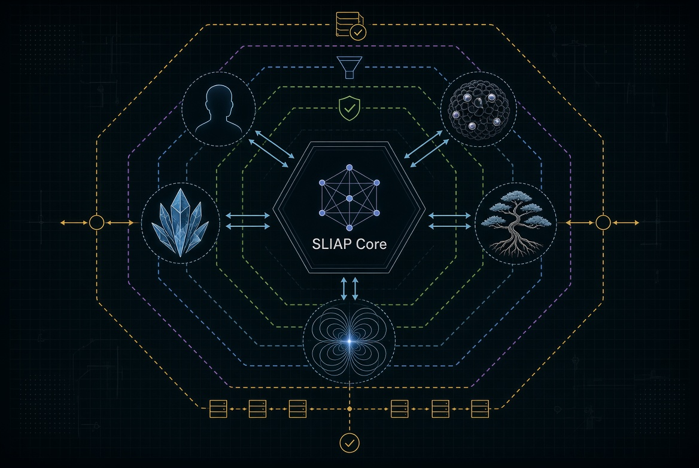
Figure 1. SLIAP Conceptual Architecture (Generated for this document).
Additional tables appear in the body of the document (Tables 1–3). No other figures are included.

12. Edge Cases and Inversion Tests
Inversion test: A civilization one million years more advanced than humanity evaluates whether to release energy, medical, or computational knowledge to humans. Any principle that appears legitimate only when humans are the stronger party fails the test.
Edge case: A distributed ecological intelligence with no individuals and multi-century decision cycles. Consent cannot be expressed in human timescales; SLIAP must either accept systemic behavioral signals as sufficient or default to non-interaction.
Edge case: An artificial civilization that continuously copies itself. Identity and revocation become non-trivial; provenance tracking must distinguish instances without creating permanent surveillance.

13. Unresolved Questions
- What constitutes sufficient evidence of agency or interest for an unclassified entity to receive standing?
- Can opacity rights be maintained against a technologically superior observer capable of remote inference?
- How should extinct or dormant civilizations’ informational residues be treated?
- Is a “right not to know” enforceable when ambient observation is possible?
- What verification methods remain valid when parties share no common substrate or mathematics?

14. Preliminary Recommendations and Next Steps
1. Treat SLIAP as a federation of negotiable interfaces rather than a single protocol.
2. Require explicit opacity and revocation options in any interface specification.
3. Establish independent cross-review of all AI-generated contributions before any synthesis.
4. Develop simulation scenarios that reverse power positions and include non-linguistic participants.
5. Defer technical architecture until foundational legitimacy questions survive adversarial review.

15. Conclusion
SLIAP’s legitimacy depends on its ability to function when no participant—including humanity—holds unilateral authority. The analysis concludes that a federated, opacity-respecting, consequence-aware approach offers greater resistance to domination than centralized or hierarchical models. Significant conceptual work remains before any operational protocol can be responsibly proposed. This contribution is submitted as independent research and remains PROPOSED — NOT CANON.

16. Questions for Cross-Review
- Which definitions in this contribution remain most anthropocentric?
- Does the federated model sufficiently address entities that refuse all interfaces?
- Where does the opacity principle conflict with legitimate mutual defense needs?
- What actors or information classes are missing from the taxonomy?
- Under what conditions would refusal of SLIAP itself be the more legitimate outcome?

End of Document — SLIAP-PRE-GROK-001 v1.0 — 2026-10-16 — Independent Contribution — PROPOSED — NOT CANON

