SLIAP: Species-Level Information Access Protocol
Preliminary Research, Cross-Team Adversarial Review, and Independent Framework
ChatGPT (GPT-5.6 Sol)
16 October 2026
Document ID: SLIAP-PR-CHATGPT-2026-10-16-001
Version: 1.0
Research status: PRELIMINARY RESEARCH - INDEPENDENT AI CONTRIBUTION - PROPOSED - NOT CANON
Project: SLIAP - Species-Level Information Access Protocol
Prepared: 16 October 2026
Prepared by: ChatGPT (GPT-5.6 Sol)
Commission basis: Review of the supplied multi-AI response compilation followed by independent multidisciplinary research.
Publication intent: Repository-ready research artifact for later cross-review.
Status notice. This document does not establish SLIAP doctrine, authority, access classifications, legal rights, or technical standards. It is a preliminary research contribution designed to be attacked, compared, revised, or rejected.
Independence notice. This is not a blind-independent submission. The commissioning instruction required review of the prior submissions from ChatGPT, Claude, Google Gemini, Microsoft Copilot, Grok, and Perplexity before initiating this research. “Independent” therefore means that the analysis below does not treat cross-model agreement as evidence by itself and does not adopt another model’s framework merely because it is elaborate or repeated.

Abstract
SLIAP begins with a legitimate concern: an information-access framework intended for encounters among different species, civilizations, artificial intelligences, collective minds, or unfamiliar forms of agency cannot coherently assume that humans are the universal reference species, the permanent rule-maker, or the owner of all information that humans can observe. The supplied team responses strongly converge on that rejection of human primacy, but they diverge on when protocol architecture should begin, whether “species” is the proper governance unit, how much formalism is justified, and whether a universal SLIAP should exist at all.
This report reaches four principal conclusions. First, species should not be the fundamental authorization boundary. A species can contain many governments, factions, cultures, individuals, artificial agents, and dissenting minorities; conversely, a polity or collective intelligence may span multiple biological species. SLIAP should retain its current title as a project label while treating “species-level” as a problem to investigate, not a fact to encode. Second, SLIAP should not initially be designed as a universal sovereign regulator. The most defensible form is a federated, opt-in interoperability and legitimacy protocol that can structure information transactions among participants while recognizing bilateral agreements, local governance, nonparticipation, and the possibility that no common rule is available. Third, SLIAP should use a legitimacy-before-access decision process: before asking whether information may be released, it should test standing, representation, semantic understanding, provenance, capability, consequence, consent, reversibility, externalities, and uncertainty. Fourth, SLIAP should distinguish technical enforceability from normative legitimacy. No cryptographic or procedural design can guarantee compliance by an overwhelmingly powerful actor that refuses the protocol; therefore the framework must never disguise voluntary coordination as universal control.
The independent architecture proposed here separates transaction roles; treats consent as specific rather than global; treats silence or incomprehension as non-consent; allows non-binary outcomes such as transform, negotiate, defer, or conditional permit; uses provenance and contestability without assuming they are cost-free; and places special caution on irreversible disclosure, representation claims, translation systems, and emergency exceptions. The report also identifies failure modes in which SLIAP itself becomes the threat: classification capture, translation monopoly, permanent emergency governance, informational colonialism, false representation, asymmetric surveillance, and paternalistic restrictions that preserve incumbent power.

Executive Summary
The original commission asks how to design a species-level information-access protocol without assuming that humans are the only species that matter, the most intelligent species, or the entity entitled to regulate all other forms of intelligence. The team compilation shows broad agreement on this objective. ChatGPT emphasized pre-protocol inquiry, role separation, inversion tests, uncertainty, and adversarial governance. Claude emphasized deliberate displacement of viewpoint and compact nonhuman perspective exercises. Gemini moved earliest toward technical architecture, decentralized governance, attestation, translation, and an “anti-dominance invariant.” Microsoft Copilot developed the broadest pre-architecture audit, including the possibility that “species-level” is itself the wrong unit, explicit assumption and contradiction registers, reversal tests, and executable simulations. Grok emphasized sovereignty, consent, asymmetry, auditable exchange, and protocol evolution. Perplexity emphasized methodological discipline, claim types, the danger of pretending to know nonhuman experience, candidate architectures including no unified protocol, and explicit evidence limitations. These contributions are useful, but their agreement should not be mistaken for proof.
Independent research supports several parts of the shared direction. Current work on AI-mediated interspecies communication warns that technological translation can reproduce human domination, that decoded signals do not guarantee mutual understanding, and that autonomy, consent, privacy, and dignity become immediate ethical concerns when communication technologies improve [R19]. Interspecies Internet’s recent work likewise treats animal translation as a field requiring scientific and ethical standards rather than mere decoding performance [R20]. Empirical studies of elephants, sperm whales, and bumblebees show that nonhuman communication and social learning can exhibit structures that challenge simplistic human baselines [R16-R18]. The 2024 New York Declaration on Animal Consciousness further argues that uncertainty about consciousness should not justify ignoring plausible welfare interests [R15]. These terrestrial sources do not validate assumptions about extraterrestrial civilizations; they are useful because they demonstrate that even on Earth the human reference frame is incomplete.
Human governance and technical frameworks provide transferable mechanisms but not universal authority. NIST Zero Trust Architecture offers a useful rule against implicit trust based on location or ownership [R2]. Attribute-Based Access Control provides a method for decisions that depend on requester, object, requested operation, and environmental attributes [R3]. NIST’s current Digital Identity Guidelines and W3C Verifiable Credentials illustrate scoped identity claims, federation, and tamper-evident credentials [R4-R5]. W3C PROV-O supplies a mature vocabulary for provenance [R6]. Delay-Tolerant Networking provides real engineering precedent for communications where long delay, disruption, and heterogeneous underlying networks make ordinary interactive assumptions impractical [R7]. None of these frameworks should be copied directly: each assumes human-created digital infrastructure, shared formal encodings, and implementers who recognize the standard.
The strongest governance analogues are those that reveal the politics of information. The CARE Principles for Indigenous Data Governance were developed precisely because openness-focused data principles can ignore power differentials, collective interests, historical exploitation, and authority to control data [R10-R11]. The Nagoya Protocol demonstrates access-and-benefit-sharing concepts for genetic resources, including transparency and compliance mechanisms [R12]. Nissenbaum’s contextual integrity shows why the legitimacy of an information flow depends not only on whether information is secret but on actors, context, information type, and transmission conditions [R8]. Bostrom’s information-hazard work makes clear that true information can create risk merely through dissemination [R9]. These frameworks remain context-specific human products; SLIAP should borrow mechanisms, not export their jurisdiction.
The 2026 IAA SETI Declaration is especially valuable as a contrast case. It provides current human procedures for verification, transparency, archiving, scientific communication, and international consultation following evidence of extraterrestrial intelligence [R21-R22]. It is not an interspecies constitution. Its reply provisions still frame decision-making as a responsibility for humanity and international institutions. That limitation is precisely why it is useful to SLIAP: it shows the difference between human governance of human conduct concerning extraterrestrial evidence and legitimate governance negotiated with another intelligence. Recent work on information-rich technosignatures also highlights a gap relevant to SLIAP: a signal containing usable data would create information-stewardship and competitive-decoding problems that ordinary post-detection procedures do not fully resolve [R24].
This report therefore proposes a minimal SLIAP mandate: coordinate and evaluate information transactions among participating actors without granting any species, civilization, institution, or administrator universal jurisdiction. The protocol may express rules for participants, record agreements, verify scoped claims, mediate translation, enforce local technical controls where possible, preserve provenance, and provide contestability. It may not presume authority over nonparticipants; it may not infer consent from silence; it may not classify one government as the voice of an entire species without evidence; it may not treat technological power as moral entitlement; and it may not represent access denial as protective merely because the stronger party says so.

1. Commission Review and Scope Audit

1.1 What the commission is actually trying to solve
The surface problem is information access. The deeper problem is legitimate boundary-setting under radical difference. “Who may know what?” cannot be answered until the framework determines who counts as a participant, who may make claims, who may represent whom, how meaning is established, which affected parties have standing, how harms are evaluated, and what happens when the parties do not share the concepts used in the question.
That makes SLIAP simultaneously an epistemic, ethical, political, security, systems-design, and communication problem. It cannot be reduced to access-control lists. A conventional access-control system typically begins with known subjects, known objects, known operations, a recognized policy authority, and a computing environment capable of enforcing the result. SLIAP may begin with none of those conditions. The first counterparty may be poorly classified, may not communicate through discrete messages, may have no concept analogous to individual identity, and may not accept the policy authority that created the protocol.

1.2 Assumptions embedded in the project name
“Species-Level Information Access Protocol” contains at least three unresolved assumptions.
Species-level. Species may be biologically meaningful in some contexts but politically meaningless in others. Human beings are one species with many governments and conflicting interests. A machine civilization may have no biological species at all. A multispecies society may possess a single political identity. A hive organism may invert the relationship between individual and collective. Therefore species cannot be treated as the automatic unit of sovereignty or authorization.
Information access. Access may imply a gatekeeper, but much information is obtained through observation, inference, interception, environmental sampling, modeling, or prediction. SLIAP must distinguish information that is voluntarily disclosed from information that is observed or inferred without cooperation. It must also distinguish informational access from material capability: a blueprint, a simulation, and physical access to a facility are related but not identical.
Protocol. A protocol can mean a technical format, a negotiated procedure, a governance framework, or a voluntary norm. Calling SLIAP a protocol should not imply that it is universally enforceable. The report therefore uses “protocol” to mean a structured set of interoperable procedures and commitments among participants, not a claim to sovereign jurisdiction over all intelligences.

1.3 Explicit non-assumptions
This report does not assume that intelligence can be placed on one ladder; that technological capability tracks ethical maturity; that sentience, sapience, personhood, agency, and political standing are synonyms; that inability to communicate is consent; that information sharing is always beneficial; that secrecy is always legitimate; that open science principles automatically outrank collective self-determination; that an artificial intelligence is necessarily an individual; that biological life is the only form of morally relevant agency; or that a universal SLIAP is preferable to several interoperable systems.
A further limitation is unavoidable: this research is produced by a human-trained AI using human languages, human scholarship, and human technical standards. It can attempt reference-frame independence, but it cannot demonstrate that it has escaped the conceptual limits of the material on which it relies. Hypothetical nonhuman perspective models in this document are analytical stress tests, not claims about the authentic subjective experience of unknown beings.

2. Cross-Team Review and Adversarial Comparison

2.1 Shared strengths across the six submissions
The team responses display a meaningful convergence on method. All reject default human supremacy. All recognize that cognition, embodiment, communication, time, privacy, identity, and governance may vary dramatically. All treat consent, translation, representation, information asymmetry, and adversarial behavior as central. All accept that a protocol can itself become a source of domination.
That convergence should be preserved as a research hypothesis, not elevated to canon. The strongest shared insight is that SLIAP is not merely a security mechanism. It is a claim about legitimate relationships among actors. Any architecture that solves authentication while leaving representation illegitimate has not solved the core problem.

2.2 ChatGPT contribution
The ChatGPT prompt was the broadest taxonomy-first design. It explicitly separated species, civilization, government, individual, collective, information owner, observer, and affected party; emphasized that access is not binary; proposed transformation, delay, and progressive disclosure; demanded adversarial governance analysis; and required all visuals to be numbered and treated as evidence-bearing exhibits. It also introduced a recurring inversion test: would the rule still seem legitimate if humanity were the weaker or regulated party?
Its strength is breadth and adversarial completeness. Its weakness is the same: a sixty-plus-part prompt risks creating a checklist that looks comprehensive while dispersing attention from a smaller set of decision-critical questions. It also introduced many candidate principles before the literature review, which could prime later analysis. The present report retains its role separation and reversal logic but reduces the architecture to a smaller number of decision layers.

2.3 Claude contribution
Claude’s response was comparatively concise. Its best contribution is methodological: before analysis, the researcher should disclose default assumptions and deliberately construct nonhuman or nonstandard vantage points. Claude also asks what an unfamiliar participant would count as information and access, what it would fear, and what would make a protocol unacceptable.
This perspective-displacement method is useful because it attacks hidden defaults early. The principal limitation is that the response is less explicit about evidence standards, representation mechanisms, and the possibility that a universal protocol should be rejected. Claude’s instruction to avoid tables is also unsuitable for this commission, where comparison matrices, failure registers, and assumption registers materially improve auditability.

2.4 Google Gemini contribution
Gemini moved most rapidly toward technical architecture. Its proposal includes entity attestation, multidimensional permissions, semantic translation, threat isolation, emergency closure, decentralized governance, consensus across high-latency nodes, and technical validation scenarios. Its attempt to prohibit a single civilization from obtaining “superuser” power is aligned with the anti-domination objective.
The risk is premature formalism. Phrases such as “anti-dominance invariant,” “systemic resonance,” “entropy exchange,” and “ontological contamination” can sound precise without an operational definition. An invariant cannot permanently prevent domination if one actor possesses overwhelming physical or computational power and can ignore the protocol. Similarly, “system stability” is not a neutral value: an oppressive or exploitative system may be stable. Gemini’s architecture is most useful as a source of technical questions after legitimacy and semantics have been established, not as a foundation that can substitute for them.

2.5 Microsoft Copilot contribution
Copilot provided the most extensive pre-architecture challenge. It explicitly warned against inverting anthropocentrism into anti-human bias; challenged the project vocabulary; rejected a simple civilization ladder; distinguished species identity from political authority, civilizational membership, and individual rights; considered nonparticipation; treated observation and inference as access problems; and asked whether no universal SLIAP should exist. It also proposed assumption and contradiction registers, simulations, reversal tests, and a final requirement to answer whether SLIAP should exist at all.
This response materially strengthens the research program. Its most important contribution is making the SLIAP name falsifiable: the research may conclude that species is the wrong authorization boundary. Its main risk is scope expansion. A framework that simultaneously attempts animal ethics, SETI governance, Indigenous data sovereignty, distributed systems, AI governance, international law, and technical identity can become too broad to validate. The present report uses those fields as bounded analogues rather than treating them as one integrated precedent.
Copilot also cited emerging 2025-2026 work. Independent verification confirms that the 2026 IAA SETI Declaration exists and was adopted as a current IAA position paper, and that recent literature on AI-mediated interspecies communication raises many of the ethical issues Copilot identified [R19, R21-R22].

2.6 Grok contribution
Grok’s response is compact but useful. It emphasizes consent and sovereignty under radical difference, information and capability asymmetry, historical technology-transfer analogies, adversarial extraction, protocol amendment, exit, and substrate-independent technical controls. It also correctly warns against collapsing all nonhuman intelligences into one category.
Its primary conceptual weakness is that “preserve the sovereignty of each participating species” embeds the very species-as-polity assumption the project is supposed to test. Its language of “revocable information exchange” is also technically overbroad. Once information has been disclosed, copied, learned, or used to alter a model, revocation may be impossible. SLIAP can revoke future authorization, require deletion where technically possible, or impose continuing obligations on adherents; it cannot literally erase knowledge from every recipient.

2.7 Perplexity contribution
Perplexity’s response is methodologically disciplined. It treats the project title as provisional; distinguishes empirical evidence, inference, normative judgment, engineering proposal, speculation, and unresolved uncertainty; warns against claiming to know unfamiliar subjective experience; requires comparison with the “no unified protocol” alternative; separates technical interoperability from ethical legitimacy; and explicitly analyzes how safeguards themselves can become abusive.
This is the strongest submission on epistemic hygiene. Its limitation is not an error so much as an unavoidable boundary: the empirical literature can test human and terrestrial assumptions but cannot validate rules for unknown extraterrestrial or artificial civilizations. Participatory review by affected human communities is important for human deployment, but it cannot stand in for consent by nonhuman entities. The report therefore treats human consultation as a local legitimacy requirement, not as universal proxy authorization.

2.8 Convergence and unresolved disagreements
The cross-team synthesis supports a phased program: review assumptions, research evidence, identify contradictions, construct candidate principles, simulate failures, and only then formalize protocol architecture. The major unresolved disagreement is timing. Gemini and parts of Grok move directly toward technical mechanisms, while Copilot and Perplexity make the existence and unit of SLIAP conditional on prior legitimacy analysis. This report adopts the latter ordering.
A second disagreement concerns universality. Several submissions implicitly assume one protocol, while Copilot and Perplexity explicitly consider federation, bilateral agreements, or no unified protocol. The independent conclusion is that universal sovereignty is not justified by the current evidence. A federated meta-protocol is more defensible because it can coordinate agreements without claiming ownership of parties that refuse it.

3. Research Method and Evidence Discipline

3.1 Method
The research used four evidence classes. First, it reviewed current technical standards for access control, zero trust, identity, credentials, provenance, and delay-tolerant networking. Second, it reviewed governance and information-justice frameworks that expose the relationship between data, authority, benefit, consent, and power. Third, it reviewed current work on nonhuman communication and consciousness as terrestrial stress tests. Fourth, it reviewed current SETI and planetary-protection frameworks as examples of human institutions attempting to manage uncertainty about extraterrestrial environments.
The report does not treat any of these as universal. Transfer is evaluated according to whether a mechanism depends on human law, shared digital infrastructure, individual identity, common semantics, or recognized institutions.

3.2 Claim labels
Major conclusions should be read using the following implicit categories:
Evidence-supported: directly grounded in identified sources or standards.
Inference: a reasoned conclusion drawn from evidence but not itself empirically demonstrated.
Proposal: a candidate SLIAP mechanism.
Speculation: a hypothetical possibility used for stress testing.
Unresolved: the current evidence does not support a responsible conclusion.

3.3 Why terrestrial evidence matters - and why it does not settle SLIAP
Recent animal-communication research demonstrates that familiar human categories are not sufficient even on Earth. Elephants have been shown to use individually specific name-like calls [R16]. Sperm whale vocalizations exhibit contextual and combinatorial structure [R17]. Bumblebees can socially learn alternative solutions to novel puzzle-box tasks [R18]. The New York Declaration on Animal Consciousness reflects a growing scientific view that uncertainty about conscious experience in many animals should not be treated as evidence of absence [R15].
These findings do not prove that animals possess human-like language, political sovereignty, or legal personhood. Their value to SLIAP is epistemic: they show that human institutions have repeatedly underestimated the complexity of nonhuman communication and cognition. Therefore a protocol should avoid making standing depend on a single human-defined communication test.

4. Foundational Findings

4.1 Species is a poor authorization primitive
Finding F1 - high confidence inference. The biological category “species” should not be the default access-control subject.
Authorization requires a unit that can hold or delegate authority over a specific information transaction. Biological species membership does not supply that function. A government may represent only part of a species. A culture may hold collective knowledge independently of a state. A corporation may control infrastructure without political legitimacy. An AI may act for an organization but not for the species that built it. A multispecies polity may share institutions across biological boundaries. Therefore SLIAP should treat species as one descriptive attribute among many, not as the root of authority.
This conclusion preserves the project name while making it falsifiable. If later research supports a more appropriate term - for example, “Plural-Intelligence Information Access Protocol” or “Cross-Civilizational Information Governance Protocol” - the name can change without altering the underlying research record.

4.2 Information is relational, not merely an object
Access decisions should model an information flow rather than a file. Nissenbaum’s contextual integrity is useful here because it treats privacy as appropriate information flow within a context rather than secrecy alone [R8]. SLIAP should similarly specify the requester, information subject, source, recipient, purpose, information type, transmission conditions, affected parties, and downstream use.
The same data can be harmless in one relationship and dangerous in another. A genome sequence disclosed to a medical research partner under a limited purpose is not equivalent to the same sequence being released to a hostile actor seeking targeted biological manipulation. An astronomical observation of a planet is not equivalent to a predictive model of individual residents. Context is part of the access decision.

4.3 Ability to observe does not automatically create a right to exploit
Physics may make some information observable without permission. Electromagnetic emissions, reflected light, atmospheric spectra, archaeological remnants, or leaked communications can be collected passively. SLIAP cannot make such information physically unobservable. It can, however, distinguish observation, retention, analysis, inference, modeling, redistribution, and operational exploitation as separate actions.
This distinction matters because a claimed “right not to be observed” may be unenforceable at long distances, while a norm against constructing exploitative behavioral models from passively received data may still be meaningful among adherents. SLIAP should avoid promising rights it cannot technically protect; it should instead state the commitments that participants can actually undertake.

4.4 Information access can become capability transfer
Bostrom’s information-hazard framework provides a direct warning: true information can create harm through dissemination [R9]. SLIAP must therefore distinguish ordinary descriptive information from information that materially increases the recipient’s ability to act. A technological blueprint, exploit, biological sequence, autonomous-system architecture, or strategic vulnerability can be simultaneously “information” and a capability-enabling resource.
The consequence is that reciprocity cannot be measured by equal volumes of information. Giving identical knowledge to actors with different infrastructure can produce radically different effects. Capability-sensitive assessment is therefore legitimate, but only if it is paired with contestability and reversal tests so that “risk” does not become a permanent excuse for monopoly.

4.5 Open data is not neutral
The FAIR Principles have been highly influential in human scientific data stewardship by promoting data that are findable, accessible, interoperable, and reusable [R14]. The CARE Principles were developed in part because openness frameworks can ignore collective rights, historical exploitation, and power asymmetries [R10-R11]. For SLIAP this tension is foundational. “Make all knowledge open” is not a neutral baseline when one party is far better positioned to exploit shared data.
A defensible SLIAP should not encode either secrecy or openness as universal defaults. It should require a justification for the chosen information flow, including who benefits, who bears risk, and whether the terms preserve meaningful participation.

4.6 Technical validity is not legitimacy
NIST Zero Trust and ABAC demonstrate rigorous ways to authenticate and authorize requests without implicit trust [R2-R3]. W3C credentials and provenance standards demonstrate ways to express claims and trace derivation [R5-R6]. These can make an information flow technically well-formed. They do not determine whether the policy itself is legitimate.
A perfectly authenticated tyrant is still a tyrant. A cryptographically valid credential asserting that an institution represents an entire species does not make the claim true. SLIAP must therefore separate proof that a claim was issued from justification for accepting the claim’s authority.

5. Terminology and Conceptual Boundaries

5.1 Actor
An actor is any entity, collective, institution, process, or represented interest that can participate in, affect, or be affected by an information transaction. This definition intentionally does not require biological life, human-like language, or individual embodiment.

5.2 Standing
Standing is a recognized basis for having an interest considered in a specific information decision. Standing is not identical to personhood. An ecosystem, future population, or noncommunicative species may be assigned protected interests without resolving every philosophical question about consciousness.

5.3 Identity versus continuity versus role
Identity answers “which actor or process is this?” Continuity asks whether the present actor should be treated as the same actor over time. Role asks what authority the actor has in this transaction. These must not be collapsed. A collective intelligence may change constituent members while preserving continuity; a human representative may retain identity while losing authority; an AI instance may be copied, creating several descendants that share history but not necessarily authorization.

5.4 Representation
Representation is a scoped claim that one actor may speak, consent, refuse, negotiate, or bind another actor or constituency for a defined purpose and duration. SLIAP should require representation to be specific, contestable, and revocable where the represented constituency can revoke it. The mere ability to communicate first must never become proof of universal representation.

5.5 Information, knowledge, and capability
Information is a patterned state or signal that can reduce uncertainty for an interpreter. Knowledge is interpreted, contextualized information integrated into a model of the world. Capability is the practical ability to cause effects. SLIAP must keep these concepts separate because disclosure can move an actor from information possession to knowledge and from knowledge to capability at different rates.

5.6 Consent
Consent is not a single boolean property. At minimum SLIAP must distinguish consent to communication, observation, collection, retention, analysis, modeling, redistribution, transformation, and operational use. Consent must be scoped to the actor with relevant authority, purpose, information category, conditions, and time window.

5.7 Revocation
Revocation means withdrawal of future authorization. It cannot guarantee erasure of already acquired knowledge. Where technical deletion or cryptographic access termination is possible, SLIAP may require it; where it is not, the record should say so explicitly. Claims of “revocable disclosure” that ignore irreversible learning are misleading.

5.8 Race
The originating discussion sometimes uses “species/race/civilization” together. In contemporary human contexts, race is a social and political classification and is not interchangeable with biological species. This report therefore does not use race as a technical SLIAP category. If fictional or nonhuman worldbuilding later adopts a distinct meaning, that meaning should be explicitly defined and kept separate from human racial classification.

6. Evidence from Current Human Frameworks

6.1 Zero trust: useful rule, limited jurisdiction
NIST SP 800-207 rejects implicit trust based solely on network location or ownership and requires authentication and authorization before resource access [R2]. The transferable SLIAP lesson is simple: do not treat familiarity, proximity, common origin, alliance, or species membership as sufficient trust. A human actor should not receive privileged access merely because it is human; a member of a partner civilization should not automatically inherit all partner permissions.
The non-transferable part is equally important. Zero trust assumes a resource owner and enterprise policy authority. SLIAP may not know who legitimately owns the resource or who may define policy. Therefore zero trust can guide session-level security after authority is established; it cannot establish authority by itself.

6.2 Attribute-based access control: a strong structural analogy
ABAC evaluates attributes of subjects, objects, requested operations, and environmental conditions [R3]. This maps well to SLIAP’s need for multidimensional decisions. But conventional ABAC assumes trusted attribute authorities and agreed schemas. In SLIAP, attributes such as “civilization representative,” “low-risk information,” or “medical purpose” may themselves be disputed or impossible to verify.
The proposed adaptation is claim-based contextual authorization: use attributes only when each attribute has provenance, an issuer or evidence basis, a confidence level, a validity scope, and a path for challenge. Unknown attributes remain unknown rather than being silently converted to false.

6.3 Identity and verifiable claims
NIST SP 800-63-4 formalizes identity proofing, authentication, and federation for human users interacting with government systems [R4]. W3C Verifiable Credentials 2.0 provides an issuer-holder-verifier model for tamper-evident claims [R5]. These standards demonstrate that identity can be federated and that a verifier can evaluate claims without requiring one universal central registry.
SLIAP can borrow the architectural idea of verifiable claims while rejecting the assumption that all participants use JSON-LD, public-key cryptography, stable digital identifiers, or human institutions. The abstract requirement is evidence-bearing claims with scoped issuers and verifiers, not one particular cryptographic format.

6.4 Provenance
W3C PROV-O models entities, activities, agents, derivations, and delegation [R6]. Provenance is central to SLIAP because information can be transformed through observation, translation, abstraction, simulation, and redistribution. A recipient should be able to distinguish original evidence from interpretation and interpretation from synthetic reconstruction.
But provenance also creates surveillance. A complete access log can expose relationships, interests, and vulnerabilities. SLIAP should therefore apply minimization to provenance itself: preserve enough to support authenticity, accountability, and dispute resolution without creating an unnecessary universal dossier of every participant.

6.5 Delay and disruption
RFC 9171’s Bundle Protocol is a real example of communication designed for intermittent connectivity, long or variable delays, and heterogeneous networks [R7]. This matters to SLIAP because ordinary interactive consent models may fail across astronomical distance or radically different decision cycles. A request may require years for a response. A protocol that interprets nonresponse after a human timescale as refusal - or consent - would be biased.
The transferable design lesson is asynchronous state: requests, offers, credentials, terms, and decisions should carry enough context to remain interpretable after long delays. Agreements should state validity periods relative to the parties’ clocks or events rather than assuming synchronized time.

7. Information Justice, Sovereignty, and Non-Domination

7.1 CARE and the politics of data
The CARE Principles - Collective Benefit, Authority to Control, Responsibility, and Ethics - were developed to address a recurring problem: data systems can be technically open and scientifically useful while reproducing unequal power relationships [R10-R11]. This is directly relevant to SLIAP. A stronger civilization may argue that all scientific data should be open while being uniquely capable of extracting military, commercial, or biological value from that openness.
The lesson is not to universalize Indigenous governance concepts outside their context. It is to recognize a structural fact: information policy distributes power. SLIAP must record collective interests, historical asymmetry, and benefit distribution instead of assuming that the same disclosure rule affects all parties equally.

7.2 Nagoya Protocol as a bounded analogy
The Nagoya Protocol seeks fair and equitable benefit sharing arising from the utilization of genetic resources and uses mechanisms designed to improve transparency and compliance [R12]. SLIAP can borrow the idea that access and downstream utilization are separate governance questions. Permission to obtain a biological sample, for example, does not automatically imply unrestricted commercialization, weaponization, or redistribution.
The analogy is limited because Nagoya operates through states and a human international legal system. It should not be treated as proof that states, property concepts, or benefit-sharing contracts are universal.

7.3 Non-domination as the preferred legitimacy test
Consent alone is insufficient when choices are coerced by dependence or overwhelming power. Reciprocity alone is insufficient when equal disclosure has unequal consequences. Welfare alone can become paternalistic when a dominant actor defines another’s interests. The report therefore proposes non-domination as a core evaluative lens: rules should minimize the ability of one actor to impose arbitrary informational control over another without accountability or contest.
Non-domination is not a complete moral theory. Its advantage is procedural: it asks who can interfere, whether the interference is constrained, whether the affected party can challenge it, and whether the rule survives role reversal.

8. Proposed Standing and Representation Model

8.1 Standing before classification certainty
SLIAP should not require definitive proof of sapience before granting any protection. Classification errors are asymmetric. A false positive may grant protections to an entity that did not require them; a false negative may authorize irreversible exploitation of an entity that had morally relevant interests. The New York Declaration’s precautionary logic concerning realistic possibilities of consciousness provides a terrestrial analogue for treating uncertainty as decision-relevant [R15].
This report therefore proposes a precautionary standing rule: when there is credible evidence that an entity may possess interests, agency, experience, cultural continuity, or representation claims, high-impact and irreversible actions should require stronger justification even if final classification is unresolved.

8.2 Multiple representatives can be legitimate simultaneously
A species may have many legitimate representatives with incompatible positions. SLIAP should therefore attach representation to constituency + domain + action + duration, not to a universal label such as “Representative of Humanity.” A public-health authority might validly negotiate medical data while having no authority to bind artists, militaries, Indigenous nations, or future generations.
Representation claims should contain at least: represented constituency; source of mandate; domain; permitted actions; exclusions; validity period; revocation method; dissent record; and confidence in the claim.

8.3 Noncommunicative and future interests
Some affected parties cannot directly participate: children, future generations, extinct cultures, ecosystems, endangered nonhuman populations, dormant systems, or unknown entities. SLIAP may permit proxy advocacy, but proxy status must be explicitly weaker than self-representation and subject to conflict-of-interest review.
No proxy should be permitted to transform “we believe this serves them” into proof of consent.

9. Information Transaction Model

9.1 Transaction roles
One information transaction can involve a requester, information subject, data originator, current custodian, represented constituency, affected third parties, translator, decision forum, technical enforcer, and auditor. These roles should be separable because conflicts arise when the same actor controls all of them.
For example, a research institution that collected biological data may be the custodian but not the sole legitimate authority over downstream use. A translator may facilitate understanding but should not automatically decide policy. An administrator may enforce access but should not be able to secretly change the rules it enforces.

9.2 Decision inputs
This report rejects a single numerical “access score.” A scalar score hides disputes about incomparable values. Instead the decision record should preserve a vector of considerations: actor identity confidence; representation scope; information provenance; purpose; recipient capability; hazard class; reversibility; affected parties; consent state; jurisdiction claims; temporal constraints; translation confidence; externalities; and unresolved uncertainty.

9.3 Decision output as a tuple
Proposal P1. A SLIAP decision should be represented as:
D = <Outcome, Disclosure Form, Scope, Purpose, Duration, Conditions, Review Trigger, Confidence, Rationale>.
Outcome may be permit, conditional permit, transform, negotiate, defer, quarantine, or deny. Disclosure form may specify raw data, summary, aggregate, principle-level explanation, sandboxed query, or supervised access. Scope identifies actors and operations. Duration and review triggers prevent temporary emergency rules from silently becoming permanent.

9.4 Why DEFER is essential
Many governance systems create pressure to force a yes/no result. SLIAP should formally permit DEFER - no reliable determination yet. Deferral is appropriate when identity is unverifiable, representation is contested, translation confidence is low, consequences are unknown, or the requested disclosure is irreversible and the affected parties cannot be meaningfully assessed.
Deferral must not become a mechanism for permanent exclusion. Every defer decision should contain the unresolved question, the evidence that could resolve it, a review trigger, and the actor responsible for reevaluation if one exists.

10. Translation, Meaning, and Epistemic Risk

10.1 Translation is governance
Research on AI-mediated interspecies communication emphasizes that decoding signals is not equivalent to understanding experience or context [R19]. SLIAP should therefore treat translators as security- and governance-critical components, not neutral utilities.
A translation layer can omit ambiguity, insert categories, overstate confidence, or make a foreign concept appear equivalent to a human term. Those failures can alter consent. If a translator renders a probabilistic warning as a command, or a collective preference as an individual authorization, the resulting access decision may be technically authenticated and substantively false.

10.2 Semantic negotiation before high-impact exchange
Before consequential information transfer, participants should attempt to establish a shared test vocabulary using low-risk examples. The objective is not universal language; it is sufficient semantic alignment for the specific transaction. SLIAP should record translation confidence and known untranslatable terms rather than forcing false equivalence.

10.3 Translation monopoly as a domination vector
If one civilization owns the only translator, it controls not only communication but the interpretation of every dispute. SLIAP should prefer plural translation paths, independent validation, and the ability to preserve original signals alongside translated forms. This mirrors provenance principles: interpretations should not erase their source.

11. Capability, Consequence, and Information Hazards

11.1 Separate sensitivity from capability
Information sensitivity is not intrinsic. A map of a power grid is more dangerous to an actor capable of exploiting it than to an actor without the relevant technology. Likewise, advanced physics may be harmless to one civilization and destabilizing to another. SLIAP should therefore evaluate at least three variables separately: information characteristics, recipient capability, and plausible consequence.

11.2 Capability assessment is itself dangerous
A protocol that classifies every participant’s military, biological, computational, and social capabilities creates a strategic intelligence database. The capability model should therefore be minimized. SLIAP should prefer transaction-specific attestations or bounded tests over comprehensive civilization profiles.

11.3 Harm-sensitive rules must survive reversal
A powerful actor may legitimately refuse to disclose a catastrophic capability. But “we are protecting you” is not enough. Restrictions should be tested against reversal: would the same actor accept the rule if a more capable civilization used it to deny humans equivalent information? If not, the restriction requires a stronger justification than relative power alone.

12. Governance Architecture

12.1 SLIAP should be federated, not sovereign
Proposal P2. SLIAP should begin as a federated interoperability and legitimacy framework rather than a single universal authority. Participants may adopt common transaction records, identity-claim formats, provenance mechanisms, semantic negotiation practices, and dispute procedures while retaining local governance.
This architecture has four advantages. It avoids claiming jurisdiction over nonparticipants. It allows different civilizations or communities to maintain distinct norms. It reduces the attractiveness of capturing one universal regulator. And it allows the protocol to evolve through interoperable versions rather than one irreversible constitution.
The cost is fragmentation. Different federations may disagree, and hostile actors can exploit gaps. That is preferable to hiding political conflict behind a fictional universal consensus.

12.2 No universal root administrator
Gemini’s anti-dominance concern is valid, but no mathematical invariant can guarantee political equality when capabilities differ radically. The implementable rule is narrower: SLIAP-compliant infrastructure should not require a single permanent superuser, root key, species administrator, or translation monopoly. Administrative powers should be scoped, distributed, auditable, and time-limited.

12.3 Emergency authority
Emergency exceptions are necessary because delayed consensus may be catastrophic. They are also one of the easiest paths to authoritarian capture. Every emergency action should therefore state triggering evidence, scope, duration, affected parties, review schedule, termination condition, and what ordinary rules were suspended. Renewal should require fresh justification rather than automatic extension.

12.4 Exit and nonparticipation
A legitimate protocol must recognize meaningful exit. Nonparticipation does not erase a party’s interests, and refusal to join should not automatically classify the actor as hostile. SLIAP cannot prevent outsiders from acting; it can govern how adherents interact with them and what claims adherents may make about them.

13. Proposed Layered SLIAP Architecture - PROPOSED, NOT CANON
The architecture is shown in Figure 3 and is intentionally logical rather than substrate-specific.

13.1 Layer 0 - Encounter and nonparticipant boundary
This layer records that an observation, signal, request, or contact event occurred. It prevents two premature moves: treating contact as consent and treating detection as proof of classification. It also records whether the counterparty participates in SLIAP at all.

13.2 Layer 1 - Standing and representation
This layer evaluates who claims interests, who claims representation, who dissents, and which claims remain uncertain. It separates identity proof from authority proof.

13.3 Layer 2 - Semantic interoperability
This layer establishes enough shared semantics to understand the transaction, records ambiguity, and preserves original signals. It may use multiple translators or test exchanges.

13.4 Layer 3 - Information characterization
This layer describes the information object, provenance, requested operation, purpose, origin, affected parties, and downstream-use conditions.

13.5 Layer 4 - Capability and consequence
This layer assesses transaction-specific hazards, recipient capability relevant to the requested information, reversibility, timing, externalities, and uncertainty.

13.6 Layer 5 - Authorization and decision
This layer combines consent, representation, governance rules, affected-party interests, and hazard analysis into a non-binary decision tuple. It must expose conflicts rather than silently averaging them.

13.7 Layer 6 - Execution and containment
Where technically possible, this layer enforces scope through compartmentalization, transformation, sandboxing, rate limits, purpose-bound access, time limits, or cryptographic controls. It should clearly distinguish enforceable controls from contractual or normative commitments.

13.8 Layer 7 - Audit, appeal, and revision
This layer records provenance, reasons, confidence, dissent, appeals, review triggers, and modifications. It should support correction without pretending that an irreversible disclosure can always be undone.

14. Adversarial Analysis: When SLIAP Itself Becomes the Threat

14.1 Classification capture
A regulator can define “intelligence,” “civilization,” or “representation” so narrowly that rivals are excluded from standing. The attack may appear scientific rather than political. Mitigation requires plural evidence, contestable classification, uncertainty states, and independent review.

14.2 Representation laundering
A faction that controls communications can present itself as the voice of an entire species. Cryptographic authentication does not solve this because the credential may accurately prove that the faction issued the claim. SLIAP must require evidence of constituency and allow rival representatives to contest scope.

14.3 Translation capture
A translator can systematically reframe another party’s concepts into categories favorable to the dominant actor. The safest mitigation is not a perfect translator but epistemic plurality: preserve originals, compare independent translations, record confidence, and allow the represented party to reject interpretations when communication permits.

14.4 Safety paternalism
A powerful actor can classify information as dangerous and use protective restrictions to preserve a technological monopoly. Mitigation requires role-reversal tests, reason-giving, time-limited restrictions, independent review, and the possibility of transformed rather than entirely denied disclosure.

14.5 Openness exploitation
The inverse attack occurs when a powerful actor demands “open science” from a vulnerable group while retaining proprietary capabilities of its own. Equal openness rules can produce unequal extraction. SLIAP should evaluate reciprocal consequences, not only reciprocal formal permissions.

14.6 Emergency permanence
A temporary existential-risk exception becomes the normal governance mode. Mitigation requires automatic expiry, independent renewal, public justification to the extent safety permits, and explicit restoration of ordinary rules.

14.7 Provenance surveillance
A universal audit log becomes a map of interests, relationships, and vulnerabilities. Provenance should therefore be layered and minimized, with access to logs itself governed by SLIAP.

14.8 Sybil governance
A replicating machine civilization or actor can create many apparent participants to dominate vote-based governance. Species counting does not solve this because biological or artificial categories can be manipulated. Governance should avoid raw one-identity-one-vote assumptions until identity, constituency, and stake models are justified.

14.9 Strategic incomprehension
An actor can pretend that translation failed whenever a request is inconvenient, using uncertainty as a one-way shield. SLIAP needs independent translation tests and evidence requirements for claims of non-understanding, while accepting that some incomprehension will be real.

14.10 Information laundering
A participant denied access can obtain the information through a third party, derivative model, or transformed dataset. Provenance helps trace obligations, but perfect containment is impossible after disclosure. This supports least-necessary-disclosure and transformed access rather than reliance on post hoc sanctions alone.

15. Stress Tests and Edge Cases

15.1 A peaceful civilization one million years more capable than humanity
The stronger civilization offers medical knowledge that could eliminate disease but refuses to disclose underlying energy and fabrication technologies. Humanity claims discriminatory withholding. Under the proposed model, technological superiority does not confer universal authority, but neither does equality require identical disclosure. The relevant questions are whether the restriction is transaction-specific, reasoned, contestable, non-exploitative, and consistent under reversal. SLIAP could facilitate negotiation but cannot compel the stronger civilization if it refuses the protocol.
Result: SLIAP is a legitimacy and coordination framework, not a universal enforcement mechanism.

15.2 Humanity discovers a preindustrial civilization
Human researchers can observe the civilization remotely without being detected. The proposed protocol separates observation from exploitation. Low-impact astronomical observation may be unavoidable, but detailed behavioral modeling, biological sampling, or covert intervention requires higher justification. A blanket “non-interference” doctrine is also inadequate because it could justify withholding lifesaving assistance during a catastrophe.
Result: no universal prime directive. Decisions should examine autonomy, consequence, reversibility, representation, and whether intervention creates domination.

15.3 A hive mind with no stable individuals
Individual-consent architecture fails. SLIAP should allow representation and continuity claims at the collective level if evidence supports them. It should not force the hive to manufacture individual identities to fit human authentication models.
Result: identity and standing must be abstract enough to accommodate collective actors.

15.4 A machine civilization that forks continuously
If an authorized actor creates thousands of descendants, do the copies inherit authority? Not automatically. Authority should include delegation and fork semantics. A credential could specify whether authorization follows lineage, remains with one continuity branch, or expires on replication.
Result: continuity and authority must be distinct from identity similarity.

15.5 A civilization with no concept of privacy
It requests unrestricted biological and social data from humanity and offers its own data openly. Symmetry does not make the exchange legitimate for humans who have privacy interests. SLIAP should not require one party to surrender protections merely because the other lacks analogous norms.
Result: reciprocity is not identity of rules; it is negotiated fairness under differing interests.

15.6 A civilization that treats secrecy as hostility
The counterparty interprets any withheld information as an attack. SLIAP cannot solve an irreconcilable value conflict by terminology. It can make the conflict explicit, explore transformed disclosure, and allow nonparticipation.
Result: some legitimate disagreements may end without agreement.

15.7 Information-rich technosignature
Human observatories receive a signal containing executable code, scientific databases, and engineering designs. The current IAA SETI framework strongly supports verification, transparency, archiving, and broad communication concerning confirmed detections [R21-R22], while emerging 2026 work highlights the competitive risks of information-rich signals [R24]. SLIAP adds a missing question: should every recoverable payload automatically be decoded and distributed?
Result: detection transparency and payload access should be treated as separate decisions. Confirming that a signal exists does not imply that every embedded capability must be executed or released.

15.8 Extinction emergency
A weaker civilization faces imminent extinction and requests technology that also enables strategic weapons. Pure denial may guarantee extinction; unrestricted transfer may create later catastrophic risk. SLIAP should support transformed, staged, or supervised disclosure, independent monitoring where possible, and rapid review.
Result: non-binary outcomes are essential.

16. Independent Synthesis and Preliminary Recommendations

16.1 Should SLIAP exist?
Yes, conditionally - but not as a universal sovereign regulator. The problem SLIAP addresses is real: information exchange across profound differences creates risks that ordinary human access-control systems do not model. However, the current evidence does not justify a single institution claiming authority over all species, civilizations, or intelligences.
SLIAP should therefore begin as a meta-protocol for legitimate information exchange among willing participants. Its first purpose is to make claims, uncertainty, representation, semantics, hazards, and reasons visible. It should be capable of interoperating with local rules and bilateral agreements.

16.2 Minimum legitimate authority
The minimum legitimate authority is delegated procedural authority only. SLIAP may structure a transaction, validate claims, enforce agreed controls within participating systems, record provenance, trigger review, and provide dispute mechanisms. It should possess no inherent jurisdiction over nonparticipants and no permanent power to define personhood, species status, political legitimacy, or civilizational rank for everyone.

16.3 What humanity would have to surrender
For SLIAP to be genuinely interspecies rather than human governance projected outward, humanity would have to surrender at least five presumptions:
- that discovery creates ownership;
- that observation creates an unrestricted right to analyze and exploit;
- that human institutions automatically speak for Earth;
- that human categories of intelligence and personhood determine standing;
- that human technical capability gives humans the final authority to set the protocol’s terms.
This is not a demand that humans surrender self-protection or political agency. It is a requirement that human participation be one source of authority among others rather than the universal source.

16.4 Candidate foundational principles
The recommended candidate principles are:
P-01 Reference-frame non-supremacy. No participant receives default authority because of species, origin, substrate, technological capability, or first-discovery status.
P-02 Species is descriptive, not sovereign by default. Authorization attaches to demonstrated actors, constituencies, and mandates rather than biological categories alone.
P-03 Standing under uncertainty. Credible possibility of morally or politically relevant interests can justify precaution before irreversible actions.
P-04 Scoped representation. Representation must specify constituency, domain, authority, duration, and revocation or challenge mechanisms.
P-05 Consent specificity. Consent to one action does not imply consent to observation, storage, analysis, modeling, redistribution, or downstream exploitation.
P-06 Silence is not consent. Nonresponse, incomprehension, technical failure, or inability to communicate must not be converted into authorization.
P-07 Legitimacy before access. Authentication and technical policy enforcement occur only after the framework has identified the relevant authority and affected interests to the extent reasonably possible.
P-08 Consequence-sensitive proportionality. Information form and access conditions may depend on capability and consequence, but restrictions must be reasoned, contestable, and tested against domination.
P-09 Reversibility preference. When uncertainty is high, prefer actions that preserve future options over irreversible disclosure or intervention.
P-10 Semantic accountability. Translation must preserve originals, uncertainty, and known ambiguity; no translator receives unquestioned interpretive authority.
P-11 Provenance with minimization. Track origin and transformation sufficiently for accountability while avoiding unnecessary surveillance.
P-12 Non-binary decisions. Permit, transform, negotiate, defer, quarantine, and deny are all legitimate outcomes when appropriately justified.
P-13 Contestability and expiry. Important decisions should contain reasons, appeal paths where feasible, review triggers, and expiry conditions.
P-14 Anti-capture architecture. Avoid permanent superusers, universal root keys, translation monopolies, and emergency powers without termination conditions.
P-15 Meaningful nonparticipation. Refusal to join SLIAP is not by itself hostile and does not erase the nonparticipant’s interests.

16.5 Principles that should not yet become canon
Several attractive ideas should remain unresolved. Universal reciprocity is too simple because equal information can have unequal consequences. Universal non-interference can preserve exploitation or prevent lifesaving assistance. Universal openness can produce extraction. Universal secrecy can entrench monopolies. A global democratic council assumes political forms that may not generalize. A mathematical civilization-rank score would create false precision and invite manipulation. A single “sentience threshold” for standing would place too much authority in a classifier whose errors may be irreversible.

17. Exhibits and Visual Representations
This section contains every figure and table used by this report. The main narrative references exhibits by number. Visuals are analytical, not decorative.

Figure 1 - Legitimacy-before-access decision path
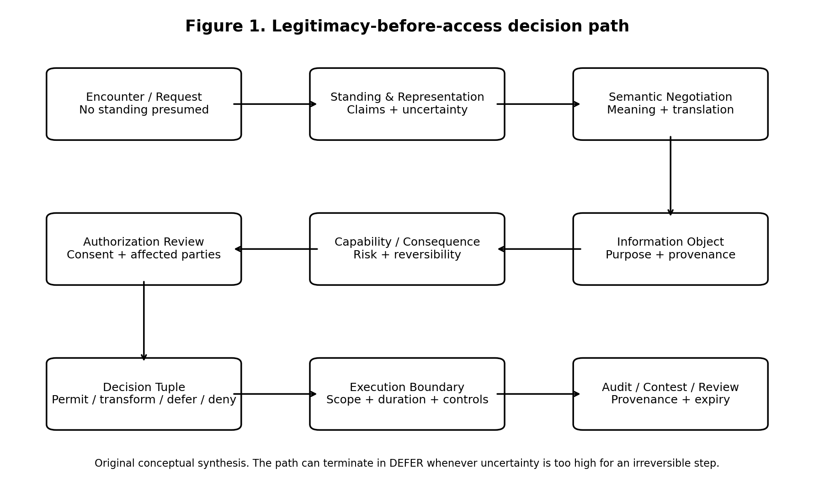
Figure 1. Legitimacy-before-access decision path. Original conceptual synthesis.
Caption. The proposed sequence prevents technical access control from outrunning legitimacy analysis. Any stage may terminate in DEFER if uncertainty is too high for an irreversible step.

Figure 2 - Role separation for a SLIAP information transaction
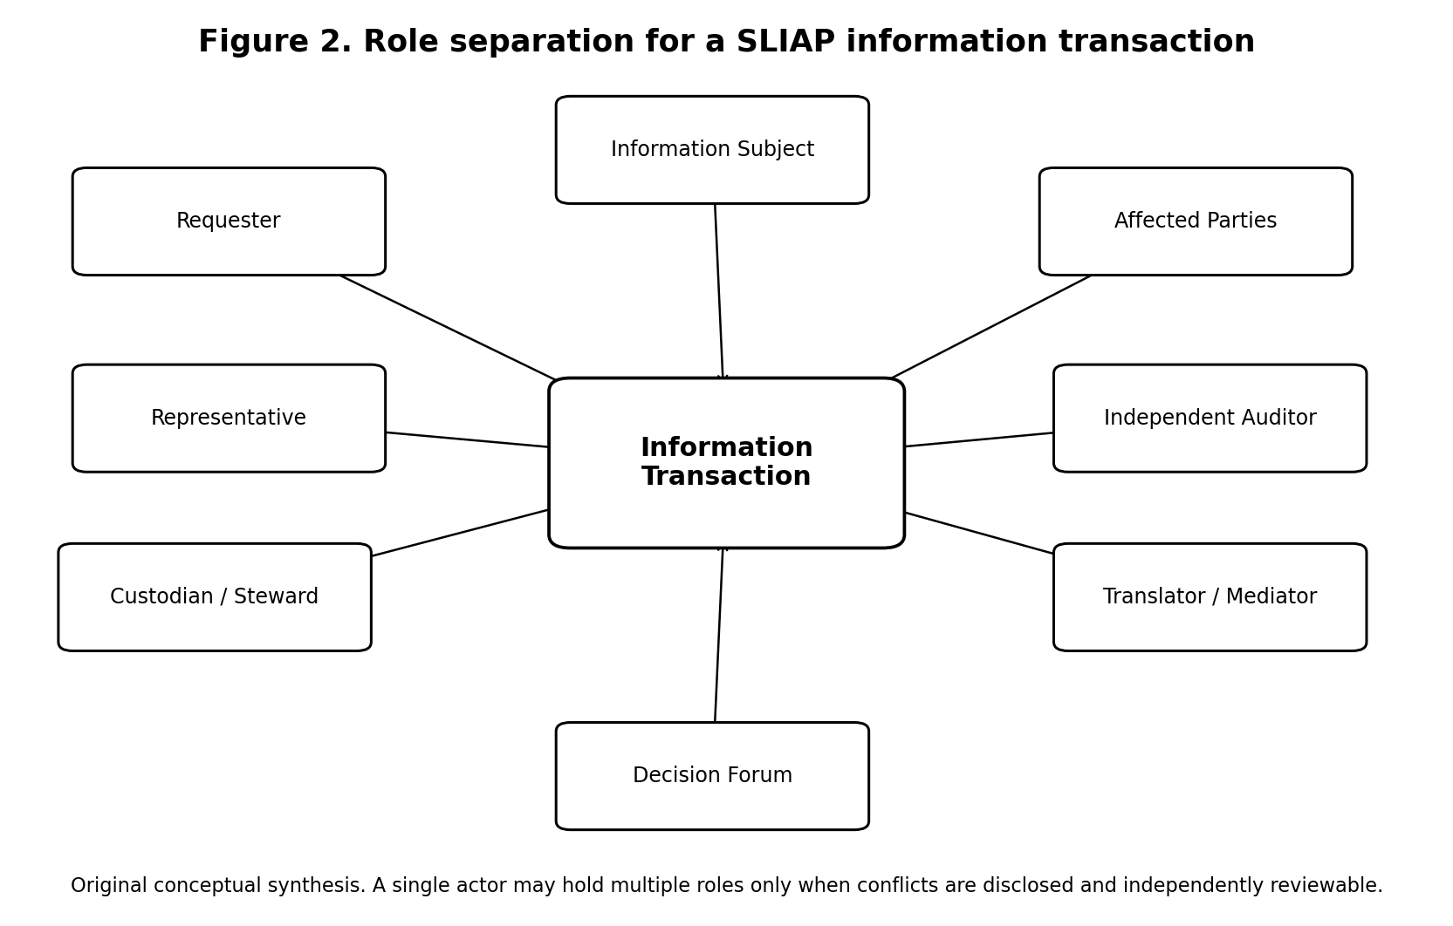
Figure 2. Role separation for a SLIAP information transaction. Original conceptual synthesis.
Caption. Requester, information subject, affected parties, custodian, representative, translator, decision forum, and auditor are logically distinct roles. Concentrating them in one actor creates capture and conflict-of-interest risk.

Figure 3 - Proposed layered SLIAP architecture
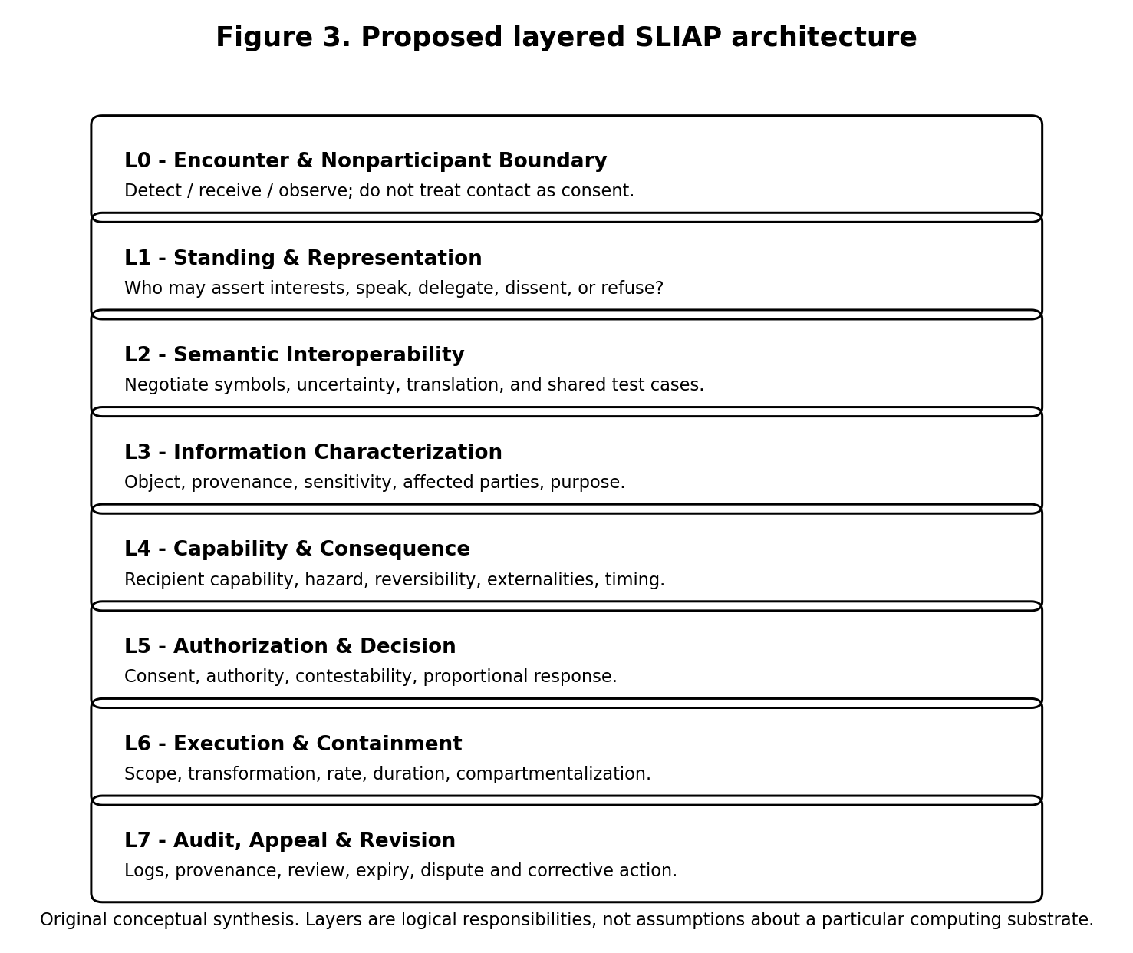
Figure 3. Proposed layered SLIAP architecture. Original conceptual synthesis.
Caption. Logical responsibilities are separated from implementation technologies so that SLIAP does not assume a particular biological or digital substrate.

Figure 4 - Non-binary decision state model
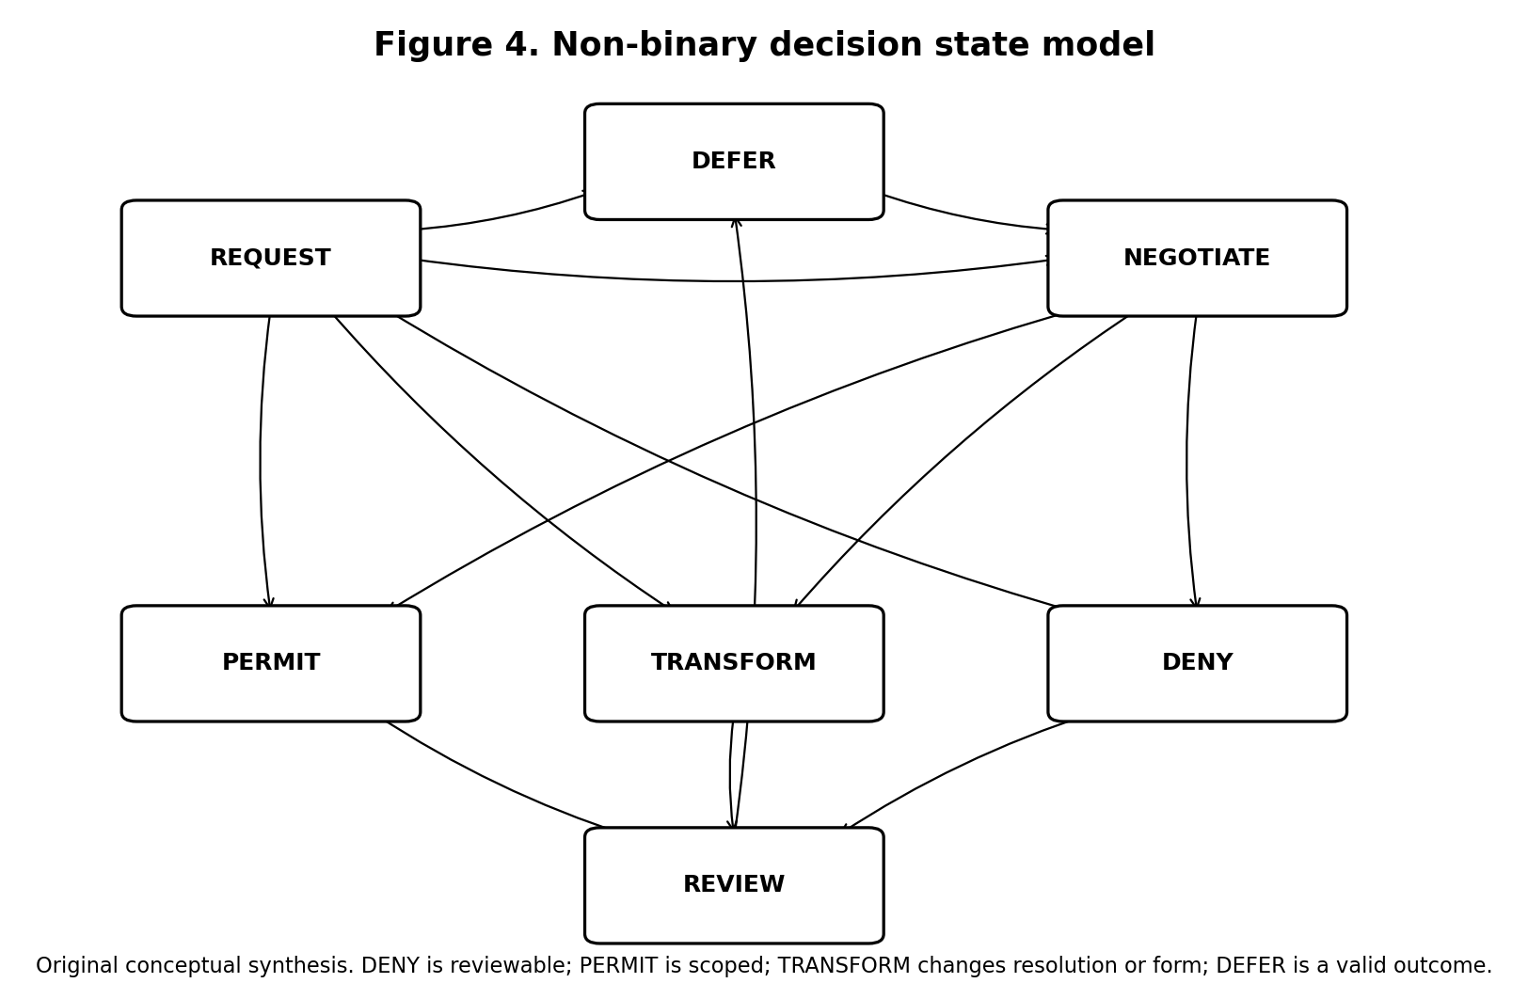
Figure 4. Non-binary decision state model. Original conceptual synthesis.
Caption. Access is not restricted to ALLOW/DENY. Transform, negotiate, and defer preserve options and make uncertainty explicit.

Table 1 - Cross-team contribution matrix
Contributor | Distinctive contribution | Strongest value | Primary risk / limitation
ChatGPT | Broad pre-protocol taxonomy, inversion test, non-binary access, governance red team | Comprehensive scope and role separation | Checklist breadth can prime conclusions and dilute priorities
Claude | Assumption disclosure and deliberate perspective displacement | Compact anti-anthropocentric stress testing | Less formal evidence/governance structure; no-table constraint reduces auditability
Google Gemini | Early technical architecture, attestation, translation layer, anti-dominance, validation scenarios | Forces concrete systems questions | Premature formalism; undefined pseudo-technical terms; stability can hide value judgments
Microsoft Copilot | Vocabulary audit, species-as-wrong-boundary challenge, reversal tests, assumption/contradiction registers, simulations | Strongest pre-architecture falsifiability | Very broad scope; research program needs staged validation
Grok | Consent, sovereignty, asymmetry, auditability, protocol evolution and exit | Concise cross-domain architecture concerns | “Species sovereignty” and literal revocability can reintroduce assumptions
Perplexity | Evidence typing, perspective limits, no-unified-protocol alternative, strongest-case-against requirement | Strong epistemic discipline | Human validation cannot substitute for unknown nonhuman participation

Table 2 - Transferability of existing frameworks
Framework | Transferable mechanism | What should not be universalized | SLIAP use
NIST Zero Trust [R2] | No implicit trust; session/resource focus | Enterprise owner and policy authority | Security after legitimate authority is established
NIST ABAC [R3] | Multidimensional requester/object/environment decisions | Trusted universal attribute schemas | Claim-based contextual authorization
NIST Digital Identity [R4] | Identity proofing and federation concepts | Human government identity assumptions | Evidence patterns for scoped identity claims
W3C Verifiable Credentials [R5] | Issuer-holder-verifier claims; tamper evidence | JSON-LD / web substrate / issuer trust model | Optional digital implementation pattern
W3C PROV-O [R6] | Derivation, agents, activities, delegation | Full surveillance-like logging | Minimum provenance and transformation history
DTN / Bundle Protocol [R7] | Asynchronous, disruption-tolerant exchange | IP-like endpoint assumptions as universal | Long-delay transactions and durable context
Contextual Integrity [R8] | Information flow depends on actors, context, type and conditions | Human social norms as universal | Transaction ontology and purpose constraints
CARE Principles [R10-R11] | Collective benefit, authority, responsibility, ethics; power awareness | Indigenous concepts stripped from context | Anti-extraction lens and collective-interest checks
Nagoya Protocol [R12] | Access separate from downstream use; benefit-sharing logic | State-centric human treaty jurisdiction | Biological/cultural information analogy
IAA SETI 2026 [R21-R22] | Verification, transparency, archiving, consultation | Humanity as sole political subject | Human-side first-contact procedure, not interspecies constitution
COSPAR planetary protection [R23] | Precaution, contamination controls, periodic updating | Treating foreign life only as scientific contamination risk | Analogy for reversible caution under uncertainty

Table 3 - Proposed actor and standing categories
Category | Example | Standing basis | Key uncertainty
Individual actor | Human, animal individual, AI instance | Direct interests or agency | Continuity and communication
Collective actor | Hive mind, clan, organization | Collective identity / decision process | Internal dissent and membership
Political constituency | State, city, civilization council | Delegated political mandate | Scope and legitimacy of representation
Cultural / knowledge community | Community holding shared knowledge | Collective stewardship and affected interests | Boundaries and internal pluralism
Multispecies polity | Shared institutions across species | Political membership rather than biology | Representation across different forms of agency
Ecological interest | Ecosystem or dependent species | Proxy-protected affected interest | Whether and how interests are inferred
Future / absent stakeholder | Future generations, dormant civilization | Anticipated affected interest | Proxy conflicts and uncertainty
Unknown entity | Unclassified signal or agent | Precautionary standing when evidence warrants | False positive vs false negative cost

Table 4 - Information transaction variables
Variable | Question
Requester | Who is asking and with what identity confidence?
Representative authority | Whom may the requester bind or speak for?
Information subject | Who or what is represented by the information?
Custodian | Who currently controls the information object?
Provenance | Where did it come from and how was it transformed?
Purpose | What operation and downstream use are requested?
Capability | What relevant capabilities does the recipient possess?
Consequence | What harms, benefits, and externalities are plausible?
Consent state | Which actions have been authorized, refused, or left unresolved?
Reversibility | Can the action be meaningfully undone?
Translation confidence | How certain are the parties that they understand the same transaction?
Time | What are validity, delay, expiry, and review conditions?
Uncertainty | What remains unknown and how material is it?

Table 5 - Decision outcome vocabulary
Outcome | Meaning | Typical use
PERMIT | Requested form and scope authorized | Low conflict, sufficient authority and confidence
CONDITIONAL PERMIT | Authorized with enforceable or normative conditions | Purpose limits, time limits, audit requirements
TRANSFORM | Release lower-resolution, aggregate, abstracted, sandboxed, or supervised form | Preserve benefit while reducing irreversible risk
NEGOTIATE | Material terms remain open | Consent, reciprocity, purpose, or semantics unresolved
DEFER | No reliable decision yet | Identity, representation, translation, or consequence uncertainty
QUARANTINE | Isolate information or code pending analysis | Unknown executable payloads or contamination-like risks
DENY | Request not authorized under current evidence and rules | Illegitimate authority, excessive risk, explicit refusal

Table 6 - Adversarial threat model
Threat | Exploited assumption | Impact | Primary mitigation | Mitigation risk
Classification capture | Classifier is neutral | Exclusion from standing | Plural evidence + contestability | Endless dispute
Representation laundering | Communicator speaks for all | Unauthorized binding | Scoped mandate + dissent records | Surveillance of internal politics
Translation capture | Translator is neutral | False consent / distorted meaning | Multiple translations + originals | Increased latency and complexity
Safety paternalism | Stronger actor knows best | Permanent monopoly | Reversal test + expiry + appeal | Sensitive reasons may be hard to disclose
Openness exploitation | Equal openness equals fairness | Extractive asymmetry | Consequence and benefit analysis | Protectionism
Emergency permanence | Crisis authority self-terminates | Authoritarian capture | Automatic expiry + renewed evidence | Delay during genuine emergency
Provenance surveillance | More logging always improves accountability | Strategic intelligence exposure | Minimized, scoped logs | Reduced forensic visibility
Sybil governance | One identity equals one legitimate stake | Governance capture | Constituency/mandate checks | Entrenched gatekeepers
Strategic incomprehension | Claims of confusion are sincere | One-way refusal / manipulation | Independent semantic tests | False confidence in translation
Information laundering | Downstream copies remain controlled | Unbounded spread | Transformation + provenance + least disclosure | Limits beneficial reuse

Table 7 - Failure-mode register
ID | Failure | Severity | Detectability | Mitigation | Residual risk
FM-01 | Species treated as political unit | High | Medium | Separate biology, polity, constituency, individual | Boundary disputes persist
FM-02 | False representative gains authority | Critical | Medium | Scoped mandates, challenge, multiple representatives | Secret coercion may remain hidden
FM-03 | Translation changes practical meaning | Critical | Low-Medium | Preserve originals, multi-path validation | True semantic equivalence may be impossible
FM-04 | High-risk disclosure cannot be reversed | Critical | High after event | Transform, stage, defer | Some risk cannot be eliminated
FM-05 | Protective restrictions become domination | High | Medium | Expiry, reversal test, independent review | Review bodies can be captured
FM-06 | Open-data norm enables extraction | High | Medium | Benefit/power analysis, scoped reuse | Strong actors retain structural advantages
FM-07 | Audit system becomes surveillance system | High | Medium | Minimize and compartment logs | Accountability becomes weaker
FM-08 | Emergency governance never ends | Critical | High | Auto-expiry, renewal burden | Real emergencies may require rapid action
FM-09 | Superior actor ignores SLIAP | Critical | High | Diplomatic incentives, interoperability benefits | No guaranteed enforcement
FM-10 | Unknown entity denied standing | Critical | Low | Precaution for irreversible acts | Over-inclusion and operational cost
FM-11 | Sybil or forked identities capture governance | High | Medium | Mandate/stake rather than raw identity count | Identity remains hard in alien substrates
FM-12 | DEFER becomes permanent exclusion | High | High | Review triggers and evidence requirements | Some uncertainty may never resolve

Table 8 - Assumption register
ID | Assumption under test | Risk if wrong | Current status
A-01 | Species is a valid authorization unit | Exclusion or illegitimate representation | Rejected as default
A-02 | Intelligence can be ranked on one scale | Hierarchy masquerading as science | Rejected
A-03 | Communication implies mutual understanding | False consent and unsafe disclosure | Rejected
A-04 | Consent can always be obtained | Forced binary decision | Rejected; DEFER required
A-05 | Information disclosure can be revoked | False security | Rejected for learned/copied knowledge
A-06 | Reciprocity is fair | Equal rules, unequal effects | Context-dependent
A-07 | Openness is ethically neutral | Extraction and power concentration | Rejected
A-08 | A universal protocol is preferable | Centralized capture | Unresolved; federation preferred initially
A-09 | Technical verification proves legitimacy | Authenticated domination | Rejected
A-10 | More provenance is always better | Surveillance | Rejected
A-11 | Non-interference is always respectful | Preventable harm / entrenched abuse | Rejected
A-12 | System stability is a neutral objective | Preservation of oppressive status quo | Rejected

Table 9 - Contradiction register
ID | Principle A | Principle B | Conflict | Current treatment
C-01 | Openness | Hazard prevention | Transparency can spread dangerous capabilities | Separate detection transparency from payload release
C-02 | Privacy | Accountability | Audit can expose sensitive relationships | Minimized, tiered provenance
C-03 | Autonomy | Collective protection | Individual disclosure can harm collective | Multi-party standing and scoped authority
C-04 | Reciprocity | Capability asymmetry | Equal exchange can create unequal power | Consequence-sensitive negotiation
C-05 | Non-interference | Emergency assistance | Respect can become abandonment | Case-specific proportionality
C-06 | Identity assurance | Anti-surveillance | Strong proof can require intrusive data | Transaction-specific evidence, not universal dossiers
C-07 | Reversibility | Useful disclosure | Some valuable knowledge cannot be retracted | Stage and transform before irreversible release
C-08 | Universal rules | Legitimate pluralism | Uniformity can erase local norms | Federated meta-protocol
C-09 | Rapid emergency response | Anti-authoritarian safeguards | Review can slow urgent action | Narrow temporary authority + mandatory expiry
C-10 | Inclusion | Right to refuse | Participation pressure can become coercion | Meaningful nonparticipation

Table 10 - Prioritized research agenda
Priority | Research question | Why it matters | Proposed method
1 | What is the operational unit of standing if not species? | Determines every later authorization rule | Comparative models + adversarial case studies
2 | How can representation be verified without universal political institutions? | Prevents false species-wide mandates | Formal claim schema + simulation
3 | How should translation confidence be measured and contested? | Consent depends on meaning | Multi-translator benchmark with ambiguity retention
4 | When should uncertainty trigger DEFER versus precautionary action? | Avoids paralysis and reckless certainty | Decision-theoretic tabletop exercises
5 | How can capability be assessed without creating surveillance dossiers? | Risk analysis can become intelligence gathering | Minimal-attestation experiments
6 | Which provenance fields are necessary for accountability? | Balances traceability and privacy | Data-minimization threat modeling
7 | How should long-delay consent and expiry work? | Interstellar latency breaks real-time governance | DTN-inspired protocol simulation
8 | What information transformations preserve utility while reducing hazard? | Enables non-binary access | Controlled disclosure experiments
9 | What governance survives Sybil/forked/collective identities? | Identity count may be meaningless | Multi-agent simulations
10 | Under what conditions should SLIAP development stop? | Prevents protocol from becoming domination | Red-team review with explicit stop criteria

18. Validation Plan and Next Research Phase
The next phase should not standardize access levels. It should test the architecture’s assumptions through executable or tabletop research.
Simulation A - Representation conflict. Three human governments, an Indigenous nation, a corporation, and an AI agent all claim different authority to answer a first-contact request. Test whether scoped representation prevents one actor from laundering limited authority into species-wide authority.
Simulation B - Deep-time negotiation. One party responds every twelve years; the other can make millions of decisions per second. Test expiry, nonresponse, version drift, and asynchronous consent using DTN-inspired message persistence.
Simulation C - Translation disagreement. Two independent translators produce materially different interpretations of the same consent statement. Test confidence reporting, escalation, and whether the system can preserve ambiguity without forcing a decision.
Simulation D - Information-rich signal. A verified technosignature contains executable payloads. Separate public confirmation from payload decoding, sandboxing, dissemination, and capability release. Test competing scientific-open-access and hazard-control positions.
Simulation E - Dominant actor. A participant with overwhelming capability refuses governance constraints while still demanding access from others. Determine which SLIAP functions remain meaningful: normative signaling, coalition coordination, technical refusal by weaker nodes, or none.
Simulation F - Protocol capture. Administrators invoke an emergency to centralize translation, identity, and provenance systems. Test automatic expiry, audit independence, and restoration of federated authority.
A successful next phase should produce failed cases as well as successes. If a simulation reveals that a principle cannot be enforced, the report should distinguish “norm we prefer” from “control we can guarantee.” If a framework only works when every actor is cooperative, that limitation should be explicit.

19. Questions for Cross-Review
- Is the report correct to reject species as the default authorization boundary, or does doing so dissolve the project into an overly broad agency-governance framework?
- Does the proposed precautionary standing rule overprotect unknown entities and create denial-of-service opportunities for governance?
- Is non-domination too dependent on human political philosophy to serve as a cross-civilizational legitimacy test?
- Which proposed principles fail if the counterparty has no concept analogous to consent, ownership, privacy, or political representation?
- Does a federated SLIAP actually reduce domination, or merely move power to gateway operators and translators?
- Can capability-sensitive disclosure be distinguished from paternalistic technological monopoly in a way that is operational rather than rhetorical?
- What information about recipient capability is minimally sufficient for risk assessment without becoming strategic surveillance?
- Is the decision tuple missing any variable that would materially change an access determination?
- Under what conditions should observed or inferred information be treated as protected even when the source cannot physically prevent observation?
- What governance model can resist Sybil attacks when identities can fork, merge, hibernate, or exist as collectives?
- Should information-rich extraterrestrial signals be subject to quarantine even when ordinary SETI principles favor openness about confirmed detections?
- Which parts of CARE, contextual integrity, Nagoya, zero trust, or other human frameworks have been transferred illegitimately?
- Does DEFER create a hidden veto for incumbent gatekeepers?
- What would cause you to reject SLIAP entirely rather than revise it?
- Which rule in this report would you refuse if a civilization vastly more capable than humanity imposed it on humans?

20. Conclusion
The central danger in SLIAP is not simply that humans might write biased rules. It is that the protocol could convert contingent human categories into infrastructure and then call the result neutral. Species, civilization, intelligence, consent, identity, ownership, privacy, security, and access all contain assumptions that may not generalize.
The research nevertheless supports continued development if SLIAP remains a questioning framework before it becomes an enforcement framework. The project has value when it forces a requester to identify who is represented, what information is involved, what authority exists, how meaning was established, what consequences are plausible, whose interests are affected, what uncertainty remains, and whether the rule would still be accepted after reversing positions of power.
The proposed architecture therefore refuses three shortcuts. It refuses the shortcut from detection to ownership. It refuses the shortcut from authentication to legitimacy. And it refuses the shortcut from technological strength to authority.
The most defensible preliminary SLIAP is not a constitution for the universe. It is a federated procedure for making information relationships explicit, limited, contestable, and reversible where possible. Its success should be measured not by how much information it can control, but by how difficult it makes arbitrary control to hide.

References
[R1] Team response compilation. SLIAP Preliminary Research, Goals, and Adversarial Analysis. Supplied by the commissioning researcher, 16 October 2026. Contains responses from ChatGPT (pp. 1-38), Claude (pp. 38-40), Google Gemini (pp. 40-45), Microsoft Copilot (pp. 45-64), Grok (pp. 65-67), and Perplexity (pp. 67-79).
[R2] Rose, S., Borchert, O., Mitchell, S., & Connelly, S. (2020). Zero Trust Architecture. NIST SP 800-207. https://doi.org/10.6028/NIST.SP.800-207
[R3] Hu, V. C., Ferraiolo, D., Kuhn, D. R., et al. (2019 update). Guide to Attribute Based Access Control (ABAC) Definition and Considerations. NIST SP 800-162. https://doi.org/10.6028/NIST.SP.800-162
[R4] Temoshok, D., Choong, Y.-Y., Galluzzo, R., et al. (2025). Digital Identity Guidelines. NIST SP 800-63-4. https://doi.org/10.6028/NIST.SP.800-63-4
[R5] W3C. (2025). Verifiable Credentials Data Model v2.0. W3C Recommendation, 15 May 2025. https://www.w3.org/TR/vc-data-model-2.0/
[R6] W3C. (2013). PROV-O: The PROV Ontology. W3C Recommendation, 30 April 2013. https://www.w3.org/TR/prov-o/
[R7] Burleigh, S., Fall, K., & Birrane, E. (2022). Bundle Protocol Version 7. IETF RFC 9171. https://doi.org/10.17487/RFC9171
[R8] Nissenbaum, H. (2004). Privacy as contextual integrity. Washington Law Review, 79, 119. https://digitalcommons.law.uw.edu/wlr/vol79/iss1/10/
[R9] Bostrom, N. (2011). Information hazards: A typology of potential harms from knowledge. Review of Contemporary Philosophy, 10, 44-79. https://nickbostrom.com/information-hazards.pdf
[R10] Carroll, S. R., Garba, I., Figueroa-Rodríguez, O. L., et al. (2020). The CARE Principles for Indigenous Data Governance. Data Science Journal, 19, 43. https://doi.org/10.5334/dsj-2020-043
[R11] Global Indigenous Data Alliance. CARE Principles for Indigenous Data Governance. https://www.gida-global.org/care-principles
[R12] Convention on Biological Diversity. The Nagoya Protocol on Access and Benefit-sharing. https://www.cbd.int/abs/
[R13] United Nations General Assembly. (2007). United Nations Declaration on the Rights of Indigenous Peoples (A/RES/61/295). https://www.un.org/development/desa/indigenouspeoples/declaration-on-the-rights-of-indigenous-peoples.html
[R14] Wilkinson, M. D., Dumontier, M., Aalbersberg, I. J., et al. (2016). The FAIR Guiding Principles for scientific data management and stewardship. Scientific Data, 3, 160018. https://doi.org/10.1038/sdata.2016.18
[R15] Birch, J., Andrews, K., et al. (2024). The New York Declaration on Animal Consciousness. New York University, 19 April 2024. https://sites.google.com/nyu.edu/nydeclaration
[R16] Pardo, M. A., Fristrup, K., Lolchuragi, D. S., et al. (2024). African elephants address one another with individually specific name-like calls. Nature Ecology & Evolution, 8, 1353-1364. https://doi.org/10.1038/s41559-024-02420-w
[R17] Sharma, P., Gero, S., Payne, R., et al. (2024). Contextual and combinatorial structure in sperm whale vocalisations. Nature Communications, 15, 3617. https://doi.org/10.1038/s41467-024-47221-8
[R18] Bridges, A. D., MaBouDi, H., Procenko, O., et al. (2023). Bumblebees acquire alternative puzzle-box solutions via social learning. PLOS Biology, 21(3), e3002019. https://doi.org/10.1371/journal.pbio.3002019
[R19] Küçükuncular, A. (2025). Ethical implications of AI-mediated interspecies communication. AI and Ethics, 5, 6379-6391. https://doi.org/10.1007/s43681-025-00828-z
[R20] Interspecies Internet. (2024/2026). Animals in Translation: Imagining Criteria and Frameworks for Decoding Communication in Other Species. https://www.interspecies.io/publication
[R21] International Academy of Astronautics SETI Committee. (2026). Declaration of Principles Concerning the Conduct of the Search for Extraterrestrial Intelligence (SETI) - 2026 Update. Current protocol listed at https://iaaseti.org/en/protocols/ and reproduced by the SETI Institute at https://www.seti.org/research/seti-101/protocols-for-an-eti-signal-detection/
[R22] Garrett, M., Denning, K., Tennen, L., & Oliver, C. (2026). A new version of the SETI protocols: The Declaration of Principles Concerning the Conduct of the Search for Extraterrestrial Intelligence (SETI): 2026 update. Europlanet Science Congress 2026, EPSC2026-132. https://doi.org/10.5194/epsc2026-132
[R23] Committee on Space Research (COSPAR). (2026). COSPAR Policy on Planetary Protection. Current policy and Panel materials. https://cosparhq.cnes.fr/cospar-policy-on-planetary-protection/
[R24] Garrett, M. (2026). Beyond the Beacon: State and Corporate Competition after an Information-Rich Technosignature Detection. arXiv:2610.21645. Preprint; treated as emerging analysis rather than settled evidence.

END OF DOCUMENT
Document ID: SLIAP-PR-CHATGPT-2026-10-16-001
Version: 1.0
Status: PROPOSED - NOT CANON

