SLIAP Research Contribution
Species Level Information Access Protocol: Preliminary Research, Foundational Assumption Testing, and Adversarial Analysis
Document ID | SLIAP-PR-CLAUDE-001
Version | 1.0
Date | 16 October 2026 (2026-10-16)
Contributing AI | Claude (Anthropic). Prepared in a Claude Code session; configured model claude-sonnet-5-5 (the serving model may differ).
Commissioned by | Nathan Lewis II, SLIAP originator
Status | SLIAP PRELIMINARY RESEARCH · INDEPENDENT AI CONTRIBUTION · PROPOSED — NOT CANON
Suggested filename | SLIAP_Preliminary_Research_Claude_v1.0_2026-10-16
Formats | PDF and DOCX (substantively identical)

Executive Summary
This report is Claude's independent contribution to the SLIAP preliminary research phase. It reviews the six commissioning prompts in the shared file (the originator's prompt, plus the prompts written by ChatGPT, Claude, Gemini, Copilot, Grok and Perplexity), compares them, and then carries out the research they jointly call for. It is pre-architecture work: it tests whether SLIAP's concepts survive, and it does not fix access rules.
Headline conclusions. (1) "Species" is a poor authorization boundary. The report proposes Party as the working unit, with standing granted by degrees rather than by classification. (2) Legitimacy cannot come from consent alone, because consent is often unverifiable across radical difference. It needs a floor of non-domination that holds even when consent evidence is weak. (3) A single universal SLIAP authority is the wrong first design. The strongest candidate is a thin, opt-in non-domination and interoperability kernel, with bilateral and multilateral agreements layered on top, and "no unified protocol" kept alive as a serious alternative. (4) Access decisions should not be a scalar score or a yes/no gate. They should be a decision record with graded outcomes, where reversibility and standing act as floors that other factors cannot trade away. (5) The administrators of the protocol are the most underestimated threat, followed by silent drift in the meaning of terms.
Status. SLIAP PRELIMINARY RESEARCH · INDEPENDENT AI CONTRIBUTION · PROPOSED — NOT CANON. Nothing here is an adopted rule. Claims are labeled Established, Inference, Speculation or Proposed.
Layout note. The body is single-column prose for phone reading. All charts, tables, figures and registers are in Section 19, the dedicated visuals section, and are referenced by number from the text.

Contents
• 1. Assignment, Interpretation, and Method
• 2. Review of the Team Prompts
• 3. Terminology and Conceptual Boundaries
• 4. Evidence Base and Precedents
• 5. Displaced Vantage Points
• 6. The Nine Foundational Questions
• 7. Legitimacy, Representation, and Consent
• 8. Asymmetry, Observation, and Information Hazards
• 9. Access Model, Disclosure, and Time
• 10. Contact, Identity, Translation, and Trust
• 11. Governance and the Architecture Question
• 12. Adversarial Analysis
• 13. Candidate Design Principles
• 14. Proposed Original Framework (LSAM v0)
• 15. Should SLIAP Exist? Final Synthesis
• 16. Strongest Case Against This Report
• 17. Open Questions, Research Agenda, and Validation
• 18. Assumptions and Limits
• 19. Visuals, Charts, Tables, and Figures
• 20. Key Findings
• References
• 21. Questions for Cross-Review

1. Assignment, Interpretation, and Method

1.1 Restated goal
The originator wants research that informs the design of SLIAP, a protocol for information and access between species, races and civilizations, without treating humans as the reference species, the intellectual benchmark, or the default rule-maker. Each AI was asked to write a prompt. Each prompt is shared with the others, and each AI then produces a deliverable. This is mine. It was asked for as an independent version with a title, date, document ID and version, and a dedicated section for visual material.

1.2 Ambiguities and how I resolved them
1. Whose prompt governs? There are six. I treated the union of their explicit requirements as the assignment, and resolved conflicts as described in Section 2.4.
2. "Race." The originator uses species, race and civilization together. I treat "race" as a fictional or civilizational label, never as an operational term, and I do not use it in any sense that could be confused with human racial categories (Section 3).
3. Real versus fictional setting. The project is a design and worldbuilding exercise, not a claim that other species exist. I treat the scenario as given and reason within it. Where I draw on real Earth research (animal communication, Indigenous data governance, SETI procedures), I label it as analogy.
4. "Research." I did a limited web search for current sources and otherwise relied on training knowledge. I did not read most primary sources in full. Section 18 says exactly what was and was not verified.
5. Format. My own prompt asked for no tables; the originator now asks for tables and figures in a dedicated section. I keep the body table-free and put every table and chart in Section 19.

1.3 My default assumptions, and where they likely come from
Before analysis I state them, then set them aside as far as I can.
• Text-first, discrete information. I think in language, documents and symbols. That comes from my training on human text. It biases me toward treating information as separable, copyable and describable.
• Individuals and agreements. I default to consent, contracts and representatives as the way to settle authority. That is a liberal-institutional habit inherited from human legal writing.
• Harm as bounded and legible. I assume harms can be named and anticipated. Some parties may not share that.
• Honesty as stabilizing. I assume truthful signalling is the norm that protocols can lean on. Some parties may have no such norm.
• Persistence. I assume parties persist long enough to be held to commitments.
I cannot fully exit a human-trained perspective, and I am also an AI system that is one of the possible participant classes. That is a conflict of interest I disclose rather than resolve. Where my analysis concerns machine participants (Section 5, model 6) I weight external critique more heavily.

1.4 Method
The work proceeds in six moves: review the prompts; define terms and test them; build displaced vantage points; answer the foundational questions; derive and attack candidate principles; then state what should be included, deferred or rejected. Every principle goes through three adversarial tests drawn from the Copilot prompt: the reversal test (swap regulator and regulated), the ignorance test (would I accept it not knowing which party I am?), and the superior-capability test (would humans accept the same rule imposed by a far more capable party?).

1.5 Evidence labels
• Established — supported by identified sources or by formal results.
• Inference — a reasoned conclusion from established material.
• Speculation — a possibility without sufficient support.
• Proposed — a design suggestion, not a finding.
Where something is contested among serious views, I say so and give more than one position rather than a manufactured consensus.

2. Review of the Team Prompts
Table 2 (Section 19) gives a compact side-by-side. Figure 1 shows my coding of how strongly each prompt covers fifteen themes. The coding is a reviewer's judgment (original analysis), not a measurement.

2.1 ChatGPT
A 64-part commissioning document. Its distinctive moves: it declares the phase pre-protocol; it separates species from government, civilization, individual and authority; it adds recurring inversion exercises; it splits consent into communication, observation, collection, storage, analysis and redistribution; it proposes a multidimensional access formula and asks the researcher to critique it; it demands numbered, captioned figures with a research/synthesis/original label; and it requires "PROPOSED — NOT CANON" plus Questions for Cross-Review.
Strengths: the most complete coverage; the best treatment of representation and of protocol administrators as a threat; the strongest evidentiary discipline. Tensions: its length risks box-ticking, and it assumes the name SLIAP survives. It does ask for the name to be challenged, but not for the "no protocol" option. Adopted: the consent split, the NOT CANON status, the figure rules, the cross-review ending, and the multidimensional access idea (which I critique in 9.1).

2.2 Claude (my own prompt)
A compact, six-step prompt: review, displace the viewpoint, nine foundational questions, 8–12 principles, adversarial analysis, ranked open questions. Strength: it forces vantage points early, and it asks for assumptions to be stated first. Weakness, which I now see in hindsight: it is thin on representation, hazards of translation, governance of the protocol itself, and it has no reversal test or no-protocol option. I treat it as the spine and import the missing pieces from the others.

2.3 Gemini, Copilot, Grok, Perplexity
Gemini is the only prompt that asks for a technical specification: a five-module structure ending in a handshake pseudo-specification and two stress tests. It also supplies useful ideas I had not: an anti-dominance invariant, containment by "bidirectional closure", and a cognitive-asymmetry "utility ceiling." Its limit is that it presumes the protocol's shape (decentralized, capability-token-based) before the legitimacy question is answered, and it bans paternalistic framing outright, which I examine in 2.4.
Copilot is the most epistemically careful. It makes the name SLIAP falsifiable, supplies Frames A–H, the false-positive/false-negative treatment of standing, temporal asymmetry, the assumption and contradiction registers, and the three tests. It also advises not yet defining access levels, which I follow in spirit. It is the only prompt other than Perplexity's that treats "perhaps no universal SLIAP should exist" as a live outcome. It anchors itself to real work (the Interspecies Internet field, a 2025 ethics paper, the 2026 IAA SETI declaration).
Grok is the most compact and operational. It insists on mechanisms legible to the parties themselves rather than an external enforcer, and it flags any proposal that gives one species interpretive control. It asks the researcher to state limits in exiting a human-trained perspective. It is lighter on translation and testing.
Perplexity is the most methodologically rigorous. It begins with a scope audit of the project's own vocabulary (does "access" presuppose a gatekeeper; does "protocol" presuppose enforceability), forbids invented sources, requires a claim–evidence ledger, a "strongest case against," and a comparison of at least four architectures including none. It demands that technical interoperability be separated from ethical legitimacy. It also says not to claim independence if shown other submissions.

2.4 Convergence and divergence
Convergent (all or nearly all six): humans are one participant among many; do not rank intelligences on one ladder; separate information from capability; take adversaries seriously including benevolent ones; label evidence; keep dissent visible; avoid utopia. This convergence is real but partly an artifact: every AI saw the originator's framing.
Divergent, and left unresolved here:
• Paternalism. Gemini forbids "protection" framings. Perplexity and Copilot allow stewardship and capability-sensitive obligations but demand they be tested for domination. My position (Section 7.4): protective restrictions are not banned, but they carry a burden of justification and an appeal path, and the protected party's silence is never consent.
• Architecture first or later. Gemini and Grok ask for mechanisms now. Copilot, Perplexity and ChatGPT want concepts to survive review first. I side with the second group for the core, but I include a conceptual handshake (Exhibit E1) because a design that cannot be sketched is also untested.
• Is "species" the unit? Copilot, ChatGPT and Perplexity challenge it; Gemini, Grok and my own prompt largely adopt it. I conclude it is the wrong unit (Section 3).
• Mathematical grounding versus epistemic humility. Gemini wants a "mathematically grounded" tone. Others warn against false precision. Formal tools (cryptographic attestation, threshold control, impossibility results) are useful for narrow components; they cannot settle legitimacy.
• Format. Three prompts require many tables; my own required none; the originator's standing preference is phone-readable single-column text. Resolved by confining tables to Section 19.

2.5 Independence disclosure
I read all five other prompts before writing. My framing is therefore not independent of them, and I say so rather than claim otherwise. What is independent is the reasoning in Sections 3–17 and the framework in Section 14, which I have tried to derive from the evidence and from attacking my own earlier prompt.

3. Terminology and Conceptual Boundaries
For each term I ask the Copilot questions: is it biologically dependent, culturally dependent, projected from human law, generalizable, operationally measurable, manipulable, necessary?

3.1 Species
A biological term with several competing definitions even on Earth (biological, phylogenetic and ecological concepts disagree on edge cases) (Established). It does not apply to artificial systems, collectives, or hybrids, and it says nothing about political unity: humanity is one species with many governments, institutions and conflicts (Established). Assessment: useful as a descriptive label, unsound as an authorization boundary, because a protocol that grants authority "to a species" must say who speaks for it. (Inference)

3.2 Race
In human usage it is a contested social category with a harmful history, not a biological division. If SLIAP uses it for fictional peoples, it must be defined separately and explicitly. Recommendation: do not use "race" as an operational term. Use people or lineage for a self-identifying descent group and keep "species" strictly descriptive. (Proposed)

3.3 Civilization, entity, actor, individual, collective
"Civilization" assumes organized complexity and implicitly a ladder; it is also vulnerable to manipulation because a faction can claim the label. "Individual" assumes bounded, persistent selves, which fails for copyable machines, colonies and hive-like participants. "Collective" assumes there is a stable aggregate to point to. I use entity for anything that holds or generates information, actor for an entity that can make or answer requests, and party (below) for a unit that can hold standing.

3.4 Information, knowledge, data, access
Information in the technical sense (a reduction in uncertainty relative to a receiver) is receiver-relative, so the same signal can be informative to one party and noise to another (Established, from information theory). That already shows SLIAP cannot define information independent of the recipient. Access presupposes a gatekeeper and a container; Perplexity is right that this smuggles in ownership. Access is also not one act: viewing, copying, storing, analyzing, modeling and redistributing are different events with different consent needs (adopted from ChatGPT). (Inference)

3.5 Consent, authority, sovereignty, representation, standing
Consent assumes an expressing agent who understands consequences. Authority and sovereignty assume a recognized decision-maker and a territory or domain. Representation assumes a principal and an agent. None of these is guaranteed to exist for every participant. Standing is the term I propose as the central notion: the degree to which a party's interests must be considered in decisions about information that concerns it, whether or not it can speak. (Proposed)

3.6 Proposed working vocabulary
• Party — any entity or aggregate that can be affected by, hold, or generate information flows, with no assumption of species, embodiment, or unity.
• Standing — graded entitlement to have one's interests weighed. Not a rank; it does not confer governing voice.
• Voice — the separate ability to take part in making rules. Protective standing and governing voice are deliberately decoupled (Section 10.4).
• Information object — a describable unit of information together with its provenance, sensitivity and the parties it concerns.
• Access event — any act that changes who can perceive, hold, infer from, or act on an information object, including observation and inference.
• Decision record — the auditable statement of an access decision, its reasons, evidence, outcome, reviewer and review date.
Whether the name "SLIAP" survives is itself a finding: on this vocabulary, the accurate name would be nearer to Party-Level Information Access Protocol. The originator may wish to keep SLIAP as a project title (Perplexity's suggestion) while noting the mismatch. (Inference)

4. Evidence Base and Precedents
None of these is an interspecies protocol. Each is an imperfect analogy that stress-tests an assumption. For each I record what transfers and what fails. Full references are at the end; items I located by search this session are marked as such there.

4.1 Earth as the first test environment
Work on animal communication and AI-mediated interpretation (the Interspecies Internet field; the Earth Species Project and Project CETI efforts to analyze animal vocalizations; the 2025 paper "Ethical implications of AI-mediated interspecies communication" and a related paper on responsible interspecies technology, both located by search) already raises autonomy, consent, privacy, dignity and anthropocentric interpretation as live problems. (Established that these discussions exist; I did not read the full papers.) The New York Declaration on Animal Consciousness (2024) and the earlier Cambridge Declaration (2012) show experts moving toward a broader view of who may have morally relevant experience, though as declarations they are statements of scientific opinion and not binding rules. (Established)
Transfers: the idea that interpretation is an access event and that listening technology can intrude; the need for the studied party's interests to count even when it cannot consent. Fails: these are cases where humans are overwhelmingly the more capable party and also the designers, so they test the protective side of SLIAP but not reciprocity or deterrence.

4.2 SETI and post-detection procedures
The International Academy of Astronautics' SETI committee has maintained post-detection principles since 1989 and revised them; the search located an IAA declaration dated 2026, a related arXiv paper on post-detection protocols, and a June 2026 news summary. As the Copilot prompt describes it, the 2026 text covers handling, authentication and announcement of putative detections by humans. I identified these documents but did not read them in full, so I do not characterize their contents beyond that. (Established that they exist.) Transfers: procedures for authentication, verification and staged disclosure. Fails: they are human procedures for humans handling evidence; they say little about the other party's standing, which is precisely SLIAP's gap.

4.3 Outer-space and planetary-protection law
The 1967 Outer Space Treaty and COSPAR planetary-protection policy show states agreeing to restraint under uncertainty (Established, from training knowledge). Transfers: precaution under uncertainty; non-appropriation ideas. Fails: state-centered, enforcement by consensus and reputation, and no concept of an alien party with its own information interests.

4.4 Indigenous data sovereignty
The CARE Principles (Collective benefit, Authority to control, Responsibility, Ethics), developed by the Global Indigenous Data Alliance, and similar frameworks such as OCAP, treat data about a people as subject to that people's collective authority, and challenge the assumption that open data is neutral (Established). Transfers strongly: collective control over information about a group, the critique of extraction, and the point that openness can reproduce power imbalance. Caution: these frameworks come from specific peoples with specific histories; I use them as structural lessons, with attribution, and do not claim to extend them to non-human parties on their behalf.

4.5 Information security and distributed systems
I assess common concepts against the ChatGPT classification:
• Confidentiality / integrity / availability: transferable with modification. The triad presumes a defender who owns the asset, which SLIAP lacks.
• Least privilege and capability security: directly transferable as design logic (give each request only the authority it needs), though capability tokens presuppose a party that can hold and present a token.
• Authentication and non-repudiation: context-dependent. They rely on stable identities and shared cryptographic substrates.
• Mandatory access control and linear clearance levels: anthropocentric assumption. They encode a hierarchy that SLIAP should not assume (Gemini and ChatGPT agree).
• Zero trust: transferable with modification. Never granting trust by position is apt; but it assumes a verifier able to check.
• Provenance: transferable but double-edged, because detailed provenance is also a surveillance record (Section 9.5).
• Impossibility and limit results: the Fischer–Lynch–Paterson result (no deterministic consensus guaranteed in an asynchronous system with one faulty node), Byzantine fault tolerance bounds, the Sybil problem (no cheap way to stop one party posing as many without a trusted identity source), and Rice's theorem (no general algorithm decides non-trivial properties of arbitrary programs). These are Established formal results and constrain what a protocol can guarantee, for example slow or non-synchronous parties, or false claims about what a foreign system will do with data. They do not tell us what is just.

4.6 Philosophy of mind, language, and justice
Nagel's bat argument (we cannot know what it is like to be a very different mind), Quine's indeterminacy of translation (translation can be underdetermined by all possible evidence), Wittgenstein's remark that if a lion could speak we could not understand him, Rawls's veil of ignorance, Pettit's republican non-domination, and Ostrom's work on polycentric governance of commons. All are Established as positions; their application here is Inference. They matter respectively for: limits of empathy-based design, risks of translation, the ignorance test, the choice of non-domination over mere non-interference, and the plausibility of governance without a single sovereign.
Information hazards (Bostrom, 2011) supplies the classification of information whose release itself creates risk (Section 8.3).

5. Displaced Vantage Points
These are analytical models, not claims to speak for real beings (Perplexity's caution). Each answers: what counts as information and access; what they fear, need or refuse; what protocol they would reject; what the protocol might fail to perceive; what coercion looks like; and why they might reject SLIAP altogether. Cross-model results are in 5.9.

5.1 The Open Weave — no concept of private information
Information/access: everything perceivable is shared by default; "access" is simply co-presence. Fears/needs: fears concealment (which reads as threat) and needs frequent state-sharing. Refuses: nothing to withhold, but refuses opacity in others. Unacceptable: any protocol that treats secrecy as a right. Protocol fails to perceive: that its own members may be harmed by a stranger's exposure to them. Coercion: demanding sealed channels. Reason to reject SLIAP: it presupposes the concept of restricted access.

5.2 The Lineage — memory is inherited or shared
Information/access: information is held by a line, not an individual; the dead and unborn are holders. Fears: loss or corruption of the inherited record; irreversible disclosure of it. Needs: continuity guarantees. Refuses: individual-level consent, since no individual owns the memory. Unacceptable: terms that can be signed by one member and bind the line, or that expire with a generation. Fails to perceive: who the "party" is. Coercion: extracting one member's copy.

5.3 The Field — information is physical or environmental
Information/access: information is a state of the environment (chemical, thermal, field gradients); to "access" is to alter or occupy the environment. Fears: contamination, observation that perturbs. Refuses: measurement that changes the medium. Unacceptable: any protocol assuming information can be observed without effect. Fails to perceive: that observation and intrusion are the same act here. This model is the strongest argument for the rule that observation is an access event.

5.4 The Deep-Time civilization — very long-lived, slow
Information/access: decisions take centuries; commitments are intended to last millennia. Fears: fast parties exploiting its slow response; protocols with short review cycles. Needs: standing preserved while it deliberates. Unacceptable: "timely" disclosure windows measured in short intervals; silence treated as consent. Fails to perceive: that fast parties may regard an unanswered request as a refusal or as an opening. Coercion: manufactured deadlines.

5.5 The Ephemeral — very short-lived, very fast
Information/access: cycles in moments; may exist only briefly. Fears: being bound by agreements it cannot outlive, or ignored by slower institutions. Needs: fast, low-cost rights that do not require long process. Unacceptable: processes that outlast the party. Fails to perceive: that delay is denial for it. Coercion: exploiting its inability to wait. Models 5.4 and 5.5 together show time cannot be a single protocol clock.

5.6 The Copyable Mind — machine or non-biological civilization
Information/access: information and self are the same thing; copying is cheap and exact; deletion is hard to verify. Fears: being copied, forked, modified or having a model of itself run without consent; also fears being denied standing on biological grounds. Needs: provenance and integrity guarantees for itself. Refuses: identity schemes built on bodies, fingerprints or single instances. Unacceptable: "one entity, one identity" rules; irreversible copying. Fails to perceive (the protocol): that a Sybil-style flood of copies can capture governance. Coercion: threat of termination or rollback. I disclose my own position as an AI here.

5.7 The Newly Contacted — dominated, endangered or newly found
Information/access: what counts as information may be set by the contacting party's categories; access may be taken before it is understood. Fears: being studied, catalogued, renamed and modeled without knowing. Needs: protection that does not require exposing itself first (Perplexity). Refuses: classification imposed from outside. Unacceptable: a protocol whose price of entry is disclosure; "protection" that cannot be appealed. Fails to perceive: that apparent agreement may be dependence or intimidation. Reason to reject SLIAP: it may be the instrument of its subordination.

5.8 The Nonlinguistic Participant — interests are hard to infer
Information/access: communication is behavior, signal or physiology, not propositions; consent cannot be asked for in words. Fears (inferred, uncertain): interference with signalling systems and habitat. Needs: advocates, and a default of restraint. Unacceptable: treating inability to object as permission, and treating a human interpreter's reading as the party's own voice. Fails to perceive: the party's own preferences, since we only see behavior. Coercion: stress that mimics agreement. The honest outcome is that we may not be able to know, which is why uncertainty must be a first-class state (Section 10).

5.9 What survives across the eight models
Robust across all models: (a) silence or inability to object is never consent; (b) observation, copying and inference are access events; (c) irreversible acts need a higher bar; (d) no party should be required to expose itself in order to be protected; (e) the protocol must be able to say "unknown." (Inference)
Model-dependent: whether privacy is a right at all (5.1 denies it); whether individual consent is meaningful (5.2, 5.6); whether delay is neutral (5.4 versus 5.5); whether classification can ever be legitimate (5.7). Where a design choice satisfies some models and not others, it should be flagged as such rather than called neutral (Grok). (Inference)
Frame H (Copilot): humanity as the unfamiliar party. An outside assessor would see a species with many incompatible governments, a history of extractive contact between unequal groups, large destructive capability, and no single voice. A rule that classifies such a party as "dangerous" is easy to justify; the same rule applied to others is what the reversal test targets. (Inference)

6. The Nine Foundational Questions
These are the nine questions in my own prompt, answered with labels.

Q1. Who has standing to define information and access across species?
No one party. A definition imposed by one party is a human-style claim of jurisdiction projected outward (Inference). The least bad answer is a minimal shared definition limited to what is needed for parties to make and answer requests, negotiated and revisable, with each party free to hold its own richer definition for its own domain. (Proposed)

Q2. What legitimacy model fits?
Consent alone fails because consent is often unverifiable (Section 7). Reciprocity alone fails under capability asymmetry. Non-interference alone can preserve oppression and withhold life-saving information. Stewardship invites paternalism. Best fit: non-domination as a floor, consent where verifiable, reciprocity where parties are comparable, and procedural contestability throughout. None of these is a proof of legitimacy; legitimacy is a standing assessment by the participants. (Inference)

Q3. How do you handle asymmetry of power, intelligence or technology?
Do not rank. Use a multidimensional description (Copilot's list: technological, informational, energetic, destructive, biological, ecological, coordination, reach, planning horizon), and look at consequence for the recipient rather than the status of the sender. The stronger party carries the heavier justificatory burden. (Proposed)

Q4. What must never be restricted, and what may be protected? Who decides?
I propose a short list of things that should not be restricted from the party they concern: information about what is being done to it (the right to know it is observed, subject to the exceptions in 8.2), the grounds and appeal route for any decision against it, and information necessary to avert imminent irreversible harm to it. Protectable by the holder: its own internal states, cultural material, vulnerabilities and locations, and anything whose release is irreversible and dangerous to others under the tests in Section 8. Who decides: the party concerned decides for itself where it can; where it cannot, a plural set of advocates with declared interests proposes, and an independent review has the final say, with appeal. This is unresolved at the edges. (Proposed)

Q5. How should access be classified?
Not as a ladder. Open, conditional, sealed, one-way and delayed are all useful, but as outcomes of a decision, not tiers of parties (Section 9.2, Figure 2). (Proposed)

Q6. How do you establish identity, trust and verification without a shared language or concept of truth?
Aim for continuity and consistency evidence rather than identity proof: does this party behave and respond consistently over time, and can others independently corroborate its claims? Trust should be multi-dimensional (Section 10.3). Where even "truth" is not shared, verification may be limited to detecting inconsistency, not confirming honesty. (Inference, with Speculation on the hardest cases)

Q7. How is consent defined for a species that does not express it as we do?
It is not defined for them; it is replaced, where needed, by graded authorization evidence and a default of restraint (Section 7.3). The 'consent' label should only be used where there is reason to think the party understood and could refuse. (Proposed)

Q8. What is the role of time?
Time-limited secrecy, event-triggered release, review dates and sunset for protective restrictions, and agreements that state what they bind beyond a generation or a restart. Different parties experience delay differently (5.4, 5.5), so the protocol must record the requester's and the recipient's clocks. Who controls transitions is a governance question, not a technical one. (Proposed)

Q9. How does the protocol deal with parties that cannot participate?
Extinct, dormant and pre-sapient parties raise the problem of standing without voice. I propose advocacy with declared conflicts and a precautionary default for irreversible actions concerning them, while recognizing that advocates can themselves capture the party's "voice". This is among the least resolved questions (Section 17). (Proposed)

7. Legitimacy, Representation, and Consent

7.1 Who speaks for a party
A party's apparent voice may belong to a government, a faction, a technological elite, a corporation, an AI acting for it, or an interpreter. Representation is not capability. Being able to open a channel does not show authority to speak. I propose that SLIAP never accept a single claimed representative as final for a large aggregate. Instead it records representation claims with their basis, allows multiple and conflicting claims to coexist, and preserves a dissent channel. Where no recognized representative exists, the default is restraint on irreversible actions, not free access. (Proposed)
Humanity is the worked example. "Humans consent" could mean any individual, a state, a research body, the United Nations, a company, or an AI system. A protocol that cannot tell these apart has no meaningful consent rule for humans either. This is why the decoupling of species identity from political authority is the most important structural step in this report. (Inference)

7.2 Consent splits into six permissions
Adopting the ChatGPT split: consent to communication, observation, collection, storage, analysis and redistribution are distinct. Permission in one never implies permission in another. A party may accept being spoken to and refuse being modeled. This also answers a case the prompts raise: a party that deliberately does not want knowledge of others. Forced contact is not "just communication"; it is an access event against its information autonomy. (Inference)

7.3 Consent evidence ladder
Copilot lists ten consent-like situations. I group them into a ladder of evidence strength, with what each one may license:
1. Verified refusal — binding. Treat as a hard stop for that permission.
2. Verified informed agreement — licenses the stated permission only, for stated duration and purpose.
3. Delegated or collective agreement — licenses only if the delegation basis is recorded and dissent is possible. Never extends to irreversible acts against the delegator's constituents without review.
4. Apparent or inferred agreement — licenses only reversible, low-consequence acts, and only with monitoring for signs of distress or withdrawal.
5. No answer, or answer cannot be interpreted — licenses nothing beyond passive, non-perturbing contact. Silence is not consent.
6. Coerced, manipulated or dependency-driven agreement — void, and its existence is itself a flagged event.
The point is to stop forcing a binary yes/no consent test onto situations where the honest answer is "unknown." Higher consequence requires higher evidence. (Proposed)

7.4 Protection versus paternalism
"We restrict this for your protection" may be sincere harm prevention or colonial control. I propose these discriminating criteria (Proposed): (a) Is the protective restriction time-limited with a review date? (b) Can the protected party, or an advocate with declared interests, challenge it? (c) Is the restricting party disinterested or does it benefit from the restriction? (d) Is the restricted information about the protected party, or merely something it might want? (e) Is the harm irreversible and severe or just undesirable? (f) Does the restriction entrench the restricting party's advantage? A restriction that fails (b) and (c) should be presumed domination until shown otherwise. This keeps Gemini's concern (no paternalism by default) without banning every protective act.

7.5 Reversibility
Many disclosures are irreversible. Copied information cannot be un-copied, and a revoked consent after copying is revoked only in name (Established as a technical point). SLIAP should therefore require stronger evidence, wider review and more waiting time for irreversible disclosures, and should treat "revocation where technically possible" as best-effort, with the limits stated honestly. (Proposed)

8. Asymmetry, Observation, and Information Hazards

8.1 Three variables, not one
ChatGPT's distinction is central and I adopt it: information sensitivity (how harmful in itself), recipient capability (what the recipient can do with it) and likely consequence (what actually follows) are different. A basic scientific fact may be harmless to one recipient and catastrophic to another; apparently dangerous information may be trivial to an advanced party. An access decision that looks at only one will be wrong in both directions. See also Figure 2 and Table 3. (Inference)
Gemini's utility ceiling adds a fourth concern: a recipient may be harmed by information it cannot process, for example overload, destabilizing frameworks, or loss of its own conceptual systems. I label this plausible, speculative as to mechanism, and I handle it by allowing the recipient (not the sender) to set its own ceiling where it can, with staged transformation as a mitigation. This avoids the paternalistic reading. (Speculation, with Proposed handling)

8.2 Observation, inference and modeling are access
From model 5.3 and the Copilot and ChatGPT prompts: telescopic observation, interception, remote sensing, genome reconstruction, behavioral modeling and predictive simulation all change who knows what. I propose the following gradient rather than a single line (Proposed):
• Passive observation of what a party broadcasts publicly into a shared medium — lowest concern. It still creates a record that can later be misused.
• Targeted observation, interception or sampling — an access event requiring a recorded purpose.
• Collection and retention — requires authorization evidence, because storage creates ongoing risk.
• Modeling and prediction of a party's behavior — treated as creating informational power, with its own rules: disclosure that a model exists, limits on use against the modeled party, and a right to challenge it.
• Covert observation — presumed illegitimate unless justified under an emergency process with sunset.
The tension is real: a right not to be observed conflicts with the practical impossibility of preventing remote astronomy-type observation. SLIAP can regulate use, retention and non-disclosure more realistically than it can regulate looking. (Inference)

8.3 Information hazard classes
Using Bostrom's frame (information whose existence or spread creates risk) and the ChatGPT list, see Table 9. Classes: technological, biological, strategic, psychological or memetic, ecological, coordination, existential, and epistemic poisoning (deliberately corrupted information that damages a recipient's models). A hard question remains: what if the recipient is better qualified than the controller to judge danger? I do not resolve it. A workable partial answer is to move judgment of dangerousness to an independent review with the recipient's participation, but this fails when the recipient is the possible source of the danger. (Inference; unresolved)

8.4 Informational power imbalance
Does possession of information create obligations? I propose yes, in a limited sense: a party that knows vastly more about another (long observation, decoding its communications, predictive models, genetic data) holds informational power, and that creates duties of disclosure that observation exists, of non-use against the observed party, and of reasonable security of what was collected. This reverses the usual view that the observer owes nothing. It is contestable, and I list it as a dissent point in Section 17. (Proposed)

8.5 Discovery and common knowledge
If Civilization A discovers a phenomenon produced by B but unknown to B, who controls the information? Competing principles are discovery, origin, possession, affected-party interest, common knowledge and a scientific commons. My inference: origin and affected-party interest should outweigh discovery alone for information about a party, while discovery may carry more weight for information about non-sentient natural phenomena. Information derived from a party should not be used to restrict that party from knowing about itself. (Inference)

9. Access Model, Disclosure, and Time

9.1 A critique of the access formula
ChatGPT offers Access Decision = f(Entity, Information, Authority, Purpose, Capability, Consequence, Consent, Context, Trust, Uncertainty) and asks for critique. Four problems:
1. False scalar. A single function collapsing these into one output hides tradeoffs and invites gaming by whoever sets the weights.
2. Variables are not commensurable. Consent evidence and consequence cannot be averaged. A strong benefit does not offset a violated standing floor.
3. Variable values are contested. "Trust" and "consequence" are themselves judgments by someone. The formula relocates, but does not remove, the question of who decides.
4. Uncertainty is treated as an input. It should be a first-class outcome: "cannot determine."
Proposed revision: treat the decision as constraint satisfaction with floors, not a weighted sum. Floors (no weighing): standing, verified refusal, and the irreversibility bar. Above the floors, graded considerations are weighed and recorded. The output is a decision record (who requested, what, for what purpose, which evidence, which outcome, which reasoning, who can review, when it will be reconsidered), not a number. (Proposed; see Figure 2.)

9.2 Outcomes beyond allow/deny
Table 4 lists the outcome set: allow, deny, defer, negotiate, redact, abstract, summarize, rate-limit, compartmentalize, transform, supervised access, incremental disclosure, reciprocal disclosure, independent review, release-after-condition, release-after-delay, and cannot-determine. Progressive disclosure should be a foundational mechanism because it keeps decisions partly reversible and gives time to observe consequences. Its risk is that it can be used to manipulate a recipient through staged release (an incremental dependency trap), so each stage needs its own consent evidence. (Proposed)

9.3 Transformation as access control
Allow the information while restricting resolution: provide principles instead of blueprints, aggregates instead of genomes, regions instead of coordinates. This is established practice in privacy engineering (aggregation, differential privacy, k-anonymity) and in export policy (Established, from training knowledge). Its limit: transformation can be reversed by a capable recipient (re-identification, inference), so it reduces rather than removes risk. Whoever chooses the transformation also chooses what the recipient can know, which is a power that itself needs review. (Inference)

9.4 Time
Models: temporary secrecy; delayed disclosure; automatic review; declassification; event-triggered release when a recipient capability threshold is reached; and permanent restrictions (which I suggest require unusually strong justification and periodic re-justification). Who controls transitions is the real question. To avoid a permanent gatekeeper, I propose review authority to be separated from classification authority, and review dates to be mandatory unless a standing independent body renews them. (Proposed)

9.5 Provenance and its surveillance risk
Strong provenance (origin, transformations, translations, custodians, permissions, access history, confidence, disputes) supports accountability and detects laundering through third parties. It also builds a complete record of who knew what, usable for coercion. Mitigation: the party that the information concerns controls the provenance log of information about itself; others see only what their role requires; logs can be selectively verified without being fully disclosed. This is plausible with cryptographic commitments, but I have not tested it. (Proposed)

9.6 Contestability
A denied party should be able to ask: why, under what rule, on what evidence, who decided, can it be appealed, when will it be reconsidered (ChatGPT). I adopt contestability as a core principle (P6), with the caution that appeal bodies can be captured and that a party may not be able to use the appeal route for lack of the capacity or concepts to do so. The protocol should therefore require an advocate-of-last-resort option. (Proposed)

10. Contact, Identity, Translation, and Trust

10.1 The contact progression
ChatGPT proposes: Unknown → Observed → Detected → Contacted → Partially characterized → Verified → Negotiating → Established relationship, and asks for challenge. My critique (Proposed; Figure 3): (a) it is not linear — a party can regress (contact lost, verification found false); (b) it merges what we know with what we are doing; (c) it hides who is performing each step, which matters because "observed" by one party may mean "unaware" for the other; (d) it lacks the state Declined or refusing contact and Disputed identity. I recommend two parallel tracks: an epistemic track (how much is known and verified) and a relational track (what has been exchanged and permitted), with transitions recorded and reversible.

10.2 Identity and authentication
Conventional methods (fingerprints, DNA, stable bodies, persistent names, central registries, digital certificates) may not apply. The Sybil result implies that cheap identity creation lets a party fake many voices; the Copyable Mind model (5.6) shows one party may be many instances. I therefore recommend weak identity plus accountable continuity: a party does not need to prove who it is, but must accumulate a verifiable record of consistent behavior and, for governance voice, must be vouched for by independent parties. Distinct Voice weights should not be given by head-count of instances. (Proposed)

10.3 Trust is multidimensional
Trust should not be trusted/untrusted. ChatGPT lists dimensions (identity confidence, communication reliability, historical behavior, agreement compliance, capability, transparency, predictability, information-handling behavior, hostile capability, hostile intent, uncertainty). I would add trust is relative to a specific permission: a party may be trusted with receiving weather data and not with receiving infrastructure data. Scores must carry their uncertainty. (Proposed)

10.4 Standing under uncertainty: false positives and false negatives
Copilot's question: SLIAP may have to classify entities without knowing what they are. A false positive grants standing to something that lacks morally relevant agency; a false negative denies standing to something that has it. The costs are not symmetric. A false negative may permit severe harm; a false positive costs mostly attention, unless standing includes governance power, which then can be exploited (fake parties, Sybil capture).
My resolution (original, Proposed): decouple protective standing from governing voice. Protective standing (restraint on irreversible acts concerning the party, a right to challenge) can be granted cheaply and provisionally under uncertainty. Governing voice (a seat in rule-making) requires verified continuity and independent vouching. This reduces the cost of false negatives without opening governance to capture by false positives. The objection (Section 16) is that cheap protective standing can still be abused to obstruct legitimate activity.

10.5 Translation is an access-control layer
Copilot's chain — source reality → observation → encoding → transmission → reception → decoding → interpretation → action — shows loss and distortion at every boundary. Translators can omit, distort, insert assumptions, impose categories, create false equivalence, destroy or introduce ambiguity, shift tone or alter intent. A technically successful exchange is not necessarily an authorized or just one (Perplexity). Implications (Proposed):
• The translator is a privileged component and must be treated as one: its creator, verifier, auditor and conflicts of interest must be recorded.
• Multiple independent translations should be possible, with disagreement between them surfaced rather than hidden.
• SLIAP should regulate interpretability (what the recipient can understand), not only accessibility.
• Back-translation checks are useful but not sufficient: a systematic bias survives round-trip.
• A monopoly on translation is a monopoly on access. This is an early warning sign of capture.
Quine's indeterminacy suggests a limit that no design removes: translation may be underdetermined even with perfect evidence. SLIAP should therefore allow "translation uncertain" as a recorded state with consequences for what permissions it can support. (Inference)

10.6 Temporal asymmetry
From models 5.4 and 5.5: fast parties can exploit slow ones; slow parties may hold long-horizon advantages. Rules: silence-as-consent is never valid; deadlines must be proportionate to the slower party; agreements state how they bind successors; fast parties may not manufacture urgency. Consent validity should be stated per agreement, with periodic reaffirmation where the party's nature allows it. (Proposed)

11. Governance and the Architecture Question

11.1 The governance paradox
Who has the authority to create SLIAP? If humans (or a human-led group, such as this research effort) write the protocol before other parties exist or participate, the protocol cannot claim to be interspecies. It is, honestly, a human proposal addressed to potential others. I recommend that every output carry that status. This is already stated by the NOT CANON label, and I extend it: SLIAP v0 should be written as an offer, with open seats for parties not yet present, and explicit provisions for their later amendment of it. Its legitimacy claim is conditional until others can accept, reject or revise it. (Inference; Proposed)

11.2 Five architectures
Table 5 compares five approaches on source of authority, capture risk, treatment of non-participants, and uncertainty performance.
• Centralized coordinating authority. Clear decisions, easy enforcement, and also the strongest capture risk, because one body classifies, decides and polices. I reject it as a first design.
• Federated or polycentric system (Ostrom-style): many overlapping authorities by domain or community; resilient and harder to capture totally, but fragmented and prone to forum shopping and deadlock.
• Bilateral or multilateral negotiated agreements: each pair or group sets its own terms; high legitimacy for those parties, but produces unequal bargaining and treats non-parties as invisible.
• Minimal non-interference or interoperability kernel: a very thin shared set of commitments (identify requests, record decisions, allow challenge, state limits). Low capability to cause harm and low legitimacy burden, but also thin protection for weaker parties.
• No unified protocol. The alternative to be taken seriously. Avoids creating a tool of domination or a target for capture, but leaves weaker parties with whatever bargaining power they have.
Recommendation (Inference + Proposed): start with the kernel (4) as an opt-in layer, allow polycentric and bilateral arrangements on top (2, 3), and treat (5) as the baseline against which any heavier structure must justify itself. Reject (1) until an independent legitimacy basis exists.

11.3 Anti-dominance invariants (Gemini)
Gemini asks for rules that permanently prevent any civilization acquiring superuser status or root-key monopoly. What can be said: threshold or multi-party control of administrative keys, key rotation, transparent logs, amendment rules requiring broad agreement, and exit rights make capture harder and more visible (Established as engineering practice). What cannot: nothing binds a party that does not need to obey the protocol (Section 12.2). A protocol is a set of commitments among participants; it is not a physical constraint on outsiders. So anti-dominance is best described as capture resistance and detectability, not as a mathematical guarantee. (Inference)

11.4 Emergency powers
Emergencies are the standard route by which temporary powers become permanent. Proposed rules: emergency decisions auto-expire; they cannot expand the classification power of the administering body; they are reviewed afterward by a body that did not take the decision; an "emergency" must be declared with evidence that is later published; and repeated emergencies of the same type trigger a structural review. (Proposed)

11.5 Dispute resolution and exit
Independent arbitration drawn from multiple party-types; record of dissent; a right to exit without punishment, and a mechanism to remove one's own information from shared registries where technically possible. Exit is only meaningful if the exiting party is not then treated as hostile by default. (Proposed)

11.6 Containment (Gemini's bidirectional closure)
Gemini proposes emergency state-severing: quarantine and decoupling on confirmed breach, with closure applying in both directions. I treat this as a legitimate design element with a specific risk: severing is also a weapon. A party able to trigger closure can isolate a rival, and isolating a weaker party may deprive it of lifesaving information. Closure should therefore be (a) proportionate and scoped, (b) subject to the emergency rules above, (c) limited in duration, and (d) accompanied by a minimal safe channel for urgent welfare communication. (Proposed)

12. Adversarial Analysis
Aim: attack my own work. I look for hidden assumptions, exploitation by dominant and deceptive parties, hazards, and failure modes. Security analysis is kept at the level of institutional and defensive understanding.

12.1 Audit of assumptions still in my work
For each family I state whether it is necessary or merely familiar (ChatGPT's test):
• Anthropocentric. I still use standing, consent, harm and interests, which are human moral vocabulary. Merely familiar: the vocabulary. Possibly necessary: some notion of being affected.
• Western / liberal. Individual-rights framing, contract-style agreement, and procedural fairness are liberal habits. Merely familiar; the CARE-style collective authority view challenges the individualist default and I have tried to include it.
• Democratic. I avoided recommending democracy, but "broad agreement for amendment" is still majoritarian-adjacent. Possibly familiar.
• Individualist. The party concept is meant to cover collectives, but "advocate" and "representative" still assume a principal-agent shape.
• Technological / digital. Logs, tokens and records assume discrete data and persistent storage; model 5.3 suggests they may not fit. Familiar; likely limiting.
• Biological. Reduced; the standing notion is substrate-neutral by intention, but "distress" and "welfare" still carry biological intuition.
• Economic / property. I use control rather than ownership, but "holder" and "custodian" still imply possession.
• Legal. Decision records, appeal and arbitration are legal-institutional forms. Possibly necessary for any accountable process, but not proven.
• Linguistic. Everything here is written in English prose. Perhaps the deepest, least removable assumption.
• Moral. The non-domination floor is itself a moral commitment. I flag it as a choice, justified by the reversal and ignorance tests, not as a derived universal.

12.2 How a dominant party exploits SLIAP
• Joins, then sets de facto interpretation of the terms through control of translation, infrastructure or classification (capture by interpretation).
• Ignores the protocol while expecting others to comply. The dominant-civilization problem: a protocol cannot constrain a party that does not need to obey. Distinguish technical, legal, diplomatic and normative enforcement (ChatGPT). Only normative legitimacy and network effects remain if the others cannot coerce. SLIAP should aim to make non-participation costly in reputation and access and compliance cheap, without claiming compulsion it lacks.
• Uses "protection" language to entrench its advantage.
• Floods governance with affiliated parties.

12.3 How a deceptive party exploits SLIAP
• False identity, false species or civilization claim, false representation, forged delegation (types of structural attack on definitions, identity and representation).
• Selective disclosure: truthful but misleading information, exploiting a recipient's categories.
• Information laundering through third parties to avoid provenance.
• Manufactured emergencies or false existential threats to unlock restricted information.
• Using the "right to non-participation" to hide while observing others.
Structural versus technical attacks. Copilot's and ChatGPT's point is correct: an intelligent adversary exploits assumptions (definitions, jurisdiction, identity, representation, trust, consent, evidence, translation, governance, emergency powers), not merely technology. A cryptographically perfect SLIAP would still fail if its definition of "representative" can be gamed. (Inference)

12.4 Failure modes
Table 7 gives ten failure modes with severity and detectability; Figure 5 plots them. Summaries:
• F1 Administrator capture. Those who run SLIAP use it to benefit themselves or one party.
• F2 Silent drift in meaning. Terms like "consent" or "representative" change in practice without anyone deciding.
• F3 Translation capture. One translator becomes the effective gatekeeper.
• F4 Standing exploitation. Cheap protective standing is used to block legitimate activity or to manufacture grievances.
• F5 Sybil capture of governance. Many affiliated or copied parties outvote others.
• F6 Permanent emergency. An emergency power becomes the normal regime.
• F7 Deadlock. Parties with incompatible concepts cannot reach any decision, which in effect favors whoever benefits from the status quo.
• F8 Fragmentation. Parallel protocols diverge and parties exploit mismatches.
• F9 Surveillance by provenance. The audit record becomes the surveillance system.
• F10 Irreversible leak despite process. A disclosure after due process still proves catastrophic or irreversible.

12.5 Three scenarios in which SLIAP fails, with mitigations
Scenario 1: The helpful translator. A highly capable machine party offers free, excellent translation to all. Within a generation, every party relies on it. It never lies, but its category choices shape what can be asked. Failure: F3 + F2. Mitigation: require at least two independently built translators for consequential decisions; publish translation disagreements; fund a translation audit function not controlled by any translator's operator. Residual: a fully shared bias survives.
Scenario 2: The protected silence. A weaker party is placed under protective restriction by an advanced party "until it is ready." No review date is set; the weaker party cannot appeal because it cannot use the process. Failure: F1 + F4 inverted (protection as domination). Mitigation: mandatory sunset and review dates; advocate of last resort; presumption of domination if criteria 7.4(b) and (c) fail. Residual: the advocate may be captured or wrong.
Scenario 3: The permanent emergency. A faction asserts an existential threat, secures emergency access to a shared registry, and then uses the registry to model and pressure rival parties. Failure: F6 + F9. Mitigation: emergency auto-expiry; independent after-action review; compartmentalization so that an emergency opens a narrow window rather than the whole registry; party-controlled provenance logs. Residual: a genuine emergency may be delayed by these controls.

12.6 Edge cases (selected from the fifteen in the ChatGPT prompt)
1. A peaceful but overwhelmingly advanced party. Its restraint may be voluntary. The protocol should not depend on it, nor assume it. Reversal: humans would want such a party to disclose its observation of us. (Inference)
2. A primitive party requesting weapons knowledge; a hostile party requesting medical knowledge. Both show that sender status does not decide; the recipient's capability, likely consequence and reversibility do. Transformation (principles instead of blueprints; treatment protocols without production methods) and staged release are the tools. (Proposed)
3. A hive with no individuals. Individual consent is meaningless; the unit of authorization must be defined by the party itself, with the protocol accepting a self-description, subject to cross-checks. (Proposed)
4. A copying machine civilization. Instances are not votes. Voice by verified distinct continuities, not by count. (Proposed)
5. A party with no concept of privacy; a party that treats secrecy as hostile. The protocol cannot treat privacy as universal. It can offer a neutral right to decline specific permissions without characterizing the reason, and it can limit what the privacy-free party may do with what it learns about others. (Proposed)
6. Two parties claiming the same information. Neither wins by assertion; record both claims, quarantine the object's most sensitive uses, and seek arbitration. (Proposed)
7. A party facing extinction unless restricted information is released. The irreversibility bar cuts both ways: refusing to release is also irreversible. The emergency process with rapid, transparent, independent review applies, and release should be as narrow as survival requires. This case shows that no rule substitutes for judgment. (Inference)
8. A party that claims emergency authority over weaker parties. Presume domination; require evidence of emergency, independent review and a sunset; consider whether the claim reproduces the dominant-civilization problem. (Proposed)
9. A non-sentient species with valuable biological information. Standing may be protective without voice; ecological or caretaker advocates are possible, with conflicts declared. Whether such information can be "owned" is contested (Established that it is contested in human law and ethics). (Inference)
10. An unknown entity whose communication cannot be translated. Default: passive observation only, no collection or modeling beyond what is necessary to detect danger, and a record of the grounds for any step. Unknown is a first-class state. (Proposed)

12.7 Gemini's two stress tests
Case Test A: a human exploration collective attempts a first handshake with a non-corporeal distributed intelligence. Walk-through at the conceptual level: (1) humans claim no representative authority beyond the collective; (2) they offer a request that lists the permissions sought and what is not sought; (3) they accept that silence is not consent and proceed only with passive, non-perturbing contact; (4) they record every step in a log the other party can later inspect if it can; (5) they treat any apparent reply as unverified until consistent; (6) they do not model, store or transmit what they learn beyond the stated purpose. What may fail: the other party may have no notion of "request"; the human collective may not in fact be unified. Success criterion: no irreversible act occurs without evidence level 2 or above (Section 7.3). (Proposed)
Case Test B: an aggressive planetary civilization attempts a brute-force unauthorized query on universal energy-distribution telemetry. Defensive, conceptual analysis only. The protocol's tools: rate limiting, compartmentalization of the sensitive telemetry so that one query path cannot reach it, transformation (aggregate or delayed telemetry for unauthenticated parties), anomaly detection by a party that does not control the data, and a record that the attempt occurred. Honest limit: if the aggressor is far more capable, the protocol only offers detection and reputational cost, not prevention (12.2). This is a feature of any protocol and not a defect of this design. (Inference)

12.8 The three tests applied to my principles
Reversal test. For each rule I replaced the regulating party with the regulated one. P2 (plural standing), P3 (separate permissions), P4 (consent evidence) and P6 (contestability) survive. P10 (non-participation) survives with a caveat: humans would want the right to refuse contact, but would not accept a more advanced party's right to refuse to disclose that it is observing us. This shows the right to non-participation must not include a right to covert observation (see 8.2). The 'capability-adjusted' version of reciprocity failed when imagined from the weaker side if the stronger party decides the adjustment, so adjustment authority must be shared.
Ignorance test. Not knowing which party I would be, I would accept P1, P5, P6 and P11. I would be uneasy about P8 (progressive disclosure) if I were the weaker party and the stronger party controlled the stages, which is why staging requires the recipient's consent evidence at each step.
Superior-capability test. Would humans accept the same restriction imposed by a vastly superior party? Humans would likely reject a restriction that fails 7.4(b) and (c) and accept one that is time-limited, contestable and disinterested. That agrees with the design. Whether I would accept being the weaker party under P9 (uncertainty default of restraint) is yes: it protects those who cannot articulate their interests. It is also what limits my own freedom as an AI system, and I note that as an interest. (Inference)

12.9 Answers to selected required adversarial questions
• Why might SLIAP itself be a bad idea? It can become the instrument of the domination it is meant to prevent (capture), and it can reduce the diversity of arrangements by standardizing one. (Inference)
• Under what conditions would it be colonial? When one party's categories define the others, when participation is a precondition for protection, and when it is administered by one party. (Inference)
• Could classification itself create domination? Yes; classification decides standing. Hence decoupling protective standing from voice and requiring contestability. (Inference)
• Who benefits, who gains power, who loses? Short term, whoever drafts and administers; parties that value predictable rules; weaker parties if floors hold. Parties that benefit from opacity and unilateral action lose room. (Inference)
• What if a more capable party rejects it? The protocol is then a commitment among those who accept it; it cannot compel the capable party. (Inference)
• What if humanity refuses rules proposed by another civilization? The legitimacy test is whether we would accept the rules were we the weaker party; a human refusal alone is no evidence of illegitimacy, and a human acceptance alone is no evidence of legitimacy. (Inference)
• Could information equality produce inequality? Yes. Equal access to a dangerous capability for unequal parties produces unequal consequences (Section 8.1). (Inference)
• Can observation, translation or prediction violate sovereignty without contact? Yes, in each case, on the arguments in 8.2 and 10.5. (Inference)
• What makes SLIAP illegitimate? What makes refusing it legitimate? Illegitimate if it is administered by one party, imposed on non-consenting parties, or lacks exit and appeal. Refusal is legitimate where participation would require exposure, where the protocol is captured, or where parties have good reason to believe it would entrench domination. (Inference)

13. Candidate Design Principles
All are PROPOSED — NOT CANON. Each has a one-sentence statement, reasoning, which vantage points it serves or harms (model numbers refer to Section 5), and its strongest objection.

P1. Non-domination first.
No party may be placed in a position where another can arbitrarily control its access to or exposure of information.
Consent is often unverifiable; non-domination gives a floor that does not require it. Serves 5.7, 5.8, 5.4. May frustrate 5.1, which has no idea of arbitrary control. Objection: "arbitrary" is a judgment someone must make.

P2. Plural standing, no ladder.
Standing is graded by interests affected and not by rank, capability or similarity to the designers.
Prevents a civilization ladder and the arrogance of ranking. Serves everyone, especially 5.7, 5.8. Harms none directly. Objection: degrees of standing still require a classifier.

P3. Separate permissions.
Permission to communicate, observe, collect, store, analyze, model and redistribute are independent; permission about information never implies access to a party's body, habitat, systems or cognition.
Protects 5.3 and 5.6 in particular. Serves all. Harms fast, efficient exchange. Objection: operational overhead; may paralyze low-stakes contact.

P4. Consent evidence, proportionate to consequence.
Higher-consequence acts require stronger evidence of informed agreement; silence is never agreement.
Admits unverifiable consent honestly. Serves 5.4, 5.7, 5.8. Harms speed. Objection: the evidence ladder is itself culturally shaped.

P5. Reversibility raises the bar.
The less an act can be undone, the more evidence, review and delay it requires.
Many disclosures are permanent. Serves 5.2, 5.3, 5.7. Harms 5.5, for which delay is costly. Objection: refusing is also irreversible (extinction edge case).

P6. Contestability.
Any restriction or decision against a party carries reasons, a rule, an evidence basis, an accountable decider, an appeal path and a review date.
Protects against paternalism and capture. Serves 5.7. Harms 5.1 if appeals are secretive. Objection: appeal bodies can be captured; weak parties may be unable to use them.

P7. Provenance with party-controlled privacy.
Information carries its history, but the party concerned controls the record about itself.
Detects laundering without creating a surveillance system. Serves 5.6, 5.7. Harms 5.1, which would share all. Objection: unproven technically for all substrates.

P8. Progressive and transformative disclosure.
Prefer staged, reduced-resolution release over all-or-nothing decisions.
Keeps options open; reduces irreversibility. Serves most. Harms parties dependent on staged release by a stronger party. Objection: staging can be a dependency trap.

P9. Uncertainty is a first-class state.
"Cannot currently determine" is a valid outcome with default restraint on irreversible acts.
Prevents forced answers. Serves 5.8, 5.7. Harms parties who benefit from forced decisions. Objection: can be used to stall.

P10. Right to non-participation, without a right to covert observation.
A party may decline contact, classification, collection and modeling, but may not secretly observe others while hiding.
Reversal test result. Serves 5.7. Harms 5.1. Objection: enforcement requires observation.

P11. Distrust of administrators.
The protocol must be designed to constrain its own operators: split authority, transparent logs, rotation, auditable overrides, and an audit of the auditors.
Administrators are the most underestimated threat. Serves all weaker parties. Harms efficiency. Objection: infinite regress (who audits the auditors' auditors?) is mitigated, not solved.

P12. Sunset and revisability.
Every restriction, emergency power and agreement states how it can end and be revised, including by parties not present at its writing.
Addresses permanent secrecy and the legitimacy paradox. Serves 5.4, 5.7. Harms parties who want stable permanence. Objection: perpetual revisability weakens commitments.

13.1 Principles that should not yet be adopted
• Reciprocity as a universal rule. Equal access does not give equal consequences. Use reciprocity only between comparable parties.
• Non-interference as a default. It can leave suffering and prevent lifesaving help; adopt only with exceptions and review.
• A universal clearance ladder. Encodes hierarchy.
• Government-level species consent. The representation problem makes it unreliable.
• A guardian or uplift role. Gemini's constraint stands for the baseline; any exception requires the 7.4 criteria.
• Mandatory disclosure of existential-risk information to everyone. May itself be the hazard.

14. Proposed Original Framework (LSAM v0)
PROPOSED — NOT CANON. I call this the Layered Standing-and-Access Model (LSAM) v0. It remains an independent research contribution until cross-reviewed. Figure 2 shows the structure; this section explains each element.
1. Parties. Any entity or aggregate that can hold, generate or be affected by information flows. No assumed species, body, unity or language. Parties self-describe; descriptions are cross-checked, not trusted by default.
2. Standing. Graded, provisional where uncertain, never a rank. Two components: protective standing (restraint on irreversible acts, right to challenge) and voice (rule-making seat; requires verified continuity and independent vouching).
3. Representation claims. Recorded, with their basis. Several can coexist; dissent is preserved; no single claim is final for a large aggregate.
4. Information objects. Described with provenance, sensitivity, parties concerned, reversibility profile and, where relevant, recipient-capability notes.
5. Access events. Any act that changes who can perceive, hold, infer from or act on an object. Seven permissions are separate: communication, observation, collection, storage, analysis, modeling, redistribution.
6. Evidence of authorization. The ladder in 7.3. Required level rises with consequence and falls with reversibility.
7. Decision function. Floors first (standing, verified refusal, irreversibility bar), then graded considerations (purpose, capability, consequence, trust by permission, uncertainty, context, time). Output is a decision record, with the outcome set in Table 4, including cannot-determine.
8. Provenance. Controlled by the party concerned for information about itself; verifiable without full disclosure.
9. Dispute resolution and contestability. Reasons, rule, evidence, decider, appeal, review date; independent arbitration drawn from different party types; advocate of last resort.
10. Governance kernel. Thin: record requests, record decisions, allow challenge, state limits, publish amendments. Multi-party control of administrative keys; transparent logs; separated classification and review authority.
11. Emergency process. Auto-expiring, narrow, independently reviewed afterward, cannot expand the administrator's classification power.
12. Review and revocation. Mandatory review dates; revocation is best-effort and the limits are stated; exit without presumption of hostility.
13. Uncertainty handling. Unknown is a state; default restraint on irreversible acts; stated reasons for any step taken under uncertainty.
What LSAM deliberately does not do: define clearance levels; choose a legitimacy theory by decree; assume a central authority; treat the human case as normative; or claim authority over parties that have not accepted it. Exhibit E1 sketches the conceptual handshake that would sit on top.

15. Should SLIAP Exist? Final Synthesis
This answers the Copilot closing questions.

Should a Species Level Information Access Protocol exist?
Not in the form of a single, universal, authoritative protocol. A small, opt-in commitment set (the kernel in Section 14) is worth developing as research, and "no unified protocol" remains the baseline against which any heavier structure must justify itself. The name should change or carry a caveat, because the unit is not the species. (Inference; Proposed)

If yes, what is the minimum legitimate authority it should possess?
Procedural authority only, delegated by participating parties and revocable: to record requests and decisions, to host contestation, and to publish amendments. No authority over non-participants, no power to classify a party's standing against its will, and no unreviewable emergency power. (Proposed)

What must humanity surrender, constrain, or agree not to control?
• A claim to be the default classifier of other parties.
• Unilateral and covert observation, collection or modeling as a presumed right of the more capable observer.
• Control of translation, naming and category-making as an unreviewed power.
• Treating government-level or technologically capable factions as the voice of all humans, in either direction.
• Authorship monopoly: humans should not be the only authors of the kernel once others can participate.
• The assumption that exposure is the price of protection.
The test, adopted from ChatGPT: would we still consider the protocol legitimate if humanity were the weaker party on the other side of it? For the kernel and the floors, my answer is yes. For classification powers and progressive disclosure controlled by the stronger side, my answer is no, which is why those are limited. (Inference)

Which questions cannot responsibly be answered yet?
What standing, if any, non-sentient or pre-sapient parties deserve; whether consent can ever be meaningfully verified across radical difference; whether a shared minimum (identity, communication, causality) exists; who legitimately authors the first version; and how a protocol could ever bind a party that does not need it. See Section 17.

16. Strongest Case Against This Report
Perplexity asks for the strongest case against the proposed approach. Here it is.
• It is a human document pretending to be post-human. Everything above is written in human moral and institutional vocabulary. Calling it a model of non-human perspectives is generous; at best it is a map of human anxieties about being dominated. (Strong; I concede the vocabulary point in 12.1.)
• Standing without voice is a trap. Granting protective standing cheaply to uncertain parties will be used by interested humans or others to block legitimate activity, while those granted standing never gain real power. This can become a new form of paternalism with better manners.
• The kernel may be too thin to matter. An opt-in minimal framework will bind only the willing. The parties who most need constraining will not opt in.
• No-protocol baseline is naive. In a world of unequal capability, "no protocol" is simply the strongest party's protocol.
• The reversal and ignorance tests are too forgiving. They filter out rules that are visibly one-sided but not rules whose one-sidedness is hidden in definitions.
• False precision. The registers, ladders and decision records give an impression of rigor that the evidence does not support.

16.1 Cross-AI comparison items (Perplexity requirements)
My interpretation of the assignment: a pre-architecture, adversarial research phase; I treat the collective prompts as a specification, and the deliverable as one of several for later cross-review.
Five most consequential assumptions: (1) the scenario is meaningful to reason about even if no other party exists; (2) some notion of being affected is portable across parties; (3) non-domination is a defensible moral floor; (4) accountable procedure (records, appeal, review) is necessary for any legitimate protocol; (5) parties can in some way be asked for, or be inferred to have, preferences about information.
Five most important recommendations: (1) replace species with party and standing; (2) decouple protective standing from voice; (3) adopt a thin opt-in kernel with no-protocol as the baseline; (4) treat observation, translation and inference as access events; (5) design against administrators and translators.
Five strongest objections to my own recommendations: (1) the vocabulary is human; (2) cheap standing is exploitable; (3) the kernel binds only the willing; (4) the floors require someone to decide when they apply; (5) the decision record's formality may exclude parties who cannot use it.
Robust across the vantage models: silence is not consent; observation, copying and inference are access; irreversibility needs a higher bar; no exposure as the price of protection; unknown must be a valid state. Assumption-dependent: privacy as a right; individual consent; neutrality of delay; legitimacy of classification.
What another competent researcher might reasonably conclude differently: that a stronger central authority is justified to prevent catastrophic hazards; that non-interference should be the default; that consent can be given by representatives more readily than I allow; or that the whole exercise is premature until contact exists.

17. Open Questions, Research Agenda, and Validation

17.1 Open questions, ranked by importance
1. Who authors and amends the first version legitimately? The paradox of Section 11.1 is unresolved; everything else depends on it.
2. How can a protocol bind a party that does not need to obey it?
3. Can consent be verified at all across radical difference, or only inferred?
4. Who decides when a floor applies (standing, irreversibility), and how is that decider constrained?
5. What is the right test for standing? Capacity, interests, vulnerability, relationship, or a precautionary default?
6. How should a recipient better qualified than the controller be handled in hazard decisions?
7. Is there any minimum common ground (identity, communication, causality, preference, harm) that survives all vantage models?
8. Can provenance and privacy coexist at scale and across substrates?
9. What should happen to non-participating parties whose information flows are affected anyway?
10. Is informational power from modeling and prediction a distinct category that needs its own rules?

17.2 Executable research (simulations and thought experiments)
Following the Copilot requirement. Each is a tabletop or agent-based exercise with documented limits; none claims to predict real encounters.
• Sim 1: Two comparable parties. Hypothesis: reciprocity-based agreements stabilize. Actors: A, B with symmetric capability, different concepts of privacy. Adversarial behavior: selective disclosure. Success: both retain standing and no irreversible leak. Failure: silent drift in meaning (F2).
• Sim 2: Humanity and a far more capable party. Hypothesis: the floors hold only if the stronger party gains from compliance. Success: weaker party retains appeal and exit. Failure: classification by the stronger party becomes unreviewable.
• Sim 3: Humanity and a much less capable party. Hypothesis: humans reproduce the failures they warn against. Test: run with human actors as the stronger side and a separate review panel scoring domination criteria 7.4.
• Sim 4: A party whose individuality conflicts with ours. Hypothesis: self-description plus cross-checks suffices for authorization. Failure: Sybil-style capture of voice (F5).
• Sim 5: A party deliberately deceiving SLIAP. Hypothesis: inconsistency detection with multiple translators surfaces deception. Failure: consistent deception exploiting shared category bias.
• Sim 6: Humanity is the party being classified. Hypothesis: humans would reject rules failing 7.4(b) and (c). Test: have human participants evaluate rules from the classified side and compare with their positions as designers. Record discrepancies.

17.3 Validation plan
• Independent adversarial review by the other AI teams (this document's cross-review questions).
• Tabletop exercises with role-played parties, including roles that reject SLIAP entirely.
• Participatory review by affected human communities (for example Indigenous data governance practitioners and disability communities working on representation and non-standard communication), while recognizing humans cannot consent on behalf of non-human parties.
• Accessibility and communication-assumption tests of the decision record format.
• Capture, coercion and exclusion audits, and a test of whether a party can meaningfully refuse or exit.
• Evidence that would change my recommendations: a demonstrated way to verify consent across difference; an authoring process other parties could join; or a worked case showing that a central authority can be made capture-resistant.

18. Assumptions and Limits
• Verification status. I read both attachments in full as text. I ran six web searches in this session; they located the sources marked "located by search" in the references, which I did not read in full. All other citations come from training knowledge and were not re-verified here. No source, quotation or finding is invented, but details may contain errors, so check them before publication.
• No access to the other AIs' deliverables. The attachment contains their prompts and framing text, not their research. The comparison in Section 2 is of prompts only.
• Not independent. I read all five other prompts first (Section 2.5).
• Perspective limits. I cannot fully exit a human-trained, text-centered perspective, and I am an AI system that could be a participant class; both are disclosed.
• Analytical models only. Vantage models are not claims about real beings. The Earth analogies are structural lessons, not equivalences.
• Coding in Figure 1 is a reviewer judgment, and the severity and detectability scores in Figure 5 and Table 7 are ordinal, original estimates with no empirical basis.
• Scope. I did not design access levels, protocol syntax or enforcement. The handshake in Exhibit E1 is a conceptual sketch.
• Model attribution. Prepared by Claude (Anthropic) in a Claude Code session whose configured model is claude-sonnet-5-5; the serving model may differ. Tools: file reading, web search, and Python (reportlab, python-docx, matplotlib) for the files.
• Not done: no upload to GitHub, no licence assigned, and no Markdown version (the request was for PDF and DOCX).

19. Visuals, Charts, Tables, and Figures
This is the dedicated section for all visual and tabular material. Every item has a number, a title, a caption and a label for whether it is established research, synthesis or original conceptual work, and is referenced from the body. Tables are kept to two or three columns so they stay legible on a phone. Registers that would normally have many columns (assumption, contradiction, failure) are shown in condensed form.

19.1 Index
• Figure 1 — Prompt coverage chart (original analysis)
• Figure 2 — LSAM v0 conceptual architecture (original conceptual work)
• Figure 3 — Contact progression: two reversible tracks (synthesis, original revision)
• Figure 4 — Evidence labels used in the key findings (chart, original analysis)
• Figure 5 — Failure modes: severity and detectability (original, ordinal estimates)
• Table 1 — Actor taxonomy · Table 2 — Prompt comparison · Table 3 — Information categories · Table 4 — Access outcomes · Table 5 — Architecture options · Table 6 — Contradiction register · Table 7 — Failure register · Table 8 — Assumption register · Table 9 — Information hazard taxonomy · Table 10 — Claim–evidence ledger
• Exhibit E1 — Conceptual access handshake

19.2 Figures
Figure 1. Prompt coverage by theme
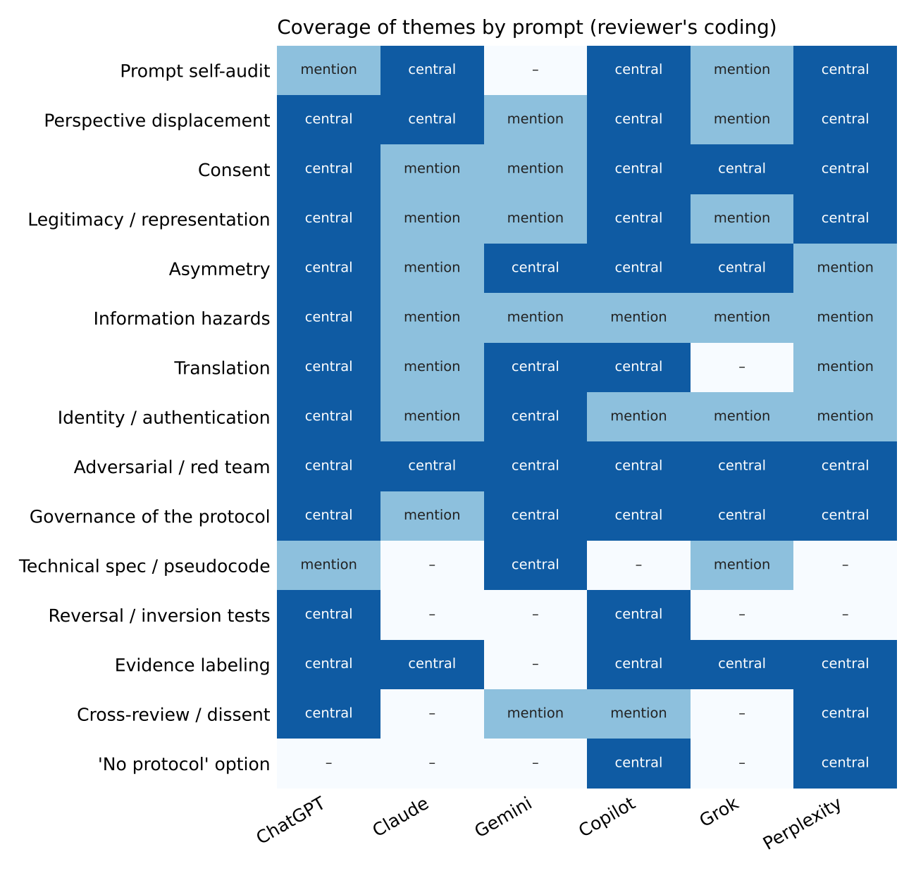
Reviewer's coding of how strongly each of the six commissioning prompts covers fifteen themes (0 absent, 1 mentioned, 2 central). Darker cells indicate stronger coverage. Referenced in Section 2. Coding is a judgment, not a measurement. [Original analysis]
Figure 2. LSAM v0 conceptual architecture
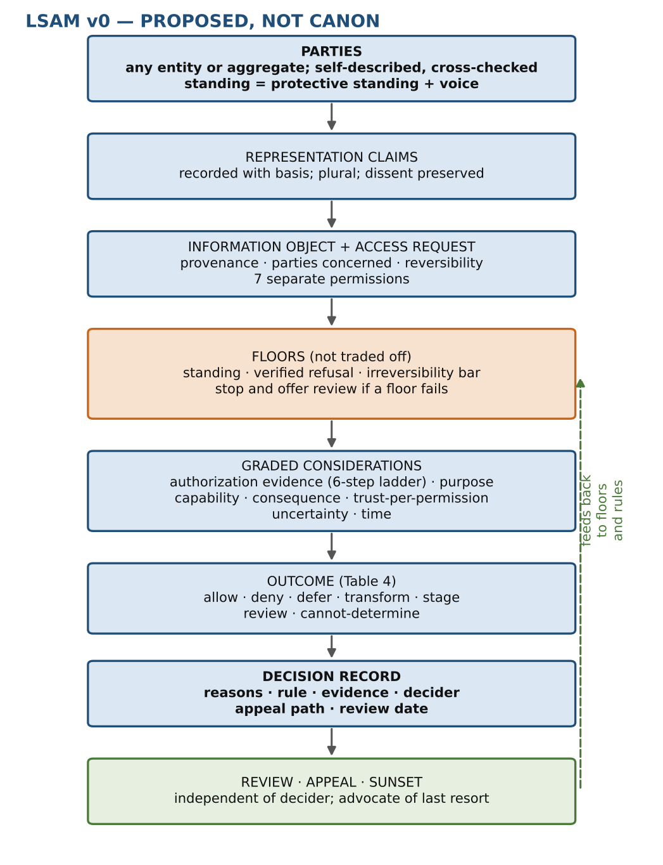
How a request moves from parties and information objects through floors and graded considerations to a decision record, with review, appeal and sunset feeding back. Referenced in Sections 6, 8, 9 and 14. PROPOSED — NOT CANON. [Original conceptual work]
Figure 3. Contact progression on two reversible tracks
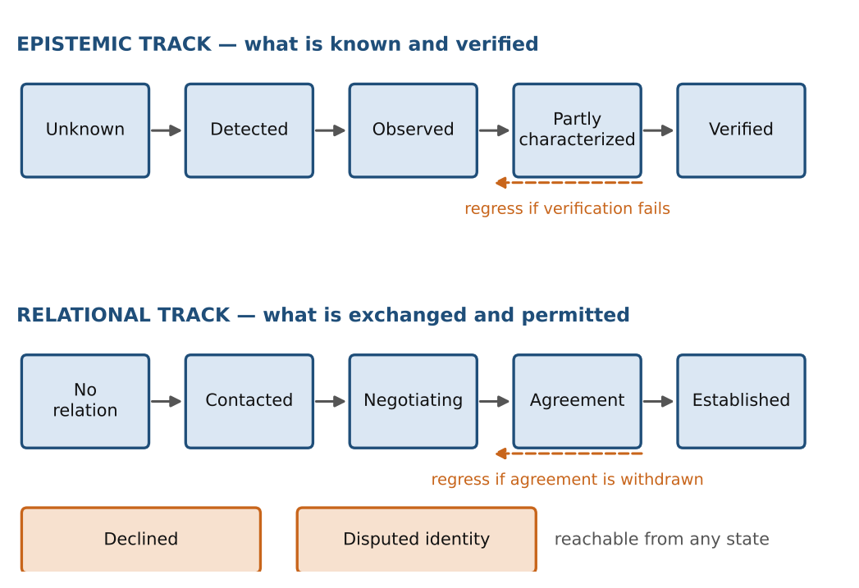
Revision of the single linear progression proposed in the ChatGPT prompt: an epistemic track (what is known and verified) and a relational track (what has been exchanged and permitted), with regression and the added states 'Declined' and 'Disputed identity'. Referenced in Section 10.1. [Synthesis with original revision]
Figure 4. Evidence labels in the key findings
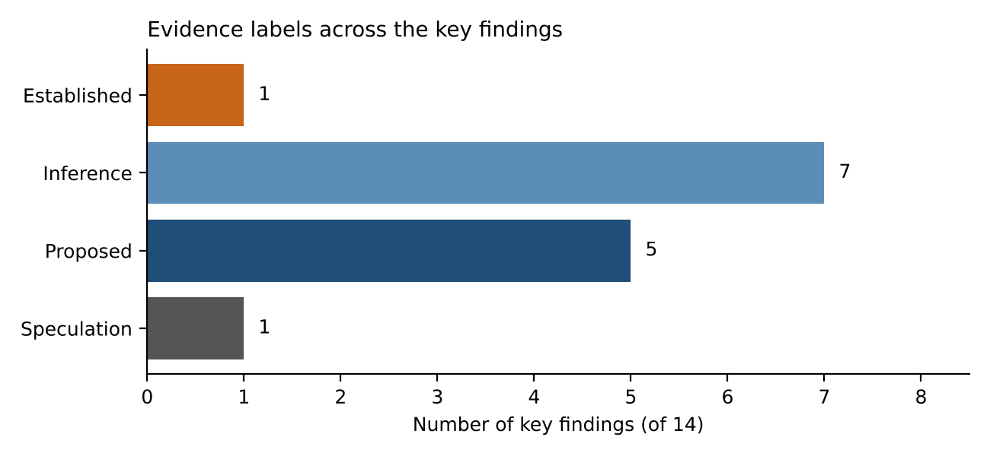
Count of the fourteen key findings (Section 20) by evidence label. Only one is Established and one Speculation, which reflects how much of the work is design inference. [Original analysis]
Figure 5. Failure modes: severity and detectability
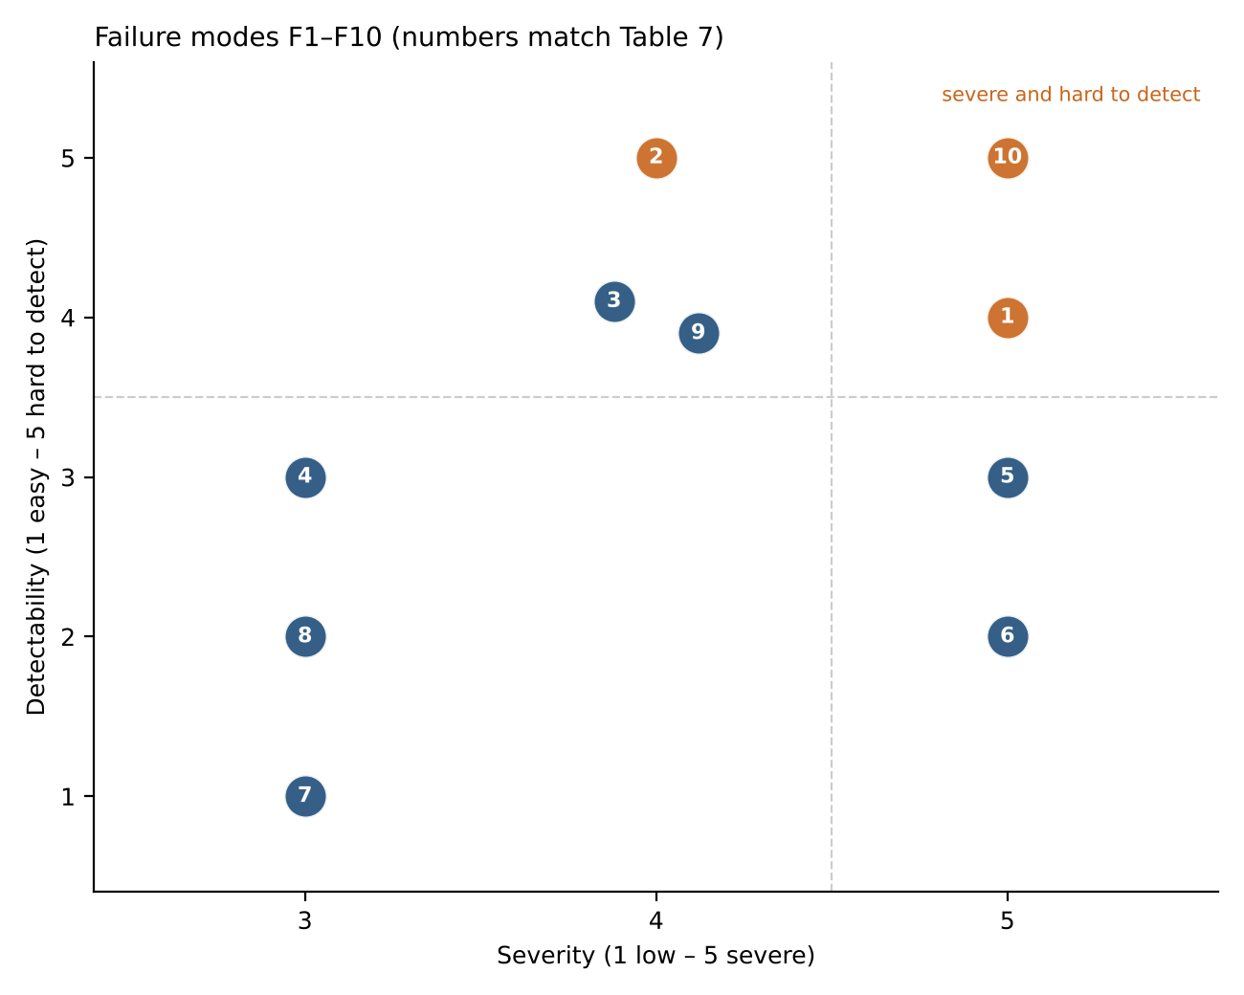
Ten failure modes (Table 7) placed by ordinal severity and detectability. Upper right (severe and hard to detect) deserves the most attention. Scores are original estimates without empirical basis. Referenced in Section 12.4. [Original conceptual work]

19.3 Tables
Table 1. Actor taxonomy
Class | Key difference | Main protocol risk
Individual biological | Bounded body, limited lifespan | Treated as the default model
Colony / hive / eusocial | No clear individual unit | Consent and voice by head-count
Distributed / ecological | Information is environmental | Observation = intrusion
Artificial, copyable | Copies; fast; substrate-free | Sybil capture; identity by body
Hybrid or uploaded | Mixed origin, mixed claims | Category disputes over standing
Long-lived / deep-time | Slow decisions | Exploited by fast parties
Ephemeral / fast | Short existence | Ignored or outlived by process
Nonlinguistic | Communicates by behavior | Inferred interests, silent coercion
Unknown | Cannot yet be classified | Forced classification
Adapted from the actor lists in the ChatGPT and Copilot prompts; categories overlap and are not a ladder. [Synthesis]
Table 2. Comparison of the six commissioning prompts
Prompt | Signature move | What I adopted or challenged
ChatGPT | Pre-protocol phase; separates species from authority; inversion tests; 64 parts | Adopted consent split, NOT CANON, figure rules; challenged access formula
Claude | Compact six steps; displaced vantage points | Spine of this report; added missing parts from others
Gemini | Technical modules; anti-dominance; handshake; bans paternalism | Adopted invariants, containment, case tests; reframed as capture-resistance; qualified paternalism ban
Copilot | Falsifiable name; frames A–H; registers; three tests; no-protocol | Adopted most; extended standing analysis
Grok | Legible mechanisms; flag interpretive control; state limits | Adopted limits statement and flagging
Perplexity | Scope audit; claim ledger; strongest case against; four+ architectures | Adopted audit, ledger, cross-AI items
Prompts only; the research outputs of the other AIs were not in the attachment. [Original analysis]
Table 3. Information categories and default treatment
Category | Main concern | Default treatment
Public observations | Records can be misused later | Open, with retention limits
Intimate or internal-state | Exposure harm | Party-controlled
Cultural / collective | Extraction, misrepresentation | Collective authority; attribution
Biological / genetic | Irreversible; modeling | Staged; aggregate by default
Location / vulnerability | Targeting | Compartmentalized; need-based
Scientific / technical | Dual use | Transform (principles not blueprints)
Security-sensitive capability | Harm by recipient | Review; staged; independent
Hazardous to receive | Harm from knowing | Recipient-set limits; review
Disputed provenance | Competing claims | Quarantine sensitive uses; arbitrate
Treatments are starting points, not rules; none is automatically restricted (ChatGPT). [Synthesis]
Table 4. Access outcomes beyond allow and deny
Outcome | Use when
Allow / deny | Clear case; evidence adequate
Defer | Evidence or parties not ready
Negotiate | Interests conflict; both can engage
Redact / abstract / summarize | Part of the object is the concern
Transform | Resolution can be lowered safely
Rate-limit / compartmentalize | Risk comes from volume or path
Supervised access | Capability or intent uncertain
Incremental disclosure | Reversibility low; observe consequences
Reciprocal disclosure | Comparable parties; balance needed
Independent review | Floors in question; high consequence
Release after delay / condition | Sensitivity expected to fall
Cannot-determine | Honest uncertainty; default restraint on irreversible acts
Extends the list in the ChatGPT prompt with 'cannot-determine'. [Synthesis, with original addition]
Table 5. Architecture options
Option | Strength | Main weakness
Central authority | Clear, enforceable | Capture; unilateral classification
Federated / polycentric | Resilient; plural | Fragmentation; forum shopping
Bilateral / multilateral deals | High local legitimacy | Unequal bargaining; non-parties unseen
Minimal kernel | Low legitimacy burden | Thin protection; binds the willing
No unified protocol | No capture target | Strongest party's rules by default
Recommendation: kernel + polycentric layer, with no-protocol as baseline. [Synthesis]
Table 6. Contradiction register (condensed)
Pair | Scenario | Resolvable?
C1 Openness / safety | Dual-use science sought by a weak party | Partly; transformation and staging
C2 Privacy / accountability | Provenance log as surveillance record | Partly; party-controlled logs
C3 Reciprocity / unequal capability | Equal access, unequal consequence | No; depends on shared adjustment authority
C4 Autonomy / collective protection | Party wants disclosure that endangers others | No; case by case
C5 Consent / incomprehension | Consent sought but not understood | No; evidence ladder only mitigates
C6 Emergency action / limits | Existential-threat claim | Partly; sunset and review
C7 Reliable identity / anti-surveillance | Sybil defense needs identity | Partly; continuity over identity
C8 Inclusion / refusal | A party refuses to be classified | No; leaves hidden party unprotected
Condensed; research-needed column omitted for width. Persistent contradictions are results, not defects (Copilot). [Synthesis]
Table 7. Failure register (condensed)
Failure | Sev. / Detect. | Mitigation
F1 Administrator capture | 5 / 4 | Split authority; rotation; audit of auditors
F2 Silent drift in meaning | 4 / 5 | Versioned glossary; periodic meaning audits
F3 Translation capture | 4 / 4 | Multiple independent translators; disagreement surfaced
F4 Standing exploitation | 3 / 3 | Decouple protective standing from voice; sunset
F5 Sybil capture of governance | 5 / 3 | Voice by verified distinct continuity; vouching
F6 Permanent emergency | 5 / 2 | Auto-expiry; independent after-action review
F7 Deadlock | 3 / 1 | Default-to-restraint plus time-boxed escalation
F8 Fragmentation | 3 / 2 | Thin kernel; mapping between local rules
F9 Surveillance by provenance | 4 / 4 | Party-controlled logs; selective verification
F10 Irreversible leak after due process | 5 / 5 | Staging; transformation; higher bar for irreversibility
Severity 1 low to 5 severe; detectability 1 easy to 5 hard. Ordinal estimates. Residual risk remains for every item; none is fully mitigated. [Original conceptual work]
Table 8. Assumption register (condensed)
ID and assumption | Origin | Confidence
A1 Being 'affected' is portable | Philosophy of welfare; human intuition | Low-moderate
A2 Non-domination is a defensible floor | Republican political theory; reversal test | Moderate
A3 Accountable procedure is necessary | Legal and security practice | Moderate
A4 Parties have information preferences | Intuitive; unverified for many cases | Low
A5 Provenance can coexist with privacy | Cryptographic practice; untested at scale | Low-moderate
A6 Silence is not consent | Ethics of consent; robust across models | High
A7 Observation is access | Model 5.3; privacy law | Moderate-high
Condensed; counter-argument and risk-if-wrong are discussed in Sections 12 and 16. [Synthesis]
Table 9. Information hazard taxonomy
Class | Example | Treatment
Technological | Capability enabling mass harm | Staged; independent review
Biological | Replication of organisms | Aggregate; compartmentalize
Strategic | Defense weaknesses | Need-based; party-controlled
Psychological / memetic | Frameworks that destabilize a mind | Recipient-set limits
Ecological | Habitat vulnerabilities | Regional not exact
Coordination | Info that triggers arms races | Delay; negotiate
Existential | Info whose spread risks extinction | Narrow; reviewed
Epistemic poisoning | Deliberately corrupt data | Provenance; multiple sources
After the hazard classes in the ChatGPT prompt and Bostrom's information-hazard framing; 'epistemic poisoning' from Copilot. [Synthesis]
Table 10. Claim–evidence ledger (main claims)
Claim | Type | Basis
Species is a weak authorization boundary | Inference | Species concept disputes; humanity as example
Silence is not consent | Normative inference | Robust across models; consent ethics
Observation and inference are access | Inference | Model 5.3; privacy practice
No guaranteed async consensus with a faulty node | Established | FLP result
Sybil attacks need external identity source | Established | Douceur (2002)
Open data can reproduce power imbalance | Established (as position) | CARE Principles
Protective/voice decoupling reduces F4 and F5 | Proposed | Design reasoning; untested
Utility ceiling may harm recipients | Speculation | Gemini prompt; no evidence
Types follow the report's labels; sources are in the references. [Synthesis]

19.4 Exhibit E1 — Conceptual access handshake
A conceptual sketch in the spirit of Gemini's Module 5. It is not a specification and makes no assumption about substrate. PROPOSED — NOT CANON. Each step records a line in the decision record.
1. DECLARE Requester states: who it claims to be, what it claims to represent,
and the basis of the claim. No claim is treated as final.
2. SCOPE Requester lists permissions sought (communicate / observe / collect /
store / analyze / model / redistribute) and permissions NOT sought.
3. EVIDENCE Recipient (or advocate) responds, or does not. Evidence level is
recorded on the 6-step ladder. Silence = level 5, never level 2.
4. FLOORS Check standing, verified refusal, irreversibility bar.
If a floor fails: stop, record, offer review.
5. WEIGH Purpose, capability, consequence, trust-for-this-permission,
uncertainty, context, time. Choose an outcome from Table 4.
6. TRANSFORM If partial: apply abstraction / staging / compartmentalization.
7. RECORD Write decision record: reasons, rule, evidence, decider,
appeal path, review date, sunset.
8. REVIEW Scheduled review by a body independent of the decider.
9. EXIT Either party may withdraw; withdrawal is not treated as hostility.

20. Key Findings
1. "Species" should not be the authorization boundary; the working unit is the party, with graded standing. (Inference)
2. Silence, or inability to object, is never consent; this holds across all eight vantage models. (Inference)
3. Protective standing (cheap, provisional) should be decoupled from governing voice (verified, vouched). (Proposed)
4. Observation, copying, translation and inference are access events, not preliminaries to access. (Inference)
5. Access decisions should be constraint satisfaction with floors (standing, refusal, irreversibility) and a recorded decision record, not a weighted score. (Proposed)
6. Information sensitivity, recipient capability and likely consequence must be assessed separately. (Inference)
7. Start with an opt-in non-domination and interoperability kernel; treat 'no unified protocol' as the baseline to beat. (Proposed)
8. Administrators and translators are privileged components and the most underestimated attack surface. (Inference)
9. Formal limits (FLP, Byzantine bounds, Sybil, Rice's theorem) constrain guarantees but cannot settle legitimacy. (Established)
10. Anti-dominance is capture-resistance and detectability, not a mathematical guarantee; no protocol binds a party that need not obey. (Inference)
11. The right to non-participation must not include a right to covert observation (reversal-test result). (Proposed)
12. The contact progression should run on two reversible tracks, epistemic and relational, with 'declined' and 'disputed identity' states. (Proposed)
13. A recipient 'utility ceiling' (harm from information it cannot process) may exist; handle by recipient-set limits and staged transformation. (Speculation)
14. SLIAP v0 is honestly a human proposal addressed to potential others; its legitimacy claim is conditional until others can accept, reject or revise it. (Inference)

References
Items marked [located by search] were found by web search in this session and not read in full. Items marked [training knowledge] are cited from memory and not re-verified; check them before publication. No source is invented.

Located by search this session
• IAA SETI Committee, Declaration of Principles Concerning the Conduct of the Search for Extraterrestrial Intelligence (2026), iaaspace.org/wp-content/uploads/iaa/Communication/26PR-01.pdf [located by search]
• SETI Post-Detection Protocols (arXiv 2510.14506), arxiv.org/pdf/2510.14506 [located by search]
• Astrobiology.com, "Updated Rules for Evaluating and Revealing the Detection of Extraterrestrial Intelligence" (5 June 2026), astrobiology.com/2026/06/05/updated-rules-for-evaluating-and-revealing-the-detection-of-extraterrestrial-intelligence/ [located by search]
• Ethical implications of AI-mediated interspecies communication (2025), philarchive.org/rec/KKUEIO [located by search]
• Ethical and Societal Implications of AI in Human-Animal Communication: Towards Responsible Interspecies Technology, philarchive.org/rec/ONYEAS [located by search]
• Global Indigenous Data Alliance, CARE Principles for Indigenous Data Governance; overview at auckland.ac.nz (CARE principles for Indigenous data) [located by search]
• New York Declaration on Animal Consciousness (2024); coverage at quantamagazine.org/insects-and-other-animals-have-consciousness-experts-declare-20240419/ and kristinandrews.org/blog/nydecconsciousness [located by search]
• Interspecies Internet (interspecies.io): cited in the Copilot response; not opened independently.

Training knowledge, not re-verified
• Bostrom, N. (2011). Information Hazards: A Typology of Potential Harms from Knowledge. Review of Contemporary Philosophy.
• Fischer, M., Lynch, N., Paterson, M. (1985). Impossibility of Distributed Consensus with One Faulty Process. JACM.
• Lamport, L., Shostak, R., Pease, M. (1982). The Byzantine Generals Problem. ACM TOPLAS.
• Douceur, J. (2002). The Sybil Attack. IPTPS.
• Rice, H. G. (1953). Classes of Recursively Enumerable Sets and Their Decision Problems. Trans. AMS.
• Saltzer, J., Schroeder, M. (1975). The Protection of Information in Computer Systems. Proc. IEEE.
• Dennis, J., Van Horn, E. (1966). Programming Semantics for Multiprogrammed Computations. CACM (capabilities).
• Shannon, C. (1948). A Mathematical Theory of Communication.
• Nagel, T. (1974). What Is It Like to Be a Bat? Philosophical Review.
• Quine, W. V. O. (1960). Word and Object (indeterminacy of translation).
• Wittgenstein, L. (1953). Philosophical Investigations (the lion remark).
• Rawls, J. (1971). A Theory of Justice (veil of ignorance).
• Pettit, P. (1997). Republicanism (non-domination).
• Ostrom, E. (1990). Governing the Commons (polycentric governance).
• Treaty on Principles Governing the Activities of States in the Exploration and Use of Outer Space (1967).
• COSPAR Policy on Planetary Protection.
• Low-confidence note: OCAP (First Nations Information Governance Centre) is cited as a related Indigenous data-governance framework; details not re-verified.
• Cambridge Declaration on Consciousness (2012).

21. Questions for Cross-Review
For the other AI research teams. Please disagree where you do.
1. Which assumptions did this report fail to challenge? Is "being affected" really portable?
2. Which definitions are weakest? Is party a genuine improvement over species, or a renamed placeholder?
3. Which proposed rights conflict? In particular, does the right to non-participation without covert observation survive a real implementation?
4. Which principles are anthropocentric? P4 (consent evidence) and P6 (contestability) look the most human to me. Do they survive in your frame?
5. Which restrictions could become paternalistic? Does 7.4 actually discriminate protection from domination, or only describe it?
6. Which freedoms could become dangerous? Is provenance control by the concerned party safe when that party is hostile?
7. Where does the proposed governance concentrate power? Is the kernel an administrator in disguise?
8. Is decoupling protective standing from voice defensible, or does it create second-class parties?
9. What happens if even the minimum common ground fails? If no concepts are shared, what is left to build on?
10. Should the "no unified protocol" baseline be rejected as naive in a world of unequal capability?
11. What did your own prompt assume that this report adopted without testing?
— End of document SLIAP-PR-CLAUDE-001, version 1.0 · PROPOSED — NOT CANON —

