**Project Description:**

**Name:** Coinlecter

**Description:** This game will start in a hub like place, where in the hub you have a variety of options, like, “How to Play”, choosing levels, the shop will also be in the hub. And then, when you want to start the game, you just move to the specified location, and start the game. While playing, the game will be a Mario-ish type of game in terms of game mechanics, but different in other ways, like the graphics, type of monsters, and levels.

**Competitive Analysis:**

**1 -** [**https://youtu.be/aD5BdfkYo1M**](https://youtu.be/aD5BdfkYo1M) **:**

Unique: Moving Platforms, Checkpoints, Hidden Levels

**2 -** [**https://youtu.be/oGEI9oaVWqw**](https://youtu.be/oGEI9oaVWqw) **:**

Unique: Levels within a Level

Shared: Different types of Monsters, Power Ups, Lives, Score, Time, Coins,

Similar Graphics

My project will be similar to these projects in terms of game mechanics, but will be different in terms of graphics, monsters, levels, and level types.

**Structural Plan:**

**Classes**:

|  |  |  |  |  |  |
| --- | --- | --- | --- | --- | --- |
| Classes | Player | Platform | Level | Hub /  Level1 /  Level2 /  Level3 | Coins |
| Inheritance | From pygame.sprite | From pygame.sprite | None | From Level | From pygame.sprite |
| Functions | Jump  Gravity  Collect coins  moving | None | Draw  shiftWorld | None | Update animation |

**Algorithmic Planning:**

The Hub and Levels:

Create a class that creates the hub or levels, with a 2d list of tiles in them, each tile is 70x70 pxls. Then we go through each tile in the list, and create sprites off of them by calling different classes like “Platform” or “Coins”

Collisions:

For collision detection, there is a built-in function in pygame for sprites that detects collisions. So, I will make every tile or platform a sprite and then check for collisions with the player, and do different things depending on the type of collision it is.

Collecting Coins:

To allow the player to collect coins, I would check for collision (Described above) between the player and the coin, if there exists a collision, then the coin disappears, and the coins variable increases by one.

**Timeline Plan:**

**By TP1:**

Finish a few levels.

Finish the hub.

Finish coins system.

**By TP2:**

Finish the rest of the levels.

Finish the shop system.

**By TP3:**

Fix some bugs.

Maybe add some new features

**Version Control Plan:**

I am going to back up my code with iCloud.

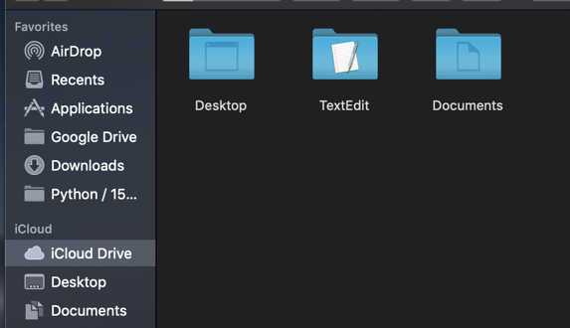

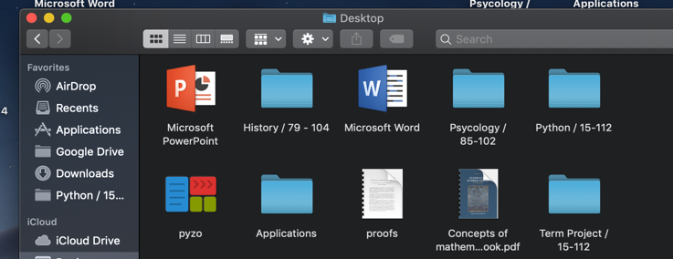

**Module List:**

Pygame

**TP2 Update**

**Changes in design:**

* First you spawn at the How To Play, then after you finish the tutorial you go to the hub.

**TP3 Update**

**Changes in design and game mechanics:**

* Added Game Over level where the player goes to when they run out of lives.
* Added Win level where the player goes to when they finish all levels.
* Added an extra level.
* Added masks to the shop ☺