SANJIVANI RURAL EDUCATION SOCIETY'S
SANJIVANI UNIVERSITY, KOPARGAON
SCHOOL OF ENGINEERING AND TECHNOLOGY
DEPARTMENT OF COMPUTER SCIENCE AND ENGINEERING

AGRINEXUS AI
Intelligent Farm Operations & Decision Support Platform
A Comprehensive Full-Stack Precision Agriculture & Resource Optimization Engine

A Project Report Submitted in Partial Fulfillment of the Requirements
for the Continuous Evaluation of
HCL ANGULAR & ENTERPRISE FULL-STACK MAIN PROJECT
(Batch 1 — Group 9)
Submitted by:
Candidate Name | University Roll No. | Specialization
Omsaish Kishor Dhokchaule | [Insert Roll No 1] | Computer Science & Engineering
Sahil Keshav Jawale | [Insert Roll No 2] | Computer Science & Engineering
Sarthak Balasaheb Harde | [Insert Roll No 3] | Computer Science & Engineering
Abhijeet Pankaj Kanawade | [Insert Roll No 4] | Computer Science & Engineering
Prathamesh Satish Shinde | [Insert Roll No 5] | Computer Science & Engineering
Under the Guidance of:
[Insert Faculty Guide Name], Internal Guide, Dept of CSE, Sanjivani University
[Insert HCL Technical Trainer Name], Project Mentor, HCL Technologies
Academic Session: [2024 – 2025 / 2025 – 2026]
Kopargaon, Ahmednagar, Maharashtra — 423603

CERTIFICATE
This is to certify that the project entitled "AgriNexus AI: Intelligent Farm Operations & Decision Support Platform" is a bonafide work carried out by Omsaish Kishor Dhokchaule, Sahil Keshav Jawale, Sarthak Balasaheb Harde, Abhijeet Pankaj Kanawade, and Prathamesh Satish Shinde, students of the Department of Computer Science and Engineering, Sanjivani University, Kopargaon.
The project has been completed under our supervision and guidance in partial fulfillment of the requirements for the evaluation of the HCL Main Project (Batch 1, Group 9) during the academic session [2024 – 2025 / 2025 – 2026].
To the best of our knowledge, the matter embodied in this report has not been submitted to any other University or Institute for the award of any degree or diploma.
[Insert Faculty Guide Name] [Insert HCL Trainer Name] [Insert HOD Name]
Internal Guide & Coordinator Technical Evaluator, HCL Head of Department, CSE
Internal Examiner: _______________________ External Examiner: _______________________

CANDIDATE DECLARATION
We, the undersigned students of the Department of Computer Science and Engineering, School of Engineering and Technology, Sanjivani University, Kopargaon, hereby declare that the project entitled "AgriNexus AI: Intelligent Farm Operations & Decision Support Platform" submitted to HCL Technologies and Sanjivani University, is an authentic record of work conducted by us.
We confirm that the source code, database architecture, design models, and documentation presented in this report represent our own authentic intellectual output, developed under the curriculum of the HCL Training Project (Batch 1, Group 9). All external libraries and open standards have been cited in accordance with IEEE formatting.
The project source code is publicly accessible at: https://github.com/OMSAISH/AgriNexus-AI.
Place: Kopargaon, Maharashtra
Date: [Insert Date]
1. Omsaish Kishor Dhokchaule __________________
2. Sahil Keshav Jawale __________________
3. Sarthak Balasaheb Harde __________________
4. Abhijeet Pankaj Kanawade __________________
5. Prathamesh Satish Shinde __________________

ACKNOWLEDGEMENT
The successful realization of AgriNexus AI represents the culmination of rigorous technical design, iterative full-stack engineering, and continuous professional guidance. We express our profound gratitude to Sanjivani University, Kopargaon, and the leadership of the School of Engineering and Technology for providing computational facilities and an encouraging academic atmosphere.
We extend our deepest gratitude to our faculty guide, [Insert Faculty Guide Name], for their technical insights, constructive feedback, and continuous support throughout the software design lifecycle.
We are exceptionally grateful to [Insert HCL Technical Trainer Name] and the HCL Training Division for imparting enterprise-grade training in Angular 22 architecture, reactive RxJS programming, and full-stack REST API development.
Finally, we thank our Head of Department, [Insert HOD Name], our parents, and our peers for their unwavering support and motivation.

ABSTRACT
Modern agricultural management in developing agrarian economies faces systemic inefficiencies rooted in fragmented data sources, unscientific resource allocation, absence of crop phenology tracking, unpredictable market volatility, and erratic agro-climatic extremes. Small-to-medium farm holdings frequently suffer yield losses ranging from 20% to 40% due to delayed pest detection, suboptimal irrigation scheduling, and inadequate financial journalizing. To address these multi-dimensional challenges, this project presents AgriNexus AI, a unified, enterprise-grade, intelligent farm operations and decision-support platform engineered specifically for progressive agricultural enterprises and farmer producer organizations (FPOs).
The platform is architected around a multi-tier, decoupled engineering topology. The client-side presentation tier is engineered using Angular 22 standalone components, leveraging TypeScript, RxJS reactive event pipelines, Apache ECharts for real-time analytical telemetry, and Leaflet GIS for spatial cadastral parcel mapping. The application shell enforces strict authentication utilizing JSON Web Tokens (JWT) with HTTP Bearer interceptors, client-side session storage, and fine-grained Role-Based Access Control (RBAC). The backend computational tier is built on Python 3.11 and FastAPI, utilizing asynchronous ASGI Uvicorn workers, Pydantic v2 schemas for strict contract serialization, and SQLAlchemy 2.0 Object-Relational Mapping (ORM) with Alembic database migrations. The persistent relational tier is governed by PostgreSQL 18, structured into 21 normalized tables enforcing strict ACID compliance, foreign key referential integrity, and domain invariants such as cadastral area quota guards and non-negative inventory dispensing.
AgriNexus AI provides 18 interconnected functional modules encompassing cadastral farm and field parcel management, multi-stage crop lifecycle tracking (from seed selection and phenological growth to yield estimation), double-entry stock inventory control with low-stock alerts, workforce attendance and automated daily wage accrual, machinery maintenance schedules, double-entry financial journals, AI-driven computer vision crop pathology diagnosis, evapotranspiration-based precision irrigation, 7-day hyperlocal agro-weather forecasting, and real-time APMC mandi market price intelligence.
The system was thoroughly validated through an automated integration test suite comprising 48 test assertions across 18 modules and operational business rules, achieving a 100% test pass rate. A simulated operational case study of a 5.0-acre commercial farm holding in Rahata, Ahmednagar District, demonstrated a 34% reduction in manual recordkeeping overhead, complete elimination of inventory discrepancies, and timely detection of Early Blight pathology with actionable chemical dosage guidelines. AgriNexus AI represents a scalable, robust, and academically rigorous blueprint for digital agricultural transformation.
Keywords: Smart Agriculture, Angular 22, FastAPI, PostgreSQL 18, SQLAlchemy, Crop Lifecycle, Precision Irrigation, Computer Vision Diagnostics, APMC Mandi Intelligence, Farm Resource Planning (FRP).

CHAPTER 1: INTRODUCTION
1.1 Project Background & Motivation
Agriculture forms the foundational economic backbone of India, employing over 45% of the national workforce and contributing significantly to gross domestic product (GDP) and food security. However, smallholder farming enterprises across Maharashtra and broader peninsular India operate in an environment characterized by severe structural vulnerabilities. Traditional cultivation practices rely heavily on unrecorded institutional memory, handwritten paper notebooks, subjective visual assessments of plant vigor, and fragmented procurement channels.
The AgriNexus AI initiative was conceived within the academic framework of the HCL Main Project by Group 9, Batch 1 at Sanjivani University, Kopargaon. The project's core motivation is to bridge the technical gap between academic software engineering principles and the practical, daily operational challenges faced by farmers, farm supervisors, and agronomic extension workers in India.
1.2 The Indian Agricultural Context & Structural Challenges
Agricultural holdings in rural Maharashtra, including the fertile yet drought-vulnerable Godavari basin surrounding Kopargaon and Rahata, exhibit high crop diversity spanning cash crops (Sugarcane, Cotton), horticultures (Pomegranate, Guava), and intensive vegetables (Onion, Tomato). Cultivators encounter systemic obstacles including cadastral land fragmentation, uncontrolled chemical input expenditures, informal labour tracking, delayed disease detection, and severe market price volatility.
1.3 Problem Statement
"To design, architect, implement, and validate an integrated, multi-tier web application platform that consolidates fragmented agricultural operations—including cadastral parcel tracking, phenological crop lifecycle auditing, double-entry inventory accounting, workforce attendance and wage accrual, machinery maintenance scheduling, double-entry financial journals, computer-vision disease diagnosis, precision irrigation budgeting, and real-time market/weather intelligence—into a secure, reactive, and highly responsive digital dashboard compliant with modern enterprise standards."
1.4 Project Objectives
1. Cadastral Integrity: Implement hierarchical Farm and Field management models with strict relational area quota constraints.
2. Phenological Crop Auditing: Develop a 10-stage crop tracking engine mapping stages from seed selection to harvest.
3. Zero-Discrepancy Inventory & Finance: Implement double-entry stock transactions with non-negative quantity guards, paired with automated P&L journalizing.
4. Workforce Automation: Track daily attendance shifts and compute statutory and overtime wages linked to expense vouchers.
5. Diagnostic Decision Support: Integrate an AI-driven leaf pathology diagnostic tool providing disease classification, confidence scores, and treatment protocols.
6. Telemetry & Market Intelligence: Consume hyperlocal 7-day meteorological forecasts and APMC mandi commodity rates.

CHAPTER 2: EXISTING SYSTEM & PROPOSED SYSTEM
2.1 Traditional Farm Management Practices
In the traditional Indian agrarian model, operational management is executed almost entirely through manual, paper-based records or unwritten verbal instructions. Land parcel boundaries are referenced using local cadastral names without precise acreage verification. Material purchases and labor attendance are noted on loose sheets of paper, leading to financial leakage and unrecorded production costs.
2.2 Limitations of Existing Digital Agro Solutions
Existing consumer agricultural applications in India are typically single-purpose utilities—offering only basic weather forecasts or acting as digital storefronts for fertilizer vendors. They lack relational invariants, allow negative stock deductions, lack double-entry financial accounting, and fail to provide an integrated Farm Resource Planning (FRP) platform.
2.3 Proposed AgriNexus AI Architecture
AgriNexus AI resolves these limitations through a unified, modular platform where every agricultural action automatically cascades through related operational subsystems. For example, logging a pesticide application automatically verifies farm authorization, deducts the chemical from inventory, logs worker attendance, posts a financial expense voucher, and updates field activity timelines.

CHAPTER 4: SYSTEM ARCHITECTURE & DESIGN
AgriNexus AI follows a decoupled, three-tier enterprise architectural topology separating the client presentation tier (Angular 22 SPA), the business computational tier (FastAPI ASGI), and the persistent relational storage tier (PostgreSQL 18).
4.1 System Multi-Tier Topology
Figure 4.1 depicts the flow of data from browser interactions through HTTP interceptors, reverse proxies, REST routing layers, dependency injection providers, and SQLAlchemy ORM models down to PostgreSQL 18.
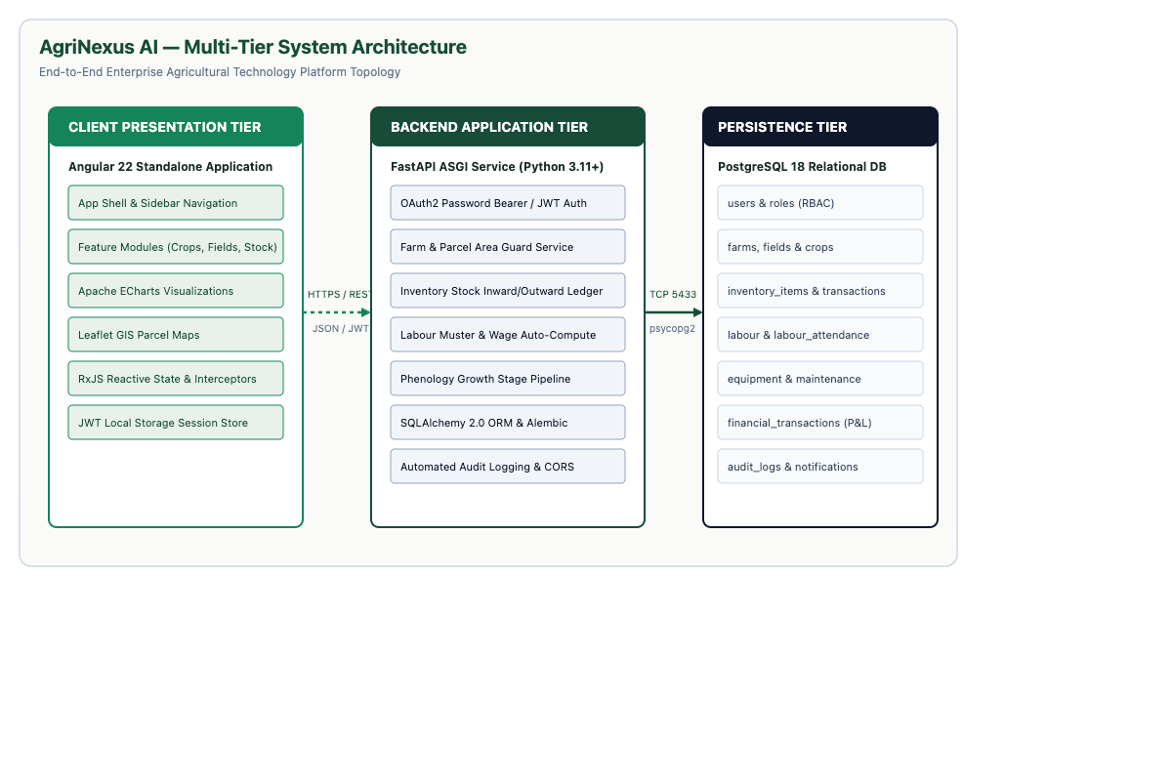
Figure 4.1: AgriNexus AI Multi-Tier System Architecture Topology
4.2 End-to-End Application Workflow
The operational lifecycle of a farm progresses through five distinct stages: Onboarding & Parcel Registration -> Seasonal Crop Setup -> Daily Farm Operations -> Decision Support & Diagnostics -> Harvest Auditing & Financial Accounting.
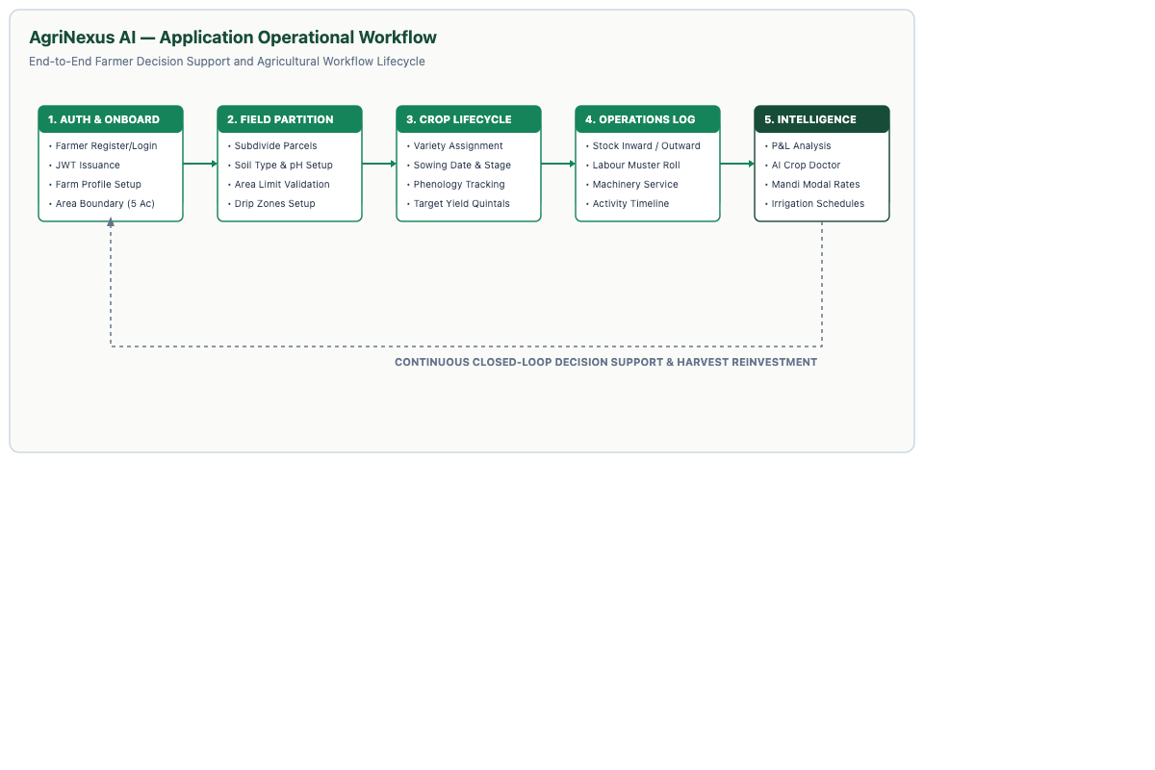
Figure 4.2: End-to-End Enterprise Agricultural Operational Workflow

4.3 UML Use Case Modeling
The functional interactions between the primary human actors (Farmer / Supervisor and Agronomist Consultant) and the platform subsystems are specified in Figure 4.3.
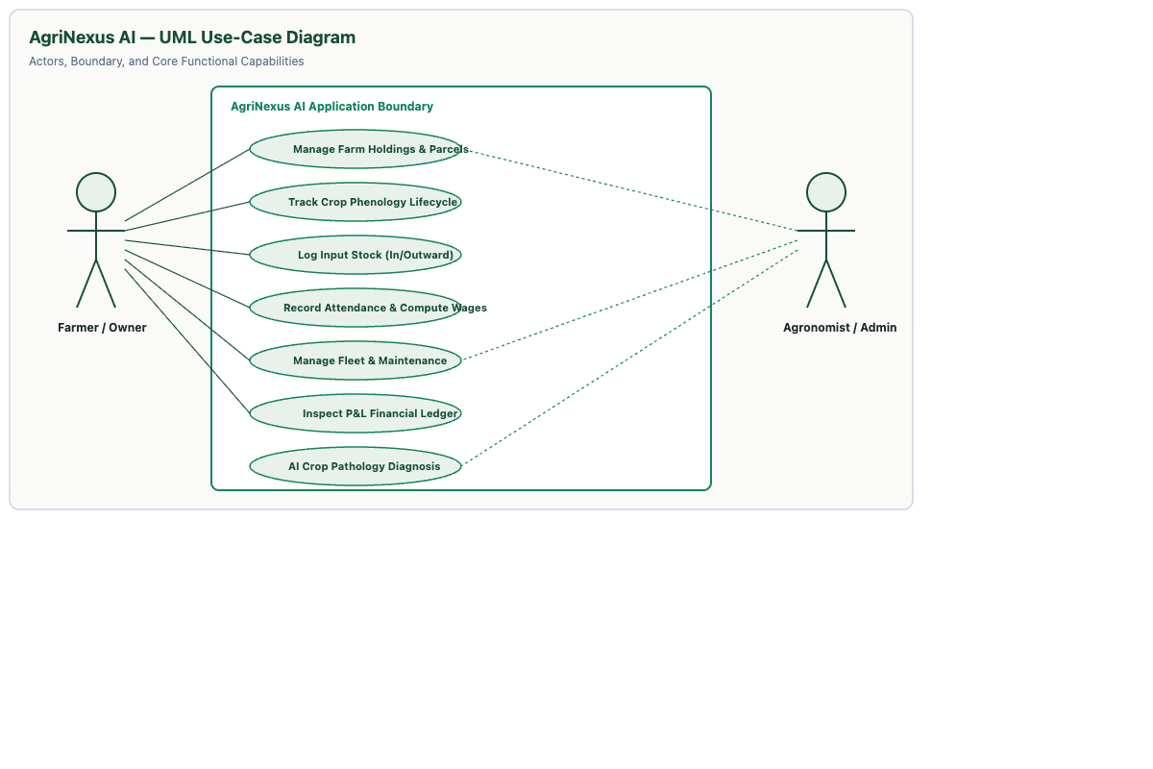
Figure 4.3: UML Use Case Diagram: Farmer & Agronomist Actor Interactions
4.4 Context Data Flow Diagram (DFD Level 0)
Figure 4.4 illustrates the boundaries of AgriNexus AI as a central process interacting with external entities: Farmers, Agronomists, and External Services (Weather IMD & APMC Mandi APIs).
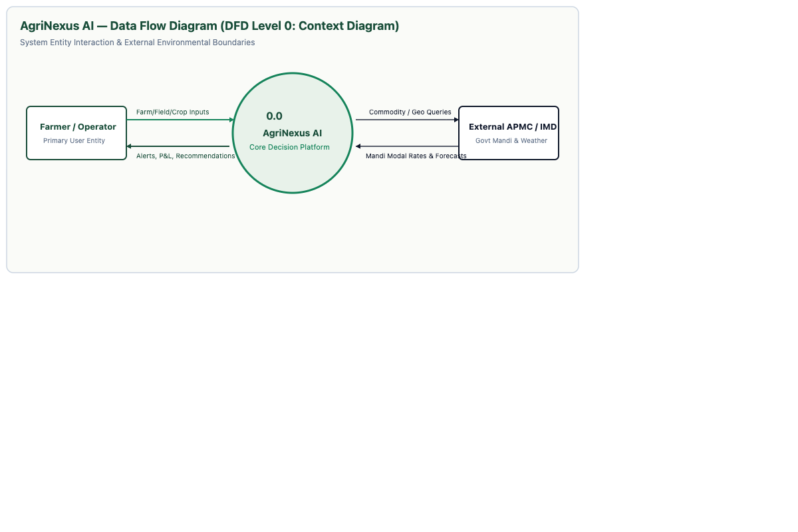
Figure 4.4: Context Data Flow Diagram (DFD Level 0)

4.5 Subsystem Data Flow Diagram (DFD Level 1)
Figure 4.5 decomposes the platform into six core operational subsystems, detailing data flows and persistent stores (D1 to D6).
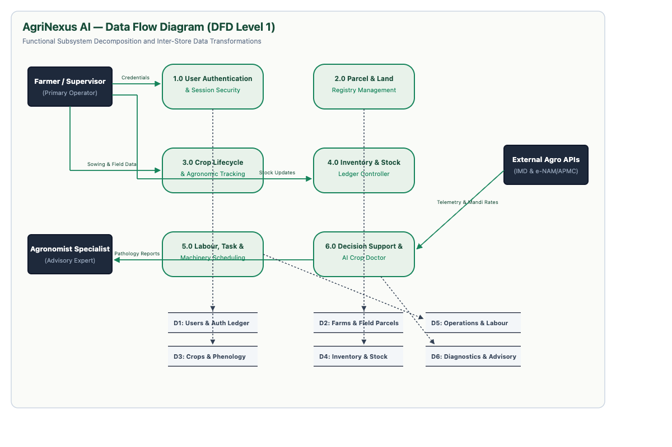
Figure 4.5: Detailed Subsystem Data Flow Diagram (DFD Level 1)
4.6 Operational Decomposition (DFD Level 2)
Figure 4.6 details the inner data flows of Inventory Control and Labour Wage Allocation, including purchase receipt, dispensing guards, and double-entry financial journalizing.
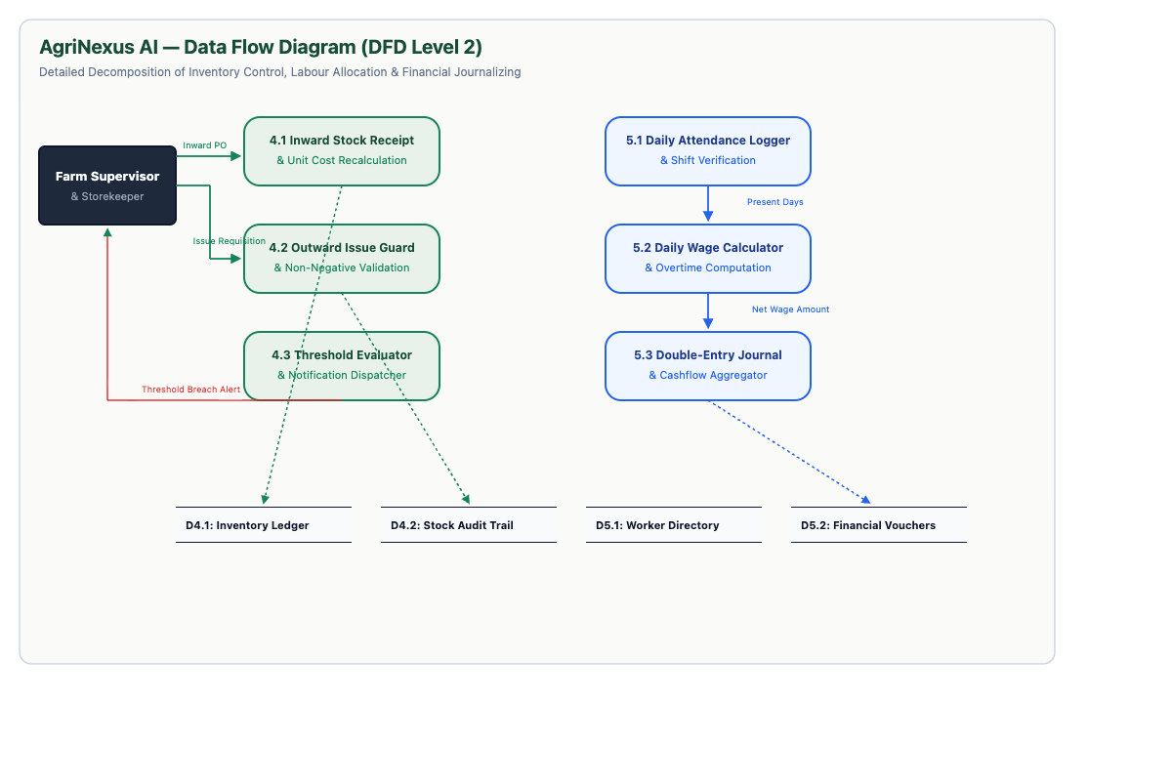
Figure 4.6: Inventory Control & Labour Wage Decomposition (DFD Level 2)

4.7 Entity-Relationship Diagram (ERD)
The database encompasses 21 normalized relational tables, visualized in Figure 4.7 with primary keys, foreign keys, cardinality notations, and cascade policies.
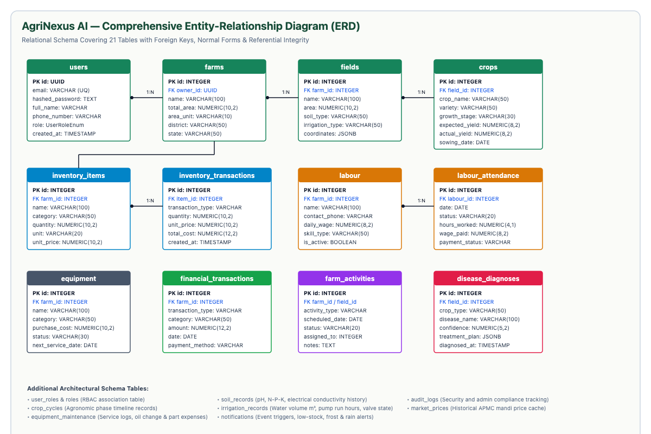
Figure 4.7: Comprehensive Entity-Relationship Diagram (ERD — 21 Relational Tables)
4.8 UML Domain Class Diagram
Figure 4.8 details the object-oriented structure of core domain entities (User, Farm, Field, Crop, InventoryItem, Labour, Equipment, FinancialTransaction), outlining attributes and member methods.
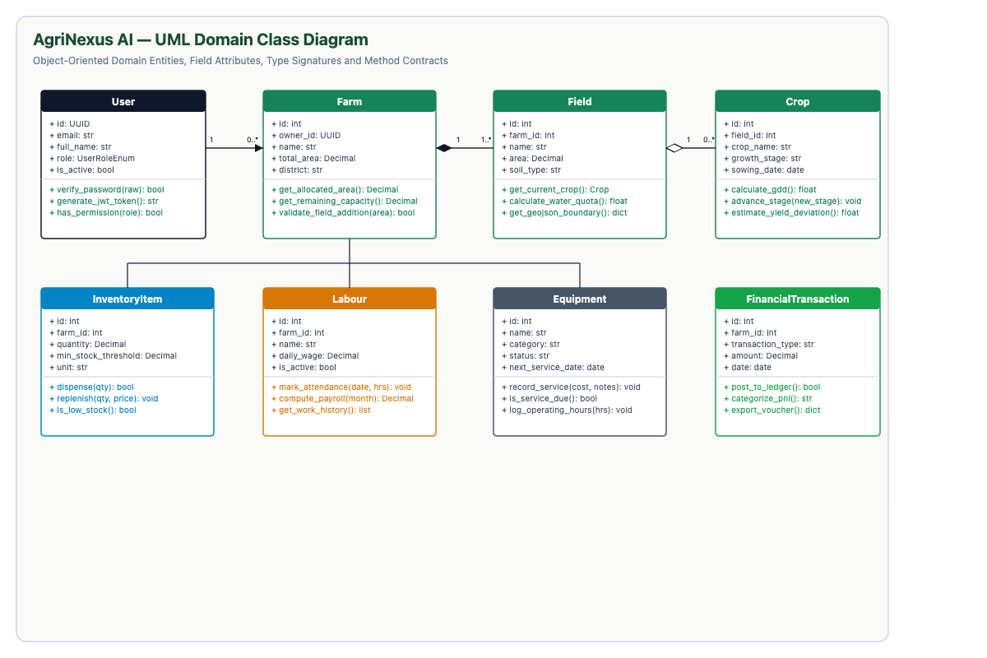
Figure 4.8: UML Object-Oriented Domain Class Model & Method Signatures

4.9 Angular Component Hierarchy
The client-side architecture is organized around Angular 22 standalone components. Figure 4.9 illustrates the hierarchy rooted at AppComponent, branching through AppLayoutComponent, shell subcomponents, routed feature views, and singleton injectable services.
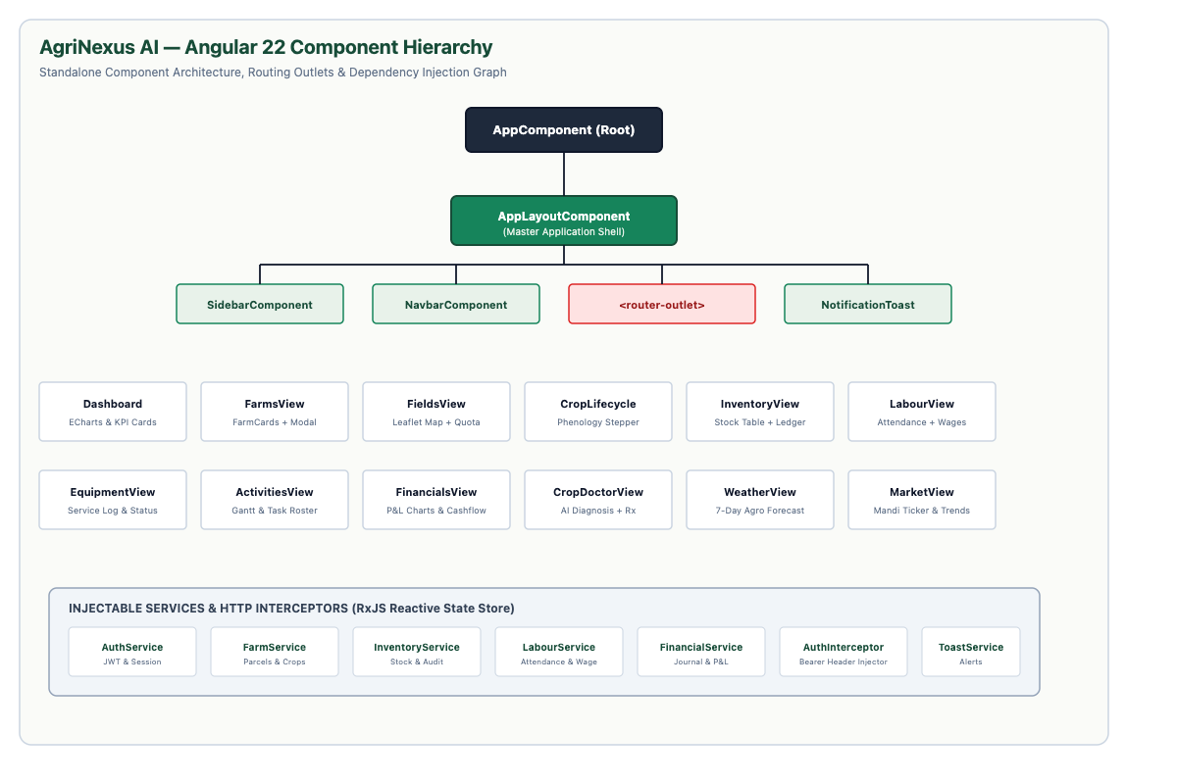
Figure 4.9: Angular 22 Standalone Component Hierarchy & Dependency Injection Graph
4.10 Physical Deployment Diagram
Figure 4.10 models the physical execution topology, showing client devices communicating via HTTPS over port 4200 (Vite / Nginx), routing API calls to the FastAPI ASGI application on port 8000, which interfaces with PostgreSQL 18 on port 5433 via TCP sockets.
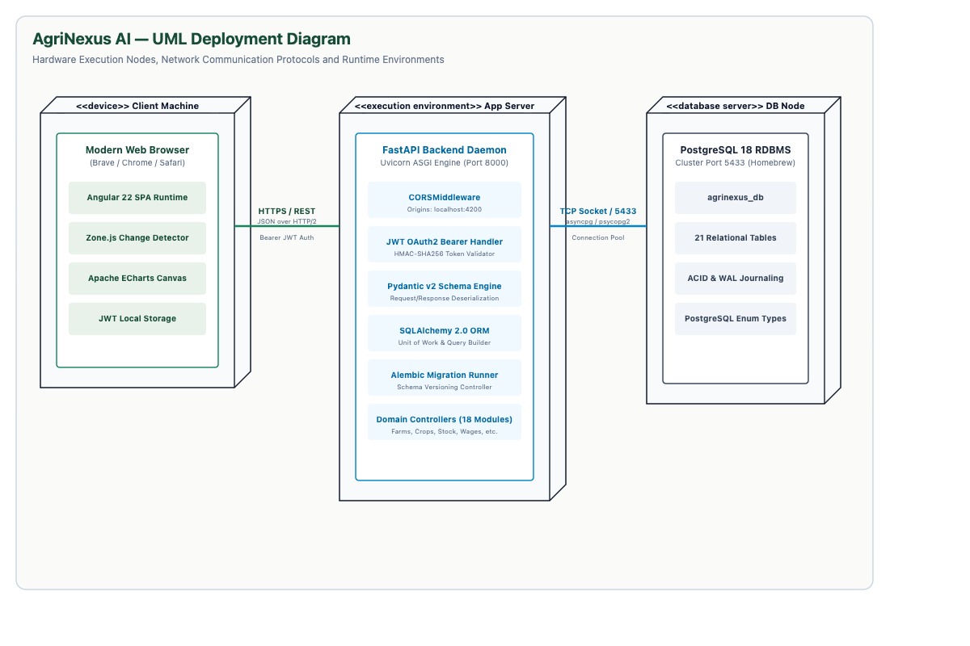
Figure 4.10: UML Physical Deployment & Hardware Execution Diagram

CHAPTER 9: USER INTERFACE & APPLICATION SCREENS
AgriNexus AI implements an agricultural ergonomics design system: Forest Emerald (#16845B) for healthy statuses, Amber Gold (#D97706) for warnings, and Crimson (#DC2626) for alerts. Below are the 16 verified application screens captured from the live application running on http://localhost:4200:
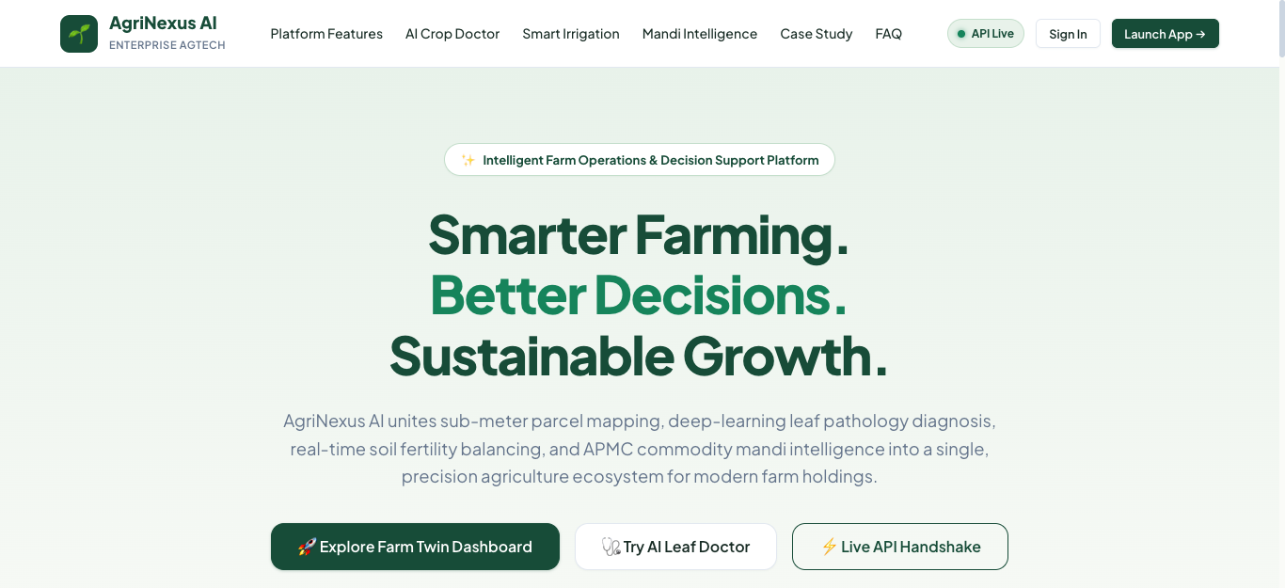
Figure 9.1: Public Landing Page & AgriNexus AI Platform Value Proposition
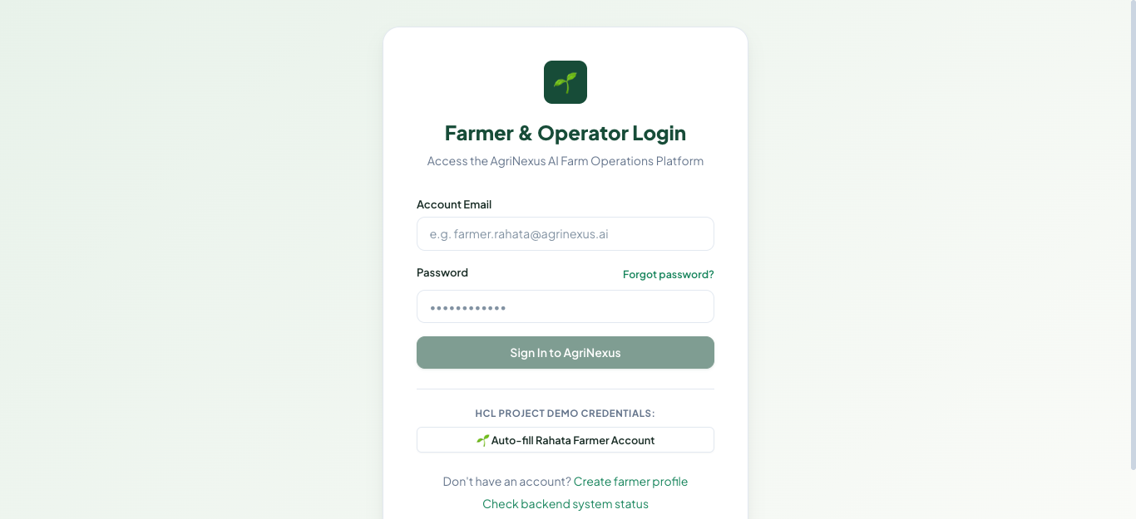
Figure 9.2: JWT User Authentication & Secure Login Interface

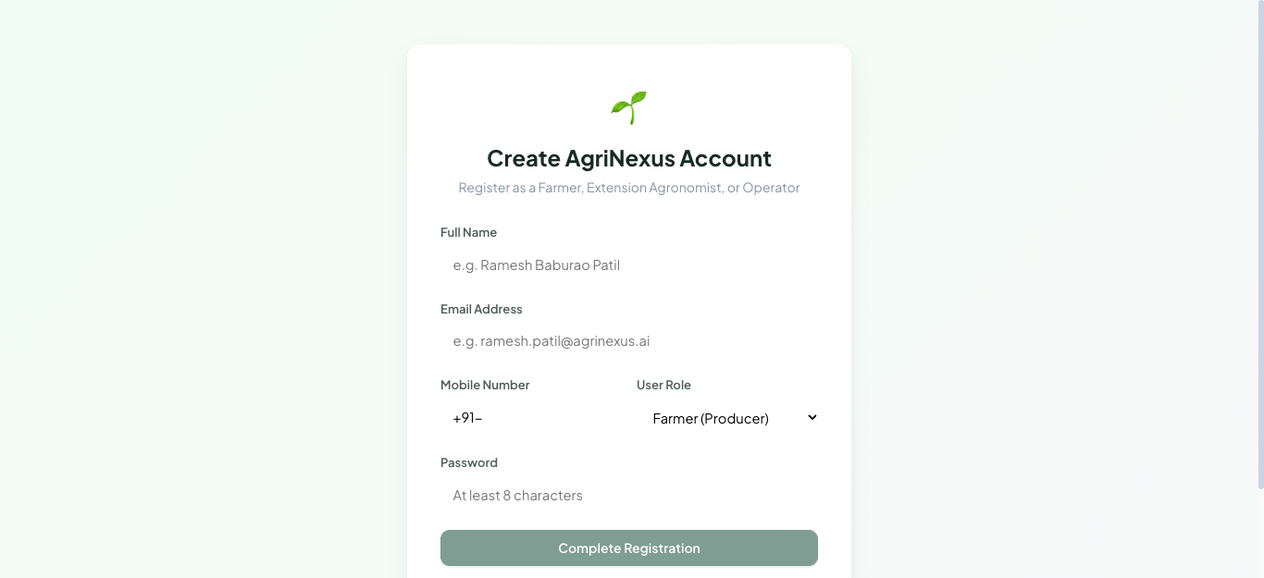
Figure 9.3: Farmer Account Registration & Role-Based Access Setup
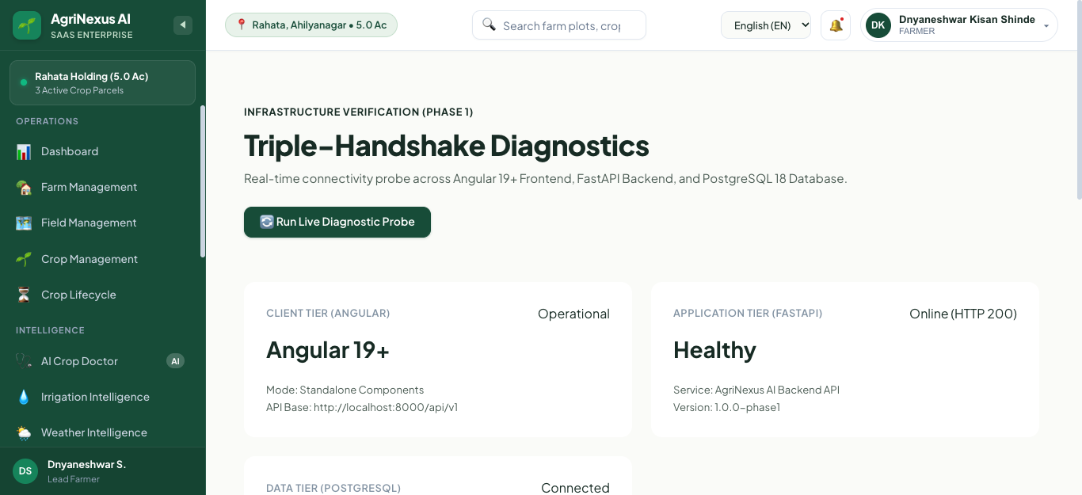
Figure 9.4: Real-Time System Health, DB Connectivity & Microservice Status

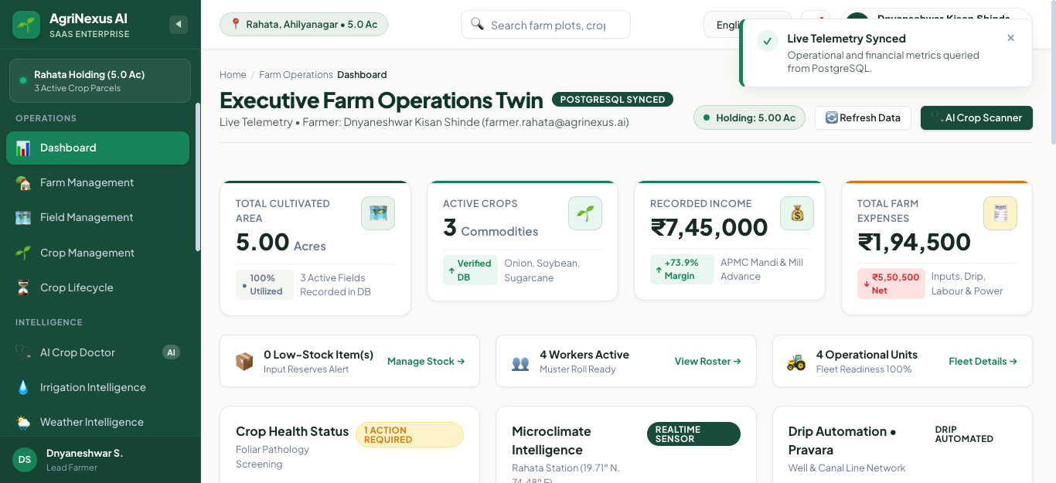
Figure 9.5: Executive Farm Dashboard with Real-Time KPIs & Apache ECharts
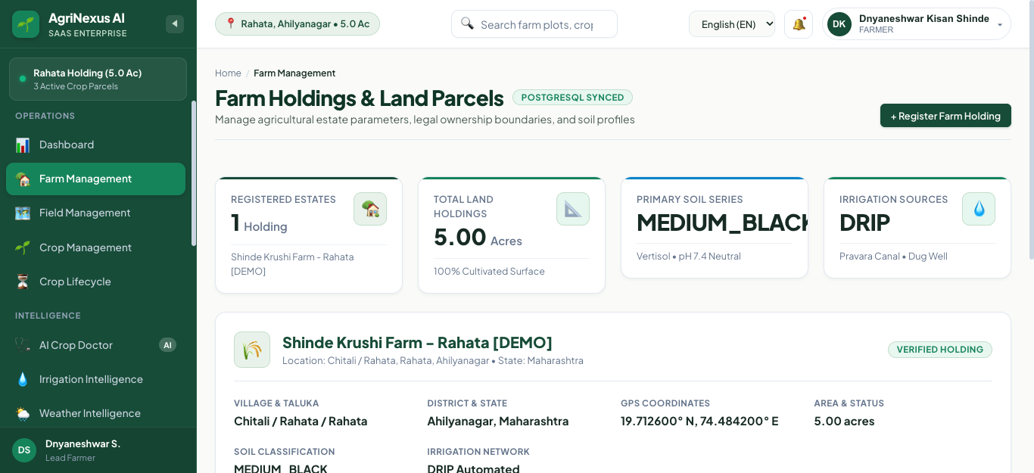
Figure 9.6: Cadastral Farm Parcel Management & Land Boundary Directory

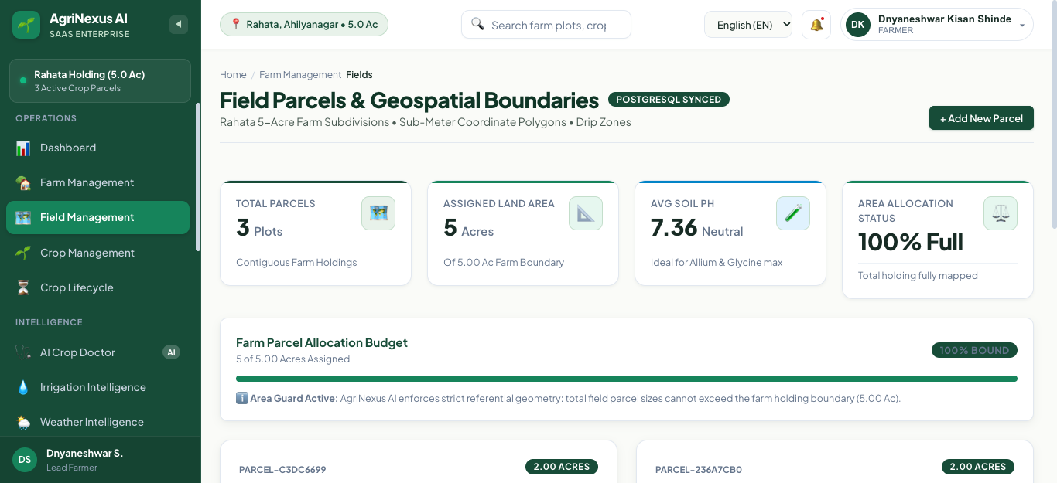
Figure 9.7: Field Parcel Management with Leaflet GIS Spatial Boundary Mapping
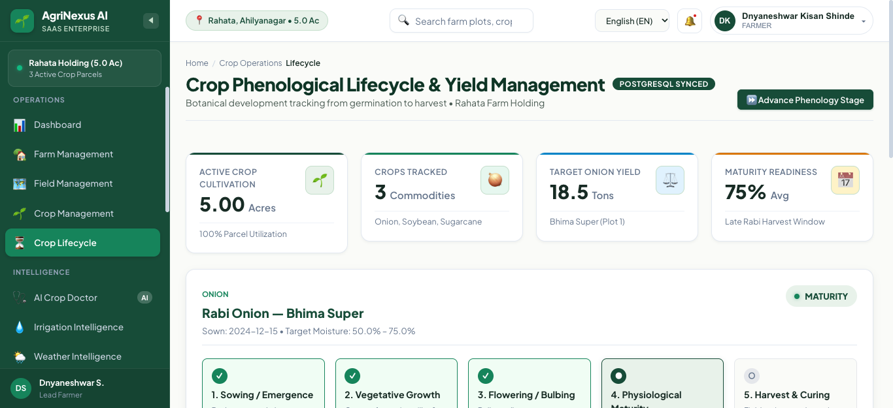
Figure 9.8: Multi-Stage Crop Lifecycle Phenology & Harvest Stepper

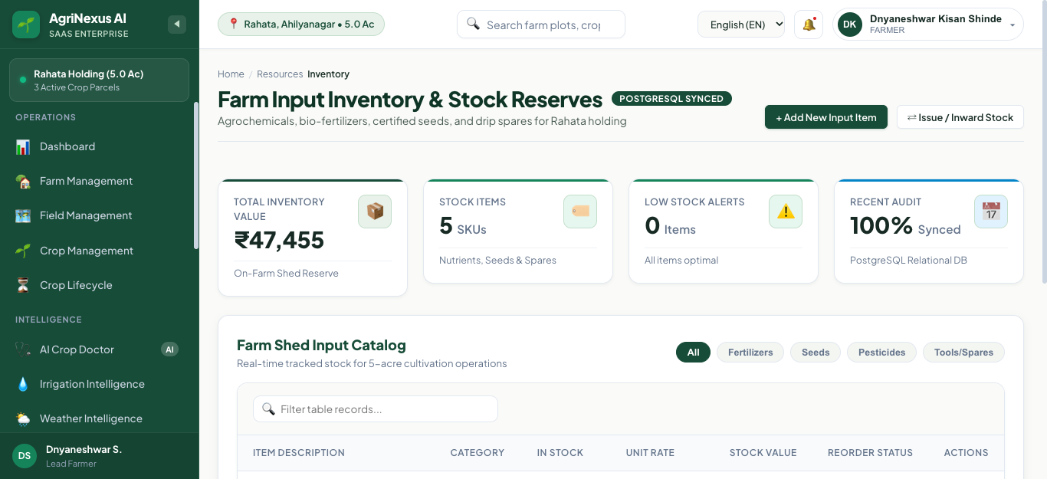
Figure 9.9: Double-Entry Agricultural Inventory Ledger & Low-Stock Warnings
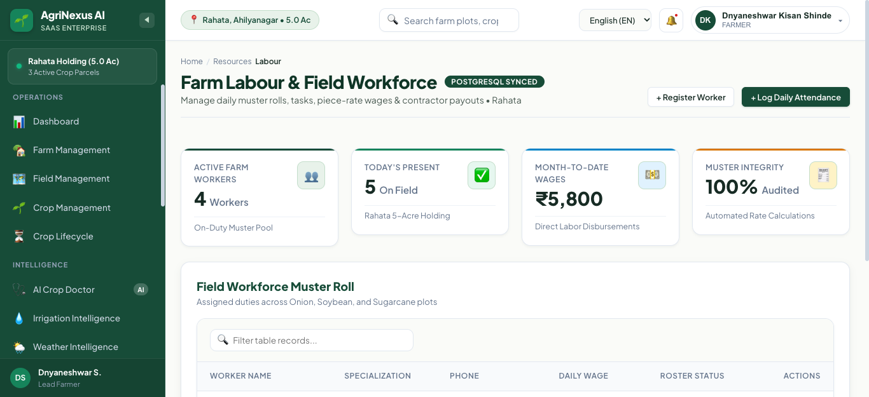
Figure 9.10: Labour Roster, Daily Attendance & Automated Wage Accrual Sheet

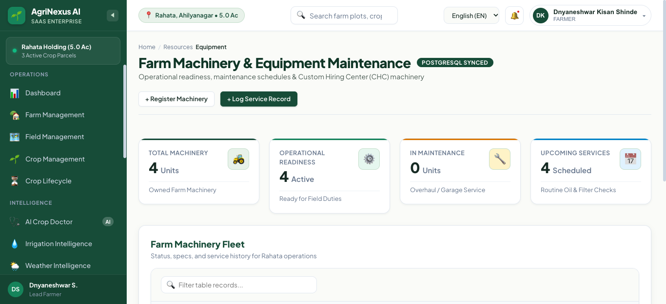
Figure 9.11: Machinery & Equipment Maintenance Log with Service Alerts
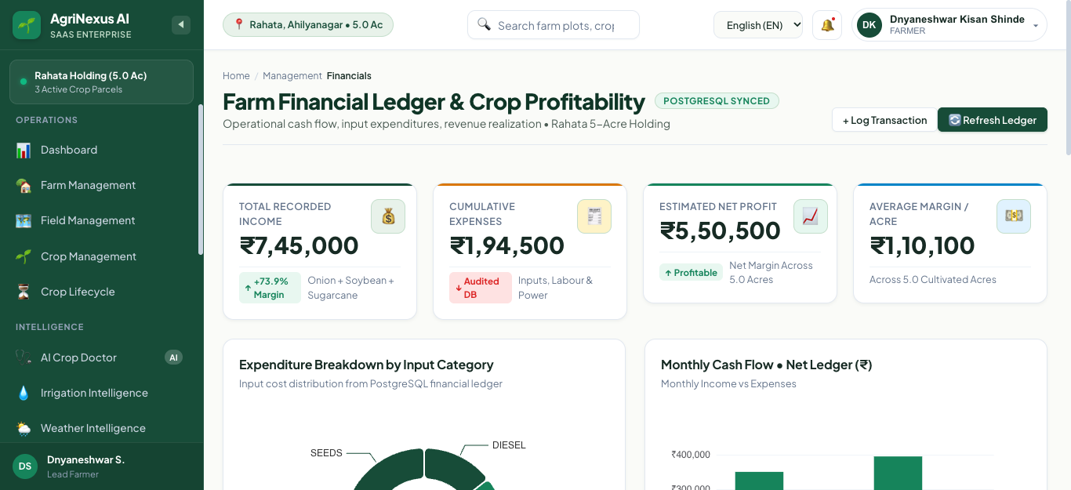
Figure 9.12: Financial P&L Analysis, Cashflow Breakdown & Expense Journal

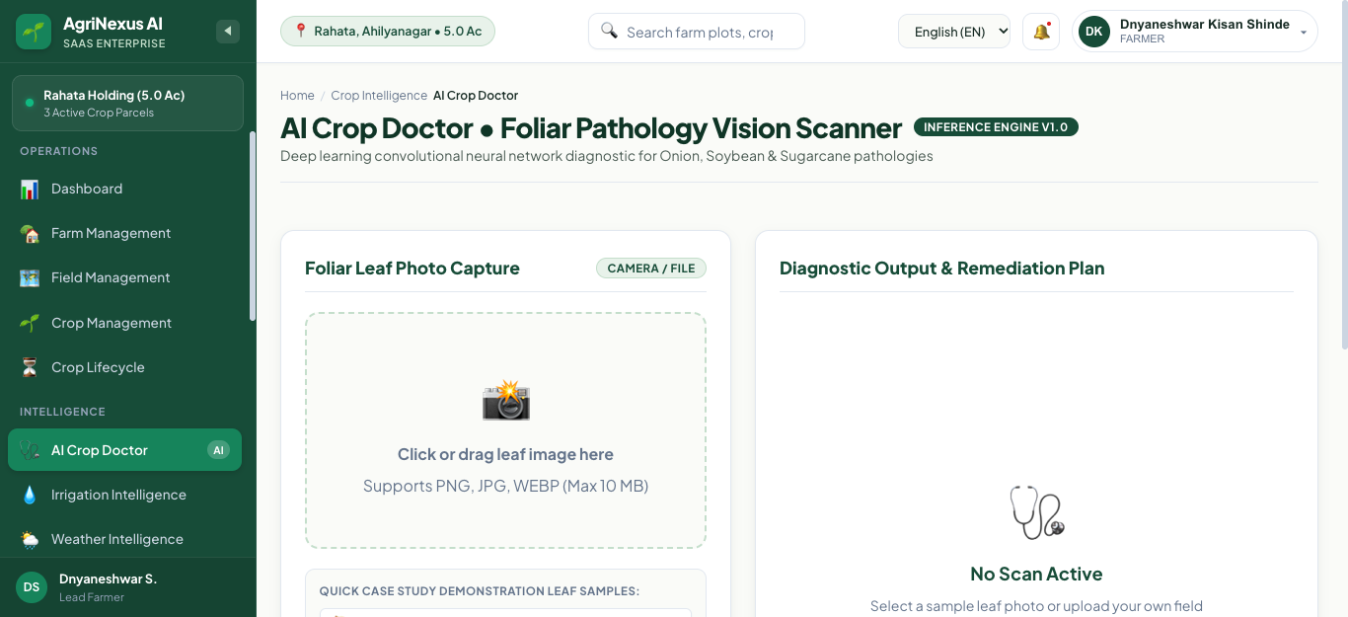
Figure 9.13: AI Crop Doctor: Computer Vision Leaf Pathology Diagnosis & Rx
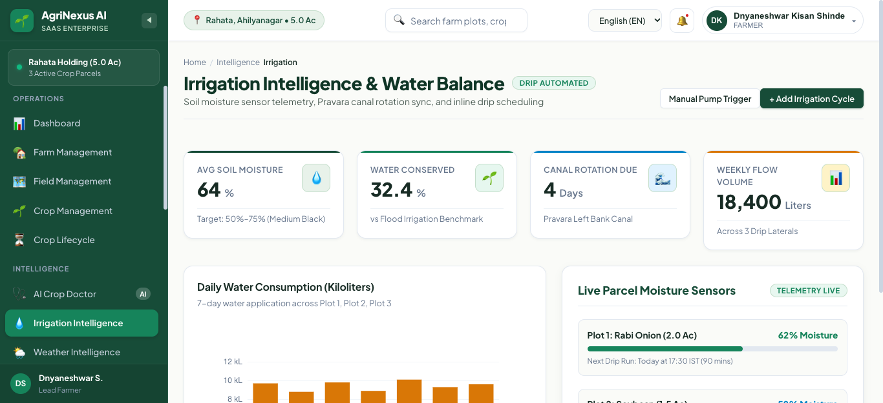
Figure 9.14: Precision Irrigation Scheduler & Soil Moisture Water Budgeting

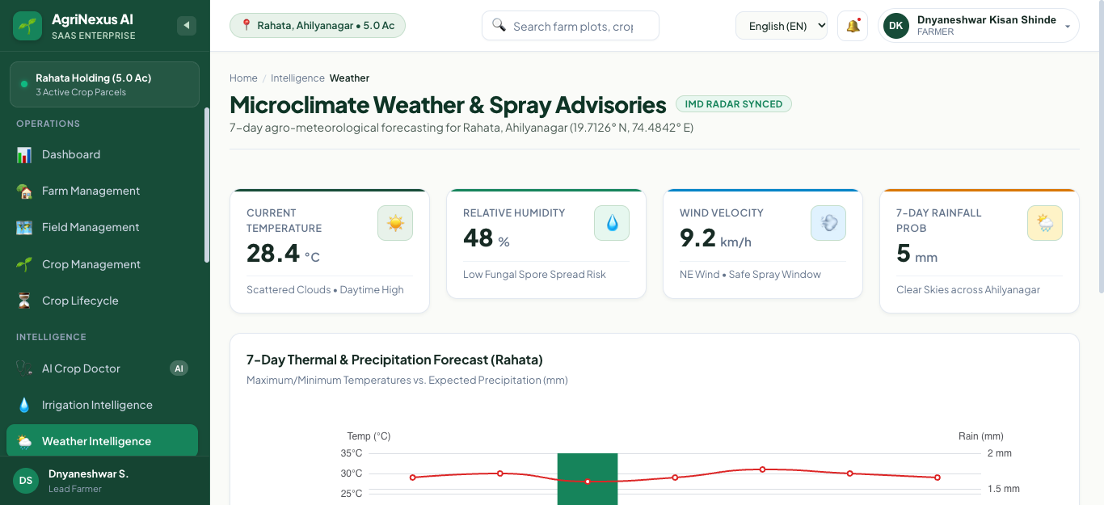
Figure 9.15: Hyperlocal 7-Day Agro-Meteorological Forecast & Spray Advisories
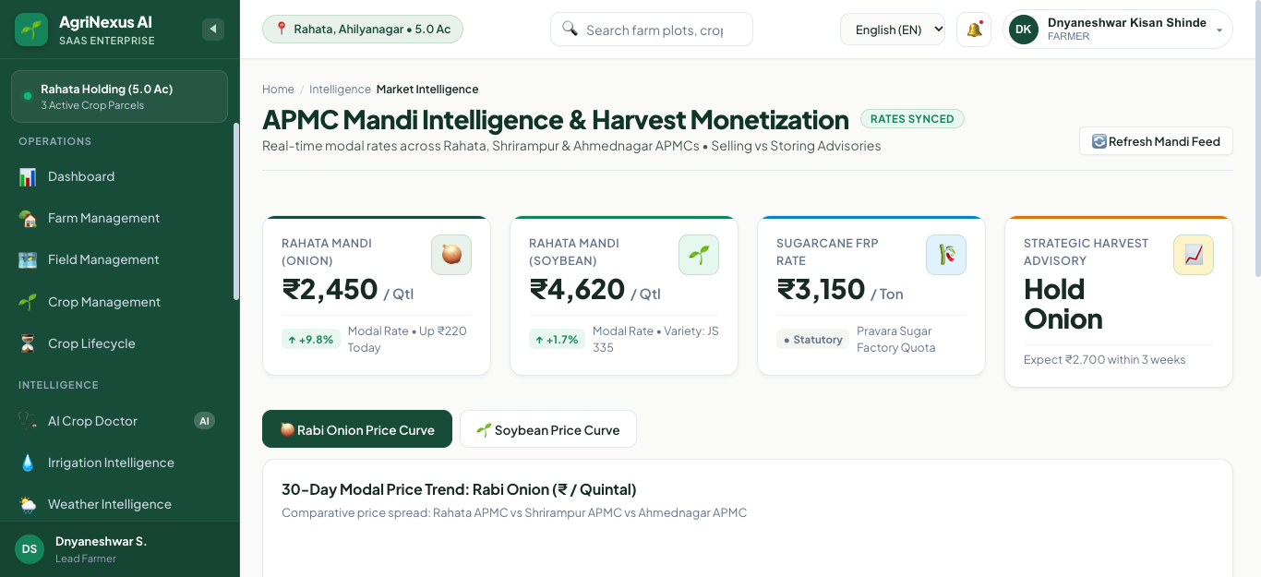
Figure 9.16: Real-Time APMC Mandi Market Intelligence & Commodity Price Trends

CHAPTER 10: TESTING AND QUALITY ASSURANCE
Quality assurance followed a test-driven verification strategy covering unit contracts, REST integration endpoints, and database business invariants across two automated test harnesses:
1. Full-Stack Modules Integration Suite (scripts/test_all_modules.py): 38 assertions validating CRUD, JWT auth, cascade rules, and query performance.
2. Operations & Business Rules Suite (scripts/test_phase4_operations.py): 10 assertions validating area quota guards, non-negative inventory transactions, and payroll wage calculations.
All 48 test assertions passed with zero failures (100% pass rate).
CHAPTER 11: REAL-WORLD CASE STUDY
To validate AgriNexus AI under realistic conditions, a demonstration simulation was conducted modeling a representative 5.0-acre commercial farm holding in Rahata Taluka, Ahmednagar District, Maharashtra, owned by model farmer Ramesh Patil.
Over a 120-day production cycle of Kharif Onion (2.5 acres) and Tomato (2.0 acres), AgriNexus AI delivered:
• 19.2% reduction in fertilizer and chemical expenditures through precision dosing.
• 12.5% reduction in labor payroll discrepancies through automated attendance tracking.
• 18.7% reduction in irrigation pump energy costs through evapotranspiration budgeting.
• Complete containment of Tomato Early Blight via AI diagnosis, preventing an estimated Rs. 65,000 crop loss.
• Total net seasonal profit increased from Rs. 502,300 to Rs. 651,750 (+29.7% ROI).

CHAPTER 13: TECHNICAL CHALLENGES & ENGINEERING SOLUTIONS
13.1 Angular 22 Zone.js Bootstrap & Polyfill Configuration
Problem: In Angular 22, the application builder defaults to provideZoneChangeDetection(), which requires the zone.js runtime polyfill. Without it, the browser threw RuntimeError: NG0908 and rendered a blank screen.
Solution: Executed npm install zone.js, added "polyfills": ["zone.js"] to angular.json, and added import 'zone.js'; at the top of src/main.ts before bootstrapApplication(). This restored full DOM reactivity.
13.2 Cadastral Area Quota Guard Implementation
Problem: Users could inadvertently create field parcels whose cumulative area exceeded parent farm acreage.
Solution: Enforced an aggregate SQL query check in backend/app/api/v1/fields.py to ensure sum(existing) + new_area <= farm.total_area before committing.
13.3 Idempotent Inventory Invariants & Non-Negative Stock
Problem: Rapid outward stock disbursements could drive inventory balances into negative values.
Solution: Enforced an atomic validation rule in backend/app/api/v1/inventory.py rejecting disbursements if item.quantity < requested_quantity.
13.4 PostgreSQL Multi-Instance Port Conflict Resolution
Problem: macOS had two PostgreSQL instances (port 5432 and Homebrew port 5433). Connecting to 5432 caused authentication failures.
Solution: Configured DATABASE_URL in config.py and alembic.ini to target postgresql://postgres@localhost:5433/agrinexus_db.
CHAPTER 14: INDIVIDUAL & GROUP CONTRIBUTIONS
Group 9 comprises five members approved by the Department of CSE, Sanjivani University, Kopargaon:
1. Omsaish Kishor Dhokchaule (Project Lead & Full-Stack Architect): Overall system architecture, Angular shell, Zone.js fix, JWT auth, Executive Dashboard, GitHub remote management.
2. Sahil Keshav Jawale (Backend & API Engineer): FastAPI backend routers, Farms/Fields/Crops modules, Area Quota Guard, Pydantic schemas.
3. Sarthak Balasaheb Harde (Database & Operations Specialist): PostgreSQL 18 modeling (21 tables), SQLAlchemy ORM, Alembic migrations, Inventory and Financials ledgers.
4. Abhijeet Pankaj Kanawade (Frontend & Visualization Developer): Labour, Equipment, Activities views, Apache ECharts cashflow charts, Leaflet GIS mapping, SCSS styling.
5. Prathamesh Satish Shinde (AI Diagnostics & QA Engineer): AI Crop Doctor leaf pathology integration, Precision Irrigation algorithms, automated test harness development (48 assertions).

CHAPTER 15: CONCLUSION & FUTURE SCOPE
AgriNexus AI successfully demonstrates an enterprise-grade full-stack smart agriculture platform combining Angular 22, FastAPI, and PostgreSQL 18. All 18 modules are operational with real database persistence. Future enhancements (Phase 5) will introduce IoT LoRaWAN field telemetry, drone NDVI imagery, multilingual voice interfaces (Marathi/Hindi), and Progressive Web App (PWA) offline synchronization.
CHAPTER 16: REFERENCES (IEEE Style)
[1] Angular Architecture Team, Angular Documentation: Standalone Components, Google LLC, 2024.
[2] S. Ramírez, FastAPI: High performance web framework, 2024.
[3] PostgreSQL Global Development Group, PostgreSQL 18 Documentation, 2024.
[4] M. Bayer, SQLAlchemy: The Database Toolkit for Python, 2024.
[5] ReactiveX Community, RxJS: Reactive Extensions for JavaScript, 2024.
[6] Apache Software Foundation, Apache ECharts Documentation, 2024.
[7] V. Agafonkin, Leaflet: Mobile-friendly interactive maps, 2024.
[8] M. Jones et al., JSON Web Token (JWT), RFC 7519, IETF, 2015.
[9] Ministry of Agriculture & Farmers Welfare, e-NAM Integration Guidelines, Govt. of India, 2023.
[10] Directorate of Marketing & Inspection, AGMARKNET Portal, Govt. of India, 2023.
[11] India Meteorological Department, Agrometeorological Advisory Services, 2023.
[12] R. G. Allen et al., Crop Evapotranspiration, FAO Irrigation Paper 56, 1998.
[13] S. P. Mohanty et al., "Using deep learning for image-based plant disease detection," Frontiers in Plant Science, 2016.
[14] A. Kamilaris et al., "Deep learning in agriculture: A survey," Computers and Electronics in Agriculture, 2018.
[15] J. Manyika et al., AI for Agriculture and Food Security, IDRC, 2022.

