**Problem Statement:**

**1)** Use the inbuilt dataset 'titanic'. The dataset contains 891 rows and contains information about the passengers who boarded the unfortunate Titanic ship. Use the Seaborn library to see if we can find any patterns in the data.

2) Write a code to check how the price of the ticket (column name: 'fare') for each passenger is distributed by plotting a histogram.

**Objective:**

Graphs are a common method to visually illustrate relationships in the data. The purpose of a graph is to present data that are too numerous or complicated to be described adequately in the text and in less space.

**Theory:**

1. R creates histogram using hist() function. This function takes a vector as an input and uses some more parameters to plot histograms.

2. The basic syntax for creating a histogram using R is −

i. hist(v,main,xlab,xlim,ylim,breaks,col,border)

3. Following is the description of the parameters used −

a. v is a vector containing numeric values used in histogram.

b. main indicates title of the chart.

c. col is used to set color of the bars.

d. border is used to set border color of each bar.

e. xlab is used to give description of x-axis.

f. xlim is used to specify the range of values on the x-axis.

g. ylim is used to specify the range of values on the y-axis.

h. breaks is used to mention the width of each bar.

**PROGRAM:**

# Create data for the graph.

v <- c(9,13,21,8,36,22,12,41,31,33,19)

# Give the chart file a name.

png(file = "histogram.png")

# Create the histogram.

hist(v,xlab = "Weight",col = "yellow",border = "blue")

# Save the file.

dev.off()

**Output:**

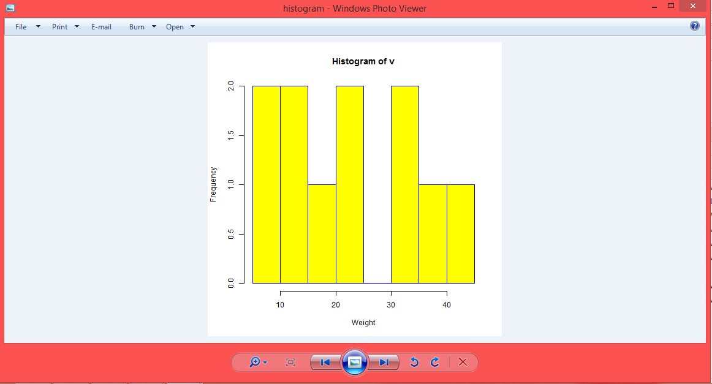

**RESULT:**

Thus the data is visualized using plotty framework.