Alquerque de doze
Text by Oliver Merkel, <Merkel.Oliver@web.de>
Table of Contents
Changes 1
Diagrams in this document 2
Rules formulated as requirements 3
Found in other rules and situations not quite clear… 6

Changes
Date | Change
2012-11-05 | Initial version.
2016-03-06 | Use start position as shown in Libro de los juegos. Refine rules and alternatives on multiple consecutive captures.

Diagrams in this document
The Alquerque game board is described in this text using
- a dash ('-') for horizontal lines along connected positions,
- a pipe ('|') for vertical lines along connected positions,
- a slash and backslash ('/' and '\') for diagonal lines along connected positions.

The board positions of the 5 times 5 board are identified by a letter plus number pair according to illustration 1.
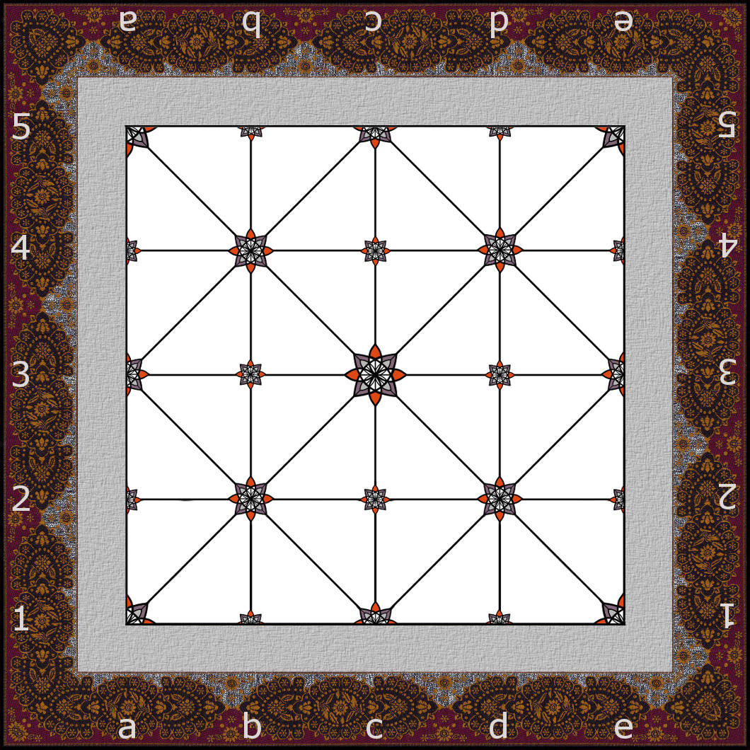
Illustration 1: https://github.com/OMerkel/Alquerque
The Alquerque game is played by two players. The diagrams use an 'X' and an 'O' for each player's checkers. Each player controls 12 checkers initially. The checkers are initially placed on the board as shown in illustration 2.
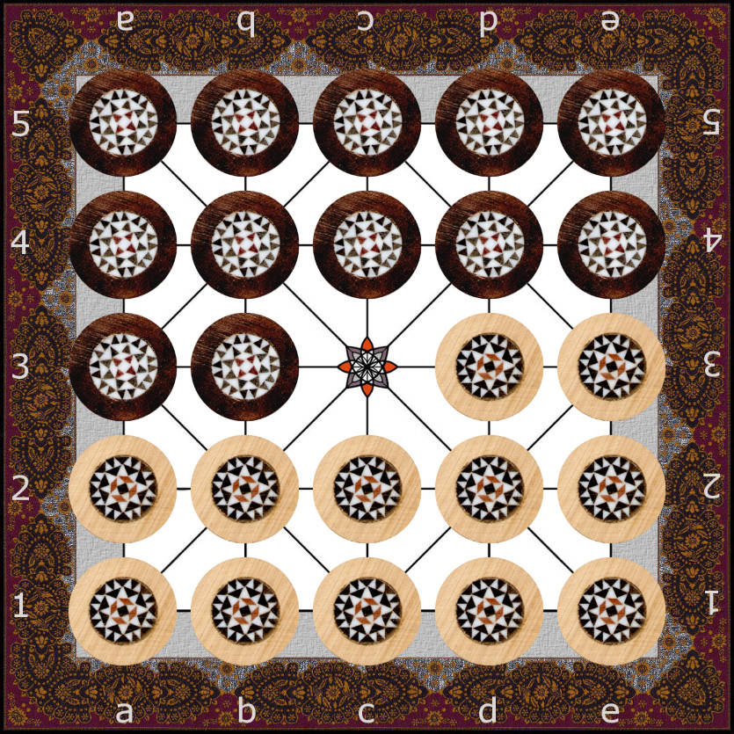
Illustration 2: https://github.com/OMerkel/Alquerque

Rules formulated as requirements
On the left side of the assignments (left of '=') a unique identifier is given for the requirement.
COMMON is used for requirements that are basic for game play.
ALFONSO is used for rules that are described as sourcing from Alfonso X, “Libro de los juegos”.
BELL identifies rules as suggested in Robert Charles Bell, “Board and Table Games from Many Civilizations, volume
1”.
ALT is used to show up alternative rules to choose from. Players shall find agreements on these alternatives first.
This way REQ.23.ALT.x.BELL means that if applying Bell's rules suggestion (REQ.19 to REQ.22) players shall
consider to choose from the set of alternatives given here.
REQ.24.ALT.x.COMMON is a set of alternatives that to my best knowledge are neither clearly covered by Alfonso X
nor Bell but shall be basic for game play. Thus it seems mandatory that players shall first choose their appropriate
intended alternative here.
REQ.25.ALT.x.y has alternatives that are suggested by Alfonso X or Bell. Alfonso X version seems to lead to draw
game situations often. Bell's version of the rule has the slight drawback that players have to remember the latest move
for each checker left in game.
Missing that a capture could be performed has usually a huge impact if applying REQ.26.ALT.1.ALFONSO. If you
intend to avoid such hard penalties use REQ.26.ALT.2 instead. This might result in more interesting game plays on the
long run.
REQ.27.ALT.1.ALFONSO might result in a huge amount of endless game situations such that players have to agree on draw situations often. Using the rules from BELL reduces these huge number of draws (REQ.27.ALT.2.BELL).
Depending on the set of chosen rules to apply it might make sense to use REQ.27.ALT.3 being even more restrictive
than just applying BELL's variant.

REQ.0.COMMON=Alquerque is a game.
REQ.1.COMMON=The game is a board game.
REQ.2.COMMON=The rectangular board has fixed dimension of 5 times 5 positions
horizontally and vertically.
REQ.3.COMMON=The twelve light checkers are placed on all positions of row 1 and
2, and positions d3 and e3 initially.
REQ.4.COMMON=The twelve dark checkers are placed on all positions of row 4 and
5, and positions a3 and b3 initially.
REQ.5.COMMON=There are two opposing players: one is controlling the light
checkers and the other is controlling the dark checkers.
REQ.6.COMMON=The player controlling light checkers moves first.
REQ.7.COMMON=Movement of checkers is performed strictly along the lines of the
board.
REQ.8.COMMON=Alfonso X: Checkers can move to an adjacent free position along the
lines only.
REQ.9.COMMON=Alfonso X: An opponent's checker on an adjacent position along a
line of an own checker is captured by jumping over it in straight line onto an
adjacent free position along the line.
REQ.10.ALT.1.COMMON=In a player's turn multiple consecutive captures
performed with the same own checker are allowed and compulsory.
REQ.10.ALT.2.COMMON=In a player's turn multiple consecutive captures performed by the same own checker are explicitly not allowed. Only single captures allowed.
REQ.10.1.ALT.1.COMMON=If REQ.10.ALT.1.COMMON is used then the first capture of the possible multiple consecutive capture is compulsory. The player may decide on each jump to stop capturing.
REQ.10.1.ALT.2.COMMON=If REQ.10.ALT.1.COMMON is used then the player must continue to capture in the possible multiple consecutive capture until no additional capture is possible. It is not necessary to select the longest possible path to capture the maximum opponent’s pieces. On alternative paths the player may decide freely on which one to continue.
REQ.10.1.ALT.3.COMMON=If REQ.10.ALT.1.COMMON is used then the player must continue to capture in the possible multiple consecutive capture until no additional capture is possible. It is mandatory to select the longest possible path to capture the maximum opponent’s pieces. Using alternative capturing paths is only allowed if the same amount of captures is possible.
REQ.11.COMMON=Checkers can not be stacked by moving one on top of the other.
REQ.12.COMMON=Checkers can not be stacked by jumping one on top of the other.
REQ.13.COMMON=Checkers captured leave the board and do not return.
REQ.14.COMMON=Jumping to perform captures is done in straight line without any
change of direction.
REQ.15.COMMON=(If REQ.10.ALT.1.COMMON is used then...)After each single straight line jump if performing multiple consecutive captures the direction of jumps may be changed although reverse direction change is not allowed.
REQ.16.COMMON=By each jump exactly one single opponent's checker is jumped over
and thus captured at a time.
REQ.17.COMMON=Checkers can not jump over or capture checkers of own color.
REQ.18.COMMON=Captures can be done any time on own turn after the game has started.
REQ.19.BELL=Bell: A light checker can not move from it's position to positions
on rows with lower numbers. Thus it can not move backwards.
REQ.20.BELL=Bell: A dark checker can not move from it's position to positions on
rows with higher numbers. Thus it can not move backwards.
REQ.21.BELL=Bell: A light checker on row 5 can can not be moved but only capture
opponent's checkers if possible.
REQ.22.BELL=Bell: A dark checker on row 1 can can not be moved but only capture
opponent's checkers if possible.
REQ.23.ALT.1.BELL=In case of using Bell's rule that checkers reaching opponent's
base row can not move but only capture: The checker is allowed to move, too, if
after the capture it is not positioned on the opponent's base row any longer.
REQ.23.ALT.2.BELL=In case of using Bell's rule that checkers reaching opponent's
base row can not move but only capture: The checker is not allowed to move any
longer but only capture even if after the capture it is not positioned on the
opponent's base row any longer.
REQ.23.ALT.3.BELL=In case of using Bell's rule that checkers reaching opponent's
base row can not move but only capture: The checker is allowed to capture
opponent's checkers horizontally only.
REQ.24.ALT.1.COMMON=A captured checker is removed from game play instantly
while being jumped. Thus it can not be reused to be jumped again in a multiple
capture move.
REQ.24.ALT.2.COMMON=In a multiple capture a captured checker stays on board and is removed from game play after the whole multiple capture is done. Thus it can (and eventually must) be reused to be jumped again during the multiple capture move.
REQ.25.ALT.1.ALFONSO=Alfonso X: A player is explicitly allowed to return his
previously moved checker to it's previous position and thus revert his last
move.
REQ.25.ALT.2.BELL=Bell: Each checker is not allowed to return to the previous
board position of this checker's latest move.
REQ.25.ALT.3=A player is not allowed to return his previously moved checker to
it's previous position and thus revert the player’s last move.
REQ.26.ALT.1=If an opponent misses to capture any checkers although compulsory captures were possible then one of the opponent's checkers able to capture is huffed (removed from game) by the player.
REQ.26.ALT.2=If an opponent misses to perform a compulsory capture then the
previous board situation before the invalid move has to be restored.
REQ.27.ALT.1.ALFONSO=Alfonso X: A player wins by capturing all opponent's checkers. A tie or draw game is possible on mutual agreement.
REQ.27.ALT.2.BELL=Bell: A player wins either by capturing all opponent's checkers or if the opponent can not perform any legal move. A tie or draw game is possible on mutual agreement.
REQ.27.ALT.3=A player wins either by capturing all opponent's checkers or if the
opponent can not perform any legal move. A draw is achieved by repetition of
exact game position and status.

Found in other rules and situations not quite clear…
When following game notations, watching others playing Alquerque, and discussing how others interpret and play
Alquerque some game situations have been found that are not covered by previous rule proposals.

Situation 1:

Light player's turn.
5X- -X-X-X
|\|/|\|/|
4O- - -X-X
|/|\|/|\|
3 -O- -X-X
|\|/|\|/|
2O- - - -
|/|\|/|\|
1O-O-O-O-O
a b c d e

• Is a4b5 capturing Dark on a5 valid?
This would be a capture along the lines of a board. According to previous rules this would be a change of direction while jumping thus being invalid (REQ.14.COMMON).

Situation 2:

Light player's turn.
5 - - -X-
|\|/|\|/|
4 - - - -X
|/|\|/|\|
3X- -X- -
|\|/|\|/|
2 - - - -X
|/|\|/|\|
1X- -X-O-O
a b c d e

• Is multiple capture d1b1a2a4 capturing Dark on c1, a1, and a3 valid?
This would be a multiple capture along the lines of a board. According to
previous rules this would be a change of direction while jumping from b1
to a2 thus being invalid (REQ.14.COMMON). A change of direction in a
multiple capture can only be performed after each single jump
(REQ.15.COMMON) and not while jumping. Each jump must follow a straight
line. Thus e1e3e5c5 capturing e2, e4, and d5 would be valid according to
the previous rule proposals.

Situation 3:

Dark player's turn.
5 - - - -
|\|/|\|/|
4 - -O-O-
|/|\|/|\|
3 - - -O-X
|\|/|\|/|
2 - - - -
|/|\|/|\|
1 - - - -
a b c d e

• Is multiple capture e3e5c3e3 capturing Light on d4, c4, and d3 valid?
Discussion here is if backward jumps are basically the same as backward
moves. If applying Bell's rule set especially REQ.20.BELL here then this
question arises. The rule text in this document distinguishes between
captures by jumps and simple moves. Thus it is assumed that jumps can be
performed in any direction and REQ.19.BELL and REQ.20.BELL refer to simple
moves only. As a result the multiple consecutive capture would be valid
and in fact mandatory here. In this situation e3c3e5e3 would be an
alternative multiple capture here with same result: Dark wins by capturing
all Light checkers.

Situation 4:

Dark player's turn.
5 - - - -
|\|/|\|/|
4 - -O-O-
|/|\|/|\|
3 - - - -X
|\|/|\|/|
2O- - - -
|/|\|/|\|
1 - - - -
a b c d e

• Dark must perform a compulsory capture here. Where does the Dark's turn end?
If using REQ.24.ALT.1.COMMON Dark has to jump e3c5c3 capturing d4 and
c4. If using REQ.24.ALT.2.COMMON Dark has to jump e3c5c3e5 capturing d4
and c4. The later means that d4 must be jumped again here since d4 is
still not removed and no alternative jump can be performed without jumping
reverse (REQ.15.COMMON, reverse direction change in consecutive multiple
captures is not allowed).

Situation 5:

Dark player's turn.
5 - - - -
|\|/|\|/|
4 - -O-O-
|/|\|/|\|
3 -O- - -X
|\|/|\|/|
2O- - - -
|/|\|/|\|
1 - - - -
a b c d e

• Dark must perform a compulsory capture here. Where does the Dark's turn end?
If using REQ.24.ALT.1.COMMON Dark must jump e3c5c3a3a1 capturing d4,
c4, b3, and a2. If using REQ.24.ALT.2.COMMON Dark could either

• jump e3c5c3a3a1 capturing d4, c4, b3, and a2 (winning the game) or
• jump e3c5c3e5 capturing d4 and c4 (game continues on Light's turn).

• Who moves first?
In ALFONSO the first player is determined by a dice roll. It is not described whether the winner of the dice roll plays Light or Dark pieces. In REQ.6.COMMON the interpretation is that such a selection by random result means the selected player will play White pieces. If player change sides and the right to start the game in consecutive plays then they will change color as well.

Enjoy your Alquerque game play…

Any more discussions needed? Do you see other situations worth discussing?
Feel free to contact me and share your experience on Alquerque.

Best regards,
--- Oliver

http://es.wikipedia.or g/wiki/Libro_de_los_juegos and http://en.wikipedia.org/wiki/Alquerque
Robert Charles Bell, “Board and Table Games from Many Civilizations, volume 1”, ISBN 0-486-23855-5, Dover Publications, 1979

