PROJECT REVIEW DOCUMENT

FOODGUARD AI
A Dual-Pipeline Food Safety Detection System Using Deep Learning, OCR and FSSAI Compliance Rules

Literature Survey • Methodology • System Design

Project title | FoodGuard AI: A Dual-Pipeline Food Safety Detection System Using Deep Learning, OCR and FSSAI Compliance Rules
Student | [Student Name] ([University Roll No.])
Guide | [Guide Name], [Designation]
Programme | B.Tech, Computer Science and Engineering
Review | [Review No.] Date: [DD/MM/YYYY]
Contents | Literature Survey, Methodology, System Design

[College logo]

DEPARTMENT OF COMPUTER SCIENCE AND ENGINEERING
[COLLEGE NAME]
(Affiliated to [University Name])
2026

TABLE OF CONTENTS

If page numbers are missing, right-click the table in Word and choose Update Field.

LIST OF FIGURES
Figure 3.1 Training methodology for the spoilage model
Figure 3.2 Label reading pipeline
Figure 4.1 System architecture of FoodGuard AI
Figure 4.2 Data flow diagram, Level 0 (context diagram)
Figure 4.3 Data flow diagram, Level 1
Figure 4.4 Use case diagram
Figure 4.5 Sequence diagram for a food check
Figure 4.6 Activity diagram: guardrails and pipeline selection
Figure 4.7 Activity diagram: verdict logic
Figure 4.8 Module diagram with main functions
Figure 4.9 Home screen (light theme)
Figure 4.10 Processing screen with scanning animation
Figure 4.11 Result screen for raw produce
Figure 4.12 Deployment diagram

LIST OF TABLES
Table 2.1 Themes of the literature survey
Table 2.2 Comparison of key works and their relevance
Table 2.3 Research gaps and how this project addresses them
Table 3.1 Phases of the project methodology
Table 3.2 Resulting dataset split
Table 3.3 MobileNetV2 backbone and FoodGuard head (input 224 × 224 × 3)
Table 3.4 HFSS limits used by the engine
Table 3.5 Evaluation plan
Table 3.6 Experimental environment
Table 4.1 Use case description: Check food safety
Table 4.2 Module responsibilities and interfaces
Table 4.3 Data stores
Table 4.4 Structure of the analysis report (JSON)
Table 4.5 REST API
Table 4.6 Input validation and safeguards
Table 5.1 Status of project components

LIST OF ABBREVIATIONS
AMP Automatic Mixed Precision
API Application Programming Interface
CAM Class Activation Mapping
CLAHE Contrast Limited Adaptive Histogram Equalisation
CLIP Contrastive Language–Image Pre-training
CNN Convolutional Neural Network
CRAFT Character Region Awareness for Text detection
CRNN Convolutional Recurrent Neural Network
CTC Connectionist Temporal Classification
DFD Data Flow Diagram
FSSAI Food Safety and Standards Authority of India
Grad-CAM Gradient-weighted Class Activation Mapping
HFSS High in Fat, Sugar and Salt
HSV Hue, Saturation, Value colour space
OCR Optical Character Recognition
OOD Out-of-Distribution
UML Unified Modeling Language
USDA United States Department of Agriculture
WHO World Health Organization

CHAPTER 1
INTRODUCTION

1.1 Project Overview
FoodGuard AI is a web application that gives a single, explained food safety verdict for a photograph. It has two analysis pipelines. Pipeline A grades raw fruit and vegetables as fresh or spoiled with a fine-tuned MobileNetV2 convolutional neural network and shows a Grad-CAM heat map of the evidence. Pipeline B reads the nutrition table on the back of a food pack with EasyOCR and checks the values against the category-specific limits for foods high in fat, sugar and salt (HFSS) set out by the Food Safety and Standards Authority of India (FSSAI).
Three guardrails run before either pipeline: a CLIP-based out-of-food filter, a category validation step, and a product identity check against barcodes and the Open Food Facts database. Every analysed item receives a 0–100 health score, a rating and information about the food, and an optional user-entered expiry date can be checked.

1.2 Problem Statement
Consumers cannot easily judge produce freshness or compare small, glossy nutrition tables with regulatory limits that differ between solid foods and beverages. Existing tools either rely only on barcode databases or classify freshness without checking whether the input is valid. The problem addressed is: from one or more smartphone photographs, produce a reliable SAFE / CAUTION / UNSAFE verdict for raw produce and packaged food, refuse to answer for unsuitable photos, and explain every decision.

1.3 Objectives
- Build a lightweight, accurate spoilage classifier for six common produce types, evaluated without data leakage.
- Build a robust OCR and parsing pipeline for Indian nutrition labels and a configurable FSSAI HFSS rule engine.
- Guard both pipelines against out-of-distribution, wrong-category and wrong-product inputs.
- Give every result an explainable health score, rating and food information.
- Deliver the system as a responsive web application and measure it with reproducible experiments.

1.4 Scope of this Document
This document is prepared for the project review. Chapter 2 presents the complete literature survey, organised by theme, with a comparative summary and the research gaps the project addresses. Chapter 3 describes the methodology: the research approach, data preparation, each algorithm with its equations and pseudocode, and the evaluation design. Chapter 4 presents the system design through architecture, data flow, UML and interface diagrams. Chapter 5 summarises the status of the work.

CHAPTER 2
LITERATURE SURVEY

2.1 Survey Methodology
Literature was collected from IEEE Xplore, the ACM Digital Library, Springer, Elsevier ScienceDirect, arXiv and Google Scholar, together with regulatory and guidance documents from FSSAI and the World Health Organization. Search terms included fruit freshness detection, food spoilage deep learning, transfer learning MobileNet, scene text recognition, nutrition label OCR, out-of-distribution detection, zero-shot image classification, Grad-CAM and front-of-pack nutrition labelling.
Works were included if they (a) introduced a method used or compared in this project, (b) addressed produce quality assessment with computer vision, (c) addressed text detection or recognition in natural images, (d) addressed the reliability of classifiers on unexpected input, or (e) defined the nutritional rules that the system enforces. The survey is organised into seven themes (Table 2.1).
Table 2.1: Themes of the literature survey
Theme | Question it answers for FoodGuard AI | Section
Image classification and transfer learning | Which network can grade produce accurately on modest hardware? | 2.2
Produce quality and spoilage detection | What has been done for fruit and vegetables, and what are the pitfalls? | 2.3
Explainable AI | How can a user see why the model decided? | 2.4
Optical character recognition | How can small, glossy label text be read reliably? | 2.5
Out-of-distribution detection and zero-shot learning | How can the system refuse photos it was not built for? | 2.6
Nutrition labelling and HFSS regulation | Which limits apply, and how are warnings shown? | 2.7
Product databases and identity matching | How can a label be matched to the product the user named? | 2.8

2.2 Image Classification and Transfer Learning
Krizhevsky, Sutskever and Hinton [1] showed with AlexNet that deep convolutional networks trained on GPUs could win the ImageNet [2] challenge by a wide margin, starting the deep learning era in computer vision. Simonyan and Zisserman [3] (VGG) showed that depth built from small 3 × 3 filters improves accuracy, at the cost of a very large number of parameters. He et al. [4] introduced residual connections (ResNet), which made networks of more than one hundred layers trainable.
For deployment on ordinary computers and phones, efficiency matters as much as accuracy. MobileNets [5] replaced standard convolutions with depthwise separable convolutions, greatly reducing computation. MobileNetV2 [6] added inverted residual blocks with linear bottlenecks, which keep accuracy close to larger networks with only about 3.4 million parameters. EfficientNet [7] scaled depth, width and resolution together, and the Vision Transformer [8] applied self-attention to image patches, but both need more data or computation to fine-tune well.
Yosinski et al. [9] showed that features learned on ImageNet transfer well to other tasks: early layers learn general edges and textures, while later layers become task-specific. Fine-tuning a pre-trained network is therefore the standard approach when only thousands of labelled images are available, as in this project. Data augmentation [10] further reduces over-fitting by generating plausible variations of training images.
Relevance: MobileNetV2 with ImageNet weights was chosen because it offers a strong balance of accuracy, speed and model size (about 9 MB for this project), and fine-tunes in minutes on a single GPU.

2.3 Produce Quality and Spoilage Detection
Kamilaris and Prenafeta-Boldú [11] surveyed deep learning in agriculture and found CNNs outperforming traditional image processing across plant disease, weed and fruit detection tasks. Bhargava and Bansal [12] reviewed computer vision for fruit and vegetable quality evaluation, covering colour, texture, shape and defect features and the move from hand-crafted features with classical classifiers to CNNs.
Mureșan and Oltean [13] introduced the Fruits-360 dataset and trained a CNN to recognise fruit types from images taken on a uniform background. Hossain, Al-Hammadi and Muhammad [14] proposed deep learning models for automatic fruit classification in industrial settings, including fine-tuned pre-trained networks. These works focus on recognising the fruit type; freshness grading is a related but harder task because the visual differences between early decay and natural variation are subtle.
This project uses the public Kaggle dataset Fresh and Stale Images of Fruits and Vegetables [15], which covers six produce types in fresh and stale states. Inspection showed that it, like many public datasets, contains many augmented copies of each original photo. Kaufman et al. [16] describe such leakage, where information from the test set is present in training data, as a common cause of over-optimistic results. Splitting by source photo, rather than by file, is necessary for an honest estimate.
Relevance: prior work establishes CNN fine-tuning as the right approach, but reported accuracies on augmented datasets can be inflated. FoodGuard AI recovers source photos and splits by them, and reports safety-oriented metrics (stale items marked SAFE) in addition to accuracy.

2.4 Explainable AI
Zhou et al. [17] proposed Class Activation Mapping (CAM), which localises the image regions responsible for a class by combining the final feature maps with the weights of a global-average-pooling classifier. Grad-CAM [18] generalised this to any CNN by weighting feature maps with the gradients of the class score, needing no change to the architecture. Grad-CAM is widely used to check that a model attends to the object rather than to background artefacts.
Relevance: Grad-CAM lets a user, and an examiner, see that the spoilage model looks at bruises and dark patches on the fruit itself. FoodGuard AI shows it with every produce verdict, together with a simple, rule-based measure of discoloured surface area.

2.5 Optical Character Recognition
Smith [19] described the Tesseract engine, a widely used open-source OCR system designed mainly for scanned documents; it performs poorly on curved, low-contrast or perspective-distorted text in photographs. Scene text recognition therefore separates detection from recognition. EAST [20] predicts word or line boxes directly with a fully convolutional network. CRAFT [21] detects individual character regions and the affinity between them, which handles curved and irregular text well.
For recognition, Graves et al. [22] introduced Connectionist Temporal Classification (CTC), which trains sequence models without character-level alignment. Shi, Bai and Yao [23] combined convolutional features, a recurrent network and CTC in CRNN, an end-to-end trainable recogniser. Long, He and Yao [24] survey the field and note that image quality (blur, glare, low resolution) remains the main source of errors. EasyOCR [25] packages CRAFT detection with a CRNN-style recogniser.
Pre-processing remains important for photographs. Otsu's method [26] chooses a global threshold to binarise an image, while Contrast Limited Adaptive Histogram Equalisation (CLAHE) [27] improves local contrast in unevenly lit regions without over-amplifying noise.
Relevance: EasyOCR (CRAFT + CRNN) was chosen over Tesseract for photographed labels. Because no single pre-processing works for every photo, FoodGuard AI reads several variants (colour, CLAHE, up-scaled, binarised) and combines them by voting.

2.6 Out-of-Distribution Detection and Zero-Shot Learning
A closed-set classifier assigns one of its known classes to every input. Guo et al. [28] showed that modern networks are often over-confident, and Hendrycks and Gimpel [29] showed that maximum softmax probability is only a weak baseline for detecting out-of-distribution (OOD) inputs. ODIN [30] improved the baseline with temperature scaling and input perturbation, and Lee et al. [31] used Mahalanobis distances in feature space. These methods need access to the classifier's internals and some tuning data.
CLIP [32] takes a different route: trained on 400 million image–text pairs, it embeds images and text in a shared space, so an image can be classified against arbitrary text prompts without task-specific training (zero-shot). Ming et al. [33] showed that such vision–language representations are effective for OOD detection by comparing an image with the names of in-distribution classes.
Relevance: FoodGuard AI uses CLIP as an independent gatekeeper. It scores each photo against 43 prompts describing produce, packaged foods, beverages, cooked dishes and non-food scenes, so non-food photos, cooked dishes, wrong categories and unsupported produce are stopped before the specialised models run.

2.7 Nutrition Labelling and HFSS Regulation
In India, the Food Safety and Standards (Labelling and Display) Regulations, 2020 [34] require nutrition information on most pre-packaged foods, declared per 100 g or 100 ml. FSSAI has published draft amendments on front-of-pack nutrition labelling [35] to highlight foods high in fat, sugar and salt. The World Health Organization recommends limiting free sugars to under 10 % of energy intake [36], sodium to under 2 g per day [37], and saturated fat to under 10 % of energy intake [38].
International experience shows that simple warnings change behaviour. Chile's labelling law introduced black octagon "HIGH IN" warnings, and Taillie et al. [39] found a significant fall in purchases of sugar-sweetened beverages after it took effect. France's Nutri-Score [40] summarises nutritional quality as a five-colour letter grade. Both approaches inspired FoodGuard AI's red hexagon warnings and its 0–100 health score.
Relevance: the system applies separate limits for solid foods (per 100 g) and beverages (per 100 ml), treats single-ingredient foods such as oil, ghee and honey as exempt, and keeps every limit in a configuration file so that it can be updated to the final notified FSSAI values without code changes.

2.8 Product Databases and Identity Matching
Open Food Facts [41] is a crowd-sourced, openly licensed database of packaged foods with barcodes, brands, ingredients and nutrition values, available through a public API. Retail barcodes follow the GS1 EAN/UPC standards [42], which include a check digit to detect misreads. USDA FoodData Central [43] provides reference nutrient values for raw foods, used here for the produce information cards.
Matching OCR text to product names must tolerate recognition errors. The Levenshtein edit distance [44] measures the number of single-character insertions, deletions and substitutions between two strings; fuzzy matching libraries build normalised similarity scores on it.
Relevance: FoodGuard AI decodes barcodes from the photo, looks products up in Open Food Facts, matches printed brands against a registry of parent companies, and compares label values with the reference record, using fuzzy matching (RapidFuzz) throughout.

2.9 Comparative Summary of Key Works
Table 2.2: Comparison of key works and their relevance
Ref. | Work (year) | Technique | Strength | Limitation / gap for this project
[6] | Sandler et al. (2018) | MobileNetV2, inverted residuals | High accuracy at low cost | Generic; must be fine-tuned for spoilage
[9] | Yosinski et al. (2014) | Feature transferability study | Justifies fine-tuning | No food-specific results
[13] | Mureșan & Oltean (2018) | CNN on Fruits-360 | Large, clean fruit dataset | Recognises fruit type, not freshness
[14] | Hossain et al. (2019) | Fine-tuned deep CNNs | Industrial fruit classification | No invalid-input handling
[12] | Bhargava & Bansal (2021) | Review of quality evaluation | Broad coverage of features | Mostly controlled imaging
[16] | Kaufman et al. (2012) | Data leakage analysis | Explains inflated results | General; not image-specific
[18] | Selvaraju et al. (2017) | Grad-CAM | Works with any CNN | Coarse localisation
[19] | Smith (2007) | Tesseract OCR | Mature, open source | Weak on photographed labels
[21] | Baek et al. (2019) | CRAFT text detector | Handles curved text | Detection only
[23] | Shi et al. (2017) | CRNN + CTC recogniser | End-to-end recognition | Sensitive to blur and glare
[29] | Hendrycks & Gimpel (2017) | Softmax OOD baseline | Simple | Weak separation
[32] | Radford et al. (2021) | CLIP zero-shot | Classifies against any text | Needs prompt design and calibration
[39] | Taillie et al. (2020) | Evaluation of Chile's warnings | Evidence that warnings work | Policy study, not a tool
[41] | Open Food Facts | Crowd-sourced database | Barcodes and nutrients | Incomplete; occasional errors

2.10 Research Gaps
The survey shows strong individual building blocks but no single tool that combines them for Indian consumers. Table 2.3 lists the gaps and how FoodGuard AI addresses each.
Table 2.3: Research gaps and how this project addresses them
Gap observed in the literature | How FoodGuard AI addresses it
Produce work recognises the type of fruit, rarely its freshness, and results on augmented datasets are often inflated by leakage. | 12-class fresh / stale classifier; split by source photo; safety metric (no stale item marked SAFE).
Classifiers give confident answers for any input, including non-food photos. | CLIP zero-shot guardrails with calibrated thresholds before any model runs.
Label-reading tools rely on barcodes alone; OCR of photographed nutrition tables is fragile. | Multi-variant OCR with voting, decimal restoration and plausibility checks; barcode used for verification.
One set of nutrient limits is applied to all foods. | Category taxonomy: solid, liquid and exempt, each with its own FSSAI limits.
Nothing checks that a label photo belongs to the product the user named. | Identity stage: barcode, Open Food Facts reference, brand families and nutrient cross-check.
Decisions are rarely explained to the user. | Grad-CAM, OCR overlays, a per-stage check list, plain-language reasons and a scored review.

CHAPTER 3
METHODOLOGY

3.1 Research Approach
The project follows a design-and-evaluate approach: each component is designed from the literature, implemented, measured on held-out data, and revised until it meets its target. Safety is the primary criterion throughout: when uncertain, the system answers CAUTION or asks for a better photo rather than guessing.
Table 3.1: Phases of the project methodology
Phase | Activities | Output
1. Requirement analysis | Study FSSAI rules; define categories and verdicts; list failure cases | Requirements, category taxonomy
2. Data acquisition | Download produce dataset; recover source photos; build OCR and OOD test sets | Leakage-free splits, test benches
3. Model development | Fine-tune MobileNetV2; calibrate decision threshold; add Grad-CAM | Spoilage model, metrics
4. Label pipeline | OCR pre-processing, parser, unit normalisation, FSSAI rule engine | Packaged-food pipeline
5. Guardrails | Design CLIP prompts; calibrate thresholds on in- and out-of-distribution sets | Stages 1–3
6. Integration | Orchestrator, review module, Flask API, web interface | Working application
7. Evaluation | Test-split metrics, guardrail rates, OCR accuracy, unit and end-to-end tests | Results, report

3.1.1 Development model
An iterative and incremental model was used. Each increment delivered a working system that was tested before the next was added: (1) the two analysis pipelines; (2) the food and category guardrails; (3) product identity verification; (4) the review module, optional expiry check and redesigned interface. This allowed measured problems, such as decimal points lost by one pre-processing method, to be fixed early.

3.2 Data Collection and Preparation

3.2.1 Produce image dataset
The Kaggle dataset [15] provides 12 classes: fresh and stale apple, banana, bitter gourd, capsicum, orange and tomato. File names reveal that each original photo was augmented many times (up to 164 copies). The preparation script recovers the source photo of every file and assigns whole photos, never individual files, to the training, validation and test sets.
Algorithm 3.1 Leakage-safe split by source photo
Input : files F with class labels; ratios (0.70, 0.15, 0.15); seed 42
for each class c:
groups <- group files of class c by source_photo_id(file name)
shuffle(groups, seed)
assign groups to train / validation / test until each ratio is reached
copy every file of a group into the split its group was assigned to
write split_report.json with per-class photo and file counts
Table 3.2: Resulting dataset split
Split | Images | Purpose
Training | 10,329 | Fit model weights
Validation | 2,145 | Select the best epoch; calibrate the threshold
Test | 2,208 | Report final results only
Distinct source photos | 1,621 | 8–32 per vegetable class; 200+ per fruit class

3.2.2 Other data
- OCR bench: six synthetic labels rendered with known values and distorted like phone photos (perspective, rotation, blur, noise, uneven light, glare), plus 20 real Indian labels from Open Food Facts.
- Guardrail calibration: 740 in-distribution test images and 54 out-of-distribution photos from Wikimedia Commons (animals, objects, people, non-food packaging and unsupported produce).
- Knowledge base: nutrition facts for the six produce types from USDA FoodData Central [43], with storage, shelf-life and spoilage signs.

3.3 Spoilage Classification (Pipeline A)

3.3.1 Network architecture
The backbone is MobileNetV2 [6] pre-trained on ImageNet. Its classifier is replaced by dropout (p = 0.3) and a linear layer with 12 outputs, giving about 2.2 million parameters in total. Table 3.3 lists the backbone stages, where t is the expansion factor, c the output channels, n the number of repeated blocks and s the stride of the first block.
Table 3.3: MobileNetV2 backbone and FoodGuard head (input 224 × 224 × 3)
Stage | Operator | t | c | n | s
1 | Conv2d 3 × 3 | – | 32 | 1 | 2
2 | Bottleneck | 1 | 16 | 1 | 1
3 | Bottleneck | 6 | 24 | 2 | 2
4 | Bottleneck | 6 | 32 | 3 | 2
5 | Bottleneck | 6 | 64 | 4 | 2
6 | Bottleneck | 6 | 96 | 3 | 1
7 | Bottleneck | 6 | 160 | 3 | 2
8 | Bottleneck | 6 | 320 | 1 | 1
9 | Conv2d 1 × 1 | – | 1280 | 1 | 1
10 | Global average pool | – | 1280 | 1 | –
11 | Dropout 0.3 + Linear (FoodGuard head) | – | 12 | 1 | –

3.3.2 Training procedure
Training uses two phases. In phase 1 the backbone is frozen and only the head is trained for 3 epochs at learning rate 1 × 10⁻³. In phase 2 all layers are fine-tuned for 12 epochs at 3 × 10⁻⁴. Both phases use AdamW [45] (weight decay 1 × 10⁻⁴), a one-cycle learning-rate schedule [46] with 15 % warm-up, batch size 64, and automatic mixed precision [47]. The model with the best validation macro-F1 is kept.
Class imbalance is handled with a class-weighted cross-entropy loss with label smoothing [48]. For a sample of true class y, predicted probabilities p over K = 12 classes and smoothing ε = 0.05:
pₖ = exp(zₖ) / Σⱼ exp(zⱼ) (3.1)
where zₖ are the logits produced by the network.
qₖ = (1 − ε)·[k = y] + ε / K (3.2)
is the smoothed target distribution.
L = − w_y · Σₖ qₖ · log pₖ (3.3)
where w_y is the weight of class y, inversely proportional to its frequency in the training set.
Augmentation (random resized crop 0.6–1.0, horizontal and vertical flips, rotation ±20°, brightness and contrast jitter ±0.3, saturation ±0.2) is applied to training images only. Hue jitter is limited to ±0.02, because colour change is the main visual signal of spoilage.
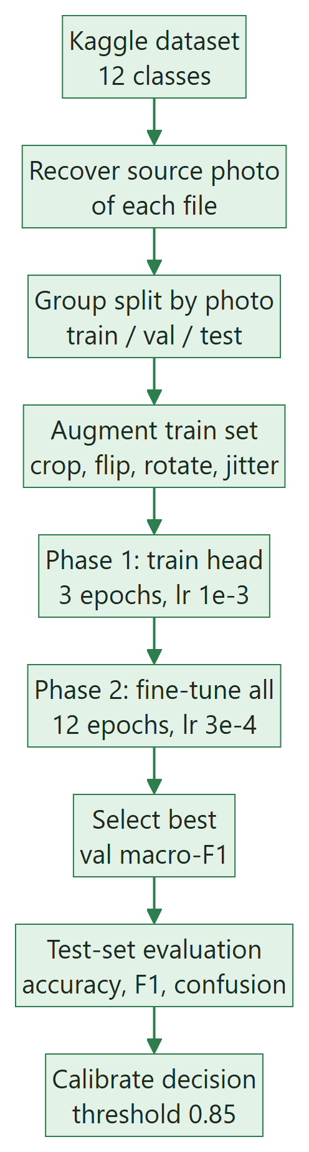
Figure 3.1: Training methodology for the spoilage model

3.3.3 Decision rule
The 12 class probabilities are grouped into a freshness probability and a staleness probability for the predicted produce type:
P_fresh = Σ_{k ∈ fresh} pₖ , P_stale = 1 − P_fresh (3.4)
verdict = SAFE if P_fresh ≥ 0.85; UNSAFE if P_stale ≥ 0.85; CAUTION otherwise (3.5)
The threshold τ = 0.85 was chosen on validation data so that no stale item is marked SAFE while few items fall into CAUTION.

3.3.4 Explanation: Grad-CAM and discolouration
For the predicted class c and the feature maps Aᵏ of the last convolutional block (spatial size Z = i × j), Grad-CAM [18] computes channel weights and a heat map:
αₖᶜ = (1/Z) · Σᵢ Σⱼ ∂yᶜ / ∂Aᵏᵢⱼ (3.6)
L_Grad-CAM = ReLU( Σₖ αₖᶜ · Aᵏ ) (3.7)
The map is up-sampled to the image size and overlaid as a colour heat map.
Independently of the network, the share of discoloured surface is measured in HSV colour space. A foreground mask of the produce is built; a pixel is counted as discoloured if it is dark (V < 60) or brown (5 ≤ H ≤ 25, S > 70, V < 130, OpenCV hue scale 0–179):
D = |discoloured ∩ foreground| / |foreground| × 100 % (3.8)

3.4 Guardrails

3.4.1 Stage 1 and 2: zero-shot scene analysis with CLIP
CLIP ViT-B/32 [32] encodes the image into an embedding f and each of the N = 43 text prompts into tᵢ. With CLIP's learned temperature s, the probability of prompt i is:
P(i | image) = exp(s · cos(f, tᵢ)) / Σₙ exp(s · cos(f, tₙ)) (3.9)
Prompts belong to six groups G (raw produce, packaged solid, packaged liquid, exempt, prepared food, non-food). Group probabilities are sums over their prompts, and the food probability is the sum over the four food groups:
P(G) = Σ_{i ∈ G} P(i | image) , P_food = P(raw) + P(solid) + P(liquid) + P(exempt) (3.10)
Algorithm 3.2 Guardrail decisions (thresholds from safety_thresholds.json)
if P_food < 0.40 -> REJECTED (not food)
if best prompt is a prepared dish -> REJECTED (cooked food is out of scope)
if category = raw and P(packaged) > P(raw) + 0.30 -> MISMATCH, suggest packaged
if category = packaged and P(raw) > P(packaged) + 0.30 -> MISMATCH, suggest raw produce
if category = raw and P(six supported produce prompts) < 0.10 -> REJECTED (unsupported)
if packaged and text regions < 6 or nutrition rows < 2 -> REJECTED (no readable table)
if label says 'per 100 ml' but category = solid (or vice versa) -> MISMATCH

3.4.2 Stage 3: product identity
Algorithm 3.3 Identity verification for packaged food
codes <- barcode decoded from the photo (OpenCV) and barcode typed by the user
if two different codes -> MISMATCH
ref <- Open Food Facts record by barcode, else by name search
(name coverage >= 0.75, prefer records that have nutrient data)
brands <- brand names found in OCR text (fuzzy score >= 70)
if a printed brand belongs to a different parent company than the named product -> MISMATCH
for each nutrient read from the label and present in ref:
divergent if |label - ref| > abs_tol(nutrient) and |label - ref| / ref > 0.35
if divergent >= 3 and divergent >= 0.6 x compared -> MISMATCH
else if divergent >= 2 -> DIVERGENT (warning)
else VERIFIED (or UNVERIFIED when nothing could be checked)
For raw produce, a typed name (English or Hindi, for example tamatar or kela) is resolved to one of the six types and must agree with what CLIP and the CNN see.

3.5 Label Reading (Pipeline B)
Figure 3.2 shows the stages of label reading. Each image is pre-processed into up to four variants. The colour and CLAHE-enhanced variants always run; the up-scaled and binarised variants run only when fewer than five nutrient rows have been found.
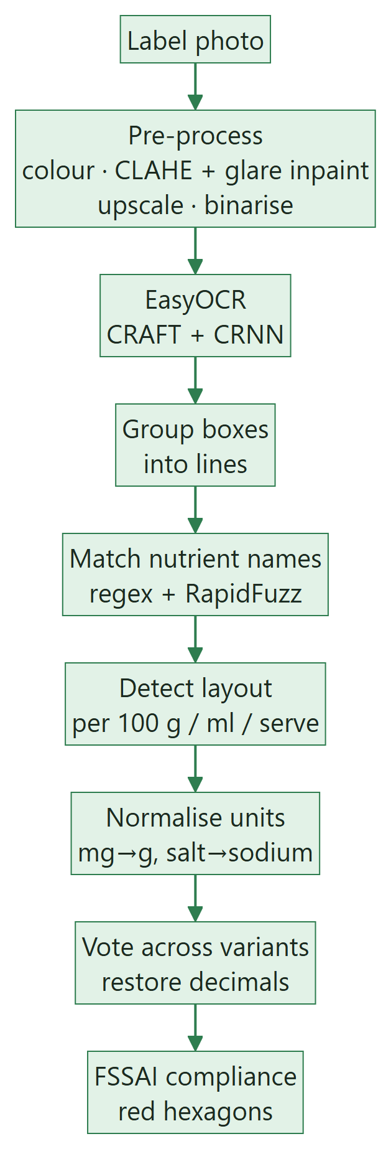
Figure 3.2: Label reading pipeline
Algorithm 3.4 Combining OCR variants
runs <- []
for v in [colour, CLAHE + glare inpaint, upscaled x1.5, adaptive binary]:
if v is upscaled/binary and max nutrients found so far >= 5: break
lines <- group EasyOCR boxes of v into text lines
runs.append(parse_nutrients(lines))
primary <- run with the most nutrient rows
for each nutrient k found in any run:
if one reading = another x 10 or x 100: keep the smaller (lost decimal point)
else if two runs agree within 1 %: keep that value (majority vote)
else keep the primary run's value
Nutrient names are matched with regular expressions and RapidFuzz to tolerate OCR errors ("Sodiurn", "Saturated Fal"). The parser detects the table layout and converts every value to the per-100 basis:
value₁₀₀ = value_serve × 100 / serving size (3.11)
sodium (g) = salt (g) / 2.5 , g = mg / 1000 (3.12)
Values that are physically impossible (more than 900 kcal or more than 100 g of a nutrient per 100 g) indicate a misread column and are rejected before scaling. If added sugar is not declared, total sugars are used as a conservative substitute.

3.6 FSSAI Compliance Engine
Algorithm 3.5 Compliance and verdict for packaged food
limits <- safety_thresholds.json[category] # empty for exempt
for each (nutrient, limit) in limits:
v <- value per 100 g / 100 ml (or total sugar for missing added sugar)
if v missing -> NOT_FOUND
elif label says '< v' and v > limit -> UNCERTAIN
elif v > limit -> EXCEEDED, add red hexagon
else -> OK
if expiry date entered and passed -> UNSAFE
elif any EXCEEDED -> UNSAFE (red hexagons)
elif any NOT_FOUND or UNCERTAIN -> CAUTION (ask for a clearer photo)
else -> SAFE
Table 3.4: HFSS limits used by the engine
Category | Basis | Added sugar | Saturated fat | Sodium
Packaged – solid | per 100 g | > 3.0 g | > 4.2 g | > 0.625 g
Packaged – liquid | per 100 ml | > 1.5 g | > 2.1 g | > 0.300 g
Packaged – exempt | – | exempt | exempt | exempt

Note: these values were taken from the project brief and must be verified against the current FSSAI notification before the final review; they are read from the configuration file, so updating them needs no code change. If the product title or a one- or two-item ingredient list matches exempt keywords (ghee, honey, mustard oil, almonds and others), the engine suggests re-running the check in the exempt category.

3.7 Review and Health Score
For raw produce the health score is the freshness confidence:
S_produce = 100 × P_fresh (3.13)
For packaged food, each limited nutrient with ratio r = value / limit contributes a penalty:
π(r) = 0 if r ≤ 0.5; 12·(r − 0.5)/0.5 if 0.5 < r ≤ 1; 12 + 23·min(1, (r − 1)/2) if r > 1 (3.14)
S_packaged = max(0, 100 − Σ π(rₙ)), capped at 45 if any limit is exceeded, 0 if expired (3.15)
The cap ensures the score always agrees with an UNSAFE verdict. Ratings are 85 and above Excellent, 70 Good, 50 Fair, 30 Poor and below 30 Avoid; stars are S / 20 rounded to half steps. Exempt foods are not scored. For each nutrient, the share of the WHO adult daily maximum (2,000 kcal energy, 50 g free sugar, 22 g saturated fat, 2 g sodium) is also reported.

3.8 Evaluation Methodology

3.8.1 Metrics
With TP, FP, FN and TN counted per class on the test set:
Accuracy = (correct predictions) / (all predictions) (3.16)
Precision = TP / (TP + FP) , Recall = TP / (TP + FN) (3.17)
F1 = 2 · Precision · Recall / (Precision + Recall) , macro-F1 = (1/K) · Σₖ F1ₖ (3.18)
Table 3.5: Evaluation plan
Component | Metric | Data | Target
Spoilage model | 12-class accuracy, macro-F1, confusion matrix | Test split (2,208 images) | > 90 % accuracy
Decision rule | Stale items marked SAFE; accuracy when decided | Test split | 0 stale → SAFE
Food filter | False rejection rate; OOD detection rate | 740 valid + 54 OOD photos | < 2 % false rejections
Unsupported produce | Detection rate | 22 unsupported produce photos | Most rejected
OCR + parser | Field accuracy (within 10 % or 0.05 g); verdict agreement | Synthetic and real labels | High on synthetic; measured on real
Rules and logic | Unit tests passing | pytest suite | All pass
Whole system | Expected verdict per scenario | HTTP end-to-end scenarios | All correct

3.8.2 Experimental setup
Table 3.6: Experimental environment
Item | Specification
Hardware | NVIDIA GeForce RTX 5060 Ti (16 GB), Windows 11 Pro
Language and frameworks | Python 3.12, PyTorch 2.11 (CUDA 12.8), torchvision 0.26, Transformers 5.17
Vision and OCR | EasyOCR 1.7.2, OpenCV 5.0, Pillow
Matching and web | RapidFuzz 3.14, Flask 3.1, HTML / CSS / JavaScript
Evaluation | scikit-learn, Matplotlib, pytest
Reproducibility | Fixed seed 42; scripts downloaddatasets.py, trainvision.py, evaluatevision.py, evaluateocr.py

CHAPTER 4
SYSTEM DESIGN

4.1 Design Goals and Principles
- Guarded pipeline: every request passes the food, category and identity checks before the specialised models run.
- Fail safe: uncertainty leads to CAUTION or a request for a better photo, never to a confident guess.
- Explainable: every verdict carries a plain-language reason, the result of each stage and evidence images.
- Configuration-driven: limits and thresholds live in JSON files, not in code.
- Modular: each concern (guardrails, vision, OCR, parsing, rules, identity, review) is a separate module with a small interface.
- Private and offline-capable: images are processed in memory and not stored; after the first run, models load without internet.

4.2 System Architecture
The system is organised in four layers: the presentation layer (HTML, CSS and JavaScript in the browser), the application layer (Flask server and the pipeline orchestrator), the analysis layer (guardrails, spoilage model, OCR, parser, rule engine, identity and review modules) and the data layer (model weights, JSON configuration and the produce knowledge base). Figure 4.1 shows the flow through the guarded pipeline.
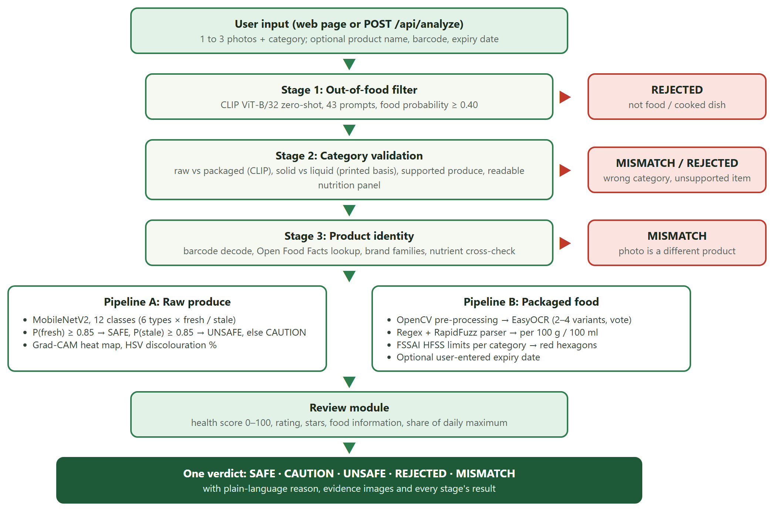
Figure 4.1: System architecture of FoodGuard AI

4.3 Data Flow Diagrams
The Level 0 data flow diagram (context diagram) in Figure 4.2 shows FoodGuard AI as a single process exchanging data with the user and the external services.
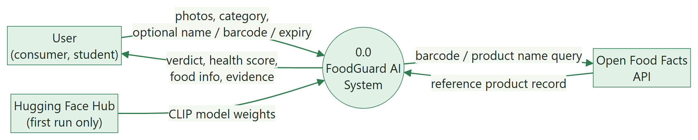
Figure 4.2: Data flow diagram, Level 0 (context diagram)
The Level 1 diagram (Figure 4.3, on the next page) decomposes the system into seven processes and four data stores. Solid arrows are data flows; dotted arrows are reads from data stores.

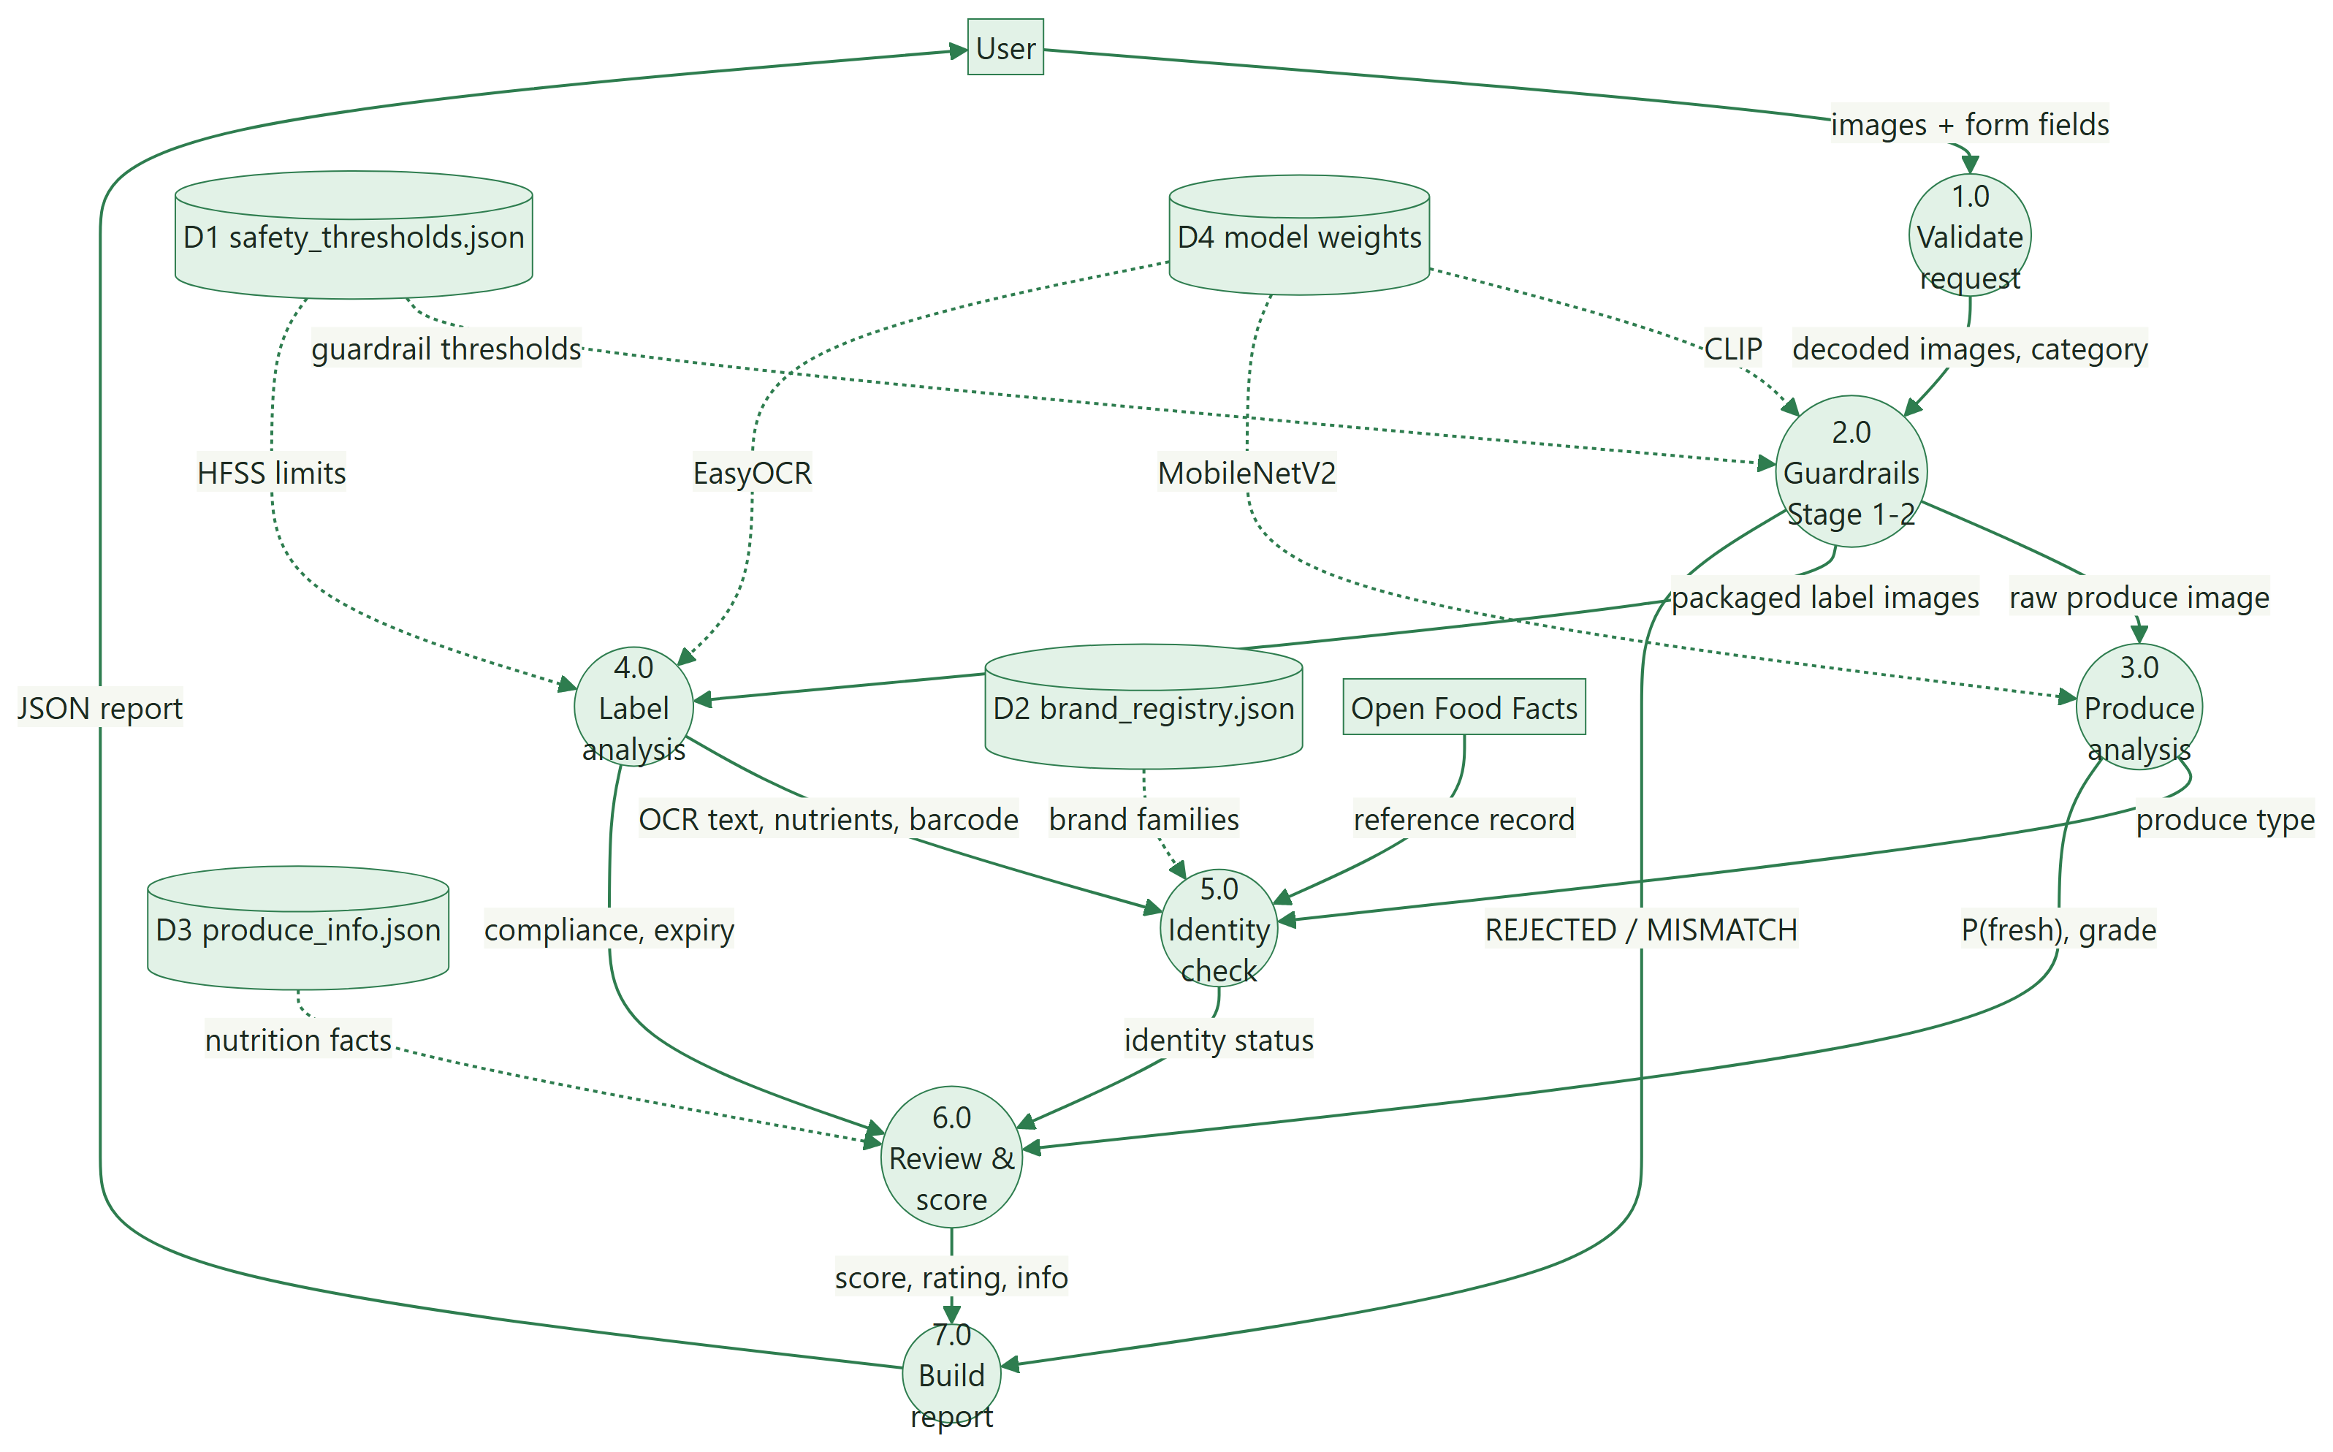
Figure 4.3: Data flow diagram, Level 1

4.4 Use Case Design
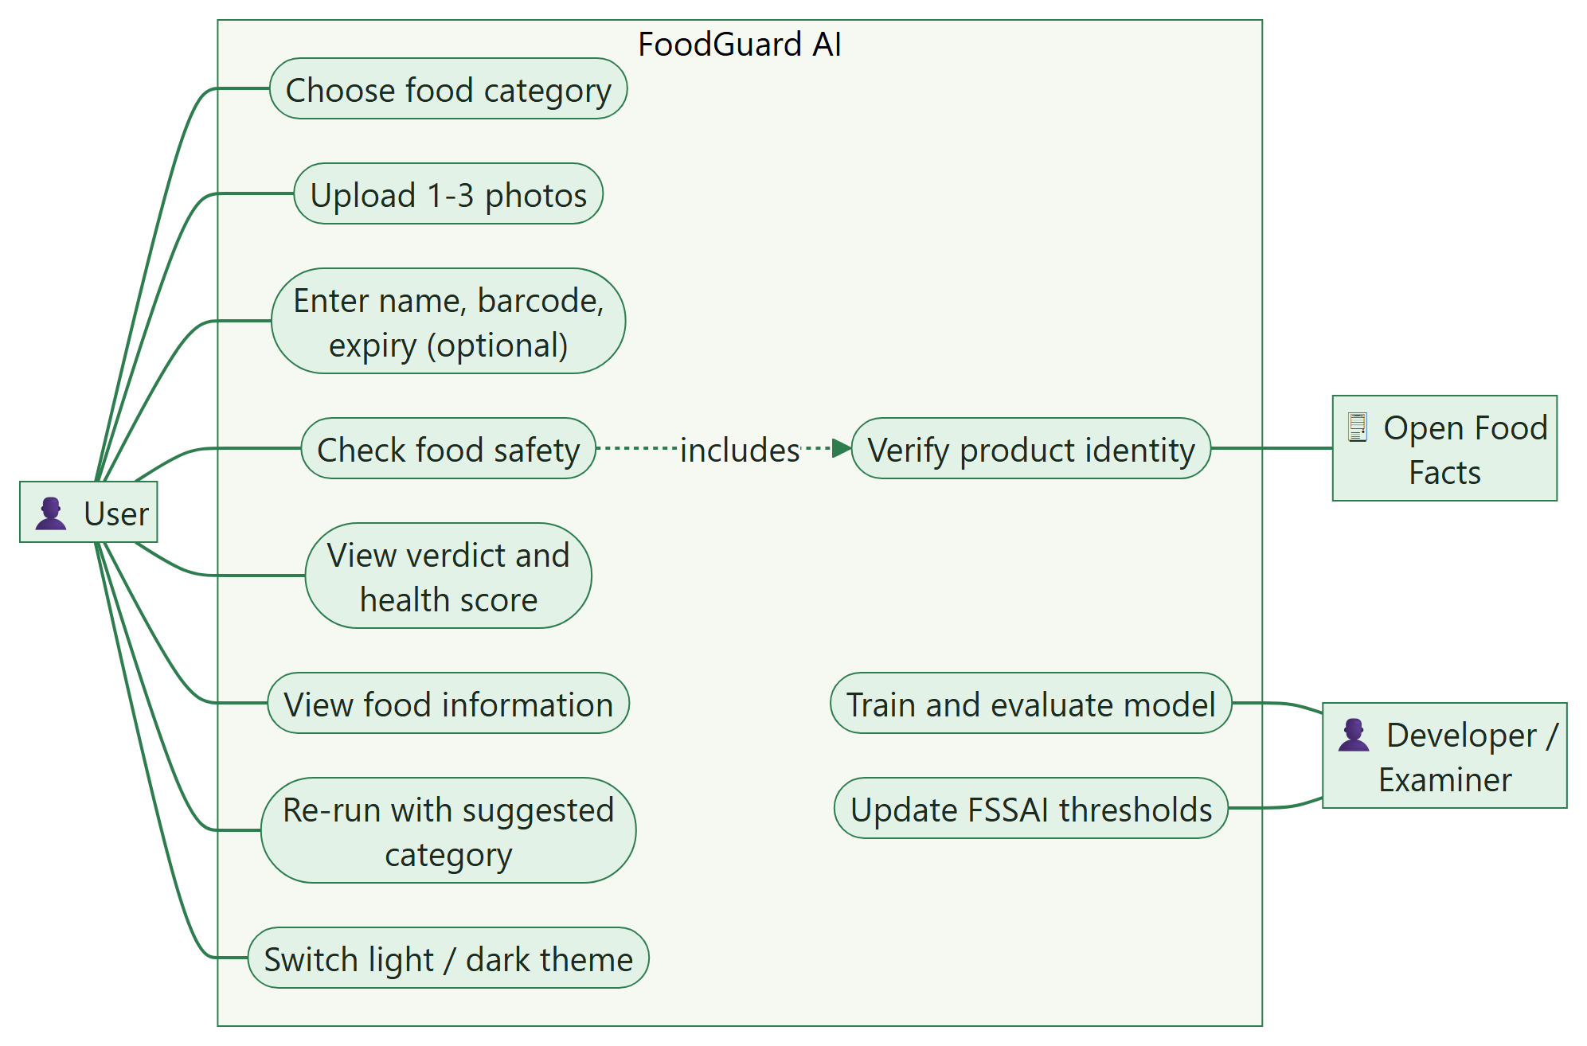
Figure 4.4: Use case diagram
Table 4.1: Use case description: Check food safety
Field | Description
Use case | UC4: Check food safety
Actors | User (primary); Open Food Facts (secondary)
Pre-conditions | Server running; models loaded; at least one photo selected
Main flow | 1. User chooses a category.  2. User adds 1–3 photos and optional name, barcode or expiry date.  3. User presses Check this food.  4. System shows the scanning animation and runs the guardrails.  5. System runs the produce or label pipeline and the identity check.  6. System shows the verdict seal, reason, health score and food information.
Alternative flows | 4a. Not food → REJECTED with advice.  4b. Wrong category → MISMATCH with a one-click re-run.  5a. Unreadable label → REJECTED or CAUTION asking for a clearer photo.  5b. Different product → MISMATCH.
Post-condition | A JSON report is displayed; no image is stored

4.5 Sequence Design
Figure 4.5 shows the interaction between components for one check. The alternative fragment shows the early exit when a guardrail fails.
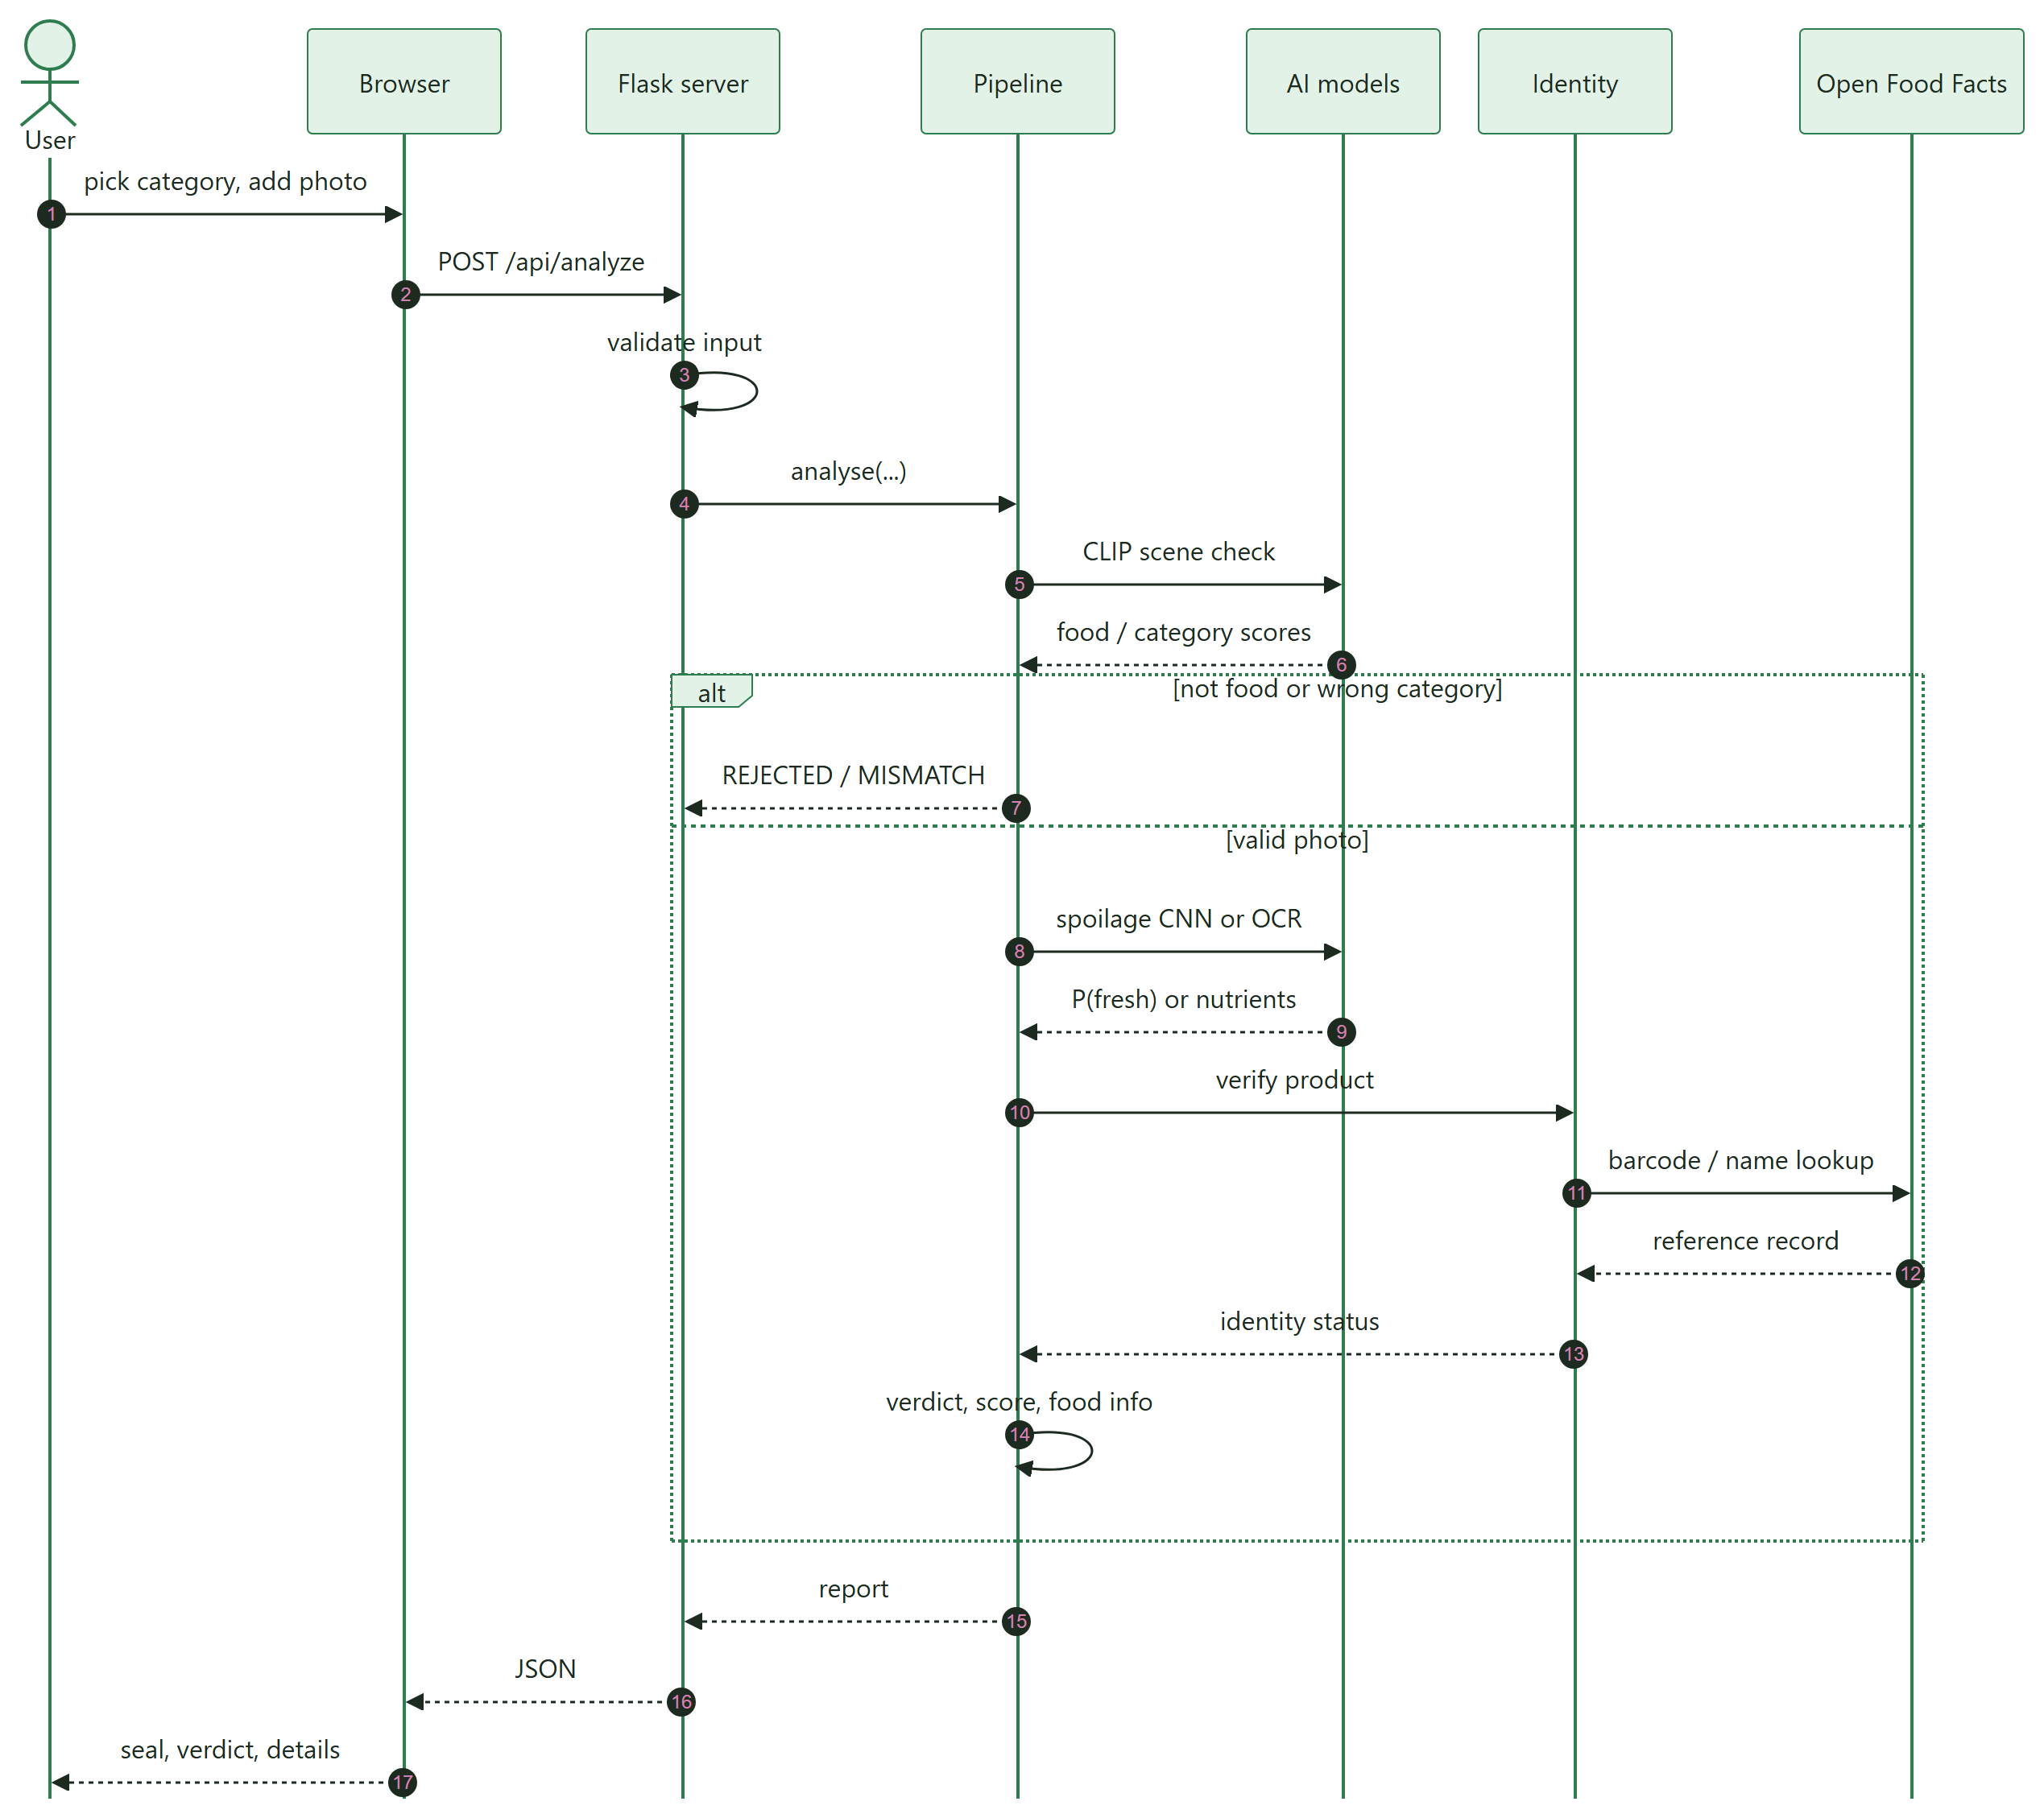
Figure 4.5: Sequence diagram for a food check

4.6 Activity Design
Figures 4.6 and 4.7 show the decision logic: first the guardrail flow that every request follows, then the verdict logic applied once a photo has passed all checks.
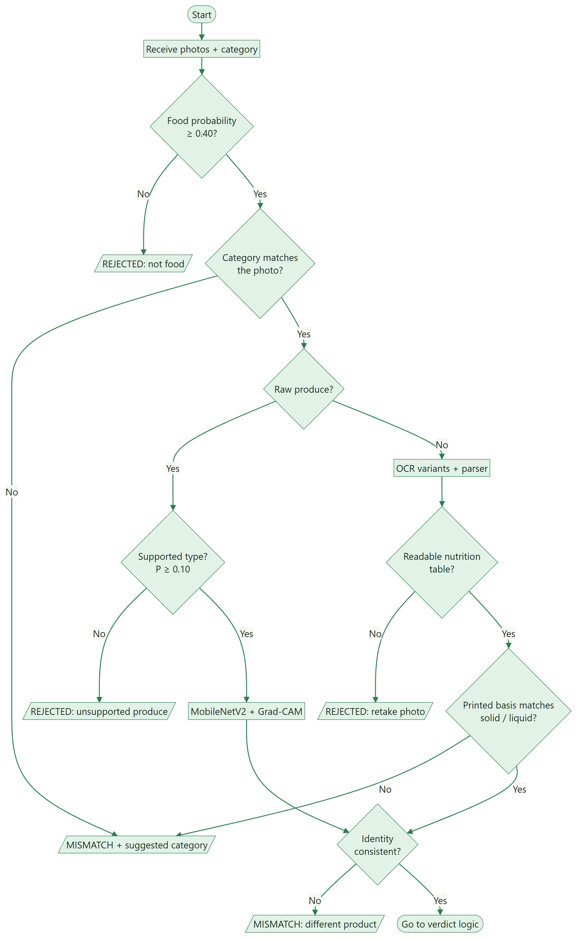
Figure 4.6: Activity diagram: guardrails and pipeline selection
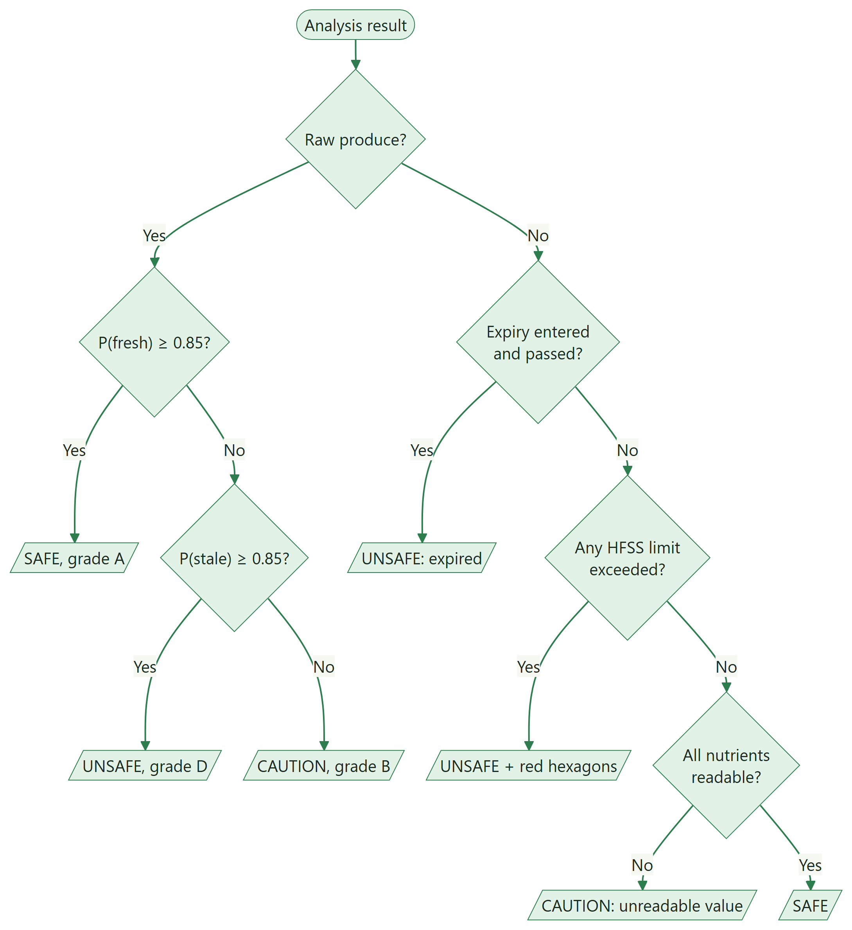
Figure 4.7: Activity diagram: verdict logic

4.7 Module Design
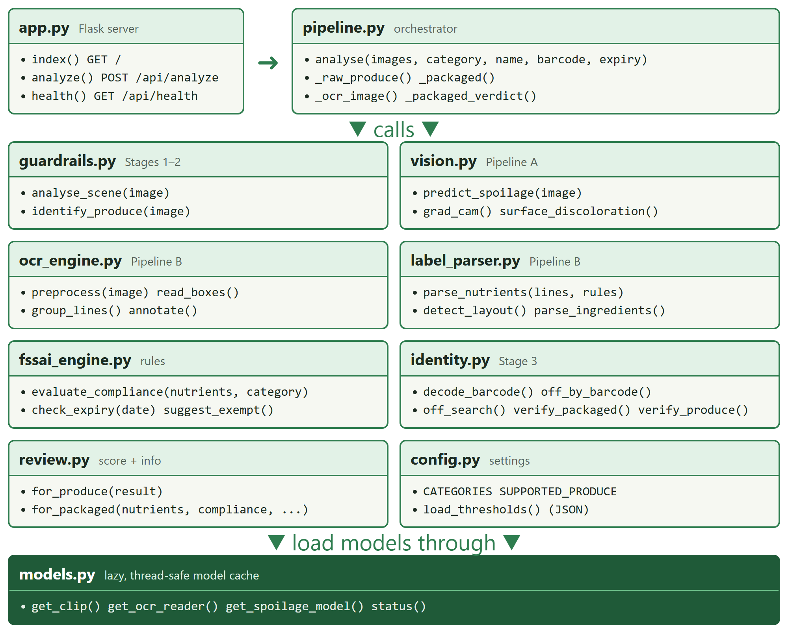
Figure 4.8: Module diagram with main functions
Table 4.2: Module responsibilities and interfaces
Module | Input | Output
guardrails | PIL image | food probability, group probabilities, best prompt, produce identity
vision | PIL image | class probabilities, P(fresh), grade, Grad-CAM PNG, discolouration %
ocr_engine | PIL image | pre-processed variants, text boxes, grouped lines, annotated image
label_parser | text lines, rules | nutrients per 100 g / ml, layout, ingredients, warnings
fssai_engine | nutrients, category, thresholds | checks, red hexagons, exempt flag; expiry status
identity | OCR text, nutrients, name, barcode | VERIFIED / DIVERGENT / MISMATCH / UNVERIFIED with reasons
review | pipeline results | score, rating, stars, breakdown, food information
pipeline | images, category, optional fields | complete report with one verdict

4.8 Data Design
The system needs no database: it keeps no user data, and its reference data is small and read-only. Configuration and knowledge are stored as JSON files, and model weights as PyTorch files. Table 4.3 lists the stores, and Table 4.4 the structure of the report returned for every request.
Table 4.3: Data stores
Store | Format | Contents
fssaiconfig/safetythresholds.json | JSON | Limits per category, nutrient rules, guardrail thresholds, exempt keywords
fssaiconfig/brandregistry.json | JSON | Brand families: brand → parent company
foodguard/data/produce_info.json | JSON | Nutrition, storage, shelf life and spoilage signs per produce type
models/spoilage_mobilenetv2.pt | PyTorch | Fine-tuned weights (9 MB) and class_names.json
Hugging Face cache | safetensors / bin | CLIP ViT-B/32 weights (downloaded once)

Table 4.4: Structure of the analysis report (JSON)
Field | Type | Description
verdict | object | status (SAFE, CAUTION, UNSAFE, REJECTED, MISMATCH), headline, reason, details
stages | array | name, status (PASS, FAIL, WARN, SKIP) and detail of each check
warnings | array | Non-blocking notes, for example an exempt suggestion
hexagons | array | Exceeded nutrients: label, value, limit
produce | object | Produce type, class probabilities, P(fresh), grade, discolouration
packaged | object | Nutrients, compliance checks, expiry, basis, ingredients, OCR text
identity | object | Identity status, checks, reference record, barcode
review | object | score, rating, stars, breakdown, info (facts, storage, daily share)
evidence | array | Grad-CAM or OCR overlay images (base64 PNG)
suggested_category | string | Category to re-run with, if a mismatch was detected

4.9 Interface Design

4.9.1 Application programming interface
Table 4.5: REST API
Method and path | Request | Response
GET / | – | Web interface (HTML)
POST /api/analyze | multipart: images (1–3), category, productname?, barcode?, expirydate? (YYYY-MM-DD) | 200 report JSON; 400 with an error message for invalid input; 413 if larger than 30 MB
GET /api/health | – | device (cuda / cpu), whether the spoilage model is trained, loaded models

4.9.2 User interface
The interface is designed to feel calm and human. The light theme uses white, off-white and leaf green; the dark theme uses deep forest tones; the choice is remembered in the browser. Headings use a serif typeface and body text a humanist sans-serif. The verdict is shown as an inspection stamp holding the health score, coloured by the verdict. While a check runs, a scanning beam sweeps over the user's own photo and the steps tick off. The layout is two columns on desktop and one column on phones, with visible keyboard focus and reduced-motion support.
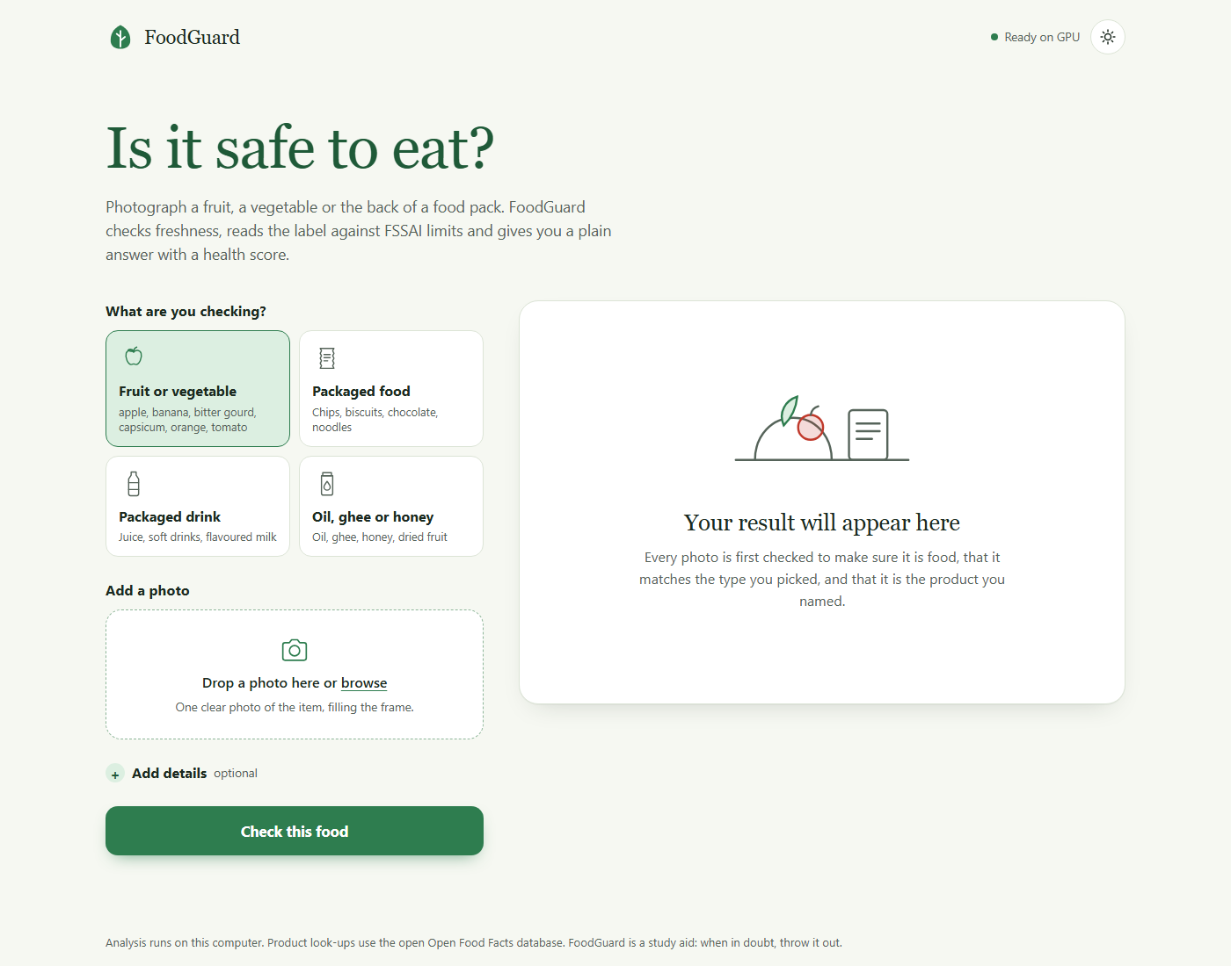
Figure 4.9: Home screen (light theme)
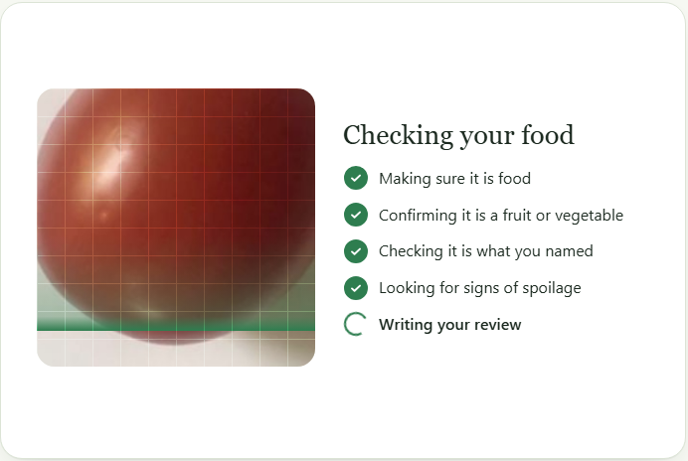
Figure 4.10: Processing screen with scanning animation
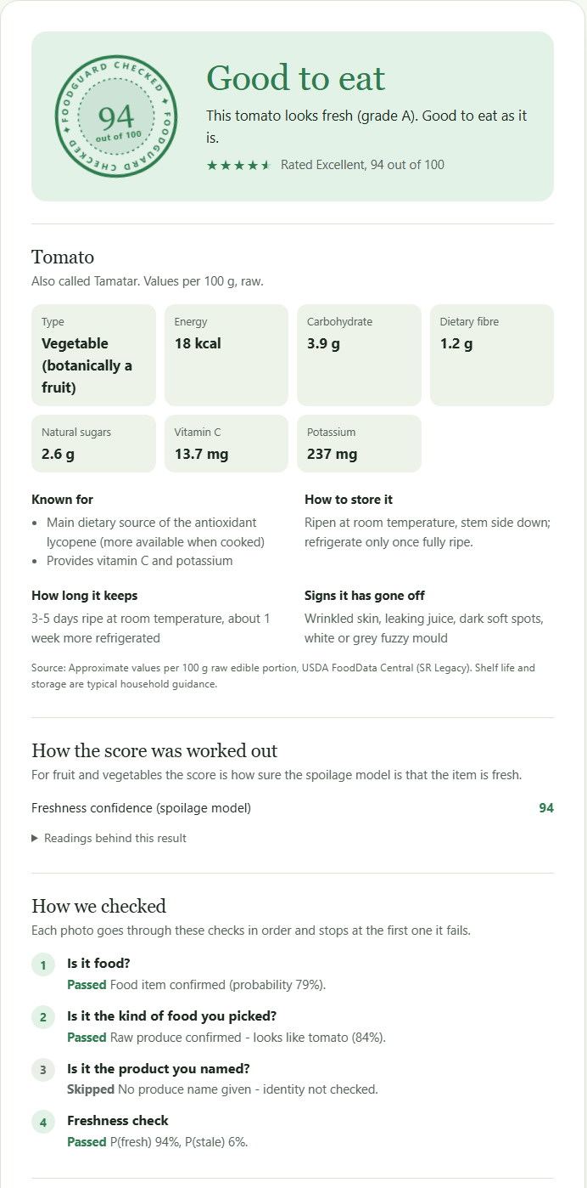
Figure 4.11: Result screen for raw produce

4.10 Deployment Design
FoodGuard AI runs on a single computer that acts as the server; any browser on the same machine or network is the client. A GPU is optional. The only external dependencies at run time are Open Food Facts look-ups; the CLIP weights are downloaded once and cached.
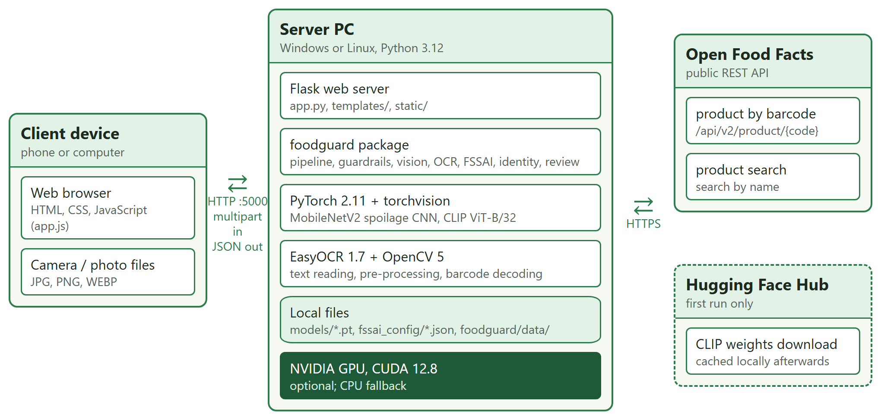
Figure 4.12: Deployment diagram

4.11 Error Handling and Security Design
Table 4.6: Input validation and safeguards
Concern | Design decision
Invalid files | Only jpg, jpeg, png, webp and bmp accepted; unreadable images rejected with HTTP 400
Oversized uploads | 30 MB request limit (HTTP 413); at most 3 images per request
Invalid fields | Unknown category or malformed expiry date rejected with a clear message
Unsuitable photos | Guardrails return REJECTED or MISMATCH instead of a guess
Concurrency | Model loading is thread-safe; a lock serialises GPU inference
Privacy | Images are processed in memory and never written to disk
External failures | Open Food Facts errors or time-outs lead to UNVERIFIED identity, not to a failure

CHAPTER 5
SUMMARY AND WORK STATUS

5.1 Summary
The literature survey established MobileNetV2 fine-tuning, CRAFT + CRNN OCR, CLIP zero-shot classification and Grad-CAM as suitable building blocks, and identified six gaps that no existing tool addresses together. The methodology turns these into a guarded dual pipeline with leakage-free data preparation, calibrated thresholds and a configurable FSSAI rule engine. The design presents the system through architecture, data flow, use case, sequence, activity, module, data, interface and deployment views.

5.2 Work Status
Table 5.1: Status of project components
Component | Status | Evidence
Dataset preparation (leakage-free split) | Completed | split_report.json
Spoilage model (MobileNetV2) | Completed | 97.2 % test accuracy, 0 stale → SAFE
Guardrails (CLIP, category, identity) | Completed | 0.4 % false rejection; 23 / 24 non-food caught at Stage 1
OCR and FSSAI rule engine | Completed | 100 % on synthetic bench; 76 % of values on real labels
Review module and optional expiry | Completed | Unit tests
Web application (light / dark themes) | Completed | Running application
Testing | Completed | 49 unit tests passing; end-to-end scenarios
Real-world test bench (own photos) | Planned | 30–50 label photos and 50–100 produce photos
Verification of FSSAI limits against notification | Pending | Cite exact clause

REFERENCES
[1] A. Krizhevsky, I. Sutskever and G. E. Hinton, "ImageNet Classification with Deep Convolutional Neural Networks," in Advances in Neural Information Processing Systems (NeurIPS), 2012.
[2] J. Deng, W. Dong, R. Socher, L.-J. Li, K. Li and L. Fei-Fei, "ImageNet: A Large-Scale Hierarchical Image Database," in Proc. IEEE CVPR, 2009.
[3] K. Simonyan and A. Zisserman, "Very Deep Convolutional Networks for Large-Scale Image Recognition," in Proc. ICLR, 2015.
[4] K. He, X. Zhang, S. Ren and J. Sun, "Deep Residual Learning for Image Recognition," in Proc. IEEE CVPR, 2016, pp. 770–778.
[5] A. G. Howard et al., "MobileNets: Efficient Convolutional Neural Networks for Mobile Vision Applications," arXiv:1704.04861, 2017.
[6] M. Sandler, A. Howard, M. Zhu, A. Zhmoginov and L.-C. Chen, "MobileNetV2: Inverted Residuals and Linear Bottlenecks," in Proc. IEEE/CVF CVPR, 2018, pp. 4510–4520.
[7] M. Tan and Q. V. Le, "EfficientNet: Rethinking Model Scaling for Convolutional Neural Networks," in Proc. ICML, 2019.
[8] A. Dosovitskiy et al., "An Image is Worth 16x16 Words: Transformers for Image Recognition at Scale," in Proc. ICLR, 2021.
[9] J. Yosinski, J. Clune, Y. Bengio and H. Lipson, "How Transferable Are Features in Deep Neural Networks?" in Advances in Neural Information Processing Systems (NeurIPS), 2014.
[10] C. Shorten and T. M. Khoshgoftaar, "A Survey on Image Data Augmentation for Deep Learning," Journal of Big Data, vol. 6, art. 60, 2019.
[11] A. Kamilaris and F. X. Prenafeta-Boldú, "Deep Learning in Agriculture: A Survey," Computers and Electronics in Agriculture, vol. 147, pp. 70–90, 2018.
[12] A. Bhargava and A. Bansal, "Fruits and Vegetables Quality Evaluation Using Computer Vision: A Review," Journal of King Saud University – Computer and Information Sciences, vol. 33, no. 3, pp. 243–257, 2021.
[13] H. Mureșan and M. Oltean, "Fruit Recognition from Images Using Deep Learning," Acta Universitatis Sapientiae, Informatica, vol. 10, no. 1, pp. 26–42, 2018.
[14] M. S. Hossain, M. Al-Hammadi and G. Muhammad, "Automatic Fruit Classification Using Deep Learning for Industrial Applications," IEEE Transactions on Industrial Informatics, vol. 15, no. 2, pp. 1027–1034, 2019.
[15] R. Potdar, "Fresh and Stale Images of Fruits and Vegetables," Kaggle dataset. [Online]. Available: https://www.kaggle.com/datasets/raghavrpotdar/fresh-and-stale-images-of-fruits-and-vegetables
[16] S. Kaufman, S. Rosset, C. Perlich and O. Stitelman, "Leakage in Data Mining: Formulation, Detection, and Avoidance," ACM Transactions on Knowledge Discovery from Data, vol. 6, no. 4, 2012.
[17] B. Zhou, A. Khosla, A. Lapedriza, A. Oliva and A. Torralba, "Learning Deep Features for Discriminative Localization," in Proc. IEEE CVPR, 2016.
[18] R. R. Selvaraju, M. Cogswell, A. Das, R. Vedantam, D. Parikh and D. Batra, "Grad-CAM: Visual Explanations from Deep Networks via Gradient-Based Localization," in Proc. IEEE ICCV, 2017, pp. 618–626.
[19] R. Smith, "An Overview of the Tesseract OCR Engine," in Proc. Int. Conf. Document Analysis and Recognition (ICDAR), 2007.
[20] X. Zhou et al., "EAST: An Efficient and Accurate Scene Text Detector," in Proc. IEEE CVPR, 2017.
[21] Y. Baek, B. Lee, D. Han, S. Yun and H. Lee, "Character Region Awareness for Text Detection," in Proc. IEEE/CVF CVPR, 2019.
[22] A. Graves, S. Fernández, F. Gomez and J. Schmidhuber, "Connectionist Temporal Classification: Labelling Unsegmented Sequence Data with Recurrent Neural Networks," in Proc. ICML, 2006.
[23] B. Shi, X. Bai and C. Yao, "An End-to-End Trainable Neural Network for Image-Based Sequence Recognition and Its Application to Scene Text Recognition," IEEE Transactions on Pattern Analysis and Machine Intelligence, vol. 39, no. 11, pp. 2298–2304, 2017.
[24] S. Long, X. He and C. Yao, "Scene Text Detection and Recognition: The Deep Learning Era," International Journal of Computer Vision, vol. 129, pp. 161–184, 2021.
[25] JaidedAI, "EasyOCR," GitHub repository. [Online]. Available: https://github.com/JaidedAI/EasyOCR
[26] N. Otsu, "A Threshold Selection Method from Gray-Level Histograms," IEEE Transactions on Systems, Man, and Cybernetics, vol. 9, no. 1, pp. 62–66, 1979.
[27] K. Zuiderveld, "Contrast Limited Adaptive Histogram Equalization," in Graphics Gems IV, Academic Press, 1994, pp. 474–485.
[28] C. Guo, G. Pleiss, Y. Sun and K. Q. Weinberger, "On Calibration of Modern Neural Networks," in Proc. ICML, 2017.
[29] D. Hendrycks and K. Gimpel, "A Baseline for Detecting Misclassified and Out-of-Distribution Examples in Neural Networks," in Proc. ICLR, 2017.
[30] S. Liang, Y. Li and R. Srikant, "Enhancing the Reliability of Out-of-Distribution Image Detection in Neural Networks," in Proc. ICLR, 2018.
[31] K. Lee, K. Lee, H. Lee and J. Shin, "A Simple Unified Framework for Detecting Out-of-Distribution Samples and Adversarial Attacks," in Advances in Neural Information Processing Systems (NeurIPS), 2018.
[32] A. Radford et al., "Learning Transferable Visual Models From Natural Language Supervision," in Proc. ICML, 2021.
[33] Y. Ming, Z. Cai, J. Gu, Y. Sun, W. Li and Y. Li, "Delving into Out-of-Distribution Detection with Vision-Language Representations," in Advances in Neural Information Processing Systems (NeurIPS), 2022.
[34] Food Safety and Standards Authority of India, "Food Safety and Standards (Labelling and Display) Regulations, 2020." [Online]. Available: https://www.fssai.gov.in
[35] Food Safety and Standards Authority of India, "Draft Food Safety and Standards (Labelling and Display) Amendment Regulations on front-of-pack nutrition labelling," 2022. [Online]. Available: https://www.fssai.gov.in
[36] World Health Organization, "Guideline: Sugars Intake for Adults and Children," Geneva, 2015.
[37] World Health Organization, "Guideline: Sodium Intake for Adults and Children," Geneva, 2012.
[38] World Health Organization, "Saturated Fatty Acid and Trans-Fatty Acid Intake for Adults and Children: WHO Guideline," Geneva, 2023.
[39] L. S. Taillie, M. Reyes, M. A. Colchero, B. Popkin and C. Corvalán, "An Evaluation of Chile's Law of Food Labeling and Advertising on Sugar-Sweetened Beverage Purchases from 2015 to 2017: A Before-and-After Study," PLOS Medicine, vol. 17, no. 2, e1003015, 2020.
[40] C. Julia and S. Hercberg, "Development of a New Front-of-Pack Nutrition Label in France: The Five-Colour Nutri-Score," Public Health Panorama, vol. 3, no. 4, pp. 712–725, 2017.
[41] Open Food Facts, "Open Food Facts: The Free Food Products Database." [Online]. Available: https://world.openfoodfacts.org
[42] GS1, "GS1 General Specifications." [Online]. Available: https://www.gs1.org/standards/barcodes-epcrfid-id-keys/gs1-general-specifications
[43] U.S. Department of Agriculture, Agricultural Research Service, "FoodData Central." [Online]. Available: https://fdc.nal.usda.gov
[44] V. I. Levenshtein, "Binary Codes Capable of Correcting Deletions, Insertions, and Reversals," Soviet Physics Doklady, vol. 10, no. 8, pp. 707–710, 1966.
[45] I. Loshchilov and F. Hutter, "Decoupled Weight Decay Regularization," in Proc. ICLR, 2019.
[46] L. N. Smith and N. Topin, "Super-Convergence: Very Fast Training of Neural Networks Using Large Learning Rates," in Proc. SPIE Artificial Intelligence and Machine Learning for Multi-Domain Operations Applications, 2019.
[47] P. Micikevicius et al., "Mixed Precision Training," in Proc. ICLR, 2018.
[48] C. Szegedy, V. Vanhoucke, S. Ioffe, J. Shlens and Z. Wojna, "Rethinking the Inception Architecture for Computer Vision," in Proc. IEEE CVPR, 2016.

